THE ROLE OF EMPLOYEE TRAINING AND DEVELOPMENT IN ENHANCING SERVICE QUALITY: A CASE STUDY OF MARRIOTT INTERNATIONAL
Table of Contents
Slide 2 – Research Background and Problem 3
Slide 3 – Aim, Objectives and Research Questions 3
Slide 4 – Key Concepts from the Literature 4
Slide 5 – Theoretical Framework 4
Slide 6 – Literature Gap and Conceptual Logic 5
Slide 7 – Research Methodology 5
Slide 8 – Data Collection and Analysis 6
Slide 9 – Objective 1: Training and Service Quality 7
Slide 10 – Objective 1: Critical Statistical Interpretation 8
Slide 11 – Objective 2: Marriott Customer Satisfaction Trend 8
Slide 12 – Objective 2: Empirical Evidence 9
Slide 13 – Marriott-Specific Training Evidence 10
Slide 14 – Recommendations, Limitations and Future Research 11
Slide 15 – Conclusion and Key references 12
References 14

Slide 2 – Research Background and Problem
Slide content
- The quality of the service provided is affected by the ability of the employees.
- Training is enabling knowledge, skills and performance
- Guest experience is an essential, consistent part of Marriott's business.
- Some quantitative evidence, but not specific to Marriott
Speaker notes
The hospitality industry is very reliant on direct employee-customer interaction, and good employee competence is crucial to the consistency of service delivery. Knowledge, skills, confidence and an ability to apply service standards can be developed through training. The dissertation suggests that Marriott is a suitable organisation to study as it is a brand that relies on its staff providing reliable and responsive service to customers at a number of properties across a range of customer needs. The issue is not if Marriott offers training, it's if training is delivered to employees in a manner that translates to service performance. There has been some previous research that has explored training, service quality and customer satisfaction in the context of hospitality organisations, yet quantitative evidence prior to this that specifically related to employee development and Marriott specific outcomes is limited.

Slide 3 – Aim, Objectives and Research Questions
Slide content
- Aim: Investigate how training and development enhance the quality of service
- Objective 1: Training and quality of service
- Objective 2: Training and customer satisfaction
- Objective 3: Improvement proposals
Speaker notes
The research objective is to understand the influence of Employee Training and Development on the quality of services at Marriott International using secondary data and quantitative research approach. The relationship between training and development and service quality is explored in objective one. Objective two uses secondary quantitative evidence to assess the impact of training and development on customer satisfaction. Objective three focuses on developing proposals for enhancements in training & development to improve service quality. The research questions are specific to these research objectives and serve as a framework for analysis.

Slide 4 – Key Concepts from the Literature
Slide content
- Providing employees with learning and development opportunities
- Service quality
- Customer satisfaction
- While training is crucial, it's not the only factor.
Speaker notes
There are three core concepts that are separated in the literature. Employee training and development are organised activities which aim to improve the knowledge, skills and work related capacities of the employees. Service quality is related to the effectiveness of service delivery and service interactions based on the customer's expectations. Customer satisfaction is a more comprehensive evaluation made after the purchase and may be affected by service encounters along with facilities, convenience, value and customer expectations. Good employee training is a logical component of employee satisfaction, which is why this distinction is important. Organisations can benefit from learning to enhance their employees' performance and service capability, as evidence of hospitality suggests; however, organisers must also consider the context and customer perception of the impact of learning.

Slide 5 – Theoretical Framework
Slide content
- Human Capital Theory
- SERVQUAL Model
- Training → capability of employees → service behaviour.
- Service behaviour → customer evaluation
Speaker notes
The study is grounded on two theoretical perspectives. Human Capital Theory is used to justify the value of investing in employees: Investing in human capital can enhance knowledge, skills and competencies that can boost productivity in an organisation. The SERVQUAL adds dimensions through which the quality of services can be judged: reliability, responsiveness, assurance, empathy and tangibles. The theoretical route is therefore training investment can increase the capability and behaviour of the employees, which can help in the delivery of service quality, and which may impact on customers' evaluation.

Slide 6 – Literature Gap and Conceptual Logic
Slide content
- There is positive evidence throughout the hospitality research.
- There is limited evidence specific to Marriott.
- Not all HRM evidence is training evidence
- Study focuses on the evidence gap for Marriott.
Speaker notes
There is a clear gap in evidence identified from the literature. There has been some existing research that has focused on employee training, service quality and customer satisfaction, though much of this is based in hospitality organisations other than Marriott or concentrates on wider human-resource practices. Some studies specifically examine the type of training – for example green training – and others investigate broader service or organisation outcomes. Marriott has also been featured in other wider hotel chain comparisons, but these comparisons will not isolate employee development as a single explanatory factor. Thus, the present study aims to fill this void by using empirical data from the hospitality industry, Marriott organisational data, and an external customer-satisfaction index..

Slide 7 – Research Methodology
Slide content
- Philosophy: Positivism
- Approach: Deductive
- Strategy: Secondary quantitative
- The choice/time-horizon is a mono-method cross section.
Speaker notes
The methodology used is Research Onion and it is designed to maintain coherence between the research questions and analysis. The study was carried out using the positivism method because the study includes relationships that can be observed and measured in the form of secondary data in the form of numbers. A deductive approach was suitable as the research was based on previously established theoretical and empirical knowledge, and the expected relationships were tested to see if they are supported by evidence. The method used was secondary quantitatively, therefore there was no questionnaire, interview, observation. A mono-method quantitative choice supports the numerical evidence and a cross-sectional analytical approach acknowledges that the participants were not followed longitudinally.

Slide 8 – Data Collection and Analysis
Slide content
- Scopus, Web of Science
- Business Source Complete, Emerald and Sage and ScienceDirect are available.
- Describe reported correlations, regression and mediation.
- Evidence collected by the research objective
Speaker notes
Incorporating secondary data, peer-reviewed academic studies and credible organisational publications which are relevant to training, service quality and customer satisfaction were carried out. It suggests the following databases such as Scopus, Web of Science, Business Source Complete, Emerald Insight, Sage Journals and ScienceDirect as suitable ones. Sources were evaluated for their relevance, credibility, methodological clarity and comparability. The analysis was conducted by extracting the context, sample and variables reported in a study based on each research objective and the findings reported. Where appropriate, descriptive statistics and percentages and trends were presented. Pearson correlations and regression coefficients and mediation estimates were reported in their statistical contexts.

Slide 9 – Objective 1: Training and Service Quality
Slide content
- Positive relationships between the studies.
- Training access: r = 0.490 /0.436
- Training benefits: r = 0.620 /0.665
- Training support: r = 0.550 /0.487
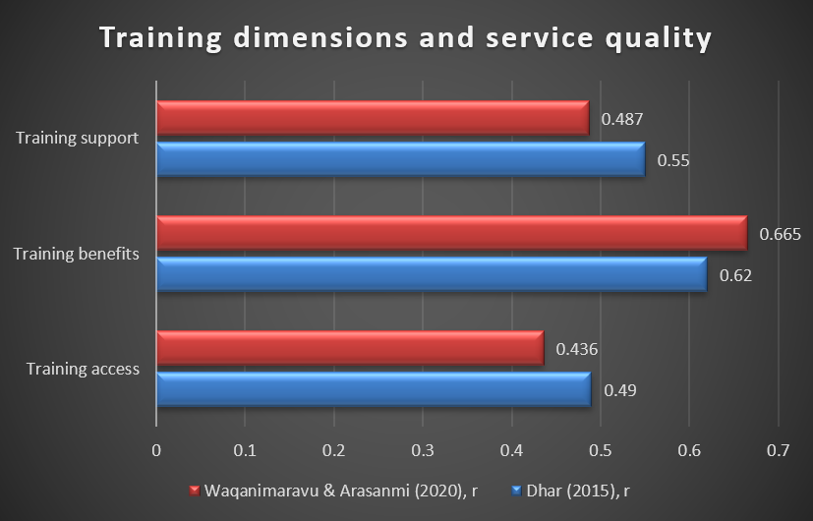
Fig. 1. Training dimensions and service quality
(Source: Generated in Excel)
Speaker notes
The relationships of training dimensions with service quality are positive and consistent in supporting objective one. Dhar found the correlations of .49 for access to training, .62 for training benefits and .55 for support for training of 494 employees in small and medium tourist hotels of Uttarakhand. Waqanimaravu and Arasanmi had .436, .665 and .487 respectively on 120 usable hospitality responses. The correlation between training benefits and the other factors is the highest in both studies as evidenced in this comparison. This is significant as it moves the focus from an employee's ability to attend training to the question of whether they have access to training.

Slide 10 – Objective 1: Critical Statistical Interpretation
Slide content
- Training access: β = .023, p > .05
- Training benefits: β = .553, p < .05
- Training support: β = .202, p < .01
- Organisational commitment is suggested as a possible mechanism
Speaker notes
The regression and mediation results confirm this critical interpretation of Objective one. The study by Waqanimaravu and Arasanmi (2016) revealed that the perceived availability of training was not a significant predictor of service quality with (beta) value of .023 and p value of >.05. Perceived training benefits, however, strongly predicted service quality with the beta being .553 and the p being less than .05, and perceived training support had beta equal to .202 and the p less than .01. The three training variables was reported to explain 46.3% of the variance in service quality. A potential mechanism for this is proposed by Dhar, who identifies organisational commitment as a mediator between training and service quality. All of the above indicate that relevance, perceived value, organisational support and the ability of employees to transfer learning into practice are key to effective training.

Slide 11 – Objective 2: Marriott Customer Satisfaction Trend
Slide content
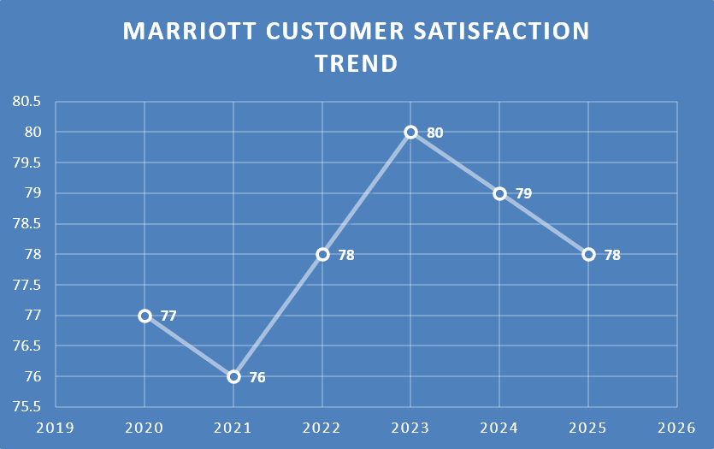
Fig. 2. Marriott customer satisfaction trend
(Source: Generated in Excel)
- 2020: 77
- 2021: 76
- 2022: 78
- 2023: 80 → 2024: 79 → 2025: 78
Speaker notes
The more cautious finding is given in Objective two, as there are no matched training or satisfaction observations available for Marriott. The external ACSI series records Marriott at 77 in 2020, 76 in 2021, 78 in 2022, 80 in 2023, 79 in 2024 and 78 in 2025. The pattern thus reflects an improvement, then a slight decrease, instead of steady increases. The key methodological insight here is that ACSI is a customer satisfaction measure, external to Marriott's internal or global satisfaction measure. Therefore, the series does not provide evidence of any movement, or context for the level of satisfaction. The dissertation then does not attempt to correlate participation in Marriott training with ACSI scores, since the scores are not observed at the same level.

Slide 12 – Objective 2: Empirical Evidence
Slide content
- Han et al. (2023): training → experience → satisfaction
- green training = experience: β = 0.399
- β = 0.621, experience → satisfaction
- For the customer satisfaction, the R² is 0.393.
Speaker notes
There is evidence from the broader hospitality sector that supports an opportunity for training to customer satisfaction. Han and colleagues applied PLS-SEM and obtained results which indicated that green training significantly influenced green experience with beta of .399 and p < 0.001, and that green experience significantly influenced customer satisfaction with beta of .621 and p < 0.001. The indirect effect was .248, the total effect was .250, and R-squared value for customer satisfaction was .393. This is certainly a good journey in customer experience but not evidence on the full training program at Marriott. Ambepitiya and Dharmasiri also found that professional training was related to service quality and customer satisfaction in the Sri Lankan hotels. HRM is more extensive than training as it is also associated with wider HRM relationships with service quality and satisfaction as found by Chand.

Slide 13 – Marriott-Specific Training Evidence
Slide content
- 2022: 78% training participation
- 2023: 90% training participation
- Leadership development and cross training.
- Attending training doesn't necessarily mean that you are an effective trainer.
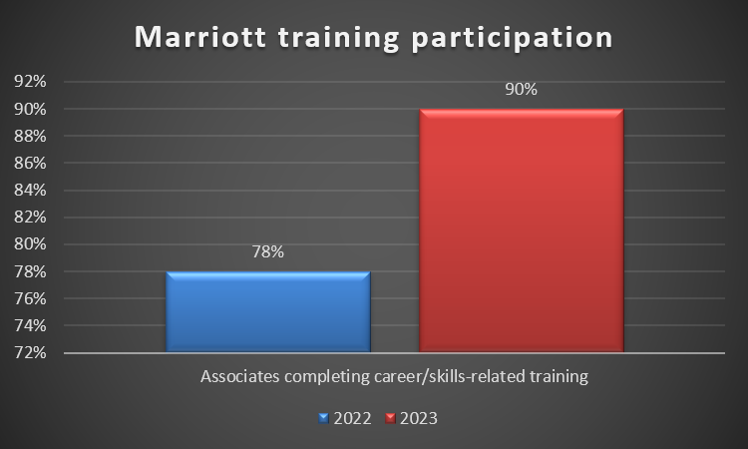
Fig. 3. Marriott Training Participation
(Source: Generated in Excel)
Speaker notes
The evidence shows a great amount of investment in learning and development (L&D) across the organisation, with a particular focus on Marriott. The percentage of associates who undertook career or skills-related training increased from 78 per cent in 2022 to 90 per cent in 2023, an increase of 12 per cent. Marriott also includes leadership development, learning support, cross training and performance development. Over 242,000 managed and franchised associates participated in classroom learning events in 2024 and around 95 percent of eligible associates completed Leadership Performance Acceleration reviews. The following indicators reflect progress in training reach and in integrating training into development processes. But participation does not equal effectiveness. Finally, in 2024, Marriott switched its digital-learning-hour approach and platform, so it is not advisable to compare later measures with earlier ones. The analytical implication is to evaluate training by applying and result. This case context is important to Marriott but does not create a causal training-to-service-quality link.

Slide 14 – Recommendations, Limitations and Future Research
Slide content
Recommendations
- Role-specific, scenario-based training
- Coaching and transfer of training are promoted at the supervisor level
- Outcome-based training evaluation
- Integrate customer feedback
Limitations/Future
- No dataset of the same level was found in the Marriott Collection.
- Longitudinal primary research to be undertaken in the future.
Speaker notes
The results result in 4 practical recommendations. First, Marriott should enhance role-specific and scenario-based training on complaint handling and communication, service recovery and problem solving as these had the strongest association with service quality, as perceived training benefits was the most important variable. Second, supervisor coaching, observation, feedback and follow-up should be employed to enhance post training transfer. Third, effectiveness of training should not be assessed merely through training attendance but should measure the impact of learning on employees' performance, service Quality measures and/or customer results. Fourth, customer feedback, complaints and service-recovery should drive training priorities. These recommendations are purposefully evidence-based and not "one size fits all. They understand the current learning environment at Marriott and are looking for ways to enhance the operational impact of training.

Slide 15 – Conclusion and Key references
Slide content
- Training is provided when appropriate and available for service quality
- It is effective when transferred to the workplace
- In the area of development, Marriott has made significant investments.
- There is no direct causal connection that can be made
Key references
- Dhar (2015)
- Waqanimaravu & Arasanmi (2020)
- Han, Kok & McClelland (2023)
- Marriott Serve 360
- ACSI Travel Studies
Speaker notes
The findings of the study conclude that the role employee training and development in improving service quality is quite important, but from the evidence found it can be concluded that the factors that affect the effectiveness of training and development are the relevance of the training, the support of the organization and the transfer of training to the workplace. Empirical evidence that supports Objective one is the positive relationship between training and service quality as seen in the hospitality field especially in relation to perceived benefits and support. There is moderate support for the objective two goal, as many other hospitality studies have identified other pathways to customer outcomes and Marriott's ACSI trend is a contextual one. Through practical suggestions, objective three is met with role-specific learning, supervisory reinforcement, outcome-based evaluation and feedback from customers. The sources that supplement the analysis are those of Dhar, Waqanimaravu and Arasanmi, Han and colleagues, ACSI Travel Studies and the evidence from Marriott Serve 360.

References
Chand, M., 2010. The impact of HRM practices on service quality, customer satisfaction and performance in the Indian hotel industry. The International Journal of Human Resource Management, 21(4), pp.551-566. https://www.tandfonline.com/doi/abs/10.1080/09585191003612059?casa_token=n-c1c-LGm74AAAAA:hNR6TqwWDh8p7fRwzkDvOZkMNvT7paPdeZF2jnu5cSSLiOsqMZgW-4TGcUcCMZnmK4CxjovbHppkag
Han, J.W., Kok, S.K. and McClelland, R., 2023. The impact of green training on employee turnover intention and customer satisfaction: An integrated perspective. Corporate Social Responsibility and Environmental Management, 30(6), pp.3006-3019. https://onlinelibrary.wiley.com/doi/abs/10.1002/csr.2534
Han, J.W., Nguyen, T.T.M., Hua, S.M. and Pham, T.H., 2023. Organizational learning through training effectiveness: evidence from the hospitality industry in Vietnam. The Learning Organization, 30(5), pp.532-553.https://www.emerald.com/tlo/article/30/5/532/378956
Papademetriou, C., Anastasiadou, S. and Papalexandris, S., 2023. The effect of sustainable human resource management practices on customer satisfaction, service quality, and institutional performance in hotel businesses. Sustainability, 15(10), p.8251. https://www.mdpi.com/2071-1050/15/10/8251
Senadhira, D.I.V., 2026. From Training to Service-Quality Behaviour: The Moderating Role of Employee Engagement in Frontline Banking. Journal of Human Resource Management Perspectives, 11(4).https://jhrmp.sljol.info/en/articles/10.4038/jhrmp.v11i4.81
Singh, A. and Ansari, A.I., 2024. Role of training and development in employee motivation: Tourism and hospitality sector. In Enhancing Employee Motivation Through Training and Development (pp. 248-261). IGI Global Scientific Publishing.https://www.igi-global.com/chapter/role-of-training-and-development-in-employee-motivation/348703
Talukder, M.B. and Kumar, S., 2024. The Development of Human Capital in The Hospitality Business.https://www.emerald.com/books/edited-volume/16897/chapter/93886465
Waqanimaravu, M. and Arasanmi, C.N., 2020. Employee training and service quality in the hospitality industry. Journal of Foodservice Business Research, 23(3), pp.216-227. https://www.tandfonline.com/doi/abs/10.1080/15378020.2020.1724850?casa_token=44p-XhLvEYkAAAAA:P3wckh43N0a_aVLdYc9bzkbs9aSYErj1TUHWoMhqfIPKFJSptQDfoRcmvk4gROV5yMyZr2sHFf7wBg
Xue, B.W., Lin, H.H., Chen, C.C., Lee, P.Y. and Hsu, C.H., 2022. How to improve the problem of hotel manpower shortage in the COVID-19 epidemic environment? Exploring the effectiveness of the hotel practice training system. Environmental Science and Pollution Research, 29(48), pp.72169-72184.https://link.springer.com/article/10.1007/s11356-022-21262-2
Zumitzavan, V., 2026. Research Methodologies and Designs. In Social Science Methodologies for Management Research: From Philosophy to Practice in the AI Era (pp. 21-40). Singapore: Springer Nature Singapore. https://link.springer.com/chapter/10.1007/978-981-95-4318-2_3

