TITLE: A BIOPSYCHOSOCIAL ANALYSIS OF POLYCYSTIC OVARY SYNDROME (PCOS) IN EARLY ADULTHOOD: A CASE STUDY OF AISHA
MODULE CODE: HWSC4005
STUDENT ID:

Table of Contents
1. Introduction 3
2. Biological Determinants and Physiological Effects of Polycystic Ovary Syndrome (PCOS) 3
2.1 Hormonal Imbalance and Endocrine Dysfunction 4
2.2 Reproductive System Effects 5
2.3 Metabolic Effects and Insulin Resistance 5
2.4 Physical Symptoms and Daily Impact 6
3. Psychological Impact of PCOS 7
4. Social Determinants and Social Impact of PCOS 9
5. Behaviour Change Approach for Aisha 11
5.1 Capability 12
5.2 Opportunity 12
5.3 Motivation 13
5.4 Recommended Behaviour Change Interventions 13
5.5 Challenges and Limitations 14
6. Conclusion 14
7. References 15

1. Introduction
Polycystic Ovary Syndrome (PCOS) is a chronic endocrine and metabolic disorder of the reproductive system, hormone control, and general well-being in persons of reproductive age. Hormonal imbalance, irregular ovulation, hyperandrogenism, and a change in metabolism are its traits (Joham et al., 2022). The following case study will investigate how Aisha's experience of PCOS is affecting her physical, psychological, and social well-being. The essay is organised in the biopsychosocial model to illustrate the interplay of biological, psychological, and social domains of health outcomes. In lieu of biological factors, the biopsychosocial model suggests that it is a combination of biological processes, psychological experiences, and social environments that affect health outcomes (Lugg, 2022). This model applies to Aisha's situation for many reasons, including PCOS impacting hormonal, social, and emotional functioning and participation in society. The downside of the model is that accounting for interactions between domains is challenging, as is its application in an even-handed, consistent way in healthcare practice.
Table 1: Prevalence and Health Risks Associated with PCOS
Measure | Evidence
PCOS prevalence | 8–13% of reproductive-age individuals
Increased metabolic risk | Greater risk for insulin resistance
Psychological impact | Higher levels of anxiety and depression risk.

2. Biological Determinants and Physiological Effects of Polycystic Ovary Syndrome (PCOS)
Aisha suffers from being affected by the physiological risks as well as some immediate symptoms caused by PCOS. Short-term side effects: irregular periods, acne, the beginning of excess hair growth, and hormonal changes. Side effects of long-term use: insulin resistance, the onset of type 2 diabetes, and cardiovascular risk (Tay et al., 2024). The biological effects are enough to propose continuous attention to PCOS, which goes beyond mere attention to the individual symptoms.
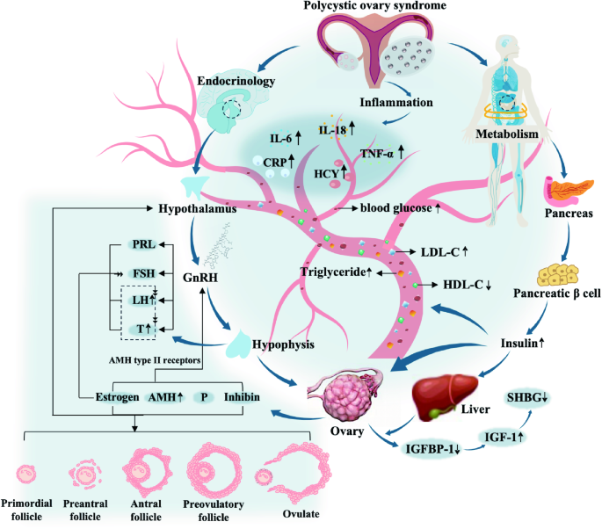
Figure 1: Physiopathology of polycystic ovary syndrome in endocrinology, metabolism and inflammation
(Source: Pingping Su, 2025)
Figure 1 shows the Biological mechanisms of PCOS associated with hormonal imbalance and ovarian dysfunction, along with other inflammatory and metabolic disturbances in various body systems.

2.1 Hormonal Imbalance and Endocrine Dysfunction
One of the most crucial physical aspects of PCOS is an irregular hormonal balance. People who have PCOS frequently have high levels of androgens, higher amounts of gonadotropins, and inefficiency in insulin regulation. Symptoms associated with excess androgens include acne, excessive facial or body hair, and disturbances of ovarian function. Hyperactivity of the androgens can increase the activity of the sebaceous glands, which can lead to the formation of acne, and hyperactivity of the androgens in hair follicles can lead to excess facial hair production. Also, thyroid dysfunction of oocytes and the occurrence of hormones interfere with the maturation of follicles and the phenomenon of ovulation, causing irregular periods. Disruptions of hormone levels produce abnormal growth of the follicles in the ovary and block regular ovulation, leading to irregular menstruation (Bergo et al., 2023). So PCOS is not just about the ovaries and is also a broader endocrine dysfunction. For Aisha, hormonal imbalance is a possible reason for some of the physical symptoms of PCOS and helps to underscore how long-term management is needed to help control PCOS. Ovulation may be disrupted, impacting the function of the reproductive organs, and their associated androgen activity might also produce a clinical condition that poses other problems during the early reproductive years. These organic changes point to the necessity of individualised strategies in healthcare, focusing on present symptoms as well as future health risks.

2.2 Reproductive System Effects
PCOS can have a great impact on reproductive health due to its impact on follicular development and ovulation. Under normal physiological conditions, ovarian follicles mature and release an egg during the menstrual cycle. But with PCOS, the hormones disrupt menstrual regulation, resulting in irregular, infrequent or absent periods. This is because of the dysregulation of communication among the hypothalamus, the pituitary, and the ovaries, which affects the production of reproductive hormones (Yousuf and Rehman, 2024). Irregular menstrual cycles are a significant biological effect of PCOS and a sign of problems in the function of the ovaries for Aisha. While not all women with PCOS will experience fertility problems, it may be challenging to conceive if ovulation isn't occurring as frequently as it should without some management. Reproductive issues related to PCOS can be a major concern during the early reproductive years. Fertility concerns may become relevant for some individuals with PCOS, although personal reproductive goals differ between individuals.

2.3 Metabolic Effects and Insulin Resistance
PCOS is also known as a metabolic disorder because of the involvement of insulin resistance. Insulin resistance results when tissues become less receptive to insulin, and increased production of insulin is needed to keep blood glucose levels normal. This cycle of high insulin levels resulting in further androgen production can result in a vicious cycle of hormone and metabolic imbalances (Houston and Templeman, 2025). Metabolic issues of PCOS may include issues with weight management, an increased possibility of developing type 2 diabetes, and an increased risk of heart and blood vessel disease (Teede et al., 2023). For Aisha, these are just a handful of reasons that knowing how to handle PCOS can be more than just about managing the symptoms of menstruation. Preventing long-term health complications is important by approaching the problem as a lifestyle and through routine checks on health care.
Table 1: Biological Effects of PCOS and Their Impact on Aisha

Physiological area | Biological changes associated with PCOS | Potential impact on Aisha
Endocrine system | Increased androgen production and hormonal imbalance | Acne, increased hair growth, and physical changes
Reproductive system | Irregular ovulation and disrupted follicle development | Irregular menstrual cycles and fertility concerns
Metabolic system | Insulin resistance and metabolic changes | Weight management difficulties and increased health risks
Ovarian function | Impaired follicular maturation | Altered menstrual patterns and reproductive challenges

2.4 Physical Symptoms and Daily Impact
Physical symptoms of PCOS may impact lifestyle. Education, physical activities, and personal habits can be impacted by fatigue and other physical and menstrual changes from androgen excess (Tandoğan et al., 2024). For Aisha, these symptoms not only include biological abnormalities but also factors that influence her broader well-being. Biological effects of PCOS strongly suggest that there is a linkage between various body systems affected by PCOS. The main physiological mechanisms involve hormonal and metabolic changes, but these also have impacts on psychological well-being and social experiences. Thus, it is crucial to comprehend the biological parameters of PCOS in order to create a more comprehensive IPB (biopsychosocial) process to effectively improve long-term health outcomes for Aisha. Fatigue and menstrual irregularities may affect attendance at university, concentration during academic activities and participation in exercise routines. Unpredictable symptoms may require additional planning around daily responsibilities and may reduce engagement with social and educational activities.

3. Psychological Impact of PCOS
It is believed to be an endocrine and metabolic disorder, although the effects of PCOS go beyond the physical realm and affect psychological health. Unaesthetic features like irregular periods, acne, and androgynous effects can affect a person's emotional state, especially for teens and young adults who may be more conscious of how they look and feel. The psychological effects of PCOS highlight the need to take into account factors beyond biology. Increased anxiety and stress are one major psychological effect related to PCOS (Nasiri-Amiri et al., 2023). There may be further emotional stress because of the lack of clear symptoms and unknown future health risks and fertility potential. Aisha might feel anxious that she may struggle to control her condition (PCOS) or what decisions the condition means she may lack because of it. Inadequate control of symptoms can also lead to frustration and loss of control over health. Another key psychological challenge of PCOS is concerning body image (Adamczak et al., 2025). These effects, which could include physical signs or symptoms such as acne, increased facial hair, weight loss or gain, and more, may have a negative impact on one's self-image. Aisha might feel different about herself, her self-esteem, and her confidence, especially in social and personal relationships when there are these changes. Some of the emotional reactions to this condition can go beyond cosmetic images, as people might think they look different from others' social standards of health and femininity.
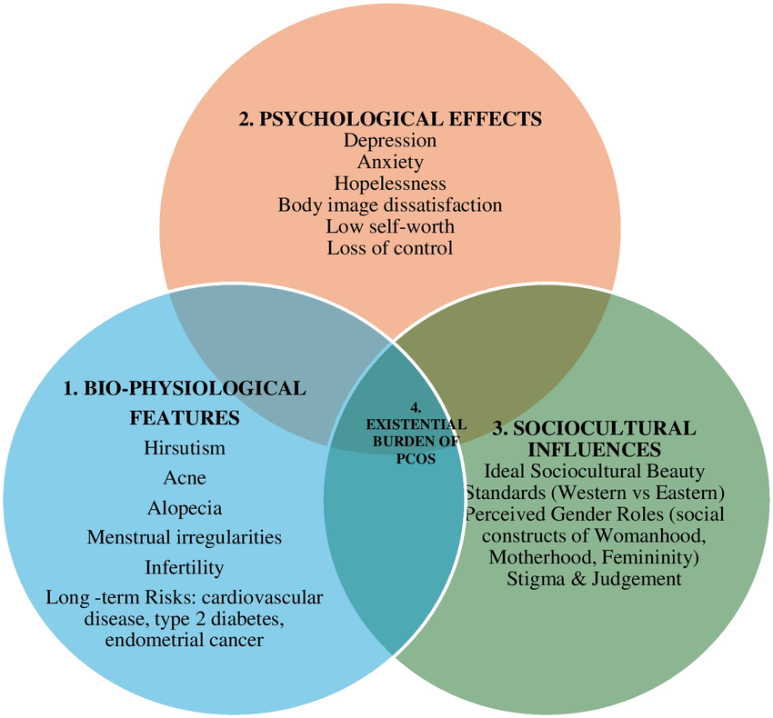
Figure 2: Biopsychosocial Model of PCOS
(Source: Faathimah Khan, 2026)
Figure 2 illustrates the interplay between biological, psychological, and sociocultural factors and their effects on PCOS symptoms, emotional health, and patient experience. Fertility issues can also cause some psychological distress to individuals with PCOS. PCOS isn't always a barrier to pregnancy, but irregular ovulation can cause worry about plans for the future. Fertility fears can add to the emotional burden and impact how Aisha views the condition in the long-term (Zhang et al., 2024). Thus, psychosocial implications of PCOS go hand in hand with their biological symptoms. Anxiety, lower self-esteem, and emotional stress can affect motivation, how well a person can cope with their health, and how likely they are to attend healthcare services. Applying a biopsychosocial approach, it is evident that a focus on emotional wellbeing is important along with medical management, and this will affect Aisha's outcomes. Thus, psychological support, education, and effective coping strategies are key elements of comprehensive PCOS care. Psychological distress can have a negative impact on Aisha's capacity to regulate their own behaviours, as anxiety and loss of confidence can drive down motivation and adherence to health care recommendations.

4. Social Determinants and Social Impact of PCOS
PCOS's effects aren't only physical or psychological, there are social impacts on the lives of those with PCOS as well. This biopsychosocial approach is focused on the connections between people's physical complaints, their emotional feelings and the effects on them, and their social context. For Aisha, PCOS can have an impact on academic life, relationships, social experiences, and needed health care assistance. Education and the university experience are relevant experiences in early adulthood in which PCOS can affect function. Fatigue, irregular menstrual periods, and emotional issues can impair a student's ability to focus and attend school, as well as engage in academic pursuits (Wright et al., 2024). Aisha might have anxiety and self-confidence issues because of her symptoms and may not actively look to attend social activities and events at the university, as this could have an impact on her wellbeing. There is the possibility of trouble in personal relationships and social self-confidence with PCOS as well. Acne, hirsutism and weight-related changes associated with PCOS may affect Aisha’s self-esteem, body image and confidence in social settings, while concerns about appearance and social judgement may contribute to reduced participation in social activities (Seva and Kempegowda, 2023). Such experiences can lead to social avoidance and/or decreased participation, and serve as an illustration of the broader social impacts of biological symptoms. Social norms of appearance, womanhood, and fertility may add to emotional distress when an individual's experience is out of keeping with society.
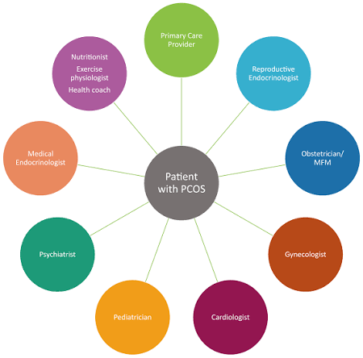
Figure 3: Polycystic Ovary Syndrome Multidisciplinary Care Model
(Source: Carolyn Guan, B.A., 2022)
Figure 3 shows the importance of integrated healthcare involving multiple specialists to support comprehensive PCOS management and improve patient outcomes. Having access to health care and social services is also a key factor in determining Aisha's coping with PCOS. Having healthcare providers and other sources of support who clearly provide information and ongoing support can help improve understanding and self-management of the condition. Individuals with low awareness, low rates of diagnosis, and lack of emotional support may impact health outcomes (Presswala and De Souza, 2023). Reassure and support Aisha to help control her PCOS, from family, friends, and health care providers. Having a good support system helps in coping, can encourage positive changes in lifestyle, and may also have a positive role in reducing loneliness. The social impact of PCOS emphasises social determinants and their effect on Aisha's health and wellbeing, which she needs to be aware of when caring for her PCOS.
Biological, psychological, and social effects from PCOS do not occur in isolation. Acne, loss of body periods and tiredness are hormonal symptoms that can make Aisha feel anxious and less confident. These psychological outcomes can then have social implications that impact participation in social activities, health care utilization and uptake of lifestyle modifications. Thus there is a need for intervention that looks at all aspects of her life, to improve outcomes.

5. Behaviour Change Approach for Aisha
Polycystic Ovary Syndrome (PCOS) demands a holistic strategy that addresses the multiple factors (biological, psychological, and social) that impact Aisha's health. Behaviour change approaches for PCOS need to be about long-term management and adherence to the condition, rather than being about short-term symptom management (Tang et al., 2026). The COM-B Behaviour Change Model, which takes into account the three elements, Capability, Opportunity and Motivation, that construct Behaviour, is suitable for developing an individualised plan for the intervention.
Table 2: COM-B Based Behaviour Change Plan for Aisha
COM-B component | Identified needs/barriers | Behaviour change strategies for Aisha
Capability | Limited awareness of the causes, symptoms, and health effects of PCOS. | Offer awareness of hormonal imbalances, symptom management, and lifestyle behaviors. Learn meal planning for meals, physical activity, and monitoring skills.
Opportunity | Need for healthcare guidance, social support, and available information | Consult regular healthcare provider visits and access to sound PCOS materials and support from family, friends, and healthcare providers.
Motivation | Decreased self-confidence, emotional vulnerability and uncertainty about doing everything with PCOS. | Set realistic goals, use psychological support and positive reinforcement to develop confidence and promote self-management in the longer term.
Behaviour outcomes | Challenges with healthy lifestyles habits | Encourage physical activity, eating well and stress reduction, and better sleep routines to help maintain physical and emotional health.

5.1 Capability
The capability component is geared toward enhancing Aisha's understanding and abilities in managing PCOS effectively. Smarter information about symptoms, hormonal changes, and lifestyle strategies can help to strengthen confidence and self-management skills. Incorporating practical activities, such as symptom tracking, meal planning, and medication and exercise planning, can contribute to her sustained health behaviours (McGowan et al., 2025). This new ability can help with lasting lifestyle changes and improved PCOS management.

5.2 Opportunity
Opportunity is the element of the opportunity component that emphasises the outside environment that facilitates or hinders Aisha's behavior change. Self-management of PCOS can be enhanced by having the ability to access health care providers, diet advice, education, and social assistance. Confidence, adherence to sustainable health behaviors, and reduced barriers to behavior change can be increased through regular medical reviews, personalised lifestyle advice, and encouragement from family and friends (Cowan et al., 2023).

5.3 Motivation
The motivation component brings into focus Aisha's confidence, emotional well-being, and personal reasons for healthier behaviours. As anxiety, stress and lack of self-esteem are among the emotional issues women with PCOS commonly experience, they can have a negative impact on motivation (Chauhan, 2025). Psychological support needs to be integrated into interventions, with easily attainable goals together with strategies to build up self-efficacy. Rather than being concerned about wanting to do everything and more, Aisha should be encouraged to take moderate steps in the right direction, moving towards her own health objectives. Feedback and realistic targets increase self-efficacy. These are personalised options where Aisha can choose realistic behaviours, and relapse planning can help maintain adherence in the long-term.

5.4 Recommended Behaviour Change Interventions
Sustainable levels of physical activity can have a positive impact on Aisha's metabolic health, insulin sensitivity and psychological well-being, through achievable, long-term physical activity habits. Optimised nutrition plans can be created and implemented to assist in maintaining hormonal balance and reduce metabolic risks, but adapted to her lifestyle needs and health care needs (Frączek et al., 2026). There may be an improvement in emotional coping (stress management) through mindfulness practices and psychological support. The COM-B model emphasises that for behaviour change, there must be knowledge, motivation, and appropriate support. Thus, combined interventions for lifestyle, mental health, and healthcare utilisation could improve Aisha's quality of life and overall management of PCOS in the long-term. Aisha might be able to start achieving moderate exercise for 20-30 minutes thrice a week for four weeks and get the healthcare provider to review this for a month. Goal setting and tracking can increase compliance and feedback and support sustained behaviour change.

5.5 Challenges and Limitations
Fatigue, University work, costs, lack of motivation and weight stigma concerns can impact behavior change. Long-term sustainability of lifestyle changes and even relapse are difficult problems (Guan et al., 2024). So, continuous intervention and appropriate expectations are required.

6. Conclusion
Polycystic Ovary Syndrome is a chronic condition affecting physical, psychological, and social health. Hormonal dysfunction, reproductive issues, and metabolic changes cause Aisha physical issues and anxiety, while low self-esteem and social pressures diminish her well-being (Adamczak et al., 2025). Thus, a medical and personal perspective is needed to understand the experiences of the individual living with PCOS and to facilitate effective management. The COM-B model encourages behaviors that work towards sustainable change by enhancing one's knowledge and motivation and by providing easier access to supportive resources. There are many lifestyle-related interventions, psychological care, and individualized, manageable approaches that can improve Aisha's long-term care and quality of life.

7. References
Adamczak, A., Głowińska, A., Banaszewska, B., Wysocka, E. and Remlinger-Molenda, A., 2025. Psychological aspects of polycystic ovary syndrome. Neuropsychiatria i Neuropsychologia/Neuropsychiatry and Neuropsychology, 20(3), pp.178-185. https://www.termedia.pl/Psychological-aspects-of-polycystic-ovary-syndrome,46,57516,0,1.html
Bergo, I., Eckert, D., Puşcaş, A., Jîtcă, G. and Terovescan, A., 2023. Hormone imbalance in polycystic ovarian syndrome. Acta Biologica Marisiensis, 6(1), pp.10-20. https://reference-global.com/download/article/10.2478/abmj-2023-0002.pdf
Chauhan, A., 2025. Exploring the mental health challenges faced by females with polycystic ovary syndrome (PCOS). Int J Psychol Sci, 7(1), pp.6-11. https://www.psychologyjournal.net/archives/2025/vol7issue1/PartA/7-1-1-747.pdf
Cowan, S., Lim, S., Alycia, C., Pirotta, S., Thomson, R., Gibson-Helm, M., Blackmore, R., Naderpoor, N., Bennett, C., Ee, C. and Rao, V., 2023. Lifestyle management in polycystic ovary syndrome–beyond diet and physical activity. BMC endocrine disorders, 23(1), p.14. https://link.springer.com/article/10.1186/s12902-022-01208-y
Frączek, J., Górka, P., Tymińska, P., Kądziołka, W., Domagała, S. and Kawka, N., 2026. The Impact of Physical Activity on Metabolic, Hormonal, and Psychological Profiles in Women with Polycystic Ovary Syndrome (PCOS): A Review of Current Evidence. Journal of Education, Health and Sport, 89, pp.69791-69791. https://apcz.umk.pl/JEHS/article/view/69791
Guan, M., Li, R., Shen, Q., Wang, G.P., Li, Z., Xiao, M. and Lei, J., 2024. Women's experience of polycystic ovary syndrome management: a systematic review and meta‐synthesis. International Journal of Gynecology & Obstetrics, 164(3), pp.857-868. https://obgyn.onlinelibrary.wiley.com/doi/abs/10.1002/ijgo.15031
Houston, E.J. and Templeman, N.M., 2025. Reappraising the relationship between hyperinsulinemia and insulin resistance in PCOS. Journal of Endocrinology, 265(2). https://journals.bioscientifica.com/joe/article-abstract/265/2/e240269/5714
Joham, A.E., Norman, R.J., Stener-Victorin, E., Legro, R.S., Franks, S., Moran, L.J., Boyle, J. and Teede, H.J., 2022. Polycystic ovary syndrome. The lancet Diabetes & endocrinology, 10(9), pp.668-680. https://www.thelancet.com/article/S2213-8587(22)00163-2/abstract
Lugg, W., 2022. The biopsychosocial model–history, controversy and Engel. Australasian Psychiatry, 30(1), pp.55-59. https://journals.sagepub.com/doi/abs/10.1177/10398562211037333
McGowan, M., Garad, R., Wadhwani, G., Torkel, S., Rao, V., Maunder, A., Osei‐Safo, E.K., Moran, L.J. and Cowan, S., 2025. Understanding barriers and facilitators to lifestyle management in people with polycystic ovary syndrome: A mixed method systematic review. Obesity Reviews, 26(2), p.e13854. https://onlinelibrary.wiley.com/doi/abs/10.1111/obr.13854
Nasiri-Amiri, F., Faramarzi, M., Omidvar, S. and Alizadeh-Navaei, R., 2023. Depression and anxiety in adolescents and young women with polycystic ovary syndrome: a systematic review and meta-analysis. International Journal of Adolescent Medicine and Health, 35(3), pp.233-242. https://www.degruyterbrill.com/document/doi/10.1515/ijamh-2022-0065/html
Presswala, B. and De Souza, L.R., 2023. The diagnostic experience of polycystic ovary syndrome: a scoping review of patient perspectives. Patient Education and Counseling, 113, p.107771. https://www.sciencedirect.com/science/article/pii/S0738399123001519
SEva, T.P. and Kempegowda, P., 2023. Body image concerns in women with polycystic ovary syndrome. European Journal of Endocrinology, 189, pp.R1-R9. https://pure-oai.bham.ac.uk/ws/portalfiles/portal/206700133/lvad110.pdf
Tandoğan, Ö., Ak, E.Y., Akdemir, A., Oskay, Ü. and Callioglu, N., 2024. Effect of polycystic ovary syndrome on the life quality of young women. Revista da Associação Médica Brasileira, 70(4), p.e20231368. https://www.scielo.br/j/ramb/a/McRSk7mKDJQzJPBtRxwSdnF/?lang=en
Tang, Y., Ying, X., Dong, P., Xu, X., Chen, M. and Jin, Y., 2026. Barriers and facilitators to health promotion behaviours in women with polycystic ovary syndrome and infertility who are actively trying to conceive: a qualitative study using the COM-B model and the Theoretical Domains Framework. BMC Women's Health, 26(1), p.223. https://link.springer.com/article/10.1186/s12905-026-04405-2
Tay, C.T., Mousa, A., Vyas, A., Pattuwage, L., Tehrani, F.R. and Teede, H., 2024. 2023 international evidence‐based polycystic ovary syndrome guideline update: insights from a systematic review and meta‐analysis on elevated clinical cardiovascular disease in polycystic ovary syndrome. Journal of the American Heart Association, 13(16), p.e033572. https://www.ahajournals.org/doi/abs/10.1161/JAHA.123.033572
Teede, H.J., Tay, C.T., Laven, J.J., Dokras, A., Moran, L.J., Piltonen, T.T., Costello, M.F., Boivin, J., Redman, L.M., Boyle, J.A. and Norman, R.J., 2023. Recommendations from the 2023 international evidence-based guideline for the assessment and management of polycystic ovary syndrome. European journal of endocrinology, 189(2), pp.G43-G64. https://academic.oup.com/ejendo/article-abstract/189/2/G43/7242362
Wright, P.J., Tavakoli, A.S. and Corbett, C.F., 2024. PCOS health-related quality-of-life and depressive symptoms across the lifespan: comparative study. Journal of Women & Aging, 36(1), pp.45-60. https://www.tandfonline.com/doi/abs/10.1080/08952841.2023.2230112
Yousuf, F. and Rehman, R., 2024. Pharmacologic management of PCOS: Menstrual irregularities. In Polycystic Ovary Syndrome (pp. 111-116). Elsevier. https://www.sciencedirect.com/science/chapter/edited-volume/pii/B9780323879323000232
Zhang, Z., Liu, M., Zhao, F., Chen, H. and Chen, X., 2024. Fertility stress, psychological resilience, and depressive symptoms in women with polycystic ovary syndrome. Cureus, 16(9). https://www.cureus.com/articles/287027-fertility-stress-psychological-resilience-and-depressive-symptoms-in-women-with-polycystic-ovary-syndrome.pdf

Online References
https://link.springer.com/article/10.1186/s13048-025-01621-6
https://www.researchgate.net/figure/Biopsychosocial-Model-of-PCOS1Bio-Physiological-Features-Clinical-manifestations-of_fig2_400705739
https://www.fertstert.org/article/S0015-0282%2822%2900193-5/fulltext

