THE ROLE OF EMPLOYEE TRAINING AND DEVELOPMENT IN ENHANCING SERVICE QUALITY: A CASE STUDY OF MARRIOTT INTERNATIONAL
Table of Contents
CHAPTER 1: INTRODUCTION 5
1.1 Introduction 5
1.2 Background and Context 5
1.3 Problem Statement 5
1.4 Research Aim and Objectives 6
1.5 Research Questions 6
1.6 Significance of the Study 6
1.7 Dissertation Structure 7
1.8 Chapter Summary 7
CHAPTER 2: LITERATURE REVIEW 8
2.1 Introduction to the Literature Review 8
2.2 Review of Related Key Concepts 8
2.2.1 Employee Training and Development 8
2.2.2 Service Quality in the Hospitality Industry 8
2.2.3 Customer Satisfaction 9
2.3 Review of Relevant Theories 9
2.3.1 Human Capital Theory 9
2.3.2 SERVQUAL Model 9
2.3.3 Theoretical Connection 9
2.4 Empirical Review 10
2.4.1 Employee Training and Service Quality 10
2.4.2 Employee Training and Customer Satisfaction 10
2.4.3 Marriott International and Hospitality-Sector Evidence 11
2.5 Literature Gap 11
2.6 Chapter Summary 12
CHAPTER 3: RESEARCH METHODOLOGY 13
3.1 Introduction 13
3.2 Methodological Framework: Application of Onion Model 13
3.2.1 Research Philosophy 13
3.2.2 Research Approach 14
3.2.3 Research Strategy/Design 14
3.2.4 Research Choices 15
3.2.5 Time Horizon 15
3.3 Data Collection Techniques 15
3.4 Analytical Techniques and Procedures 16
3.5 Ethical Issues 16
3.6 Chapter Summary 17
CHAPTER 4: ANALYSIS AND DISCUSSION OF RESULTS 18
4.1 Introduction 18
4.2 Data Overview and Analytical Context 18
4.3 Objective 1: Relationship Between Employee Training and Service Quality 19
4.4 Objective 2: Impact of Employee Training and Development on Customer Satisfaction 21
4.5 Marriott-Specific Training Evidence and Integrated Discussion 23
4.6 Overall discussion of findings against research objectives 24
4.7 Summary 25
CHAPTER 5: CONCLUSION AND RECOMMEDATIONS 26
5.1 Introduction 26
5.2 Summary of Findings 26
5.3 Recommendations 26
5.3.1 Implement role-specific, scenario-based training 26
5.3.2 Strengthen post-training transfer and supervisor support 27
5.3.3 Evaluate training effectiveness through outcomes 27
5.3.4 Integrate customer feedback into training design 27
5.4 Limitation of the Study 27
5.5 Suggested Areas for Future Research 28
5.6 Summary 28
REFERENCES 29

CHAPTER 1: INTRODUCTION

1.1 Introduction
Training and development of employees continue to be central in the management of hospitality as the quality-of-service provision is pegged on the knowledge, skills and behaviour of the employees in dealing with customers. Training underpins the performance of tasks and employee engagement in tourism and hospitality organisations (Arwab et al., 2023). This rapport is particularly applicable to Marriott International, where stable service provision determines customer satisfaction and brand image. The paper takes a look at how training and development can be used to improve the service quality of Marriott International using secondary quantitative evidence and frames the research context, problem, aim, objectives, questions and significance of the investigation.

1.2 Background and Context
The hospitality sector is direct worker-customer, so workforce competence is the core of uninterrupted service provision. The knowledge, confidence and motivation of employees through training and development can influence the effectiveness of service standards applied in hotel operations. The studies in the tourism and hospitality sector reveal that training is a key tool in the facilitation of employee motivation and work performance (Singh and Ansari, 2024). Marriott International is a good organisational setting since its global brand image hinges on the employees who offer reliable and responsive guest experiences in diverse properties, service functions, and diverse customer requirements.

1.3 Problem Statement
Marriott International uses its employees to translate standards of service into actual consistent experiences for guests, but there is no consistency in implementation once the training is uneven, highly focused or hard to implement in operations. Research studies indicate that operational training may have practical limitations of work scopes such as coverage, implementation and change of behaviour (Way et al., 2025). This poses a research problem in that the quantifiable relationship among employee training, service quality, and customer satisfaction at Marriott International has not been sufficiently investigated via secondary quantitative evidence. The research is filling this gap by evaluating how more intensive training and development relate to better service output.

1.4 Research Aim and Objectives
Research Aim:
To explore how employee training and development can help improve the quality of service in Marriott International through a quantitative study of secondary data.
Research Objectives:
- To test how employee training and development are related to service quality in Marriott International.
- To measure the effects of employee training and development on customer satisfaction with secondary quantitative data.
- To give proposals on how to improve the training and development of employees to increase the quality of service offered at Marriott International.

1.5 Research Questions
- How is employee training and development related to service quality of Marriott International?
- What effect does employee training and development have on customers based on secondary quantitative data?
- Which is the advice to improve employee training and development to improve the quality of services offered at Marriott International?

1.6 Significance of the Study
The research has both practical and scholarly implications in that it demonstrates the role of employee development as a means to enhance service quality at Marriott International. Hospitality organisations rely on competent employees, whereas human capital development helps to maintain the competence of the workforce and organisational effectiveness (Talukder and Kumar, 2024). The results can be used to make training choices at Marriott and can be used to inform future research in hospitality.

1.7 Dissertation Structure
The dissertation is arranged into five chapters. Chapter 1 presents the purpose and research topic. Chapter 2 reviews the past research, whereas Chapter 3 outlines the research methods. The results are presented and discussed in Chapter 4. Chapter 5 concludes and provides recommendations as well as limitations and future research suggestions.
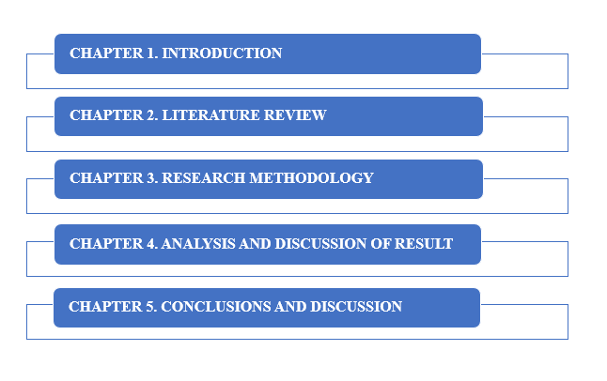

Figure 1.1 Dissertation Structure
(Source: SmartArt)
The above image displays the ordered structure of the dissertation.

1.8 Chapter Summary
This chapter prefigures the rest of the dissertation by laying the groundwork of the research, stating the research problem, goal, objectives, questions and significance. It elaborates the reason behind the importance of training and development of employees in the hospitality industry and why Marriott International offers a suitable organisational focus. The chapter also sketches the second quantitative direction of the work and determines the anticipated correlation between training and service quality and customer satisfaction. The dissertation outline explains the ways the literature review, methodology, analysis and conclusion chapters justify the investigation.

CHAPTER 2: LITERATURE REVIEW

2.1 Introduction to the Literature Review
In this chapter, literature regarding training and development of employees, quality of services and customer satisfaction in the hospitality industry was reviewed. As Kodom-Wiredu et al., (2022) indicated, formal and informal developmental processes in diverse workplace environments have been explored in hospitality learning research. The review evaluated critical concepts, pertinent theories, evidence and gaps that inform the Marriott International research.

2.2 Review of Related Key Concepts

2.2.1 Employee Training and Development
Employee training and development were defined as the organised activities that enhance the knowledge, skills and work-related capabilities of employees. The study by Han et al., (2023) revealed that the effectiveness of training aids organisational learning in the hospitality industry in enhancing the acquisition and application of knowledge by employees. This implied that training provided value as learning moved to work behaviour instead of course participation. In the case of Marriott International, development was still pertinent since the consistency of the services relied on how the employees would implement the standards in diverse positions and hotels.

2.2.2 Service Quality in the Hospitality Industry
Service quality in hospitality explained how the experiences of the guest were satisfied or failed to meet expectations in terms of interactions, facilities and service delivery. Olawuyi and Kleynhans, (2025) published a study revealing a continuous focus on service quality, published between 2014 and 2024. The idea was still complicated due to the assessment of tangible conditions and employee behaviour by the guests. This rendered competence by the staff significant, as haphazard reactions could undermine the impressions of trustworthiness, responsiveness and assurance throughout Marriott International hotels.

2.2.3 Customer Satisfaction
Customer satisfaction was the rating of the customer in regard to whether the hotel experience was as expected or even better. In the study conducted by Anas, (2024), hotel satisfaction was influenced by how customers evaluated their service experiences in a hospitality environment. Satisfaction was not the same as service quality since it was a more extensive judgement post-consumption. In the case of Marriott International, this differentiation was important as training had an impact on service encounters, and satisfaction was also determined by facilities, value, convenience and personal expectations.

2.3 Review of Relevant Theories

2.3.1 Human Capital Theory
The Human Capital theory considers the employee knowledge, skills and capabilities as organisational resources which were developed by investing in development. Aman-Ullah et al., (2022) found that human capital was relevant in organisational performance and the same was conditioned by the leadership. The theory provided a valuable framework in which the training at Marriott International could enhance employee competence, although it lacked a comprehensive demonstration of how learning led to particular guest-service results.

2.3.2 SERVQUAL Model
The SERVQUAL model evaluated the level of quality of service based on the differences in the expectations of the customers and the perceived level of service. Cancino and León, (2026) argued that hotel research had utilised various instruments to quantify the quality of services provided, and that no particular method could quantify all the customer experience dimensions. SERVQUAL was also applicable to investigate the aspects of reliability, responsiveness, assurance, empathy and tangibles, but subjective expressions might differ among properties and different categories of customers.

2.3.3 Theoretical Connection
Human Capital Theory gave the answer to the question as to how training investment could enhance the competence of employees, and SERVQUAL showed how better behaviour could influence the judgements of the guests. Senadhira, (2026) observed that the correlation between training and movement to service-quality behaviour was conditional on the fact that employees participated in service-frontline banking. This affirmed the relationship between learning and customer-facing outputs, although in the non-hospitality environment, this could not be applied directly. According to the Marriott International study, both theories were found to be related to training, quality of service, as well as customer satisfaction.

2.4 Empirical Review

2.4.1 Employee Training and Service Quality
Employee training has been considered in response to the instability of operations and shortage of employees in the hotel industry. Xue et al., (2022) indicated that the assessment of the hotel practice training systems had been conducted in cases of the COVID-19 manpower pressures. This evidence implied that there might be some way to introduce employees to changing responsibilities and keep them going to work by structured workplace learning. The research was still useful as it related the training to operating ability but not as an independent human resource process. Its crisis-oriented context restricted its broader use, as emergency staffing environments varied from normal hotel operations. In the case of Marriott International, the evidence favoured studying the roles of whether the consistency of service quality across the roles was promoted through training, besides appreciating the roles of the organisational scale and brand standards that might influence the relationship.

2.4.2 Employee Training and Customer Satisfaction
Customer satisfaction had been associated with the hotel being able to satisfy the needs of their guests by delivering on room, facilities and service delivery. The study conducted by Kusumawati et al., (2025) had explored hotel room requirements in terms of guest satisfaction and sustainability. This view revealed that satisfaction was not a result of employee behaviour only since there were physical conditions and choice of operation that influenced the experience. Training might play a role in the process of identifying needs, addressing concerns and standards, where employees were concerned. The study provided valuable customer-based information, but the areas highlighted on room needs meant little direct coverage of training impacts. The current research put into view employee development as well as the quality of service and customer satisfaction in Marriott International.

2.4.3 Marriott International and Hospitality-Sector Evidence
Data about Marriott International has frequently been present in comparisons of large hotel chains as opposed to dedicated research on employee development. Fu, (2026) claimed that a decade-long comparison of United States market approaches in the United States of America compared Marriott with Hilton, Hyatt, IHG and Accor. This evidence placed Marriott in a competitive arena whereby service consistency, innovation and brand differentiation played a role. The comparative design enhanced the industry knowledge but had minimal focus on the direct association between the training and customer results. This restriction provided an argument for a Marriott-exclusive study based on secondary quantitative data to determine the relationship between training and development of employees in terms of service quality and customer satisfaction.

2.5 Literature Gap
Past studies had explored training efficacy, quality of services and customer satisfaction within hospitality organisations, yet results were yet to be consolidated completely. As Xue et al., (2022) explained, training had facilitated operational capability, whereas, as Fu, (2026) explained, Marriott had been primarily evaluated based on wider market comparisons as opposed to employee-development results.
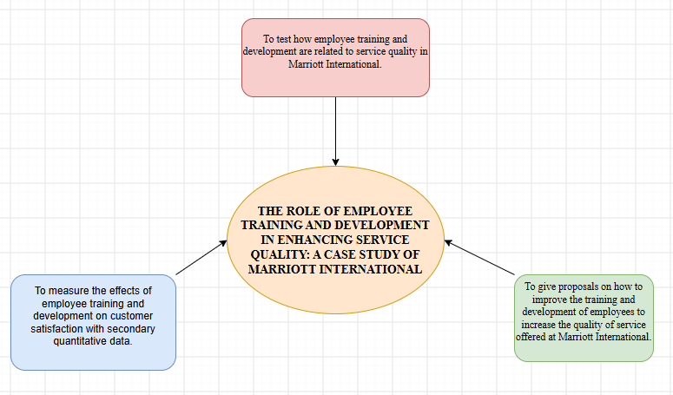

Figure 2.1: Conceptual Framework of the Study
(Source: Draw.io)
The above image displays the conceptual framework, which shows the connection between employee training and development and the quality of service and customer satisfaction at Marriott International.

2.6 Chapter Summary
This chapter has examined the training and development of employees, quality and customer satisfaction of services in hospitality. It explored the Human Capital Theory and SERVQUAL and compared empirical evidence relating to training, guest outcomes and Marriott International. The review found limited Marriott-specific quantitative data that links employee development and service quality and satisfaction. This gap provided the conceptual framework of the study and led to the methodological decisions provided in the following chapter.

CHAPTER 3: RESEARCH METHODOLOGY

3.1 Introduction
This chapter provides an explanation and justification for the methodology decisions to explore the role of employee training and development in improving service quality at the Marriott International. The methodology is consistent with the research aim, objectives and research questions from Chapter 1 and 2. It is a secondary data design as the study is not based on new responses but on existing quantitative data. Zumitzavan (2026) state that the methodological decisions made in such a research should be coherent from the starting point of the philosophy to the development of the theory to the methodological decision for the strategy for the next step would be the data collection and analysis methods. This coherence and the credibility of findings is illustrated with the Research Onion.

3.2 Methodological Framework: Application of Onion Model
Zumitzavan (2026) offer a systematic framework with regards to the philosophy, approach to theory development, methodological choice, strategy, time horizon, and procedures and techniques. It involves justification of methodological decisions in relation to the research problem. For this study the layers are: (1) positivist philosophy and deductive approach, (2) quantitative secondary data approach, (3) systematic source selection approach and (4) statistical analysis approach. The model thus fits the purpose of demonstrating methodological coherence and can be used to explain reasons for the choice of research decisions.

3.2.1 Research Philosophy
The study is based on positivist with this research philosophy, because with this study it aims to examine the relationship between employee training and development, service quality and customer satisfaction on which is easy to observe and measure. Almusaed et al. (2025) associate positivism with observable reality, quantifiable evidence, structured methods and statistical analysis. These are qualities that are associated with the use of numerical evidence from previous sources, not the subjective accounts of interview.
Researcher detachment is also facilitated by positivism. Consistent procedures and predefined variables minimize personal interpretation and the ability to replicate the procedures. But the quality of services and satisfaction are based on perception which sometimes cannot be expressed numerically, and this is overcome by interpretation also with the help of theoretical and empirical literature. Positivism is suitable because it offers a structured approach to the evaluation of measurable patterns.

3.2.2 Research Approach
A deductive approach is taken because the study starts with existing theoretical and empirical knowledge, and investigates whether predicted relationships are confirmed by the evidence. As per the Human Capital Theory, the investments made in employees can lead to improved capabilities and organisational performance, and SERVQUAL offers a framework to understand the dimensions of service quality (Papademetriou et al., 2023). These views indicate that the enhancement of employee development is needed for improving services and customer satisfaction.
Deduction is a reasoning process that moves from known ideas to a set of propositions that are supported by evidence (Almusaed et al., 2025). The approach connects the literature review, conceptual framework, analysis and conclusions. This gives a logical foundation to investigate the relationships that were identified in the research questions and provide a logical link between data analysis and the theoretical foundation laid in Chapter 2.

3.2.3 Research Strategy/Design
The research design is secondary, quantitative, and systematic analysis of research and evidence from the field of academia and organizations. This is in line with the approved methodology which calls for secondary quantitative data and statistical analysis. Primary questionnaires, interviews or observations are not needed as the research questions can be explored based available numerical data related to training, service quality and customer satisfaction. The strategy ensures access to a wider evidence base that is efficient and does not include recruiting Marriott staff or customers. When the information is relevant, accessible and reliable enough, secondary data can be useful, as indicated by Almusaed et al. (2025). But the secondary research can pose threats as the sources might be based on different measures, period and purpose. Sources need to be evaluated for relevance, credibility, methodological transparency and comparability, therefore. Sources are preferred to be peer-reviewed and/or from credible organisations; poorly documented sources are not included. Findings analysed within the bounds of the evidence. This is to enhance transparency and acknowledge that secondary evidence might not be directly comparable across studies.

3.2.4 Research Choices
Using mono-method quantitative choice is suitable since the research is focused on secondary data presented in numerical form and analysed statistically. Patterns and relationships between training and service quality/customer satisfaction can be identified through quantitative analysis, in a consistent way. It is also in keeping with the positivist philosophy and deductive methodology. A quantitative design has the advantage over mixed methods since there are no qualitative primary data gathered, and the goals of the study can be met using measurable indicators (Grace et al., 2023). It has a limitation that numerical evidence does not explain all of the organisational mechanisms, so this is solved by theoretically discussing it with Human Capital Theory, SERVQUAL and previous research. The methodological selection thus keeps on the same tone and allows a critical interpretation of the results.

3.2.5 Time Horizon
In the study, the approach taken is a cross sectional analytical approach with evidence based on the period of the study. While the publication of the sources may indicate different years, the observations are analysed within the time frame of the research. This is fitting since the study is cross-sectional and does not follow up participants. Where measurements vary, trends are interpreted with caution as it could be due to a training or service quality difference; it could be due to a difference in data collection period or measurement techniques.

3.3 Data Collection Techniques
Secondary data was used in this study and the primary sources of data were peer reviewed academic articles and credible organizational publications related to Marriott International, employee training and development, service quality and customer satisfaction (Jeong et al., 2023). The databases that are relevant are: Scopus, Web of Science, Business Source Complete, Emerald Insight, Sage Journals and ScienceDirect. Sources were screened for relevance, recency, credibility and methodological clarity. Sources poorly documented and other duplicates were not included. This systematic approach deepens the trustworthiness and accountability of evidence.

3.4 Analytical Techniques and Procedures
Analysis is conducted in a systematic order. The first step is to arrange the extracted evidence based on the three objectives and study variables. Second, descriptive statistics like frequencies, percentages, means and reported trends are used when the data underpinning them allow. Patterns are presented in tables and charts. Third, interpretation can only be done statistically, and correlation analysis is applied where it is appropriate and possible, that is, where suitable numerical observations have been made. A critical appraisal table for literature-based evidence includes each study's setting, sample/dataset, variables, findings, and methodological strengths and weaknesses. This helps in the comparison of studies, as well as identifying convergence and divergence. Interpretation of findings in the light of the Human Capital Theory and SERVQUAL and mapping of findings to the research objectives and questions. The analysis therefore clarifies findings, compares the findings with previous research and provides implications for Marriott's training and their service quality. Numerical result is not brought in unless there is a secondary evidence which can be traced back to it.

3.5 Ethical Issues
Ethical responsibility is still relevant, even for secondary data research. The study adheres to the approved ethics and uses publicly available information or information that is suitable for academic purposes. Personal information is not unnecessarily gathered and identifiable information from sources is omitted or anonymised when necessary. There are appropriate safeguards outlined in the UK GDPR and Data Protection Act 2018 for the processing of personal data for research purposes, such as minimising the amount of data used and safeguarding individuals' rights (ICO, 2026). Sources are cited correctly in CCCU Harvard style and data is not used to support desired conclusions. Research records are kept securely and interpretations do not stray from the evidence. These measures help to maintain confidentiality, integrity, transparency and responsible use of secondary data.

3.6 Chapter Summary
This chapter explained why it is deemed as a positivist approach, deductive and mono-method quantitative methodology using secondary data. The Research Onion connected the philosophy, approach, strategy, time horizon, data collection and analysis. The methodology is intended to ensure clarity of the results and take into account the constraints of secondary data. The findings are presented and critically discussed in relation to the research objectives, literature and theoretical framework in the next chapter.

CHAPTER 4: ANALYSIS AND DISCUSSION OF RESULTS

4.1 Introduction
The secondary quantitative data is analysed in this chapter to assess the significance of employee training and development to improve the service quality in Marriott International. The analysis is organized around the three objectives, including training, service quality relationships, customer satisfaction and evidence-informed recommendations. Reported correlations, regression and mediation results are compared across the relevant hospitality studies, and the participation in training with Marriott is then explored as a contextual organisational variable as is the external customer-satisfaction indicator. Findings are related to Human Capital Theory and SERVQUAL for interpretation. The findings are related to Human Capital Theory and SERVQUAL to relate between the employee's capability and service quality outcomes. Special focus is placed on consistency, statistical significance, contextual differences and limitations, and no causal statements are made that are not supported by secondary resources.

4.2 Data Overview and Analytical Context
The analysis relies on secondary quantitative data from peer-reviewed empirical studies in the hospitality sector as well as Marriott International's corporate disclosures and Serve 360 disclosures and American Customer Satisfaction Index (ACSI) data. The empirical studies provide reported Pearson correlations, regression coefficients and mediation estimates examining relationships between employee training and service quality or customer-related outcomes. There are indicators of involvement in training and investment in L&D within the organisation, including involvement in skills and career-related training, provided via Marriott-specific evidence. In 2022, 78% of Marriott associates received the training; in 2023, that figure went up to 90%. ACSI offers a customer-satisfaction benchmark, and Marriott's company level score is 78 in 2025. Importantly, the analysis is based on reported secondary statistics and not an artificial respondent-level dataset is constructed. To perform a direct causal test, service-quality and customer-satisfaction observations would need to be matched in the publicly available data from Marriott, and these aren't provided. Findings are interpreted comparatively and critically and not made with unsupported causal claims.

4.3 Objective 1: Relationship Between Employee Training and Service Quality
The data analysed for Objective 1 shows a regular positive relationship between employee training and service quality, but one that varies according to the training dimension. Pearson's correlations from both Dhar (2015) and Waqanimaravu and Arasanmi (2020) are compared in Fig. 4.1. Dhar found that service quality was correlated with training access (r=49) training benefits (r=62) and training support (r=55) based on data collected from 494 workers of small and medium tourist hotels in Uttarakhand. The results of Waqanimaravu and Arasanmi (2020), were r=0.436 and r=0.665 and r=.487 respectively based on 120 usable hospitality responses. This means that training benefits had the highest correlation in both studies, implying that the usefulness of training by the employees may have a greater impact than access to training.
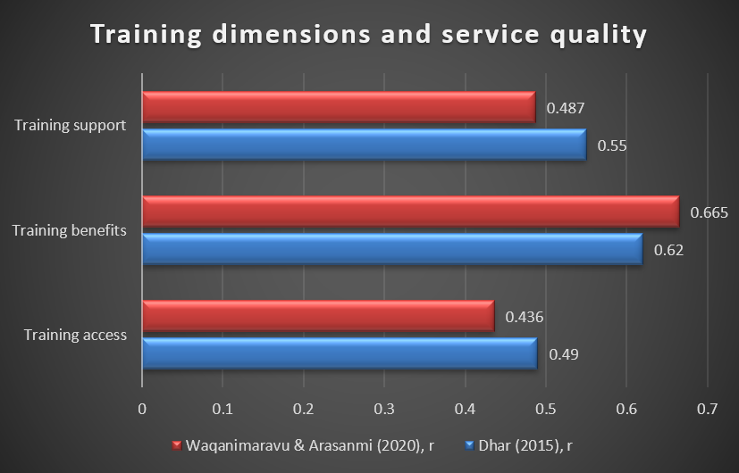
Fig. 4.1. Training dimensions and service quality
(Source: Generated in Excel)
There is a more critical interpretation of the regression evidence. Their results indicate that the perceived access to training was not a significant predictor of service quality (β=0.023, p>0.05), while the perceived training benefit and perceived support of training were significant predictors of service quality (β=0.553, p<0.05; and β=0.202, p<0.01, respectively). The three training variables accounted for 46.3% of the variance in service quality, according to the authors. The results of these show that being provided with training is not enough to ensure better service results. The relevance and perceived benefits of training on the other hand, seem to be more important, alongside organisational support. This is especially so in the case of Marriott, since a high rate of training participation does not necessarily result in service quality.
Dhar's results are consistent and give an explanatory mechanism. The study found that organisational commitment is a mediator between the training and service quality, it is suggested that training may affect service outcomes indirectly via attitudes in the organisation. Its reported relationships with training and service quality were positive and the mediation analysis indicated that the training dimensions had a relationship with organisational commitment and organisational commitment had a relationship with service quality. The evidence also indicates that training effectiveness could be influenced in addition to training content, by the readiness and capacity of the employees to transfer learning in the organisation.
The outcomes of the findings can be understood based on Human Capital Theory that conceptualizes training as an investment that nurtures employees' knowledge and skills and can enhance the productive capacity of employees. In a hospitality setting, improved capability can help to ensure greater uniformity of employee actions and service. SERVQUAL is a free tool that helps to understand service quality in terms of reliability, responsiveness, assurance and empathy. Training can have an impact on these dimensions through increased competence, communication and problem solving skills for employees, but the studies reviewed do not show that training alone improves each SERVQUAL dimension.
Overall objective 1 has been reasonably well established, but the relationship cannot be assumed to be causal. The studies are conducted in various hospitality contexts and employ various measures; both studies are observational in nature, not a controlled long-term test. Therefore their results should be interpreted as indication of positive associations and plausible mechanisms. For Marriott, it means that there is a need to move beyond participation rates and consider the learning strategy that can facilitate learning which is useful and relevant to the role. This interpretation also lends greater credibility to the recommendations outlined in chapter 5.
The comparative evidence also illustrates the need to consider the statistical coefficients in the context of the models where they were obtained, and not rank them as if they were equivalent measures. The correlation coefficient measures the association between two variables, the regression coefficient measures the effect of the unique predictor in a model, and the mediation coefficient represents the effect in a structural pathway. This suggests that the correlation for training benefits should not be interpreted as evidence that benefits have a bigger causal effect than training does. However, the findings of the two studies combined provide evidence that the quality of training and the reinforcement in the organisation are more important to pay attention to than just training availability.

4.4 Objective 2: Impact of Employee Training and Development on Customer Satisfaction
There is positive evidence of the relationship between employee development, service delivery and customer satisfaction with the caveat of context. The external American Customer Satisfaction Index (ACSI) for Marriott rose from 76 in 2021 to 80 in 2023, dropping to 79 in 2024 and 78 in 2025. There are also one or two series of longer duration, with scores of 77 in 2020 and 78 in 2022. This is not an upward trend but an improvement followed by a small decline. However, it is important to note that ACSI is an external measure of customer satisfaction and should not be viewed as a measure of Marriott's internal or global satisfaction. Thus, any changes in scores cannot be used as the sole evidence of the impact of employee training.
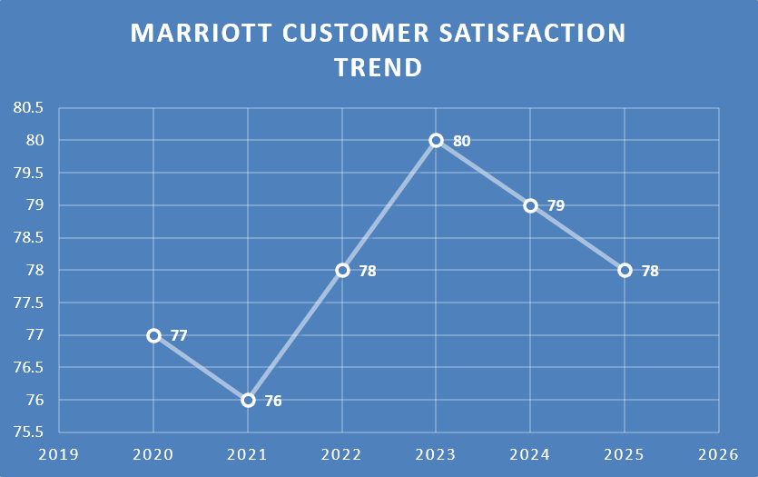
Fig. 4.2. Marriott customer satisfaction trend
(Source: Generated in Excel)
Empirical Hospitality Research offers better evidence for a possible relationship between training and customer satisfaction. Ambepitiya and Dharmasiri (2017) studied 53 workers and 30 visitors of 10 small and medium size hotels in Sri Lanka. They found that customer-facing employees with professional training had higher levels of service quality and customer satisfaction, which underscores the value of ongoing training for customer-facing staff. The relatively small and context-specific samples of the study, however, make it difficult to generalize findings to any other entity other than Marriott International.
Han et al. (2023) offer quantitative evidence for the indirect pathway with PLS-SEM. The result of their study on hospitality showed that green training had a significant influence on green experience (β=.399, p<.001) and green experience had a significant influence on customer satisfaction (β=.621, p<.001). The indirect effect of green training on green experience) was .248 and total effect on customer satisfaction) was .250. R² was .393 which meant that 39.3% of the variance in customer satisfaction could be explained by the model. This is relevant, as their findings show that training can have an intervening service/customer-experience effect on satisfaction, as well as an effect from training itself. However, this is a study of green training and should not be assumed as evidence of the overall training programme offered by Marriott.
In addition, Chand (2010) also confirms the overall link between human resources practices and customer outcomes. The study analysed HRM practices at 52 Indian hotels, with 260 employees and 260 customers, and determined that HRM practices had a positive effect on service quality and customer satisfaction through the use of structural equation modelling. Finally, HRM practices are different from training and development, and so the findings related to HRM should be understood as providing contextual evidence of the training findings, not as evidence specific to training.
As a whole, there is a growing body of evidence to support Objective 2 namely that employee development can be a pathway to customer satisfaction in terms of service capabilities and customer experience. But even Marriott's publicly available data can't provide matched observations that directly connect training participation with customer satisfaction. The more Marriott participated in training in 2023 (90%) compared to 2022 (78%) should not be statistically correlated with ACSI scores. Thus, training is a potential and evidence-based determinant of customer satisfaction that needs to be supported by learning relevance, application, and service execution. This separation is not made with any hyperbole, but it does give some justification for the recommendations in Chapter 5. This also highlights the importance of systematically assessing training performance and its results beyond mere participation.

4.5 Marriott-Specific Training Evidence and Integrated Discussion
Evidence shows an organisational commitment to employee Learning and Development as demonstrated by Marriott specific evidence. The percentage of associates who have finished career/skill training rose 12 percentage points to 90% in 2023, up from 78% in 2022 (Fig. 4.3). This suggests broader training reach; participation measures show coverage over effectiveness and/or the transfer of learning to service performance.
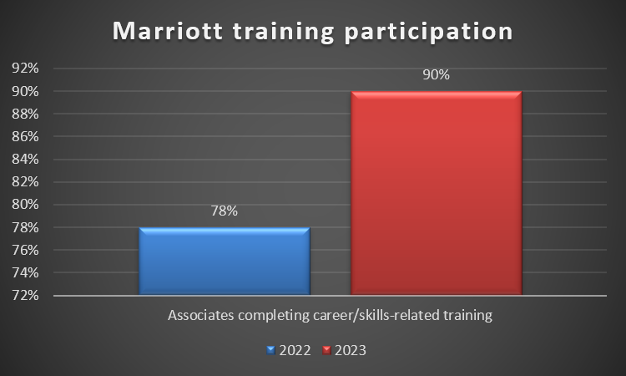
Fig. 4.3. Marriott Training Participation
(Source: Generated in Excel)
Training is only part of Marriott's development plan. Human Capital involves Growing Great Leaders and Investing in Associates and Creating Access to Opportunity. Learning coordinators provide assistance to associates' learning and development journeys and leadership development programmes are provided. A second activity is cross-training, which is used by Marriott to build up capability. In 2024, the firm experienced over 242,000 managed and franchised associates who participated in classroom learning events, and around 95% of eligible associates who completed Leadership Performance Acceleration reviews. These evidence reflects development is as part of processes of performance and career.
But comparisons of training hours must be made with caution. In July 2024, Marriott also switched its learning approach and platform to digital learning that is shorter and strengthened. As a result, the 2024 digital-learning hours cannot be directly compared to previous training-hour measures. This strengthens the importance to measure training based on results not just on attendance or number of hours. Combining the evidence and Objectives 1 and 2 opens up a theoretical pathway that training may improve employee knowledge and capability, which in turn may help to improve service delivery, which in turn may help to improve customer experience and customer satisfaction. Human Capital Theory helps to understand and analyse the capability development mechanism, and SERVQUAL offers a structure to consider how employee competence may affect service-quality dimensions. However, this pathway is not a causal model that has been tested statistically for Marriott. Data on the observations of service quality and customer-satisfaction are not available in conjunction with individual training participation. So Marriott's training investment ought to be seen as a capability measure and effectiveness as a learning transfer, employee performance and customer outcomes.

4.6 Overall discussion of findings against research objectives
The overall results support all three research objectives, though the evidence is not necessarily robust. Empirical studies in hospitality confirm objective 1 in the theory, showing that the dimensions of training are positively related to service quality and that perceived training benefits and organisational support are particularly linked to service quality. Objective 2 is moderately supported by hospitality evidence that suggests that employee development leads to customer-related outcomes but the Marriott ACSI trend is contextual, but not causal. Objective 3 is therefore tackled in evidence-informed implications which focus on transfer of learning, organisational support and relevant training. Together, the findings suggest that increasing the effectiveness of training is more about how the training is applied than participation, and publicly accessible Marriott data are not yet sufficient to draw direct causal inferences.

4.7 Summary
Positive relationships between employee training and service quality were found in this chapter in relation to training that has practical benefits and organisational support. C-sat trend offers context and training participation offers significant organisational investment. Training should be relevant to the workplace, and provide job-related benefits and assistance beyond participation, but should not be directly causative.

CHAPTER 5: CONCLUSION AND RECOMMEDATIONS

5.1 Introduction
This chapter summarizes the main findings of the study in relation to the research objectives, provides evidence to support recommendations to Marriott International, highlights the methodological limitations of this study, outlines areas for further research, and summarizes the overall findings of this study in terms of the role of employee training and development in improving service quality.

5.2 Summary of Findings
Objective 1 detected a positive correlation between training and service quality, in which training benefits and organisational support were more highly correlated than training access itself. This clarifies the Human Capital Theory as if training can build employee capability and SERVQUAL offers a framework to understand service-quality improvement.
Evidence was identified, relating to Objective 2, that there is a positive route from employee development to service capability and customer experience which leads to customer related outcomes. Marriott's ACSI scores, however, are external evidence which can only help provide a context, and shouldn't be used to argue that training led to a change in satisfaction.
Objective 3 suggests that Marriott should provide training, transfer, supervisory support and evaluation based on outcomes that are relevant. In summary, training participation indicates organizational commitment, but the effectiveness of the training should be evaluated based on the application and results of the services provided, and not on the number of people who participate in the training.

5.3 Recommendations

5.3.1 Implement role-specific, scenario-based training
Practical training is more appropriate to front line training areas such as complaint handling, communication, service recovery and problem solving, which should be developed and enhanced for Marriott. This recommendation is based on the evidence identifying that perceived trainings benefits was the strongest correlation with service quality.

5.3.2 Strengthen post-training transfer and supervisor support
Learning should be reinforced using coaching, observation, feedback and follow-up activities. This would enable the application of training to everyday service delivery and is based on evidence that organisational support drives service-quality outcomes.

5.3.3 Evaluate training effectiveness through outcomes
Beyond rates of participation, Marriott should measure training through the lens of learning application, employee performance, service-quality metrics and customer outcomes. This is important because 90% participation does not necessarily mean effectiveness of the training.

5.3.4 Integrate customer feedback into training design
Priority should be given to training that addresses repetitive service-recovery-related customer complaints and to customer satisfaction feedback. It would allow Marriott to match employee training to the needs of the customer and increase the links between the training, service delivery, and customer satisfaction. Implementation should be consistent with any service/reoccurring issues and with properties operational feasibility.

5.4 Limitation of the Study
The study was conducted using secondary data and hence only matched, employee-level measures of training were available as well as service quality and customer satisfaction. Data from ACSI are not Marriott's internal or global measure of customer satisfaction. In addition, there are some variations in the studies reviewed with regard to context, sample, and measurement methods. Causal inference is limited in several studies which utilize cross sectional design. The results, therefore, do not prove that training had a direct effect on changes in service quality or customer satisfaction; nor do they prove that a direct relationship exists between the two.

5.5 Suggested Areas for Future Research
Further research is drawn from the collection of primary data from both Marriott workers and customers and should include longitudinal design to study the outcomes of training over time. Matched training, service-quality and customer-satisfaction assessments might provide further support when the cause is assessed. Generalisability could also be enhanced if there were comparative research to be conducted across managed and franchised hotels or geographical regions.

5.6 Summary
Employee training and development is found to be a key factor in improving service quality especially in the context of relevance, support and transfer of training to the workplace. Marriott has made a good investment in its employees' development, although there is insufficient secondary data to directly link training to customer satisfaction results.

REFERENCES
Almusaed, A., Almssad, A. and Yitmen, I., 2025. Introduction to quantitative research. In Practice of Research Methodology in Civil Engineering and Architecture: A Comprehensive Guide (pp. 489-528). Cham: Springer Nature Switzerland. https://link.springer.com/chapter/10.1007/978-3-031-97393-2_15
Aman-Ullah, A., Mehmood, W., Amin, S. and Abbas, Y.A., 2022. Human capital and organizational performance: A moderation study through innovative leadership. Journal of innovation & knowledge, 7(4), p.100261.https://www.sciencedirect.com/science/article/pii/S2444569X22000968
Ambepitiya, K.R. and Dharmasiri, U.R., 2017. The study of professional training to improve customer satisfaction in small and medium scale hotels in Sri Lanka. Colombo Business Journal, 8(1). https://cbj.sljol.info/en/articles/10.4038/cbj.v8i1.14
Anas, M., 2024. Customer satisfaction in the hotel industry: A case study from Makassar City. Journal of Economic Education and Entrepreneurship Studies, 5(1), pp.135-150.https://journal.unm.ac.id/index.php/JE3S/article/view/3265
Arwab, M., Adil, M., Nasir, M. and Ali, M.A., 2023. Task performance and training of employees: the mediating role of employee engagement in the tourism and hospitality industry. European Journal of Training and Development, 47(9), pp.900-920.https://www.emerald.com/ejtd/article/47/9/900/43329
Cancino, I.A.G. and León, R.J., 2026. Measuring service quality in the hotel industry: a systematic review of instruments. International journal of scientific management and tourism, 12(1), p.2.https://dialnet.unirioja.es/servlet/articulo?codigo=10813074
Chand, M., 2010. The impact of HRM practices on service quality, customer satisfaction and performance in the Indian hotel industry. The International Journal of Human Resource Management, 21(4), pp.551-566. https://www.tandfonline.com/doi/abs/10.1080/09585191003612059?casa_token=n-c1c-LGm74AAAAA:hNR6TqwWDh8p7fRwzkDvOZkMNvT7paPdeZF2jnu5cSSLiOsqMZgW-4TGcUcCMZnmK4CxjovbHppkag
Dhar, R.L., 2015. Service quality and the training of employees: The mediating role of organizational commitment. Tourism management, 46, pp.419-430. https://www.sciencedirect.com/science/article/pii/S0261517714001538?casa_token=dKiRjhuTsjsAAAAA:enY9PEoJGQSPuXtGC8lysYxGkJ5hvGScC71xG9gXIua1aZfDGLfQwUITr4s0mfjFPlUeI9-TfyE
Fu, R.J., 2026. INNOVATING HOSPITALITY: TEN-YEAR COMPARATIVE ANALYSIS OF MARRIOTT, HILTON, HYATT, IHG, AND ACCOR’S US MARKET STRATEGIES. Artificial Intelligence, Machine Learning, & Robotics in Business, 2(1), pp.40-63.https://journals.flvc.org/aimlrb/article/view/141010
Grace, H., Banson, K. and Saraf, A., 2023. Mixed-methods research. In Translational Radiation Oncology (pp. 531-536). Academic Press. https://www.sciencedirect.com/science/article/pii/B9780323884235000297
Han, J.W., Kok, S.K. and McClelland, R., 2023. The impact of green training on employee turnover intention and customer satisfaction: An integrated perspective. Corporate Social Responsibility and Environmental Management, 30(6), pp.3006-3019. https://onlinelibrary.wiley.com/doi/abs/10.1002/csr.2534
Han, J.W., Nguyen, T.T.M., Hua, S.M. and Pham, T.H., 2023. Organizational learning through training effectiveness: evidence from the hospitality industry in Vietnam. The Learning Organization, 30(5), pp.532-553.https://www.emerald.com/tlo/article/30/5/532/378956
Jeong, M., Shin, H.H., Lee, M. and Lee, J., 2023. Assessing brand performance consistency from consumer-generated media: the US hotel industry. International Journal of Contemporary Hospitality Management, 35(6), pp.2056-2083. https://www.emerald.com/ijchm/article-abstract/35/6/2056/116936
Kodom-Wiredu, J.K., Coetzer, A. and Redmond, J., 2022. Informal learning research in hospitality and tourism: A systematic review. Journal of Hospitality and Tourism Management, 52, pp.13-28.https://www.researchgate.net/profile/Justice-Kodom-Wiredu/publication/361117280_Informal_learning_research_in_hospitality_and_tourism_A_systematic_literature_review/links/6500de4b68ca5847e3d5a87a/Informal-learning-research-in-hospitality-and-tourism-A-systematic-literature-review.pdf
Kusumawati, F.D., Sulistyo, A. and Arisanti, Y., 2025. IDENTIFICATION OF HOTEL ROOM NEEDS IN CREATING GUEST SATISFACTION AND SUSTAINABLE MANAGEMENT. Journal of Management: Small and Medium Enterprises (SMEs), 18(3), pp.1747-1759.https://ejurnal.undana.ac.id/index.php/JEM/article/download/21478/8913
Olawuyi, O.S. and Kleynhans, C., 2025. A Bibliometric Analysis of Service Quality in the Hospitality Industry (2014–2024). Administrative Sciences (2076-3387), 15(6).https://search.ebscohost.com/login.aspx?direct=true&profile=ehost&scope=site&authtype=crawler&jrnl=20763387&AN=186207221&h=jnB9ar3S6FMPCiL1K1loQfPL5FPbzuQeVhS08WQDBkiqxRJVLwgkQecPEKczimZ%2F6zBa%2BkmqGXmOrKTwYiBpCQ%3D%3D&crl=c
Papademetriou, C., Anastasiadou, S. and Papalexandris, S., 2023. The effect of sustainable human resource management practices on customer satisfaction, service quality, and institutional performance in hotel businesses. Sustainability, 15(10), p.8251. https://www.mdpi.com/2071-1050/15/10/8251
Senadhira, D.I.V., 2026. From Training to Service-Quality Behaviour: The Moderating Role of Employee Engagement in Frontline Banking. Journal of Human Resource Management Perspectives, 11(4).https://jhrmp.sljol.info/en/articles/10.4038/jhrmp.v11i4.81
Singh, A. and Ansari, A.I., 2024. Role of training and development in employee motivation: Tourism and hospitality sector. In Enhancing Employee Motivation Through Training and Development (pp. 248-261). IGI Global Scientific Publishing.https://www.igi-global.com/chapter/role-of-training-and-development-in-employee-motivation/348703
Talukder, M.B. and Kumar, S., 2024. The Development of Human Capital in The Hospitality Business.https://www.emerald.com/books/edited-volume/16897/chapter/93886465
Waqanimaravu, M. and Arasanmi, C.N., 2020. Employee training and service quality in the hospitality industry. Journal of Foodservice Business Research, 23(3), pp.216-227. https://www.tandfonline.com/doi/abs/10.1080/15378020.2020.1724850?casa_token=44p-XhLvEYkAAAAA:P3wckh43N0a_aVLdYc9bzkbs9aSYErj1TUHWoMhqfIPKFJSptQDfoRcmvk4gROV5yMyZr2sHFf7wBg
Way, K.A., Johnston, N.E., Reardon, J. and Betsy, G.M., 2025. Addressing food waste in restaurant training: Practices and challenges. Tourism and Hospitality, 6(3), p.121.https://search.proquest.com/openview/301c3b67d00093f6fdf5421a43784e35/1?pq-origsite=gscholar&cbl=5465920
Xue, B.W., Lin, H.H., Chen, C.C., Lee, P.Y. and Hsu, C.H., 2022. How to improve the problem of hotel manpower shortage in the COVID-19 epidemic environment? Exploring the effectiveness of the hotel practice training system. Environmental Science and Pollution Research, 29(48), pp.72169-72184.https://link.springer.com/article/10.1007/s11356-022-21262-2
Zumitzavan, V., 2026. Research Methodologies and Designs. In Social Science Methodologies for Management Research: From Philosophy to Practice in the AI Era (pp. 21-40). Singapore: Springer Nature Singapore. https://link.springer.com/chapter/10.1007/978-981-95-4318-2_3

