MODULE CODE AND NAME CMA4008, SITE PRACTICE 1
MODULE LEADER DR IMAD DAGHER
COHORT JAN 2025
LEVEL 4
ASSESSMENT COMPONENT(S) PORTFOLIO

Student Name:
Student ID:
Table of Contents
1.0 Introduction and Project Overview 4
1.1 Context of the project and scope 6
1.2 Project aim and objectives 6
1.3 Project timeline and construction phases 6
1.4 Significance of the project 7
2.0 Change control mechanisms in construction 7
2.1 Change in construction and other unexpected issues 7
2.2 Change control process involving large-scale projects 8
2.3 Application to the Bloomberg Building 8
2.4 Control change register 8
2.5 Commercial implications involving change 10
3.0 Risk management and role of a risk register 10
3.1 Risk management within construction 10
3.2 Identifying risk within a Bloomberg-type project 10
3.3 Assessment of likelihood and consequences 11
3.4 Risk Assessment Matrix 11
3.5 Risk Register 12
3.6 Residual Risks 13
4.0 Lessons from wider construction industry 14
4.1 Construction industry lessons and response to change 14
4.2 Technology and change management 14
4.3 Wider implications related to economic costs 15
4.4 Skills, collaboration, and adaptability 15
5.0 Conclusion 16
References 17

List of Tables
Table 1: Control Change Register 9
Table 2: Risk Register 13

List of Figures
Figure 1: Bloomberg's European Headquarters Construction Design 7
Figure 2: Risk Assessment Matrix 12

1.0 Introduction and Project Overview

1.1 Context of the project and scope
Bloomberg's 'European headquarters' is a significant commercial project within the city of London and lies between St. Paul's Cathedral and the Bank of England. Designed by Foster + Partners, it features two interconnected structures covering an area of 3.2 hectares and providing 1.1 million square feet of office area, public space, and retail units. Its purpose was to locate all London employees of Bloomberg in a sustainable place (Dp9.co.uk, 2022).

1.2 Project aim and objectives
The project aimed to construct a consolidated and collaborative European establishment that accommodates the majority of Bloomberg's London workforce, while giving them a working environment through which they can harness an innovative, sustainable, and advanced work culture.
The objectives of the project were as follows.
Firstly, to deliver enhanced quality involving office accommodations and an environment for workforce collaboration.
Secondly, to deploy advanced engineering and building service-based systems that lead to an improvement of a building’s operations and carry out better construction prowess.
Thirdly, to integrate public development perspectives for better environmental performance.

1.3 Project timeline and construction phases
It took several years for the project to finish, with the establishment of the Roman Mithraeum in 2010 (Netlify.app, 2021). In the year 2012, Sir Robert McAlpine was selected to complete the construction of this £550 million flagship (Cross, 2012). The construction works comprised two offices, communal spaces, engineering systems, and the entrance to the new Bank Underground station. The offices were opened in October 2017 (Foster Partners, 2017). A depiction of the construction planning can be viewed in Figure 1.
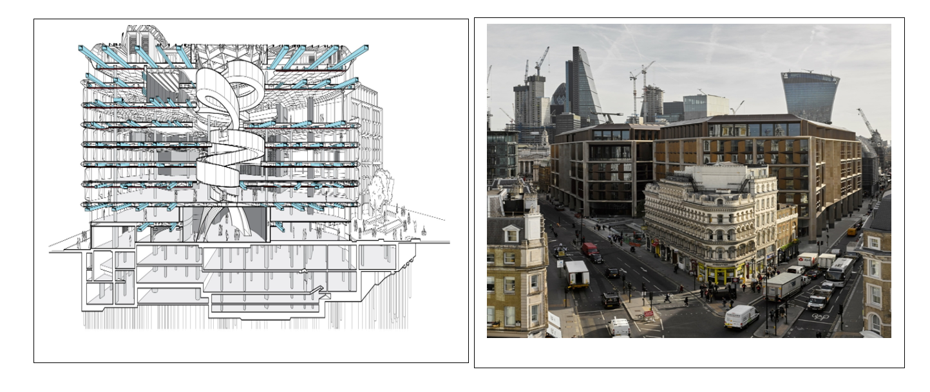
Figure 1: Bloomberg's European Headquarters Construction Design
(Source: https://www.architectsjournal.co.uk/buildings/building-study-foster-ramps-it-up-at-bloomberg)

1.4 Significance of the project
The essence of this project stems from the amalgamation of architectural, engineering, and ecological goals with strict urban conditions. This accomplishment is supported by the score of 98.5% awarded to the project in terms of BREEAM Outstanding certification (Netlify.app, 2021). This provides the basis for analysing change management and risk management in the following sections.

2.0 Change control mechanisms in construction

2.1 Change in construction and other unexpected issues
There may be multiple reasons for variations in projects, including conception and design issues, ineffective management, changes in technology, and external factors (Gunduz and Mohammad, 2020; Padala et al., 2022). Based on an analysis of 3951 changes in 19 construction projects, Padala et al. (2022) identified 85 reasons and 45 consequences of changes in projects. Given this, it is necessary to evaluate the effects of change on cost, schedule, productivity, quality, and stakeholders’ relations.
The Bloomberg project is an excellent example of how unforeseen site conditions lead to significant changes. The excavation and restoration of the Roman Temple of Mithras resulted in delaying construction and increasing costs (Foster Partners, 2017). In response to these developments, subcontractors carried out revisions of the initial versions of both temporary and permanent works, which led to the reduction of construction time by more than two months (Robert Bird Group, 2016).

2.2 Change control process involving large-scale projects
The change control process comprises identifying and documenting changes, evaluating cost, schedule, and risk, obtaining approvals, implementing the changes, and evaluating the results (Naji et al., 2022). This is essential because poorly implemented changes can generate the need for rework, cause disruptions, and lead to productivity losses (Love et al., 2019). For instance, 95 construction projects show that the average change orders were equal to 5.9%, cost overruns were equal to 3.0%, whereas for schedule overruns, the average was 7.4%, demonstrating the usefulness of an efficient change control process (Shrestha et al., 2019).

2.3 Application to the Bloomberg Building
At the initial stage of project execution, changes need to be logged and given a reference number. The project manager is responsible for the programme and technical aspects; the design team evaluates feasibility, and contractors provide information about resources and construction potential. The commercial manager checks that costs and contractual aspects are managed before getting a go-ahead from the client. The importance of collaboration in the process of change orders is derived from the fact that changes have a significant influence on project performance and stakeholders (Nguyen and Do, 2021).

2.4 Control change register

Possible Change | Cause of the change | Expense-related Impact | Programme Impact | Risk Impact | Proposed Responses | Approval by Authorised Personnel
Archaeological activity impacting sequence of construction work | Unforeseen archaeological excavationary circumstances around the construction site | High | High | High | Reprogramming the works already affected; seeking other acceleration options. | Client with Project Manager
Temporary works to be redesigned | Structural activity-related constructions to be accelerated | Medium | Positive depending on success | Medium | Reviewing technical redesign options and overall constructability | Project Manager and Design Team
Method of construction undergoing modification | Sequencing issues or site-related ordeals like hard gravel or porous soil | Medium | Medium | Medium | Looking into alternative methods before final authorisation | Contractor and Design Team
Substitution of construction material or resources | Availability issue involving raw materials and construction materials | Medium | Medium | Medium | Assessing costs, performance, and other factors for equivalent or alternative options | Commercial Manager and Client
Scope adjustment from client-driven agenda | Revision of operational requirements | High | Medium | High | Formal variation assessment and approval | Commercial Manager and Client

Table 1: Control Change Register
(Source: Gunduz and Mohammad, 2020; Padala et al., 2022; Love et al., 2019)

2.5 Commercial implications involving change
Change management is important for safeguarding business interests as well as governance. Each accepted change must be logged together with its reason, scope, cost, schedule influence, potential risk, and approver. The need for such detailed record-keeping is explained by the relationship between change orders and rework and the lower profit margins of contractors. Thus, rework accounted for 0.39% of the project value in the sample of 98 projects (Love et al., 2019). Knowledge of change management allows estimating and accepting changes appropriately, thus controlling costs.

3.0 Risk management and role of a risk register

3.1 Risk management within construction
The inherent uncertainty of construction projects can be attributed to their technical complexity, having multiple parties involved, as well as the changing conditions on-site. Thus, in contrast to a one-time assessment, a continuing process of risk identification, analysis, response and monitoring is necessary (Kallow et al., 2022). Recent empirical research has established a connection between risk identification, monitoring, and mitigation and project success, and has also studied the relationship between risk transparency and coping ability, including the effectiveness of organisations in coping with uncertainty (Kallow et al., 2022).

3.2 Identifying risk within a Bloomberg-type project
The Bloomberg initiative illustrates the importance of systematic recognition. Archaeological challenges surrounding the construction site caused delays in the programme implementation and a steep rise in costs, forcing contractors to introduce measures to speed up the process. According to the Robert Bird Group, as indicated earlier, the redesigned temporary and permanent works shortened the construction schedule of the affected operation by more than 2 months (Robert Bird Group, 2016). Consequently, the risks that a Bloomberg-type project may face include failure to harmonise the design, uncertainty related to archaeological sites, disruption in supply, escalation of cost, delay in programme, safety occurrences, and changes in legal and sustainability compliance. Furthermore, digital coordination may be helpful in risk management, since studies show that BIM can significantly contribute to risk identification and management even though its use comes together with certain implementation risks (Rehman et al., 2020).

3.3 Assessment of likelihood and consequences
The project can look into a 5*5 qualitative risk matrix, whereby both likelihood and consequence are scored from 1 (being lowest) to 5 (being highest). Therefore, the risk score can be calculated as follows (Lapidus et al., 2022).
Risk Score=Likelihood*Consequence
Hence, the resulting score requires management attention, serving as a form of authorial assessment for the case, instead of purely being derived from Bloomberg as a form of statistics (Lapidus et al., 2022).

3.4 Risk Assessment Matrix

Likelihood (on the right) | 1 | 2 | 3 | 4 | 5
Consequence (below)
5 (Severe Category) | 5 | 10 | 15 | 20 | 25
4 (Major Category) | 4 | 8 | 12 | 16 | 20
3 (Moderate Category) | 3 | 6 | 9 | 12 | 15
2 (Minor Category) | 2 | 4 | 6 | 8 | 10
1 (Insignificant Category) | 1 | 2 | 3 | 4 | 5
Figure 2: Risk Assessment Matrix
(Source: Self-created)

3.5 Risk Register

Risks | Likelihood (Out of 5) | Consequence (Out of 5) | Risk Score  (L*C) | Residual Risk Likelihood  (Out of 5) | Residual Risk Consequence  (Out of 5) | Residual Risk Score (L*C) | Mitigation
Archaeological site-related uncertainties | 4 | 4 | 16 | 2 | 4 | 8 | Contingency planning post early investigation using specialists for digging and excavation
Design-related coordination failure | 3 | 4 | 12 | 2 | 3 | 6 | BIM-based coordination with multidisciplinary design-based reviewing
Disruption of supply | 3 | 4 | 12 | 2 | 4 | 8 | Alternative supplier choice consideration or earlier procurement of resources
Delay in construction programmes | 3 | 5 | 15 | 2 | 5 | 10 | Monitoring critical path and looking into acceleration-based planning
Expense-related escalation | 4 | 4 | 16 | 2 | 4 | 8 | Forecasting contingency and formal change-related control plans
Table 2: Risk Register
(Source: Self-created)

3.6 Residual Risks
The process of mitigation does not remove uncertainty, but weakens the degree of exposure involving the project. Such residual risk calls for its continuous ownership and follow-up. This seems important for Bloomberg-type projects because one cannot fully manage archaeology, design interface, and external supply (Nabawy et al., 2020). The risk register should therefore remain a live management tool, since any indicator could trigger a reassessment. This is true as it corresponds to the general recommendations in the literature, which argue for a systematic approach to risk identification instead of using previous experience (Nabawy et al., 2020).

4.0 Lessons from wider construction industry

4.1 Construction industry lessons and response to change
Due to its scale and complexity, Crossrail serves as an appropriate benchmark for the UK construction industry, due to the reliance on strong coordination between companies as well as exchange of information, contractor involvement, and supply-chain participants. To support the BIM strategy, Crossrail made use of a Common Data Environment (CDE), promoting it as a 'single source of truth', linking 3D models with asset management information and scheduling (Taylor, 2018). A better understanding can be gained by viewing Figure 3. This shows that digital technology would be effective only when integrated into governance processes and information management systems, rather than implemented as an independent software solution.
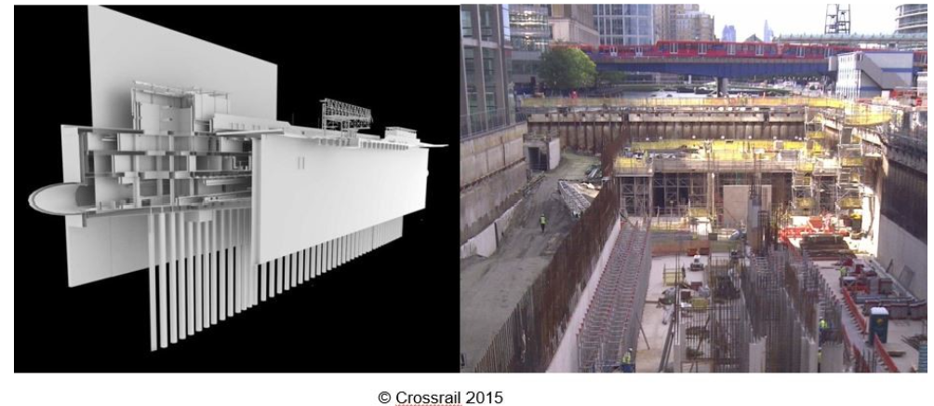
Figure 3: Crossrail’s 3D model merging with asset management information and scheduling
(Source: https://www.linkedin.com/pulse/bim-lessons-australia-from-crossrail-brian-middleton)

4.2 Technology and change management
The implementation of Building Information Modelling, or BIM, is expected to enhance performance around conflicting design management across multidisciplinary teams, enabling companies to identify design conflicts without the need for appearing on site and therefore reducing the amount of rework. Chahrour et al. (2020) came up with a cost-benefit analysis of the BIM-driven clash detection process as used on a major building project, demonstrating approximately 20% cost savings resulting from using BIM. Although the finding should not be treated as universally valid, it indicates the significant impact of digital collaboration in a financially measurable aspect. Digital twins allow remote monitoring and prediction; nevertheless, a review of the literature has revealed that the application of the digital twin concept in most case studies examined is actually problematic and limited (Opoku et al., 2021).

4.3 Wider implications related to economic costs
The process of adopting technology entails costs of software, hardware, training, information standards, and organisational change. According to the experience of Crossrail, technology must be put in place, along with processes and infrastructure, while the Information Academy solved knowledge gaps for project teams, contracts, and suppliers (Ahmad 2016). In 2023, the UK Infrastructure and Projects Authority revealed that construction materials were over 40% more expensive compared to January 2020, which caused pressure on budget expenditures and supply chains (Gov.UK, 2024, pp. 9). Thus, commercial managers need to balance implementation costs against the savings from eliminating rework, problems, and ineffective purchases.

4.4 Skills, collaboration, and adaptability
The Information Academy of Crossrail demonstrates that a successful digital transformation relies on people in addition to technologies. It mainly concentrates on People, Process and Technology, and aims to align contractors and suppliers with standard information practices (Ahmad, 2016). Hence, key competencies for Bloomberg-type projects must include skills such as digital skills, communication, collaboration capabilities, problem-solving and negotiation skills, and even an ability to make commercial judgments. To be successful, the teams must possess relevant technical expertise to transform the information into an integrated decision-making process (Aasen and Klakegg, 2023). While technology can enhance change control, the collaboration of leadership and stakeholders is still important for assessing the impact of the change, finding a solution and implementing changes without transferring uncontrolled costs, time, and quality risks.

5.0 Conclusion
The archaeological considerations impacting Bloomberg's European Headquarters show how unexpected events can interfere with scheduled construction activities and have implications for costs and resources. For change control to be effective, good practices must involve notifying the changes that have taken place, assessing and approving them by project managers, designers, contractors, clients, and commercial managers for assessing their technical, financial and contractual implications. The establishment of change registers is an effective instrument for ensuring accountability and reducing risks arising from unregulated exposure of a project.
The complementary nature of risk management with that of change control lies in the systematic identification and prioritisation of uncertainties involving a construction project. As shown through the 5*5 matrix instance, it is possible to set the level of risk priorities based on the level of probability and consequences; Risk registers allow organising effective mitigation and monitoring actions. It is critical to realise that mitigation does not guarantee the complete elimination of uncertainties. For instance, the archaeological conditions or disruptions of supply may continue having an impact in the future for the Bloomberg building. Therefore, risk registers must be dynamic instruments that should be used to reevaluate and adjust actions if needed.
The lessons learned from Crossrail have showcased the fact that successful adaptation relies on blending technology with processes and people. BIM and a Common Data Environment can improve information coordination and help with quicker identification of design issues, as training and collaboration can enable people to convert digital data into successful actions. However, the adoption of technology brings with it costs of implementation, the need for skills development, and changes in the organisation. Economic turbulence puts an extra weight on the importance of making informed business decisions.
About the future, digitalisation, AI, BIM, and digital-twin technology create great opportunities for increasing the efficiency of predictive risk management, collaboration and productivity; however, construction companies must deal with cyber security, interoperability, lack of skills, regulatory changes, environmental demands, and uncertainty in the supply chain. Thus, construction change management involves ensuring proper governance, active risk management, using the best technologies, good teamwork, and necessary practical experience for preparing the companies for both possible and unexpected changes while keeping in mind the costs, deadlines, quality, and profitability of the projects.

References
Aasen, A.F. and Klakegg, O.J. (2023). Human resilience and cultural change in the construction industry: Communication and relationships in a time of enforced adaptation. Frontiers in Built Environment, 9, p.1287483. DOI: 10.3389/fbuil.2023.1287483.
Chahrour, R., Hafeez, M.A., Ahmad, A.M., Sulieman, H.I., Dawood, H., Rodriguez-Trejo, S., Kassem, M., Naji, K.K. and Dawood, N. (2020). Cost-benefit analysis of BIM-enabled design clash detection and resolution. Construction Management and Economics, 39(1), pp.55–72. DOI: 10.1080/01446193.2020.1802768.
Cross, L. (2012). Sir Robert McAlpine proposes to lend lease to £550m Bloomberg HQ job. [online] Construction News. Available at: https://www.constructionnews.co.uk/sections/news/sir-robert-mcalpine-beats-lend-lease-to-550m-bloomberg-hq-job-06-03-2012/ [Accessed 26 Aug. 2026].
Dp9.co.uk (2022). Bloomberg’s new European Headquarters. [online] Dp9.co.uk. Available at: https://dp9.co.uk/project/bloomberg/ [Accessed 26 Aug. 2026].
Foster Partners (2017). Bloomberg’s New European headquarters launched in the City of London. [online] Foster Partners. Available at: http://fosterandpartners.com/ [Accessed 26 Aug. 2026].
Gov.UK (2024). Analysis of the National Infrastructure and Construction Pipeline 2023 reporting to Cabinet Office and HM Treasury. [online] Assets.publishing.service.gov.uk, London, England: Assets.publishing.service.gov.uk, pp.1–43. Available at: https://assets.publishing.service.gov.uk/media/65bb845421f73f000de0ba66/CCS0723973198-002_PN7393387_IPA_National_Infrastructure_and_Construction_Pipeline_Web_Accessible_converted.pdf [Accessed 26 Aug. 2026].
Gunduz, M. and Mohammad, K.O. (2020). Assessment of change order impact factors on construction project performance using analytic hierarchy process (AHP). Technological and Economic Development of Economy, 26(1), pp.71–85. Doi: 10.3846/tede.2019.11262.
Kallow, M.A., Bodla, A.A., Ejaz, A. and Ishaq, M.R. (2022). How do risk management practices lead to project success in the construction industry? The mediated moderation of risk coping capacity and risk transparency. International Journal of Construction Management, 23(16), pp.2779–2787. DOI: 10.1080/15623599.2022.2095719.
Lapidus, A., Topchiy, D., Kuzmina, T. and Chapidze, O. (2022). Influence of the construction risks on the cost and duration of a project. Buildings, [online] 12(4), p.484. DOI: 10.3390/buildings12040484.
Love, P.E.D., Ika, L.A., Ahiaga-Dagbui, D.D., Locatelli, G. and Sing, M.C.P. (2019). Make-or-break during production: Shedding light on change orders, rework and contractors' margin in construction. Production Planning & Control, 30(4), pp.285–298. DOI: 10.1080/09537287.2018.1535675.
Nabawy, M., Ofori, G., Morcos, M. and Egbu, C. (2020). Risk identification framework in construction of Egyptian mega housing projects. Ain Shams Engineering Journal, 12(2), pp.1489–1499. DOI: 10.1016/j.asej.2020.09.016.
Naji, K.K., Gunduz, M. and Naser, A.F. (2022). An adaptive neurofuzzy inference system for the assessment of Change Order Management performance in construction. Journal of Management in Engineering, 38(2), p.04021098. Doi: 10.1061/(asce)me.1943-5479.0001017.
Netlify.app (2021). Bloomberg London: Delivering the world’s most sustainable office building with Bloomberg. [online] Netlify.app. Available at: https://stanhope-plc.netlify.app/project/bloomberg-london/ [Accessed 11 Sept. 2026].
Nguyen, V.T. and Do, S.T. (2021). Assessing the relationship chain among causes of variation orders, project performance, and stakeholder performance in construction projects. International Journal of Construction Management, 23(9), pp.1592–1602. DOI: 10.1080/15623599.2021.1988197.
Opoku, De G.J., Perera, S., Osei-Kyei, R. and Rashidi, M. (2021). Digital twin application in the construction industry: A literature review. Journal of Building Engineering, 40(1), p.102726. DOI: 10.1016/j.jobe.2021.102726.
Padala, S.P.S., Maheswari, J.U. and Hirani, H. (2022). Identification and classification of change causes and effects in construction projects. International Journal of Construction Management, 22(14), pp.2788–2807. doi:10.1080/15623599.2020.1827186.
Rehman, M.S.U., Thaheem, M.J., Nasir, A.R. and Khan, K.I.A. (2020). Project schedule risk management through building information modelling. International Journal of Construction Management, 22(8), pp.1489–1499. DOI: 10.1080/15623599.2020.1728606.
Robert Bird Group (2016). Bloomberg: Robert Bird Group. [online] Robert Bird Group. Available at: https://www.robertbird.com/rbg-projects/bloomberg/ [Accessed 24 Aug. 2026].
Shrestha, P.P., Shrestha, K.K. and Zeleke, H.B. (2019). Probability of change orders and the effect on cost and schedule for new public school buildings. Engineering, Construction and Architectural Management, 26(6), pp.1087–1104. DOI: 10.1108/ecam-01-2018-0017.
Taylor, M. (2018). Crossrail project: Application of BIM (building information modelling) and lessons learned. [online] Crossrail Learning Legacy. Available at: https://learninglegacy.crossrail.co.uk/documents/crossrail-project-application-of-bim-building-information-modelling-and-lessons-learned/ [Accessed 26 Aug. 2026].

