Slide 1 - Title Slide
Financial Analysis of Tesco PLC

Speaking Notes:
Good morning, everyone. Today, I am presenting my financial analysis of Tesco PLC, focusing on evaluating its financial performance and investment potential through ratio analysis. In this presentation, I analyse Tesco’s financial position by examining key areas including profitability, liquidity, efficiency and investor-related performance indicators.
I use Tesco’s financial information together with financial analysis concepts to understand how effectively the company generates returns, manages resources and creates value for shareholders. I also evaluate Tesco’s strategic position, future growth opportunities and potential investment risks before providing my final recommendation.
My objective is to determine whether Tesco demonstrates strong financial sustainability and whether it remains an attractive option for long-term investors.

Slide 2 - Tesco PLC: Business Overview
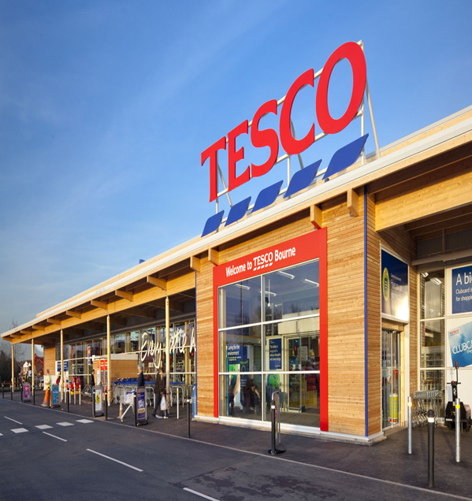
Speaking Notes:
I am starting my analysis with Tesco PLC as one of the biggest multinational retailers in the UK. Tesco's primary lines of business are grocery retail, convenience stores, online grocery retailing and wholesale services. The company also owns Booker wholesale, giving it a bigger footprint in the independents and food service.
I think Tesco's status as a FTSE 100 listed company is significant as it means their financial results are going to have a direct impact on the views of shareholders. The vast customer base, high brand exposure and being present at numerous physical and digital online shops are advantages for Tesco.
Tesco's Annual Report sees the company maintaining its commitment to delivering low-cost solutions to customers, alongside new digital services and operational efficiencies.
The following factors form a good base to analyse the financial performance and investment potential of Tesco:

Slide 3 - Tesco Business Model and Strategic Position
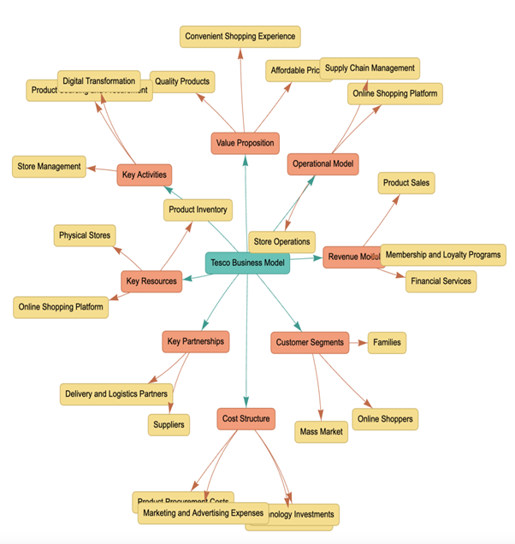
Speaking Notes:
In this slide, I evaluate Tesco’s business model and strategic position. I observe that Tesco generates most of its revenue from grocery sales through supermarkets, convenience stores and online platforms.
A key strength within Tesco’s business model is the Clubcard ecosystem. Tesco uses customer data analytics to understand purchasing behaviour and provide personalised offers, which helps improve customer loyalty and retention.
I also consider Booker wholesale as an important extension of Tesco’s operations because it allows the company to serve independent retailers and food service customers.
The combination of physical stores and digital platforms improves Tesco’s ability to adapt to changing consumer preferences and strengthens its competitive position.

Slide 4 - Tesco Strategic Strengths
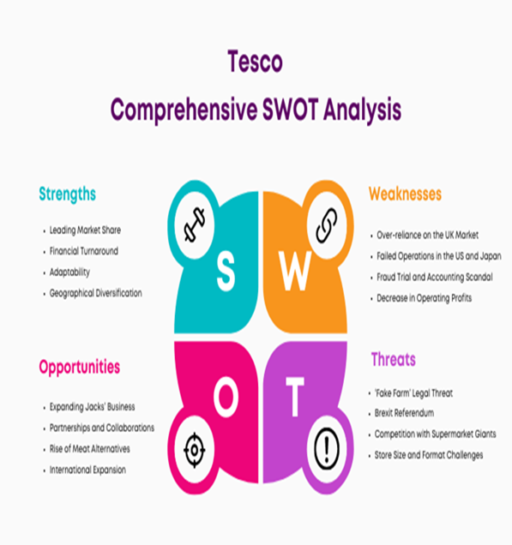
Speaking Notes:
I identify several strategic strengths that support Tesco’s market position. Firstly, Tesco benefits from a large retail infrastructure and strong brand reputation, which allows the company to maintain customer loyalty within a competitive grocery market.
Secondly, Tesco’s use of Clubcard data supports better decision-making by helping the company understand customer needs and improve operational efficiency.
I also evaluate supply chain management as an important strength because efficient inventory control allows Tesco to maintain product availability while managing costs.
Finally, Tesco’s investment in digital transformation supports future growth by improving customer experience and operational effectiveness.
These strengths contribute towards Tesco’s ability to remain competitive in the long term.

Slide 5 - Financial Ratio Analysis Framework
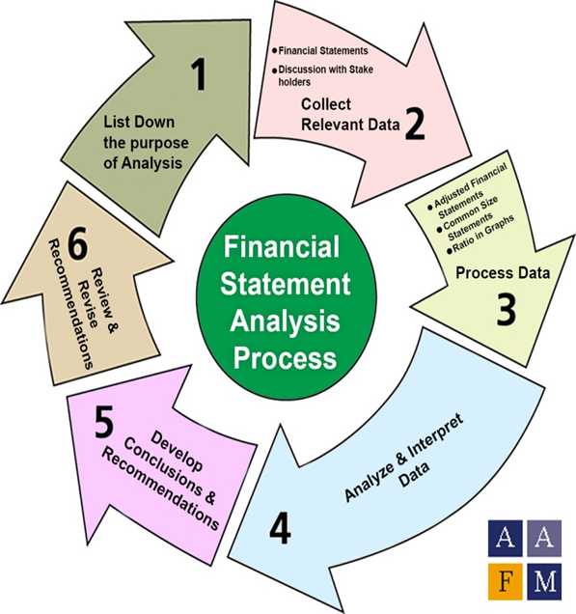
Speaking Notes:
To evaluate Tesco’s financial performance, I apply financial ratio analysis using information obtained from the company’s annual reports.
I use profitability ratios to understand Tesco’s ability to generate earnings from its sales and invested capital. I analyse liquidity ratios to evaluate whether Tesco can meet its short-term financial obligations.
I examine efficiency ratios to understand how effectively Tesco manages operational resources such as inventory and working capital. Investor ratios are also considered because they provide insights into shareholder returns and market expectations.
This framework allows me to move beyond simple financial figures and critically evaluate Tesco’s overall financial health and investment attractiveness.

Slide 6 - Revenue Growth Performance
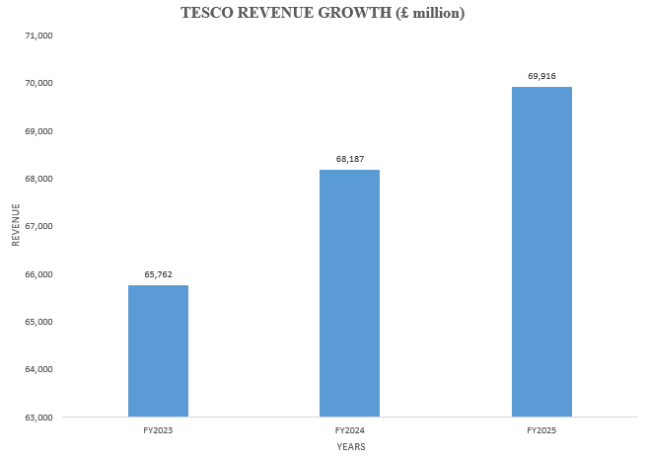
Speaking Notes:
In this slide, I evaluate Tesco’s revenue growth performance during the three-year period from FY2023 to FY2025. I observe that Tesco’s revenue increases from £65.76 billion in FY2023 to £69.92 billion in FY2025, showing consistent growth in sales performance.
This increase indicates that Tesco continues to maintain strong customer demand and market presence despite operating in a highly competitive grocery retail environment.
I do not consider revenue growth alone as a complete measure of financial success because higher sales do not always lead to higher profitability. I analyse profitability ratios in the following section to understand whether Tesco converts revenue growth into improved earnings.
Reference: Tesco PLC (2025) Annual Report and Financial Statements.

Slide 7 - Profitability Analysis
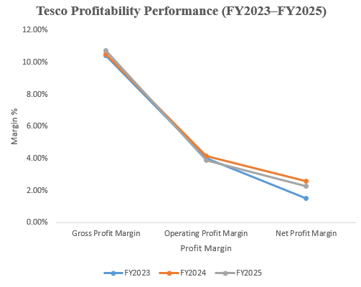
Speaking Notes:
In this section, I analyse Tesco’s profitability performance using gross profit margin, operating profit margin and net profit margin.
I observe that Tesco’s gross profit margin improves from 10.41% in FY2023 to 10.72% in FY2025, indicating improved control over product profitability. Operating profit margin decreases slightly from 4.03% to 3.88%, which highlights pressure from operating costs and competitive pricing strategies.
The net profit margin improves from 1.52% to 2.29% during the period, suggesting stronger earnings retention compared with FY2023.
Overall, I conclude that Tesco maintains profitability, but the low-margin nature of grocery retail requires continuous cost management.
Reference: Hasidi et al. (2024).

Slide 8 - Return on Capital Employed (ROCE)
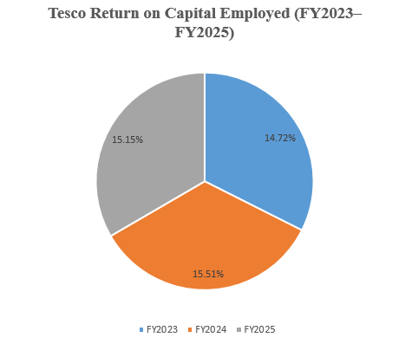
Speaking Notes:
I evaluate Tesco’s Return on Capital Employed to understand how efficiently the company uses invested resources to generate operating returns.
The analysis shows that Tesco’s ROCE remains consistently strong, increasing from 14.72% in FY2023 to 15.51% in FY2024 before slightly reducing to 15.15% in FY2025.
I interpret this stability as evidence that Tesco continues to use shareholder and business capital effectively. Although the slight decline in FY2025 requires monitoring, the overall performance indicates efficient capital utilisation.
From an investor perspective, maintaining a strong ROCE demonstrates Tesco’s ability to generate returns from the resources invested in the business.
Reference: Pal and Ukil (2025).

Slide 9 - Liquidity Analysis
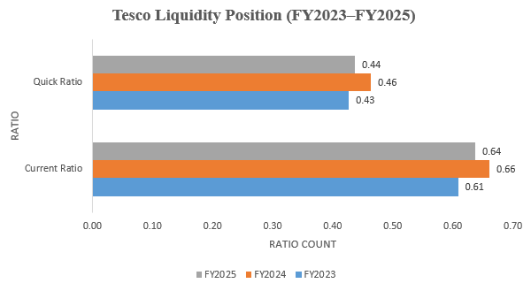
Speaking Notes:
In this slide, I analyse Tesco’s liquidity position using the current ratio and quick ratio.
I observe that Tesco’s current ratio remains below one throughout the analysed period, moving from 0.61 in FY2023 to 0.64 in FY2025. The quick ratio follows a similar trend, increasing slightly from 0.43 to 0.44.
Although these ratios appear lower compared with traditional liquidity benchmarks, I consider the characteristics of the grocery retail industry. Tesco benefits from rapid inventory turnover and strong supplier relationships, which reduces the requirement for holding large current asset balances.
I evaluate Tesco’s liquidity position as controlled rather than financially weak.
Reference: Li (2024).

Slide 10 - Efficiency Analysis
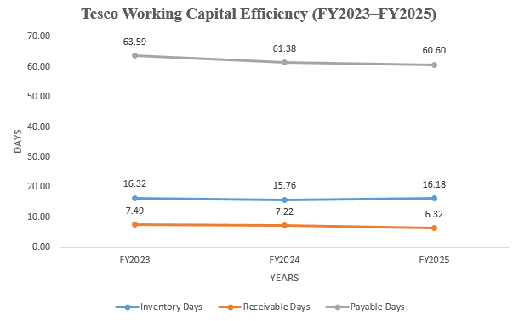
Speaking Notes:
I evaluate Tesco’s operational efficiency by analysing inventory days, receivable days and payable days.
The results show that Tesco maintains stable inventory management, with inventory days remaining around 16 days across the three-year period. Receivable days improve from 7.49 days in FY2023 to 6.32 days in FY2025, indicating improved collection efficiency.
At the same time, payable days remain above 60 days, demonstrating Tesco’s ability to utilise supplier credit effectively.
I consider these results positive because effective working capital management supports cash flow generation and operational stability. This efficiency provides Tesco with flexibility to manage daily retail operations effectively.
Reference: Salah et al. (2023).

Slide 11 - Overall Financial Performance Summary

Speaking Notes:
In this slide, I summarise Tesco’s overall financial performance based on the previous ratio analysis.
I observe that Tesco demonstrates positive revenue growth, stable profitability and effective operational management during the analysed period. The profitability analysis indicates that Tesco continues generating earnings despite operating in a competitive retail environment.
I also identify that liquidity remains controlled due to the characteristics of the grocery retail model, where fast inventory movement and supplier credit support cash flow management.
From an investor perspective, I consider Tesco financially resilient because the company combines revenue growth, operational efficiency and consistent shareholder returns. Continued focus on cost control remains important to protect future profitability.
Reference: Tesco PLC (2025) Annual Report and Financial Statements.

Slide 12 - Earnings Per Share (EPS) Analysis
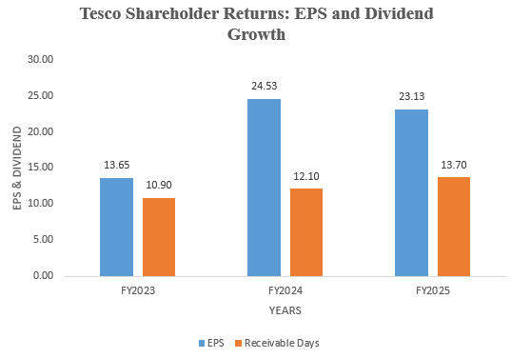
Speaking Notes:
I analyse Earnings Per Share to evaluate the value generated for Tesco’s shareholders.
The results show that Tesco’s EPS increases significantly from 13.65 pence in FY2023 to 24.53 pence in FY2024. Although EPS decreases slightly to 23.13 pence in FY2025, it remains considerably higher than the FY2023 level.
I interpret this performance as evidence of improved earnings generation and stronger shareholder value creation. I also recognise that EPS performance should be analysed alongside other financial indicators because short-term earnings changes may be affected by different operational and market factors.
Overall, Tesco demonstrates improved earnings capability during the period.
Reference: Tesco PLC (2025) Annual Report and Financial Statements.

Slide 13 - Dividend Performance
Speaking Notes:
In this slide, I evaluate Tesco’s dividend performance to understand how effectively the company rewards shareholders.
I observe that Tesco’s dividend per share increases consistently from 10.9 pence in FY2023 to 13.7 pence in FY2025. This continuous increase indicates management confidence in the company’s cash-generation ability.
From an investor perspective, dividend growth is an important factor because it provides a direct return to shareholders and can improve investor confidence.
I also consider that sustainable dividends depend on maintaining strong future profitability and cash flows. Tesco’s increasing dividend trend is positive, but continued financial discipline remains essential.
Reference: Al-Najjar and Kilincarslan (2022).

Slide 14 - Price Earnings (PE) Ratio Analysis
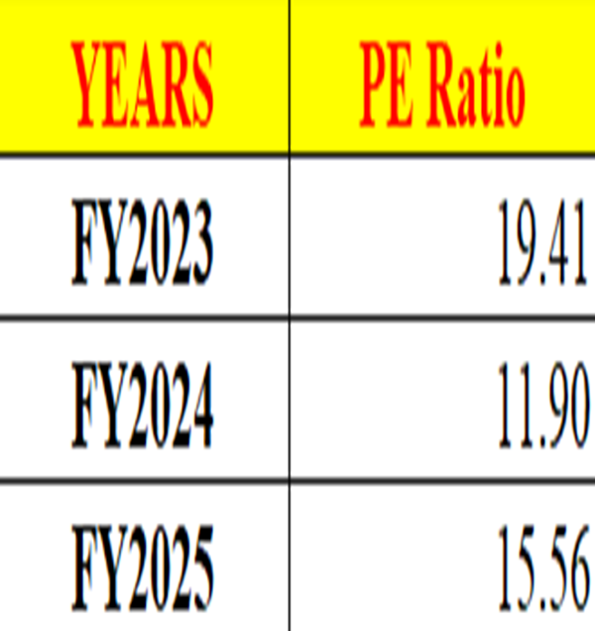
Speaking Notes:
I analyse Tesco’s Price Earnings ratio to understand how the market values the company’s earnings.
The PE ratio decreases from 19.41 in FY2023 to 11.90 in FY2024 before increasing to 15.56 in FY2025. I interpret this movement as a change in investor expectations regarding Tesco’s future earnings performance.
The increase in FY2025 suggests that market confidence improves as investors are willing to pay a higher value for Tesco’s earnings compared with the previous year.
I recognise that PE ratios should not be evaluated independently. Investors should compare Tesco’s valuation with competitors and consider broader market conditions before making investment decisions.
Reference: Boubaker et al. (2023).

Slide 15 - Investment Evaluation: Strengths and Risks

Speaking Notes:
In this slide, I evaluate Tesco from an investor perspective by considering both strengths and potential risks.
I identify several positive factors, including consistent revenue growth, strong market presence, improving shareholder returns and efficient working capital management. These factors indicate that Tesco maintains a stable financial position.
I also recognise important challenges. The grocery retail sector experiences intense competition, which creates pressure on pricing and operating margins. Inflation and rising operational costs may also affect future profitability.
I consider Tesco a financially stable organisation, but investors should continue monitoring competitive pressures and margin performance.
Reference: Broekhuizen et al. (2024).

Slide 16 - Annual Report Evaluation
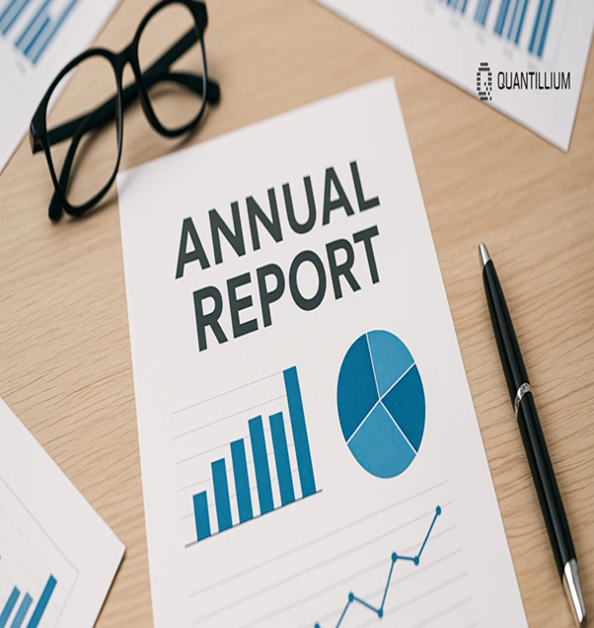
Speaking Notes:
In this slide, I evaluate the importance of Tesco’s annual report as a source of financial information for investors.
I use Tesco’s annual report to obtain key financial data, including revenue, profitability figures, earnings per share and dividend information. The annual report provides transparency by presenting financial performance, strategic priorities and business risks.
I also recognise that annual reports mainly represent historical performance and may reflect management’s perspective regarding future expectations. I do not rely only on annual report information instead, I combine financial statement analysis with academic concepts and ratio evaluation to develop a balanced investment assessment.
Reference: Kim et al. (2024).

Slide 17 - Risk Management
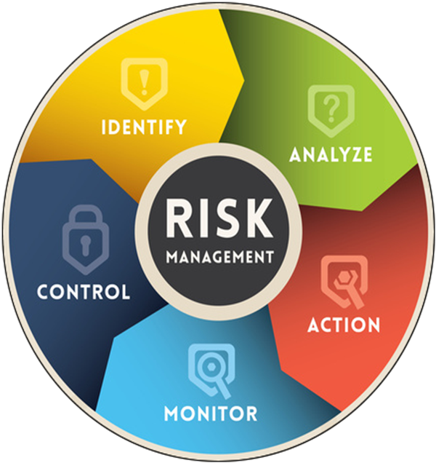
Speaking Notes:
In this section, I analyse the key risks that may influence Tesco’s future financial performance.
I identify supply chain disruption, inflationary pressures, increasing operating costs and competitive intensity as important challenges within the retail sector. Tesco manages these risks through strong supplier relationships, operational efficiency and investment in technology.
I consider risk management essential because strong financial performance alone does not guarantee future success. A company must also maintain resilience against external uncertainties.
From an investor perspective, Tesco’s established infrastructure and operational capabilities provide protection against many risks, although continuous monitoring is required to maintain profitability and competitiveness.
Reference: Wibowo et al. (2024).

Slide 18 - Future Growth Opportunities

Speaking Notes:
In this slide, I evaluate Tesco’s future growth opportunities and strategic direction.
I identify digital transformation, online grocery expansion and customer data analytics as important opportunities for future development. Tesco’s Clubcard platform allows the company to understand customer behaviour and improve personalised marketing strategies.
I also consider operational efficiency improvements as an opportunity to strengthen profitability by controlling costs and improving resource utilisation.
From my analysis, I believe Tesco’s combination of physical retail strength and digital capabilities provides a strong foundation for future growth. Tesco must continue adapting to changing consumer preferences and increasing competition within the retail sector.
Reference: Verhoef et al. (2023).

Slide 19 - Investment Recommendation
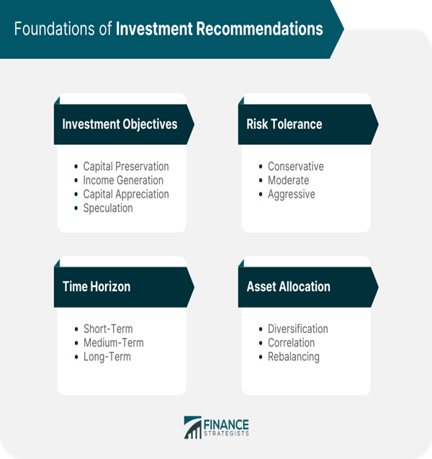
Speaking Notes:
Based on my overall financial analysis, I provide my investment recommendation for Tesco PLC.
I consider Tesco a financially stable company due to its consistent revenue growth, strong operational efficiency and increasing shareholder returns. The analysis shows positive indicators, including improved EPS performance, growing dividends and stable ROCE.
I also recognise that Tesco operates in a highly competitive industry where maintaining margins remains challenging.
I recommend a long-term HOLD position because Tesco demonstrates strong fundamentals and resilience, but investors should continue monitoring profitability pressures and market competition before increasing investment exposure.
Reference: Yao et al. (2024).

Slide 20 - Conclusion
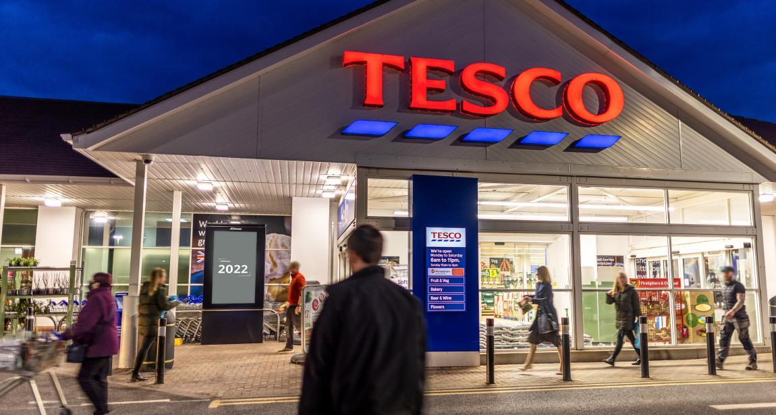
Speaking Notes:
To conclude my presentation, I evaluate Tesco as a financially resilient organisation with strong market positioning and stable investment potential.
My analysis shows that Tesco achieves consistent revenue growth, maintains effective working capital management and provides increasing returns to shareholders through improved EPS and dividend payments.
Although profitability remains affected by competitive pressures within the grocery retail sector, Tesco demonstrates strong operational capabilities and financial stability.
Overall, I conclude that Tesco remains an attractive long-term investment opportunity, provided investors continue evaluating future risks, market conditions and the company’s ability to maintain sustainable growth.
Reference: Tesco PLC (2025) Annual Report and Financial Statements.

Reference
Abdullah, A. and Muchran, M., 2026. Dividend policy and its impact on financial performance and corporate social responsibility: A literature study. Journal Social Society, 6(1), pp.519-528.https://pusdig.my.id/jss/article/view/1025
Broekhuizen, T., Nguyen, D.K. and Fabian, N.E., 2024. A strategic innovation perspective on digital transformation: the example of small and medium enterprises. In A Research Agenda for Digital Transformation (pp. 11-44). Edward Elgar Publishing.https://www.elgaronline.com/edcollchap/book/9781035306435/book-part-9781035306435-7.xml
Dymitrowski, A. and Szillat, P., 2026. 2 Defining the Business Model. Strategic Inter-Organizational Relationships: The Impact of the Relational Business Model on Resilience and Sustainability, p.2.https://books.google.com/books?hl=en&lr=&id=uxrHEQAAQBAJ&oi=fnd&pg=RA1-PA1991&dq=Teece,+D.J.+(2022)+%E2%80%98Business+models,+business+strategy+and+innovation%E2%80%99,+Long+R&ots=oypEH7A7hU&sig=vJ0X0tQxGfnxS_7rCHP1A_geHc8
Grewal, D., Guha, A., Beccacece Satornino, C. and Becker, M., 2025. The future of marketing and marketing education. Journal of Marketing Education, 47(1), pp.61-77.https://journals.sagepub.com/doi/pdf/10.1177/02734753241269838
Hasidi, M.H., Baheri, J. and Hajar, K.I., 2024. Financial performance evaluation using profitability and liquidity ratio analysis. Jurnal Ilmiah Manajemen Kesatuan, 12(4), pp.1347-1358.https://pdfs.semanticscholar.org/b6db/13d72f9e39e0d2030f6d9613c7165cb8adc4.pdf
Kim, A., Muhn, M. and Nikolaev, V., 2024. Financial statement analysis with large language models. arXiv preprint arXiv:2407.17866.https://rotmandigital.ca/wp-content/uploads/2025/01/Financial-Statement-Analysis-with-Large-Language-Models.pdf
Li, K., 2024. Liquidity ratios and corporate failures. Accounting & Finance, 64(1), pp.1111-1134.https://onlinelibrary.wiley.com/doi/abs/10.1111/acfi.13174
Moolkham, M., Petchchedchoo, P., Kumsuprom, S. and Panmanee, P., 2025. Digital transformation, financial efficiency, financial effectiveness and firm values. KKBS Journal of Business Administration and Accountancy, 9(3), pp.21-38.https://so04.tci-thaijo.org/index.php/kkbsjournal/article/download/278963/190886
Nasution, Y.A. and Yusleny, Y., 2023, February. Financial Performance Measurement Using Profitability Ratios And Liquidity Ratios. In Proceeding Medan International Conference on Economic and Business (Vol. 1, pp. 1730-1741).https://proceeding.umsu.ac.id/index.php/Miceb/article/download/282/303
Oh, K., Jeong, E. and Yoo, H., 2023. Effects of working capital management on small and medium-sized enterprises' profitability from the continuity of supply chain relationships. Global Business & Finance Review (GBFR), 28(5), pp.51-66.https://www.econstor.eu/bitstream/10419/305917/1/id554.pdf
Ortner, T., Hautz, J., Stadler, C. and Matzler, K., 2025. Open strategy and digital transformation: A framework and future research agenda. International Journal of Management Reviews, 27(3), pp.324-345.https://onlinelibrary.wiley.com/doi/pdf/10.1111/ijmr.12379
Pal, A. and Ukil, A., 2025. An Empirical Study on the Relationship of Profitability and Liquidity Management of some select Listed Oil Companies in India. Journal of Academic Advancement, 4(02), pp.41-46.https://jaa.kbsaa.org/index.php/j/article/download/84/72
Putri, B.M. and Ardiyani, K., 2026. The Effect Of Good Corporate Governance On Financial Performance With Intellectual Capital As A Moderator (An Empirical Study Of Banking Subsector Companies Listed On The Indonesia Stock Exchange From 2021 To 2024). Citizen: Jurnal Ilmiah Multidisiplin Indonesia, 6, pp.22-39.https://journal.das-institute.com/index.php/citizen-journal/article/download/1447/909
Salah, A., Çağlar, D. and Zoubi, K., 2023. The impact of production and operations management practices in improving organizational performance: The mediating role of supply chain integration. Sustainability, 15(20), p.15140.https://www.mdpi.com/2071-1050/15/20/15140
Sany, S. and Yonatan, N., 2023. Liquidity and Profitability of Retail Companies: Evidence from Indonesia. International Journal of Organizational Behavior and Policy, 2(2), pp.77-86.https://ijobp.petra.ac.id/index.php/ijobp/article/download/115/108
Tesco PLC., 2025. Annual Report and Financial Statements 2025.https://www.tescoplc.com/investors/reports-results-and-presentations/annual-report-2025
Tran, N.T., Le, N.T. and Nguyen, T.D., 2025. Corporate Social Responsibility Disclosure and Financial Performance: Empirical Evidence From Vietnam. Economic and Business Review, 27(3), pp.141-159.https://www.ebrjournal.net/cgi/viewcontent.cgi?article=1357&context=home
Tran, T.T.H. and Dang, N.H., 2026. A META-ANALYTIC REVIEW OF THE IMPACT OF FINANCIAL REPORTING QUALITY ON FIRM VALUE AND PERFORMANCE: EVIDENCE FROM SYSTEMATIC LITERATURE SYNTHESIS.https://www.researchgate.net/profile/Dang-Hung-2/publication/404322807_A_META-ANALYTIC_REVIEW_OF_THE_IMPACT_OF_FINANCIAL_REPORTING_QUALITY_ON_FIRM_VALUE_AND_PERFORMANCE_EVIDENCE_FROM_SYSTEMATIC_LITERATURE_SYNTHESIS/links/69f3f3f9b1dace04f143c712/A-meta-analytic-review-of-the-impact-of-financial-reporting-quality-on-firm-value-and-performance-Evidence-from-systematic-literature-synthesis.pdf
Umam, F. and Damayanti, S.M., 2023. The Role of Financial Ratios on Optimizing Company Performance At PT Angkasa Pura Retail. Journal of Economics and Business UBS, 12(2), pp.689-707.https://jurnal.ubs-usg.ac.id/index.php/joeb/article/download/137/369
Wibowo, F.A., Satria, A., Gaol, S.L. and Indrawan, D., 2024. Uncovering Financial Performance and Efficiency: A Glimpse into Indonesia's State-Owned Enterprises (SOEs) Construction Industry Debt and Financial Risk.https://www.preprints.org/frontend/manuscript/68ae6c3c0a1ab7cfabf33a93c5fb4da7/download_pub

Appendix
