2018-19
?
AND WHEN
HOW
,
WHERE
,
WHAT
produce for their food. They also hunted animals.
1 n
forests, and collected roots, fruits and other forest
about the vast wealth of plants in the surrounding
that is, people who gathered their food. They knew
people who lived here were skilled gatherers, —
hundred thousand years. Some of the earliest
have lived along the banks of this river for several
Find the river Narmada on Map 1 (page 2). People
Where did people live?
heard, the plays they saw, the songs they sang.
about the games children played, the stories they
musicians, and scientists. We can also find out
merchants, priests, crafts persons, artists,
the lives of hunters, herders, farmers, rulers,
houses in which they lived. We can find out about
people ate, the kinds of clothes they wore, the
There are several things we can find out — what
What can we know about the past?
can be done.
But what about long, long ago? Let us see how it
Last year: ask somebody who remembers.
television, read a newspaper.
Yesterday: you could listen to the radio, watch
Finding out what happened
so many years ago?
she wondered, could anyone know what had happened
fell on a small headline: “One Hundred Years Ago.” How,
Rasheeda sat reading the newspaper. Suddenly, her eyes
Rasheeda’s question
WHAT, WHERE, HOW AND WHEN?
CHAPTER 1
Evaluation Warning : The document was created with Spire.PDF for Python.


2018-19
I
–
OUR PASTS
n 2
Physical Map of the Subcontinent
MAP : 1
India. These were some of the other areas where
hills to the north-east and the Vindhyas in central
and cattle, and lived in villages. Locate the Garo
People also began rearing animals like sheep, goat,
barley about 8000 years ago are located here.
men first began to grow crops such as wheat and
northwest. Some of the areas where women and
Now find the Sulaiman and Kirthar hills to the
Evaluation Warning : The document was created with Spire.PDF for Python.
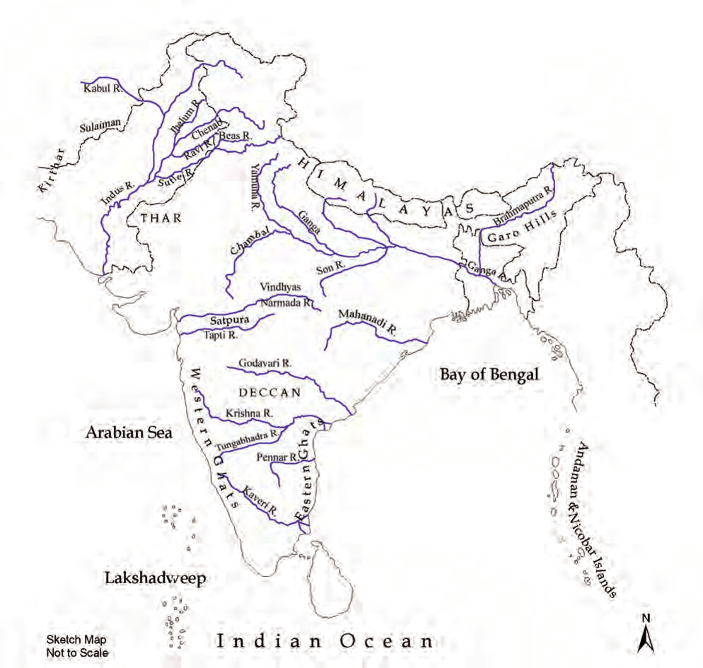

2018-19
?
AND WHEN
HOW
,
WHERE
,
WHAT
also came into the subcontinent and settled here.
3 n
and cross the seas. People from across the frontiers
who wanted could and did scale the mountains
While it was difficult to cross these frontiers, those
seas form the natural frontiers of the subcontinent.
Look at Map 1 once more. Hills, mountains and
Why do people travel nowadays?
these led to the sharing of ideas between people.
wanting to discover new and exciting places. All
perhaps travelled driven by a spirit of adventure,
and advice on the way. Finally, some people
village, town to town, stopping to offer instruction
And religious teachers walked from village to
ships, carrying valuable goods from place to place.
Besides, merchants travelled with caravans or
marched in armies, conquering others’ lands.
disasters like floods or droughts. Sometimes men
search of livelihood, as also to escape from natural
never impossible. So, men and women moved in
and seas made journeys dangerous at times, but
mountains including the Himalayas, deserts, rivers
the subcontinent to another. The hills and high
Throughout, people travelled from one part of
mountains.
were set up in other parts of the country as well.
of Asia by seas, hills and
powerful, and set up a large kingdom. Kingdoms
separated from the rest
now lying in the state of Bihar. Its rulers were very
it is very large, and is
to the south of the Ganga was known as Magadha
smaller than a continent,
Son. In ancient times the area along these rivers
because although it is
called a subcontinent
Locate the Ganga and its tributary called the
South Asia is often
tributaries, and along the sea coasts.
China and Myanmar.
developed on the banks of the Ganga and its
of Afghanistan, Iran,
rivers. Later, about 2500 years ago, cities
neighbouring countries
earliest cities flourished on the banks of these
Lanka) and the
Nepal, Bhutan and Sri
larger river). About 4700 years ago, some of the
Pakistan, Bangladesh,
(tributaries are smaller rivers that flow into a
countries of India,
Trace the river Indus and its tributaries
(including the present
first grown are to the north of the Vindhyas.
map of South Asia
agriculture developed. The places where rice was
Facing Page: This is a
Evaluation Warning : The document was created with Spire.PDF for Python.


2018-19
I
–
OUR PASTS
n 4
away by insects, some were destroyed, but many
turn to page 45.
Over the years, many manuscripts were eaten
birch bark manuscript,
as the birch, which grows in the Himalayas.
to make books. To see a
pages and tied together
or on the specially prepared bark of a tree known
leaves were cut into
hand). These were usually written on palm leaf,
years ago. The palm
(this comes from the Latin word ‘manu’, meaning
written about a thousand
manuscripts, because they were written by hand
This manuscript was
were written long ago. These are called
manuscript.
A page from a palm leaf
past. One is to search for and read books that
There are several ways of finding out about the
Finding out about the past
3500 years ago). Later it was used for the country.
earliest composition in Sanskrit (dated to about
west, and who are mentioned in the Rigveda, the
used for a group of people who lived in the north-
the river was called India. The name Bharata was
Hindos or the Indos, and the land to the east of
ago and were familiar with the Indus, called it the
who came through the northwest about 2500 years
Greece in your atlas. The Iranians and the Greeks
Indus, called Sindhu in Sanskrit. Find Iran and
India and Bharat. The word India comes from the
Two of the words we often use for our country are
Names of the land
over several hundreds of years.
stone, composing music, and even cooking food
traditions. People have shared new ways of carving
These movements of people enriched our cultural
Evaluation Warning : The document was created with Spire.PDF for Python.
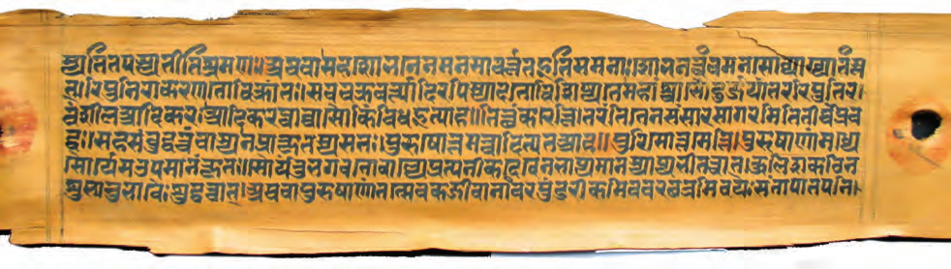

2018-19
?
AND WHEN
WHERE HOW
,
WHAT
survive for a long time.
5 n
are made of hard, imperishable substances usually
others of bone, baked clay or metal. Objects that
coins. Some of these objects may be made of stone,
find tools, weapons, pots, pans, ornaments and
excavate (dig under the surface of the earth) to
area.
which were used in this
paintings and sculpture. They also explore and
and Aramaic (below),
remains of buildings made of stone and brick,
languages, Greek (top)
They study the
different scripts and
archaeologists.
inscribed in two
objects are called
inscription was
use a language. This
who study these
written, or speak, we
the past. Those
When we read what is
made and used in
of letters or signs.
things that were
script. Scripts consist
many
other
anything, we use a
8. When we write
There were
about him in Chapter
the difficulties?
Ashoka. You will read
could have been
of a ruler named
surface? And what
inscribed on the orders
writing on a hard
Afghanistan. It was
Kandahar, present-day
the advantages of
ago, and was found in
Can you think of
to about 2250 years
kings often kept records of victories in battle.
This inscription dates
queens) recorded what they did. For example,
An old inscription.
well, where men and women (including kings and
them. There are other kinds of inscriptions as
inscribed so that people could see, read and obey
or metal. Sometimes, kings got their orders
writings on relatively hard surfaces such as stone
We can also study inscriptions. These are
(languages used by ordinary people) and Tamil.
written in Sanskrit, others were in Prakrit
were epics, poems, plays. Many of these were
of kings, medicine and science. Besides, there
subjects: religious beliefs and practices, the lives
monasteries. These books dealt with all kinds of
have survived, often preserved in temples and
Evaluation Warning : The document was created with Spire.PDF for Python.
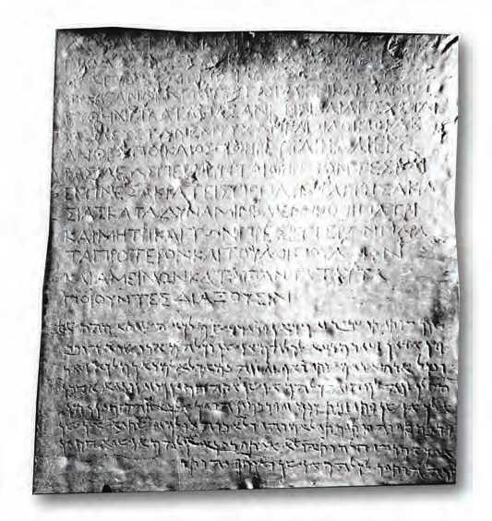

2018-19
I
–
OUR PASTS
different practices and customs in different parts
n 6
Also, as is true even today, people followed
different from those of crafts persons, and so on.
kings and queens, the lives of merchants were
of herders or farmers were different from those of
different groups of people. For example, the lives
attention to the fact that the past was different for
We have used the word ‘pasts’ in plural to draw
Did you notice the title of this book, Our Pasts?
One past or many?
sources like clues to find out about our pasts.
archaeologists are like detectives, who use all these
reconstruct it bit by bit. So historians and
about the past becomes an adventure, as we
archaeology. Once sources are found, learning
found from manuscripts, inscriptions and
often use the word source to refer to the information
Historians, that is, scholars who study the past,
is found frequently by archaeologists?
they survive in a charred form. Do you think cloth
seeds of grain or pieces of wood have been burnt,
past. Plant remains survive far more rarely — if
birds, and fish — to find out what people ate in the
Archaeologists also look for bones — of animals,
we use today?
different from the ones
In what ways is the coin
2500 years ago.
were in use from about
Coins such as this one
Right : An old silver coin.
ago.
used about 4700 years
Pots like these were
city.
Left : A pot from an old
Evaluation Warning : The document was created with Spire.PDF for Python.
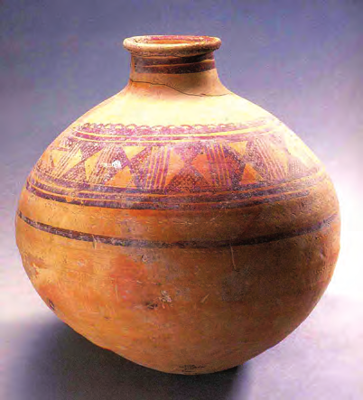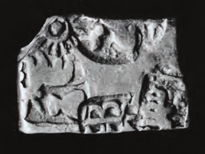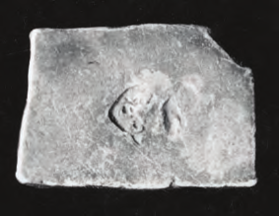

2018-19
?
AND WHEN
HOW
,
WHERE
,
WHAT
7 n
our starting point.
dates going back from the present, using 2000 as
Christ) added on. In this book, we will refer to
backwards and usually have the letters BC (Before
dates before the birth of Christ are counted
means 2000 years after the birth of Christ. All
Christ, the founder of Christianity. So, 2000
date generally assigned to the birth of Jesus
something. These years are counted from the
mention the day, month and year, 2000 and
If somebody asks you the date, you will probably
What do dates mean?
lives, there is much that remains unknown.
While archaeology helps us to find out about their
herders did not keep records of what they did.
hunters, fishing folk, gatherers, farmers or
victories. Generally, ordinary people such as
they fought because they kept records of their
We know a great deal about kings and the battles
Besides, there is another kind of difference.
as these existed in the past as well.
on others for supplies of food. Differences such
By contrast, most people living in cities depend
by fishing, hunting, and collecting forest produce.
living in the Andaman Islands get their own food
of the country. For example, today most people
Evaluation Warning : The document was created with Spire.PDF for Python.


