GENERAL CONFEDERATION OF LABOR OF VIETNAM  
**TON DUC THANG UNIVERSITY  
FACULTY OF INFORMATION TECHNOLOGY**



**SOFTWARE ENGINEERING**

WATCHING MOVIE WEBSITE

*Instructing Lecturer*: **Mr. LE NGOC THACH**

*Student’s name*: **CAO MINH PHAT – 517H0153**

**NGUYEN TRAN BAO DAI –517H0103**

Group **: 06-07**

**HO CHI MINH CITY, YEAR 2020**

GENERAL CONFEDERATION OF LABOR OF VIETNAM  
**TON DUC THANG UNIVERSITY  
FACULTY OF INFORMATION TECHNOLOGY**



**SOFTWARE ENGINEERING**

WATCHING MOVIE WEBSITE

*Instructing Lecturer*: **Mr. LE NGOC THACH**

*Student’s name*: **CAO MINH PHAT – 517H0153**

**NGUYEN TRAN BAO DAI –517H0103**

Group **: 06-07**

**HO CHI MINH CITY, YEAR 2020**

**ACKNOWLEDGEMENT**

- We would like to send our most sincere thanks to lecturer  
Le Ngoc Thach.  
- During the teaching process, he devoted himself to teaching, providing and  
imparting important and necessary knowledge so that we can apply and complete the  
project in the best way.  
- Besides, Group 0 would like to thank the teacher for guiding,  
supporting and reminding our group to be able to complete the project on schedule  
- We sincerely thank you!

THIS PROJECT WAS ACCOMPLISH AT TON DUC THANG UNIVERSITY

I commit that this product belong to us with the guardian of Mr. Le Ngoc Thach. The content of research, result of this project is honest and has not been published

in any form before. The data in the tables for analysis, comment and evaluation were collected by the author from various sources in the reference section.

Besides, our project used many kinds of comments, assessments as well as data

from another authors, organizations. This project has original quotes and annotations.

If any fraud is detected, I will take full responsibility for the contents of my

project. Ton Duc Thang University is not involved to any violations of copyright and

copyright caused by me during implementation (if any).

*Ho Chi Minh City, November 18th 2019*

*Author*

*(sign and write full name)*

*Cao Minh Phát*

EVALUATION AND INSTRUCTION LECTURER

**Confirmation of the teacher instructor**

_______________________________________________________________________________________________________________________________________________________________________________________________________________________________________________________________________________________________________________________________________________________________________________________________________________

*Ho Chi Minh City, November 18th 2019*

*(sign and write full name)*

**The assessment of the teacher marked**

_______________________________________________________________________________________________________________________________________________________________________________________________________________________________________________________________________________________________________________________________________________________________________________________________________________

*Ho Chi Minh City, November 18th 2019*

*(sign and write full name)*

TABLE OF CONTENTS

ACKNOWLEDGEMENT 3

THIS PROJECT WAS ACCOMPLISH AT TON DUC THANG UNIVERSITY 1

EVALUATION AND INSTRUCTION LECTURER 2

TABLE OF CONTENTS 3

CHAPTER 1 – EXECUTIVE SUMMARY 5

1.1 The problem of the system 5

1.2 Scope of the system 5

CHAPTER 2 – INTRODUCTION 6

… 6

CHAPTER 3 – ANALYSIS PRESENTATION 7

3.1 Events 8

3.1.1 User 8

3.1.2 Admin 8

3.1.3 description the user’s activity on web 8

3.1.4 description the admin's activity on web 9

3.2 Actor 9

3.3 Flow chart 10

3.4 Use case detailed description 11

3.5 List of use case 11

3.6 Use case detailed description 12

3.6.1 Register 12

3.6.2 login 13

3.6.3 Search & choose film 14

3.6.5 manage account 15

3.6.6 Managers login 16

3.6.7 film management 17

3.6.8 interaction management 18

3.6.9 User management 18

3.6.10 manage notification 19

3.7 Activity diagram 21

3.8 Class diagram 23

3.9 Sequence diagram 25

3.10 Collaboration diagram 27

CHAPTER 4 – IMPLEMENT 28

4.1 Homepage 28

4.2 Website admin 28

Picture 4.3:Movie posting interface 30

CHAPTER 5: CONCLUSION 32

5.1 Research results of the thematic 32

REFERENCES 33

CHAPTER 1 – EXECUTIVE SUMMARY

1.1 The problem of the system

With the entertainment needs for everyone today, especially many busy people who do not have time to go to the cinema, we have designed a website to meet the entertainment needs of both movies and cabinet. Humorous content for viewers.

The movie-watching website PhimHay is a website that provides online movie and entertainment services, the site offers many movie genres as well as from different countries for all ages. The website also offers funny clips and clips. Jokes for young people

Our team has built up a clear, beautiful web system, convenient for users as well as audiences to have the best experience.

1.2 Scope of the system

The web system has the function to help users interact with the movie and the admin as well as to contribute advice to the website, and thereby making the premise for the admin to improve as well as upgrade the service for the audience.

The web system has the ability to upgrade, expand and increase the number of people accessing the site at the same time. Ability to manage and optimize the database.

CHAPTER 2 – INTRODUCTION

You’re in the right place if you’re into love with watching movies. Movies and TV serials are a fun area where people love to spend their leisure time. Making a visit to the cinema or movie theatre sometimes seems like a waste of time and money. In such a scenario, streaming movies online is left as an option as it helps you not only  
save time and money but also make things convenient. Imagine life when you get to watch movies at your fingertips and for free. Watch a movie, drama or a serial. All of it at your comfort.

CHAPTER 3 – ANALYSIS PRESENTATION

- The theories in this document with the main intent are:

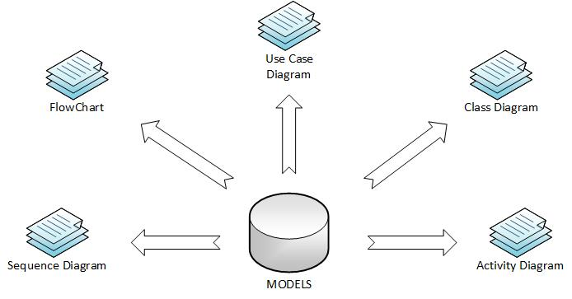

***Figure 1: A Model would be a complete description of a system***

***from a particular perspective****.*

* + An Actor would be someone or something that must interact with the system under development.
  + A use case would be a pattern of behavior the system exhibits that each use case is a sequence of related actions performed by an actor and the system in a dialogue. A flow of events document would be created for each use cases.
  + A use case diagram would present an outside view of the system.
  + A sequence diagram display would object interactions arranged in a time sequence.
  + A class diagram would show the existence of classes and their relationships in the logical view of a system.
  + An activity diagram would be a variant of state-chart diagrams organized

according to actions, and mainly targeted towards representing the internal behavior of a method.

3.1 Events

3.1.1 User

- watch movies online, download movies

- Search for movies by name and genre

- Log in and register

- Comment and rating

- Choose your favorite movies to list

- Edit user information

3.1.2 Admin

In addition to using the user functions, Amin has the ability to:

- Upload the movie to the server as well as the movie information onto the system

- Manage users and user comments

- Reply, reply to user comments, comments

- Add ads to make a profit for the site

3.1.3 description the user’s activity on web

- If the user has not yet registered, the user can only access the website to view basic movies and search for movies

- The website will provide registration service for those who do not have an account: Here users only need to create a username, password and fill in personal information and mail to confirm. The site's terms then press the register button

-When the user has an account, the user can log in to the system: Here the user will be provided with additional functions such as commenting, feedback, downloading movies and adding his favorite movies to the movie list. In addition, users can also change and manage their personal information.

3.1.4 description the admin's activity on web

- Admin will have a private login page to the management system. After logging in, the admin will have access to the database as well as the movie and user management page (user).

- admin will be granted the right to upload movies or edit movie information on the movie management page

- admin has the right to respond and manage user comments

- If the user violates the terms of the page will be deleted account email account will not be banned from registration

3.2 Actor

**- Guests:** are who able to interact with the system without register, guests have the same interaction rights as members except for comments and ratings

**- Members**: interact with system as a official member, members have the right to use the functions allowed in the site

**- Admin:** is who able to interact with the system as a manager, the admin has access to the web server, use, query functions in the system

3.3 Flow chart

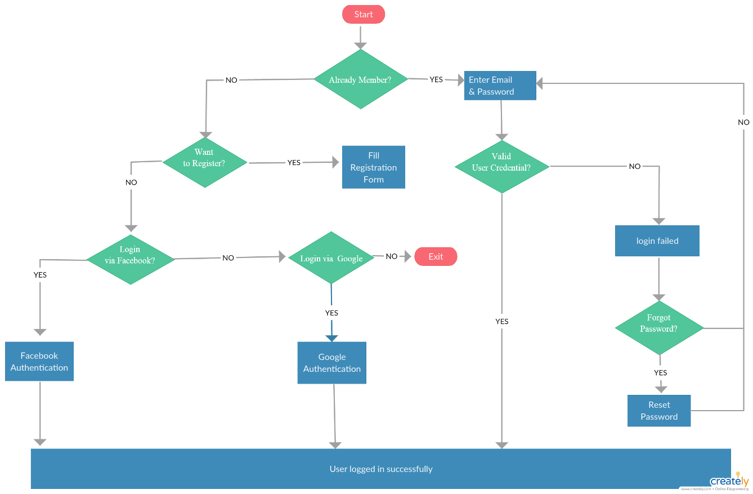

***Figure 2: The flow chart of registration process***

3.4 Use case detailed description

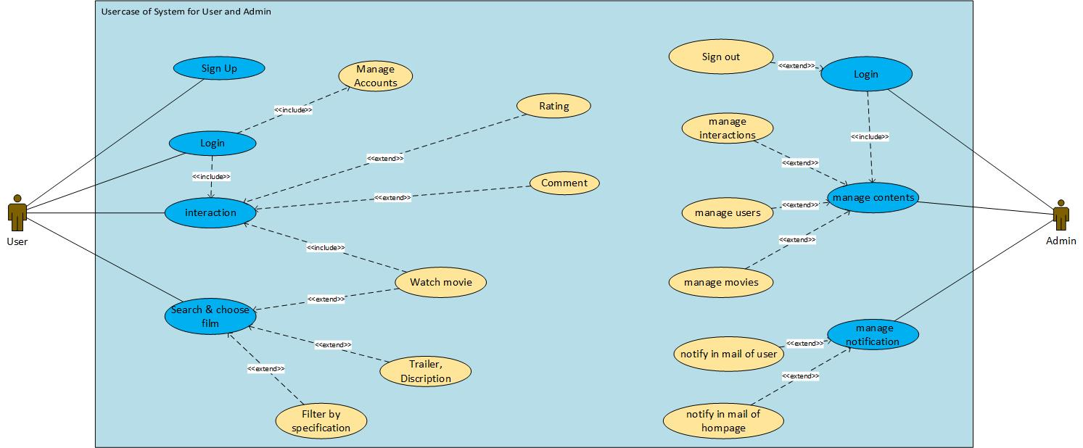

***Figure 3: The use case diagram of “ Watching movie website”***

3.5 List of use case

* **Register:** Guest can create account to have full access to interact with system by select interface “register”, after that fill the information form to create new account
* **Login:** Member login to interact with system by select interface “log in” and fill the username, password.
* **Forgot password:** Sometime users may be forgot their password, users just click “Forgot password” button on screen, the system interface will show place to write their mail, and get their password back when their mail is true.
* **Account management:** Members after logging in have the right to update personal information changes
* **Search & choose film:** Essential steps to watching movies
* **Movie interaction:** Member after login can interact with movie through select and text to interaction form or rating star for movie
* **Webserver Login:** The function can only be used by administrators, by logging in to the domain\admin, managers can log into the webserver to manage data.
* **Film management:** function of the management system, the manager after logging into the system has the right to add, delete, update film, change information, add trailer, …
* **Interaction management:** function of the management system, the manager after logging into the system has the right to manage manage user interaction with the movies.
* **User management:** function of the management system, the manager after logging into the system has the right to manage user account, change, update, account banned,…
* **Manage Notification:** This function allows the admin to notify on the site as well as the user's mailbox

3.6 Use case detailed description

The following is to document by using “use case report” for the development in  
of future phases of developing a software system for watching movie website.

* **Use case description for user:**

3.6.1 Register

* **Description:**

This Use case allow for user register account

Actor is User

* **Flow of Events**

This use case will always appear on the homepage of the web

This use case will appear with the login usecase

1. Basic Flows:

The user will access the site's registration page

1. Alternative Flows:

There is no alternative flows for this use case.

* **Special Requirement**

Some information of User need to confirm by phone number

* **Preconditions**

There is no preconditions for this use case.

* **Post-Conditions**

User logined and use functions for users who have an account

* **Extension points**

User information will be stored in the database

3.6.2 login

* **Description:**

This Use case allow for user login

Actor is User

* **Flow of Events**

This use case will always appear on the homepage of the web

This use case will appear with when user want to rating or comment

1. Basic Flows:

The user will access the site's login page

1. Alternative Flows:

- There is no alternative flows for this use case.

* **Special Requirement**

There is no special requirement for this use case.

* **Preconditions**

User must have registered

* **Post-Conditions**

User can login and use functions for users who have an account(comment,rating,add favorite movie)

* **Extension points**

User information will be checked in the database

3.6.3 Search & choose film

* Description:

This Use case allow for user search and choose movie

Actor is User

* Flow of Events

This use case will always appear on the homepage of the web

This use case will appear with when user want to find or choose movie to watch

1. Basic Flows:

The user will function of web.There is search and choose movie

User can find by key word or by category

1. Alternative Flows:

- There is no alternative flows for this use case.

* Special Requirement

There is no special requirement for this use case.

* **Preconditions**

There is no preconditions for this use case.

* **Post-Conditions**

User choose one movie and see more detail of movie

* Extension points

Movie and detail will be taken in database

3.6.4 Movie interaction

* Description:

This Use case allow for user interact with movie and make some feedback about web and movie

User can comment ,rating and add to farvorite list

Actor is User

* Flow of Events

This use case will always appear on page’s movie ,when user choose 1 movie

1. Basic Flows:

The user will use function of web.

1. Alternative Flows:

- There is no alternative flows for this use case.

* Special Requirement

There is no special requirement for this use case.

* Preconditions

User need to login to use these functions

* Post-Conditions

User comment,rating,add to favorite list…

* Extension points

Everything will be stored in database

Movie and detail will be taken in database

3.6.5 Manage account

* Description:

This usecase allow to user can manage,update and edit information

Actor is User

* Flow of Events

This use case will appear on page’s user manage ,when user login and want to edit account

1. Basic Flows:

The user will function of user.

1. Alternative Flows:

- There is no alternative flows for this use case.

* Special Requirement

Some information of User need to confirm by phone number

* Preconditions

User need to login to use this functions

* Post-Conditions

User updated user information and click on submit button

* Extension points

information will be stored in database

* **Use case description for Managers:**

3.6.6 Managers login

* Description:

This Use case allow for admin login

Actor is Admin

* Flow of Events

This use case only appear in page management of admin

1. Basic Flows:

The admin will access the site's login page

1. Alternative Flows:

- There is no alternative flows for this use case.

* Special Requirement

There is no special requirement for this use case.

* Preconditions

Admin must to have account

* Post-Conditions

Admin control and edit something in database of page if admin want

* Extension points

Admin information will be checked in the database

3.6.7 film management

* Description:

This Use case allow for admin manage everything of movie in database

Actor is Admin

* Flow of Events

This use case only appear in page management of admin

1. A,Basic Flows:

The admin will access the site's login page

Admin will use these function of management(add movie,update and delete movie)

1. B,Alternative Flows:

- There is no alternative flows for this use case.

* Special Requirement

There is no special requirement for this use case.

* Preconditions

Admin must to have account

* Post-Conditions

Admin edit or update something in database of movie page

* Extension points

Every action will be affect to database of web

3.6.8 interaction management

* Description:

This Use case allow for admin manage comment and feedback of user

Actor is Admin

* Flow of Events

This use case only appear in page management of admin

1. Basic Flows:

The admin will access the web page

Admin will use these function of management(reply comment)

1. Alternative Flows:

- There is no alternative flows for this use case.

* Special Requirement

There is no special requirement for this use case.

* Preconditions

Admin must to have account and login for admin

* Post-Conditions

Admin control and delete comment,feedback

* Extension points

Every action will be affect to database of web

3.6.9 User management

* Description:

This Use case allow for admin manage information of user

Actor is Admin

* Flow of Events

This use case only appear in page management of admin

1. Basic Flows:

The admin will access to database

Admin will use these function of management(delete,ban,search information of user)

1. Alternative Flows:

- There is no alternative flows for this use case.

* Special Requirement

There is no special requirement for this use case.

* Preconditions

Admin must to have account and login for admin

* Post-Conditions

Admin control and manage information of user

* Extension points

Every action will be affect to database of web and information of user

3.6.10 manage notification

* Description:

This Use case allow for admin manage and notify in mail of user or homepage

Actor is Admin

* Flow of Events

This use case only appear in page management of admin

1. Basic Flows:

The admin will access to database

Admin will use these function of management(delete,ban,search information of user)

1. Alternative Flows:

- There is no alternative flows for this use case.

* Special Requirement

There is no special requirement for this use case.

* Preconditions

Admin must to have account and login for admin

* Post-Conditions

Admin apply notification

* Extension points

Every action will be affect to database of web and information of user

3.7 Activity diagram

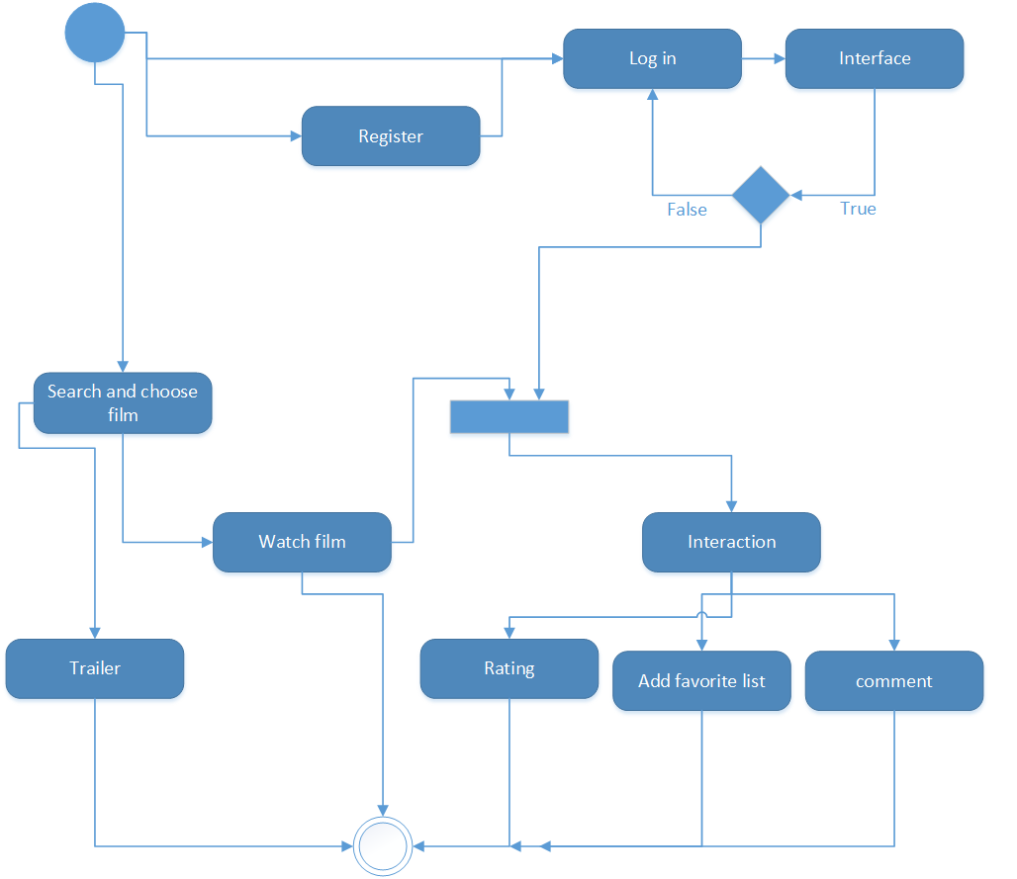

***Figure 4: The activity diagram of “watching movie website” show how user can interact with system***

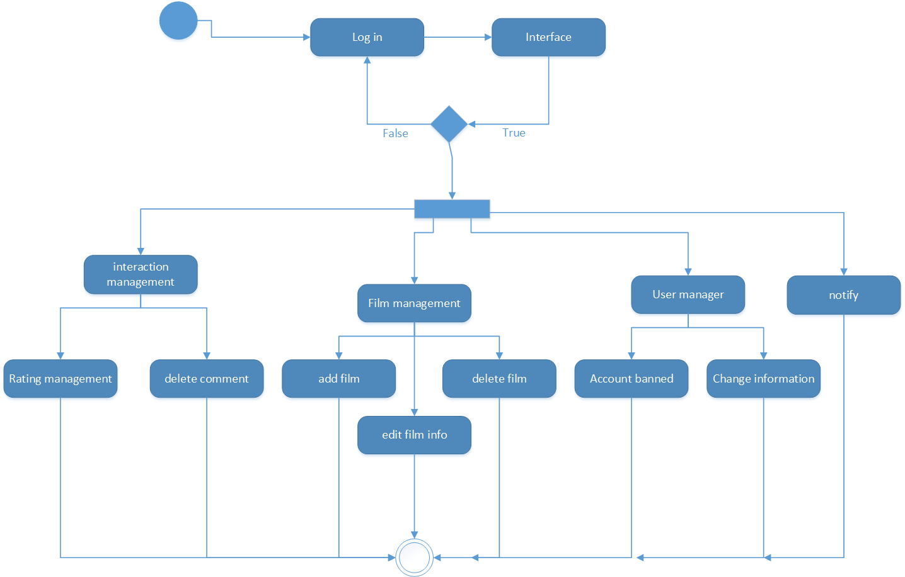

***Figure 5: The activity diagram of “watching movie website” show how managers can interact with system***

3.8 Class diagram

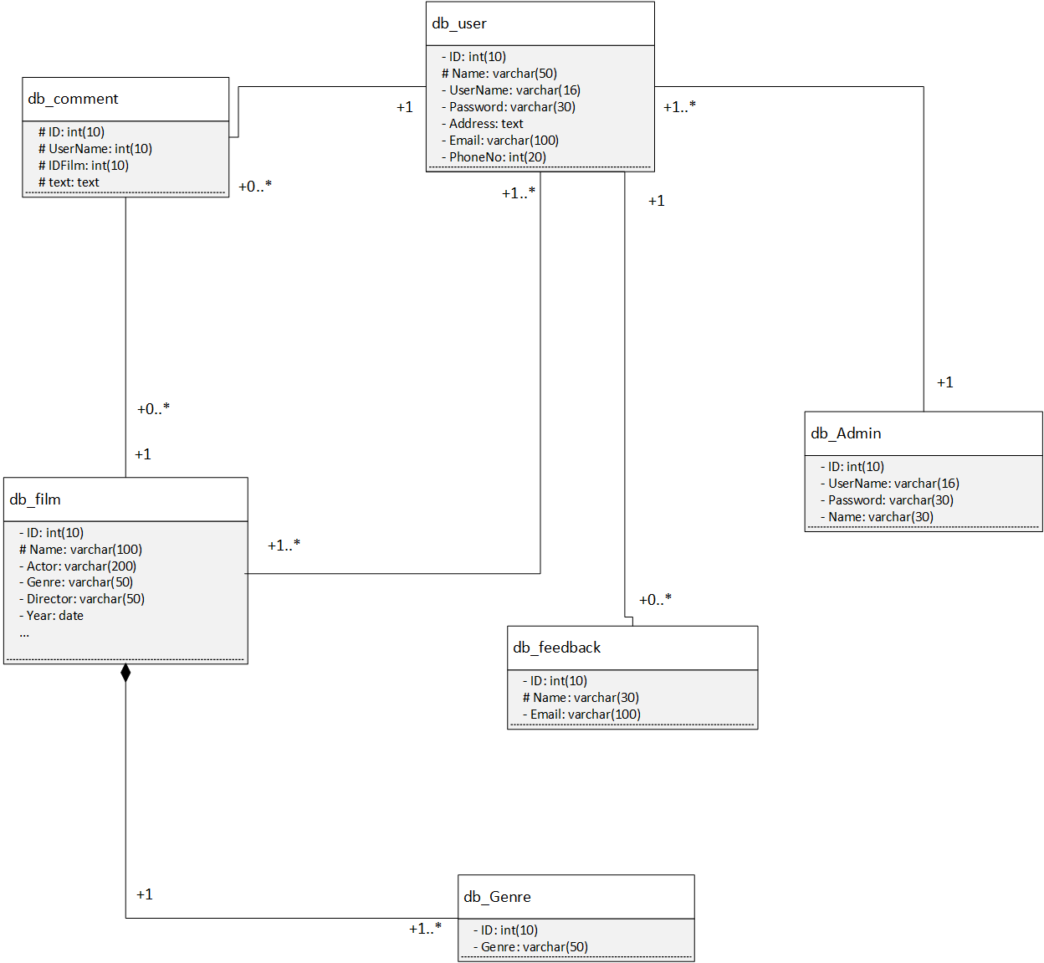

***Figure 6: The class diagram of “watching movie website” in analysis phase***

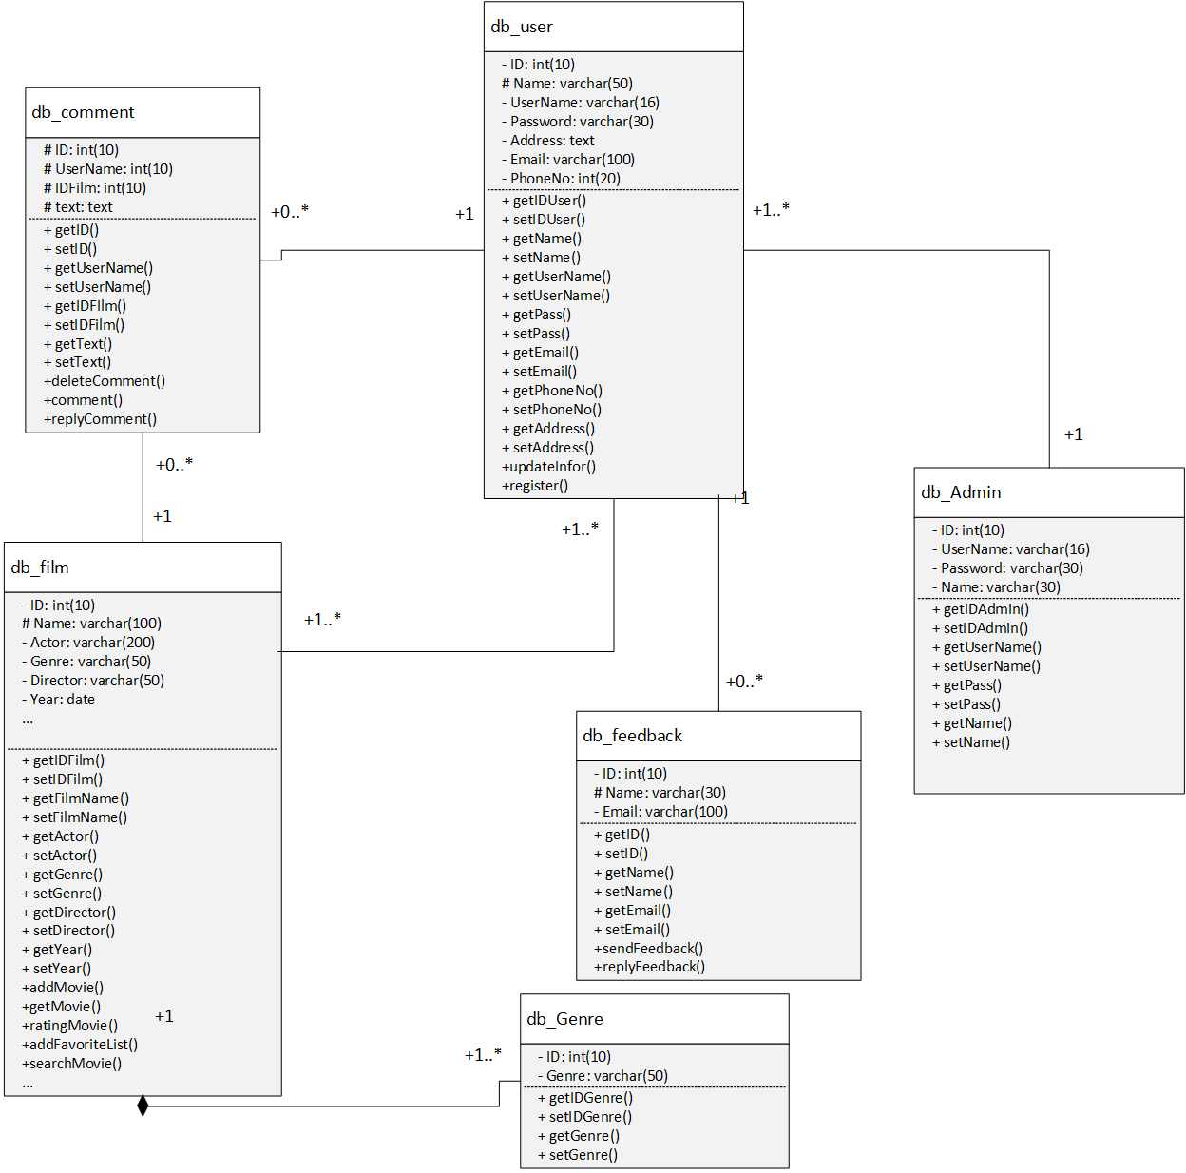

***Figure 7: The class diagram of “watching movie website” in design phase***

3.9 Sequence diagram

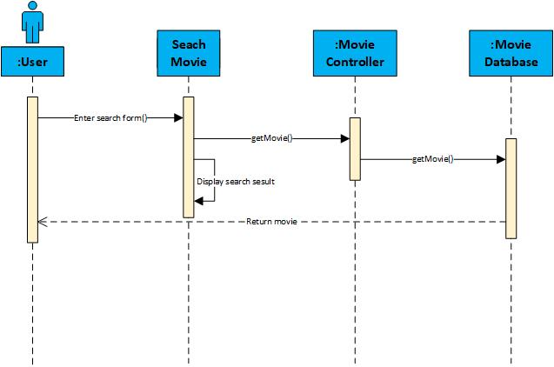

***Figure 7: The sequence diagram of “watching movie website” show how to search movies***

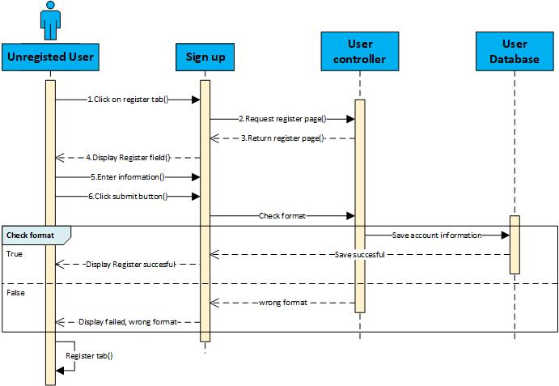

***Figure 8: The sequence diagram of “watching movie website” show how to register movies***

3.10 Collaboration diagram

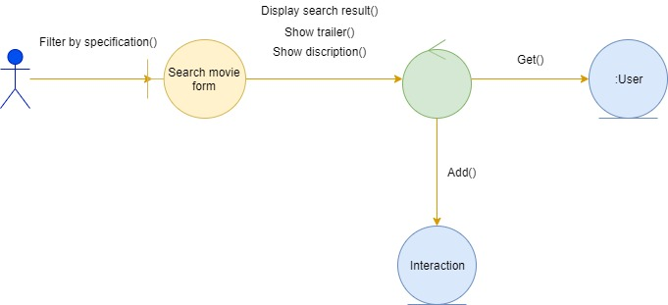

***Figure 9: The collaboration diagram for search and select movie***

CHAPTER 4 – IMPLEMENT

4.1 Homepage

## 

4.2 Website admin

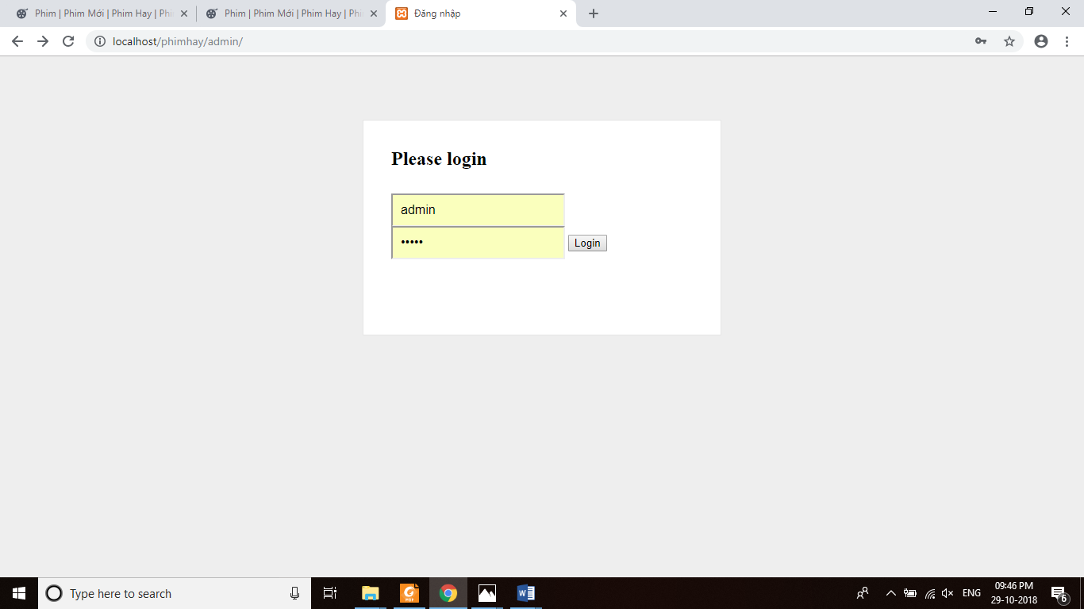

Picture4.1: Administration page login interface

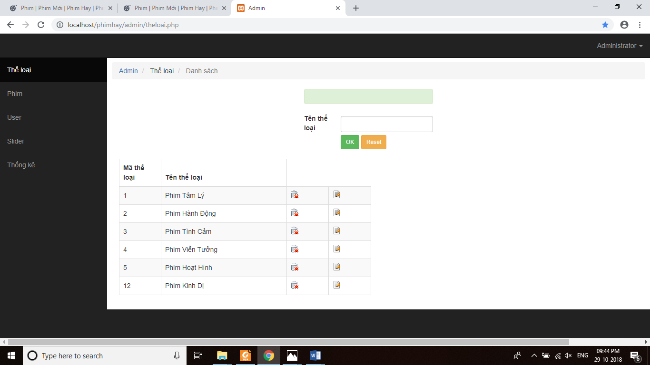

Picture4.2 Administration page interface

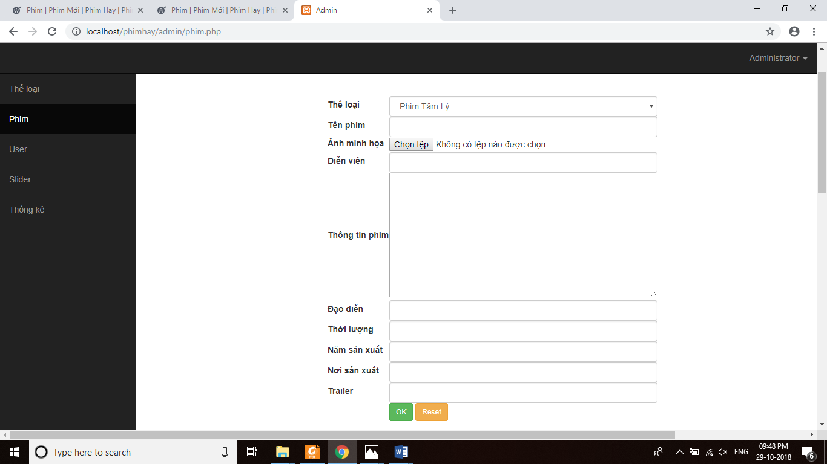

Picture 4.3:Movie posting interface

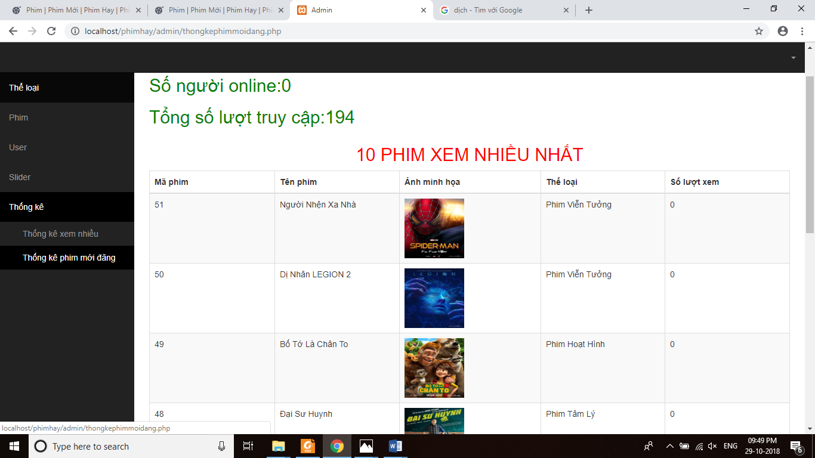

Picture 4.4: Interface for reporting movie statistics



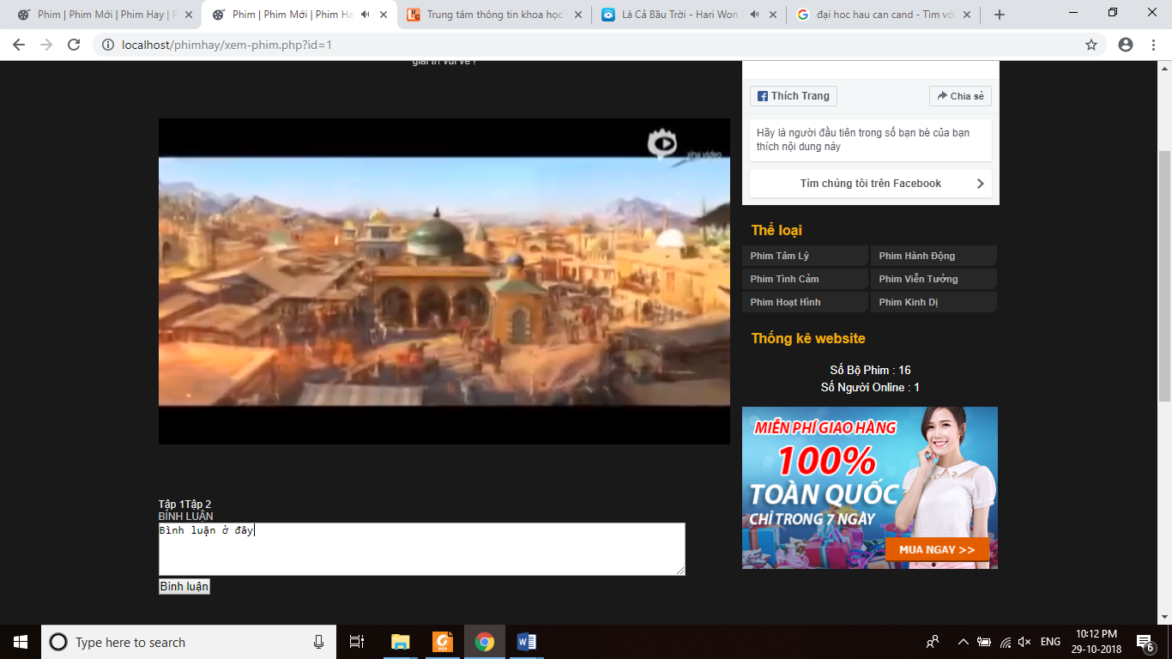 Picture 4.5: Movie information interface

Picture 4.6: Interface Comment

CHAPTER 5: CONCLUSION

5.1 Research results of the thematic

This system is just a functional process without complicated process so far.

The output product seems to satisfy all users but will certainly have to wait for.

However, the system still has many shortcomings, I hope everyone can support and comment on the system so we can improve it better.

REFERENCES

## Vietnamese

|  |  |
| --- | --- |
|  | Chu Đình Phú (2016), “*Lập trình cơ bản PHP và MySQL*”, Trường Đại học FPT. |
|  | Phạm Hữu Khang, Hoàng Đức Hải, “*Lập trình ứng dụng SQL server toàn tập*”, NXB Lao động Xã hội năm 2007*.* |
|  | Nguyễn Minh Thành (2013), *Giáo trình Cơ sở dữ liệu MySQL*, NXB Thành phố Hồ Chí Minh. |

## English

|  |  |
| --- | --- |
|  | Joel Murach, Ray Harris (2013), “*Murrach’s PHP and MySQL*”. |