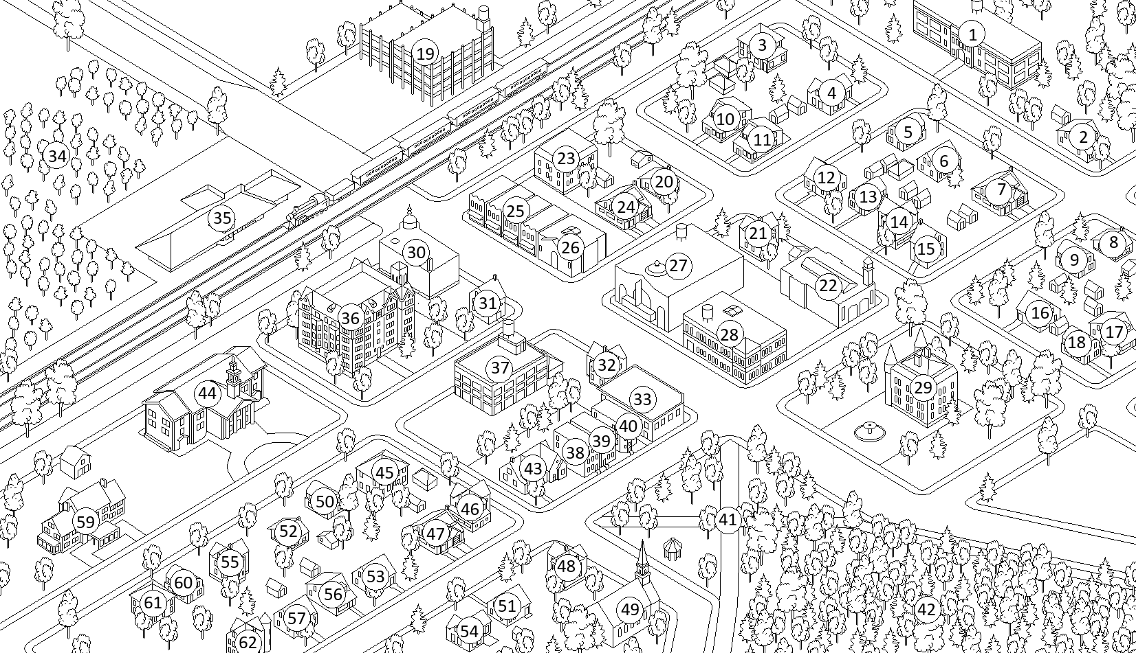

| **Number** | **Name** | **Var** |
| --- | --- | --- |
| 1 | exteriorHighschool |  |
| 2 | exterior2 |  |
| 3 | exterior3 |  |
| 4 | exterior4 |  |
| 5 | exterior5 |  |
| 6 | exterior6 |  |
| 7 | exterior7 |  |
| 8 | exterior8 |  |
| 9 | exterior9 |  |
| 10 | exterior10 |  |
| 11 | exterior11 |  |
| 12 | exterior12 |  |
| 13 | exterior13 |  |
| 14 | exterior14 |  |
| 15 | exterior15 |  |
| 16 | exterior16 |  |
| 17 | exterior17 |  |
| 18 | exterior18 |  |
| 19 | exteriorWarehouse |  |
| 20 | exterior19 |  |
| 21 | exterior20 |  |
| 22 | exteriorMosque |  |
| 23 | exterior21 |  |
| 24 | exterior22 |  |
| 25 | exteriorShops |  |
| 26 | exteriorNightclub |  |
| 27 | exteriorMall |  |
| 28 | exteriorWorkshop |  |
| 29 | exteriorCastel |  |
| 30 | exteriorMovieTheater |  |
| 31 | exterior23 |  |
| 32 | exterior24 |  |
| 33 | exteriorPoliceStation |  |
| 34 | vineyard |  |
| 35 | exteriorStation |  |
| 36 | exteriorPublicHousing |  |
| 37 | exteriorFactory |  |
| 38 | exterior25 |  |
| 39 | exterior26 |  |
| 40 | exterior27 |  |
| 41 | exteriorPark |  |
| 42 | forest |  |
| 43 | exterior |  |
| 44 | exteriorTownHall |  |
| 45 | exterior28 |  |
| 46 | exterior29 |  |
| 47 | exterior30 |  |
| 48 | exterior31 |  |
| 49 | exteriorChurch |  |
| 50 | exterior32 |  |
| 51 | exterior33 |  |
| 52 | exterior34 |  |
| 53 | exterior35 |  |
| 54 | exterior36 |  |
| 55 | exterior37 |  |
| 56 | exterior38 |  |
| 57 | exterior39 |  |
| 58 |  |  |
| 59 | exteriorHospital |  |
| 60 | exterior40 |  |
| 61 | exterior41 |  |
| 62 | exterior42 |  |