BattleTech World Editor

New Additions
Keys
Raise camera Page Up
Lower camera Page Down
Rotate camera left Home
Rotate camera right End
Pitch camera forward -
Pitch camera back +
Increase draw distance W
Decrease draw distance Q
Raise sea level Insert
Lower sea level Delete

Object database
object types template
stats templates

Force list
deployment template

menu changes

Installation.
Overview
Getting Started
Navigation around the map.
Editing textures.
Modifying Heights
Changing Tile Attributes
Copying tile areas.
Creating Edge Brushes
Object DataBase
Loading Objects
Object Stats
Defining Zones.
Defining Creation Points
Defining Motion Paths

Installation.
Run the SETUP program in the WESETUP directory to install the world editor. This will also do a version check of any current installation of DirectX and install it if necessary. You should now be able to run the editor from the Start menu.

Overview
After executing the editor, you will be presented with a window containing four pains. The four pains are as follows:

Top Left 3D View.
Top Right Object database ( not implemented ).
Bottom Left 2D View.
Bottom Right Texture selection.

3D View.
This view gives a true 3D view of the terrain, from this view you can paint textures onto and modify the height of the terrain to create hills, mountains, ravines etc.

2D View.
This view gives a top down 2D view of the world. From this view you can paint textures and copy and paste areas.

Texture View.
This view displays the currently loaded textures with the currently selected texture highlighted and is used for selecting which texture to use when painting , filling etc.

Object Database View.
(Not Implemented)

Getting Started
Creating a new world.
Select NEW from the FILE menu. This creates a new project ready for you to work with.

Setting the map size.
Select MAP PREFERENCES in the MAP menu. In the width field enter the width of the map in tiles, in the height field enter the height of the map in tiles i.e. 128 and 128. In the Grid spacing field enter the size of a tile i.e. 256 which will give a tile size of 256 by 256 units.

Loading a texture set.
Select ADD TEXTURES in the TEXTURE menu. A file selector will appear, select the bitmap that contains the textures you want to use and click OK. Note that currently only one texture set can be loaded at any one time. The program will now cut the textures out of the bitmap and place them in the texture view window. The default size of a texture is 64 by 64 pixels. If your textures are a different size then select TEXTURE PREFERENCES in the TEXTURE menu. Enter the correct width and height of the textures in pixels and click on OK.

NOTE. Textures must be laid out sequentially in a bitmap running left to right and top to bottom. The bitmap should be a 256 colour PCX format file.

Loading a height map.
To speed up the creation of landscape you can create a 256 colour grey scale image in an art package such as Paint Shop Pro and import it into the editor. To do this select LOAD HEIGHT MAP in the MAP menu. A file selector will appear, select the bitmap that you want to use and click OK. The editor will use the colour of each pixel in the image to calculate the height at each location in the landscape with black being the lowest and white being the highest. In order for this to work the grey scale image must be the same size as the map. So, if the map is 128 by 128 tiles in size then the grey scale image must be 128 by 128 pixels in size. The grey scale image should also be in PCX format.

Setting height scaling.
Heights are always stored internally as a value between 0 and 256 so in order to provide for a more varied range you can set a scaling factor which will be used for rendering. To do this select HEIGHT SCALING in the MAP menu, enter a scaling factor and click on OK, all heights will now be multiplied by this value.

Saving the world.
Select SAVE or SAVE AS in the FILE menu.

Loading an existing world.
Select OPEN in the FILE menu.

Navigation around the map.
Navigating in the 3D view.
There are two ways to navigate in the 3D view.

With the camera.
Hold down shift and the left mouse button, now move the mouse. This changes the camera viewing axis. Hold down shift and the right mouse button, now move the mouse up or down. Moving the mouse up moves you forward along the camera’s viewing axis. Moving the mouse down moves you backward along the viewing axis.

With the satellite view.
In the top left of the 3D view there is a scaled 2D map of the world as might be seen from a satellite, you can position yourself anywhere in the world by moving the mouse into this area and pressing the left button.

Navigating in the 2D view.
There are two ways to navigate in the 2D view.

With the scroll bars.
Use the mouse to reposition the windows scroll bars and hence the position in the world.

With the satellite view.
In the top left of the 2D view there is a scaled 2D map of the world similar to that in the 3D view. You can position yourself anywhere in the world by moving the mouse into this area and pressing the left button.

Editing textures.
Selecting the current texture.
Move the mouse pointer into the texture view and click on the texture you want to paint with.

There are a number of tools used for specifying which texture is used on which tile as follows. These tools can used in either the 2D or 3D views.

Get Texture.
Click on the Get Texture tool in the tool bar and then right click on a tile in the map. The texture for that tile will now become the current texture for painting.

Paint Texture.
Click on the Paint Texture tool in the tool bar. You can now paint with the currently selected texture in the map by clicking or holding down the left mouse button.

Fill Texture.
Click on the Fill Texture tool in the tool bar. You can now use the currently selected texture to perform a flood fill in the map.

Paint With Edges.
This tool allows you to paint a texture such as rock and automaticly paint the edge transitions as well. For this to work you must have created an edge brush. See the section on Defining Edge Brushes. To select which edge brush to use, select Edge Brushes in the view menu. now click on the left and right arrows in the edge brush view to select the crush you want. click on the small of large circle to select the size of the brush, these settings will now be used when ever you paint with the Paint With Edges tool.

Modifying Heights
The following tools can be used for modifying the geometry of the landscape. These tools can only be used in the 3D view.

Get Height.
Click on the Get Height tool in the tool bar. Now click on a vertex in the 3D view. The height of that vertex will now become the current height for painting.

Paint Height.
Click on the Paint Height tool in the tool bar. You can now paint with the currently selected height by clicking or holding down the left mouse button.

Drag Height.
Click on the Drag Height tool in the tool bar. Now click on a vertex in the 3D view and hold down the left mouse button and move the mouse up or down to modify the height of the vertex.

Changing Tile Attributes

Set Triangle Direction 1 and Set Triangle Direction 2.
Click on these tools to set the direction of the triangles within a tile.

Show Tile and Hide Tile.
Click on these tools to enable or dissable the drawing of certain tiles. This is usefull in reducing sorting artifacts by turning of drawing of tiles which would be hidded by an object such as a building.

Copying tile areas.
The following tools allow you to copy and paste areas of the map. These tools can only be used in the 2D view.

Define Copy Rectangle.
Click on the Define Copy Rectangle tool in the tool bar. Now click on one corner of the area in the 2D view you wish to copy and hold down the mouse button, now move the mouse to the opposite corner of the area you wish to copy and release the mouse button. The specified area has now been copied to the copy buffer.

Paste Textures.
After defining a copy rectangle click on the Paste Textures tool in the tool bar. Now click on the 2D view at the position you wish to paste. The textures will be copied to the map but not the geometry.

Paste Heights.
After defining a copy rectangle click on the Paste Heights tool in the tool bar. Now click on the 2D view at the position you wish to paste. The geometry will be copied to the map but not the textures.

Paste All.
After defining a copy rectangle click on the Paste All tool in the tool bar. Now click on the 2D view at the position you wish to paste. The textures and geometry from the copy buffer will be copied to the map.

Creating Edge Brushes
Edge brushes greatly increase the textureing of landscapes involving transitions between textures ie grass to water , rock to snow etc. To use an edge brush you must first define the textures that it needs. To do this select Edge Brushes in the View menu and fill in the brush patterns by selecting a texture in the texture selection window and then clicking it in the edge brush view.

The patterns to be defined for a typical transition would appear as below:
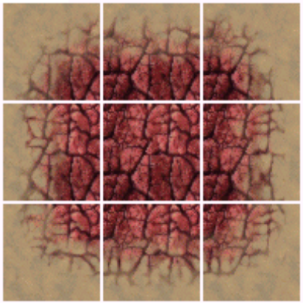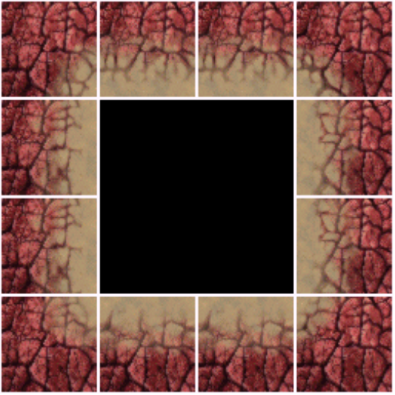
The main brush The inside corners
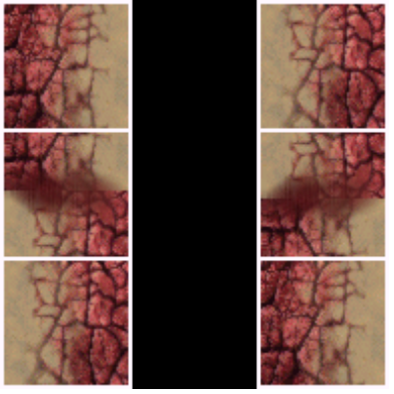
The diagonals

Up to 16 edge brushes may be defined in this way.

Object DataBase
The object database has a simple hierarchical structure. Each object type is loaded only once but can be instantiated many times. The database is displayed as a list in a window in the top right of the screen. The fields in the list are as follows:
Object Name - The name of the object, usually the filename.
Instances - The number of times the object is used in the world.
Flags - Not used at present.
Description - A brief description of the object, currently always says ‘3D Object’.

Loading Objects

To load an object into the database , select the Add Object item in the Objects menu and select the object file to load. The objects name will now appear in the object database window.

Place Object
To place the object in the world, click on it’s name in the database window, click on Place Object and click in the 2D view where you want the object to be placed. You can place as many instances of an object as you want but each object can only be loaded into the database once.
Moving Objects

Drag Object
To change an objects location in the world, click on the Drag Object tool in the tool bar. To change it’s position click on the object in the 2D world with the left mouse button and move the cursor while holding the button down. Release the button when finished. To change the altitude of an object click on it in the 3D view and move the cursor up and down while holding the left mouse button down. Release the button when finished. ( Note if gravity is enabled in the object snap options dialog then changing the objects position will snap it’s altitude to the landscape beneath it. )

Get Height
You can get the altitude of any vertex in a 3D model in and use it as the current height for painting landscape height. To do this click on the Get Height tool , now click on the vertex in the model whose height you want to use. This height will now become the current height got painting.

Rotate Object
To rotate an object, click on the rotate object tool in the tool bar, now click on the object to rotate in the 3D view , hold down the left mouse button and move the mouse to rotate. Currently you can only rotate about the Y-Axis of the object. The intervals for rotation are defined in the object snap options dialog.

Select Object
To Select an object , click on the Select Object tool in the toolbar ,move the cursor over the object in the 2D view and press the left mouse button. The objects bounding box will turn red to indicate that it is selected.

De-Select Object
To De-Select an object , click on the De-Select Object tool in the toolbar ,move the cursor over the object in the 2D view and press the left mouse button. The objects bounding box will turn white to indicate that it is no longer selected.

Select All
To select all objects in the world, click on Select All in the Objects menu.

De-Select All
To de-select all the objects in the world, click on De-Select All in the Objects menu.

Remove Selected
Cick on Remove Selected in the Objects menu to delete all selected objects from the world. ( Note. Deleting objects in this way only removes the instances from the world , the object remains in the database. To remove the object from the data base , click on it’s name in the database window and press DEL. )

Snap Preferences
To modify the snap preferences for positioning and rotating objects , select Snap Preferences in the Objects menu.
For positioning object one of the following options can be selected:
Custom - You can specify your own snap interval for X and Z.
No Snap - Snap is dissabled.
Tile Center - Objects are snaped to the center of the nearest tile.
Tile Top Left - Objects are snaped to the top left of the nearest tile.
Tile Top Right - Objects are snaped to the top right of the nearest tile.
Tile Bottom Left - Objects are snaped to the bottom left of the nearest tile.
Tile Bottom Right - Objects are snaped to the bottom right of the nearest tile.
To modify the interval for rotating objects , enter a value from 1 to 359 in the Angle Snap field.
To enable or dissable gravity when positioning objects tick or clear the Gravity Enabled option.

Object Stats
Currently each object and each instance of an object has a stats file attached to it. This file can be edited by right clicking on the object. If you right click on the name of the object in the database window then you can edit the stats for that object type. If you right click on the instance of an object in either the 2D or 3D views then you can edit the stats for that instance of an object. The Edit Stats dialog allows you to directly edit the stats , import a text file to use as the stats file and export the current stats to a text file.

Defining Zones.
(Not Implemented)

Defining Creation Points
(Not Implemented)

Defining Motion Paths
(Not Implemented)

