

**School for Computing and Informatics**

**Programming**

**Course: Programming**

Instructor: Dr. Jalal Kiswani

TA: Wasayef Ananzeh

**Assignment for Programming**:

1. Five points that explain Why Java is better than C.
2. Check that you install JDK version 1.8 for 64 bits.
3. Check that you install Eclipse 2019 -12-R.
4. Send screen shot of the version of installed java by using the CMD on your PC and type this command java -version

The previous requirements must be uploaded on our repository on GitHub; For simplicity, I want to explain the steps for that again:

1. On your Repository that you collaborate with me, copy the Https of this repo.

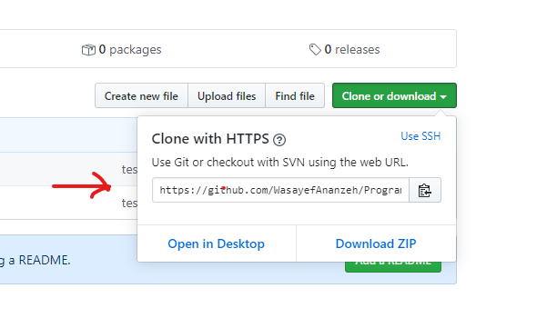

1. On your PC, on your directory like (D:), right click-choose from the choices- Git Clone,
2. new window will appear, you must paste the Https of the previous step on the URL bar.

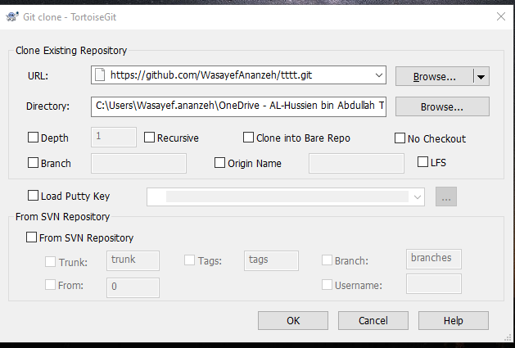

(the result of this step is new folder in D: with the same name of our repo).

1. The requirements, of any assignment, add it to .zip file which name with the (assignment-number of the assignment)
2. Copy this .rar to the file which is made in step c then right click on the added file and make this steps: 1- add 2- commit 3- push

