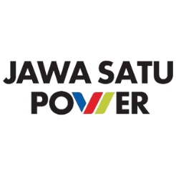
Aug 2024 - CRI2408P46-Rev 00
ASSET MANAGEMENT APPLICATION
DEVELOPMENT
FOR PT JAWA SATU POWER

Proprietary Notice

The information and data furnished in this document shall not be disclosed outside PT Jawa Satu Power (JSP) and shall not be duplicated, used or disclosed in whole or part for any purpose other than to evaluate this proposal; provided, that if a contract is awarded to this offer or as a result of or in connection with the submission of this information / data, JSP shall have the right to duplicate, use or disclose the information/data to the extent provided in the contract.
This restriction does not limit JSP right to use information contained in the proposal if it is obtained from another source without restriction.
The information contained herein is to be used by the recipient solely for the purpose for which it was supplied. It shall not be disclosed in whole or in part, by any other party without the written permission of CRI.
CRI shall not be liable for any damages which the assignor, or assignor’s clients, vendors, consultants or other third party, may incur as a result of applying or using the results of CRI’s work, unless there is misconduct or gross negligence on the part of CRI or on the part of the persons used by CRI to carry out the work.

Document Infor
Author(s) | Classification
Muslim Haqqon HN Sagala | Confidential

Title
ASSET MANAGEMENT APPLICATION FOR PT JAWA SATU POWER.

Extract
This proposal describes the technical aspects of Asset Management Application development for PT Jawa Satu Power. Commercial and technical aspects are discussed in this proposal.

Project Info
End User | Clients Ref.
PT Jawa Satu Power (JSP) | Novian Lisdi Wahyoto
CRI Project No | CRI Project Name
CRI2408P46-Rev 01 | Asset Management App JSP

Revision
Rev | Date | Author | Approved by | Description
01 | Sep 10th 2024 | Haqqon Sagala | Chandra Salim | After Discussion
00 | Aug 28th 2024 | Haqqon Sagala | Chandra Salim | 1st Submission

TABLE OF CONTENT
TABLE OF CONTENT 4
BACKGROUND 6
INTRODUCTION 7
I. SUMMARY 8
II. DURATION & COMMERCIAL 9
II.1 Work Duration & Schedule 9
II.2 Commercial 10
II.2.1 Terms & Conditions 10
II.2.2 Payment Schedule 10
III. CUSTOMISABLE APPLICATION 11
III.1 Application Appropriation and Analysis of Needs 12
III.2 Application Plan & Design 12
III.3 Plan & Design Implementation 13
III.4 Application’s Testing & Update 14
III.5 On-Site Installation & Usage Assistance 14
IV. ASSET MANAGEMENT DASHBOARD FOR JSP 15
IV.1 Integrity Status 15
IV.2 Asset Profile 16
IV.3 Production Profile 16
IV.4 Budget & Cost Profile 17
V. CRI ESTABLISHED APPLICATION 18
V.1 Overview 18
V.2 Global Business Flow 19
V.3 Mandatory and Optional Modules 20
V.4 Asset Management Modules 20
V.4.1 Dashboard 20
V.4.2 Asset Register 21
V.4.3 Equipment Criticality Analysis 24
V.4.4 SCE Identification 27
V.4.5 SCE Performance Standard 29
V.4.6 Failure Mode & Effect Analysis (FMEA) 30
V.4.7 Life Data Analysis 32
V.4.8 Reliability Block Diagram 35
V.4.9 Reliability Centered Maintenance (RCM) 40
V.4.10 Inspection, Testing, and Preventive Maintenance (ITPM) 42
V.4.11 Risk Based Inspection (RBI) 44
V.4.12 Corrosion Management 47
VI. RIGHTS AND RESPONSIBILITIES 51
VI.1 Rights 51
VI.2 Responsibilities 51
VII. QUALITY ASSURANCE 52
VII.1 Validity and Availability 52
VII.2 Contact 52
VIII. CRI EXPERIENCES 53

BACKGROUND
Power plant companies recognize the critical importance of digitalization in managing their assets. Within the context of maintenance and operations, the role of digital asset management cannot be overstated. The industry heavily relies on the reliability and availability of equipment to ensure seamless and safe production operations.
The strategic adoption of information technology is paramount for companies seeking to optimize operational efficiency, enhance reliability, and mitigate risks. By leveraging information technology, organizations gain convenience in managing various maintenance and operational activities. Real-time monitoring of equipment conditions, early detection systems to preempt production disruptions, and centralized data repositories all contribute to the wisdom of implementing digitalization programs, particularly within the power plant sector.
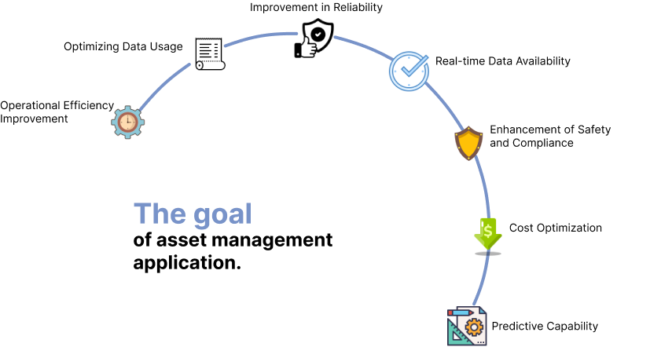
Figure 0-1 The Goal of Asset Management Application
The strategic adoption of digital technology empowers companies to continuously monitor equipment conditions in real-time. This capability facilitates maintenance teams in early detection of potential issues, enabling swift troubleshooting and efficient maintenance planning. Moreover, digital technology supports in-depth analysis of equipment performance, allowing management to make precise decisions regarding maintenance schedules and equipment replacement. Consequently, leveraging digital technology enhances reliability, security, regulatory compliance, and cost efficiency—all critical factors for the sustainability and success of oil and gas operations.

INTRODUCTION
PT Cliste Rekayasa Indonesia (CRI) has made a proposal for asset management application offerings for PT Jawa Satu Power (JSP), which is expected to address the issues or problems currently faced by JSP.
PT Jawa Satu Power (JSP) or Jawa-1 Project is a joint venture between PT Pertamina Power Indonesia (“PPI”), Garuda Power Holdings B.V., and Sojitz Global Investment B.V. On December 5, 2016, the Company was founded as a Special Purpose Company (SPC) to run, control, and manage assets and business activities of gas-fired power plants with the largest CCGT technology in Southeast Asia.
In running its operations, the Company engages with more than 20 companies around the world, including Japan, Korea, the United States, Europe, and Indonesia. These companies include 3 (three) main EPC consortium members and 2 (two) joint venture members in FSRU, namely PT Jawa Satu Regas, 3 (three) funding companies namely JBIC, NEXI, and ADB, as well as 5 (five) commercial banks, namely Mizuho Bank, MUFG Bank, Société Générale Bank, OCBC Bank, and Credit Agricole Bank, including several consultants in financial, legal, and technical fields.
The Company manages the Jawa-1 project with a high complexity scheme due to a complete power plant construction with pre-facilities needed, 52 km-length transmission, and a main substation. In addition, the project is an integration between the power plant and FSRU.

SUMMARY
Summary of this proposal are:
- This proposal explains the development of new web-based asset management application for PT Jawa Satu Power.
- The step of developing new application in summary are (See Chapter III for details):
- The detailed tasks for the App Appropriation & Analysis of Needs phase are as follows:
- Defining needs
- Create scope and boundary of work
- The detailed tasks for the App Plan & Design phase are as follows:
- UML Design
- Database planning and design
- UI and UX design
- The detailed tasks for the Plan & Design Implementation phase are as follows:
- API development and implementation
- Front-End implementation
- Back-End implementation
- And the detailed tasks for the App Testing & Update phase are as follows:
- End to end testing
- User acceptance testing
- Performance testing
- Security testing
- The Duration & Commercial information in this proposal is to develop Asset Management web-based Application. See Chapter II.1.
- The modules that will be provided in the application are as follow:
- Dashboard (section V.4.1)
- Asset Register (Mandatory) (section V.4.2)
- Equipment Criticality Analysis (section V.4.3)
- SECE Identification (section V.4.4)
- SECE Performance Standard (section V.4.5)
- Failure Mode & Effect Analysis (FMEA) (section V.4.6)
- Life Data Analysis (section V.4.7)
- Reliability Block Diagram (section V.4.8)
- Reliability Centered Maintenance (RCM) (section V.4.9)
- Inspection, Testing, and Preventive Maintenance (ITPM) (section V.4.10)
- Risk Based Inspection (RBI) (section V.4.11)
- Corrosion Management (section V.4.12)
- CRI developed Application is come with build-in Application Programming Interface (API) feature, this feature is to ensure communication compatibility to other application.
- The proposal deliverable duration is 3 months and covers 1 month of warranty period after User Acceptance Test (UAT).
- The Warranty period id to cover minor update and eliminate any bugs.
- Other information included in this proposal are:
- Concept of JSP Asset Management Dashboard development. See Chapter IV.
- Brief of CRI established CMMS application (C-TRUST). See Chapter V.

DURATION & COMMERCIAL

Work Duration & Schedule
The project duration will be influenced by the specific needs of JSP. The timeline shown in Figure II-1 outlines the development schedule for the asset management web-based application, assuming that the modifications required for each module remain at a moderate level.

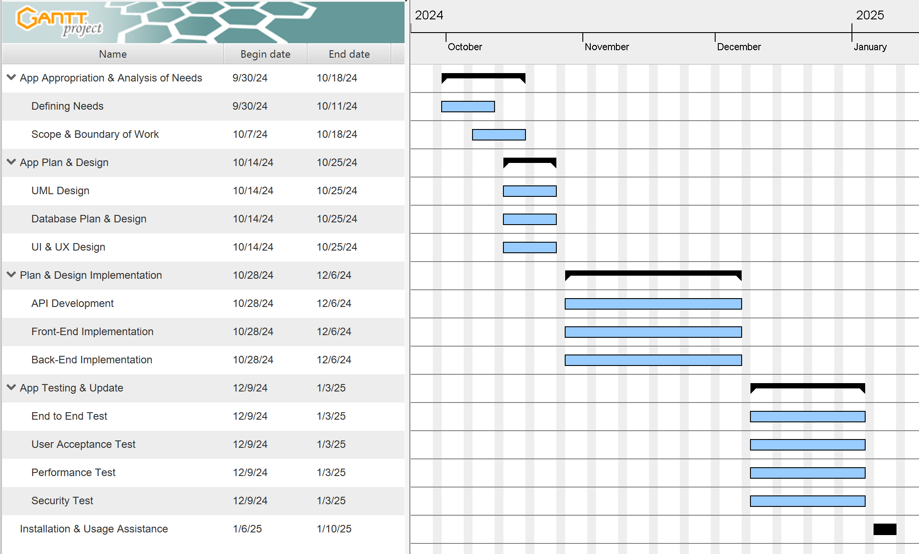
Figure II-1 Asset Management App Development Timeline

Commercial
Cost of developing Asset Management web-based Application is defined in Table II-1 below.
Table II-1 Maintenance Strategy Review and Development Cost
NO | DETAILS | QTY | UNIT | UNIT PRICE (IDR) | TOTAL  (IDR)
1 | Dashboard Module | 1 | LumpSum
2 | Asset Register Module | 1 | LumpSum
3 | Equipment Criticality Analysis Module | 1 | LumpSum
4 | SECE Identification Module | 1 | LumpSum
5 | SECE Performance Standard Module | 1 | LumpSum
6 | Failure Mode & Effect Analysis Module | 1 | LumpSum
7 | Life Data Analysis Module | 1 | LumpSum
8 | Reliability Block Diagram Module | 1 | LumpSum
9 | Reliability Centered Maintenance Module | 1 | LumpSum
10 | ITPM Module | 1 | LumpSum
11 | Risk Based Inspection Module | 1 | LumpSum
12 | Corrosion Management Module | 1 | LumpSum
SUB-TOTAL
VAT (PPN 11%)
GRAND-TOTAL
In Words : Rupiahs only ====
Note :
- The price above is for Development of Asset Management Web-Based Application.

Terms & Conditions
- Additional work not previously outlined in the proposal will be defined based on CRI’s Change Order (CO) system. No additional work will be initiated before a CO is agreed between CRI and the Client.
- The indicative time schedule provided assumes that all the required information is made available to CRI in time.
- The total costs for each analysis included presentation / meeting online for Kick-off meeting and preliminary result.
- Short casual meetings between Client online, Client’s Jakarta office and at CRI’s office are at no charge.
- Invoices will be issued based on progress detailed in the payment schedule.
- The price in the table above includes Withholding tax (PPh 23) and exclude Value Added Tax (PPN 11%).
- All activities will be conducted in Jakarta.
- Any covered required activities to be performed outside Jakarta is at JSP office Karawang. Other may incur fair cost.

Payment Schedule
Payment conditions are net and to be paid as per progress of each Scope of Work:
- Term I – 40% of Contract Value;
After Application Plan & Design (UI/UX) is approved.
- Term II – 55% of Contract Value;
After approval of User Acceptance Test (UAT).
- Term III – 5% of Contract Value;
After warranty period end.
Note:
Contract Value is the Total Value of all scope in the Table II-1

CUSTOMISABLE APPLICATION
Addressing the challenges faced by numerous industries in managing extensive assets and striving for excellence in process safety, operational reliability and data security, CRI offers customizable application development solutions.
CRI offers a customizable web-based application with several key capabilities:
- Compliance with International Standards
CRI provides a robust application built on standardized methodologies, ensuring versatility and applicability to various business needs. Our application complies with the following standards: API 691, ISO 14224, BS EN IEC 60812, IEC 61703, SAE JA 1011, SAE JA 1012, API 580, and EN 61078.
- Integration with Company Active Directory
CRI application seamlessly integrates with the client’s Active Directory system, simplifying user management and enhancing security.
- Advanced Security Layers
In addition to login passwords, the CRI application features JSON Web Token (JWT) authentication, Multi-Factor Authentication (MFA), and Single Sign-On (SSO) to ensure comprehensive database security.
- Customizable Monitoring Dashboard
Our application offers a fully customizable monitoring dashboard tailored to meet the specific needs of each client.
- Efficient User Management
CRI application includes a powerful and user-friendly management system, streamlining user administration.
- Detailed History Log Sheet
The application maintains a comprehensive history log for each user, with the capability to retrieve files referenced within a specified time frame.
- Accessible from anywhere
CRI application is a web-based application that means accessibility from any internet connected area.
- Data connectivity
The application maintains data interconnectivity between each module, as well as communication to other application via Application Programming Interface (API).
To enhance these core capabilities, CRI emphasizes a collaborative approach with users to ensure robust application development as defined in next Sub-Chapters. Along with the modules we have already developed, we also offer the option to create new modules tailored to your specific needs. However, please note that developing a new module may require more time compared to modifying existing ones.
The development of Asset Management Application will take approximately 3 months, with the time allocated for each phase as follows:

Application Appropriation and Analysis of Needs
The objective of application appropriation and analysis of needs is to ensure that the application workflow and user interface are developed based on the ease of actual procedure and needs.
The methodology used in this stage is described in the flowchart below:
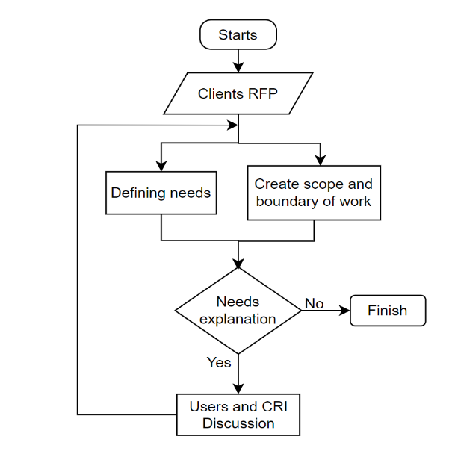
Figure III-1 Methodology for Application Appropriation and Analysis of Needs
At this stage, we will collaborate with JSP to formulate the requirements and establish the boundaries of the application's capabilities. This phase involves defining the module's constraints, identifying the necessary features, and outlining the methodology or workflow for the module's development. JSP's involvement is crucial in achieving a shared understanding of these aspects, and their willingness to provide explanations to clarify any matters that require further discussion will be essential.
The expected duration for this phase is three (3) weeks. The timeline may be shortened if you already have a methodology for the work or the module to be developed

Application Plan & Design
The objective of application plan and design is to meet user needs, to simplify user access and management of their data. The application is anticipated to operate within a web-based system. The application also shall have an ability to communicate with other applications, as well as be capable of future development.
The methodology used in this stage is described in the flowchart below:
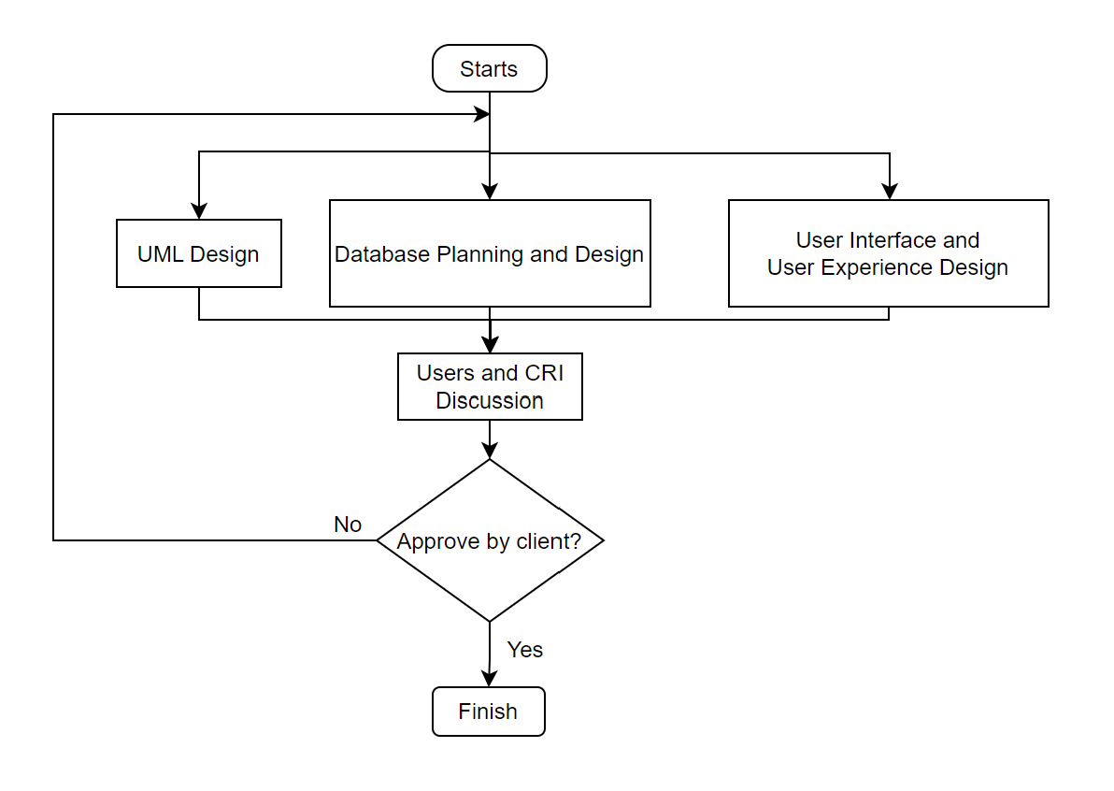
Figure III-2 Methodology for Application Plan & Design
At this stage, the application development planning, UML design, UI, and UX designs that have been created will be evaluated by JSP. This process aims to determine the planning for application development, UML design, and interface design planning to be implemented in the application. The results of this design plan require approval from JSP to proceed to the next stage. At this stage, scheduled meetings and discussions to facilitate this work progress can be arranged.
The expected duration for the Plan and Design phase is two (2) weeks, following the completion of the App Appropriation and Analysis of Needs phase.

Plan & Design Implementation
The objective of Plan & Design Implementation is to follow the plan and application design to develop the application that was previously initiated in the earlier stage. In this stage, the integration between the front end and back end is also performed, resulting in an application ready for testing.
The methodology used in this stage is described in the flowchart below:
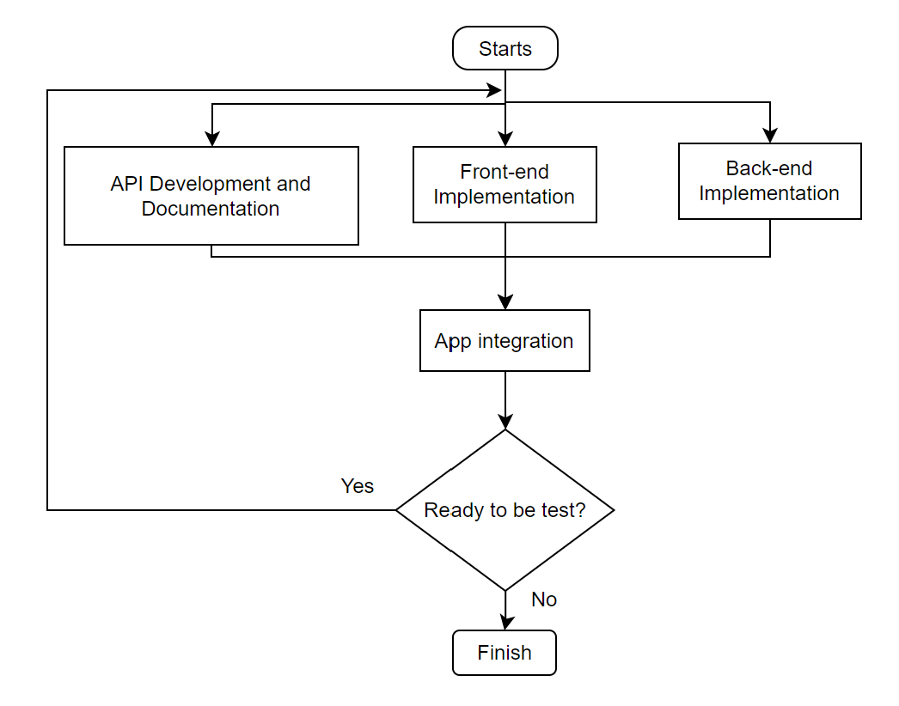
Figure III-3 Methodology for Plan & Design Implementation
At this stage, CRI will develop the application according to the previously established plan. Once the application is completed, it can be presented to JSP for feedback and evaluation. When the application meets the requirements, it can be prepared for testing in the next phase.
The expected duration for this phase is approximately six (6) weeks, starting after the completion of the Application Plan and Design phase.

Application’s Testing & Update
The objective of app testing is to make sure the development of the application has been following the design as client and IT developer discussed.
The methodology used in this stage is described in the flowchart below:
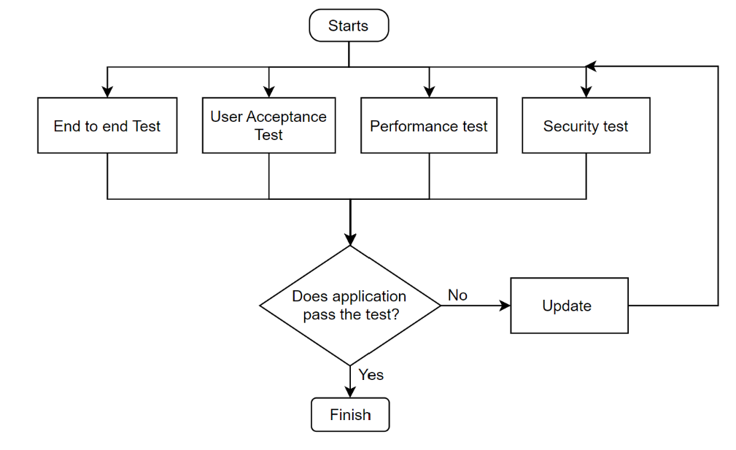
Figure III-4 Methodology for Application's Testing & Update
In this stage, the application undergoes four categories of testing: end-to-end testing, user acceptance testing, performance testing, and last but not least, security testing. These four tests are conducted simultaneously to ensure testing efficiency. If the application fails during the testing process, debugging and application improvement will be carried out as part of the application updating process.
The expected duration for this phase is four (4) weeks, following the completion of the Plan & Design Implementation phase.

On-Site Installation & Usage Assistance
The objective of on-site installation & usage assistance is to make sure that the user (client, helpdesk, coordinator, and technician) of the application will have the same understanding and skill.
In this stage, CRI will assist in the installation of the completed application. The application will be adapted to the existing environment on JSP’s devices. Additionally, user guidance services for the application will also be provided by CRI. This assistance program will conduct by online meetings and shall be attended by all users that is on site.
The expected duration for this phase is one (1) week, following the completion of the Application Testing & Update phase.

ASSET MANAGEMENT DASHBOARD FOR JSP
Based on the discussion or mini-workshop with the JSP on Tuesday, August 6, 2024, CRI specially developed a mockup for the application dashboard designed to meet JSP's needs. The information displayed on the dashboard is a summary of various tasks, such as RCM, RBI, anomaly management, and others.
Please note that the mockup we have created is a preliminary representation of what we believe JSP may require. JSP is welcome to request the addition of information as needed. All aspects, including the layout, color scheme, types of graphs used, and other elements, can be fully customized according to your needs.
Below is the mockup of the dashboard we have developed, which includes information such as:

Integrity Status
On the integrity status section of the dashboard, a summary of the results from tasks such as RCM and RBI will be displayed. The information includes summaries of critical and risk equipment, anomaly equipment categorization, total maintenance for preventive and corrective actions, inspection interval summaries, and equipment SIL grouping summaries. Once again, it's important to emphasize that what we have developed is a general overview and can still be customized according to your needs.
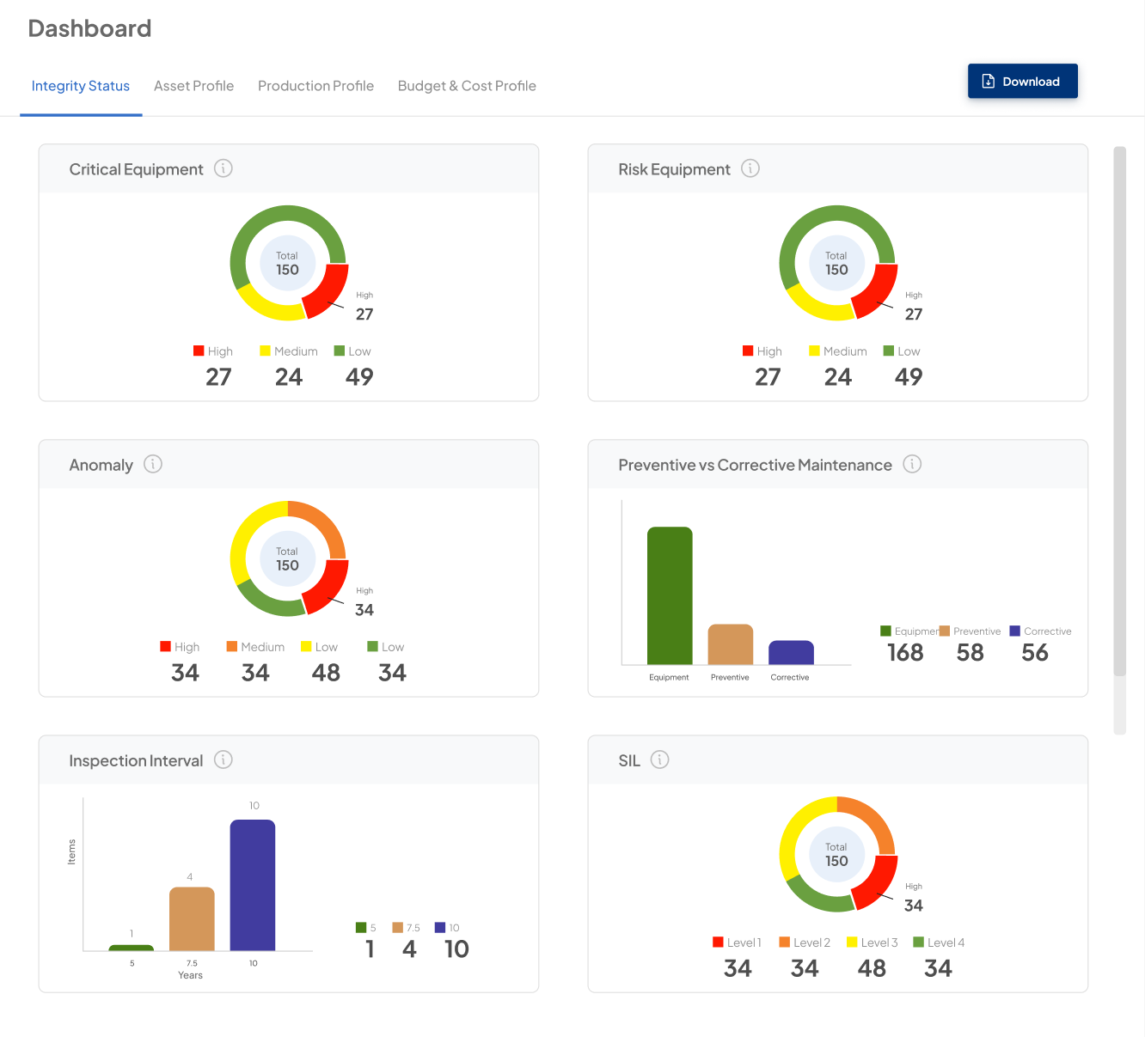
Figure IV-1 Asset integrity dashboard

Asset Profile
On the asset profile section of the dashboard, a summary of the assets JSP own will be displayed. This may include information such as the total amount of equipment for each type, the total number of ready to operate equipment, the total equipment that requires inspection, and more. Both the information presented and the dashboard's appearance can be customized to meet your specific needs.
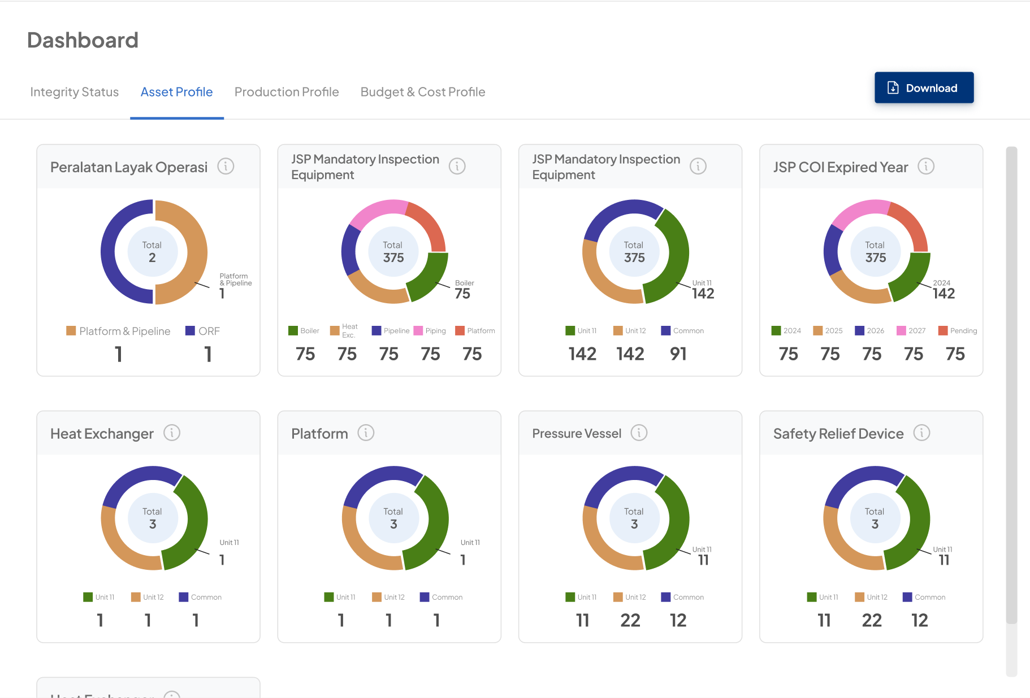
Figure IV-2 Asset profile dashboard

Production Profile
On the production profile section of the dashboard, various information can be displayed in graph form, including daily generation, plant heat rate, and plant availability. Both the information presented and the data visualization methods used can be tailored to meet your specific needs.
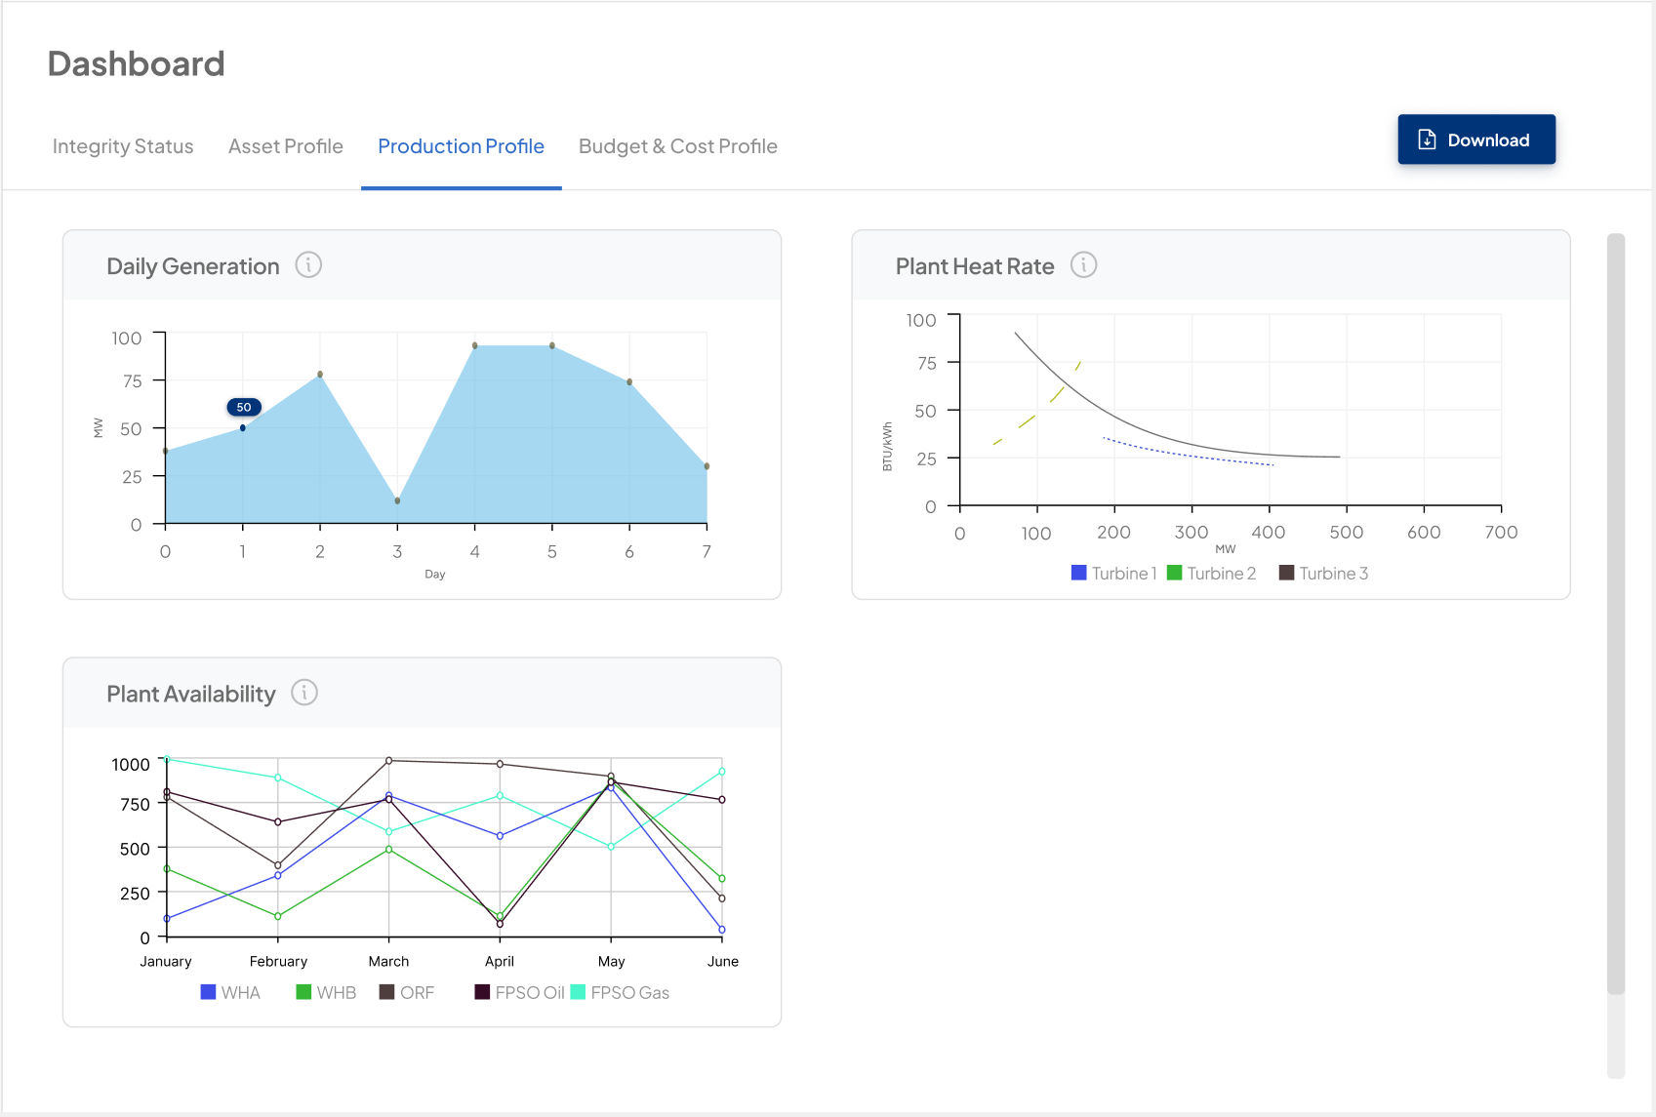
Figure IV-3 Production profile dashboard

Budget & Cost Profile
In this section, the profile of the budget and costs for inspections, integrity work, and maintenance will be displayed. Both the information presented and the data visualization methods can be customized according to your needs.
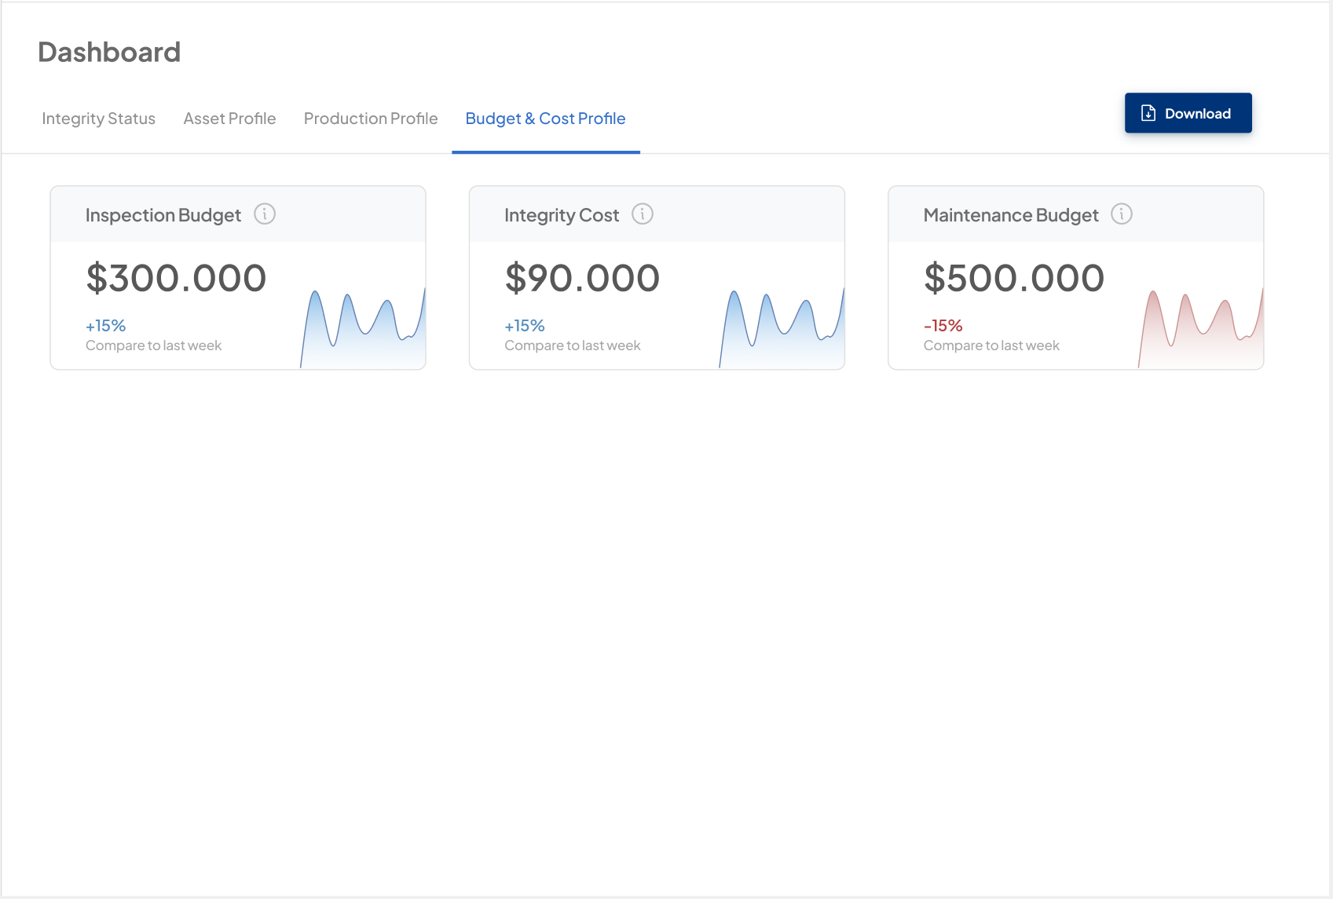
Figure IV-4 Budget & cost profile dashboard

CRI ESTABLISHED APPLICATION

Overview
CRI has developed a comprehensive asset management system, C-TRUST, that has been successfully adopted by several of our clients. Our clients have integrated our asset management app into their operations, where it has proven instrumental in addressing challenges related to asset management and reliability assessment. Our solution has enhanced their ability to manage assets effectively, streamline processes, and ensure the reliability of their operations.
The primary purpose of our asset management application is to help clients address challenges related to asset management and reliability assessment. This includes tasks such as creating master data or asset registers, managing spare parts and cataloguing, conducting asset criticality analysis (ECA), and developing reliability block diagrams (RBD). By utilizing our application, clients can significantly enhance the effectiveness and efficiency of their asset management processes. In addition to optimizing these processes, our application is also capable of generating reports that align seamlessly with each client's specific reporting templates.
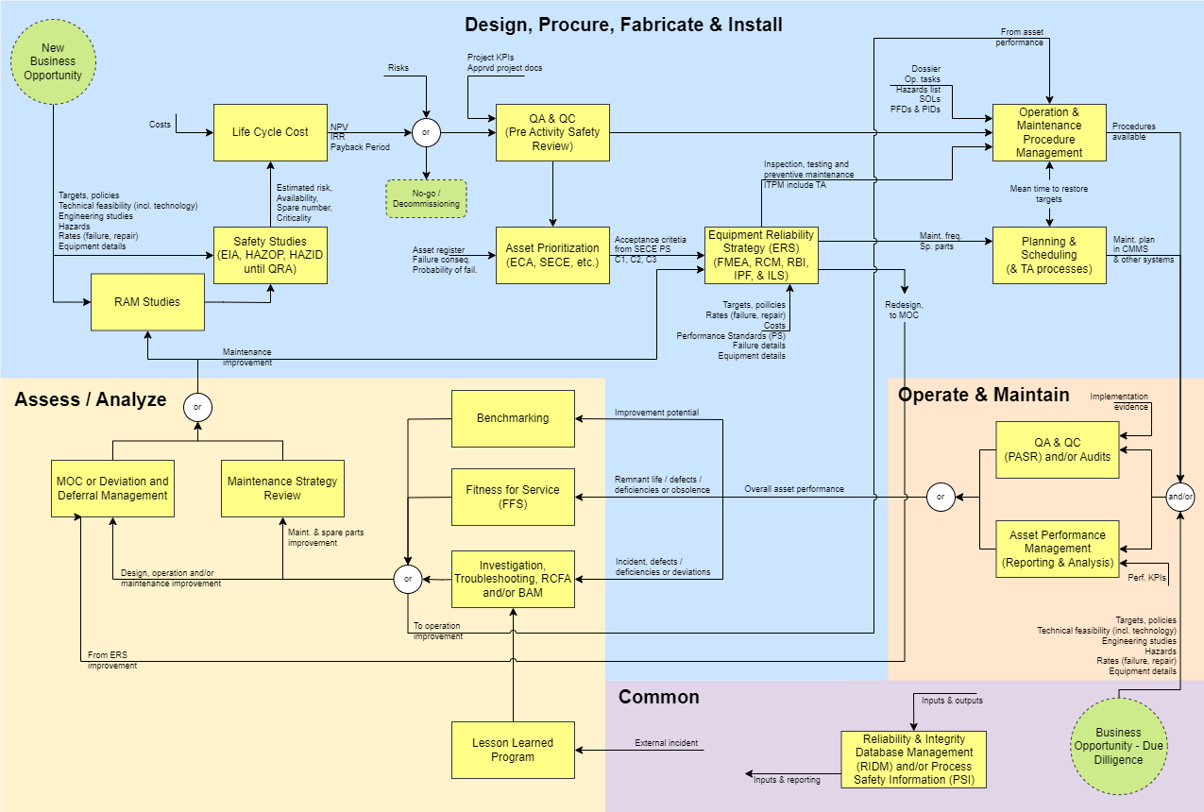
Figure V-1 Asset Management Global Business Flow
CRI’s asset management application consists of several modules that can be purchased as a complete package or individually, based on JSP’s specific needs. Each module within our asset management application is fully customizable, allowing JSP to include any information that JSP require. JSP can also request changes to the app's appearance to better align with JSP’s preferences. Additionally, our application is designed to integrate seamlessly with JSP’s existing systems, ensuring a smooth and cohesive user experience.
Our application also features a functionality for recording each change made to the data input into the system. This allows us to track which user made the change, what was modified, and when the change occurred. This audit trail provides several benefits: it enhances accountability by identifying who made specific updates, ensures data integrity by allowing for easy verification of changes, and facilitates troubleshooting and compliance by providing a clear history of modifications. With this information, you can easily recall change details and maintain a comprehensive record, which is invaluable for audits, historical analysis, and future reference.

Global Business Flow
CRI’s asset management application is designed based on the Global Business Flow for asset management. As illustrated in Figure V-1, the asset management process is generally divided into three major phases: Design, Procure, Fabricate & Install; Operate & Maintain; and Assess / Analyse. The asset management flow is a recurring cycle, where the processes within each phase are periodically performed on a regular basis.
In the Design, Procure, Fabricate & Install phase, the process begins with setting targets from both a business and reliability perspective. Engineering studies, such as Reliability, Availability, Maintainability (RAM) analysis and safety studies such as Hazard and Operability (HAZOP) study, are conducted to assess and formulate strategies to achieve these targets. Following this, asset prioritization is performed, which is then used to develop an equipment reliability strategy. This strategy may involve techniques like FMEA (Failure Modes and Effects Analysis), RBI (Risk-Based Inspection), RCM (Reliability-Centered Maintenance), among others. Subsequently, an Operation & Maintenance Procedure is established, along with a maintenance scheduling plan based on the developed strategy.
After the strategies and schedules for operation and maintenance are established, the process moves to the Operate & Maintain phase. In this phase, all the operational and maintenance strategies that have been developed are executed. Quality Assurance (QA) and Quality Control (QC) are also conducted for all activities. Additionally, Asset Performance Management is carried out to assess the performance of the assets based on the implemented operational and maintenance strategies.
The process then moves to the Assess / Analyse phase. In this phase, investigations or troubleshooting are conducted to identify the root causes of any issues that arose during the Operate & Maintain phase. This can be achieved through methods such as Root Cause Failure Analysis (RCFA) and/or Bad Actor Management (BAM). Additionally, a review of the implemented maintenance strategies is performed to improve the existing strategies. Any changes made are documented through a Management of Change (MOC) system. After the investigation, review, and implementation of changes to the assets, the process returns to RAM (Reliability, Availability, Maintainability) studies to evaluate whether the changes have positively impacted the overall asset performance.
CRI’s asset management application is meticulously designed to empower our clients to execute each phase of asset management with optimal effectiveness and efficiency. The application features seamlessly integrated modules, ensuring that any data changes made in one module automatically update across all related modules. This integration not only enhances data accuracy but also streamlines workflows, reduces manual effort, and minimizes the risk of errors. By providing a unified platform for managing assets, the application helps our clients improve decision-making, increase operational reliability, and ultimately maximize the value of their assets.

Mandatory and Optional Modules
All modules available in CRI’s asset management application can be purchased either as a complete package or individually, based on your specific needs. Additionally, you can request the development of custom modules tailored to your requirements. However, please note that the Asset Register module is mandatory, as it serves as the central hub where all data from other modules is linked to the asset data entered in the Asset Register.

Asset Management Modules
This section provides a detailed explanation of the asset management modules that have been developed and are currently under development by CRI. The key features and outputs of each module will also be described.

Dashboard
The dashboard module displays summarized information from other modules, including calculation results, analyses, and any other desired data. You have the flexibility to select which information or key performance indicators (KPIs) you want to be displayed, allowing you to customize the dashboard to focus on the metrics most relevant to your needs. This enables you to view the overall performance of your assets at a glance, tailored to your specific priorities.
Some of the information that can be displayed on the dashboard module we have developed includes Plant Event Availability (Figure V-2), Plant Event Reliability (Figure V-3), total critical equipment for each category (Figure V-4), and more. The information displayed can also be customized according to your preferences and can be presented in various formats, such as graphs, charts, or tables.
This module also includes an “Export Data” feature, allowing you to download information from the dashboard and save it to your computer’s storage in Excel format. The exported file format can be customized to meet your preferences, including options such as PDF, Word, and other formats.
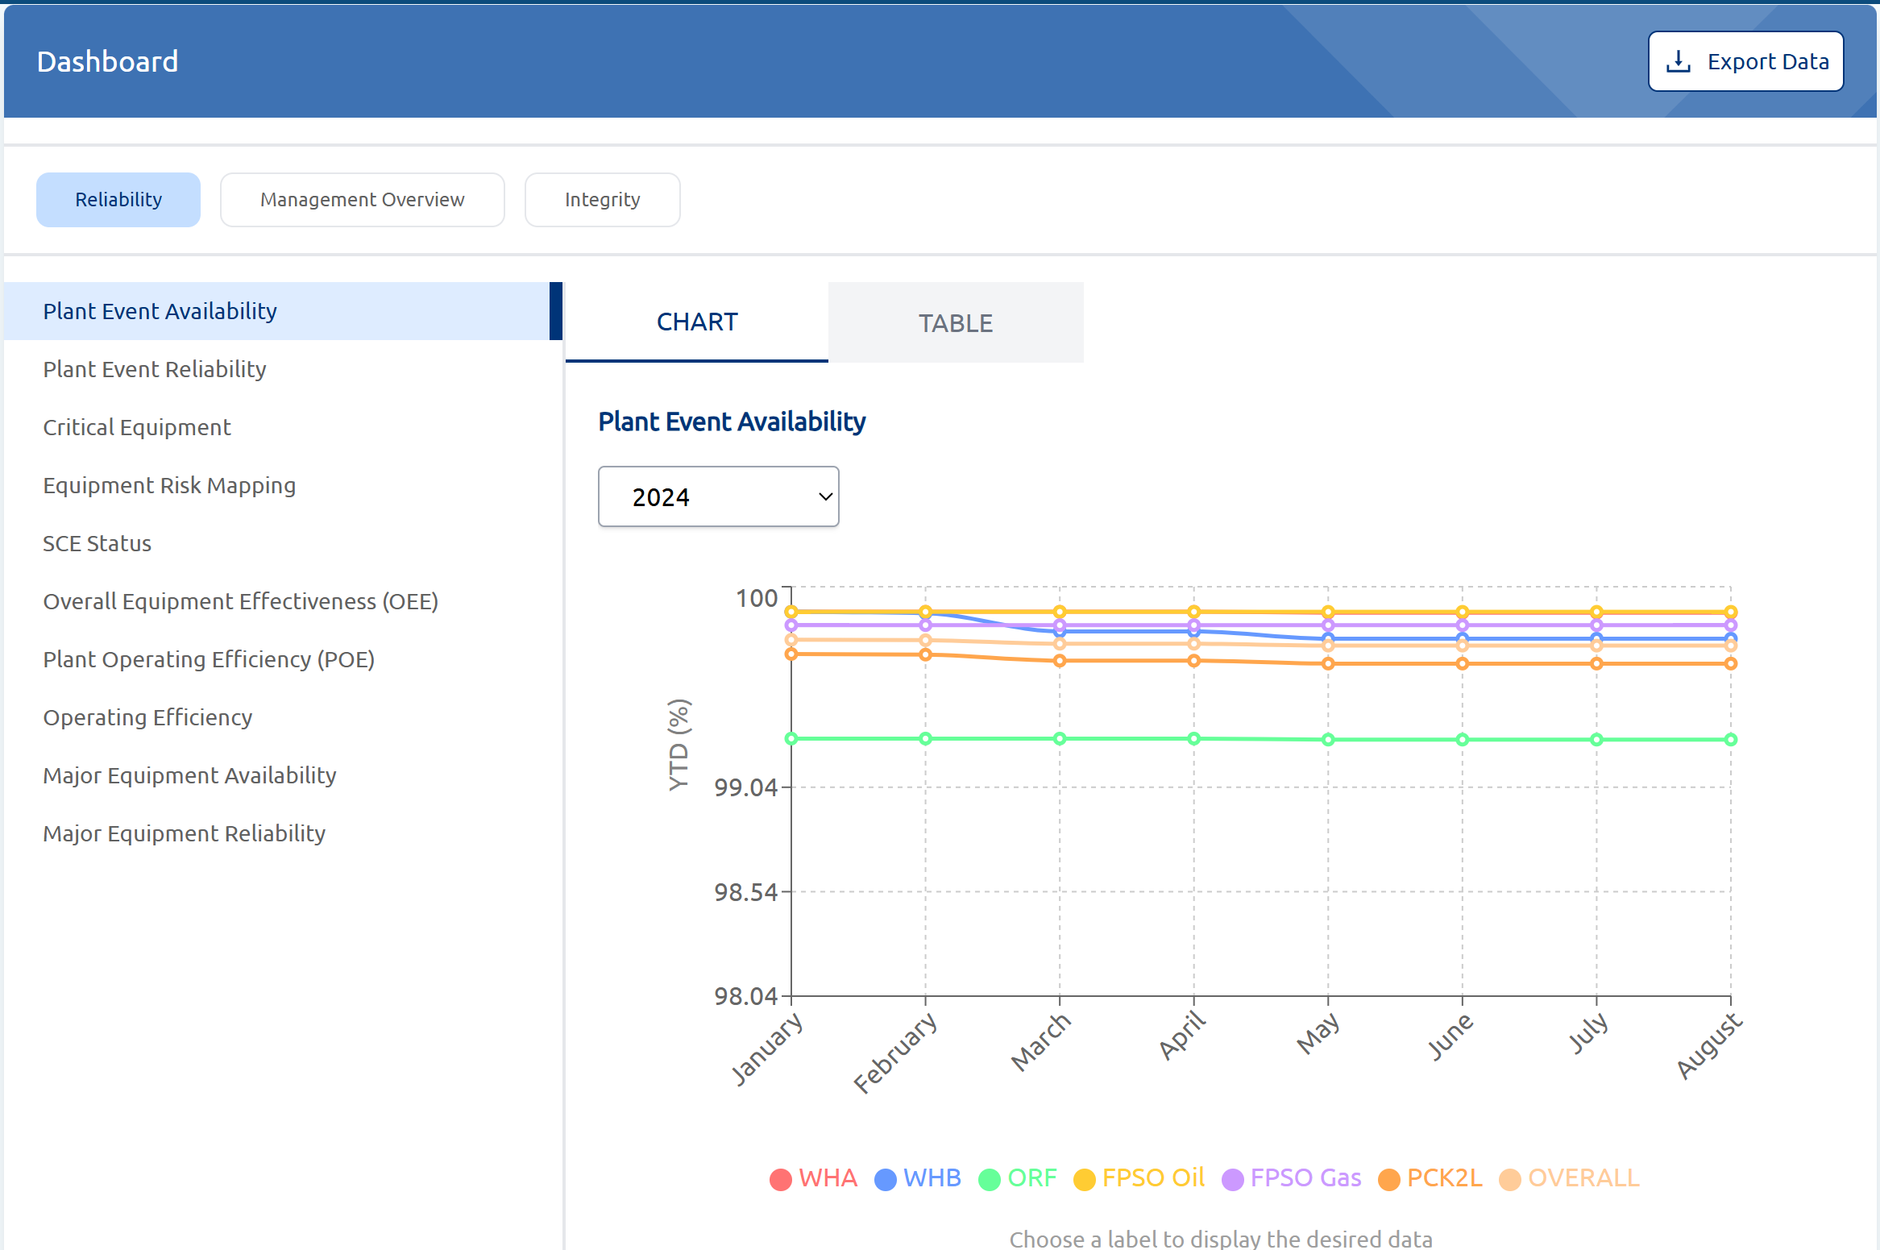
Figure V-2 Plant Event Availability

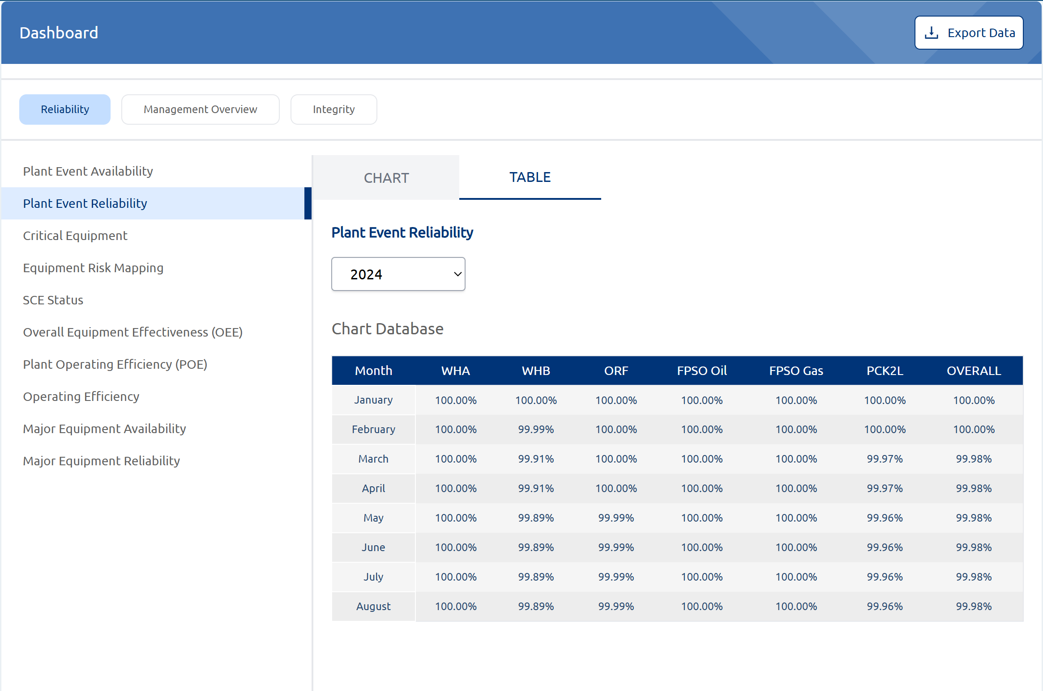
Figure V-3 Plant Event Reliability

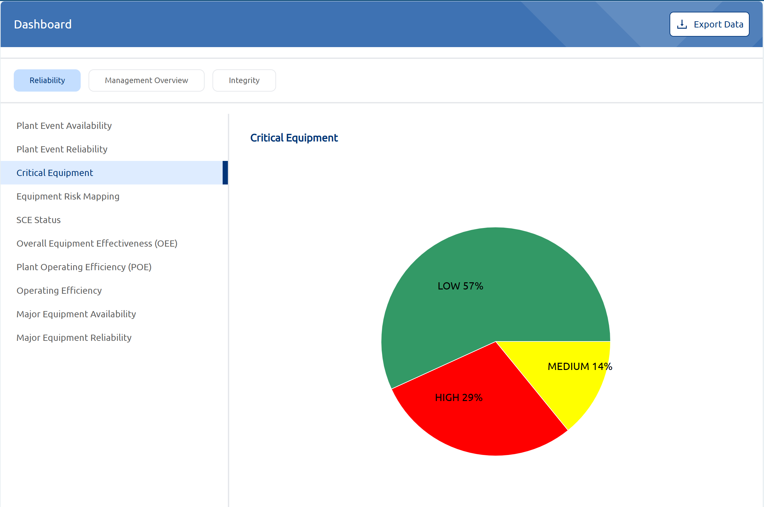
Figure V-4 Critical Equipment

Asset Register
The Asset Register module is the core component of the asset management application we have developed, therefore, this module is deemed mandatory. All assets are entered into this module and organized according to international standards, such as ISO 14224, Kraftwerk-Kennzeichen-System (KKS), or internal references used by the client. Every piece of information and calculation from other modules is directly linked to the respective assets that have been previously entered into the Asset Register module.
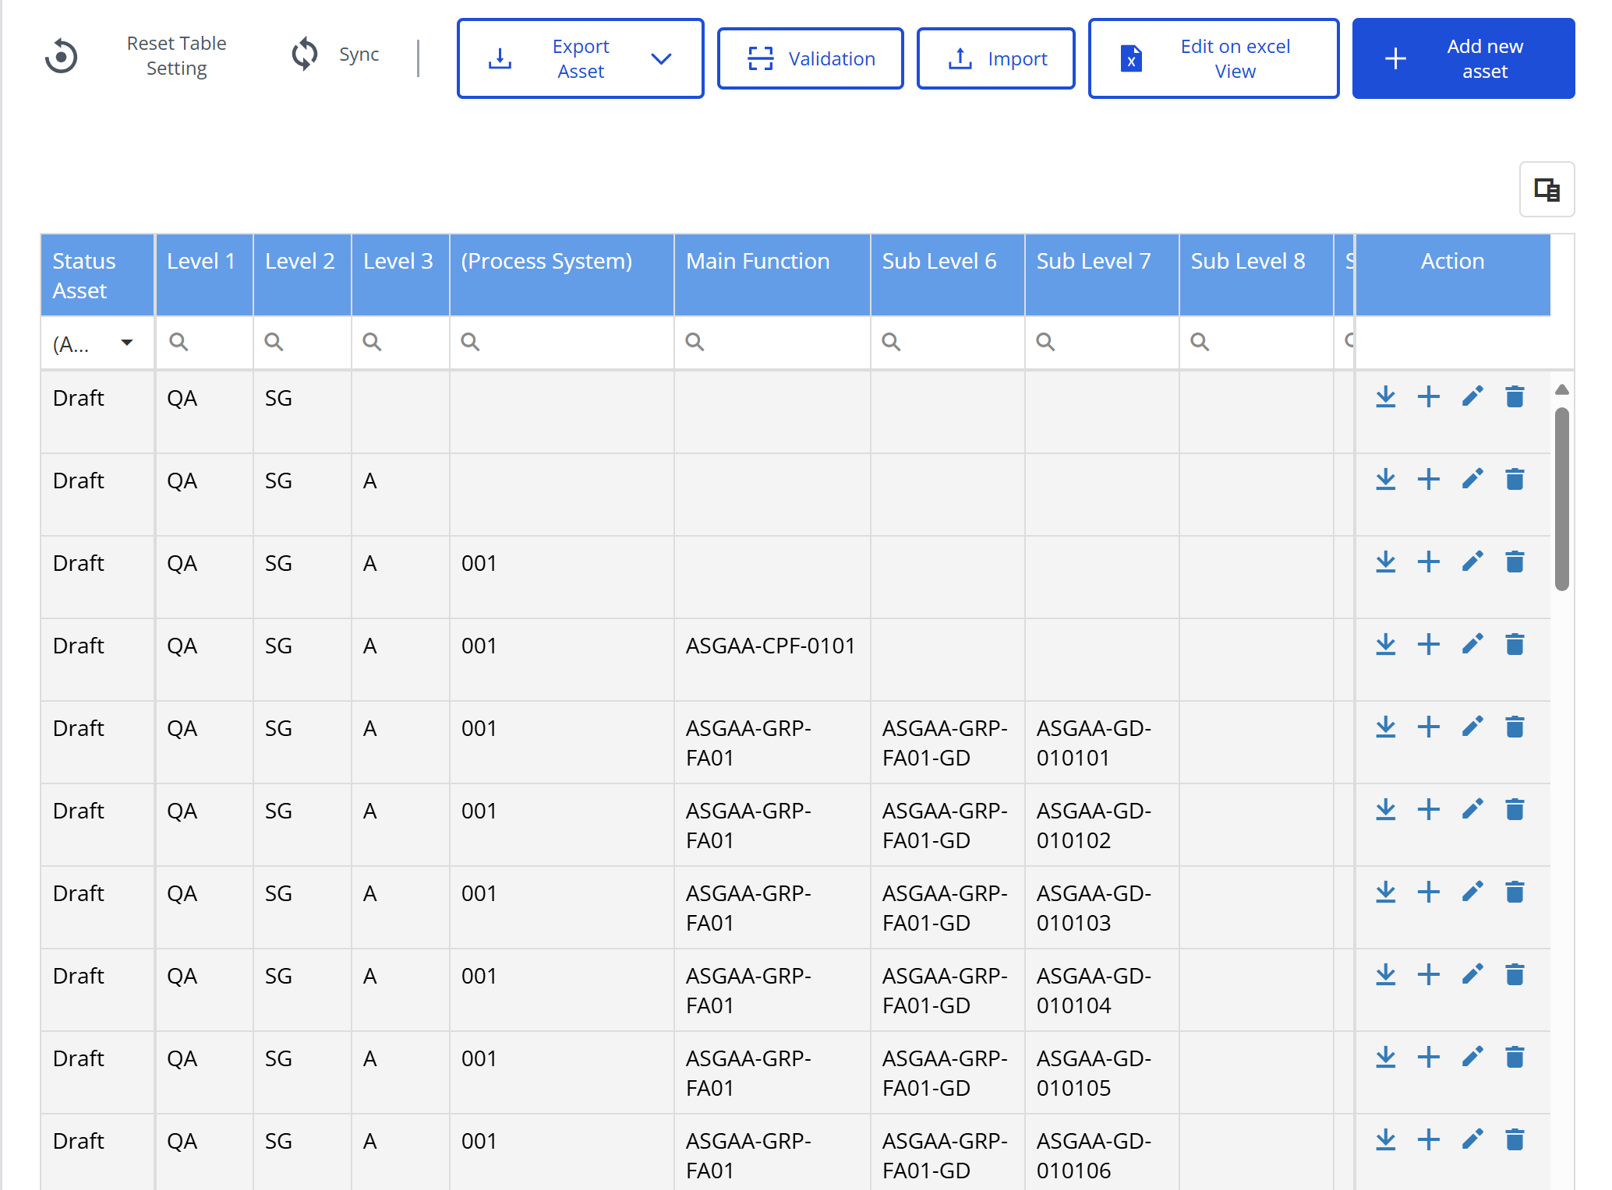
Figure V-5 Asset Register Module
Some of the key features provided in this module are:
- Add new asset
In this module, users have the option to input assets manually into a dedicated input window. This process allows for the detailed and precise recording of asset details. If changes are required or if incorrect information was entered initially, users can easily edit the previously input data to ensure accuracy and up-to-date information.
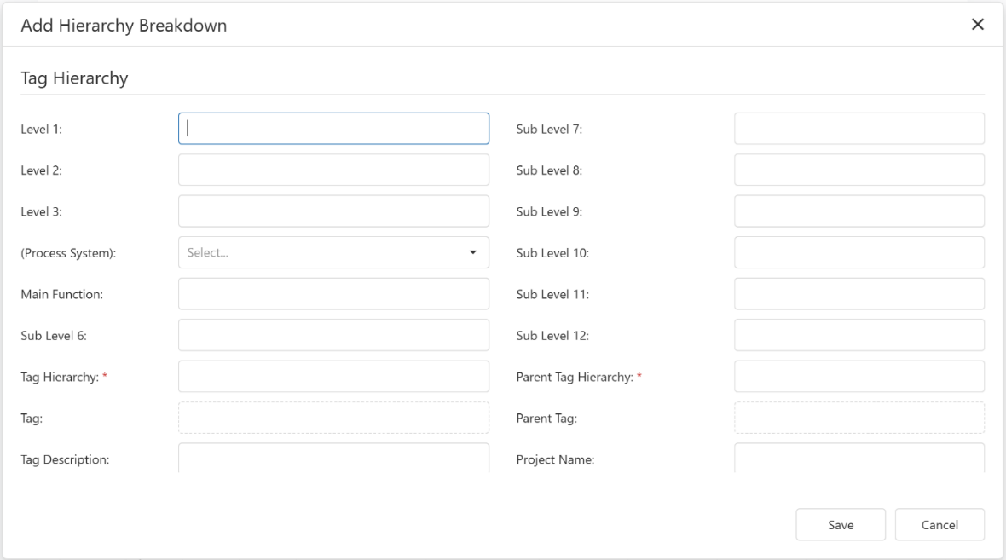
Figure V-6 Add new asset
- Import feature
The import feature allows users to efficiently input a large volume of asset data into the application simultaneously. users first need to download the provided Excel template. They should then fill out this template with data for all the assets they own. Next, on the Asset Register module page, users will upload the completed Excel file via the import asset window. The asset data will then be automatically input into the application
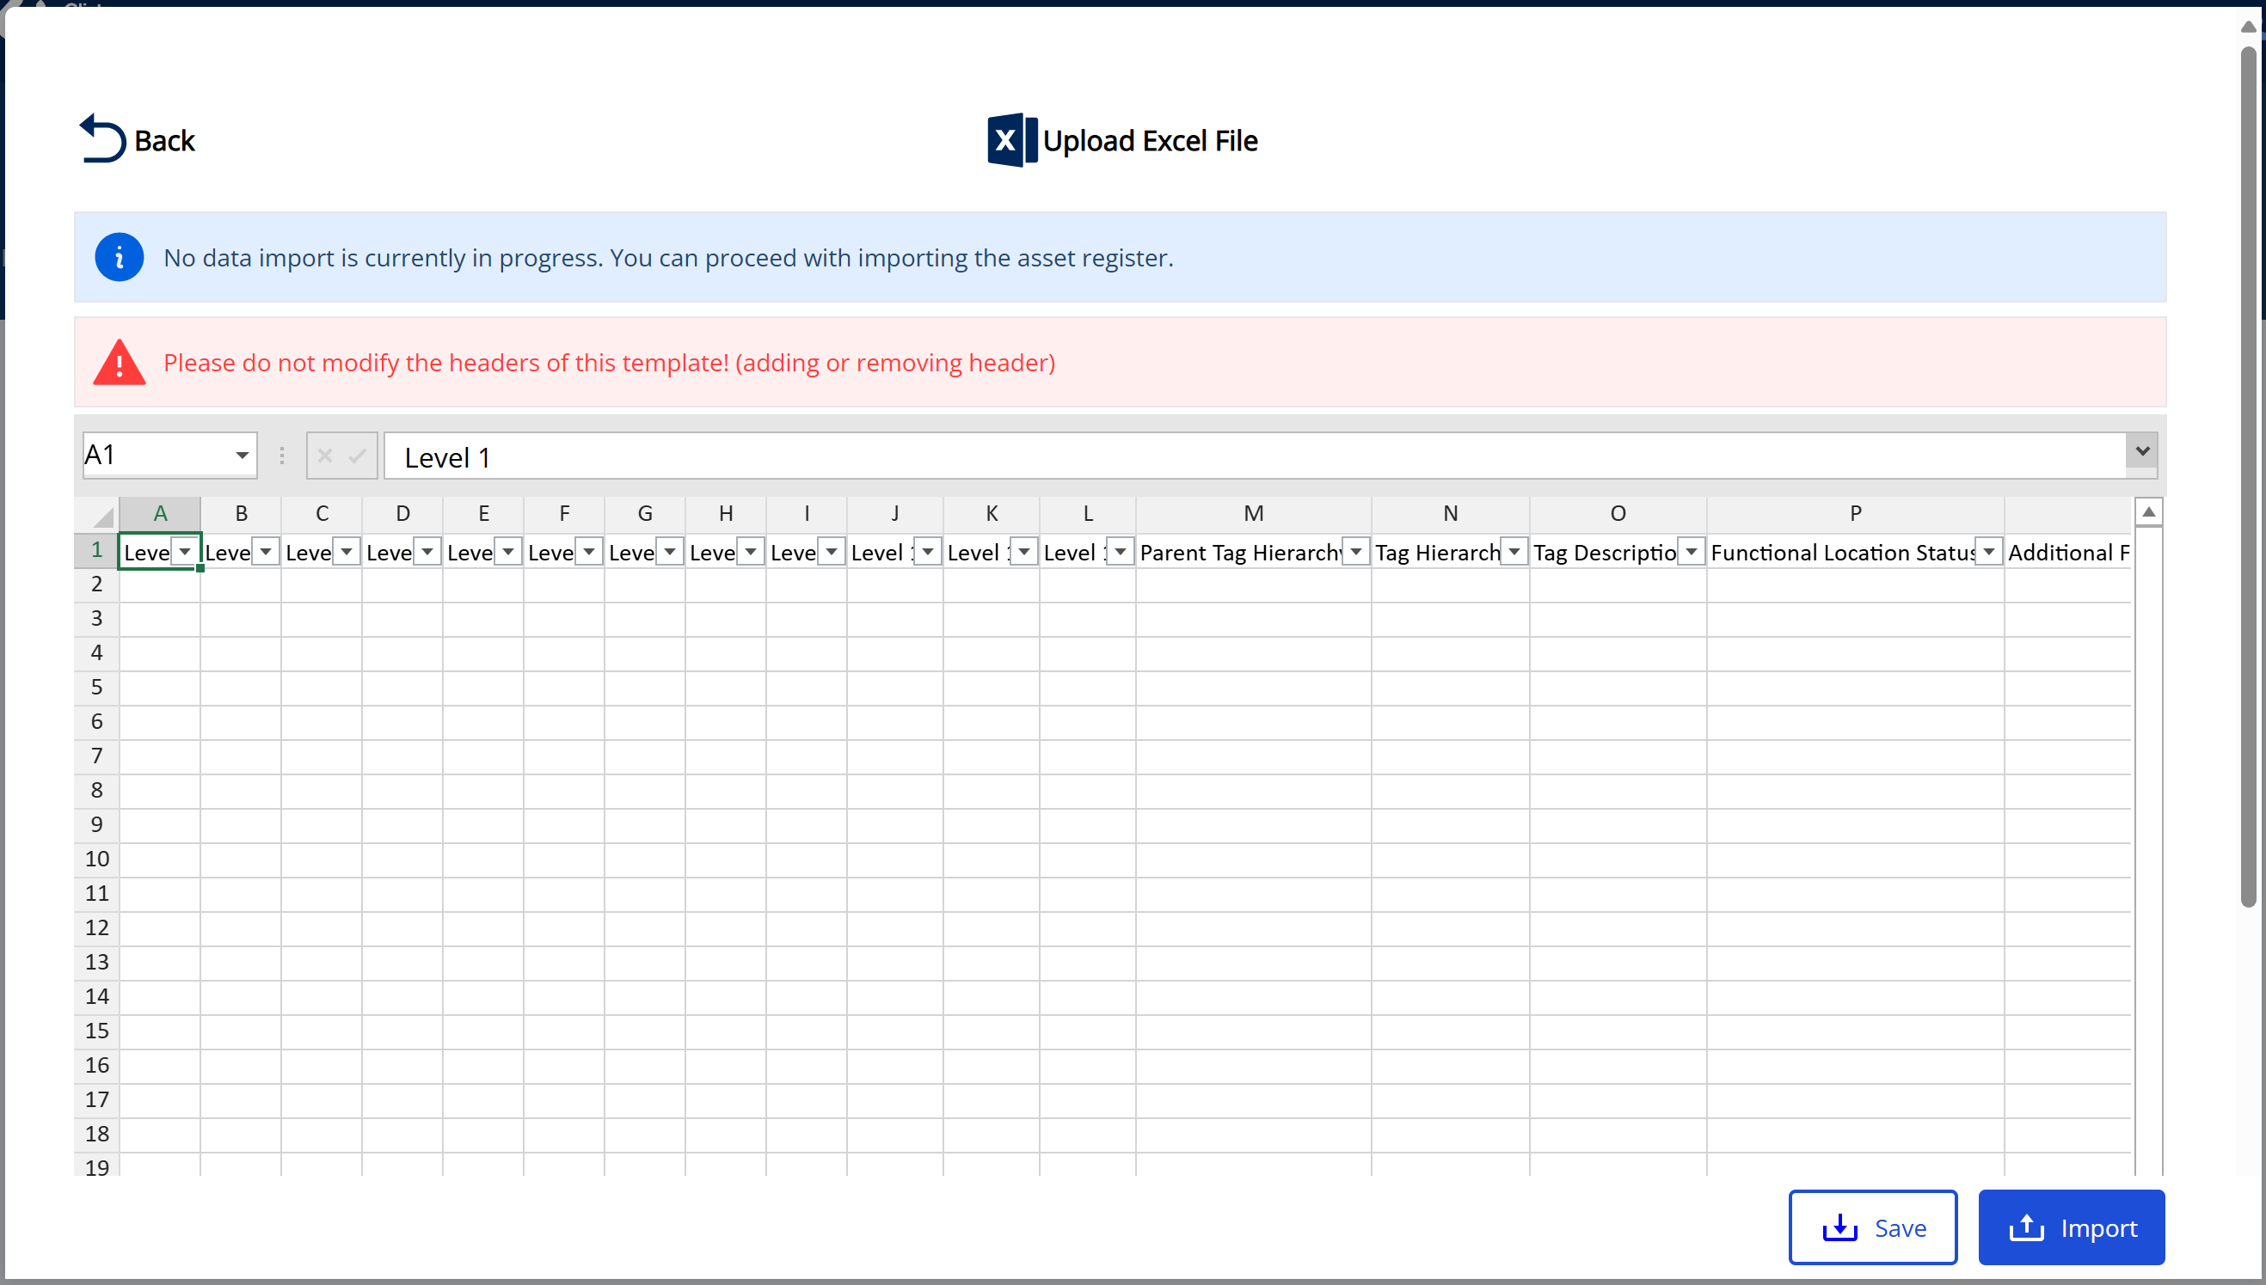
Figure V-7 Import excel file
- Edit on excel view
This feature has the ability to edit data that has already been input using an Excel view. This feature facilitates more efficient data editing, as it allows users to make changes in a format they are already familiar with. Since most users are accustomed to working with Excel, this functionality streamlines the editing process, making it quicker and more intuitive to update asset information.
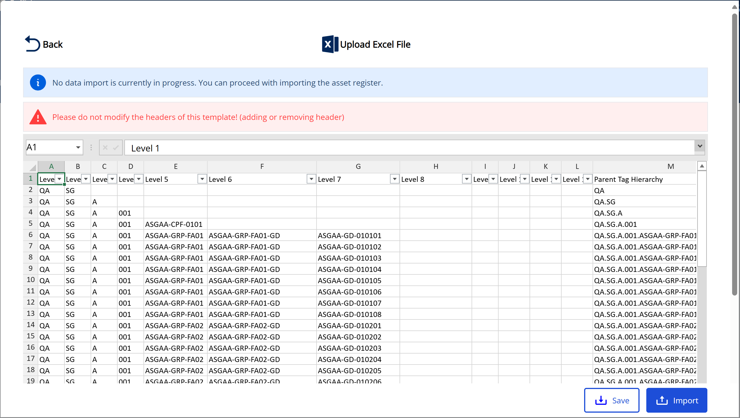
Figure V-8 Edit data with excel view
- Export
In addition to the import feature, the module also offers an export functionality that allows users to save the entered data in an Excel format. This feature enables users to download and store the asset data directly to their computer’s storage. It provides the flexibility to create backups, share information with stakeholders, or perform offline analysis, ensuring effective management and access to asset information outside of the application.
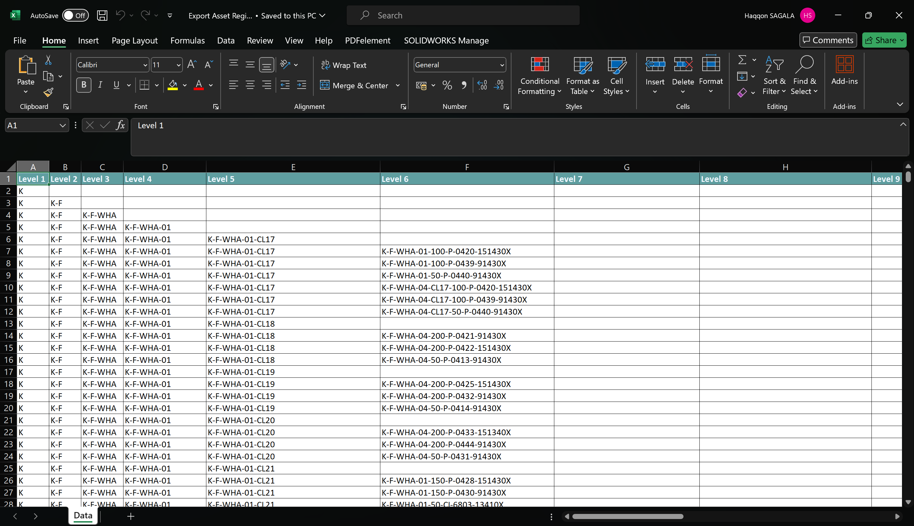
Figure V-9 Export asset register to excel

Equipment Criticality Analysis
In this module, an analysis is conducted to determine the criticality level of each piece of equipment listed in the asset register. The method used can be tailored to the client's request, whether it be a risk matrix, System and Equipment Reliability Prioritization (SERP), or another approach. The method we have implemented for the Equipment Criticality Analysis module is the risk matrix.
Some of the key features provided in this module are:
- Risk matrix view
This feature displays the risk matrix used in the Equipment Criticality Assessment (ECA). The information includes detailed descriptions of each level for Probability of Failure (PoF) and its consequences. The size of the matrix, as well as the descriptions for each PoF and consequence, can be customized according to the client’s needs. The criticality level for each combination of PoF and failure consequence is also displayed and can be tailored to meet the client's specific requirements.
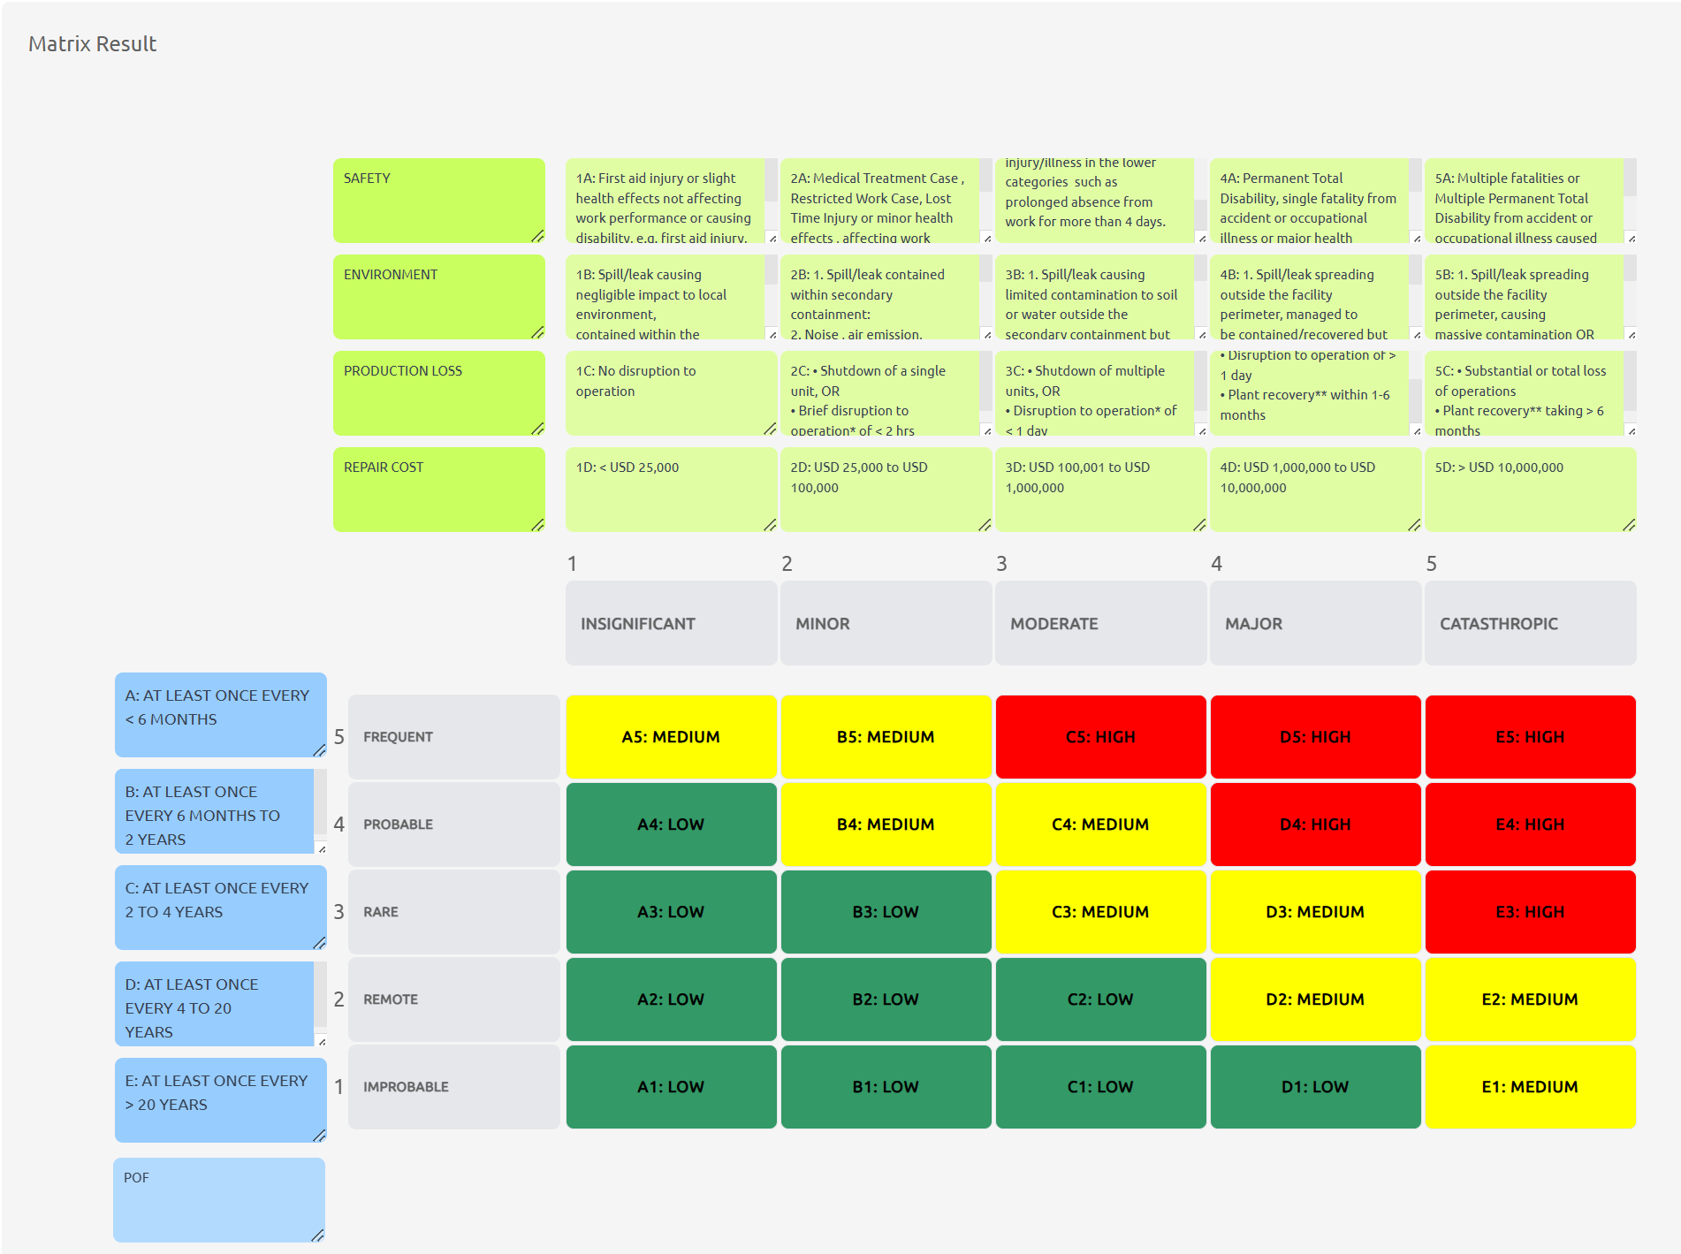
Figure V-10 Risk matrix view
- ECA assessment table
This feature displays a table containing the criticality levels of each piece of equipment. In this table, you can define the failure effects and Probability of Failure (PoF) for the equipment. The criticality level of the equipment will then be automatically displayed based on the established risk matrix.
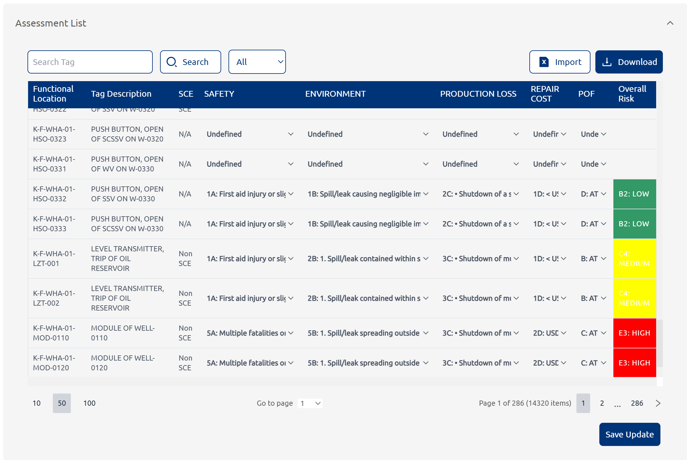
Figure V-11 ECA assessment table
- Import excel file
This feature allows users to input multiple data entries into the ECA assessment table at once. Users simply download the provided Excel template, fill in the table within the Excel file, and upload the completed file through the designated window. The data will then be automatically updated in the system.
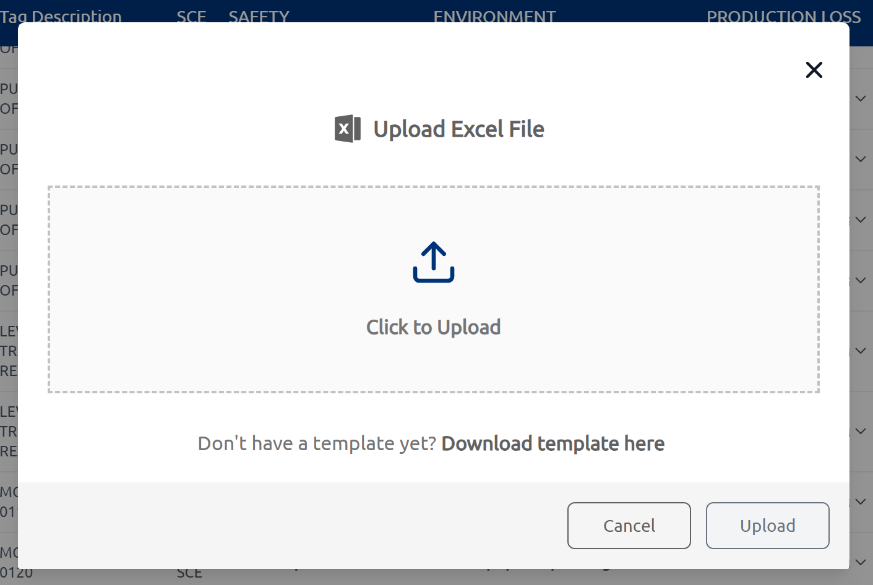
Figure V-12 Import excel file
- Export to excel
This feature allows users to export data from the application into an Excel file, which can be saved to their computer's internal storage. This provides the benefit of easy data access and the ability to share or analyze the information offline.
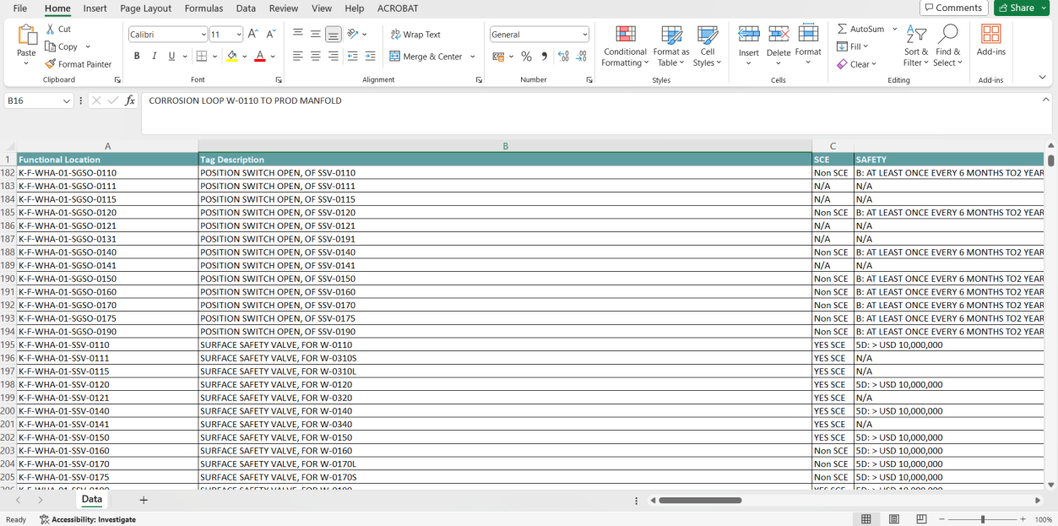
Figure V-13 Export ECA table to excel

SCE Identification
This module is designed to analyze each piece of equipment listed in the asset register to determine whether it qualifies as Safety Critical Equipment (SCE).
Some of the key features provided in this module are:
- SCE identification assessment table
This table contains information about the equipment and their descriptions, along with a series of safety-related questions or statements to determine whether the equipment qualifies as SCE. Users can directly answer each question in the table with a "Yes" or "No," and the SCE status of the equipment will be automatically displayed.
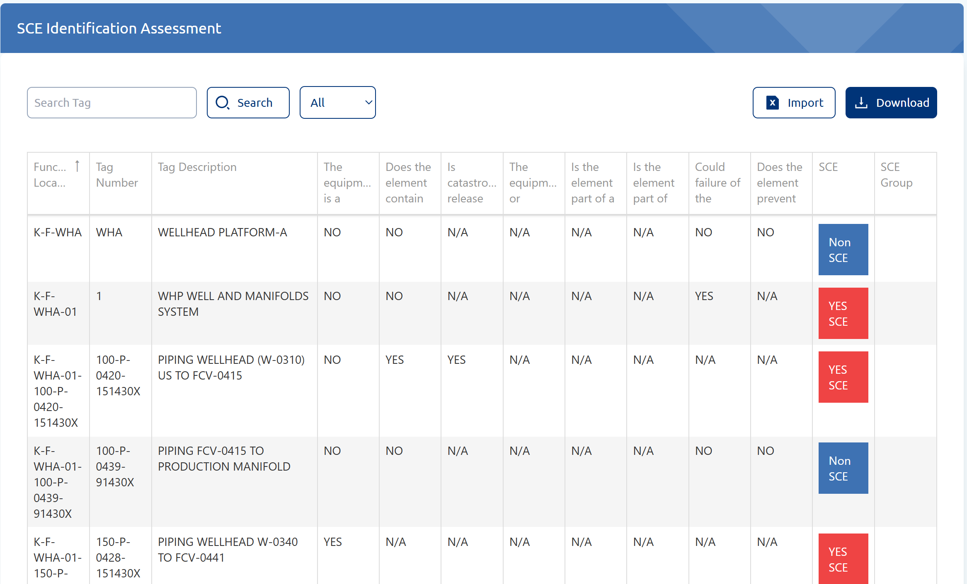
Figure V-14 SCE identification assessment table
- Import data from excel
In addition to directly editing data in the table, there is also an import feature that allows users to upload large amounts of data into the SCE identification table simultaneously. Users simply download the provided Excel template, fill in the table, and then upload the completed file through the designated window. This feature streamlines the data entry process, saving time and reducing the potential for manual errors by enabling bulk uploads.
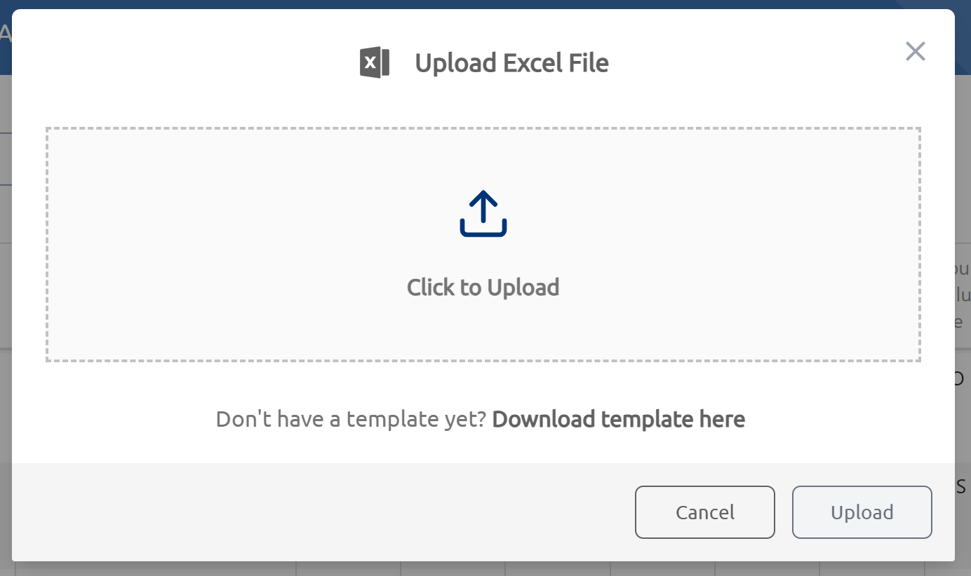
Figure V-15 Import data from excel
- Export data to excel
Users can also export the data from the table within the application into an Excel file and save it to their computer's internal storage. This feature provides easy access to data for offline analysis, sharing, or record-keeping, enhancing flexibility and convenience in managing information.
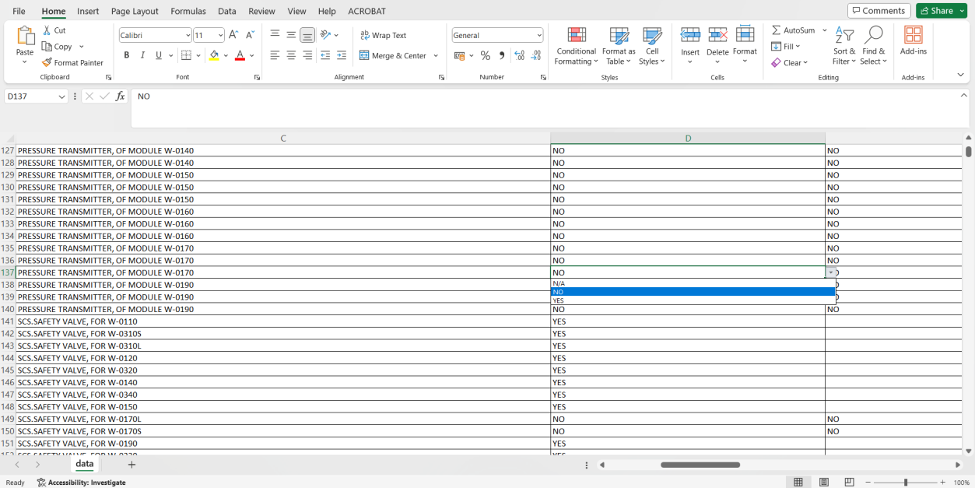
Figure V-16 Export SCE data to excel

SCE Performance Standard
This module is designed to store all performance standard files for SCE equipment. The module we developed organizes and stores these performance standard files according to the platforms owned by the client.
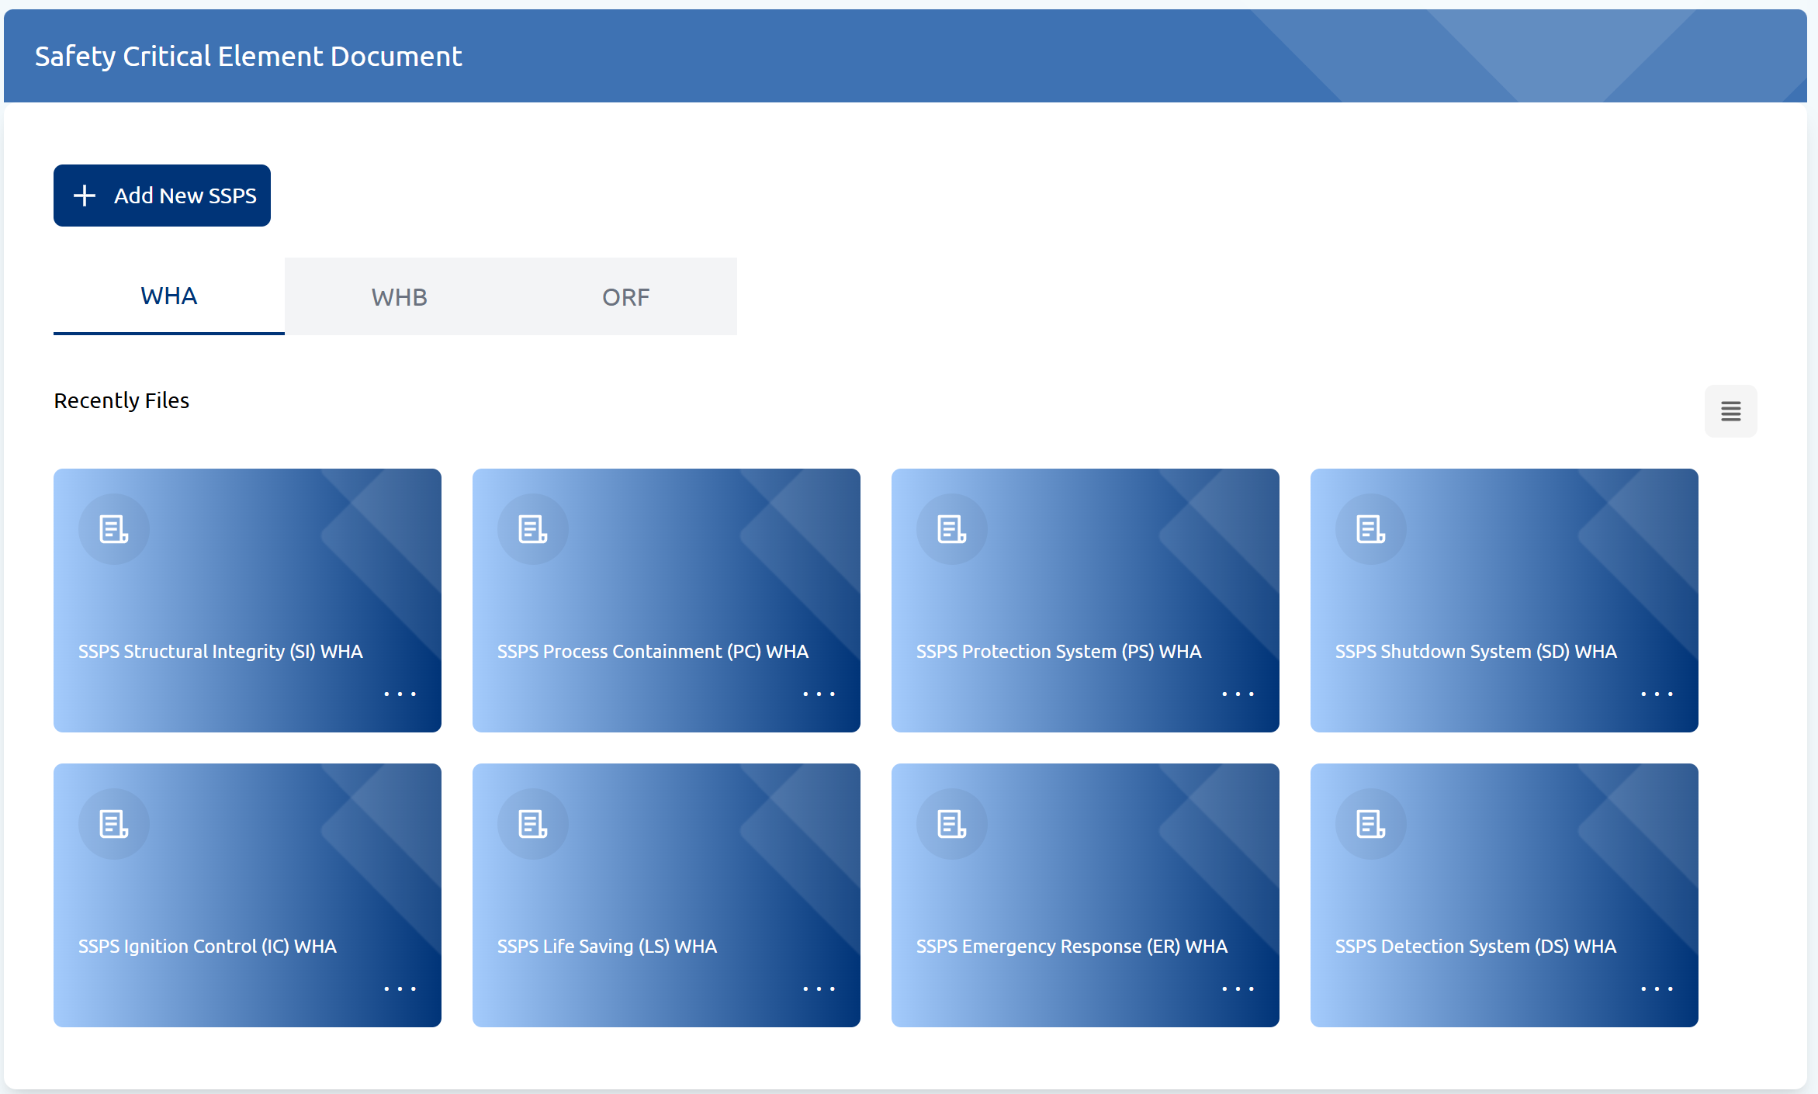
Figure V-17 SCE performance standard module
Some of the key features provided in this module are:
- Add new SPSS (Site Specific Performance Standard)
This feature allows users to add new performance standard files for specific platforms. In the available window, users need to input the SPSS name, select the platform, and upload the performance standard file.
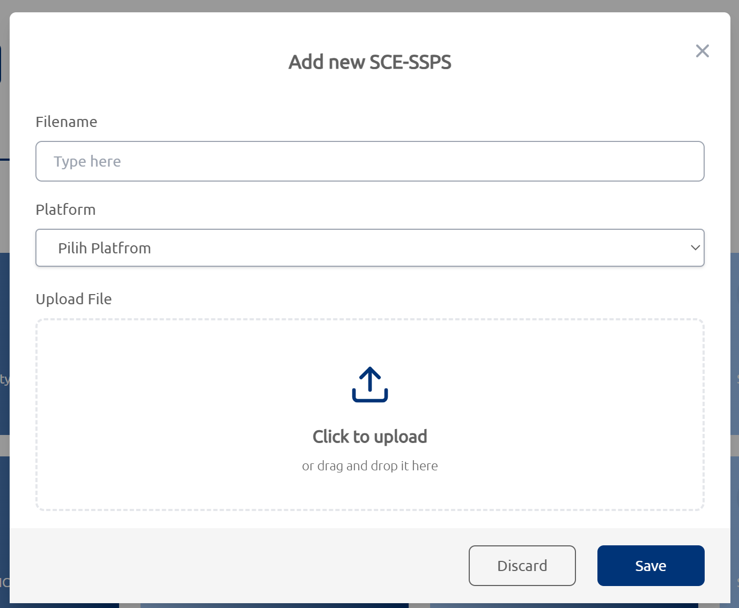
Figure V-18 Add new SCE-SPSS
- Download, edit and delete SPSS
This feature provides several functions, including the ability to download uploaded files, edit the names of the SPSS, and delete the SPSS if changes or errors occur.
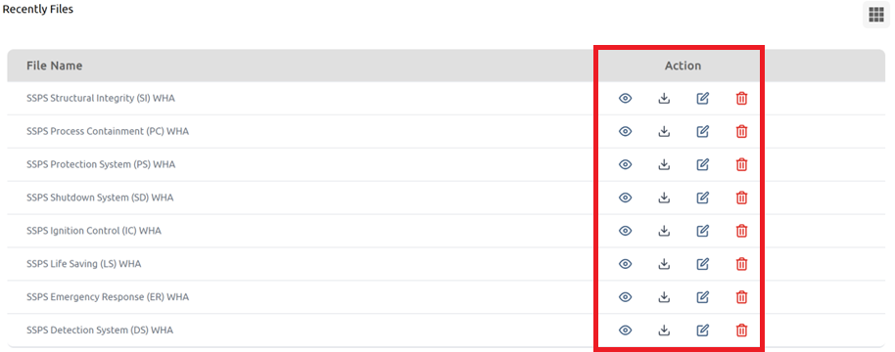
Figure V-19 Download, edit and delete SPSS

Failure Mode & Effect Analysis (FMEA)
This module is designed to support the execution of Failure Mode & Effect Analysis (FMEA). Users can input the types of failure modes for equipment listed in the asset register and enter the corresponding failure mechanisms based on the identified failure modes. Additionally, users can specify the detection methods for each failure mode, along with its associated effects.
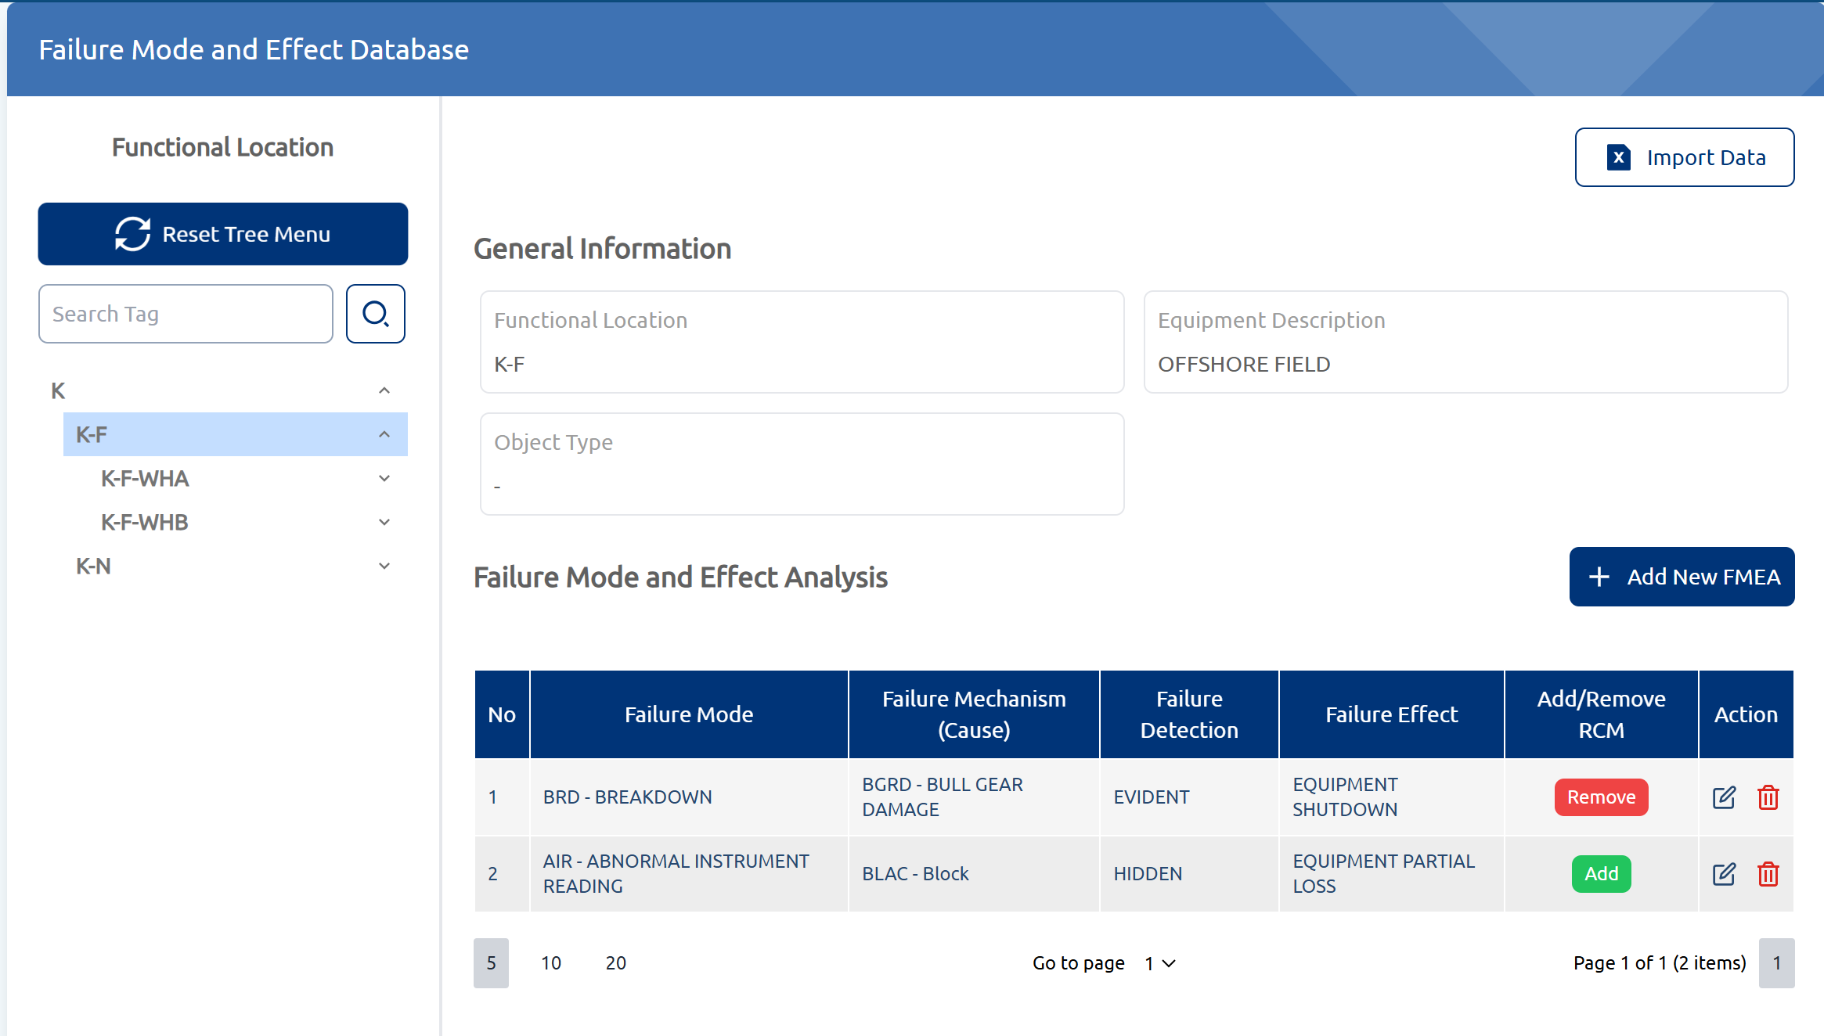
Figure V-20 Failure mode & effect analysis (FMEA) module
Some of the key features featured in this module are:
- Add new FMEA
With this feature, users can add new FMEA entries for specific assets registered in the asset register. Users select a failure mode from the provided dropdown list, then choose the corresponding failure mechanism. Additionally, users can specify the failure detection method and the associated failure effects.
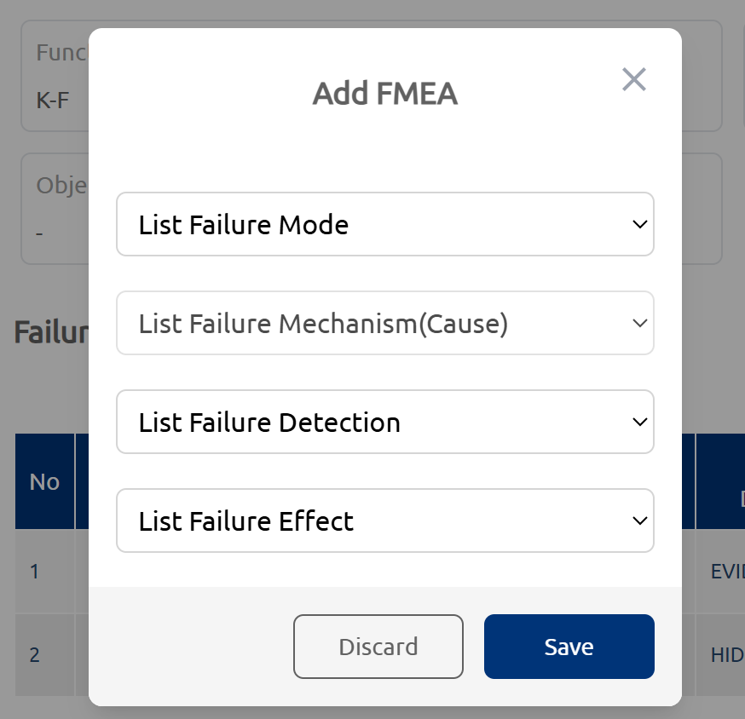
Figure V-21 Add new FMEA
- Edit or delete FMEA
This feature allows users to edit or delete existing FMEA entries if errors or incorrect data are identified.
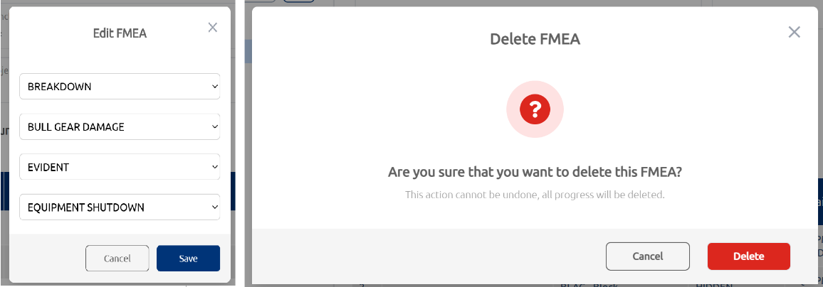
Figure V-22 Edit or delete FMEA
- Import data
This feature allows users to import FMEA data from an Excel file, enabling them to input a large volume of data at once. Users first need to download the Excel template, fill out the table, and then upload the completed file through the designated window.
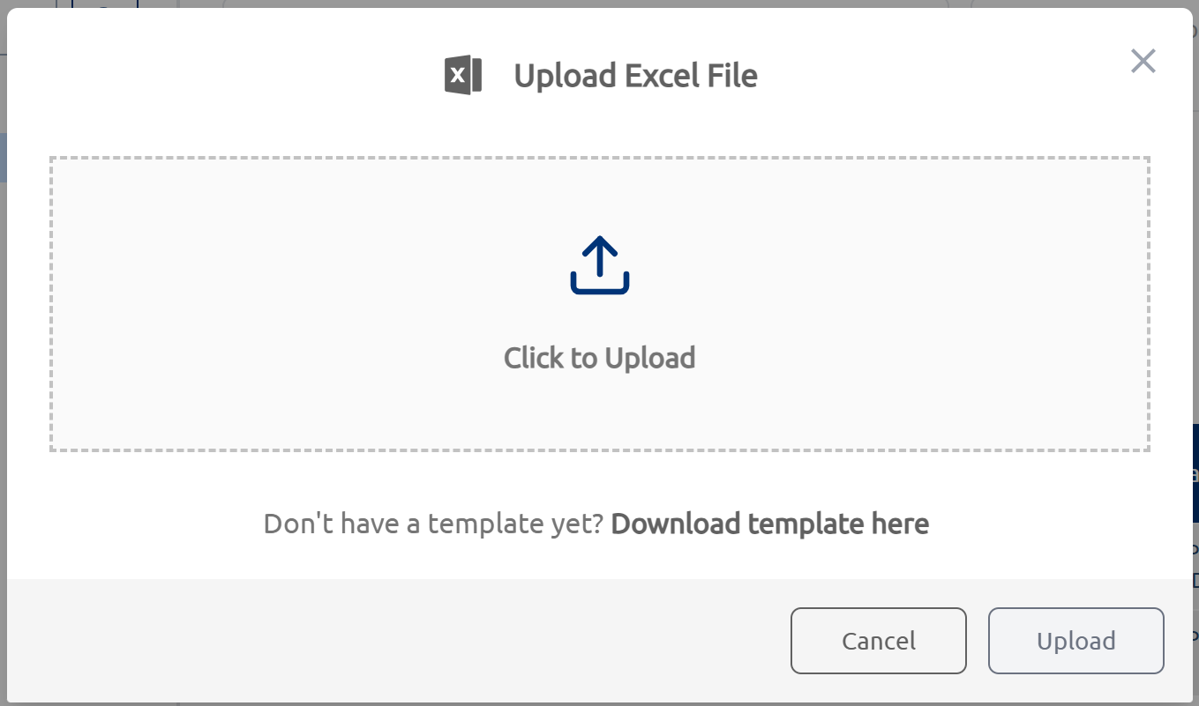
Figure V-23 Import data from excel file
- Add / remove RCM
This feature allows users to select which failure modes should be added to or removed from the Reliability Centered Maintenance (RCM) Assessment. When a FMEA is added to the RCM, it will appear in the RCM module, where users can perform the RCM assessment on it (details will be provided in the RCM module, section V.4.9). Conversely, if a FMEA is removed from the RCM, it will be deleted from the RCM module.
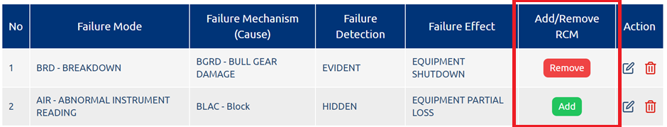
Figure V-24 Add / remove RCM

Life Data Analysis
This module conducts a comprehensive Life Data Analysis (LDA). Users input the failure history for a specific asset registered in the asset register, including details such as failure time, start and end of repair, start and end of run time, and additional failure-related information. Background calculations are then performed to determine key metrics, including Mean Time Between Failures (MTBF), Mean Time to Repair (MTTR), and equipment reliability.
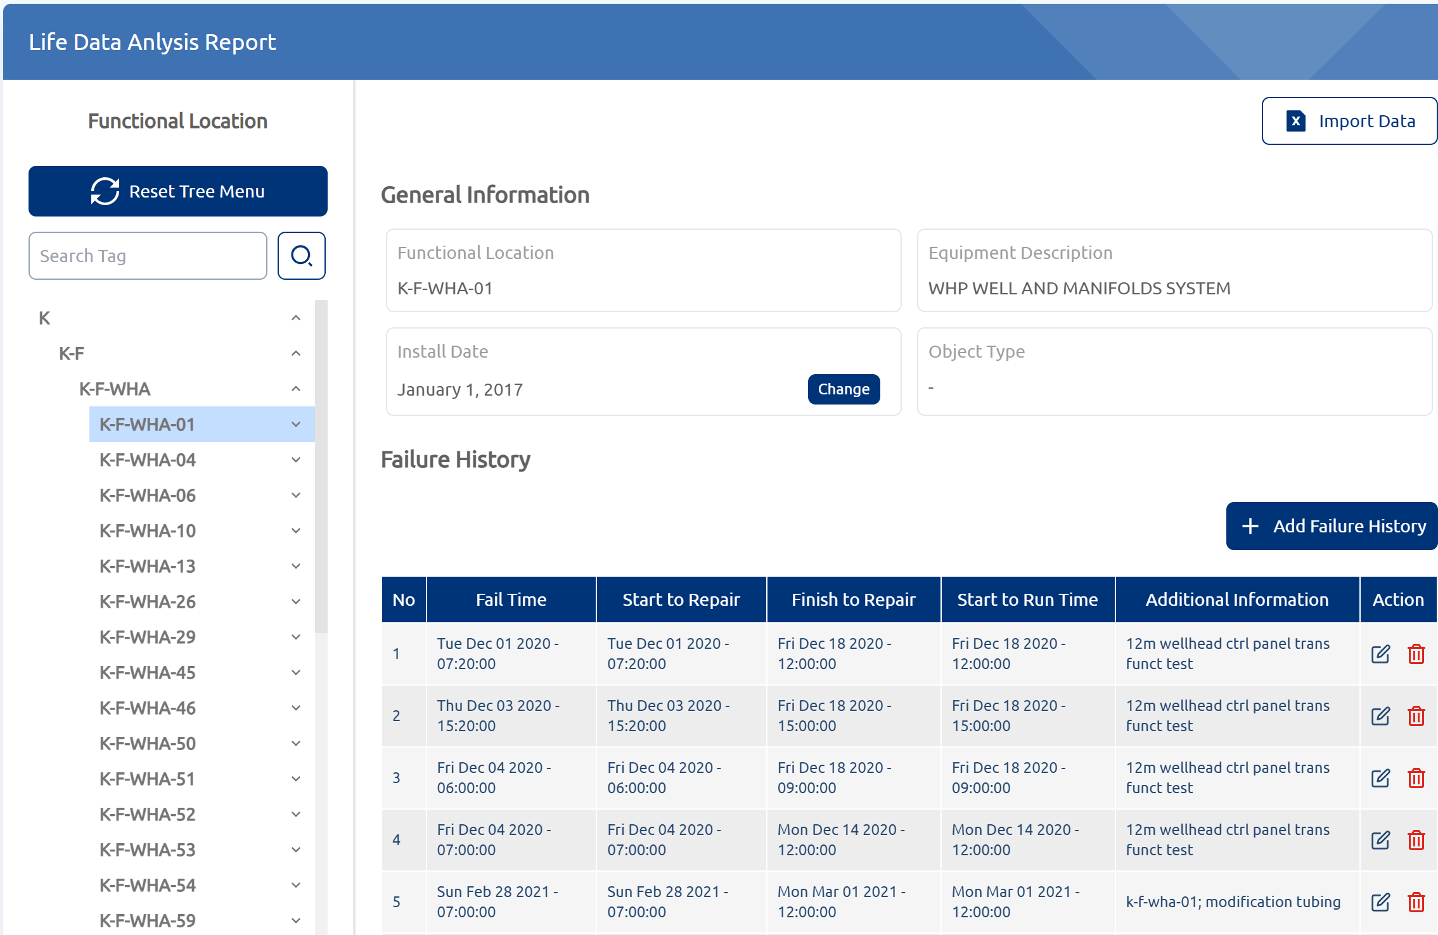
Figure V-25 Life data analysis module

Some of the key features provided in this module are:
- Add failure history
This feature allows users to input failure history data for a specific piece of equipment. The information entered includes fail time, start and end of repair time, start and end of run time, and additional relevant details. The data is then saved in the failure history table.
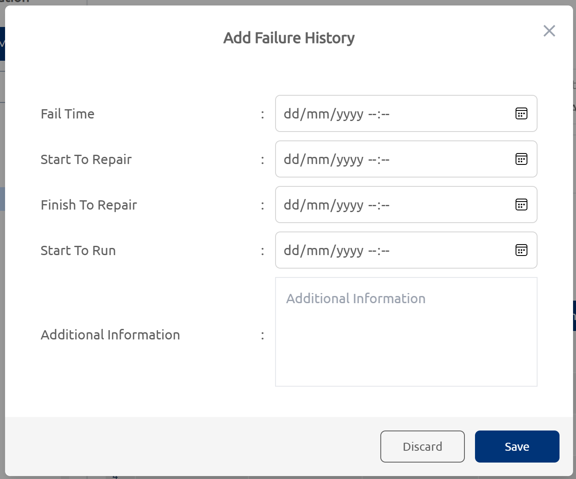
Figure V-26 Add failure history
- Import failure history data
In addition to manually adding failure history data, users can also import failure history information using an Excel file. Users can download the template, fill out the table with the relevant data, and then upload the completed Excel file through a designated window. The data will be automatically saved in the failure history table.

Figure V-27 Import excel file
- Distribution graph
This feature displays graphs of the reliability function over time, failure rate function, and probability density function, based on the failure history data. Users can select the distribution used in the calculations, including Weibull, exponential, or normal distribution.
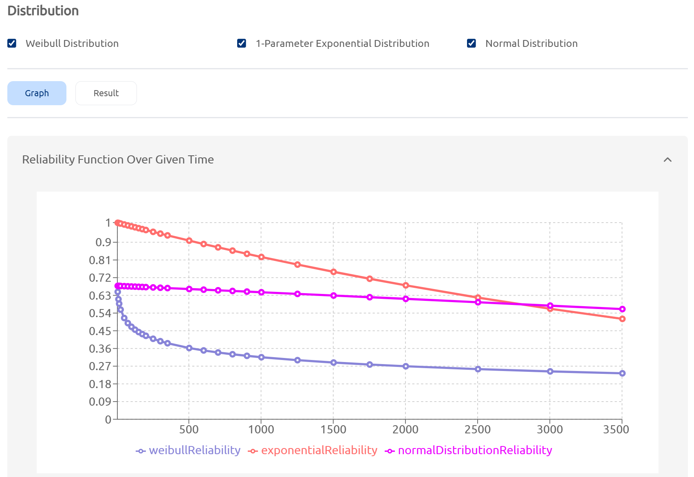
Figure V-28 Reliability function over given time graph
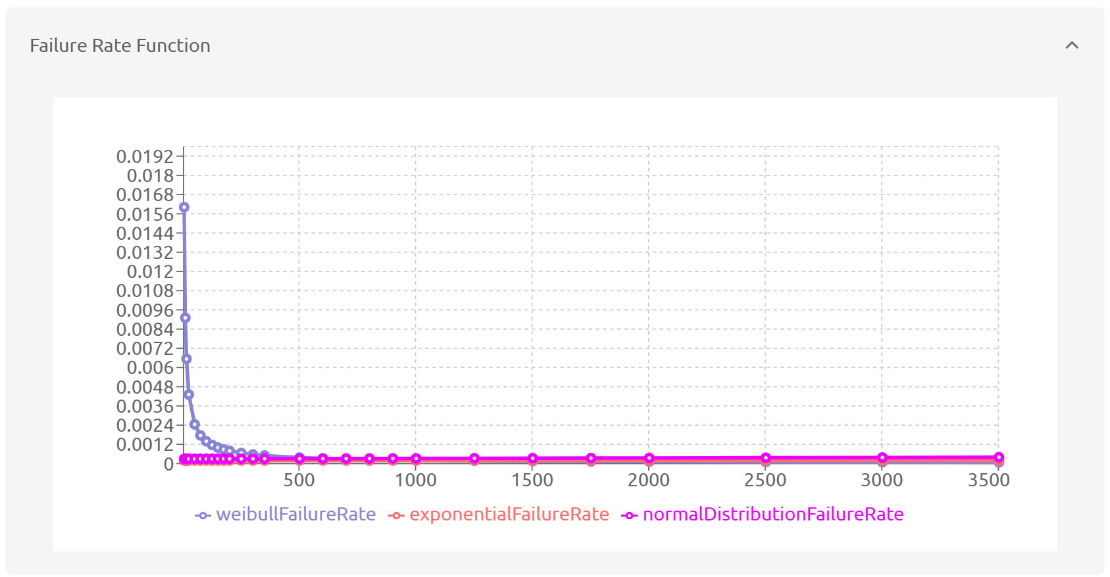
Figure V-29 Failure rate function graph
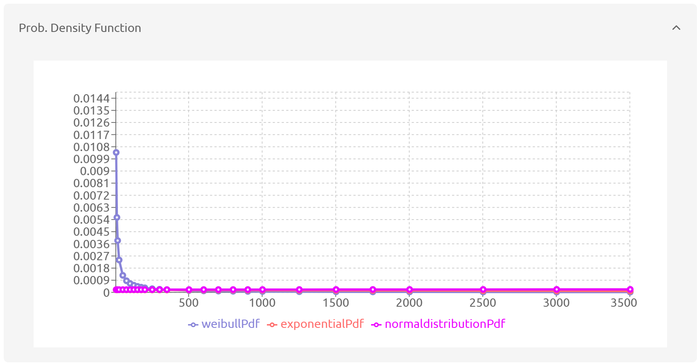
Figure V-30 Probability density function graph
- Calculation result
This feature displays calculation results based on the failure history data. Users can choose which distribution to use for the calculations, including Weibull, exponential, or normal distribution. The displayed results include Reliability, Mean Time to Repair (MTTR), Mean Time Between Failures (MTBF), failure rate, inherent availability, and shape and scale parameters for Weibull distribution. Users can adjust the input hours to obtain reliability values for specific times or modify the reliability value to determine the operating time required to achieve the desired reliability.
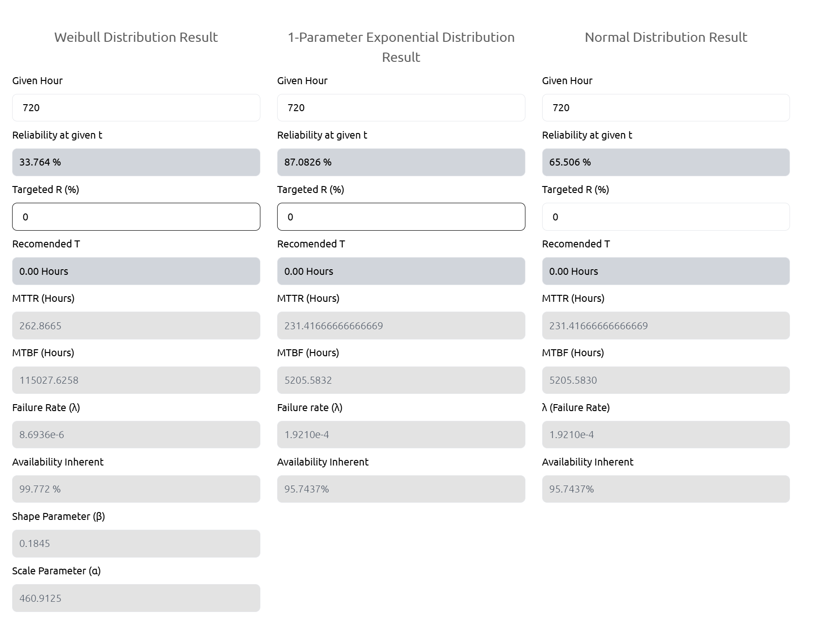
Figure V-31 Life data analysis calculation result

Reliability Block Diagram
If the reliability of equipment is assessed through life data analysis, then reliability block diagrams (RBD) are used to calculate the reliability of a system or platform. This module enables users to construct a comprehensive RBD for their system or platform, offering extensive flexibility with numerous configuration options to tailor the RBD to their specific needs.
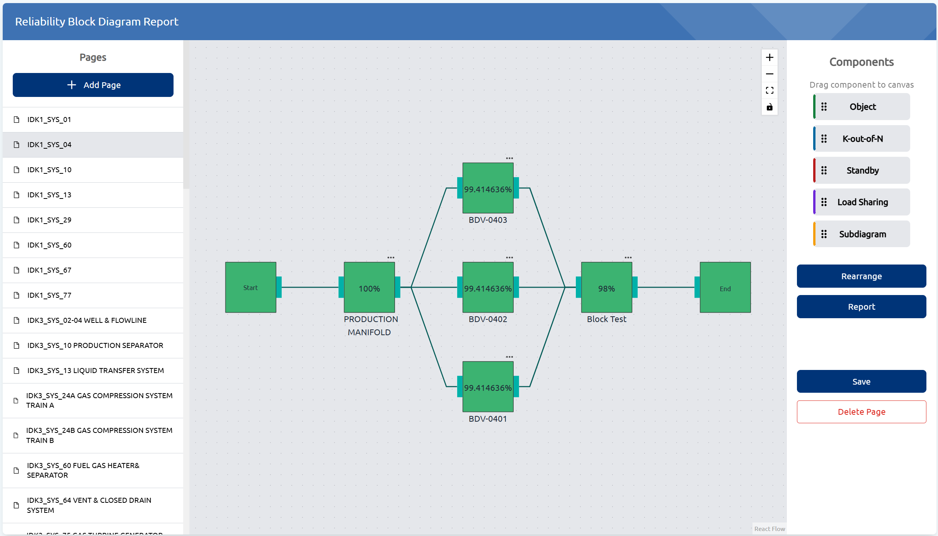
Figure V-32 RBD module
Some of the key features in this module are:
- Add page
To create the RBD, users must first add a new page where the diagram will be developed. User also need to assign a title to this page.
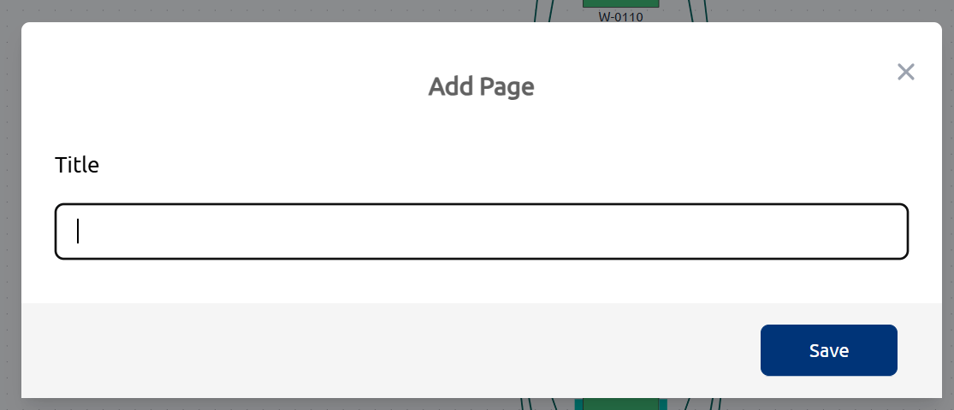
Figure V-33 Add page
- Insert object
To add a block or configure a simple RBD, users can drag the 'object' button from the right side of the page onto the RBD canvas. Users can then connect each block according to the desired configuration.
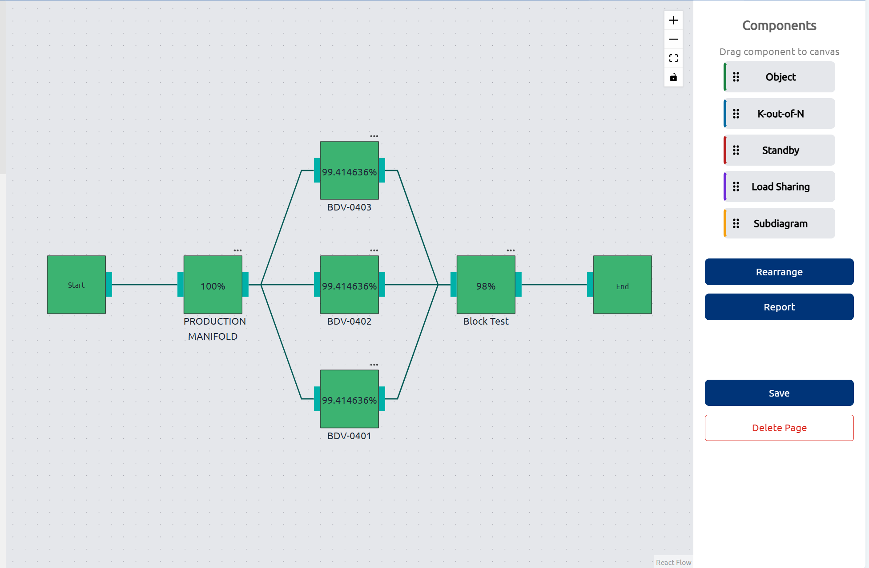
Figure V-34 Insert object to make a simple RBD
- K out of N configuration
To create a more complex RBD, users can utilize the "K out of N" configuration by dragging the "K out of N" button onto the RBD canvas.
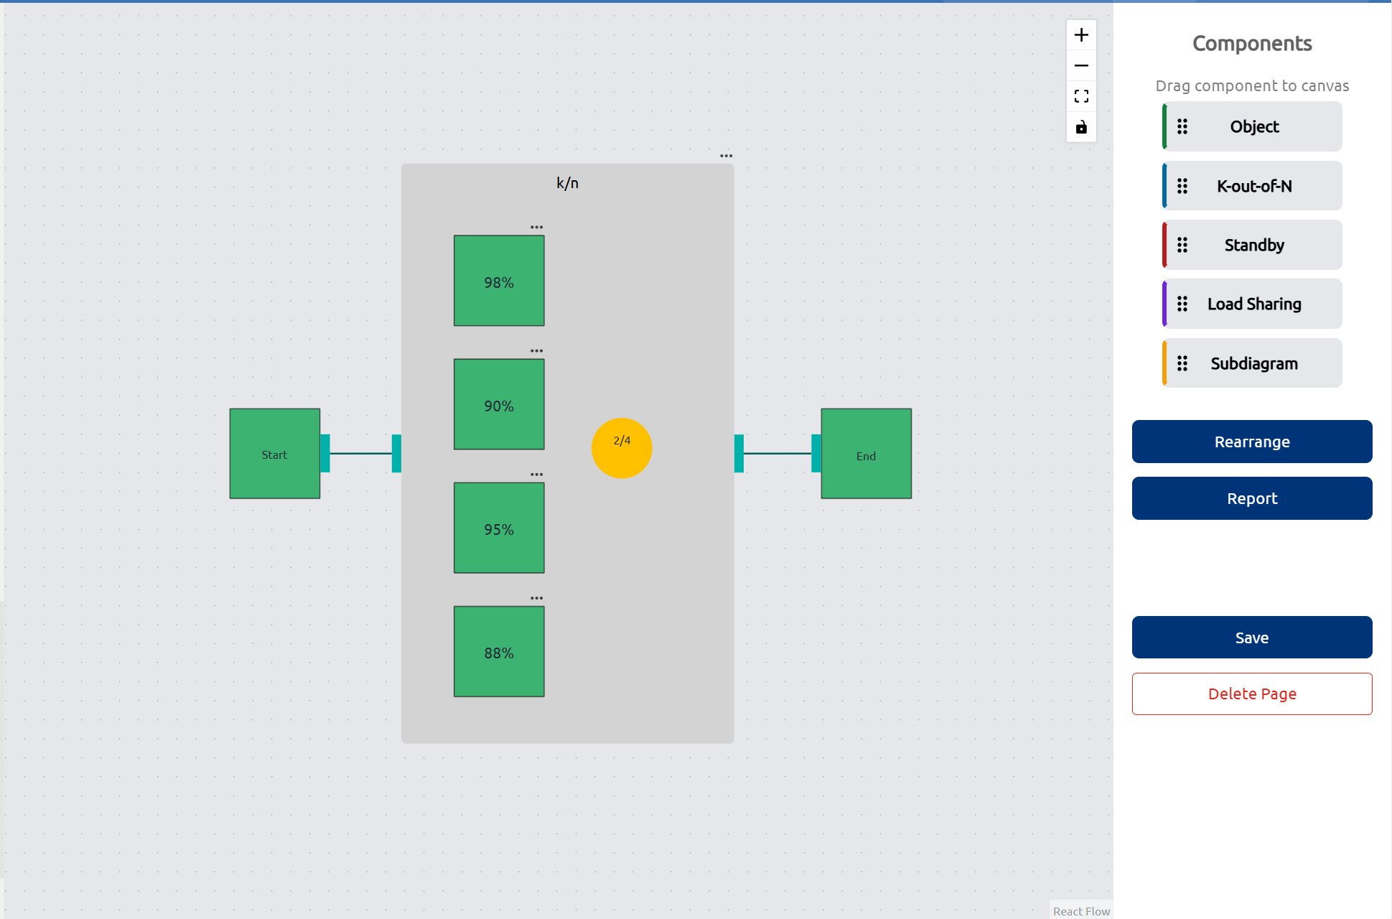
Figure V-35 K out of N configuration
- Standby configuration
For equipment with standby units that serve as backups in the event of a failure, users can create an RBD using the standby configuration by dragging the "Standby" button onto the RBD canvas.
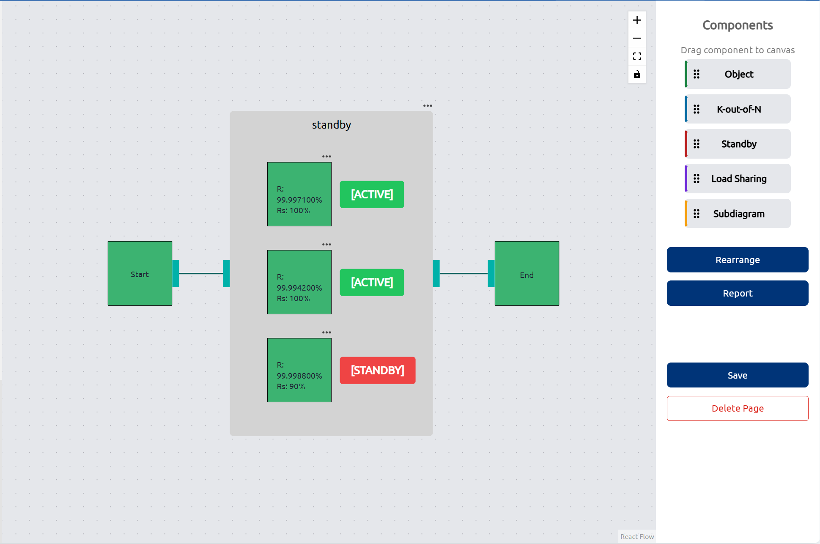
Figure V-36 Standby configuration
- Load sharing configuration
For scenarios where multiple identical pieces of equipment operate simultaneously to perform the same task, such as configurations like 2x50% or 3x50%, users can apply the load sharing configuration by dragging the "Load Sharing" button onto the RBD canvas.
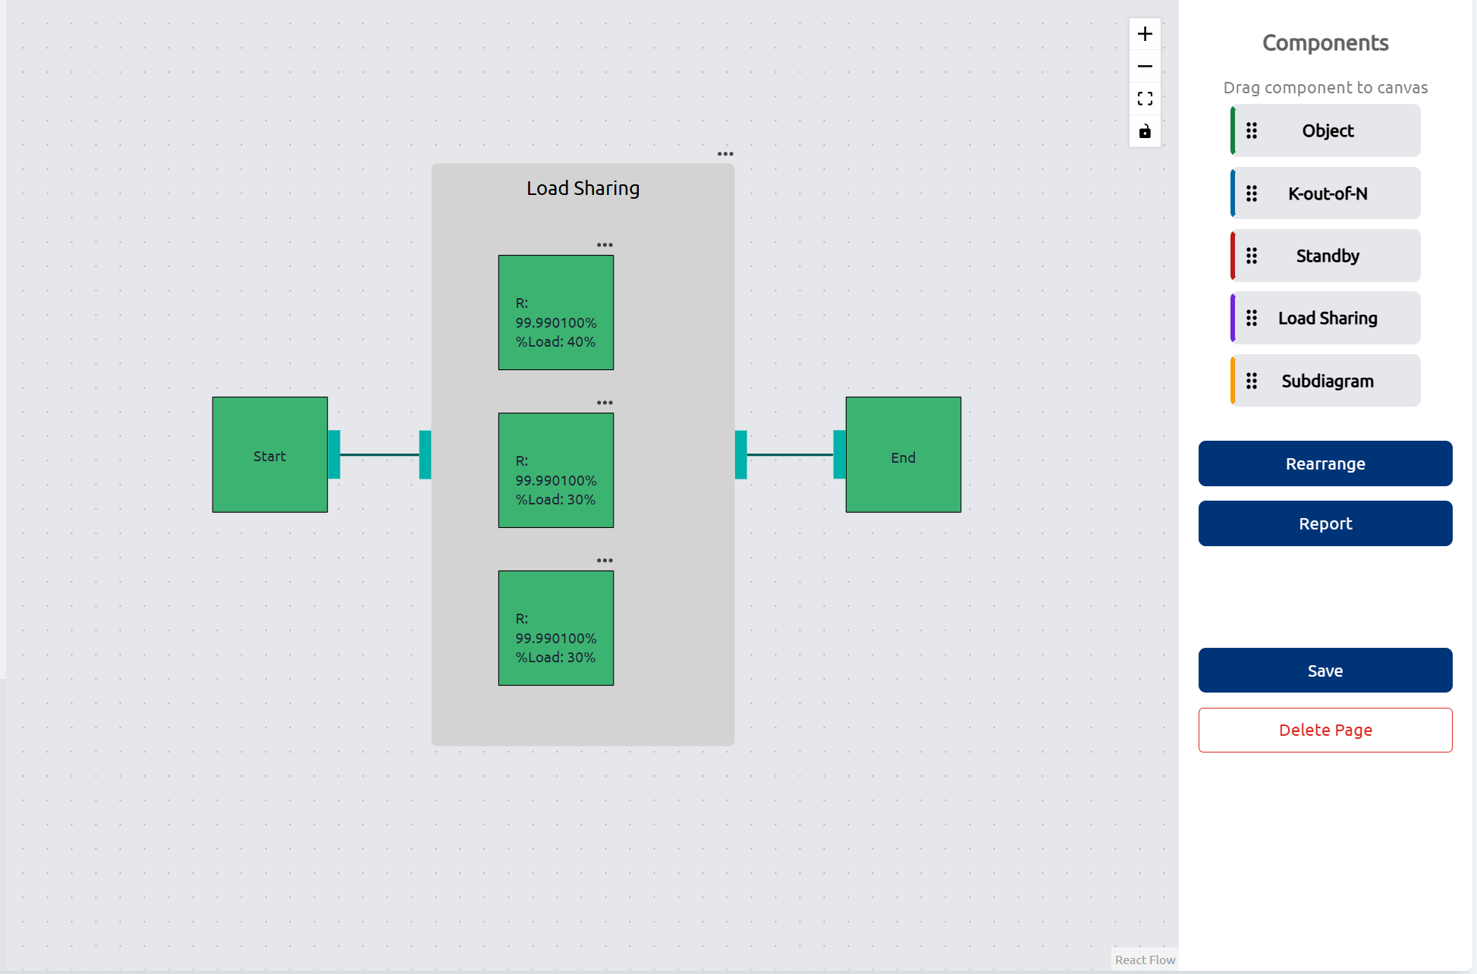
Figure V-37 Load sharing configuration

- Subdiagram
The subdiagram feature is used to combine RBDs from multiple pages. This feature is ideal for creating an RBD for a platform comprising several systems, each with its own configuration.
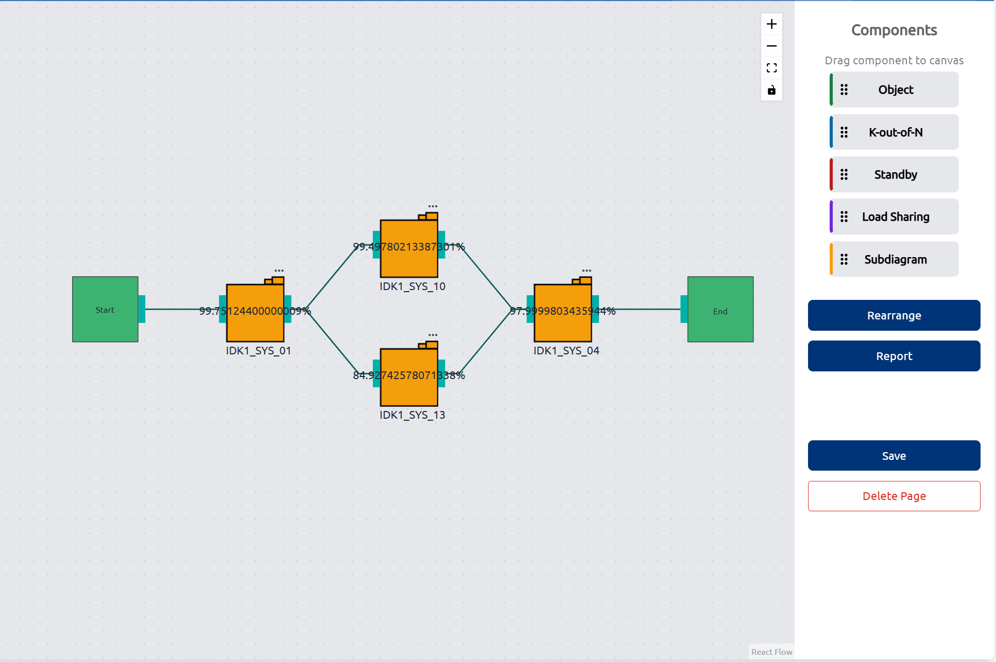
Figure V-38 Subdiagram
- Rearrange block
This feature is designed to organize and tidy up the appearance of the RBD created by users. It enhances the clarity and readability of the diagram, making it easier to understand and analyze complex reliability structures.
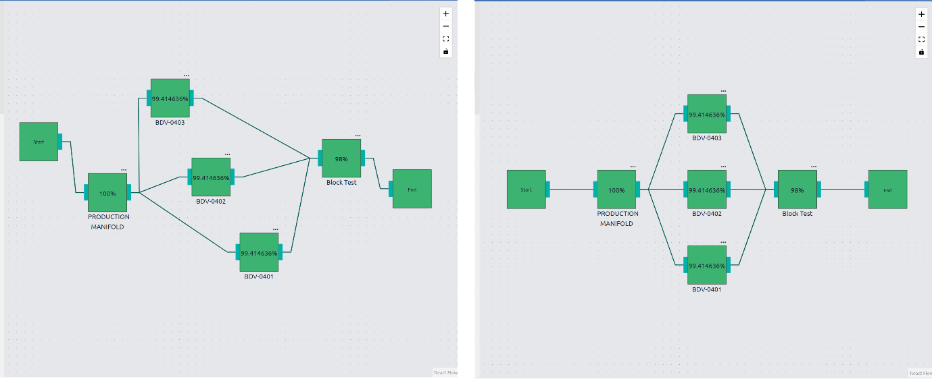
Figure V-39 Before and after rearrange

- Report
This feature calculates the reliability of the selected RBD. By analyzing the configurations and connections within the diagram, it provides a detailed reliability assessment, helping users evaluate the performance and dependability of their systems.
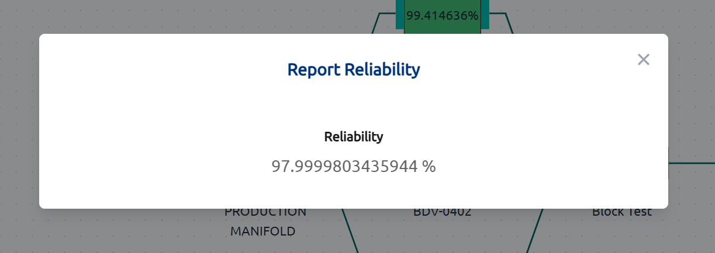
Figure V-40 Reliability report

Reliability Centered Maintenance (RCM)
This module is designed to facilitate Reliability Centered Maintenance (RCM) assessments. Within this module, there is a table that lists the failure modes for which maintenance task strategies will be developed. The failure modes displayed in this table are those that have been added to RCM from the FMEA module (section V.4.6.)
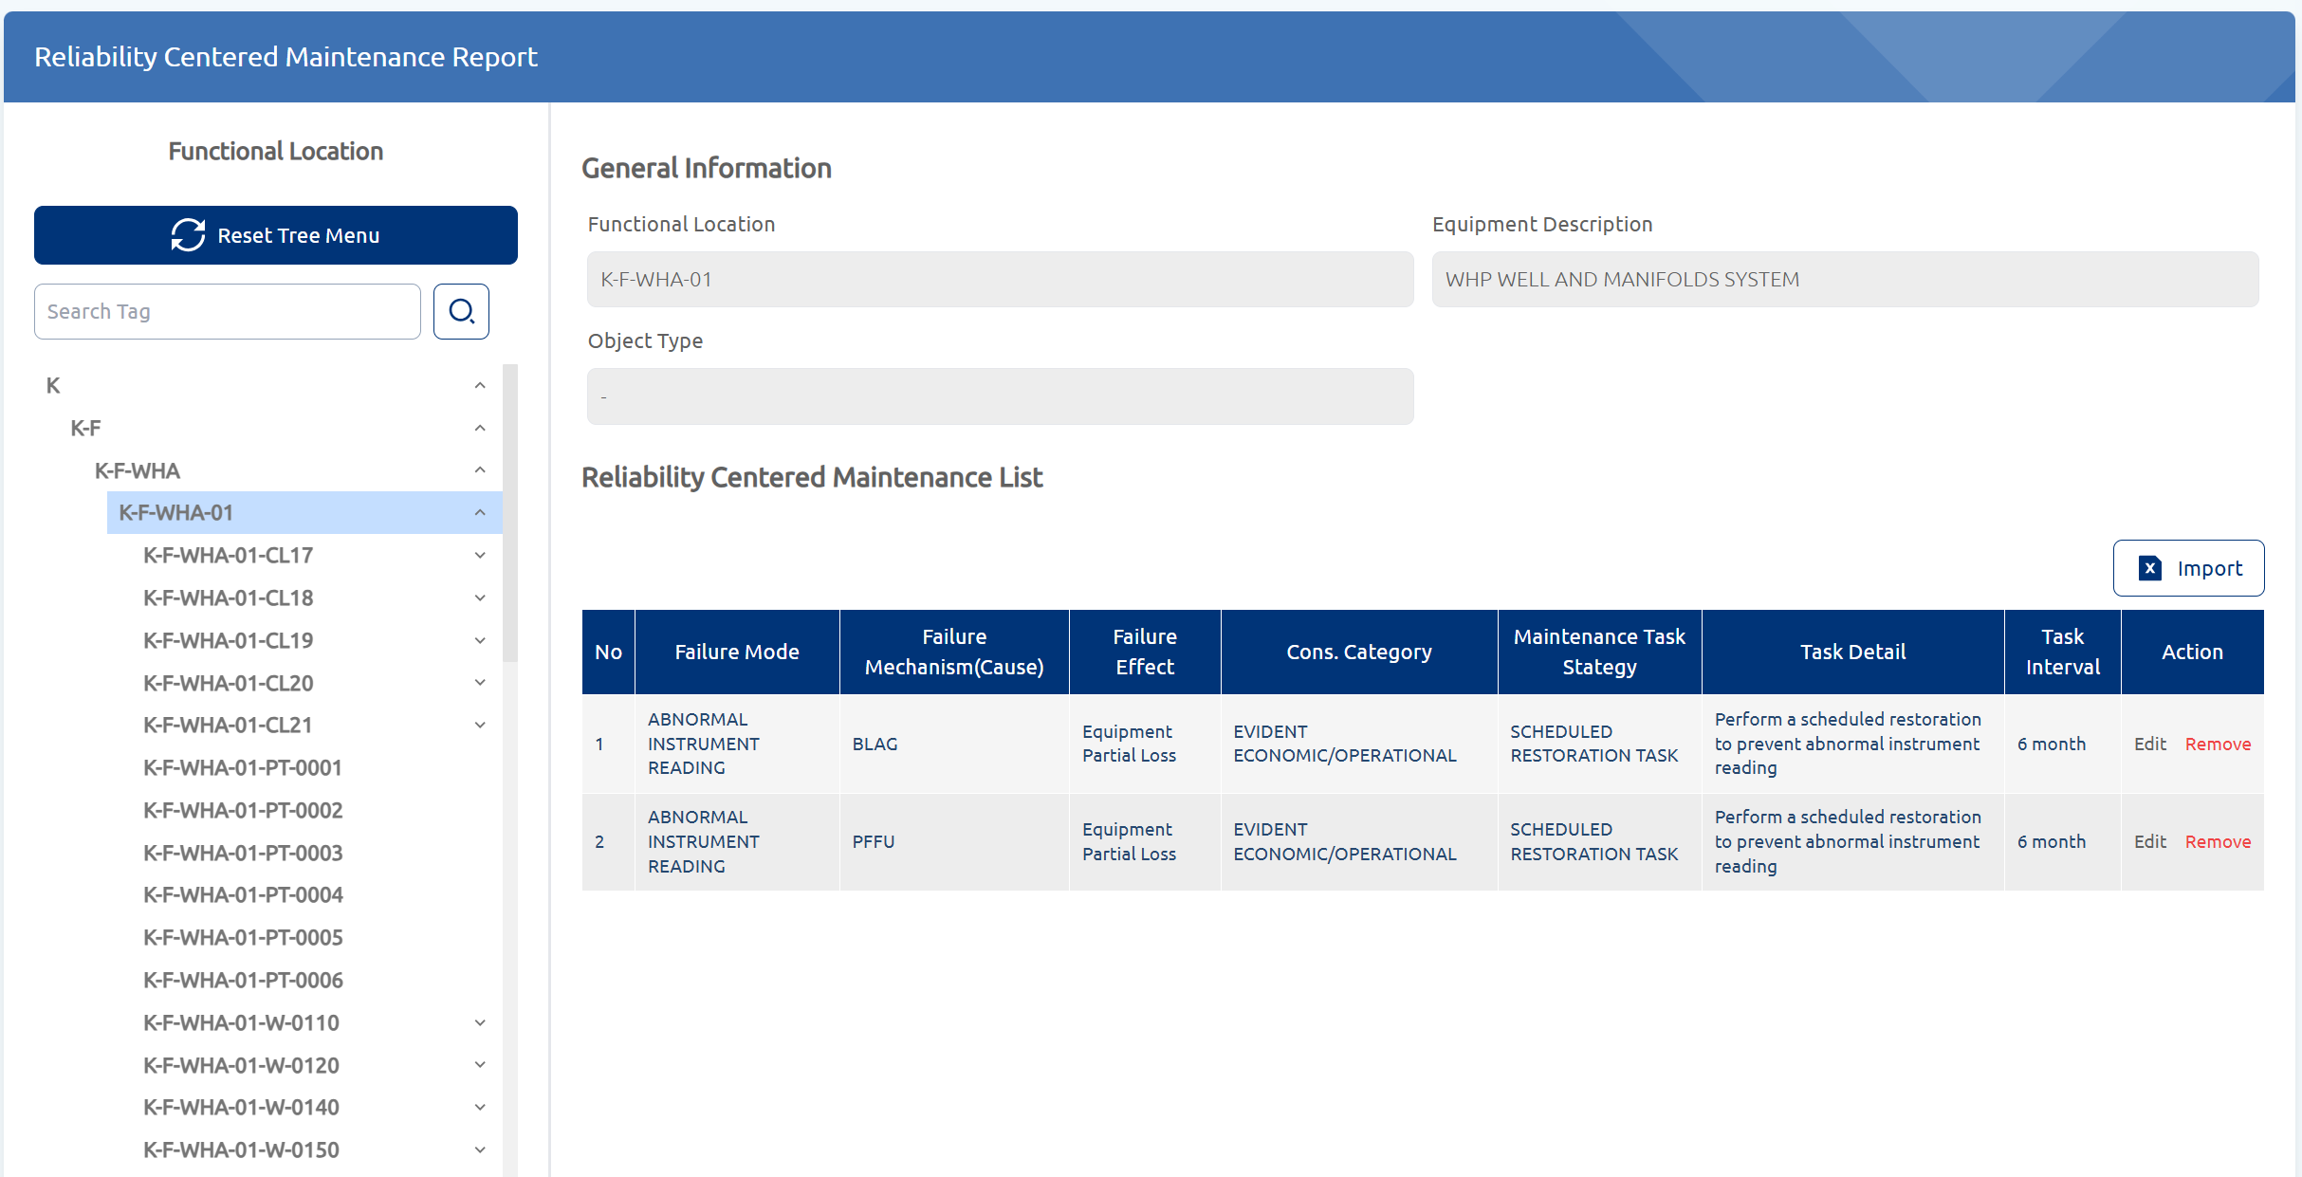
Figure V-41 RCM module
Some of the key features provided in this module are:
- Edit task
This feature is used to determine the maintenance task strategy for a specific equipment's failure mode. The information input by the user includes the consequence category, maintenance task strategy, task details, and task interval.
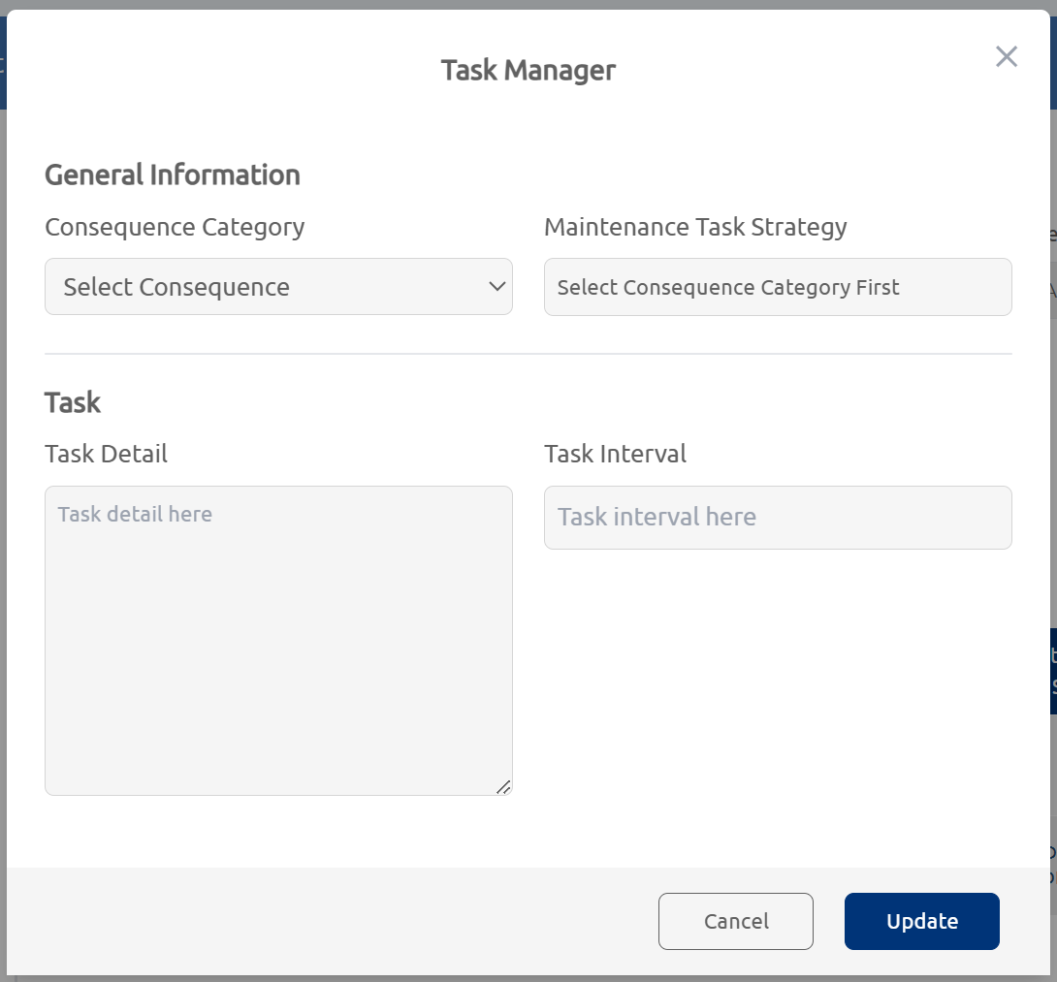
Figure V-42 Edit task
- Remove task
If the user wishes to delete an existing maintenance task strategy, this feature can be utilized. It will remove all information previously entered in the edit task feature, allowing the user to input new, more accurate information.
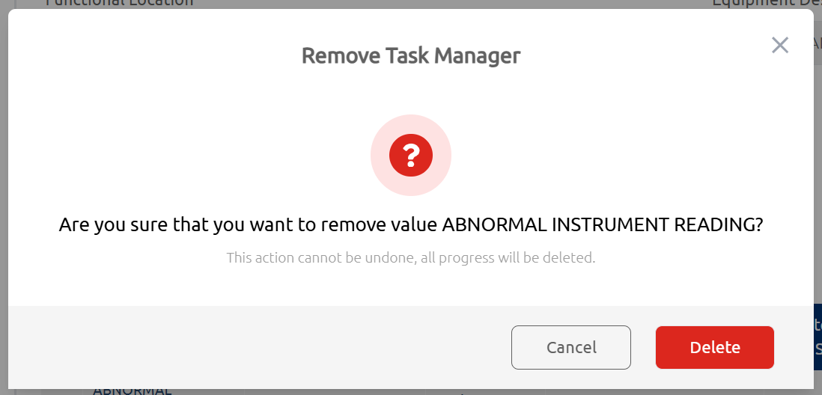
Figure V-43 Remove task
- Import data
With this feature, users can input maintenance strategy data for multiple failure modes simultaneously. Users need to download the provided Excel template, fill in the table, and then upload the completed Excel file through the designated window.

Figure V-44 Import excel file

Inspection, Testing, and Preventive Maintenance (ITPM)
This module is designed to facilitate the development of strategies for Inspection, Testing, and Preventive Maintenance (ITPM). The ITPM list table includes information such as the equipment and its description, the type of equipment (e.g., instrument or electrical), risk category information, SCE status, tasks for inspection, testing, or preventive maintenance, task frequency, and the duration required to complete each task.
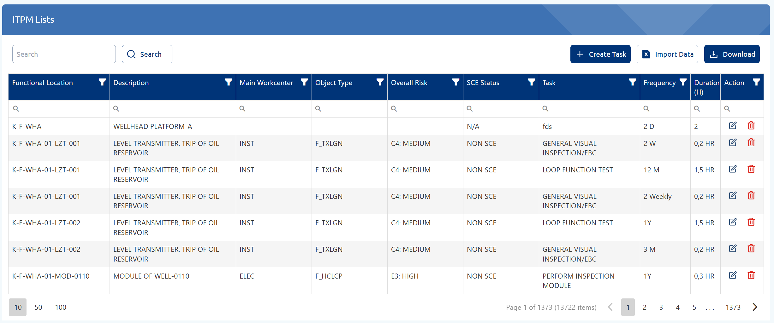
Figure V-45 ITPM Module
Some of the key features featured in this module are:
- Create task
This feature is used to create new tasks for inspection, testing, or preventive maintenance. The information that users need to input includes general asset details, the detail of the task, task interval and duration, system conditions during task execution, the responsible party for carrying out the task, and the number of workers required to complete the task.
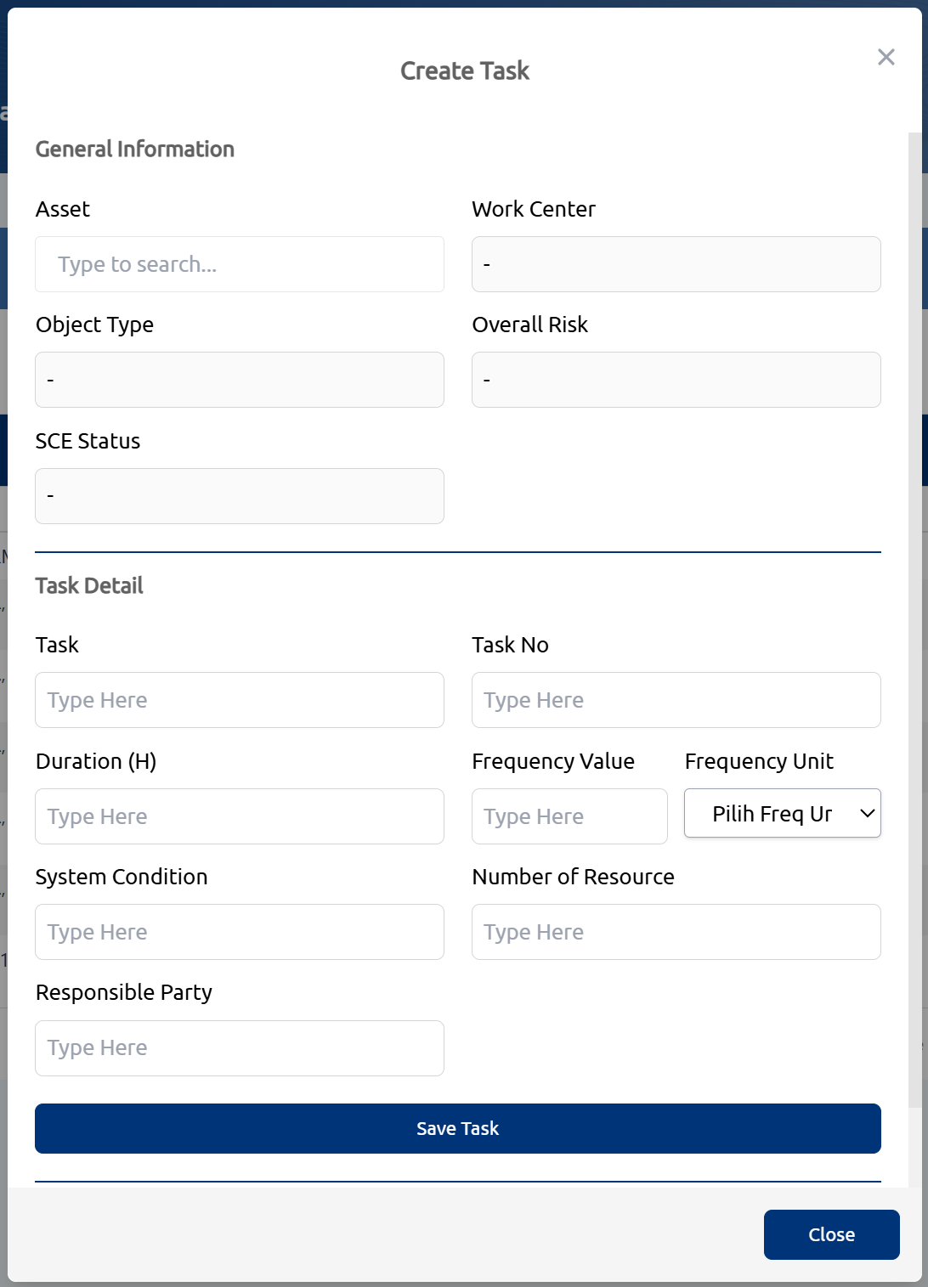
Figure V-46 Create ITPM task
- Import data
This feature allows users to input multiple ITPM task data simultaneously. Users need to download the provided Excel template, fill in the table, and then upload the completed Excel file through the designated window.

Figure V-47 Import excel file
- Export data
This feature allows users to export the data from the ITPM list table into an Excel format and save it to their computer’s internal storage.
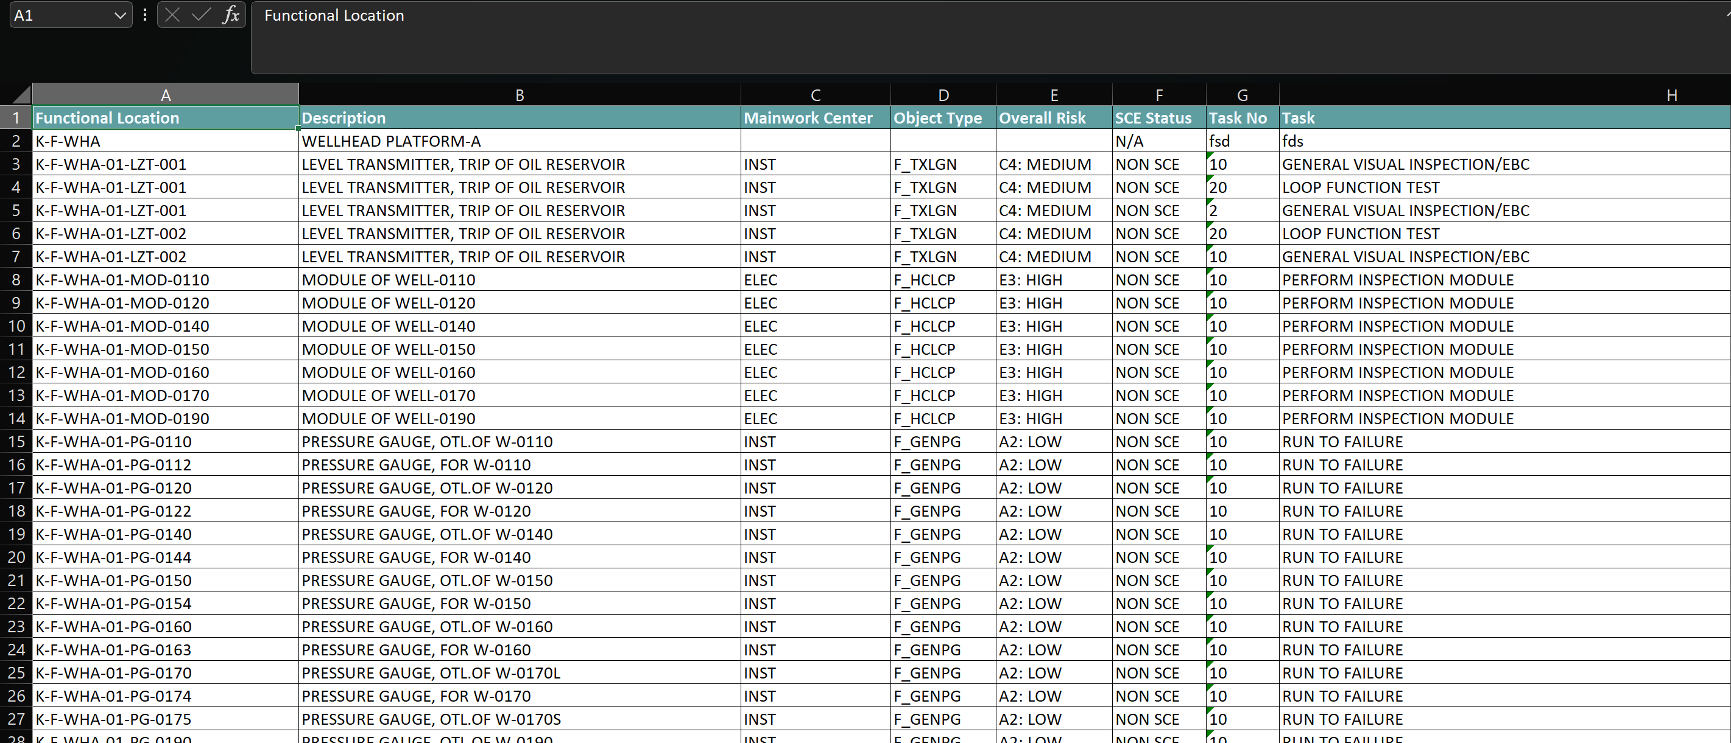
Figure V-48 Export data to excel file

Risk Based Inspection (RBI)
The Risk-Based Inspection module is currently under development by CRI. The purpose of this module is to create inspection strategies for equipment at the pipeline, structure, and facility levels.
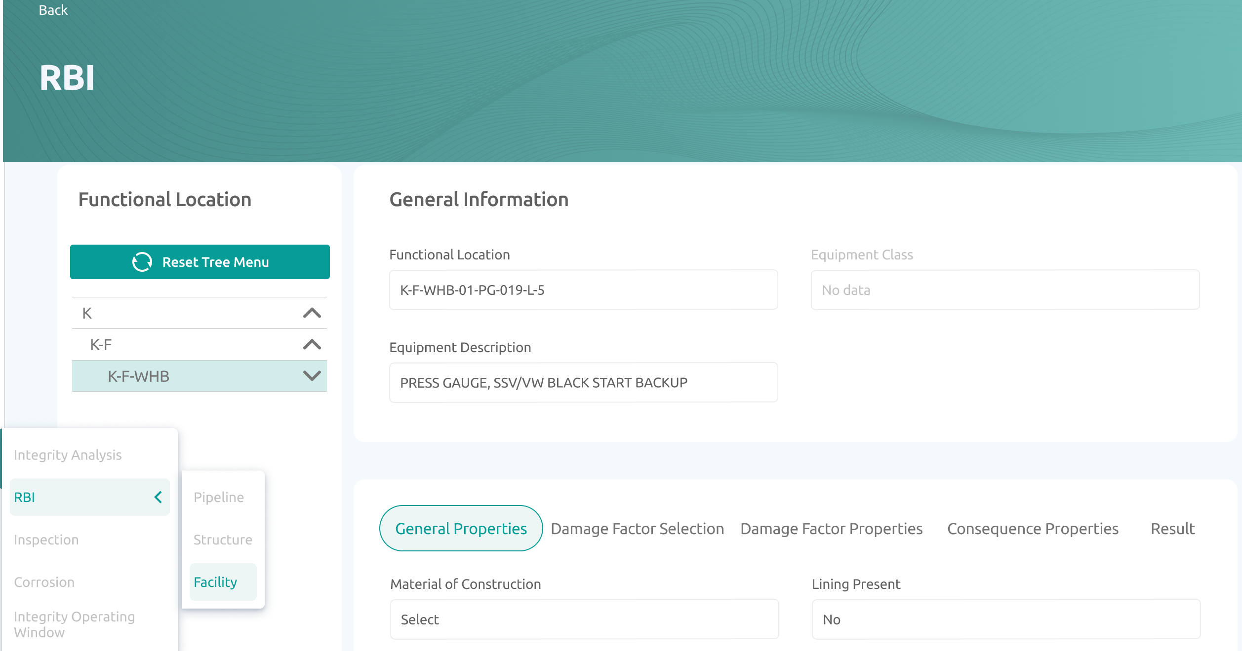
Figure V-49 RBI module
Some of the key features provided in this module are:
- Adding general properties of equipment
This feature allows users to enter the general properties of the selected equipment. Some of the properties that need to be input by the user include the material used, insulation type, fluid type and pH, operating pressure and temperature, and more.
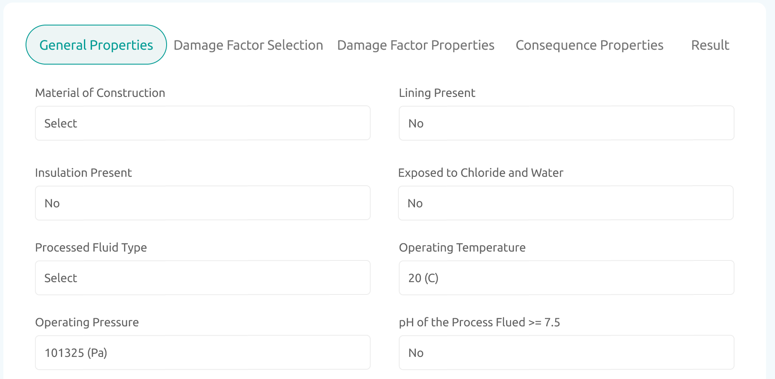
Figure V-50 Adding general properties
- Damage factor selection
This feature allows users to identify the damage factors that may cause deterioration of the selected equipment. A list of damage factors is provided, and users can simply choose the ones that are applicable.
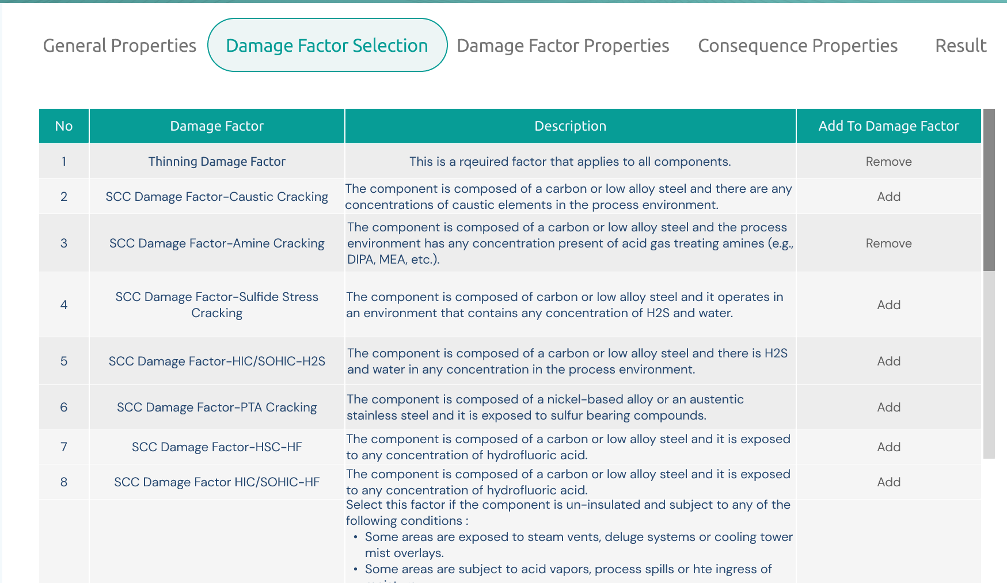
Figure V-51 Damage factor selection
- Damage factor properties
In this feature, users will enter the information or properties of the selected damage factors. The properties to be input will vary depending on each specific damage factor.
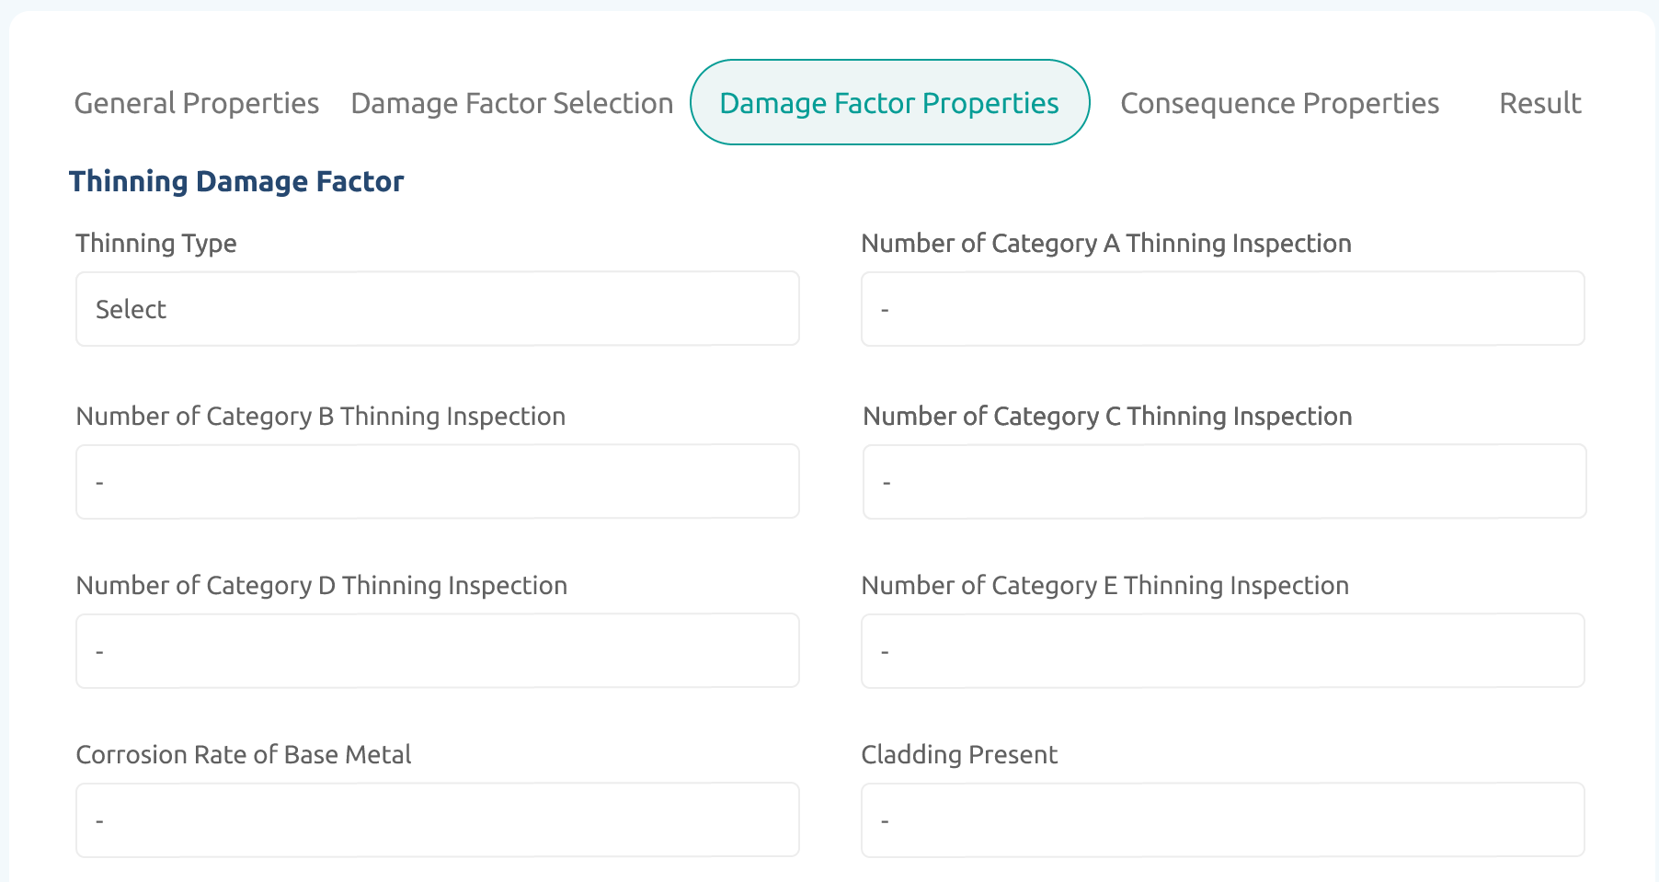
Figure V-52 Damage factor properties
- Consequence properties
This feature allows users to determine the consequence properties of the equipment in the event of damage or leakage. The consequence properties entered by the user include flammability, toxicity, and financial impact.
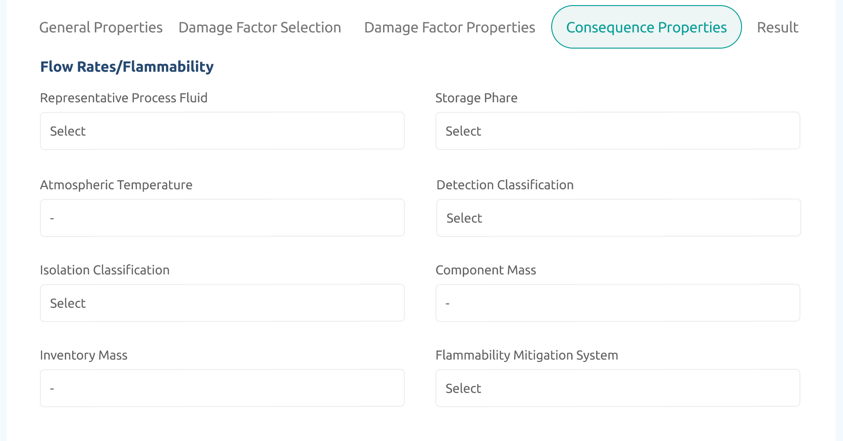
Figure V-53 Consequence properties
- RBI result
In this feature, all calculation results based on the information provided by the user in the previous features will be displayed. The information shown includes, among other things, the area and financial consequence results, damage factor calculations, and recommended inspections that can be conducted.
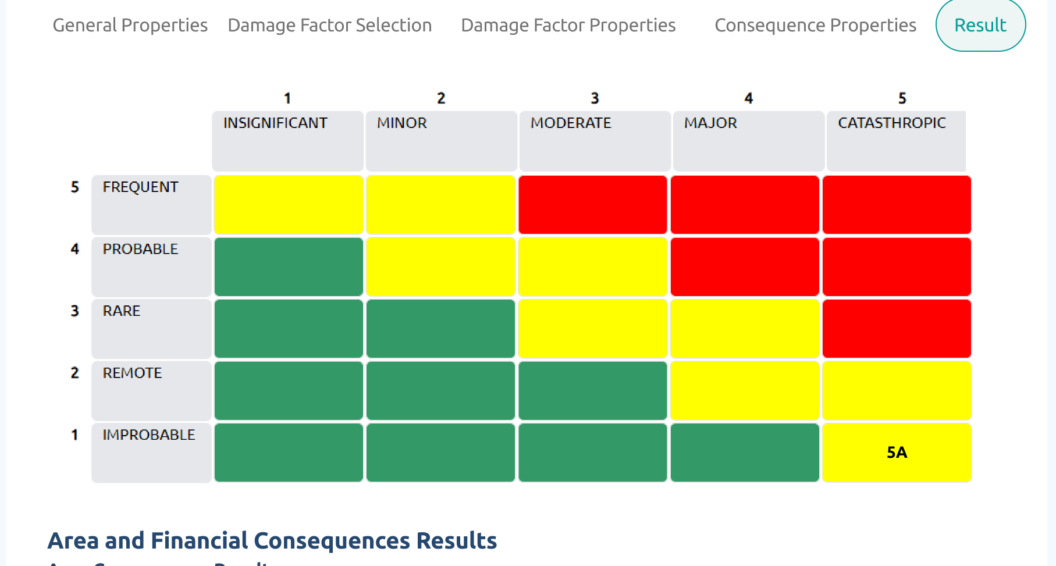
Figure V-54 RBI Result

Corrosion Management
This module is designed for monitoring corrosion in owned equipment. It is currently in the design phase. Users will group several pieces of equipment into a single group or circuit based on the material used, the type of insulation, the fluid flowing through the equipment, as well as the operating temperature and pressure.
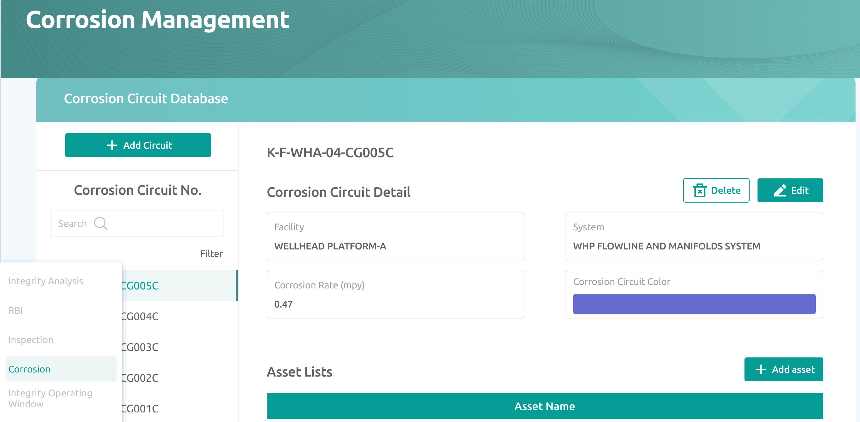
Figure V-55 Corrosion management module
Some of the key feature featured in this module are:
- Add Circuit
With this feature, users will define groups or circuits for similar equipment based on site, facility, reference P&ID and PFD, service fluid, insulation, and other criteria. Users will also input circuit numbers to differentiate one circuit from another.
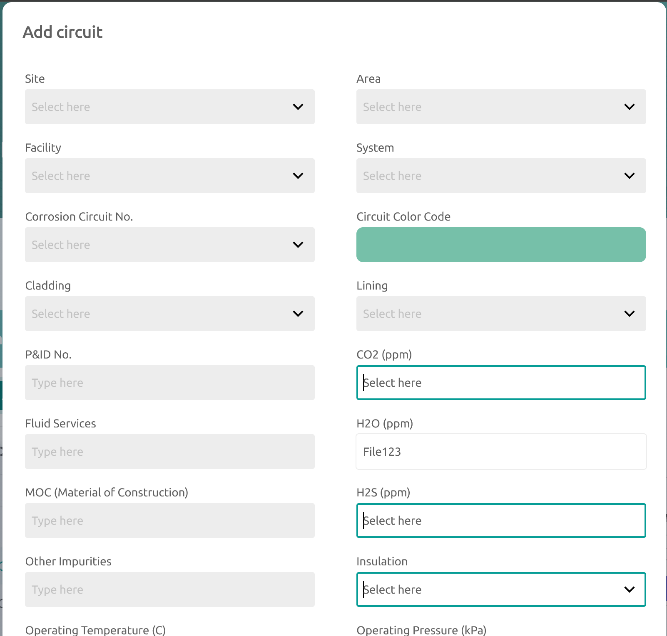
Figure V-56 Add circuit
- Adding asset list
In this feature, users will select the list of assets that are included in the previously created circuit or group. Only assets that have been registered in the asset register can be chosen.
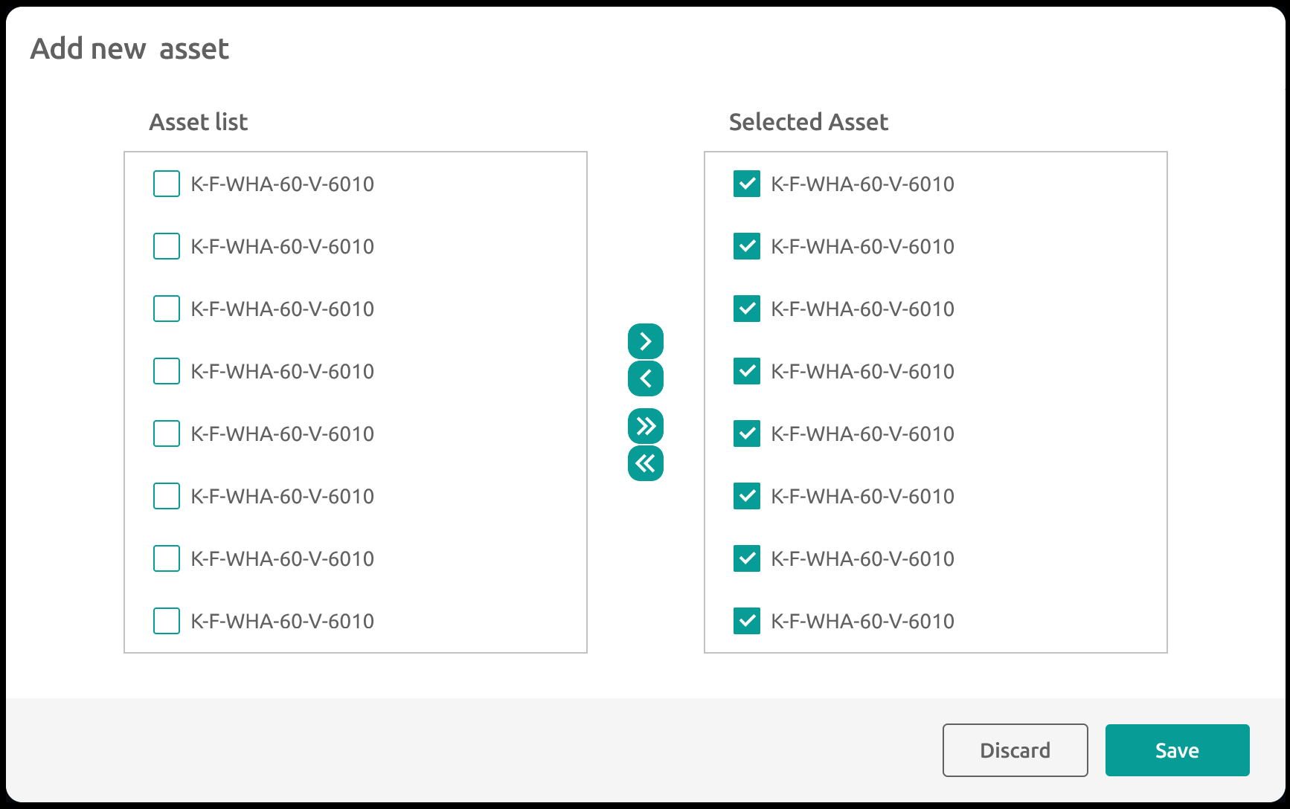
Figure V-57 Add asset list
- Adding damage mechanism
With this feature, users can select the damage mechanisms that may occur in the equipment grouped within a specific circuit. A dropdown list of damage mechanisms is provided, and users can simply choose the appropriate ones and add a brief description.
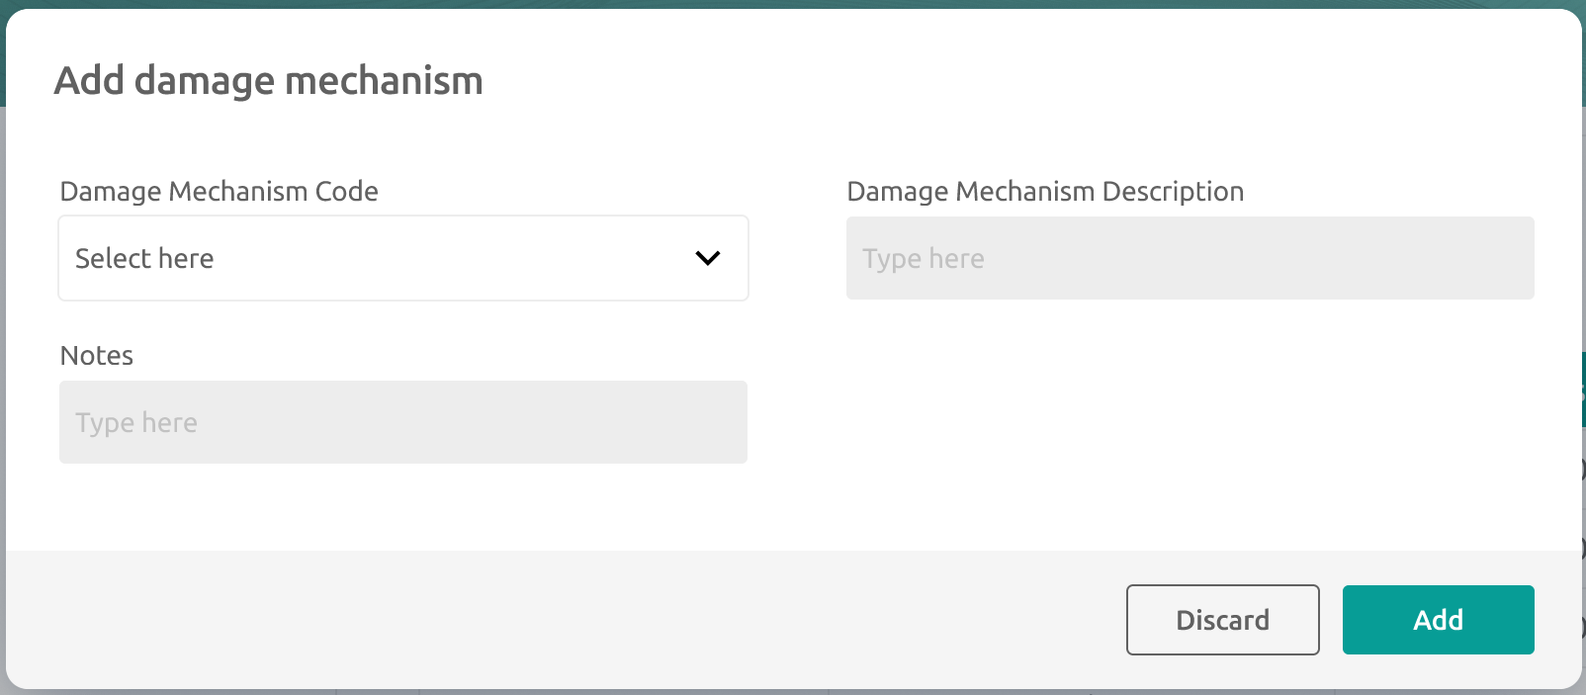
Figure V-58 Add damage mechanism
- Adding reference drawing
To simplify the monitoring and identification of assets within a specific circuit, a feature allows users to input reference drawings, such as P&IDs and PFDs. This enhances accuracy and efficiency by providing easy access to essential documentation for effective asset management.
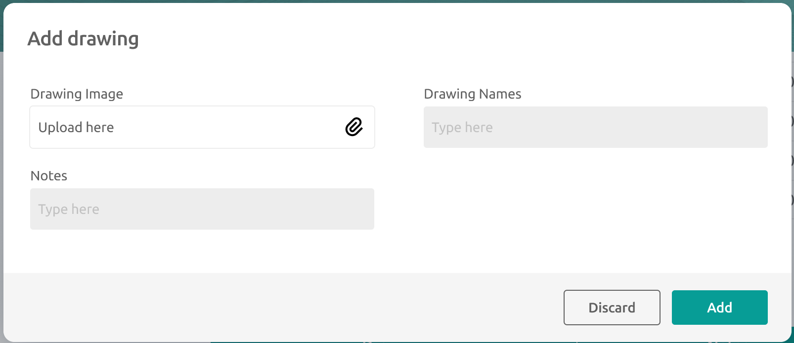
Figure V-59 Add reference drawing
- Corrosion monitoring method
In this module, users will enter information for various available corrosion monitoring methods. The module includes several methods, such as corrosion coupons, corrosion probes, online ultrasonic testing (UT), fluid sampling, solid sampling, and corrosion inhibitors. Users will input the necessary information for each corrosion monitoring method.
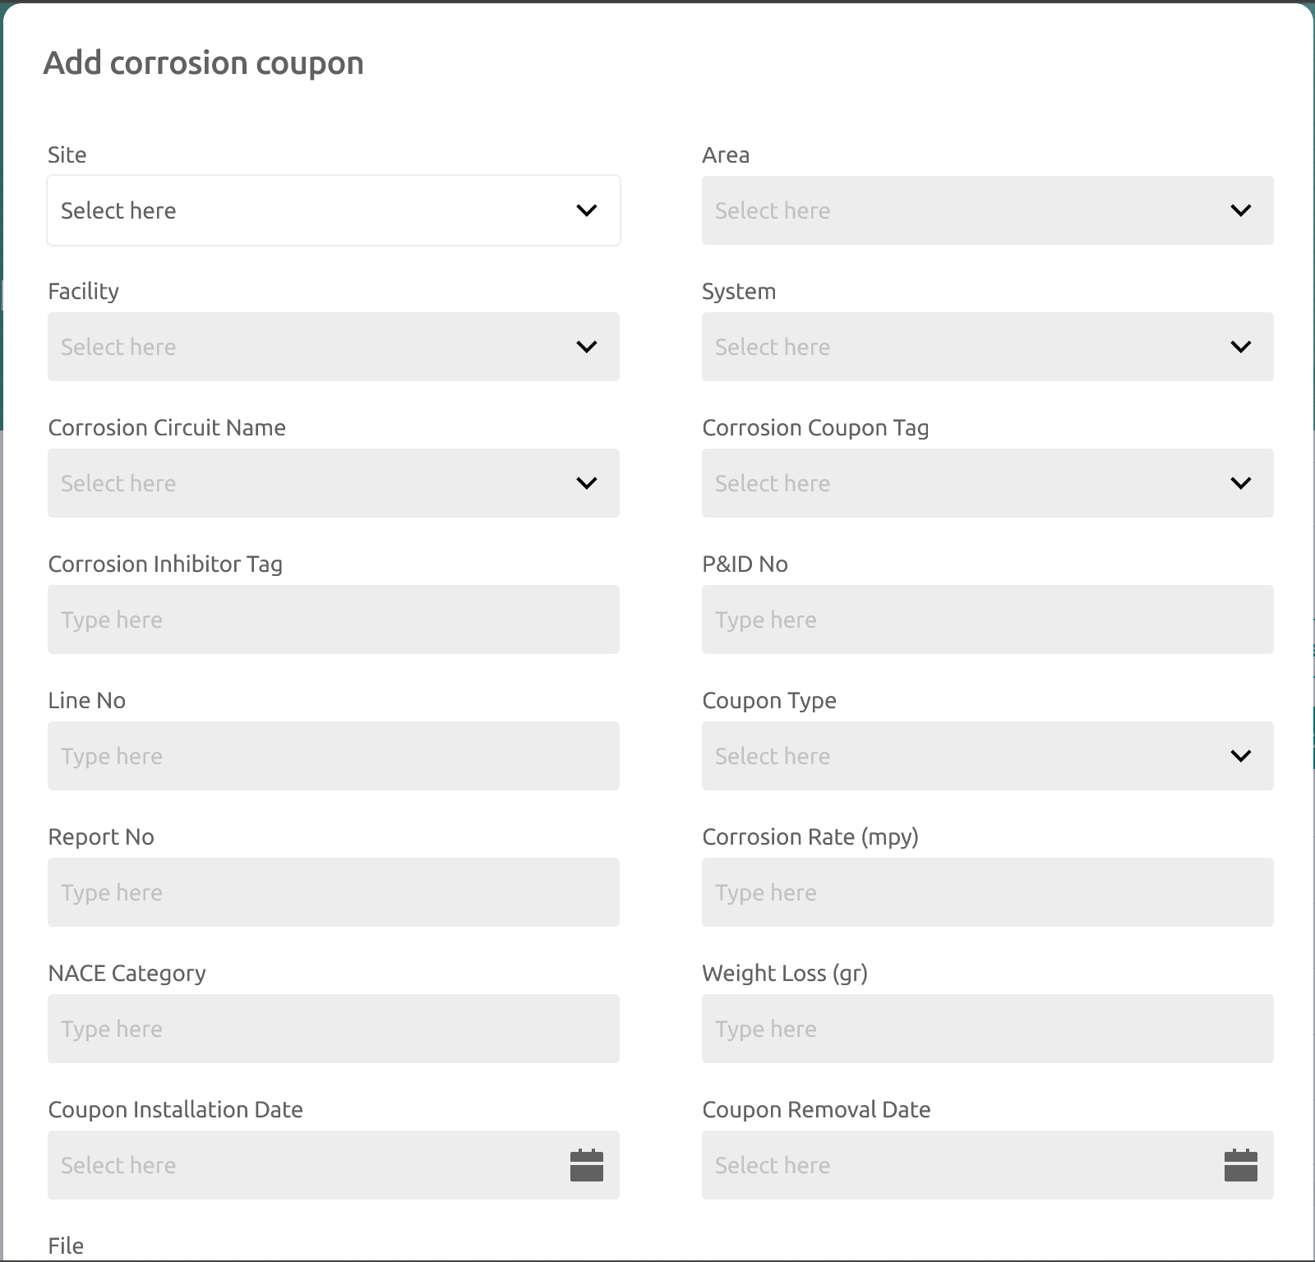
Figure V-60 Adding corrosion monitoring method (corrosion coupon)
- Corrosion monitoring
In this module, users can view the corrosion rate results from all available corrosion methods. The information is displayed in the form of a graph showing corrosion rate versus time.
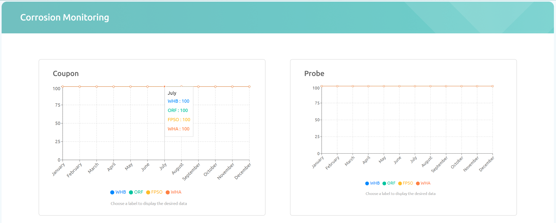
Figure V-61 Corrosion monitoring

RIGHTS AND RESPONSIBILITIES
As our valued client, JSP have certain rights and responsibilities that contribute to the success and efficiency of this work.

Rights
JSP rights are described as following:
- Quality of Service:
JSP is entitled to receive high-quality and professional consulting services in line with industry standards.
- Transparency:
JSP has the right to clear and transparent communication regarding the scope of work, project timelines, and associated costs.
- Project Understanding:
JSP has the right to ensure that the consulting team understands the project requirements and objectives.
- Evaluation:
JSP has the right to evaluate and provide feedback on the deliverables and progress of the project at agreed-upon intervals.
- Confidentiality:
JSP's information and data will be treated with the utmost confidentiality, and CRI will take necessary measures to protect sensitive information.

Responsibilities
JSP responsibilities are described as following:
- Vocal Point:
JSP shall appoint a designated vocal point who will serve as the primary representative for information communication on behalf of JSP.
Any detail task received by CRI will be represented by Vocal Point.
- Information Provision:
It is JSP's responsibility to provide accurate and timely information necessary for the successful execution of the consulting services.
- Cooperation:
JSP's active cooperation and collaboration are crucial to the smooth progress of the project. This includes providing timely approvals and responses
- Payment:
Timely payment of agreed-upon fees is a responsibility that ensures the continued provision of CRI's consulting services.
- Feedback:
Providing constructive feedback on the deliverables and promptly addressing any concerns will contribute to the refinement and success of the project.

QUALITY ASSURANCE
The work will be done in accordance with the procedures given in CRI’s Quality Management System that has been certified according to ISO 9001:2015. The Quality Assurance (QA) system is based on one main procedure, common for all the various activities in CRI, and several more detailed procedures and quality checks developed to suit each activity.
The quality system is based on a three-level check, which is performed and documented.
- Control of own work
- Quality check by experienced personnel
- Approval / independent control of the project and of the quality assurance
All information submitted to CRI will be treated as confidential.

Validity and Availability
The proposal is valid for 30 days from the date of issue. Beyond this date, the availability of resources could be amended: consequently, start-up time, schedule and associated prices would be modified accordingly.

Contact
We would like to thank you for the opportunity of proposal submission to JSP, we assure you of the best services of ours.

Sincerely yours,

Chandra Salim
Ir., M.T., IPM, AER, CMRP
Managing Director
PT Cliste Rekayasa Indonesia
+62 812 1981 0869
chandra.salim@cliste.co.id

CRI EXPERIENCES
Table VIII-1 CRI experiences on software development
No | Application Name  & Modules/Features | Location | Main Contractor  & End User | Duration of Work
1 | LDA Desktop App  Features:  - Asset List Creation  - Failure History Recording  - Characteristic Analysis  - MTBF Calculation  - MTTR Calculation  - Visualization and Reporting  - Iterative Improvement | Jakarta | PT. LAPI ITB  End User:  PERTAMINA RU VII KASIM | March 2024 – June 22024
2 | PRAISe (Petronas Reliability & Asset Integrity Integrated System)  Modules:  - Asset Register  - Equipment Criticality Analysis (ECA)  - SCE  - SCE Performance Standard  - FMEA  - LDA  - RBD  - RCM  - ITPM | Jakarta | PT. SPIE OIL & GAS SERVICES INDONESIA  End User:  PETRONAS CARIGALI INDONEISA | July 2023 – February 2024
3 | PRIMES  Modules:  - Asset Register  - Spare Part List – Equipment (SPL-E)  - Spare Part File – Equipment (SPF-E)  - Material Master | Jakarta | PT. CLISTE REKAYASA INDONESIA  End user:  SPIE GLOBAL SERVICES ENERGY (THAILAND) | April 2023 – October 20224

