Mar 2026 - CRI2603P100-Rev 00
EXCELLENCE
WEB-BASED CUSTOMIZABLE
ANALYTICAL CMMS – PHASE 1
GENTING OIL KASURI PTE. LTD.

Prepared for:
Genting Oil Kasuri PTE. LTD.

Proprietary Notice

The information and data furnished in this document shall not be disclosed outside Genting Oil Kasuri PTE. LTD. and shall not be duplicated, used or disclosed in whole or part for any purpose other than to evaluate this proposal; provided, that if a contract is awarded to this offer or as a result of or in connection with the submission of this information / data, GOKPL shall have the right to duplicate, use or disclose the information/data to the extent provided in the contract.
This restriction does not limit GOKPL right to use information contained in the proposal if it is obtained from another source without restriction.
The information contained herein is to be used by the recipient solely for the purpose for which it was supplied. It shall not be disclosed in whole or in part, by any other party without the written permission of CRI.
CRI shall not be liable for any damages which the assignor, or assignor’s clients, vendors, consultants or other third party, may incur as a result of applying or using the results of CRI’s work, unless there is misconduct or gross negligence on the part of CRI or on the part of the persons used by CRI to carry out the work.

Document Info
Author(s) | Classification
Nadya Friska | Confidential

Title
EXCELLENCE – WEB BASED ANALYTICAL CMMS PHASE 1 FOR GENTING OIL KASURI PTE. LTD.

Extract
This proposal describes the technical aspects of EXCELLENCE web-based analytical CMMS Customizable Phase 1 for Genting Oil Kasuri PTE. LTD. (GOKPL). The Phase 1 is to cover module: Asset Register, Spare Part Management, Asset Prioritization, Maintenance Task Development, Inspection Testing and Preventive Maintenance (ITPM), Work Order (WO) and Permit To Work (PTW).
Commercial and technical aspects are discussed in this proposal.

Project Info
End User | Clients Ref.
Genting Oil Kasuri PTE. LTD. (GOKPL) | Daniel Ridwan Silaban
 | Oddyanto Koloway
CRI Project No | CRI Project Name
CRI2601P100-Rev 00 | EXCELLENCE Phase 1 - GOKPL

Revision
Rev | Date | Author | Reviewed by | Approved by | Description
00 | Mar 10th 2026 | Nadya Friska | Habil Tria Sakti | Chandra Salim | 1st Submission

TABLE OF CONTENTS
TABLE OF CONTENTS 4
BACKGROUND 6
INTRODUCTION 9
I. PROPOSAL SUMMARY 10
II. DURATION & COMMERCIAL 11
II.1 Work Duration & Schedule 11
II.2 Commercial 12
II.2.1 Main Cost 12
II.2.2 Terms & Conditions 12
II.2.3 Payment Schedule 12
III. TECHNICAL 13
III.1 Work Deliverables 14
IV. METHODOLOGY 16
IV.1 Asset Management Concept 16
IV.2 Roadmap CMMS Development for GOKPL 16
IV.3 P1 Application Appropriation and Analysis of Needs 18
IV.4 P1 Application Plan & Design 18
IV.5 P1 Plan & Design Implementation 19
IV.6 P1 Application’s Testing & Update 20
IV.7 P1 On-Site Installation & Usage Assistance 20
IV.8 Maintenance Contract 21
V. EXCELLENCE CMMS 22
V.1 EXCELLENCE - Web-based Application 22
V.2 EXCELLENCE Brief Previews 23
VI. PROJECT TEAM & ELIGIBILITY 29
VI.1 Project Team 29
VI.2 CRI Eligibility 30
VII. RIGHTS AND RESPONSIBILITIES 31
VII.1 Rights 31
VII.2 Responsibilities 31
VIII. QUALITY ASSURANCE 32
VIII.1 Validity & Availability 32
VIII.2 Contact 32
IX. ANNEXES 33
IX.1 CRI Experiences 33

BACKGROUND
Reliability comes with the basic idea of maintenance: how to maintain a system to keep the system running its function within the expected time. Since reliability does not exclusively belong to asset handling, it has been being developed to be one of fundamental elements of industries to control its business sustainability and quality. Along this line, there are 5 pillars that internationally recognized to be simultaneously established for Maintenance & Reliability EXCELLENCE goals: Business & Management, Manufacturing Process Reliability, Equipment Reliability, Leadership & Organization, and Work Management.
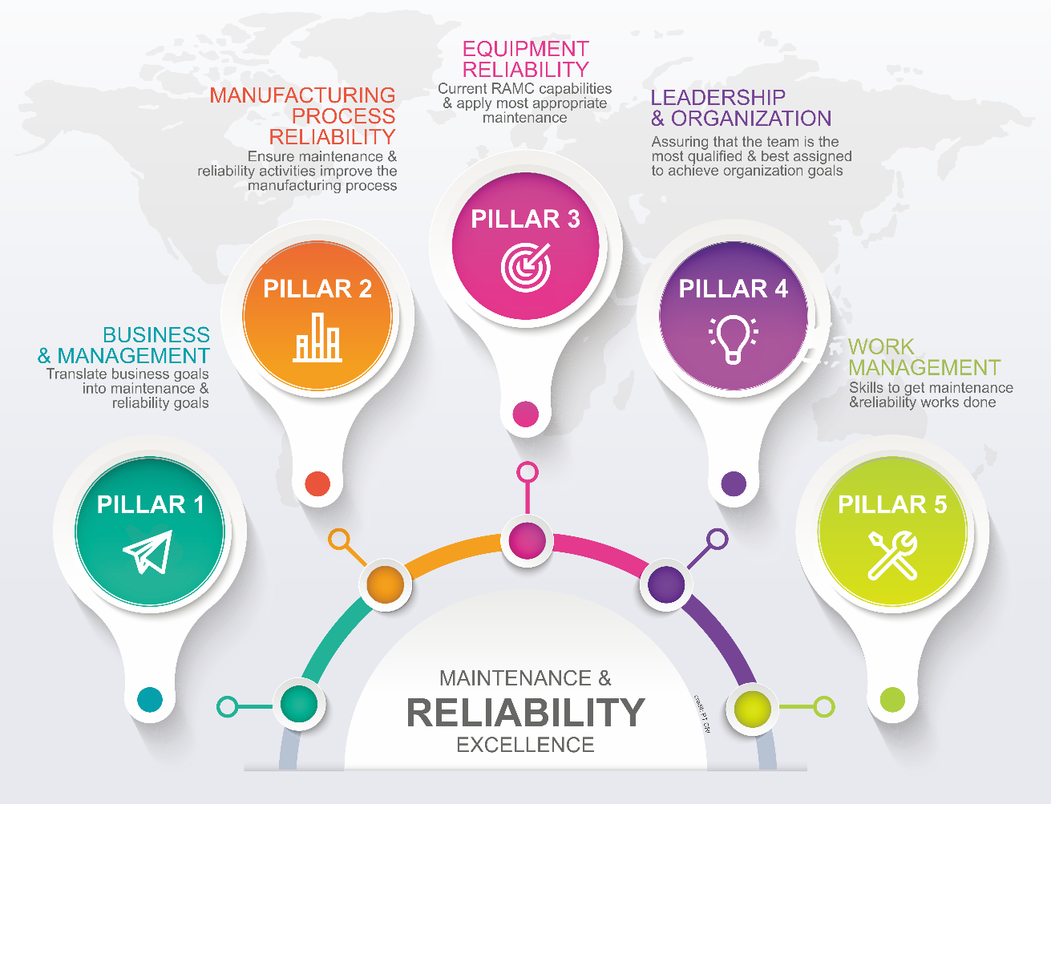
Figure 0-1. Maintenance & Reliability EXCELLENCE (MREX) Pillars
Reliability improvement, however, is not limited to the product design itself. For example, during initial product development an aggressive reliability growth program can play a major role in determining final product reliability. During manufacture a good quality control program will maintain product design reliability by ensuring conformance to production specifications and tolerances and by reducing variability in the manufacturing process. Inspection and acceptance sampling procedures ensure that raw material and supplier parts meet agreed standards.
Once a product becomes operational, failures may be reduced through preventive maintenance. sound parts replacement policies, engineering modifications, and careful attention to environmental conditions and operating loads.
Once the system is operational, downtime can be decreased (maintainability improved) with the proper amount of repair resources, including maintenance technicians, test equipment, and available spare parts. Secondary considerations such as skill levels, resupply lead times. maintenance training, and the ease of use of technical manuals will also improve maintainability. Reliability and maintainability engineering, therefore, must be practiced throughout the product's life cycle.
Reliability includes of these works but not limited to: Company Goals to Reliability Availability Maintainability Prescribe, Reliability Availability Maintainability (RAM) Works, Reliability Centered Maintenance (RCM), Reliability Performance Monitoring, Life Cycle Analysis, Reliability Growth, Reliability Assurance Plan, Computerized Maintenance Management System (CMMS), etc. Each task delivers a connection within one to each other supporting Pillar 3 and Pillar 2 in Maintenance & Reliability EXCELLENCE program goals.
Oil and gas companies recognize the critical importance of digitalization in managing their assets. Within the context of maintenance and operations, the role of digital asset management cannot be overstated. The industry heavily relies on the reliability and availability of equipment to ensure seamless and safe production operations.
The strategic adoption of information technology is paramount for companies seeking to optimize operational efficiency, enhance reliability, and mitigate risks. By leveraging information technology, organizations gain convenience in managing various maintenance and operational activities. Real-time monitoring of equipment conditions, early detection systems to preempt production disruptions, and centralized data repositories all contribute to the wisdom of implementing digitalization programs, particularly within the oil and gas sector.
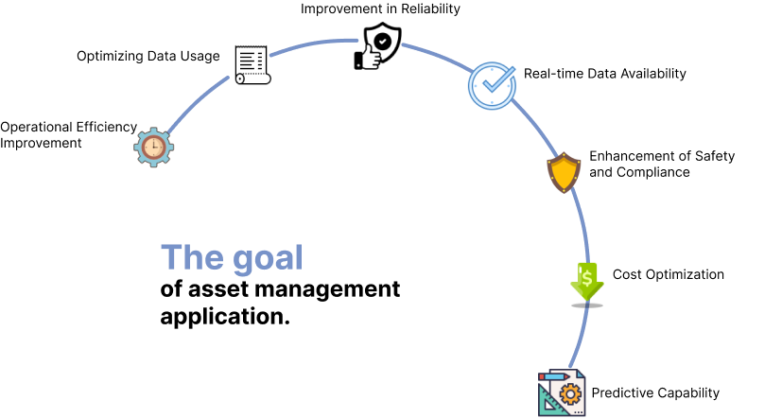
Figure 0-2 The Goal of CMMS Application
The strategic adoption of digital technology empowers companies to continuously monitor equipment conditions in real-time. This capability facilitates maintenance teams in early detection of potential issues, enabling swift troubleshooting and efficient maintenance planning. Moreover, digital technology supports in-depth analysis of equipment performance, allowing management to make precise decisions regarding maintenance schedules and equipment replacement. Consequently, leveraging digital technology enhances reliability, security, regulatory compliance, and cost efficiency—all critical factors for the sustainability and success of oil and gas operations.
This proposal specifically concerns the development of customized web-based analytical CMMS for Phase 1. The Phase 1 is to cover modules: Asset Register, Spare Part Management, Asset Prioritization, Maintenance Task Development, Inspection Testing and Preventive Maintenance (ITPM), Work Order (WO) and Permit to Work (PTW).
The Phase 1 implementation aims are to ensure excellent integration of work management, asset management, planning and scheduling, analytics for streamline maintenance workflows and reduce costs. This CMMS will also be integrated to Inventory Management and Purchasing, Health Safety Environment (Permit To Work)

INTRODUCTION
PT Cliste Rekayasa Indonesia (CRI) is requested to provide a proposal for the development of customizable web-based analytical Operation and Maintenance Software by Genting Oil Kasuri PTE. LTD. (GOKPL).
GOKPL is proactively advancing its digital transformation by modernizing the operation and maintenance program. The primary objective is to seamlessly integrate maintenance and operational activities into a unified web-based software platform accessible to multiple stakeholders involved in the Field’s operations. This comprehensive analytical Computer Maintenance Management System (CMMS) synergistically combines modules for greenfield needs: Asset Register and Spare Part Monitoring (Inventory Management and Purchasing), Asset Prioritization (SECE & ECA), Maintenance Task Development, Inspection Testing & Preventive Maintenance (ITPM), WO Creation & PTW, Condition Assessment and Renewal Planning, Reporting and Documentation, and System Integration to other System (Ex: ERP, Scada, Etc). The result is a powerful solution that delivers significant benefits to the company, enhancing efficiency and effectiveness across all CMMS activities.
This system is designed to track work orders, inventory management, equipment maintenance schedules, and performance metrics to improve operational efficiency, reduce downtime, and extend asset life.
The objective of this proposal is to outline the methodology employed by CRI in developing the customizable web-based analytical CMMS Software. Within this document, we will delve into the specifics of how CRI plans to design, develop, test, and deploy the application, ensuring seamless integration with the servers provided by GOKPL.
This proposal also contains information:
- Quote price in lump sum and Indonesian Rupiah (To be developed)
- Detail illustration schedule for all activities (Figure II-1)
- List of services provided as part of deliverables (Table III-1)

PROPOSAL SUMMARY
This section summarizes the key content of the offered proposal. The details of the discussion can be read in respective sub-chapters.
- Local Content
EXCELLENCE customizable web-based analytical CMMS has been being developed by CRI with full Indonesia local resources (100% TKDN).
- Commitment to Excellence
CRI is dedicated to delivering EXCELLENCE performance in all customizable application development work.
- Work Execution Timeline
The overall development work execution sequence spans 11 (eleven) months. A detailed sequence illustration is provided in Figure II-1.
- Invoicing and Payment Schedule
The work will be invoiced according to the payment schedule outlined in Section II.2.3.
- Technical Methodology
The detailed technical methodology to be implemented is described in Section III.
This proposal includes 1st year maintenance contract.
- Proposed Modules
The proposed modules of the Phase 1 project detail information on the scope are described in Chapter III. Roadmap of following Phases are described in Table IV-1.
- Deliverables
The deliverables for this project are outlined below. For detailed information on the scope, please refer to Table III-1.
- Site Visit is scheduled twice (2 times) with maximum duration of 10 (ten) days each visit.
- The benefits of EXCELLENCE products are summarized in Section V.

DURATION & COMMERCIAL

Work Duration & Schedule
The project schedule for the CMMS software development will undergo review and discussion by CRI and GOKPL.
Assuming timely receipt of all necessary data and business processes by the CRI team, the estimated development duration for this software is 11 months.
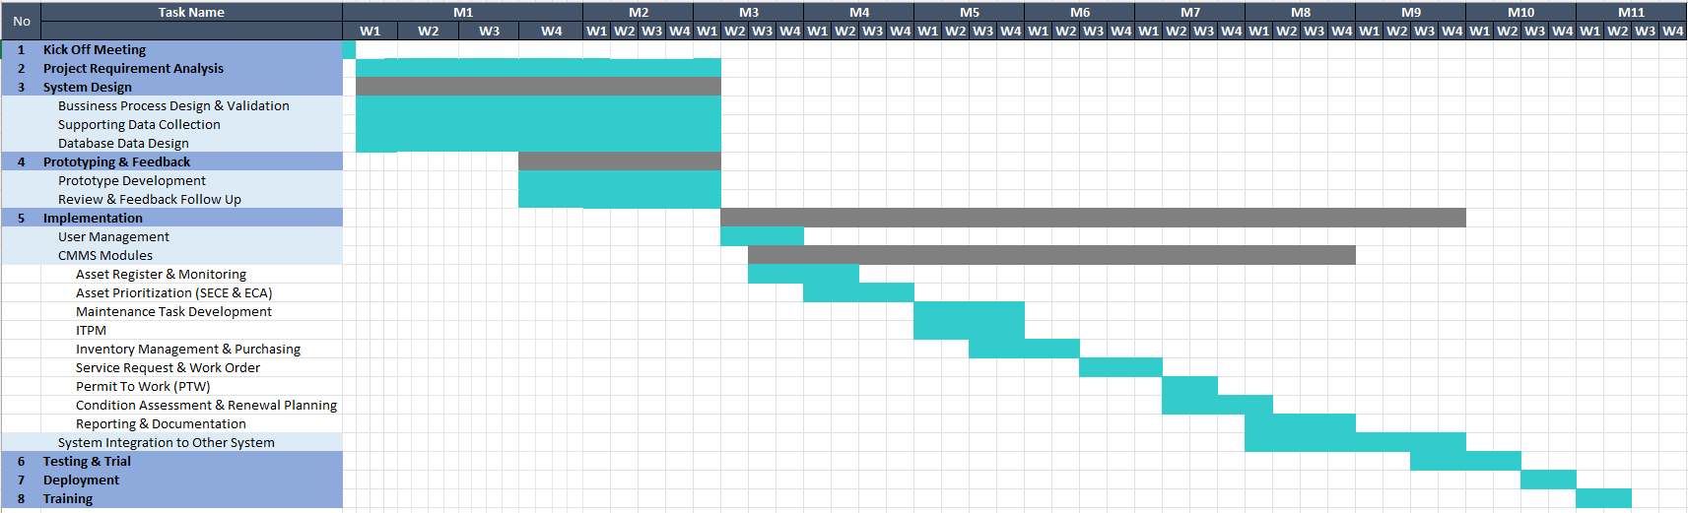
Figure II-1. Phase 1 Customization EXCELLENCE Timeline

Commercial
Cost of the works are defined in tables below.

Main Cost
[To be developed]
In Words : Indonesian Rupiahs only ===

Terms & Conditions
- The CMMS Phase 1 Development cost includes 1st year maintenance contract service, start from Work Acceptance (BAST) is signed.
- The Server Infrastructure Cost (if any) of table above is excluding cargo delivery cost and installation cost.
- The Yearly Maintenance Contract excludes the cost of Site Visit (if needed). The maintenance of software will mainly be executed remotely from Jakarta. Please refer to Section IV.8 for battery limit of Maintenance Contract.
- Phase 1 Yearly Maintenance Contract covers maintenance of developed modules in Phase 1.
- The yearly maintenance contract cost applied for 2nd year and on.
- Additional work not previously outlined in the proposal will be defined based on CRI’s Change Order (CO) system. No additional work will be initiated before a CO is agreed between CRI and the Client.
- The indicative time schedule provided assumes that all the required information is made available to CRI in time.
- The total costs for each analysis included presentation / meeting online for Kick-off meeting and preliminary result.
- Short casual meetings between Client online, Client’s Jakarta office and at CRI’s office are at no charge.
- Invoices will be issued based on progress detailed in the payment schedule Section II.2.3.
- The price above includes WHT tax and exclude VAT.
- All activities will mainly be conducted in Jakarta.

Payment Schedule
Payment conditions are net and to be paid per document submission to GOKPL:
[To be developed]

TECHNICAL
Following in-depth technical discussions held, GOKPL is committed to developing cutting-edge software for Computer Maintenance Management System (CMMS).
The primary objective behind developing this application is to enhance operational efficiency and streamline maintenance activities at GOKPL. This sophisticated software empowers engineers and users by enabling real-time asset monitoring, efficient scheduling of preventive maintenance tasks, and seamless work order management.
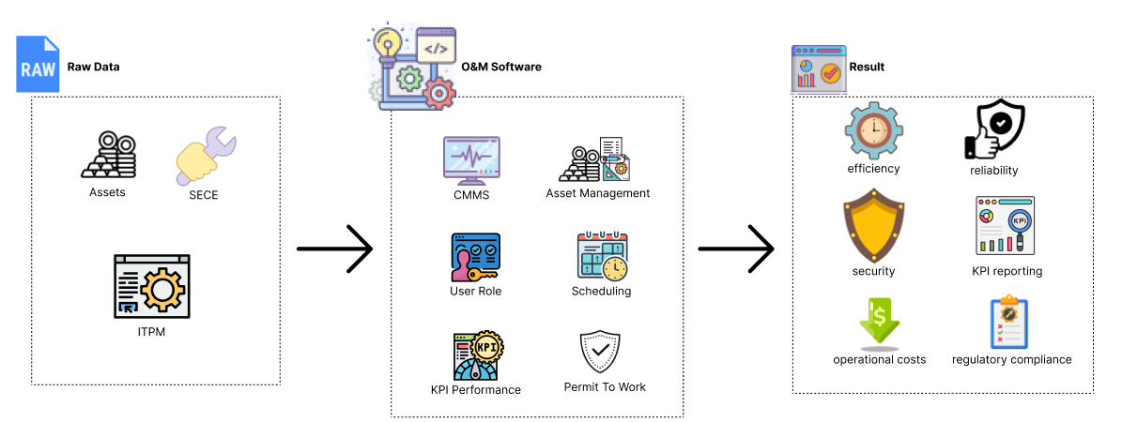
Figure III-1 CMMS Software General Flow
To achieve these objectives, the following modules are required:
Computer Maintenance Management System (CMMS)
The CMMS module is meticulously crafted to strategically plan, meticulously track, and effectively manage all maintenance activities and equipment/facility upkeep within oil and gas production installations. By harnessing the power of CMMS, organizations can achieve the following advantages:
- Operational Efficiency: Streamlining maintenance workflows and ensuring timely interventions.
- Cost Reduction: Optimizing maintenance schedules, minimizing downtime, and reducing overall maintenance expenses.
- Health safety environment (Permit To Work): Implementing preventive measures, adhering to safety protocols, and enhancing facility reliability.
- Reliability Boost: Ensuring consistent performance and minimizing unplanned disruptions.
Incorporating CMMS into production facilities is a prudent step toward achieving operational EXCELLENCE and maintaining the highest standards of safety and reliability. To achieve that, the CMMS module in this CMMS Software possesses the following functions:
- Service Requests and Work Order Management
- Automatic Work Order Creation from Maintenance Requests
- Calendar View
- Centralized Work Order Management Portal
- Custom Maintenance Checklist Templates
- Maintenance Checklist Responses
- Preventive or Recurring Maintenance Work Orders
- Work Order Creation and Assignment
- Scheduling
- Maintenance Scheduling Calendar
- Project and People Tracking
- Cost Tracking
- Project Reporting
- Projects
- Staff Records
- Time Tracking
- Permit To Work (HSE)
- PTW Integration to CMMS
- Asset Inventory
- Asset Register and Monitoring
- Asset Hierarchies
- Asset Records
- Assets List View
- Assets Visualization in a Floor Plan
- Automatic Downtime Update
- Depreciation Tracking
- Downtime Tracking
- Generating Barcodes and QR Codes
- Interactive Equipment's Subcomponent Mapping
- Interactive Plans and Mapping
- Warranty Tracking
- SECE (Asset Prioritization)
- ECA (Asset Prioritization)
- Preventive & Predictive Maintenance (PM) Tasks and Schedules (ITPM)
- Inventory Management and Purchasing
- Condition Assessment and Renewal Planning
- Reporting and Documentation
- System Integration with Other System (Ex: ERP, Scada, Etc)
- User Management
All modules and features mentioned above will be further discussed based on user requirements.

Work Deliverables
This proposal is to deliver works as per define in Table III-1 below.
Table III-1. Deliverables of this work
NO | DELIVERABLES | SCOPE COVERAGE
1. | Ready to be used customized web-based for office. | Website application, with agreed modules.
2. | Installation and usage assistance service. | Assistance of first implementation on site. ⁽²⁾
NOTES:
- The application will be prepared for future development continuity.
- Only cover the service for total 3 days, exclude the transportation and accommodation fee.

METHODOLOGY

Asset Management Concept
Grand design of asset management for GOKPL based on ISO 55000 Series and the global business workflow for asset management will be implemented for development continuity. All the development will focus on applicability of the GOKPL process business, customized completely to leverage GOKPL maintenance and operation.
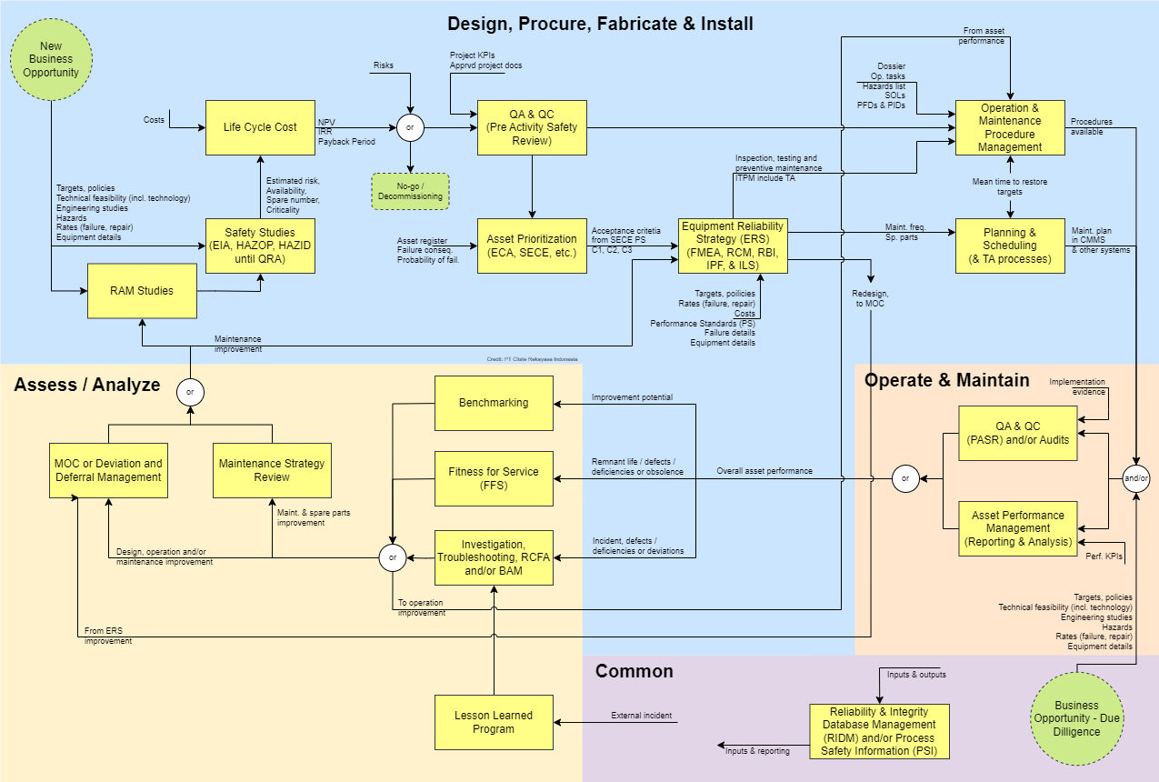
Figure IV-1 Asset Management Grand Design

Roadmap CMMS Development for GOKPL
Phase 1
The objective of Phase 1 CMMS development for GOKPL is to ensure the Operation Readiness Assurance of GOKPL startup and early year operation & maintenance. The goal is to smoothly integrate safety rules into daily work planning & operation, ease of asset data development, data integration to existing ERP (SAP) and Work Order creation.
Phase 2
The recommended objective of Phase 2 CMMS development for GOKPL is to advance the Reliability & Asset Integrity assessment methodology to ensure a clear quantitative analytical data as basis of maintenance program implementation efficiency. The automation integration between asset data and assessment analysis will kept on track as living program from Phase 1.
Phase 3
The recommended objective of Phase 3 CMMS development for GOKPL is to advance the real-time Reliability & Asset Integrity characteristic calculation. Hence it ensures a recommendation that based on actual running operation data. The automation integration between asset data and assessment analysis will kept on track as living program from Phase 1 & Phase 2.
Table IV-1 Recommended CMMS Development Roadmap for GOKPL
MODULES CATEGORY | PHASE 1 | PHASE 2 | PHASE 3
Asset Inventory | Asset Register & Hierarchy
Asset Data Enhancement | Inventory Management & Purchasing | Cataloguing
 |  | Bill of Material (BOM)
Asset Prioritization | Safety Environment Critical Element (SECE)
 | Equipment Criticality Analysis (ECA)
Failure Code Development | Failure Mechanism / Threat Standard Code |  | Integration to RCFA
 | Failure Mode & Effect Analysis (FMEA)
Task Development | Vendor Recommendation Task | SECE Performance Standard | Integration to Life Data Analysis
 | Task List Details | Corrosion Management
 |  | Certification Management
 |  | Reliability Centered Maintenance (RCM)
 |  | Risk Based Inspection (RBI)
Inspection, Testing & Preventive Maintenance (ITPM) | Job Bundling | Integration to: SECE PS, Corrosion Management, Certification Management, RCM, RBI
 | Load Levelling
Work Order (WO) | Work Order Generation
Permit to Work (PTW) | Permit to Work
System Integration | Integration to ERP & SCADA data | Realtime connectivity
 |  | Integration to Corrective & Non-Corrective Event Record
Maintenance Execution Record | Corrective & Non-Corrective Maintenance Execution Record
 | Condition Assessment and Renewal Planning
 | Historical Record
Reporting & Documentation | Maintenance Activities
Defect Deferral Elimination |  | Anomaly Management
 |  | Bad Actor Management (BAM)
 |  | Root Cause & Failure Analysis (RCFA)
 |  | Integrity Operating Window (IOW)
Reliability Characteristic Analysis |  |  | Analytical Reliability Block Diagram
 |  |  | Life Data Analysis
AI Powered Analysis |  |  | Artificial Intelligent (AI) powered Reporting

P1 Application Appropriation and Analysis of Needs
The objective of data collection is to ensure that the application workflow and user interface are developed based on the ease of actual procedure and needs.
At this stage, GOKPL needs will be formulated, and the boundaries of the application's capabilities will be established. GOKPL involvement in formulating the requirements and defining the scope of work is necessary to achieve a shared understanding of the application's capabilities. Therefore, GOKPL is expected to be willing to provide explanations to clarify any matters that require further clarification.

Methodology in this stage:
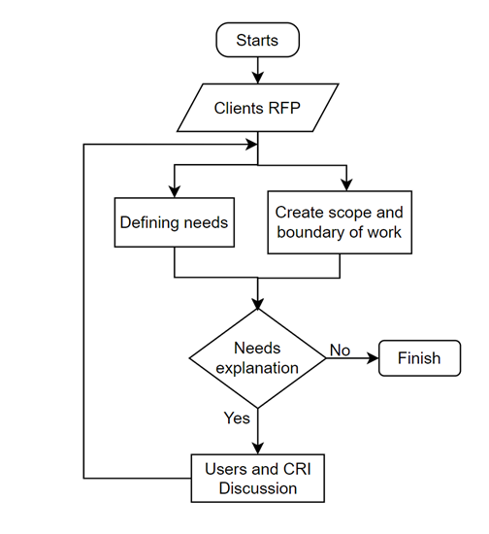
Figure SEQ Figure \* ARABIC 4 Application Appropriation and Analysis of Needs Phase
Figure IV-2 Application Appropriation and Analysis of Needs
The duration expected for this work is 1 Month 2 Weeks in parallel with Application Plan and Design stage.

P1 Application Plan & Design
The objective of application plan and design is to meet user needs, to simplify user access and management of their data. The application is anticipated to operate within a web-based system. The application also shall have an ability to communicate with other applications, as well as be capable of future development.
At this stage, the application development planning, UML design, UI, and UX designs that have been created will be evaluated by GOKPL. This process aims to determine the planning for application development, UML design, and interface design planning to be implemented in the application. The results of this design plan require approval from GOKPL to proceed to the next stage. At this stage, scheduled meetings and discussions to facilitate this work progress can be arranged.

The Application Planning & Design methodology:
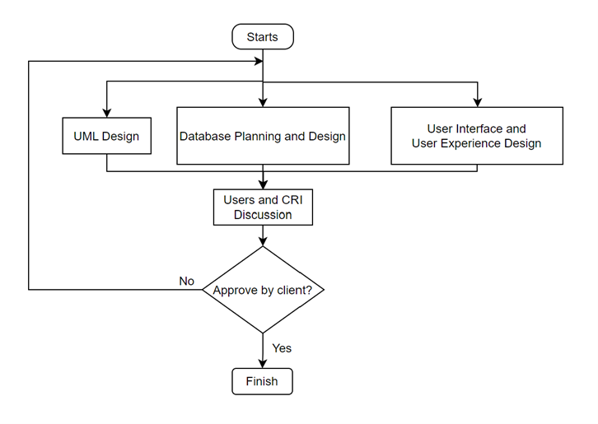
Figure SEQ Figure \* ARABIC 5 Application Plan & Design Phase
Figure IV-3 Application Plan & Design

The duration expected for Application Development work is 1 Month 2 Weeks in parallel with Application Appropriation and Analysis of needs.

P1 Plan & Design Implementation
The objective of Plan & Design Implementation is to follow the plan and application design to develop the application that was previously initiated in the earlier stage. In this stage, the integration between the front end and back end is also performed, resulting in an application ready for testing.
The methodology is done with detail:
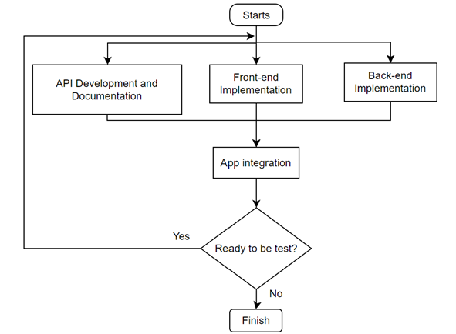
Figure SEQ Figure \* ARABIC 6 Application Plan & Design Implementation Phase
Figure IV-4 Plan & Design Implementation

At this stage, CRI will develop the application according to the previously established plan. Once the application is completed, it can be presented to GOKPL for feedback and evaluation. When the application meets the requirements, it can be prepared for testing in the next phase.
The duration expected for Implementation, testing, update, and deployment is 6 Month.

P1 Application’s Testing & Update
The objective of app testing is to make sure the development of the application has been following the design as client and IT developer discussed.
The methodology is done with detail:
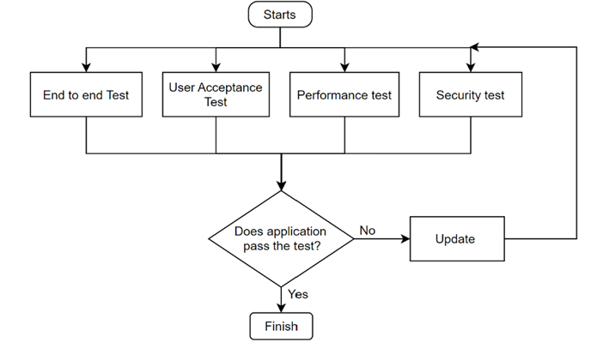
Figure SEQ Figure \* ARABIC 7 Application’s Testing & Update
Figure IV-5 Application’s Testing & Update

In this stage, the application undergoes four categories of testing: end-to-end testing, user acceptance testing, performance testing, and last but not least, security testing. These four tests are conducted simultaneously to ensure testing efficiency. If the application fails during the testing process, debugging and application improvement will be carried out as part of the application updating process.
The duration expected for Implementation, testing, update, and deployment is 1 Month.

P1 On-Site Installation & Usage Assistance
The objective of on-site installation & usage assistance is to make sure that the user (client, helpdesk, coordinator, and technician) of the application will have the same understanding and skill.
In this stage, CRI will assist in the installation of the completed application. The application will be adapted to the existing environment on GOKPL devices. Additionally, user guidance services for the application will also be provided by CRI. This assistance program will conduct by online meetings and shall be attended by all users that is on site.
The duration expected for On-Site Installation & Usage Assistance work is 1 Month.

Maintenance Contract
The proposed price of this proposal includes 1st year maintenance contract. (If any) bugs found during the implementation of EXCELLENCE during first year (after work acceptance), will be handled and resolved by CRI team with no additional charge. This to exclude major update (affect to business process).
Below is the coverage detail of the maintenance contract:
Included in Maintenance Contract:
- Bug fixes related to existing features delivered during initial implementation.
- Minor system adjustments (e.g., label changes, layout alignment, or field validations) that do not require significant development.
- Technical support related to system errors or malfunctions (via email or remote session).
- Performance tuning of existing modules when necessary and feasible without major rework.
- Database health check and cleanup assistance when requested.
- Immediate response time during working hours, and less than 3 hours response time during public holiday & weekend. Problem solving time may vary depend on case load.
Excluded from Maintenance Contract:
- Major system enhancements or new feature development not originally included in project scope.
- Requests that require significant workflow changes or new business logic implementation.
- Integration with third-party systems not included in initial project.
- Custom report/dashboard creation beyond those delivered during implementation.
- User training refreshment or onboarding for new personnel after the initial training session.
- On-site support (unless specifically agreed otherwise).

EXCELLENCE CMMS

EXCELLENCE - Web-based Application
CRI has roll out a comprehensive asset management system, EXCELLENCE that has been successfully adopted by several of our clients. Our clients have integrated our asset management app into their operations, where it has proven instrumental in addressing challenges related to asset management and reliability assessment. Our solution has enhanced their ability to manage assets effectively, streamline processes, and ensure the reliability of their operations.
As part of this project, GOKPL will receive access to EXCELLENCE web-based application, a tool that customizable to GOKPL needs. This platform offers tools for real-time analytics, comprehensive reporting, and task tracking, tailored to enhance efficiency and decision-making.
Our application also features a functionality for recording each change made to the data input into the system. This allows us to track which user made the change, what was modified, and when the change occurred. This audit trail provides several benefits: it enhances accountability by identifying who made specific updates, ensures data integrity by allowing for easy verification of changes, and facilitates troubleshooting and compliance by providing a clear history of modifications. With this information, you can easily recall change details and maintain a comprehensive record, which is invaluable for audits, historical analysis, and future reference.
Addressing the challenges faced by numerous industries in managing extensive assets and striving for EXCELLENCE in process safety, operational reliability and data security, CRI offers customizable application development solutions. This section in detail focusing on development of Cataloguing Module.
EXCELLENCE customizable web-based application comes with several key capabilities:
- Compliance with International Standards
CRI provides a robust application built on standardized methodologies, ensuring versatility and applicability to various business needs. Our application complies with the following standards: API 691, ISO 14224, BS EN IEC 60812, IEC 61703, SAE JA 1011, SAE JA 1012, API 580, and EN 61078.
- Integration with Company Active Directory
EXCELLENCE seamlessly integrates with the client’s Active Directory system, simplifying user management and enhancing security.
- Advanced Security Layers
In addition to login passwords, EXCELLENCE features JSON Web Token (JWT) authentication, Multi-Factor Authentication (MFA), and Single Sign-On (SSO) to ensure comprehensive database security.
- Customizable Monitoring Dashboard
Our application offers a fully customizable monitoring dashboard tailored to meet the specific needs of each client.
- Efficient User Management
EXCELLENCE includes a powerful and user-friendly management system, streamlining user administration.
- Detailed History Log Sheet
The application maintains a comprehensive history log for each user, with the capability to retrieve files referenced within a specified time frame.
- Accessible from anywhere
EXCELLENCE is a web-based application that means accessibility from any internet connected area.
- Data connectivity
The application maintains data interconnectivity between each module, as well as communication to other application via Application Programming Interface (API).
- Data Library
EXCELLENCE come with data library, that can be used to store document (i.e. technical drawings, paper work analysis report, etc) with its detail revision status. This data library featured with history log that enable information of when and who store the document.
- Other functionalities that improve asset management system.

EXCELLENCE Brief Previews
The use of EXCELLENCE software in supporting Operation Readiness activities will undoubtedly have a positive impact. This is due to the various features offered by EXCELLENCE. The advantages and ready-to-use features of EXCELLENCE include:
- Realtime Inter-Modules Integration of AR (Asset Register)
Digitalization in asset management refers to the process of adopting digital technologies to oversee and optimize assets. This encompasses the utilization of software and asset management systems to record, track, and manage asset-related information. Real-time access to asset data from anywhere enhances visibility and control over these assets. With centralized and structured data, data analysis becomes more efficient and effective, enabling informed decision-making.
- Reliability and Asset Integrity integrated module
- Management Dashboard
Ensuring all the work is monitored online, EXCELLENCE is equipped with management dashboard.
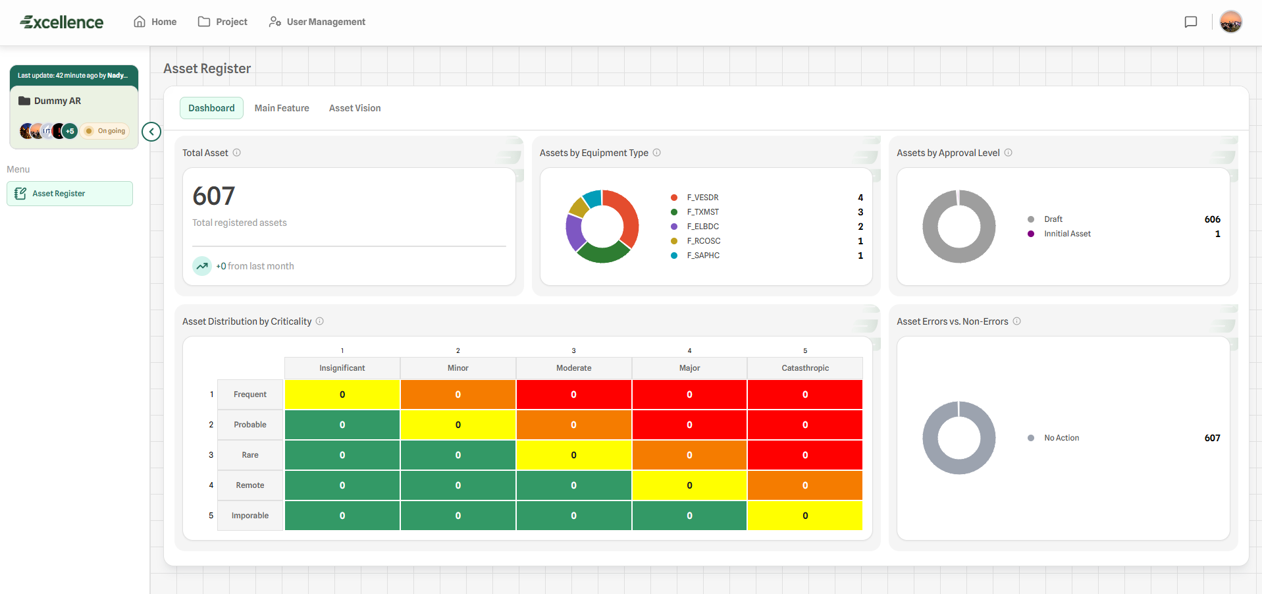
Figure V-1. A brief management reporting dashboard in EXCELLENCE

- Asset Register
Ensure all assets are recorded and organized according to their hierarchy/level, EXCELLENCE is equipped with a customizable column name and position. This Asset Register & Asset Hierarchy module is comply with ISO 14224 standard.

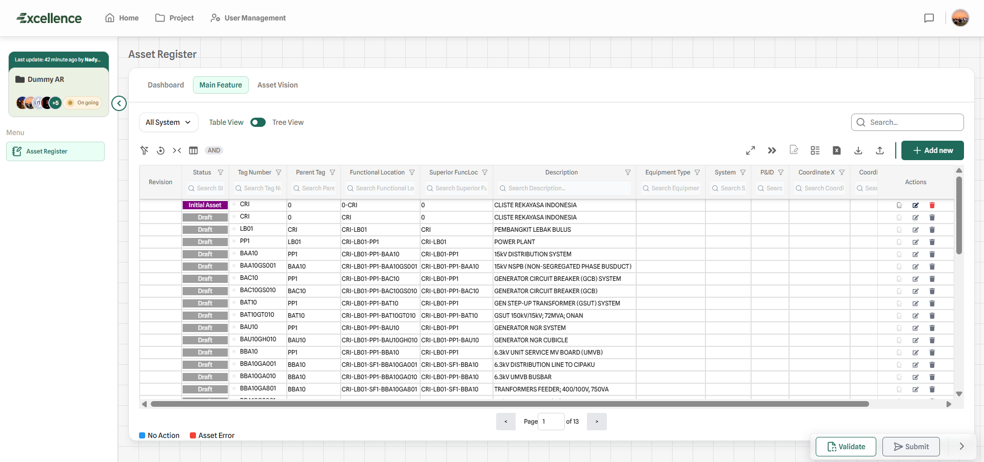
Figure V-2. EXCELLENCE Asset Register Module
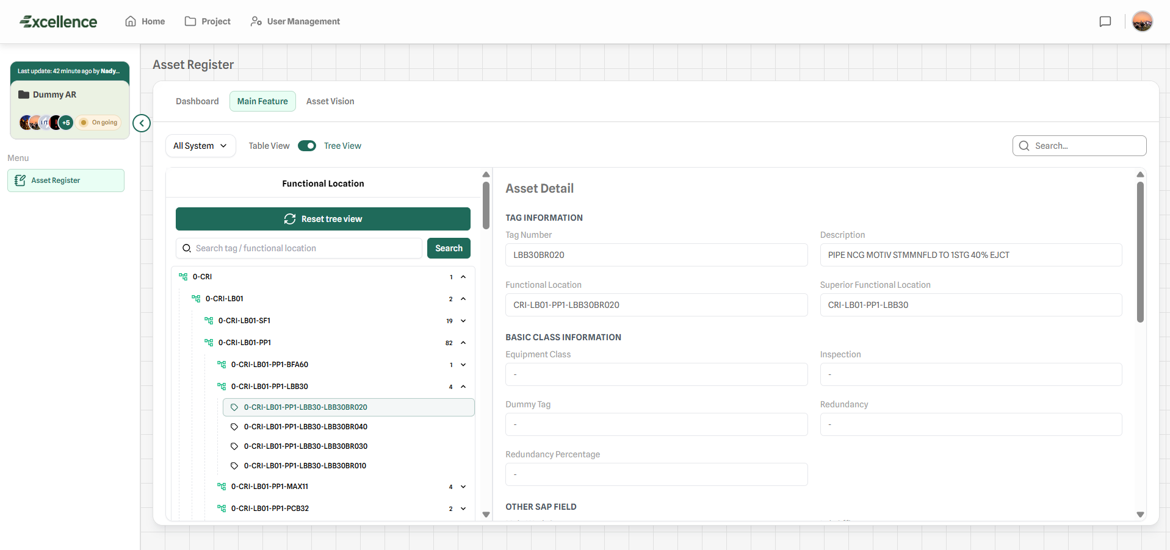
Figure V-3. EXCELLENCE Asset Register Module with Tree View
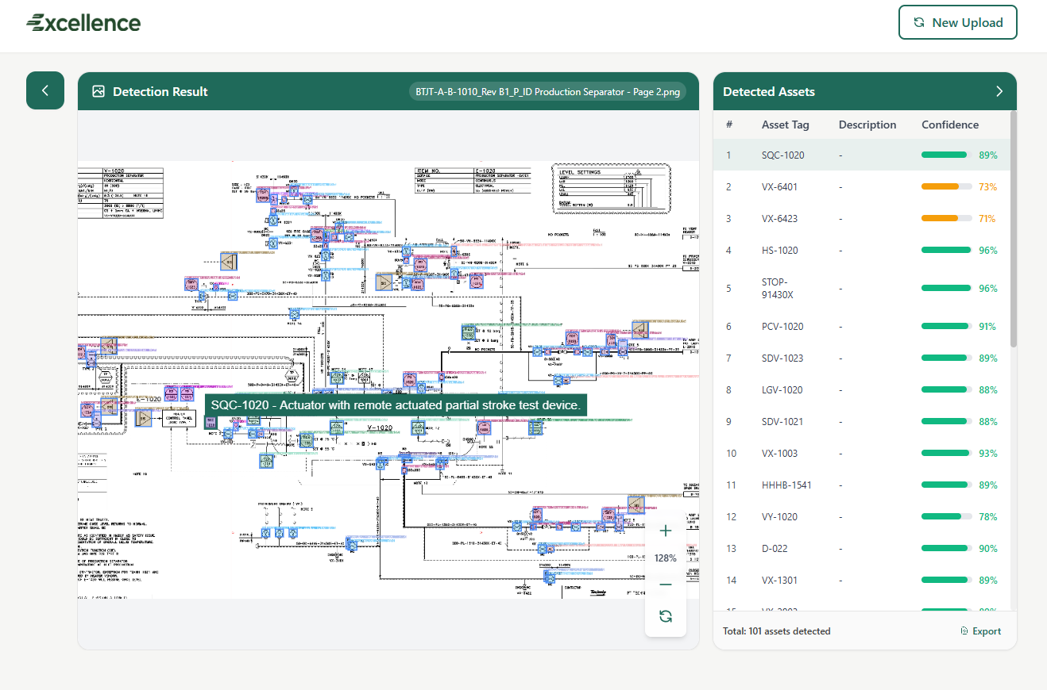
Figure V-4. EXCELLENCE Asset Register Module with AI-Powered Asset Vision

- ECA
Identify and prioritize critical equipment based on their potential impact / consequence (on safety, environment, production, and repair cost) and their probability of failure (occurrence).

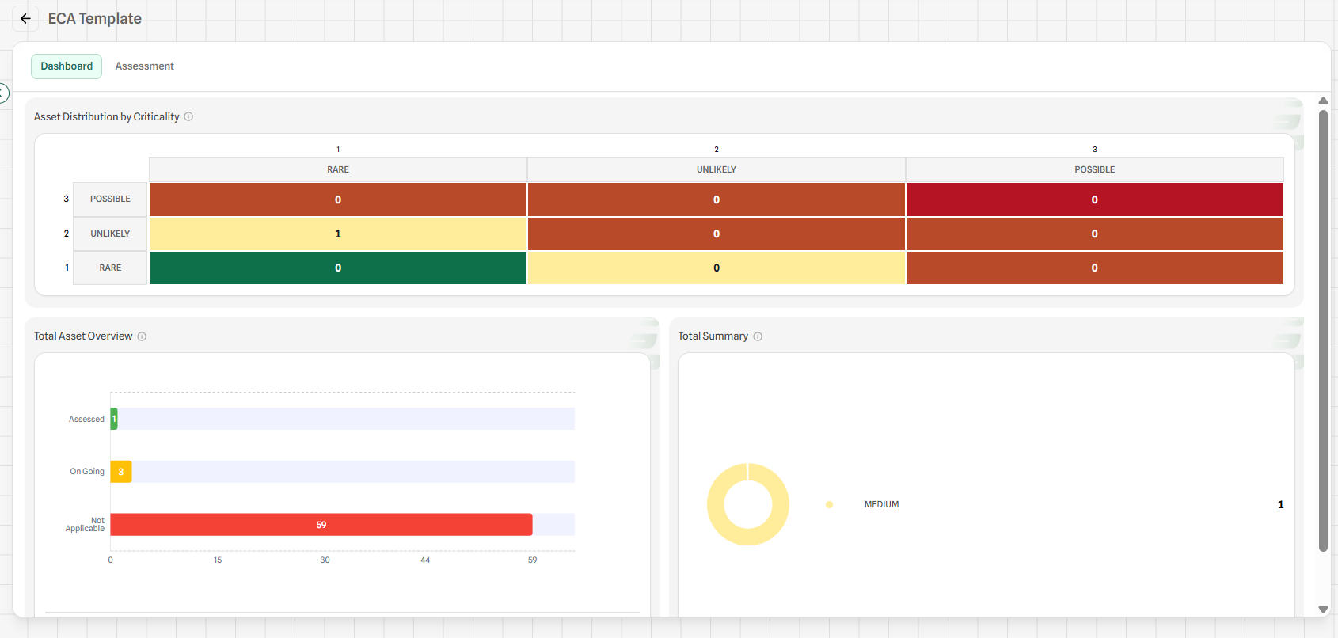
Figure V-5. Full Customizable Risk Matrix in EXCELLENCE ECA Module

- SCE
Identify and prioritize equipment whose failure would cause or contribute to major safety-related accidents.

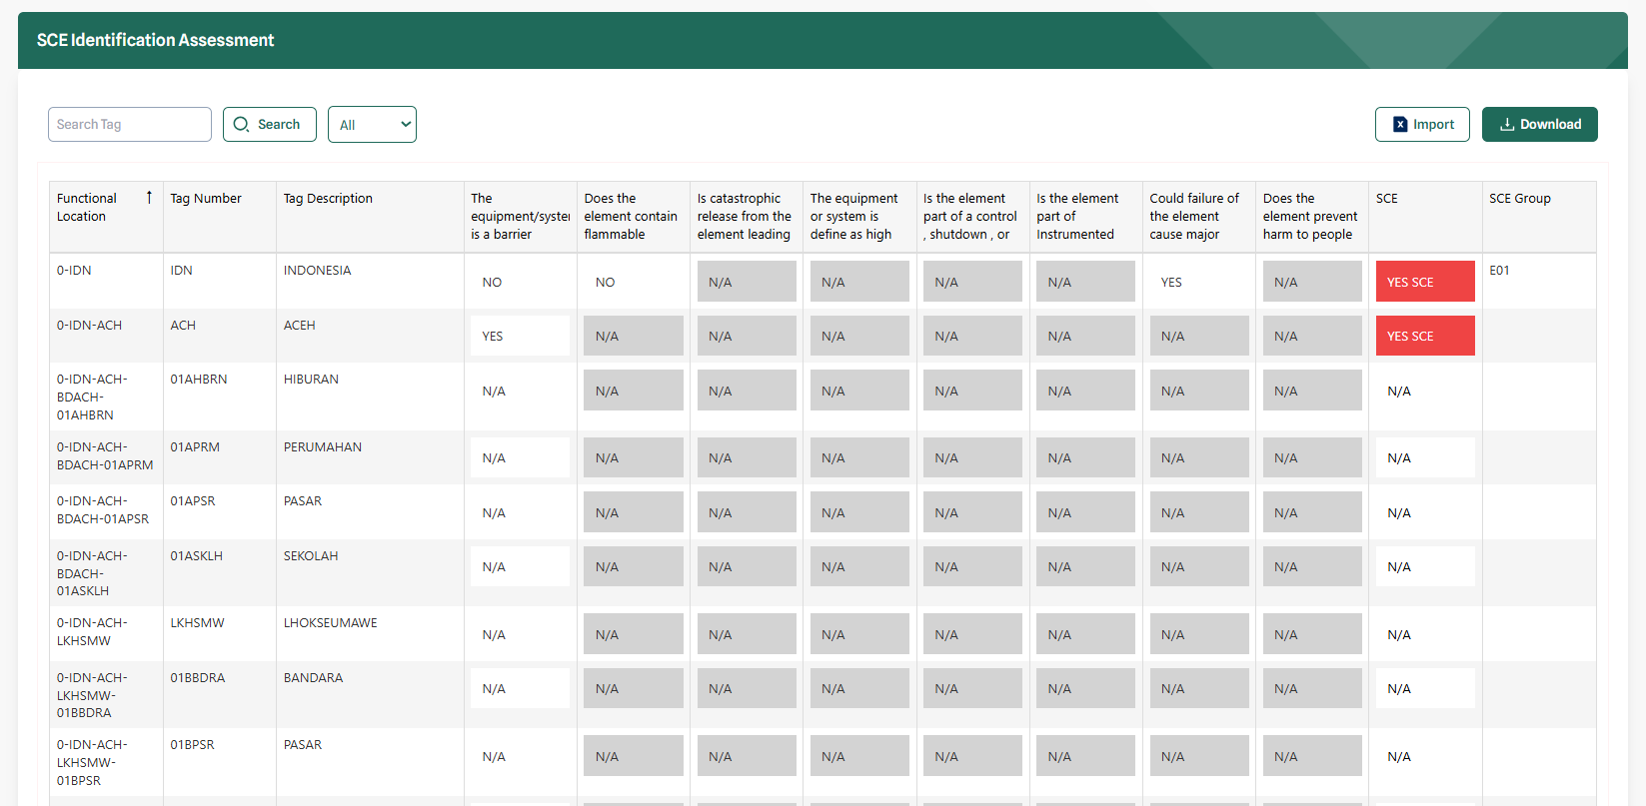
Figure V-6. Safety Critical Element (SCE) worksheet in EXCELLENCE

- FMEA
Systematically identify potential failure modes within a system, sub-system or equipment and assess the potential effects of these failures. FMEA is also provide database for RCM Analysis. FMEA module is equipped with Failure Mode & Failure Causes database as per ISO 14224 and OREDA.

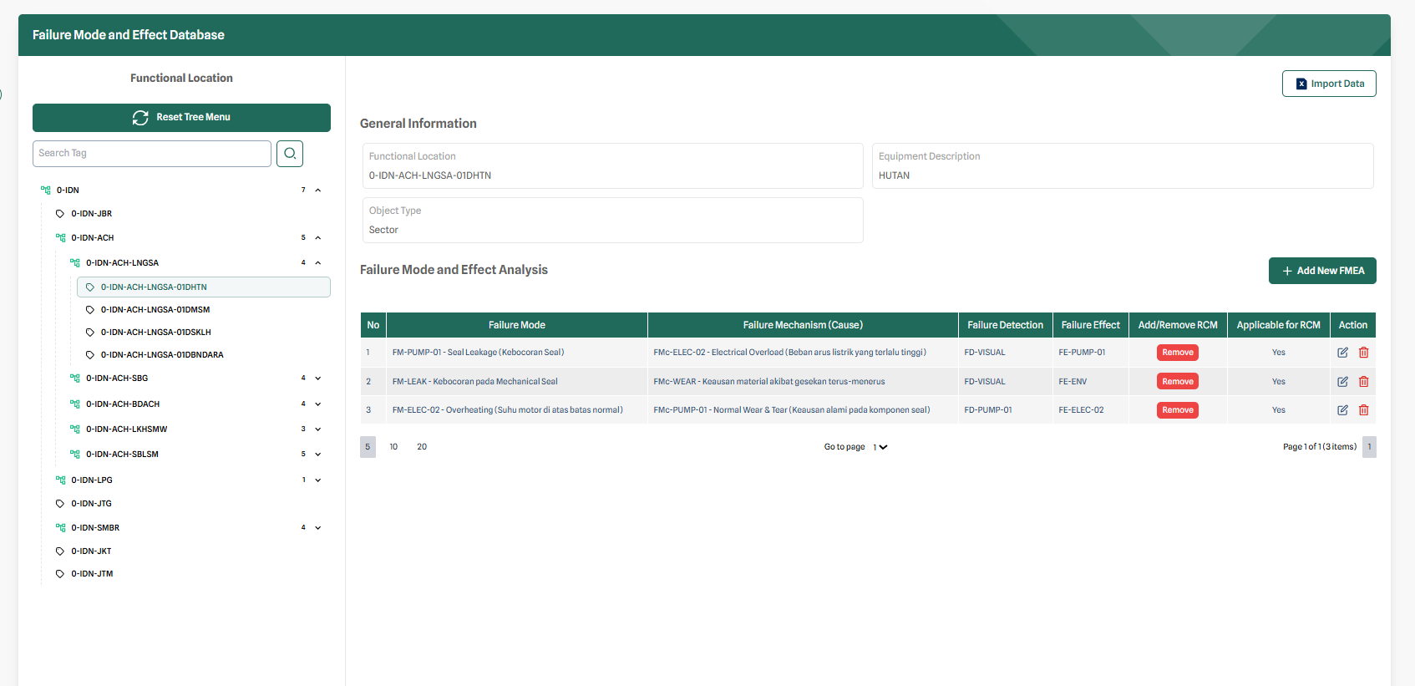
Figure V-7. FMEA Module in EXCELLENCE

- Reliability Centered Maintenance (RCM)
Identify maintenance strategies required to ensure an asset meets its mission requirements in its operational environment.

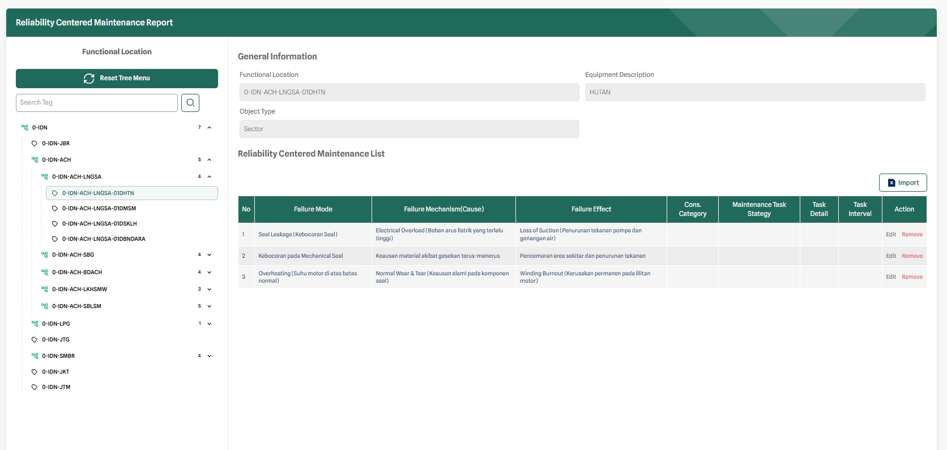
Figure V-8. RCM Module in EXCELLENCE

- Interactive Reliability Block Diagram
Assess the Reliability value of systems and sub-systems by modelling the interconnections and dependencies between various components or subsystems using an interactive Reliability Block Diagram graphical representation. This RBD Module is standardised referring to EN 61078.
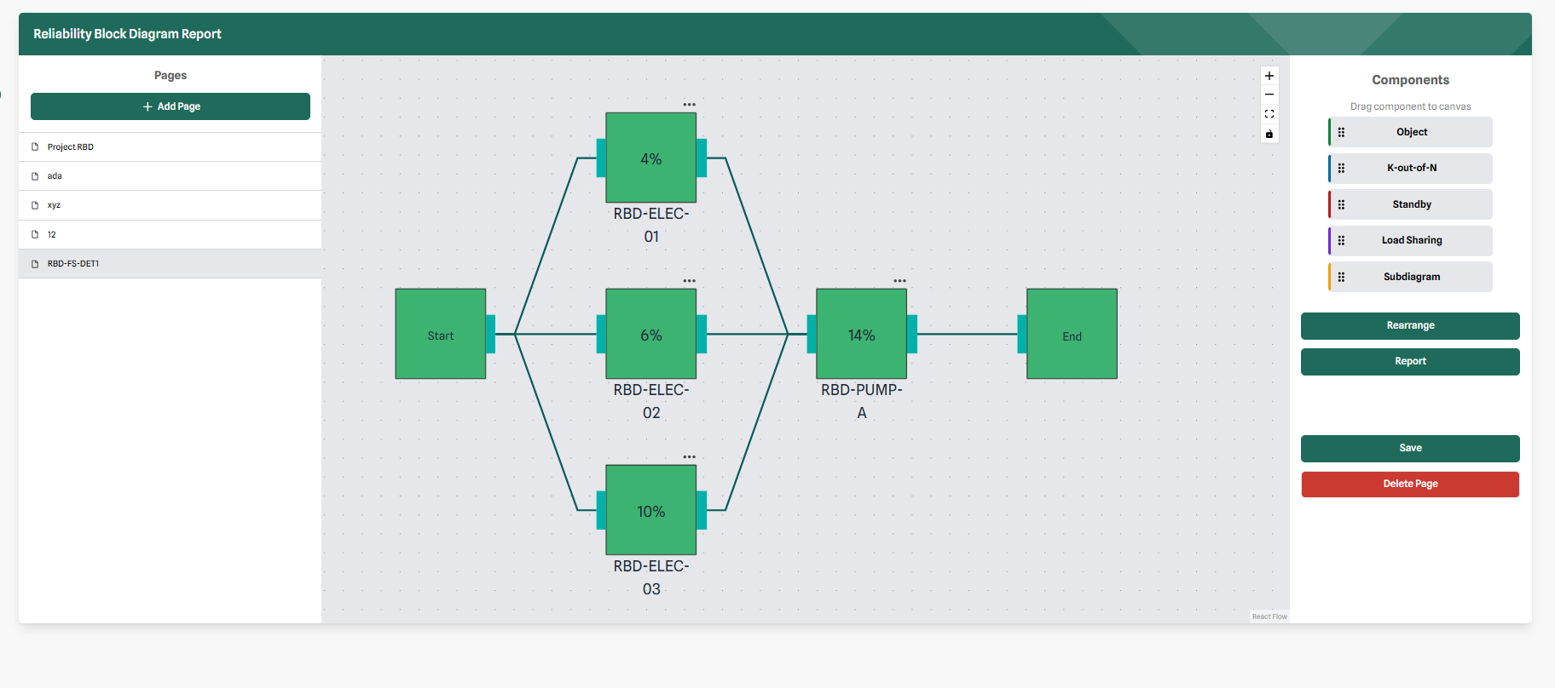
Figure V-9. Interactive Dynamic Reliability Block Diagram (RDB) in EXCELLENCE

- Life Data Analysis (LDA)
Evaluate the reliability of components, sub-systems, or systems, by analyzing life data collected from field activity using Weibull Distribution, 1-P Exponential Distribution, and Normal Distribution.
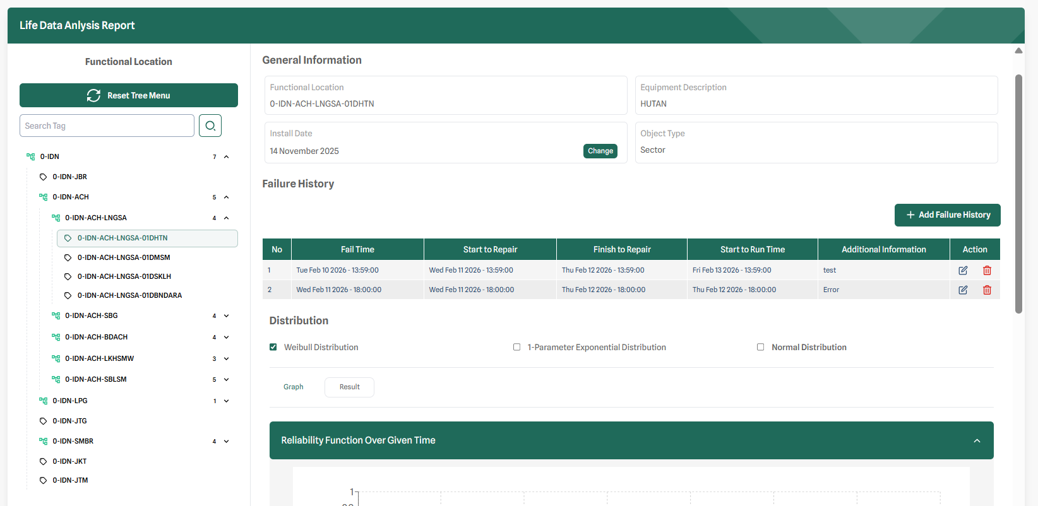
Figure V-10. Life Data Analysis (LDA) module in EXCELLENCE

- ITPM, Load Leveling & Job Bundling
As a repository for all inspection, testing, and preventive maintenance activity from RCM Analysis, RBI Analysis, and other analysis.

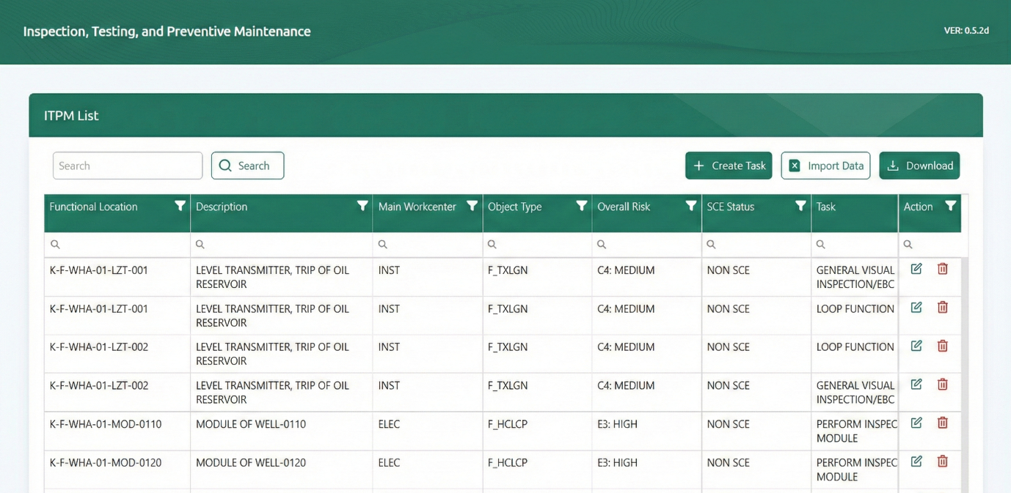
Figure V-11. ITPM Module in EXCELLENCE

PROJECT TEAM & ELIGIBILITY

Project Team
The organizational structure of this project can be seen in Figure VI-1 below.
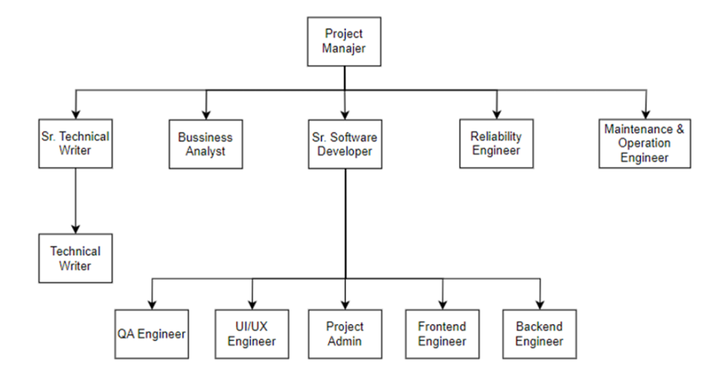
Figure VI-1 Project Organigram

The project team will consist of the following key personnel:
Table VI-1. Key Personnel
NO. | NAME & CERTIFICATION / TRAINING | ROLE
1. | Muhammad Gilang Dewantara;  - Insinyur (Ir.)  - Certified Maintenance & Reliability Professional (CMRP)  - API 580 certified  - ISO 55001 Auditor | Project Manager;  Asset Management Specialist  (Reliability & Asset Integrity)
2. | Chandra Salim;  - Insinyur (Ir.)  - Master of Science (M.Sc.)  - Insiyur Pratama Muda (IPM)  - ASEAN Engineer  - Certified Maintenance & Reliability Professional (CMRP)  - ISO 55001 Auditor | Sr. Asset Management Specialist  (Reliability)
3. | Suprayoga,  ISO 55001 Auditor | Sr. Asset Management Specialist  (Safety, Reliability, Maintenance & Operation)
4. | Abram Dionisius Antory;  - Master of Science (M.Sc.)  - Certified Maintenance & Reliability Professional (CMRP)  - ISO 55001 Auditor | Sr. Technical Writer;  Functional Engineer
5. | Habil Tria Sakti;  - Back-end Developer by Binar Academy  - Data Analytics Workshop: Power BI & Python  - ISO 55001 Auditor | Sr. Software Developer,  Backend Engineer
6. | Naufal Ariful Amri;  - Front-end Developer by Binar Academy | Front-end Engineer
7. | Muhammad Retian Faali;  - Data Analytics Workshop: Power BI & Python  - ISO 55001 Auditor | Front-end Engineer
8. | Abid Ardiyanto;  - Agentic Artificial Intelligence  - Data Analytics Workshop: Power BI & Python | Front-end & Back-end Engineer
9. | Nadya Friska;  - IPCA Programming & Software Development  - Data Analytics Workshop: Power BI & Python  - ISO 55001 Auditor | Back-end Engineer
10. | Mochammad Nasir;  - Data Analytics Workshop: Power BI & Python | Back-end Engineer
11. | Fuadi Aiman;  - Data Analytics Workshop: Power BI & Python  - UI/UX Research and Design by Binar Academy  - Kelas Pohon (UI/UX intensive class) by Insan Desain  - Certified Business Operations Associate by IEEEL Institute | UI/UX Designer
12. | Akbar Muchlis;  - Ethical hacker certified | Quality Assurance
13. | Gita Angraini;  - K3 | Document Control

Please be noted that the availability of personnel will vary with time and the actual start-up time and duration of the project can be agreed once the work has been granted by the assignor.

CRI Eligibility
CRI is eligible of materials and software to run scope of work on this project. Table VI-2 below show the information of material and software related to SOW.
Table VI-2. PT CRI Eligibility
NO | ITEM | DESCRIPTION | LICENSE
1 | ISO 55000 2024 | Asset Management – Vocabulary, Overview and Principles | CRI
2 | IEC 60812 2018 | Failure Modes and Effects Analysis (FMEA & FMECA) | CRI
3 | ISO 14224: 2016 | Petroleum, Petrochemical and Natural Gas Industries — Collection and Exchange of Reliability and Maintenance Data for Equipment | CRI
4 | OREDA 2024 | Offshore & Onshore Reliability Data 2024 | CRI
5 | Quanterion - NPRD 2024 | Quanterion - Non-electronic Part Reliability Data | CRI
6 | Quanterion - EPRD 2024 | Quanterion - Electronic Part Reliability Data | CRI
7 | Quanterion - FMD 2024 | Quanterion - Failure Mode / Mechanism Distributions | CRI
8 | SAE JA 1011 | Evaluation Criteria for Reliability-Centered Maintenance (RCM) Processes | CRI
9 | SAE JA 1012 | A Guide to the Reliability-Centered Maintenance (RCM) Standard | CRI

RIGHTS AND RESPONSIBILITIES
As our valued client, GOKPL have certain rights and responsibilities that contribute to the success and efficiency of this work.

Rights
GOKPL rights are described as following:
- Quality of Service:
GOKPL is entitled to receive high-quality and professional consulting services in line with industry standards.
- Transparency:
GOKPL has the right to clear and transparent communication regarding the scope of work, project timelines, and associated costs.
- Project Understanding:
GOKPL has the right to ensure that the consulting team understands the project requirements and objectives.
- Evaluation:
GOKPL has the right to evaluate and provide feedback on the deliverables and progress of the project at agreed-upon intervals.
- Confidentiality:
GOKPL's information and data will be treated with the utmost confidentiality, and CRI will take necessary measures to protect sensitive information.

Responsibilities
GOKPL responsibilities are described as following:
- Vocal Point:
GOKPL shall appoint a designated vocal point who will serve as the primary representative for information communication on behalf of GOKPL.
Any detail task received by CRI will be represented by Vocal Point.
- Information Provision:
It is GOKPL's responsibility to provide accurate and timely information necessary for the successful execution of the consulting services.
- Cooperation:
GOKPL's active cooperation and collaboration are crucial to the smooth progress of the project. This includes providing timely approvals and responses
- Payment:
Timely payment of agreed-upon fees is a responsibility that ensures the continued provision of CRI's consulting services.
- Feedback:
Providing constructive feedback on the deliverables and promptly addressing any concerns will contribute to the refinement and success of the project.

QUALITY ASSURANCE
The work will be done in accordance with the procedures given in CRI’s Quality Management System that has been certified according to ISO 9001:2015, ISO 14001:2015 and ISO 45001:2018. The Quality Assurance (QA) system is based on one main procedure, common for all the various activities in CRI, and several more detailed procedures and quality checks developed to suit each activity.
The quality system is based on a three-level check, which is performed and documented.
- Control of own work
- Quality check by experienced personnel
- Approval / independent control of the project and of the quality assurance
All information submitted to CRI will be treated as confidential.

Validity & Availability
The proposal is valid for 30 days from the date of issue. Beyond this date, the availability of resources could be amended: consequently, start-up time, schedule and associated prices would be modified accordingly.

Contact
We would like to thank you for the opportunity of proposal submission to GOKPL, we assure you of the best services of ours.

Sincerely yours,

Chandra Salim
Ir., M.T., IPM, ASEAN Eng, CMRP
Managing Director
PT Cliste Rekayasa Indonesia
+62 812 1981 0869
chandra.salim@cliste.co.id

ANNEXES

CRI Experiences
Table IX-1. CRI Related Experiences
No | Contract/Project Name  & Scope of Work | Location | Contract Number | Main Contractor  & End User | Address of  Main Contractor | Status
1 | PRAISe (Petronas Reliability & Asset Integrity Integrated System)  SOW:  - Core Module Development  - Module integration and connectivity  - Analytical and Predictive Features  - Security and access management | Jakarta | 22130076-OB | SPIE Oil & Gas Services Indonesia  End User:  PETRONAS Lubricants International (PLI) | Graha Surveyor Indonesia  Lt. 15 suite 1501,  Jl. Jend. Gatot Subroto Kav. 56 Jakarta 12950  (021) 5264853 | Ongoing on  (Phase 2)
2 | Reliability Availability RU VII Kasim: Pressure Transmitter for Pertamina kilang international  SOW:  - Creating tools for Analyze (Weibull, Exponential, and Normal) distribution | Jakarta | 037/SO.SBS-CRI/VII/2021 | Pertamina  Kilang International | Tower Fastron, Gedung Grha Pertamina, Jl. Medan Merdeka Tim. No.2 Lantai 9, RT.6/RW.1, Gambir, Kecamatan Gambir, Kota Jakarta Pusat, Daerah Khusus Ibukota Jakarta 10110  (021) 50863000 | Delivered on time by  June 2024
3 | PRIMES for SPIE Oil and Gas Services Thailand  SOW:  - Asset Register & Hierarchy  - SPL-E  - MMRF | Thailand | SP-21290-005-XI-2019 | SPIE Oil & Gas Services Indonesia  Eng User:  SPIE Oil & GAS Services Thailand | 1010, Shinawatra Tower 3 18th floor unit 1801, Vibhavadi Rangsit Rd, Chatuchak, Bangkok 10900, Thailand  (021) 2967 5128 | Delivered on time by  September 2024

