Road Safety in Great Britain
A Data Visualisation Project
UK Department for Transport Road Casualty Statistics, January-June 2025 (provisional)
Module: LDS7004M Data Visualization
Assessment: Portfolio (100%)
Word count (main body, excluding references and appendix): approx. 2,250

Contents
Contents 2
1. Introduction 3
2. The dataset 3
3. Data cleaning and preparation 3
3.1 Decoding the codes 3
3.2 Handling missing and invalid values 4
3.3 Creating new helpful columns 4
4. How I chose the visualisations 4
5. Findings 5
5.1 When do collisions happen? 5
5.2 Conditions and severity 7
5.3 Where do collisions happen? 7
5.4 Who gets hurt? 8
6. Limitations and recommendations 10
7. Conclusion 10
References 11
Appendix: Python code 12

1. Introduction
Road safety is something that affects everyone who uses the roads, whether they drive, cycle or walk. Every year the police record thousands of road collisions in Great Britain, and behind each record is a real person who was hurt. The aim of this project is to take a large, real-world road safety dataset and turn it into clear pictures that tell a story. Good data visualisation matters because numbers in a giant spreadsheet are very hard to understand, but a well-made chart can show a pattern in a few seconds (Knaflic, 2015).
This report looks at two simple questions. First, when and where do road collisions happen? Second, who gets hurt and how badly? To answer these I cleaned the data, explored it, and built a set of charts using Python. I also made a one-page poster that pulls the main findings together. The full, runnable code is provided as a Jupyter notebook and is also copied into the appendix of this report.

2. The dataset
The data comes from the UK Department for Transport (DfT) and is part of their open “Road Safety Data” collection (Department for Transport, 2025). It is collected by the police using the STATS19 reporting form, which officers fill in when they attend an injury collision on a public road (Department for Transport, 2025). I used the provisional 2025 release, which covers the first half of the year.
The dataset is made of three linked tables that share a common collision reference, so they can be joined together:
- Collisions - 48,472 rows, one per collision (date, time, location, road type, weather, severity).
- Casualties - 60,991 rows, one per injured person (age, sex, road-user type, severity).
- Vehicles - 87,805 rows, one per vehicle involved (vehicle type, driver age and sex).
Because there are three tables, tens of thousands of rows and many columns, this is a complex dataset rather than a simple one. The period covered runs from 2025-01-01 to 2025-06-30.
One important point about this data is that it is stored as code numbers, not words. For example, severity is saved as 1, 2 or 3 instead of “Fatal”, “Serious” or “Slight”, and a missing answer is saved as -1. This means the data has to be decoded before it can be used, which is the first cleaning job below.

3. Data cleaning and preparation
Cleaning the data had four main steps. I used the pandas library in Python for all of this (McKinney, 2017).

3.1 Decoding the codes
I built small “look-up” dictionaries that match each code number to its real meaning, using the official DfT data guide (Department for Transport, 2025). For example, the severity codes 1, 2 and 3 become Fatal, Serious and Slight. I did this for severity, day of week, weather, road surface, light, urban/rural, age band, sex and road-user type. This makes every chart easy to read because the labels are words, not numbers.

3.2 Handling missing and invalid values
In this data a missing answer is stored as -1. I changed these -1 values into proper “missing” values so they would not be counted as real data or drawn on the charts. The table below shows how much was missing in the main columns. Most fields were almost complete, which is good.
Column | Missing (-1) values | % of rows
speed_limit | 185 | 0.4%
light_conditions | 307 | 0.6%
weather_conditions | 422 | 0.9%
road_surface_conditions | 922 | 1.9%
age_of_vehicle | 87,805 | 100% (column dropped)

One column, age of vehicle, was -1 for 100% of rows - every single record. As it held no usable information, I removed it completely. This is a normal part of cleaning: keep what is useful and drop what is not.

3.3 Creating new helpful columns
I turned the text date into a proper date so I could pull out the month, and I took the first two digits of the time field to get the hour of the day (0-23). These two new columns made the “when” charts possible. I also created a simple “KSI” idea (Killed or Seriously Injured) by grouping the Fatal and Serious cases together, which is the standard measure road-safety analysts use.

4. How I chose the visualisations
I picked each chart type to match the kind of data and the point I wanted to make, following the basic idea that the chart should fit the question (Cairo, 2016). I kept one colour for each severity level across the whole project (blue = slight, orange = serious, dark red = fatal) so the reader only has to learn the colours once. I also tried to keep the charts clean and not add decoration that does not help, which follows Tufte’s (2001) idea of not wasting “ink”. The main choices were:
- Bar charts for comparing groups, such as collisions by day of week or casualties by road-user type, because bars are the easiest way to compare sizes (Few, 2012).
- A line/area chart for the hour of the day, because time is continuous and a line shows the rise and fall clearly.
- A heatmap for day-of-week against hour-of-day, because it shows a lot of numbers in a small grid and makes the busy times jump out.
- Stacked percentage bars for severity by weather and by urban/rural, because they show the share of each severity inside each group, not just the totals.
- A hexbin map using latitude and longitude, because the location data is geographic and a map is the natural way to show “where”.
- A donut chart for the overall severity split, used once only, to give a quick sense of the whole.

5. Findings
Before the detailed charts, the headline numbers set the scene. In the first half of 2025 the police recorded 48,472 collisions, involving 60,991 casualties and 87,805 vehicles. Of the collisions, 696 were fatal and 11,964 were serious, so about 26.1% were “killed or seriously injured” (KSI) events. Figure 1 shows this split.
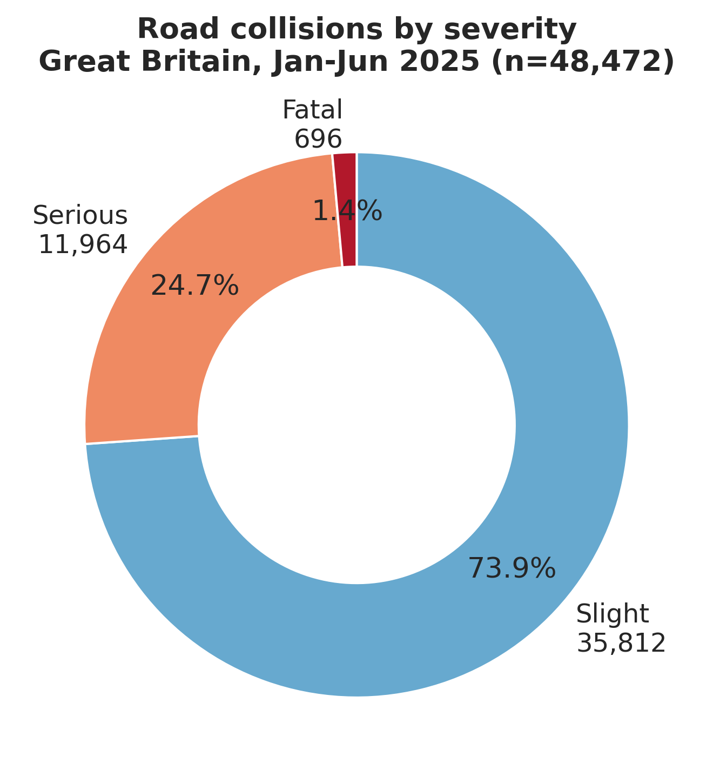
Figure 1: Most collisions are slight, but a serious minority are fatal or serious.

5.1 When do collisions happen?
Figure 2 shows that collisions are higher on weekdays than at weekends, with Friday the busiest day. This points to commuting and work traffic being a big factor.
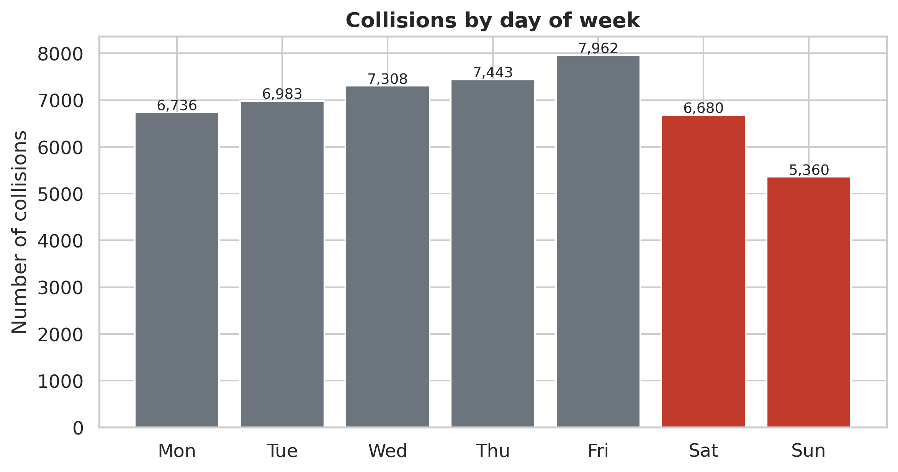
Figure 2: Collisions by day of week - weekdays are busier than weekends, peaking on Friday.
Figure 3 looks at the hour of the day. There are two clear peaks: a morning peak around 8am and a bigger evening peak around 5pm. These are the classic rush hours when the most people are travelling to and from work and school.
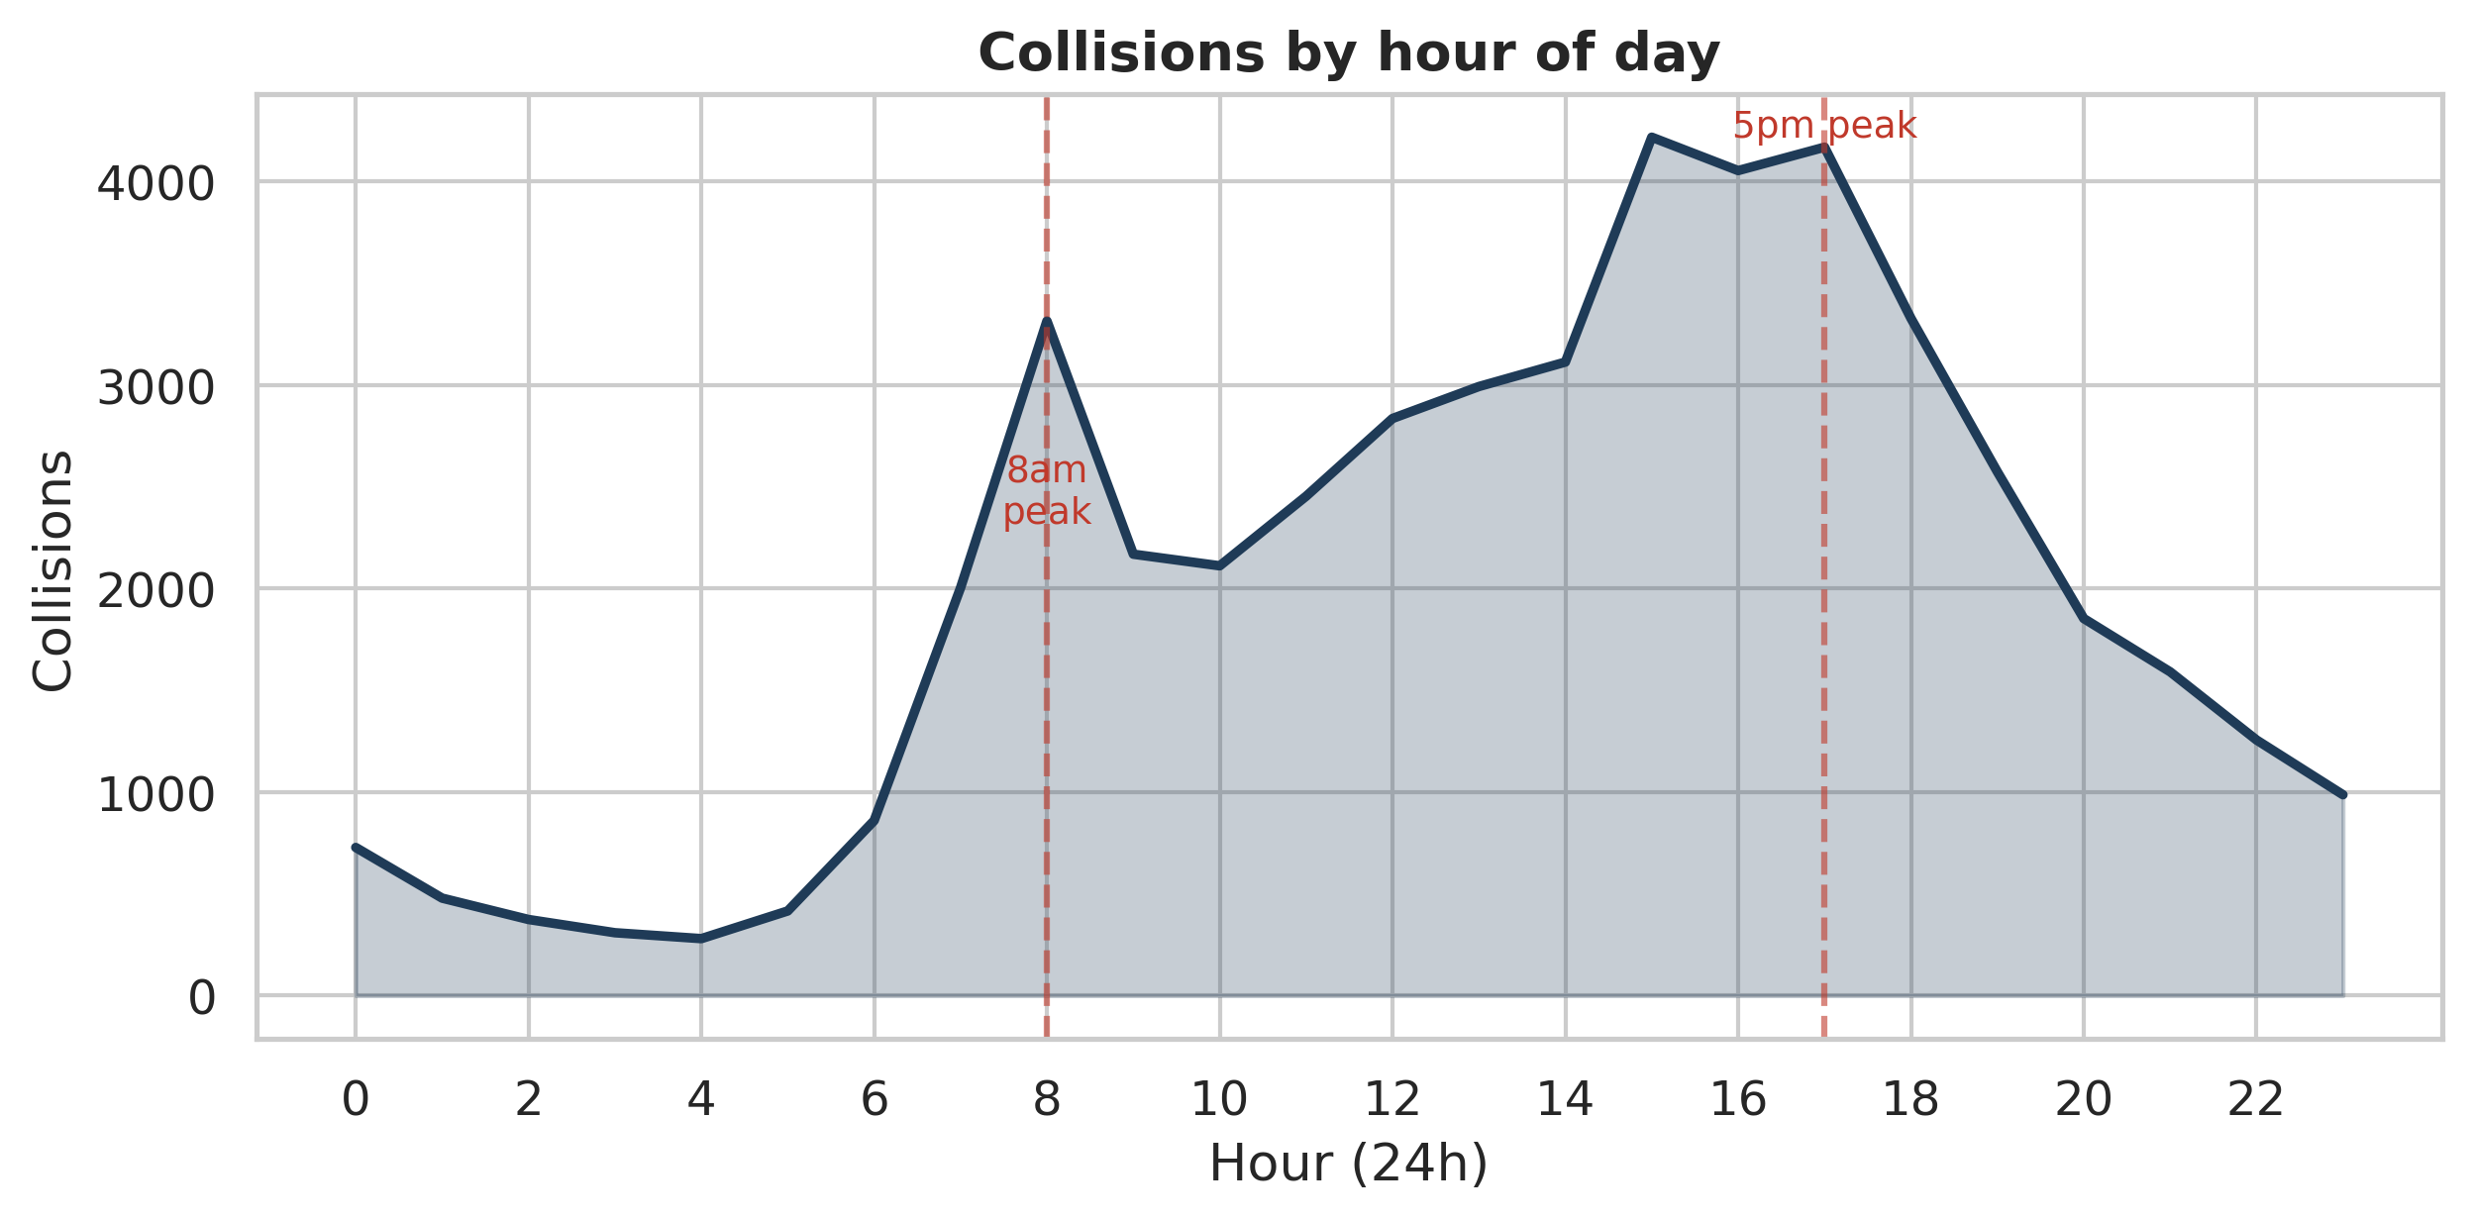
Figure 3: Collisions by hour of day - two rush-hour peaks at about 8am and 5pm.
The heatmap in Figure 4 combines day and hour together and makes the pattern even clearer. The dark squares show the morning and evening rush hours run from Monday to Friday, while at weekends collisions are spread out more into the afternoon and evening. The single darkest point is Friday at 3-5pm.
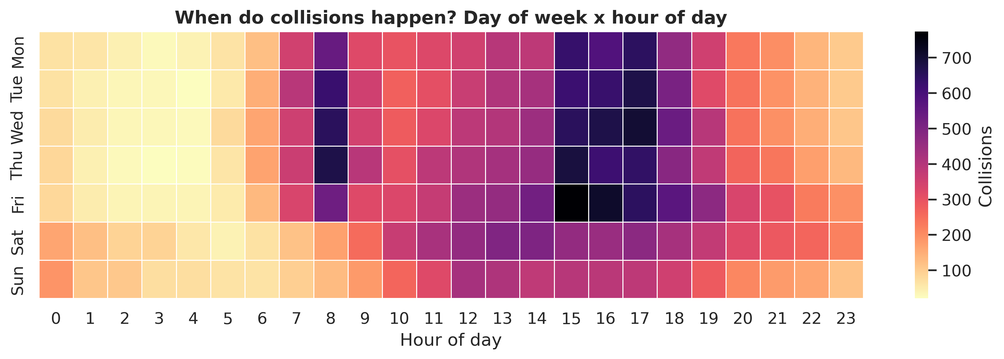
Figure 4: Day-of-week by hour-of-day. The weekday rush-hour pattern is very clear.

5.2 Conditions and severity
It is easy to assume that bad weather causes most crashes, but the data tells a more careful story. About 85.3% of collisions happen in fine weather and about 74.8% in daylight. This is mainly because that is when most driving happens. Figure 5 looks at the share of severity inside each weather type, and here fog and snow show a higher proportion of serious and fatal outcomes, even though they have fewer collisions overall.
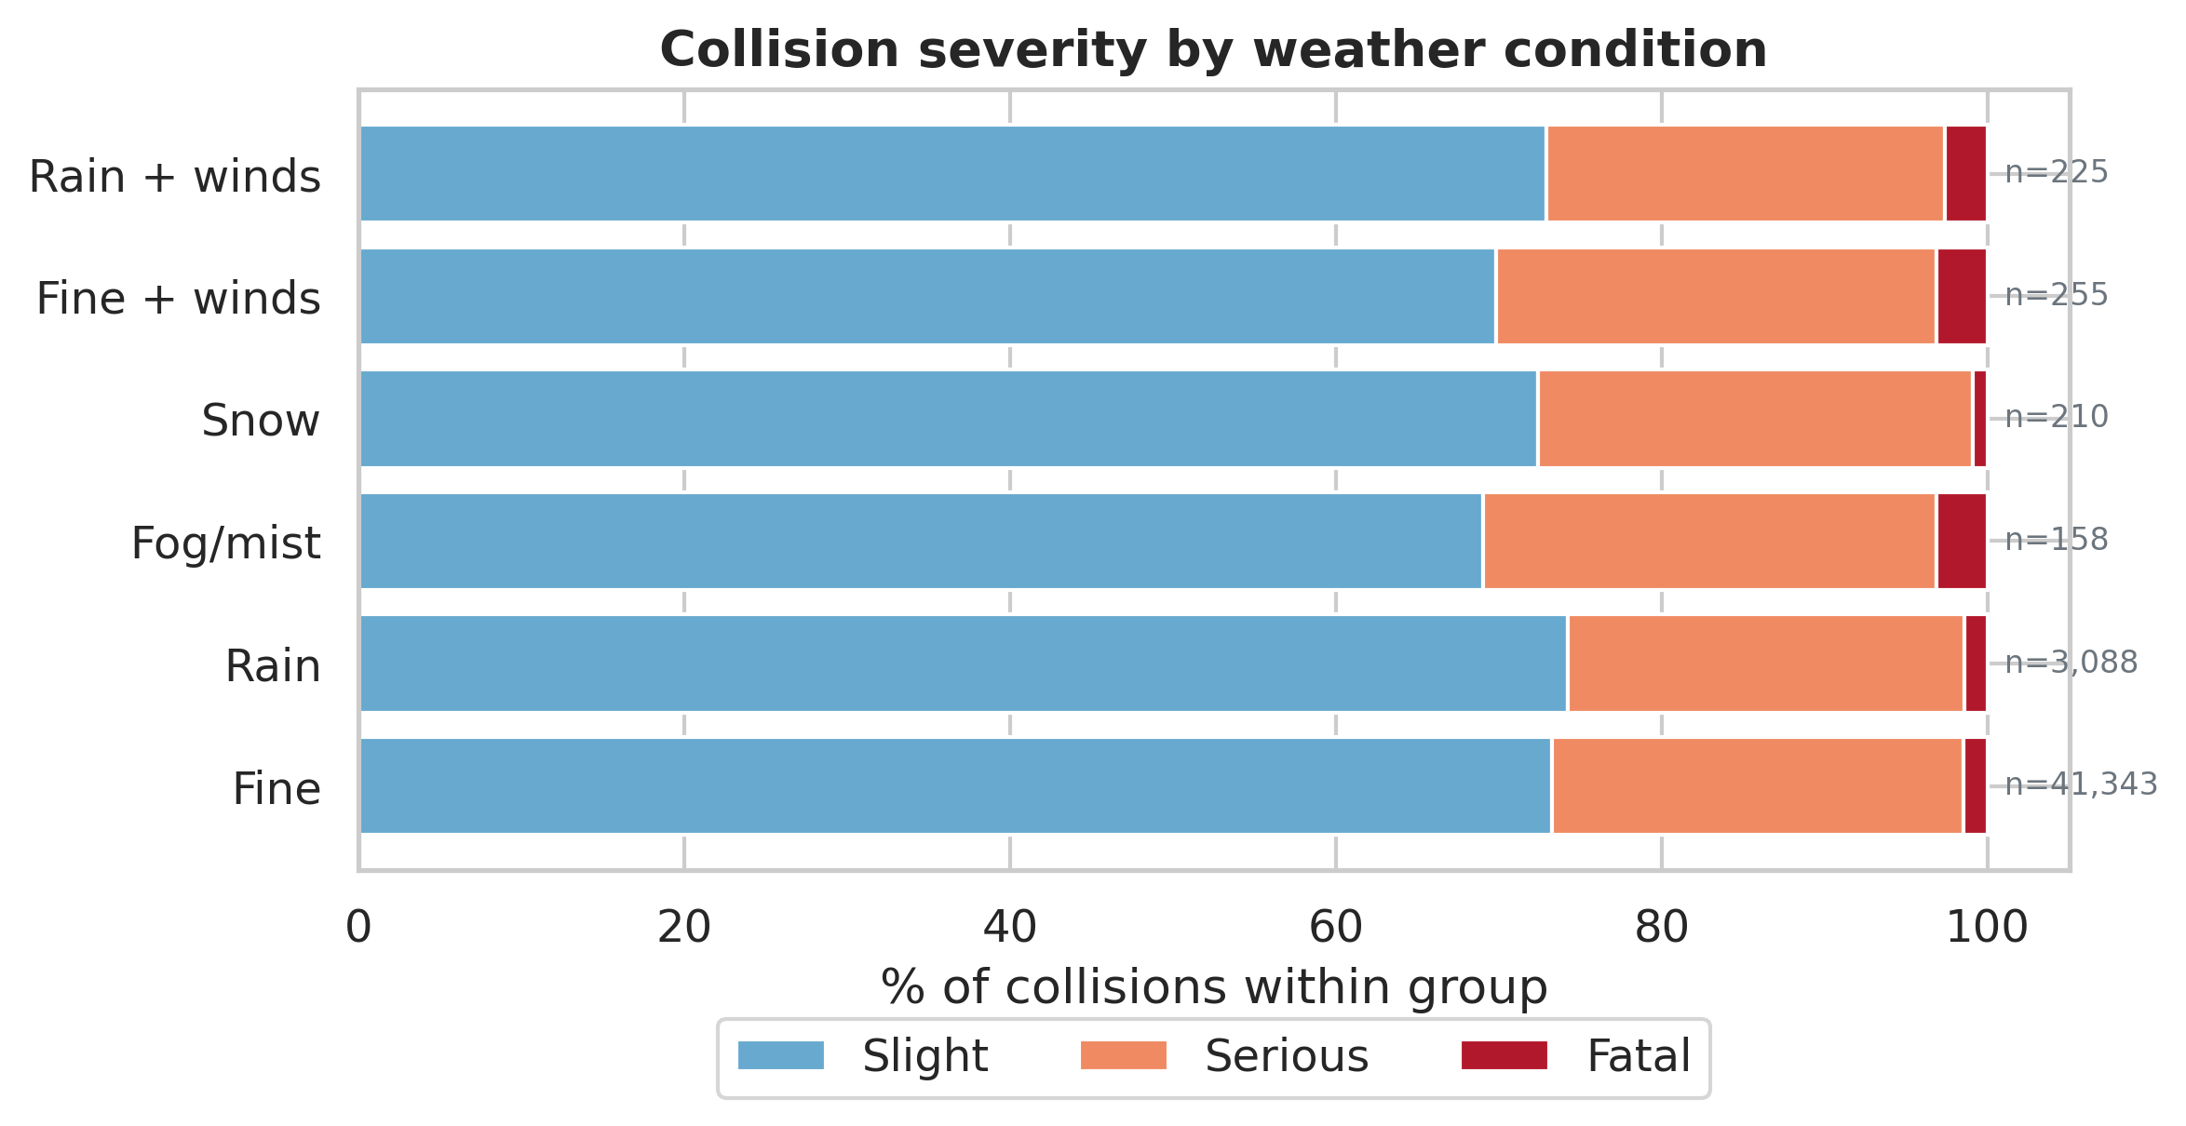
Figure 5: Severity share by weather. Fine weather has the most collisions, but fog and snow are proportionally more serious.
Speed limit also matters. Figure 6 shows the share of KSI collisions rises as the speed limit goes up, and is highest on 60 mph roads (mostly rural single-carriageway roads). Motorways (70 mph) are lower because they are built for higher speeds and have no oncoming traffic.
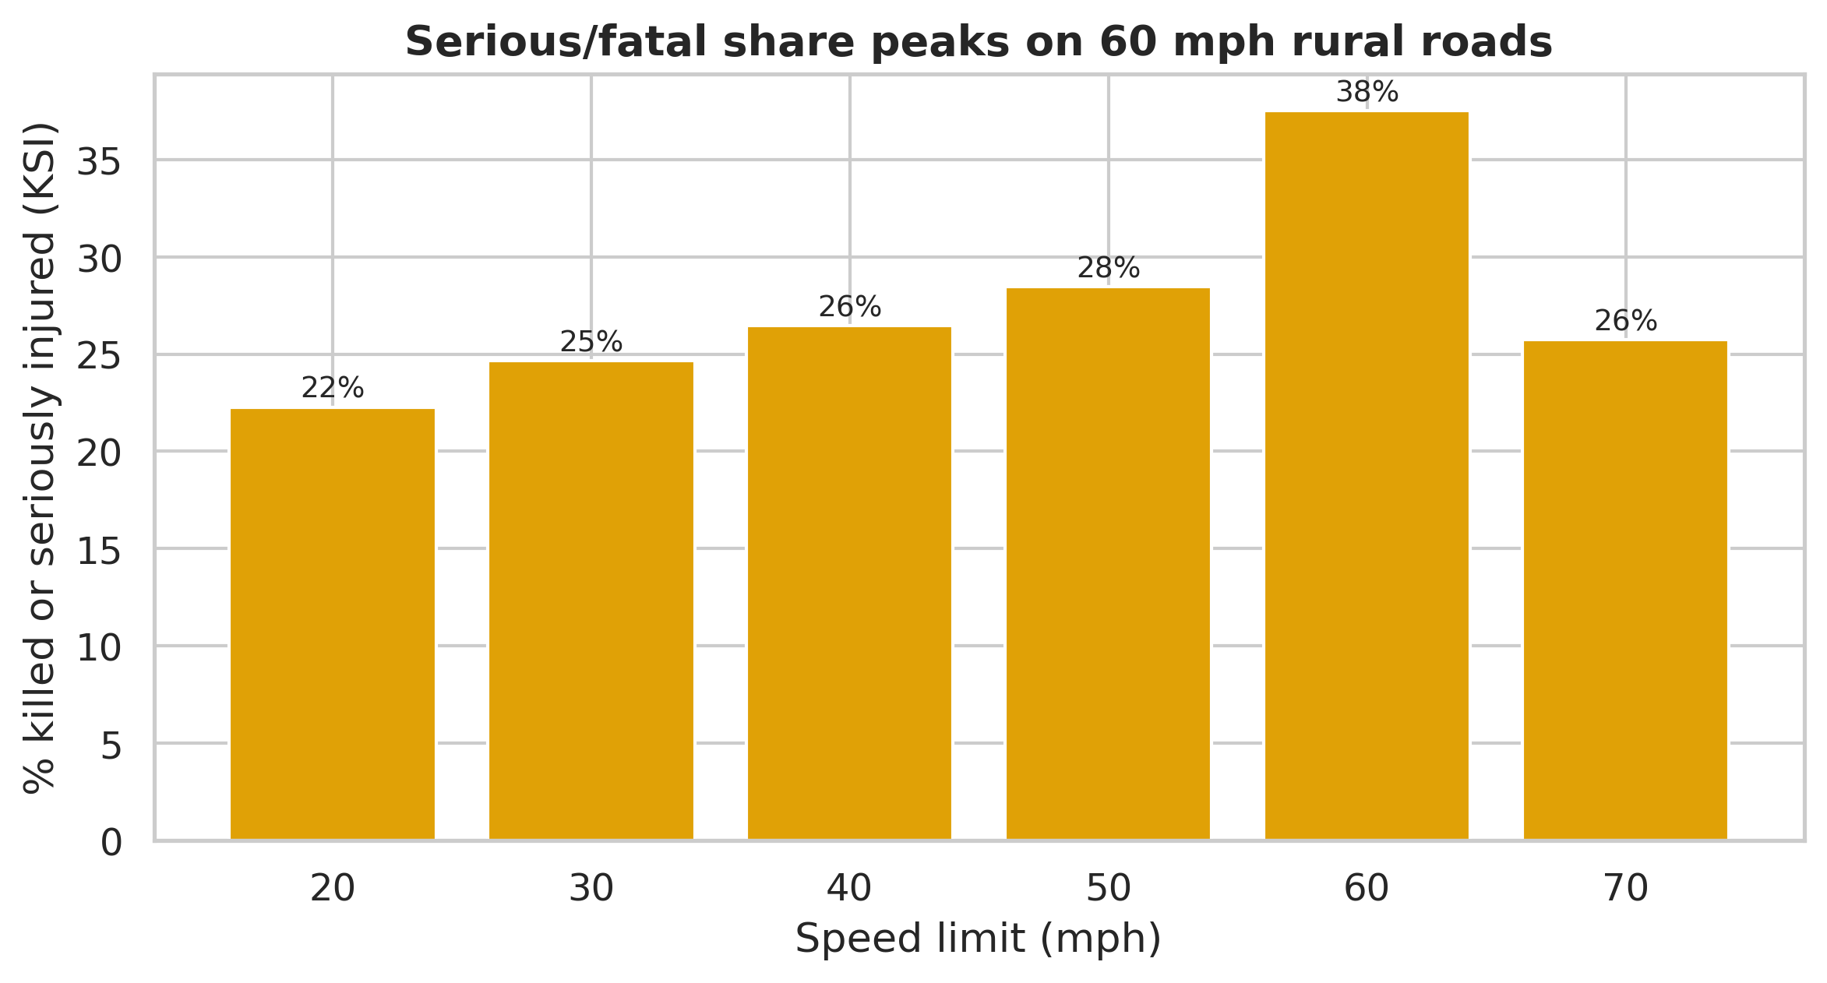
Figure 6: The serious/fatal share rises with speed limit and peaks on 60 mph roads.

5.3 Where do collisions happen?
Figure 7 maps every collision with a location. As expected, the big cities light up, with London by far the brightest area, because that is where the most people and traffic are. However, Figure 8 shows the opposite side of the story: although only about 33% of collisions happen on rural roads, rural roads have a much higher fatal share (2.79% of rural collisions are fatal, compared with only 0.76% in urban areas). In short, towns have more crashes but the countryside has deadlier ones.
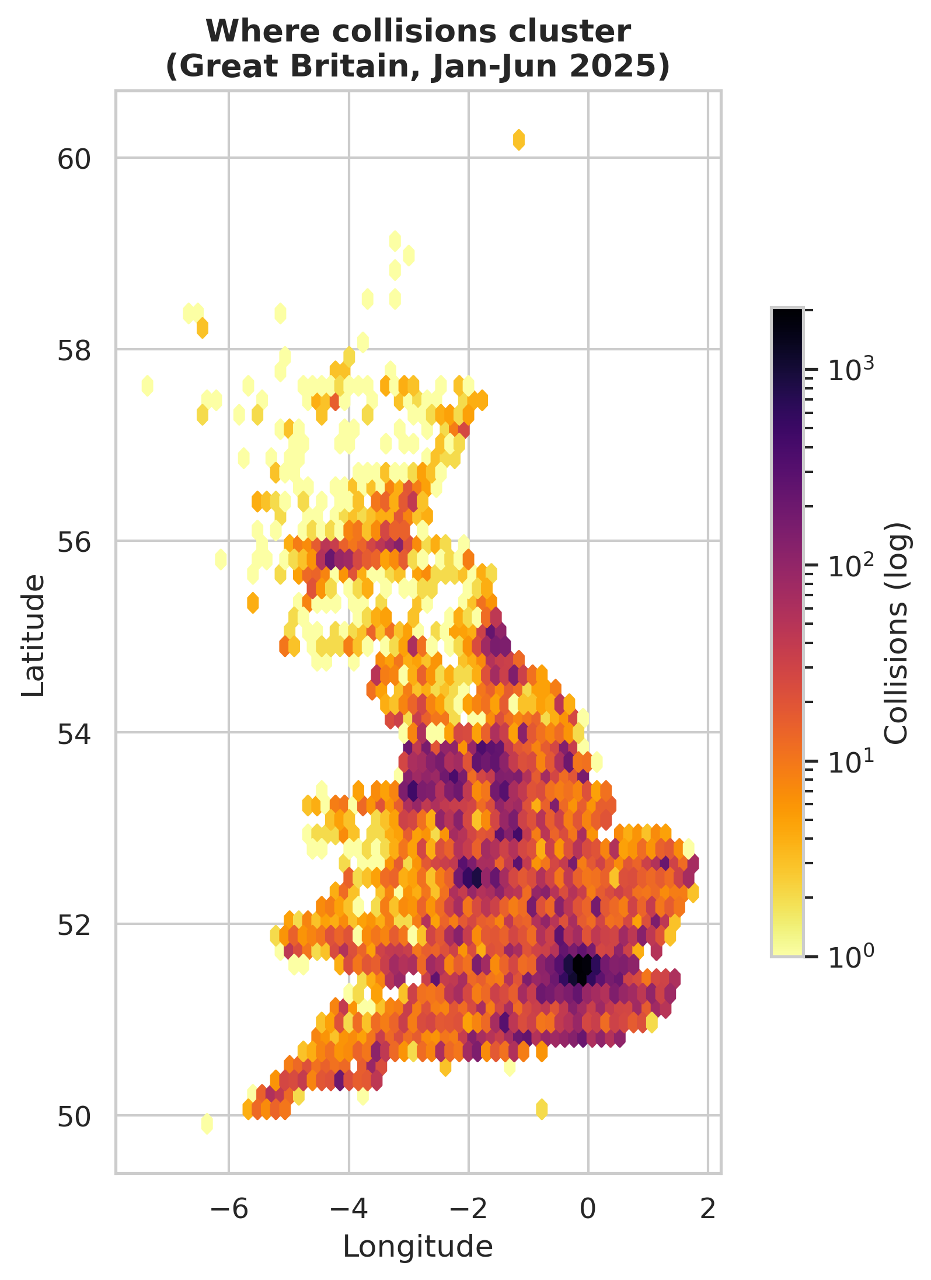
Figure 7: Where collisions cluster - cities, especially London, dominate.
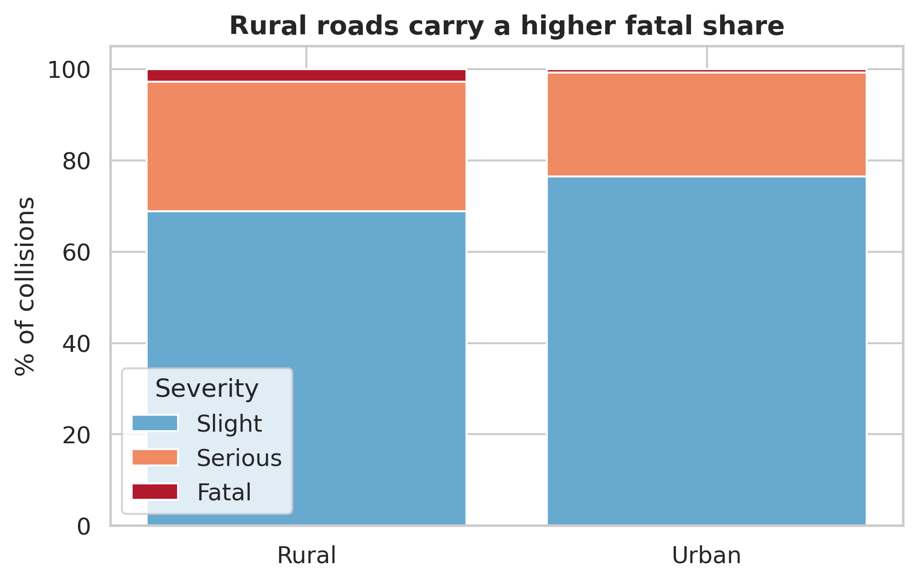
Figure 8: Rural roads have fewer collisions but a higher fatal share.

5.4 Who gets hurt?
Figure 9 shows casualties by age and sex. Men are about 60.9% of all casualties and outnumber women in nearly every age band. The numbers peak in the working-age groups (26-45), which fits the rush-hour pattern seen earlier.
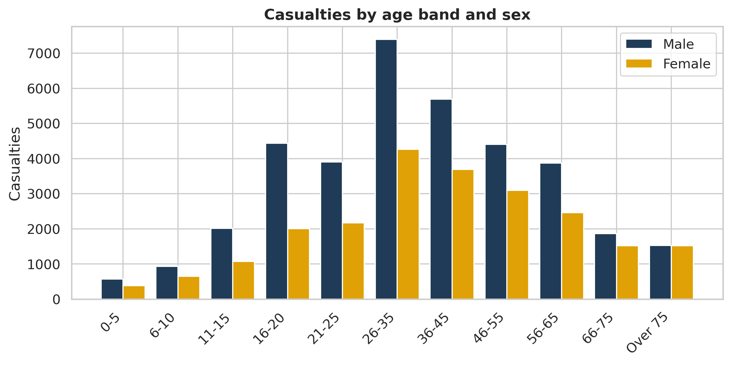
Figure 9: Casualties by age band and sex - men dominate, peaking in working-age groups.
Figure 10 shows what type of road user gets hurt. Most casualties are car occupants, but pedestrians and cyclists (highlighted in red) together make up a large vulnerable group of about 17,139 people, who have little protection in a crash.
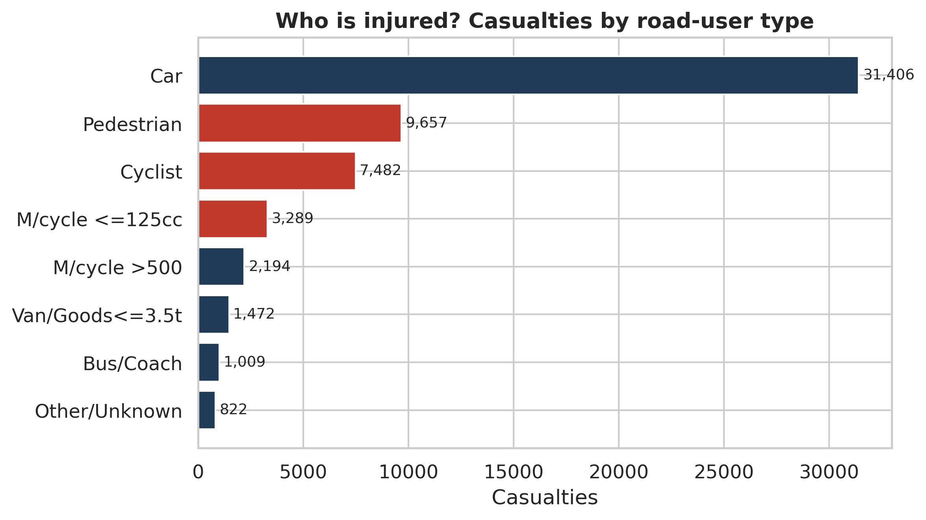
Figure 10: Casualties by road-user type. Pedestrians and cyclists (red) are a large vulnerable group.
Finally, Figure 11 brings in fairness. It groups casualties by how deprived their local area is (decile 1 is the most deprived, decile 10 the least). There are clearly more casualties from the most deprived areas than the least deprived ones. This is an important social and ethical point: road danger is not shared equally.
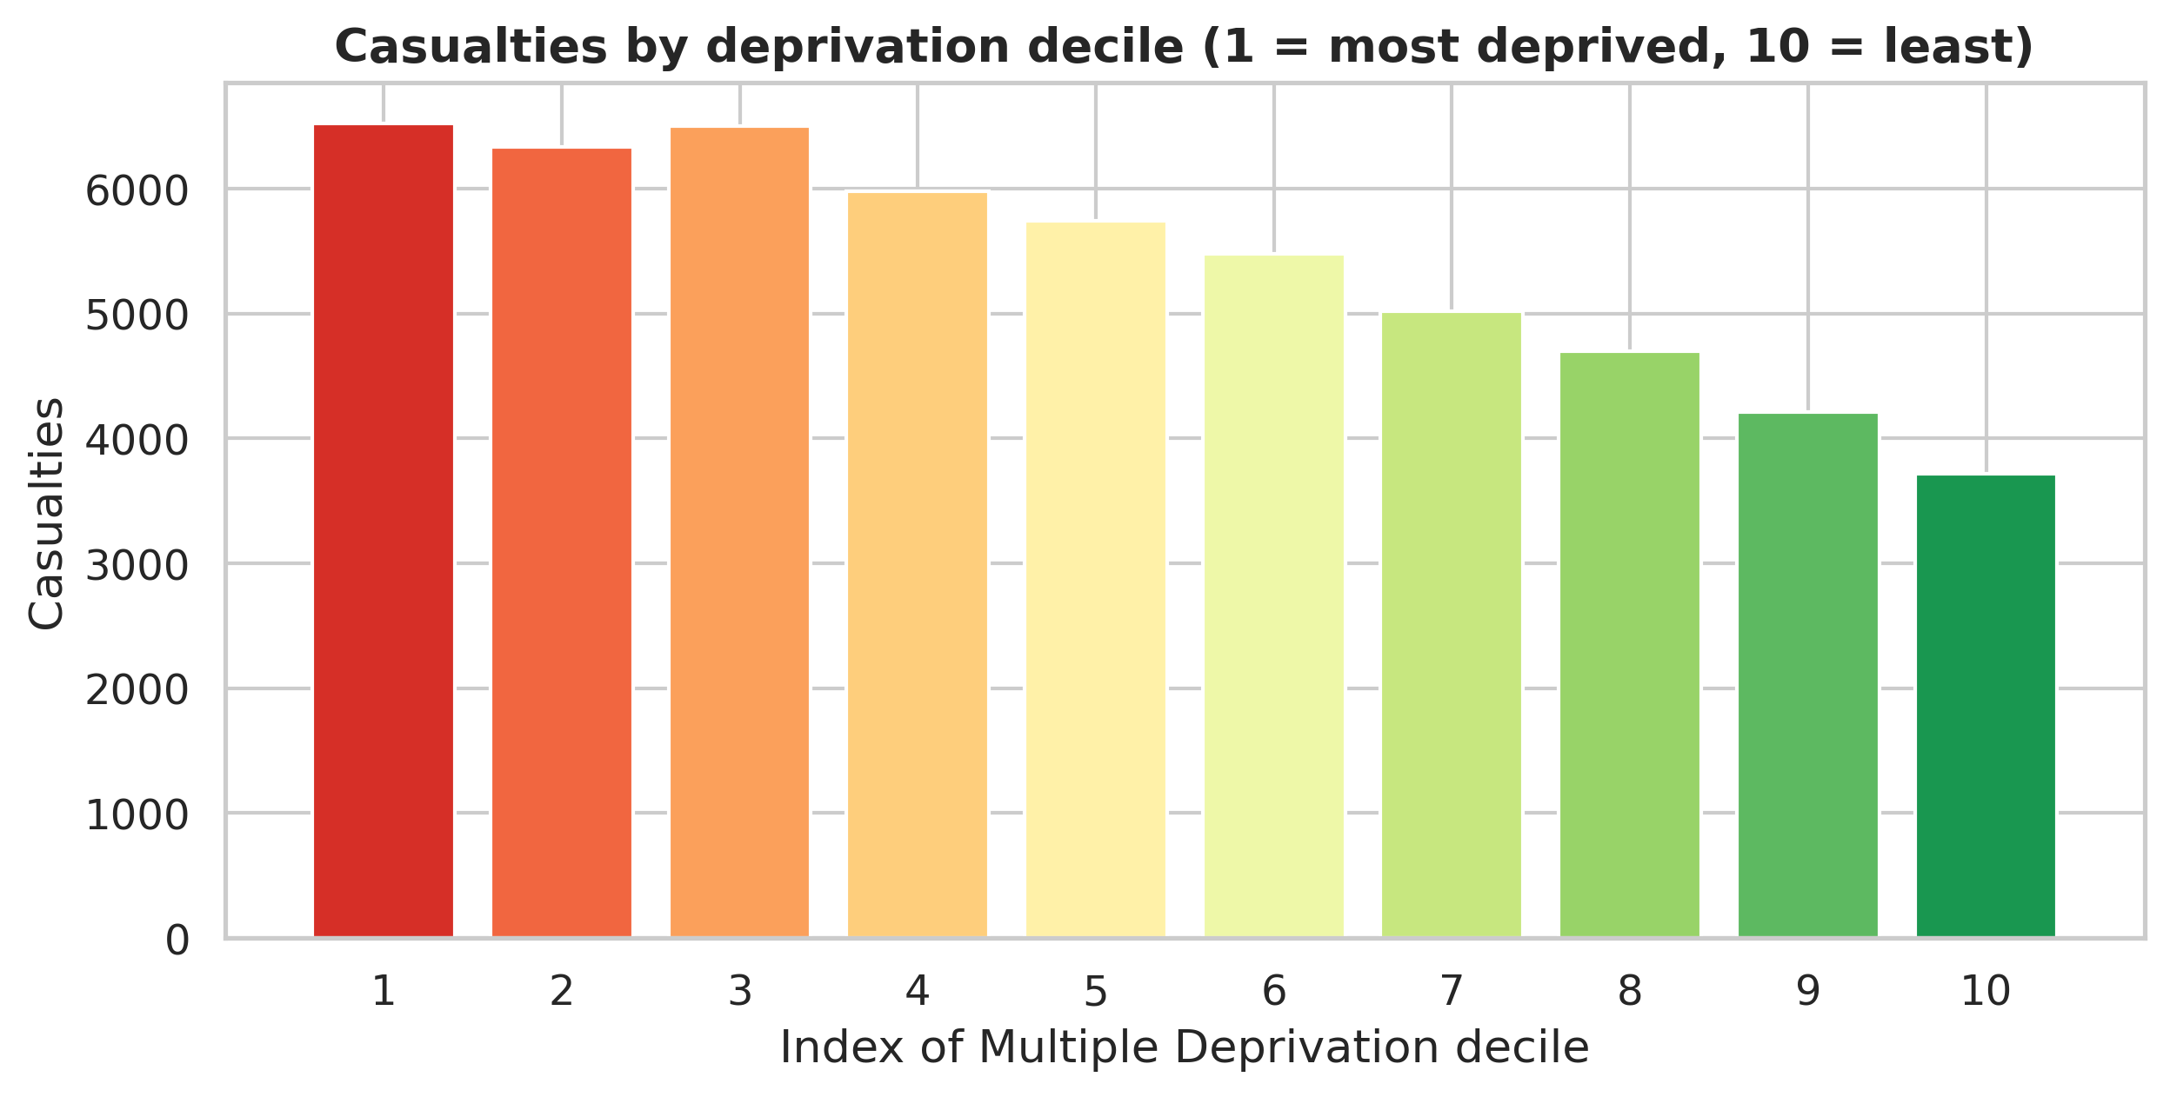
Figure 11: Casualties by deprivation decile - more casualties come from the most deprived areas.

6. Limitations and recommendations
This analysis has some limits that are honest to point out:
- The data is provisional and only covers January to June 2025, so the totals will change later and the deep-winter months are only partly included.
- STATS19 only records collisions reported to the police that involved an injury. Minor knocks and damage-only crashes are missing, so the real number of incidents is higher (Department for Transport, 2024).
- Some fields had missing (-1) values, and one column had to be dropped completely, so a few details are incomplete.
- The numbers are not adjusted for exposure (how many miles people actually drive in each condition). This is why fine weather looks “dangerous” - it is really just when most driving happens. A rate per mile driven would be fairer but that data is not in this file.
Based on the findings, a few simple recommendations follow. Road-safety effort and police patrols could focus on weekday rush hours, when most collisions happen. Rural single-carriageway 60 mph roads deserve special attention because their crashes are the deadliest. Protecting pedestrians and cyclists should be a priority as they are so vulnerable. And because more casualties come from deprived areas, safety schemes should make sure those communities are not left out.

7. Conclusion
Turning a large, coded government dataset into clear charts made it possible to see real patterns in road safety. Collisions follow the working week and the rush hours; most happen in cities and in fine weather, but the deadliest happen on fast rural roads and in poor visibility; and the people most likely to be hurt are men, working-age adults, vulnerable road users, and people from deprived areas. These are exactly the kinds of patterns that are almost impossible to spot in raw numbers but become obvious once the data is visualised well.

References
Cairo, A. (2016) The Truthful Art: Data, Charts, and Maps for Communication. Berkeley, CA: New Riders.
Department for Transport (2024) STATS20: Instructions for the completion of road collision reports. London: Department for Transport.
Department for Transport (2025). Road safety open data. [online] GOV.UK. Available at: https://www.gov.uk/government/statistical-data-sets/road-safety-open-data.
Few, S. (2012) Show Me the Numbers: Designing Tables and Graphs to Enlighten. 2nd edn. Burlingame, CA: Analytics Press.
Hunter, J.D. (2007) ‘Matplotlib: A 2D graphics environment’, Computing in Science & Engineering, 9(3), pp. 90-95.
Knaflic, C.N. (2015) Storytelling with Data: A Data Visualization Guide for Business Professionals. Hoboken, NJ: Wiley.
McKinney, W. (2017) Python for Data Analysis. 2nd edn. Sebastopol, CA: O’Reilly Media.
Tufte, E.R. (2001) The Visual Display of Quantitative Information. 2nd edn. Cheshire, CT: Graphics Press.
Waskom, M. (2021) ‘seaborn: statistical data visualization’, Journal of Open Source Software, 6(60), 3021.

Appendix: Python code
The complete, runnable code is provided as the accompanying Jupyter notebook (road_safety_analysis.ipynb), which also shows every output. The same code is reproduced below for reference.
import pandas as pd
import numpy as np
import matplotlib.pyplot as plt
import seaborn as sns

sns.set_theme(style="whitegrid", font_scale=1.05)
NAVY, RED, AMBER, TEAL, GREY = "#1f3b57", "#c0392b", "#e0a106", "#2a9d8f", "#6c757d"
# one colour per severity, used in every chart so the reader learns it once
SEV = {"Fatal":"#b2182b", "Serious":"#ef8a62", "Slight":"#67a9cf"}
sev_order = ["Slight", "Serious", "Fatal"]
plt.rcParams.update({"figure.dpi":110, "axes.titleweight":"bold"})

# ----------------------------------------

collision = pd.read_csv("dft-road-casualty-statistics-collision-provisional-2025 (1).csv", low_memory=False)
casualty = pd.read_csv("dft-road-casualty-statistics-casualty-provisional-2025.csv", low_memory=False)
vehicle = pd.read_csv("dft-road-casualty-statistics-vehicle-provisional-2025.csv", low_memory=False)

print("Collisions:", collision.shape)
print("Casualties:", casualty.shape)
print("Vehicles: ", vehicle.shape)
collision.head(3)

# ----------------------------------------

# --- STATS19 code lookups (from the DfT Road Safety Open Data guide) ---
sev_map = {1:"Fatal", 2:"Serious", 3:"Slight"}
dow_map = {1:"Sun",2:"Mon",3:"Tue",4:"Wed",5:"Thu",6:"Fri",7:"Sat"}
light_map = {1:"Daylight",4:"Dark - lit",5:"Dark - unlit",6:"Dark - no lighting",7:"Dark - unknown"}
weath_map = {1:"Fine",2:"Rain",3:"Snow",4:"Fine + winds",5:"Rain + winds",6:"Snow + winds",7:"Fog/mist",8:"Other",9:"Unknown"}
surf_map = {1:"Dry",2:"Wet/damp",3:"Snow",4:"Frost/ice",5:"Flood",6:"Oil",7:"Mud",9:"Unknown"}
urb_map = {1:"Urban",2:"Rural",3:"Unallocated"}
cclass_map = {1:"Driver/Rider",2:"Passenger",3:"Pedestrian"}
sex_map = {1:"Male",2:"Female",3:"Unknown",9:"Unknown"}
ageb_map = {1:"0-5",2:"6-10",3:"11-15",4:"16-20",5:"21-25",6:"26-35",7:"36-45",8:"46-55",9:"56-65",10:"66-75",11:"Over 75"}
type_map = {0:"Pedestrian",1:"Cyclist",2:"M/cycle <=50cc",3:"M/cycle <=125cc",4:"M/cycle 125-500",5:"M/cycle >500",
8:"Taxi",9:"Car",10:"Minibus",11:"Bus/Coach",16:"Horse",17:"Agricultural",18:"Tram",
19:"Van/Goods<=3.5t",20:"Goods 3.5-7.5t",21:"Goods>=7.5t",22:"Mobility scooter",90:"Other",
97:"M/cycle unknown",98:"Goods unknown"}

# ----------------------------------------

# --- Decode the COLLISION table ---
collision["date"] = pd.to_datetime(collision["date"], format="%d/%m/%Y")
collision["month"] = collision["date"].dt.month_name().str[:3]
collision["hour"] = pd.to_numeric(collision["time"].str[:2], errors="coerce") # take the HH part
collision["Severity"] = collision["collision_severity"].map(sev_map)
collision["DOW"] = collision["day_of_week"].map(dow_map)
collision["Light"] = collision["light_conditions"].map(light_map)
collision["Weather"] = collision["weather_conditions"].map(weath_map)
collision["Surface"] = collision["road_surface_conditions"].map(surf_map)
collision["Urban"] = collision["urban_or_rural_area"].map(urb_map)
collision["speed"] = collision["speed_limit"].replace(-1, np.nan) # -1 means 'missing'

# --- Decode the CASUALTY table ---
casualty["Severity"] = casualty["casualty_severity"].map(sev_map)
casualty["Class"] = casualty["casualty_class"].map(cclass_map)
casualty["Sex"] = casualty["sex_of_casualty"].map(sex_map)
casualty["AgeBand"] = casualty["age_band_of_casualty"].map(ageb_map)
casualty["Type"] = casualty["casualty_type"].map(type_map).fillna("Other/Unknown")
casualty["IMD"] = casualty["casualty_imd_decile"].replace(-1, np.nan)

# --- Decode the VEHICLE table ---
vehicle["VType"] = vehicle["vehicle_type"].map(type_map).fillna("Other/Unknown")
vehicle["DSex"] = vehicle["sex_of_driver"].map(sex_map)
print("Decoding done. Example:")
collision[["date","Severity","DOW","Weather","Urban","speed"]].head()

# ----------------------------------------

key_cols = ["speed_limit","light_conditions","weather_conditions","road_surface_conditions"]
missing = {c: int((collision[c]==-1).sum()) for c in key_cols}
print("Missing (-1) values in collision table:", missing)
print("age_of_vehicle is -1 for", round(100*(vehicle['age_of_vehicle']==-1).mean(),1), "% of rows -> drop it")
vehicle = vehicle.drop(columns=["age_of_vehicle"])

# ----------------------------------------

print("Period :", collision['date'].min().date(), "to", collision['date'].max().date())
print("Collisions :", f"{len(collision):,}")
print("Casualties :", f"{len(casualty):,}")
print("Vehicles :", f"{len(vehicle):,}")
sv = collision['Severity'].value_counts()
print("Fatal/Serious/Slight:", sv.get('Fatal',0), "/", sv.get('Serious',0), "/", sv.get('Slight',0))
print("Killed or seriously injured (KSI) share:",
round(100*(collision['Severity'].isin(['Fatal','Serious'])).mean(),1), "%")

# ----------------------------------------

vals = [sv['Slight'], sv['Serious'], sv['Fatal']]
labs = [f"Slight\n{sv['Slight']:,}", f"Serious\n{sv['Serious']:,}", f"Fatal\n{sv['Fatal']:,}"]
plt.figure(figsize=(6,5))
plt.pie(vals, labels=labs, colors=[SEV['Slight'],SEV['Serious'],SEV['Fatal']],
autopct=lambda p:f"{p:.1f}%", startangle=90, counterclock=False,
wedgeprops=dict(width=0.42, edgecolor='w'), pctdistance=0.78)
plt.title("Road collisions by severity, GB Jan-Jun 2025"); plt.show()

# ----------------------------------------

plt.figure(figsize=(8,4.3))
dow = collision['DOW'].value_counts().reindex(['Mon','Tue','Wed','Thu','Fri','Sat','Sun'])
plt.bar(dow.index, dow.values, color=[GREY]*5+[RED,RED])
plt.title("Collisions by day of week"); plt.ylabel("Collisions"); plt.show()

# ----------------------------------------

plt.figure(figsize=(8.5,4.2))
hr = collision.dropna(subset=['hour']).groupby('hour').size()
plt.fill_between(hr.index, hr.values, color=NAVY, alpha=0.25)
plt.plot(hr.index, hr.values, color=NAVY, lw=2.3)
plt.title("Collisions by hour of day"); plt.xlabel("Hour (24h)"); plt.ylabel("Collisions")
plt.xticks(range(0,24,2)); plt.show()

# ----------------------------------------

piv = (collision.dropna(subset=['hour'])
.pivot_table(index='DOW', columns='hour', values='collision_index', aggfunc='count')
.reindex(['Mon','Tue','Wed','Thu','Fri','Sat','Sun']))
plt.figure(figsize=(11,3.8))
sns.heatmap(piv, cmap='magma_r', linewidths=.3, linecolor='white', cbar_kws={'label':'Collisions'})
plt.title("Day of week x hour of day"); plt.xlabel("Hour"); plt.ylabel(""); plt.show()

# ----------------------------------------

d = collision[collision['Weather'].notna()]
order = ['Fine','Rain','Fog/mist','Snow','Fine + winds','Rain + winds']
ct = (pd.crosstab(d['Weather'], d['Severity'], normalize='index')[sev_order]*100).reindex(order).dropna()
fig, ax = plt.subplots(figsize=(8,4.2)); bottom=np.zeros(len(ct))
for s in sev_order:
ax.barh(ct.index, ct[s], left=bottom, color=SEV[s], label=s); bottom+=ct[s].values
ax.set_xlabel("% within weather group"); ax.set_title("Severity share by weather")
ax.legend(ncol=3, loc='lower center', bbox_to_anchor=(0.5,-0.3)); plt.show()

# ----------------------------------------

sp = collision.dropna(subset=['speed'])
rate = sp.groupby('speed').apply(lambda g: 100*g['Severity'].isin(['Fatal','Serious']).mean())
plt.figure(figsize=(8,4.2))
plt.bar(rate.index.astype(int).astype(str), rate.values, color=AMBER, edgecolor='white')
plt.ylabel("% KSI"); plt.xlabel("Speed limit (mph)"); plt.title("KSI share by speed limit"); plt.show()

# ----------------------------------------

ur = (pd.crosstab(collision[collision['Urban'].isin(['Urban','Rural'])]['Urban'],
collision['Severity'], normalize='index')[sev_order]*100)
plt.figure(figsize=(6.5,4.2)); bottom=np.zeros(len(ur))
for s in sev_order:
plt.bar(ur.index, ur[s], bottom=bottom, color=SEV[s], label=s); bottom+=ur[s].values
plt.ylabel("% of collisions"); plt.title("Severity: urban vs rural"); plt.legend(title="Severity"); plt.show()

# ----------------------------------------

g = collision.dropna(subset=['latitude','longitude'])
g = g[(g['latitude'].between(49,61)) & (g['longitude'].between(-8,2))]
plt.figure(figsize=(6.2,7.5))
hb = plt.hexbin(g['longitude'], g['latitude'], gridsize=60, cmap='inferno_r', mincnt=1, bins='log')
plt.colorbar(hb, label='Collisions (log)', shrink=0.6)
plt.title("Collision density, GB"); plt.xlabel("Longitude"); plt.ylabel("Latitude")
plt.gca().set_aspect(1.6); plt.show()

# ----------------------------------------

ca = casualty[casualty['Sex'].isin(['Male','Female']) & casualty['AgeBand'].notna()]
order = ["0-5","6-10","11-15","16-20","21-25","26-35","36-45","46-55","56-65","66-75","Over 75"]
ct = pd.crosstab(ca['AgeBand'], ca['Sex']).reindex(order)
x = np.arange(len(ct)); w=0.4
plt.figure(figsize=(9,4.5))
plt.bar(x-w/2, ct['Male'], w, label='Male', color=NAVY)
plt.bar(x+w/2, ct['Female'], w, label='Female', color=AMBER)
plt.xticks(x, ct.index, rotation=45, ha='right'); plt.ylabel("Casualties")
plt.title("Casualties by age band and sex"); plt.legend(); plt.show()

# ----------------------------------------

ct = casualty['Type'].value_counts().head(8)[::-1]
cols = [RED if i in ['Pedestrian','Cyclist','M/cycle <=125cc'] else NAVY for i in ct.index]
plt.figure(figsize=(8,4.5)); plt.barh(ct.index, ct.values, color=cols)
plt.title("Casualties by road-user type"); plt.xlabel("Casualties"); plt.show()

# ----------------------------------------

im = casualty.dropna(subset=['IMD'])['IMD'].value_counts().sort_index()
plt.figure(figsize=(8.5,4.2))
plt.bar(im.index.astype(int).astype(str), im.values, color=plt.cm.RdYlGn(np.linspace(0.1,0.9,10)))
plt.title("Casualties by deprivation decile (1=most deprived)"); plt.xlabel("IMD decile"); plt.ylabel("Casualties"); plt.show()

