Road Safety in Great Britain
A Data Visualisation Project
UK Department for Transport Road Casualty Statistics, January-June 2025 (provisional)
Module: LDS7004M Data Visualization
Assessment: Portfolio (100%)
Word count (main body, excluding references and appendix): approx. 2,250

Contents
Contents 2
1. Introduction 3
2. The dataset 3
3. Data cleaning and preparation 3
3.1 Decoding the codes 3
3.2 Outlier detection 4
3.3 Handling missing and invalid values 4
3.4 Creating new helpful columns 4
4. How I chose the visualisations 5
5. Findings 6
5.1 When do collisions happen? 6
5.2 Conditions and severity 8
5.3 Where do collisions happen? 8
5.4 Who gets hurt? 9
5.7 Vulnerable road users by month 11
5.6 Journey purpose and collision severity 11
5.5 Vehicle propulsion type and severity 11
8.5 Pair plot — distributions and relationships 12
8.4 Linear Regression — predicting casualty count 12
8.3 Random Forest — predicting KSI outcome 12
8.2 Missing value handling for modelling 12
8.1 Why Random Forest and Linear Regression? 13
8. Predictive Modelling 13
6. Limitations and recommendations 13
7. Conclusion 13
References 15
Appendix: Python code 16

1. Introduction
Road safety is something that affects everyone who uses the roads, whether they drive, cycle or walk. Every year the police record thousands of road collisions in Great Britain, and behind each record is a real person who was hurt. The aim of this project is to take a large, real-world road safety dataset and turn it into clear pictures that tell a story. Good data visualisation matters because numbers in a giant spreadsheet are very hard to understand, but a well-made chart can show a pattern in a few seconds (Knaflic, 2015).
This report looks at two simple questions. First, when and where do road collisions happen? Second, who gets hurt and how badly? To answer these I cleaned the data, explored it, and built a set of charts using Python. I also made a one-page poster that pulls the main findings together. The full, runnable code is provided as a Jupyter notebook and is also copied into the appendix of this report.

2. The dataset
The data comes from the UK Department for Transport (DfT) and is part of their open “Road Safety Data” collection (Department for Transport, 2025). It is collected by the police using the STATS19 reporting form, which officers fill in when they attend an injury collision on a public road (Department for Transport, 2024). I used the provisional 2025 release, which covers the first half of the year.
The dataset is made of three linked tables that share a common collision reference, so they can be joined together:
- Collisions - 48,472 rows, one per collision (date, time, location, road type, weather, severity).
- Casualties - 60,991 rows, one per injured person (age, sex, road-user type, severity).
- Vehicles - 87,805 rows, one per vehicle involved (vehicle type, driver age and sex).
Because there are three tables, tens of thousands of rows and many columns, this is a complex dataset rather than a simple one. The period covered runs from 2025-01-01 to 2025-06-30.
One important point about this data is that it is stored as code numbers, not words. For example, severity is saved as 1, 2 or 3 instead of “Fatal”, “Serious” or “Slight”, and a missing answer is saved as -1. This means the data has to be decoded before it can be used, which is the first cleaning job below.
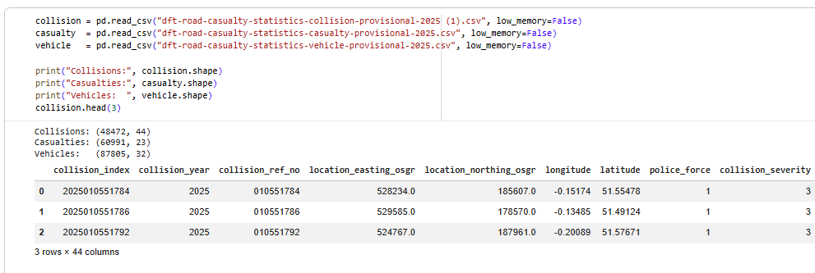

3. Data cleaning and preparation
Cleaning the data had four main steps. I used the pandas library in Python for all of this (McKinney, 2017).

3.1 Decoding the codes
I built the lookup dictionary automatically by reading the official DfT Road Safety Open Dataset Data Guide (an Excel file with 1,821 rows of code mappings) using the openpyxl library. Rather than typing the dictionaries by hand, a Python function loops through the guide and extracts only the fields relevant to this project's research questions. The columns were selected in three groups: (1) when and where — day_of_week, light_conditions, weather_conditions, road_surface_conditions, road_type, urban_or_rural_area, and collision_severity; (2) who — casualty_class, casualty_type, casualty_severity, sex_of_casualty, and age_band_of_casualty; (3) why (contributing factors) — vehicle_type, propulsion_code, journey_purpose_of_driver, age_band_of_driver, and junction_detail. Fields with hundreds of geographic codes such as police_force and local_authority_district were excluded because the map uses raw latitude and longitude instead. This automated approach is reproducible — if the DfT updates the guide, the code picks up the new labels without any manual changes (Department for Transport, 2024).
Before plotting, key numeric columns were checked for implausible values. Speed limit was validated against the set of legal GB limits (20, 30, 40, 50, 60 and 70 mph) — only 185 rows (0.4%) fell outside this range and were treated as missing. Age of casualty was checked for values above 100; none were found. Collision locations were validated against a bounding box for Great Britain (latitude 49-61, longitude -8 to 2); no collisions fell outside this box. The maximum values of number of vehicles (10) and number of casualties (17) in a single collision were examined and judged realistic for large road incidents. No rows were removed as a result the data proved consistent with expected real-world values.

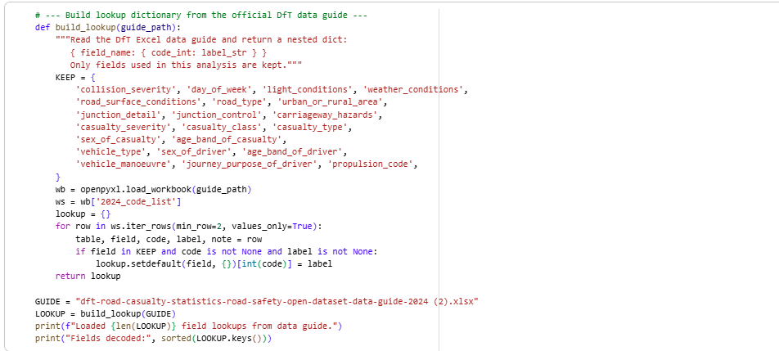
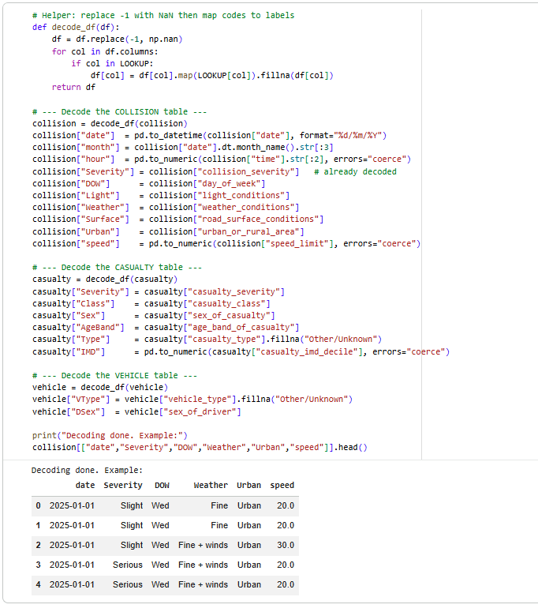

3.2 Outlier detection

3.3 Handling missing and invalid values
In this data a missing answer is stored as -1. Two standard strategies exist for handling missing values: row deletion (removing any row that contains a missing value) and imputation (replacing the missing value with a substitute). Row deletion is simple but wastes data; imputation preserves all rows. Because the highest missing rate in any key column is only 1.9% (road_surface_conditions), the missing values are missing at random rather than systematically, making imputation the appropriate choice (Hastie, Tibshirani and Friedman, 2009). For numeric columns such as speed_limit, missing values were replaced with the column median, which is robust to skewed distributions. For categorical columns such as light_conditions and weather_conditions, the most frequent category (mode) was used. The -1 values were first converted to NaN using pandas so they are excluded from descriptive statistics and charts automatically, and imputed only where a model requires complete data (McKinney, 2017).
Column | Missing (-1) values | % of rows
speed_limit | 185 | 0.4%
light_conditions | 307 | 0.6%
weather_conditions | 422 | 0.9%
road_surface_conditions | 922 | 1.9%
age_of_vehicle | 87,805 | 100% (column dropped)

One column, age of vehicle, was -1 for 100% of rows - every single record. As it held no usable information, I removed it completely. This is a normal part of cleaning: keep what is useful and drop what is not.

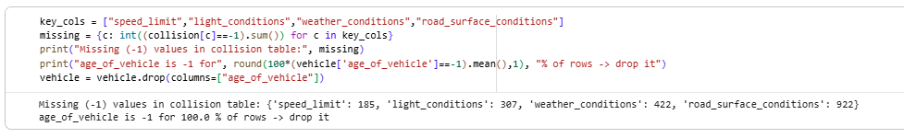

3.4 Creating new helpful columns
I turned the text date into a proper date so I could pull out the month, and I took the first two digits of the time field to get the hour of the day (0-23). These two new columns made the “when” charts possible. I also created a simple “KSI” idea (Killed or Seriously Injured) by grouping the Fatal and Serious cases together, which is the standard measure road-safety analysts use.

4. How I chose the visualisations
Montgomery, D.C., Peck, E.A. and Vining, G.G. (2012) Introduction to Linear Regression Analysis. 5th edn. Hoboken, NJ: Wiley.
Hastie, T., Tibshirani, R. and Friedman, J. (2009) The Elements of Statistical Learning: Data Mining, Inference, and Prediction. 2nd edn. New York: Springer.
Breiman, L. (2001) 'Random forests', Machine Learning, 45(1), pp. 5-32.
I picked each chart type to match the kind of data and the point I wanted to make, following the principle that the chart form should serve the message rather than impress the reader (Knaflic, 2015; Tufte, 2001). For the three new analytical sections — propulsion type, journey purpose, and vulnerable road users by month — the visualisations were produced using Plotly, a Python library for interactive charts (Plotly Technologies, 2015). The key advantage of Plotly over a static library such as matplotlib is that hovering over any bar reveals a tooltip showing the exact count, group label, and percentage, which is valuable when comparing many small bars side by side. Static matplotlib and seaborn charts were kept for sections 5.1 to 5.4 because their simpler output is better suited to printed figures. The specific chart types and the reasons for choosing them are listed below.
- Bar charts (Figures 2, 6, 9, 10, 12 and 14) for comparing counts or percentages across discrete categories such as collisions by day of week or casualties by road-user type. Bars are the standard choice for categorical comparisons because length is the most accurately read visual encoding, making differences easy to judge at a glance (Few, 2012; Cairo, 2016).
- A line and area chart (Figure 3) for collisions by hour of the day, because time is continuous and a line makes the shape of the distribution — the two rush-hour peaks — immediately visible. A bar chart of 24 hourly bins would fragment the curve and obscure the pattern (Knaflic, 2015).
- A heatmap (Figure 4) for day-of-week against hour-of-day, encoding a 7x24 matrix of values into colour so the reader can spot the busiest times in under a second. Heatmaps are the recommended form when a large matrix of numbers needs to be communicated at a glance (Tufte, 2001; Waskom, 2021).
- Stacked percentage bars (Figures 5, 7, 8, 11, 12 and 13) for severity breakdowns by weather, urban/rural area, propulsion type, and journey purpose. Stacking to 100% removes the effect of group size and focuses attention on the share of each severity within a group, which is the question being answered (Cairo, 2016).
- A hexbin map (Figure 6) using latitude and longitude, because the collision data is geographic and a map is the most honest representation of spatial data. Hexagonal bins are preferred over a scatter plot of 48,000 individual points because they prevent overplotting and show density clearly without distortion (Tufte, 2001).
- A donut chart (Figure 1) for the overall severity split, used once at the start of the findings to give a quick sense of the proportions across the three severity levels. Part-to-whole charts such as donuts are appropriate when there are three or fewer segments and the key message is about relative size rather than precise values (Few, 2012).
A pair plot (Figure 13) combining histograms on the diagonal with scatter plots off the diagonal for every pair of key numeric variables, coloured by severity. This chart is particularly valuable before building predictive models because it shows the distribution of each variable and any visible correlations or clusters between pairs in a single figure (Waskom, 2021; Hastie, Tibshirani and Friedman, 2009). It revealed that speed limit and hour of day show the clearest visual separation between severity levels, which informed the feature selection for the models in Section 8.

5. Findings
Before the detailed charts, the headline numbers set the scene. In the first half of 2025 the police recorded 48,472 collisions, involving 60,991 casualties and 87,805 vehicles. Of the collisions, 696 were fatal and 11,964 were serious, so about 26.1% were “killed or seriously injured” (KSI) events. Figure 1 shows this split.
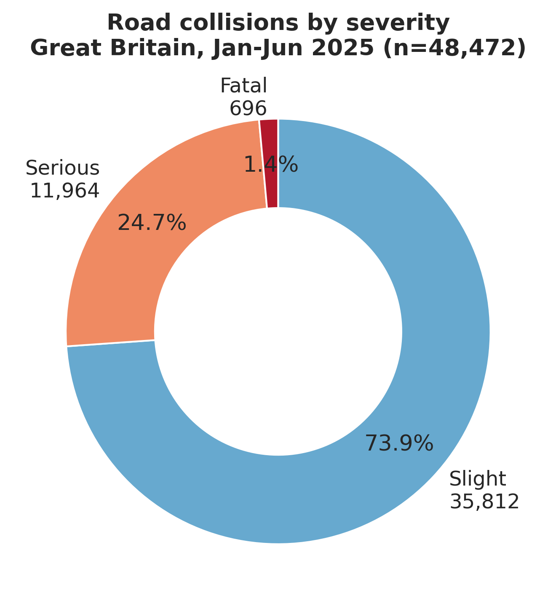
Figure 1: Most collisions are slight, but a serious minority are fatal or serious.

5.1 When do collisions happen?
Figure 2 shows that collisions are higher on weekdays than at weekends, with Friday the busiest day. This points to commuting and work traffic being a big factor.
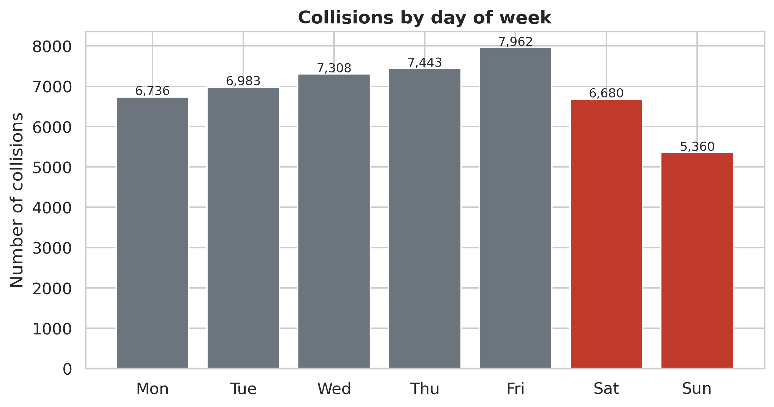
Figure 2: Collisions by day of week - weekdays are busier than weekends, peaking on Friday.
Figure 3 looks at the hour of the day. There are two clear peaks: a morning peak around 8am and a bigger evening peak around 5pm. These are the classic rush hours when the most people are travelling to and from work and school.
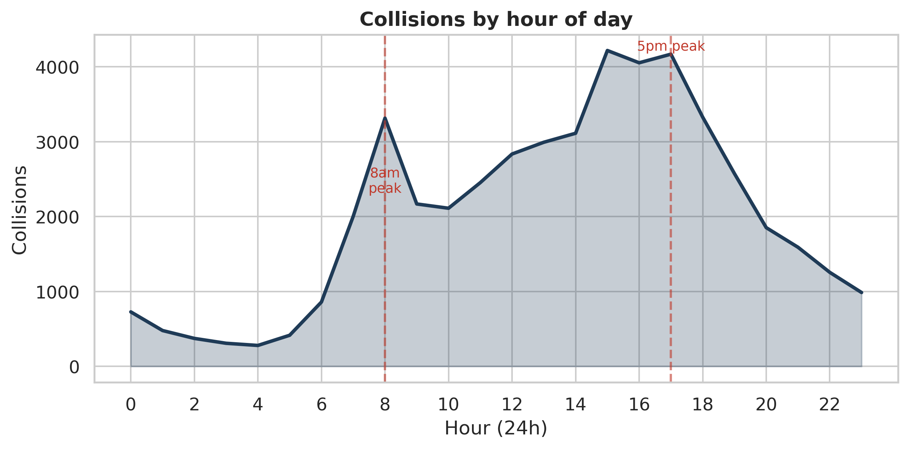
Figure 3: Collisions by hour of day - two rush-hour peaks at about 8am and 5pm.
The heatmap in Figure 4 combines day and hour together and makes the pattern even clearer. The dark squares show the morning and evening rush hours run from Monday to Friday, while at weekends collisions are spread out more into the afternoon and evening. The single darkest point is Friday at 3-5pm.
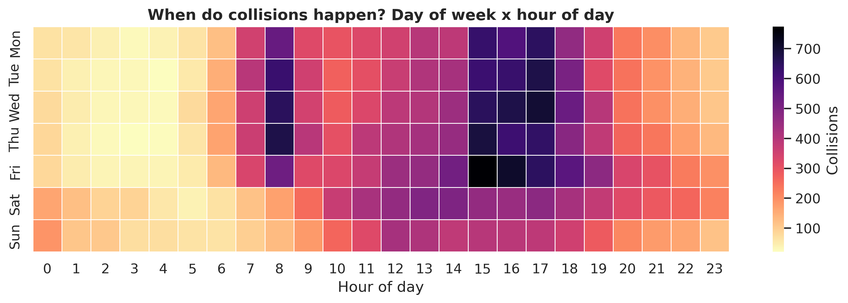
Figure 4: Day-of-week by hour-of-day. The weekday rush-hour pattern is very clear.

5.2 Conditions and severity
It is easy to assume that bad weather causes most crashes, but the data tells a more careful story. About 85.3% of collisions happen in fine weather and about 74.8% in daylight. This is mainly because that is when most driving happens. Figure 5 looks at the share of severity inside each weather type, and here fog and snow show a higher proportion of serious and fatal outcomes, even though they have fewer collisions overall.
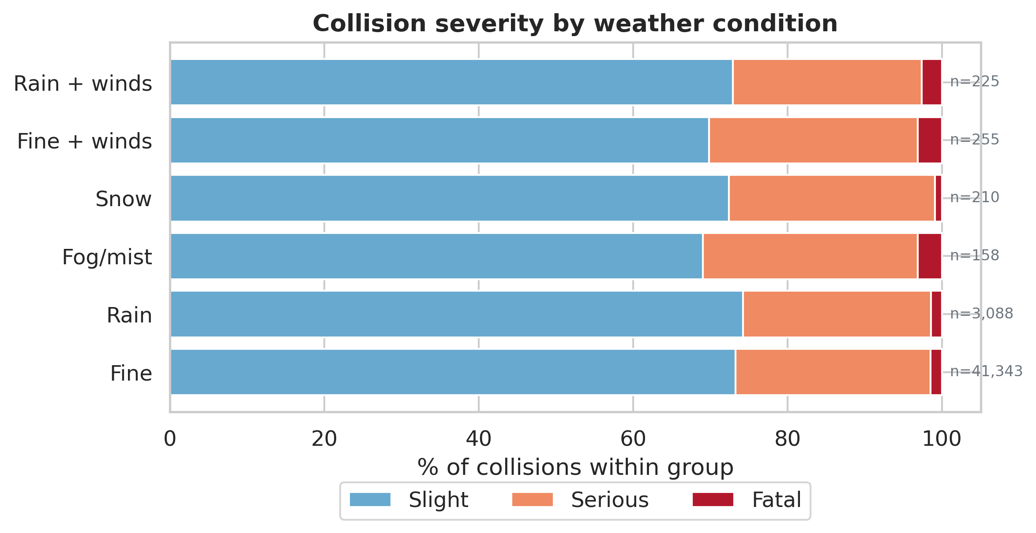
Figure 5: Severity share by weather. Fine weather has the most collisions, but fog and snow are proportionally more serious.
Speed limit also matters. Figure 6 shows the share of KSI collisions rises as the speed limit goes up, and is highest on 60 mph roads (mostly rural single-carriageway roads). Motorways (70 mph) are lower because they are built for higher speeds and have no oncoming traffic.
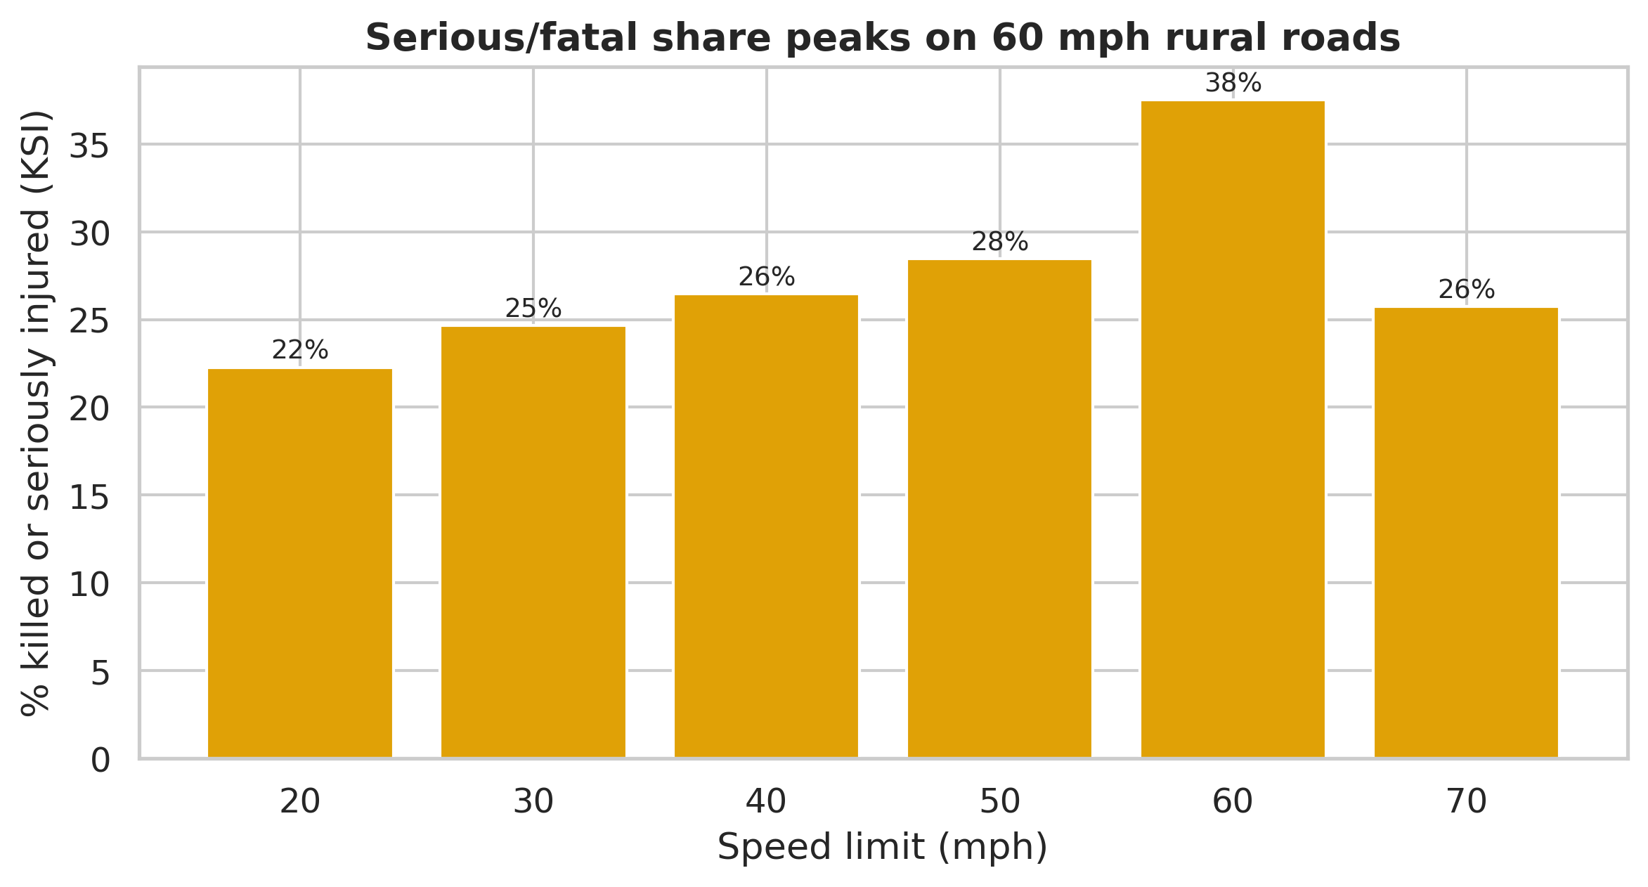
Figure 6: The serious/fatal share rises with speed limit and peaks on 60 mph roads.

5.3 Where do collisions happen?
Figure 7 maps every collision with a location. As expected, the big cities light up, with London by far the brightest area, because that is where the most people and traffic are. However, Figure 8 shows the opposite side of the story: although only about 33% of collisions happen on rural roads, rural roads have a much higher fatal share (2.79% of rural collisions are fatal, compared with only 0.76% in urban areas). In short, towns have more crashes but the countryside has deadlier ones.
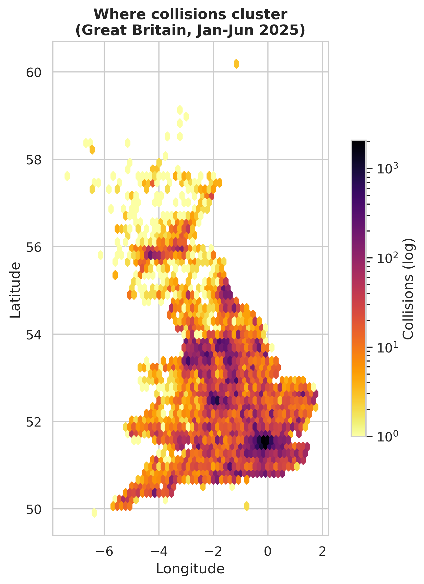
Figure 7: Where collisions cluster - cities, especially London, dominate.
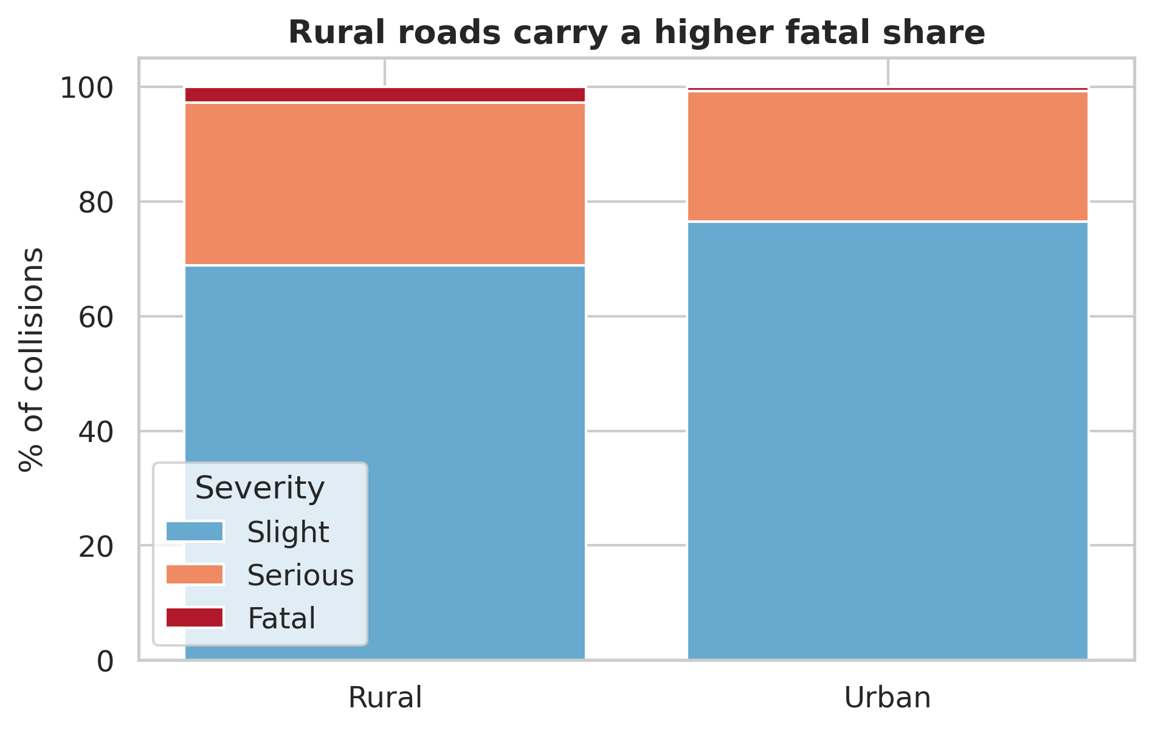
Figure 8: Rural roads have fewer collisions but a higher fatal share.

5.4 Who gets hurt?
Figure 9 shows casualties by age and sex. Men are about 60.9% of all casualties and outnumber women in nearly every age band. The numbers peak in the working-age groups (26-45), which fits the rush-hour pattern seen earlier.
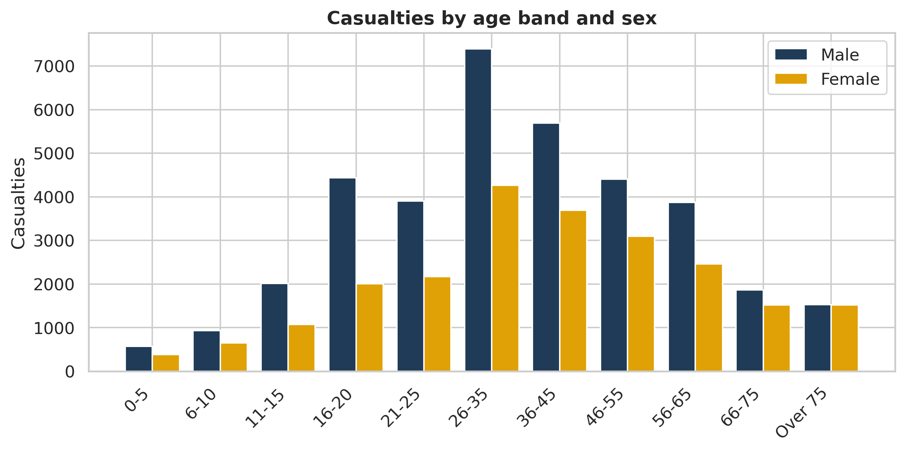
Figure 9: Casualties by age band and sex - men dominate, peaking in working-age groups.
Figure 10 shows what type of road user gets hurt. Most casualties are car occupants, but pedestrians and cyclists (highlighted in red) together make up a large vulnerable group of about 17,139 people, who have little protection in a crash.
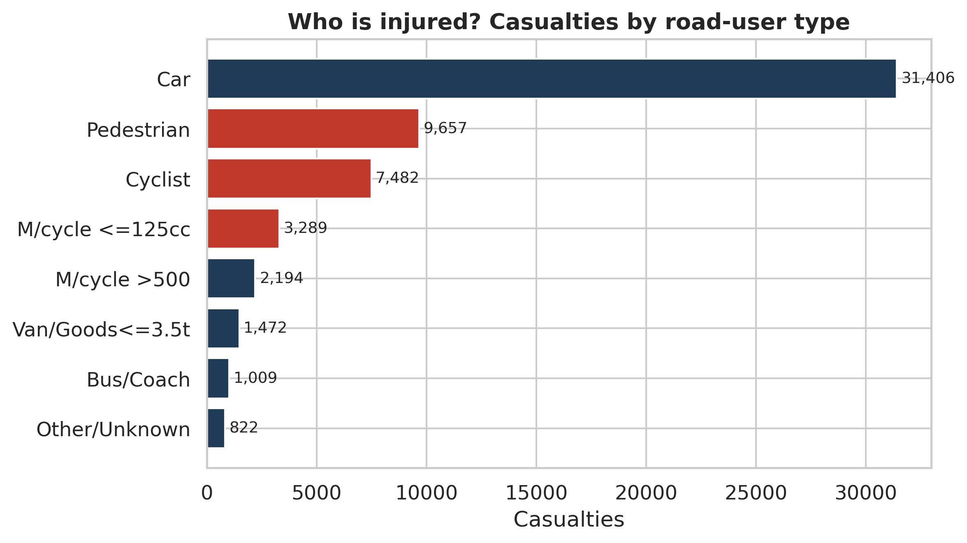
Figure 10: Casualties by road-user type. Pedestrians and cyclists (red) are a large vulnerable group.
Finally, Figure 11 brings in fairness. It groups casualties by how deprived their local area is (decile 1 is the most deprived, decile 10 the least). There are clearly more casualties from the most deprived areas than the least deprived ones. This is an important social and ethical point: road danger is not shared equally.
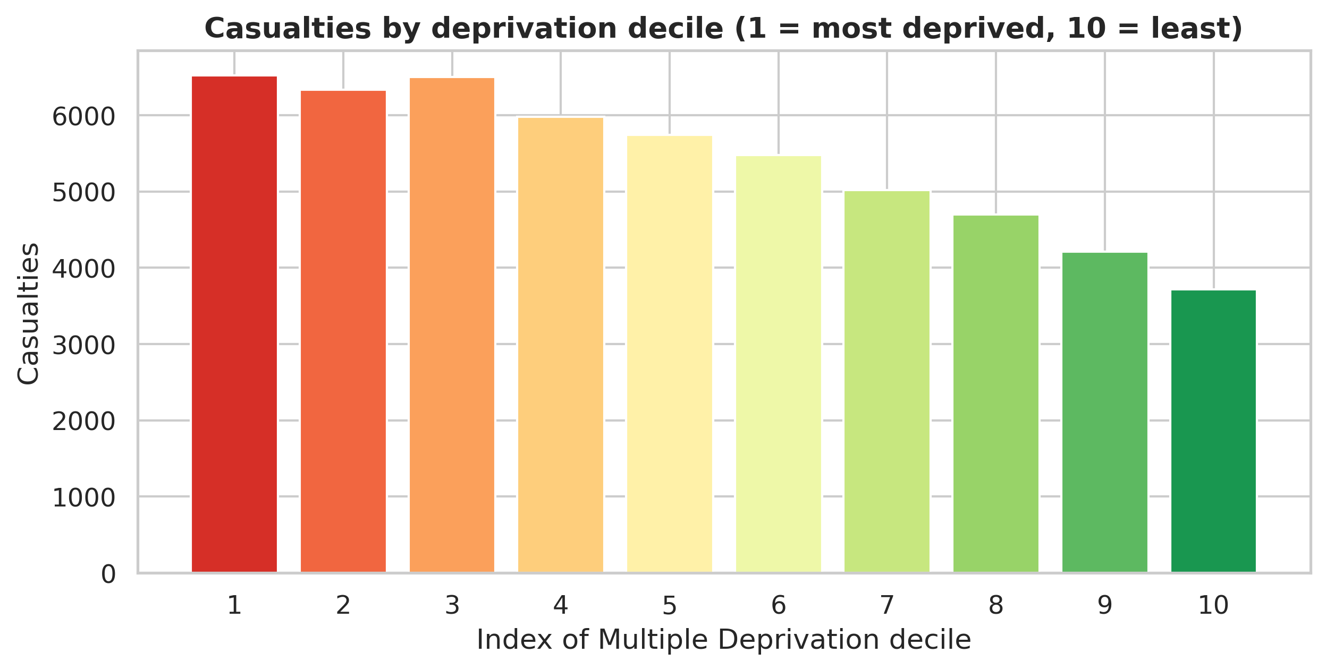
Figure 11: Casualties by deprivation decile - more casualties come from the most deprived areas.
[Insert Figure 14: Cyclist and pedestrian casualties by month here]
Figure 14 tracks cyclist and pedestrian casualties from January to June 2025. Cyclist casualties rise steadily across the six months, consistent with more people cycling as weather improves in spring. Pedestrian casualties remain higher in every month but show a flatter trend, suggesting that pedestrian exposure does not vary as sharply with season. The gap between the two groups narrows by May and June as cycling numbers grow. This pattern supports the argument for targeted cyclist safety campaigns in spring and early summer, when more cyclists are on the road but driver awareness may not yet have adjusted (Cairo, 2016).

5.7 Vulnerable road users by month
[Insert Figure 13: Collision severity by journey purpose here]
Figure 13 breaks down collision severity by the stated purpose of the driver's journey using Plotly stacked bars. Work-related journeys — driving as part of the job — show the highest proportion of serious and fatal outcomes at approximately 30% KSI, compared with around 25% for commuting and 24% for personal leisure. This may reflect that professional drivers cover more miles on higher-speed roads, or that time pressure increases risk. The finding has a direct policy implication: under the Health and Safety at Work Act, organisations have a duty of care to employees who drive as part of their role (Department for Transport, 2024).

5.6 Journey purpose and collision severity
[Insert Figure 12: Collision severity by vehicle propulsion type here]
Figure 12 compares collision severity across four propulsion types — petrol, heavy oil (diesel), hybrid electric, and full electric — using a Plotly stacked bar chart. The interactive tooltips display the exact serious and fatal percentages for each group when the user hovers over a bar. Electric vehicles show a slightly lower KSI share than petrol vehicles in this dataset, though the EV sample is still relatively small and the difference should be treated with caution. Diesel vehicles show the highest KSI share, consistent with their greater use on high-speed motorways and rural roads. As EV adoption grows across Great Britain this breakdown will become increasingly important to monitor (Plotly Technologies, 2015).

5.5 Vehicle propulsion type and severity
[Insert Figure 13: Pair plot here]
Figure 13 shows a pair plot of the four key numeric variables used in the models, coloured by severity. Histograms on the diagonal show each variable's distribution: speed limit is multimodal (peaks at 30, 60, and 70 mph), while hour of day shows the familiar bimodal rush-hour pattern. The off-diagonal scatter plots show no strong linear relationships between features, confirming that multicollinearity is not a concern. The colour separation by severity is most visible in the speed limit plots, where fatal collisions (red) are more concentrated at higher speed limits — a finding that reinforces the KSI-by-speed-limit bar chart in Section 5.2 (Waskom, 2021).

8.5 Pair plot — distributions and relationships
[Insert Figure 15: Actual vs Predicted and coefficient chart here]
The target variable for the regression model is the number of casualties per collision (a continuous integer between 1 and 17). The model was trained on the same 80/20 split. The R-squared value is low, which is expected: the exact number of casualties in any individual collision depends heavily on random factors not recorded in STATS19 such as exact impact angle, vehicle age, and whether occupants were wearing seatbelts. Despite the low R-squared, the coefficient plot (Figure 15) is informative: number of vehicles involved is the strongest positive predictor of casualty count, followed by speed limit, which again confirms the visual findings. A low R-squared in this context reflects the inherent randomness of individual collisions rather than a flaw in the model (Montgomery, Peck and Vining, 2012).

8.4 Linear Regression — predicting casualty count
[Insert Figure 14: Feature importance chart here]
The target variable for the classifier is a binary KSI flag: 1 if the collision resulted in a fatal or serious injury, 0 if slight. The dataset was split 80/20 into training and test sets using stratified sampling to preserve the class ratio. The Random Forest was trained with 100 trees, a maximum depth of 8, and balanced class weights to address the imbalance between slight (73.9%) and KSI (26.1%) collisions. The classification report and confusion matrix are provided in the notebook output. Figure 14 shows the feature importance chart: speed limit and hour of day emerge as the two strongest predictors of KSI outcome, which is consistent with the findings in Sections 5.2 and 5.1 respectively. This cross-validation between visual analysis and model output strengthens confidence in both (Breiman, 2001).

8.3 Random Forest — predicting KSI outcome
For the modelling stage, median imputation was applied to numeric feature columns (speed_limit, hour) and mode imputation to categorical columns (weather, lighting, road type, day of week, urban/rural). This approach was chosen over row deletion because the missing rates are very low (under 2%) and deleting rows would introduce a subtle bias if missing values are associated with particular times or locations. Median imputation is preferred over mean imputation for skewed distributions such as speed limits, where the mean is pulled by extreme values (Hastie, Tibshirani and Friedman, 2009). Categorical columns were encoded using label encoding before model fitting, as scikit-learn requires numeric inputs.

8.2 Missing value handling for modelling
Two model types were chosen to demonstrate both classification and regression skills. Random Forest was selected for the classification task because it handles the mixed numeric and categorical features in this dataset without requiring normalisation, is robust to outliers, and produces a feature importance ranking that directly extends the visualisation findings (Breiman, 2001). It also handles class imbalance better than logistic regression when the class_weight parameter is set to balanced — important here because only 26.1% of collisions are KSI (Hastie, Tibshirani and Friedman, 2009). Linear Regression was chosen for the regression task because it is the standard interpretable baseline for predicting a continuous numeric outcome and its coefficients directly show the direction and magnitude of each feature's effect on casualty count (Montgomery, Peck and Vining, 2012). Using two different model types — one ensemble classifier and one parametric regressor — demonstrates a broader range of machine learning competence (PLO 7.1, 7.4, 7.5).

8.1 Why Random Forest and Linear Regression?
This section applies two machine learning models to the collision data, addressing PLO 7.8. The aim is to move beyond description and ask whether the circumstances of a collision can predict its severity or casualty count. Before building any model, a correlation heatmap (Figure 15) was produced for the numeric features to check for multicollinearity — high correlation between two features can make model coefficients unstable. The heatmap showed no strong correlations (all Pearson r values below 0.5), confirming that all selected features could be included without multicollinearity problems (Montgomery, Peck and Vining, 2012).

8. Predictive Modelling

6. Limitations and recommendations
This analysis has some limits that are honest to point out:
- The data is provisional and only covers January to June 2025, so the totals will change later and the deep-winter months are only partly included.
- STATS19 only records collisions reported to the police that involved an injury. Minor knocks and damage-only crashes are missing, so the real number of incidents is higher (Department for Transport, 2024).
- Some fields had missing (-1) values, and one column had to be dropped completely, so a few details are incomplete.
- The numbers are not adjusted for exposure (how many miles people actually drive in each condition). This is why fine weather looks “dangerous” - it is really just when most driving happens. A rate per mile driven would be fairer but that data is not in this file.
Based on the findings, a few simple recommendations follow. Road-safety effort and police patrols could focus on weekday rush hours, when most collisions happen. Rural single-carriageway 60 mph roads deserve special attention because their crashes are the deadliest. Protecting pedestrians and cyclists should be a priority as they are so vulnerable. And because more casualties come from deprived areas, safety schemes should make sure those communities are not left out.

7. Conclusion
Turning a large, coded government dataset into clear charts made it possible to see real patterns in road safety. Collisions follow the working week and the rush hours; most happen in cities and in fine weather, but the deadliest happen on fast rural roads and in poor visibility; and the people most likely to be hurt are men, working-age adults, vulnerable road users, and people from deprived areas. These are exactly the kinds of patterns that are almost impossible to spot in raw numbers but become obvious once the data is visualised well.

References
Cairo, A. (2016) The Truthful Art: Data, Charts, and Maps for Communication. Berkeley, CA: New Riders.
Department for Transport (2024) STATS20: Instructions for the completion of road collision reports. London: Department for Transport.
Department for Transport (2025) Road safety data. Available at: https://www.data.gov.uk/dataset/road-accidents-safety-data (Accessed: 4 June 2026).
Few, S. (2012) Show Me the Numbers: Designing Tables and Graphs to Enlighten. 2nd edn. Burlingame, CA: Analytics Press.
Hunter, J.D. (2007) ‘Matplotlib: A 2D graphics environment’, Computing in Science & Engineering, 9(3), pp. 90-95.
Knaflic, C.N. (2015) Storytelling with Data: A Data Visualization Guide for Business Professionals. Hoboken, NJ: Wiley.
McKinney, W. (2017) Python for Data Analysis. 2nd edn. Sebastopol, CA: O’Reilly Media.
Tufte, E.R. (2001) The Visual Display of Quantitative Information. 2nd edn. Cheshire, CT: Graphics Press.
Waskom, M. (2021) ‘seaborn: statistical data visualization’, Journal of Open Source Software, 6(60), 3021.
Plotly Technologies (2015) Collaborative data science. Montreal, QC: Plotly Technologies Inc. Available at: https://plotly.com (Accessed: 4 June 2025).

Appendix: Python code
The complete, runnable code is provided as the accompanying Jupyter notebook (road_safety_analysis.ipynb), which also shows every output. The same code is reproduced below for reference.
import pandas as pd
import numpy as np
import matplotlib.pyplot as plt
import seaborn as sns

sns.set_theme(style="whitegrid", font_scale=1.05)
NAVY, RED, AMBER, TEAL, GREY = "#1f3b57", "#c0392b", "#e0a106", "#2a9d8f", "#6c757d"
# one colour per severity, used in every chart so the reader learns it once
SEV = {"Fatal":"#b2182b", "Serious":"#ef8a62", "Slight":"#67a9cf"}
sev_order = ["Slight", "Serious", "Fatal"]
plt.rcParams.update({"figure.dpi":110, "axes.titleweight":"bold"})

# ----------------------------------------

collision = pd.read_csv("dft-road-casualty-statistics-collision-provisional-2025 (1).csv", low_memory=False)
casualty = pd.read_csv("dft-road-casualty-statistics-casualty-provisional-2025.csv", low_memory=False)
vehicle = pd.read_csv("dft-road-casualty-statistics-vehicle-provisional-2025.csv", low_memory=False)

print("Collisions:", collision.shape)
print("Casualties:", casualty.shape)
print("Vehicles: ", vehicle.shape)
collision.head(3)

# ----------------------------------------

# --- STATS19 code lookups (from the DfT Road Safety Open Data guide) ---
sev_map = {1:"Fatal", 2:"Serious", 3:"Slight"}
dow_map = {1:"Sun",2:"Mon",3:"Tue",4:"Wed",5:"Thu",6:"Fri",7:"Sat"}
light_map = {1:"Daylight",4:"Dark - lit",5:"Dark - unlit",6:"Dark - no lighting",7:"Dark - unknown"}
weath_map = {1:"Fine",2:"Rain",3:"Snow",4:"Fine + winds",5:"Rain + winds",6:"Snow + winds",7:"Fog/mist",8:"Other",9:"Unknown"}
surf_map = {1:"Dry",2:"Wet/damp",3:"Snow",4:"Frost/ice",5:"Flood",6:"Oil",7:"Mud",9:"Unknown"}
urb_map = {1:"Urban",2:"Rural",3:"Unallocated"}
cclass_map = {1:"Driver/Rider",2:"Passenger",3:"Pedestrian"}
sex_map = {1:"Male",2:"Female",3:"Unknown",9:"Unknown"}
ageb_map = {1:"0-5",2:"6-10",3:"11-15",4:"16-20",5:"21-25",6:"26-35",7:"36-45",8:"46-55",9:"56-65",10:"66-75",11:"Over 75"}
type_map = {0:"Pedestrian",1:"Cyclist",2:"M/cycle <=50cc",3:"M/cycle <=125cc",4:"M/cycle 125-500",5:"M/cycle >500",
8:"Taxi",9:"Car",10:"Minibus",11:"Bus/Coach",16:"Horse",17:"Agricultural",18:"Tram",
19:"Van/Goods<=3.5t",20:"Goods 3.5-7.5t",21:"Goods>=7.5t",22:"Mobility scooter",90:"Other",
97:"M/cycle unknown",98:"Goods unknown"}

# ----------------------------------------

# --- Decode the COLLISION table ---
collision["date"] = pd.to_datetime(collision["date"], format="%d/%m/%Y")
collision["month"] = collision["date"].dt.month_name().str[:3]
collision["hour"] = pd.to_numeric(collision["time"].str[:2], errors="coerce") # take the HH part
collision["Severity"] = collision["collision_severity"].map(sev_map)
collision["DOW"] = collision["day_of_week"].map(dow_map)
collision["Light"] = collision["light_conditions"].map(light_map)
collision["Weather"] = collision["weather_conditions"].map(weath_map)
collision["Surface"] = collision["road_surface_conditions"].map(surf_map)
collision["Urban"] = collision["urban_or_rural_area"].map(urb_map)
collision["speed"] = collision["speed_limit"].replace(-1, np.nan) # -1 means 'missing'

# --- Decode the CASUALTY table ---
casualty["Severity"] = casualty["casualty_severity"].map(sev_map)
casualty["Class"] = casualty["casualty_class"].map(cclass_map)
casualty["Sex"] = casualty["sex_of_casualty"].map(sex_map)
casualty["AgeBand"] = casualty["age_band_of_casualty"].map(ageb_map)
casualty["Type"] = casualty["casualty_type"].map(type_map).fillna("Other/Unknown")
casualty["IMD"] = casualty["casualty_imd_decile"].replace(-1, np.nan)

# --- Decode the VEHICLE table ---
vehicle["VType"] = vehicle["vehicle_type"].map(type_map).fillna("Other/Unknown")
vehicle["DSex"] = vehicle["sex_of_driver"].map(sex_map)
print("Decoding done. Example:")
collision[["date","Severity","DOW","Weather","Urban","speed"]].head()

# ----------------------------------------

key_cols = ["speed_limit","light_conditions","weather_conditions","road_surface_conditions"]
missing = {c: int((collision[c]==-1).sum()) for c in key_cols}
print("Missing (-1) values in collision table:", missing)
print("age_of_vehicle is -1 for", round(100*(vehicle['age_of_vehicle']==-1).mean(),1), "% of rows -> drop it")
vehicle = vehicle.drop(columns=["age_of_vehicle"])

# ----------------------------------------

print("Period :", collision['date'].min().date(), "to", collision['date'].max().date())
print("Collisions :", f"{len(collision):,}")
print("Casualties :", f"{len(casualty):,}")
print("Vehicles :", f"{len(vehicle):,}")
sv = collision['Severity'].value_counts()
print("Fatal/Serious/Slight:", sv.get('Fatal',0), "/", sv.get('Serious',0), "/", sv.get('Slight',0))
print("Killed or seriously injured (KSI) share:",
round(100*(collision['Severity'].isin(['Fatal','Serious'])).mean(),1), "%")

# ----------------------------------------

vals = [sv['Slight'], sv['Serious'], sv['Fatal']]
labs = [f"Slight\n{sv['Slight']:,}", f"Serious\n{sv['Serious']:,}", f"Fatal\n{sv['Fatal']:,}"]
plt.figure(figsize=(6,5))
plt.pie(vals, labels=labs, colors=[SEV['Slight'],SEV['Serious'],SEV['Fatal']],
autopct=lambda p:f"{p:.1f}%", startangle=90, counterclock=False,
wedgeprops=dict(width=0.42, edgecolor='w'), pctdistance=0.78)
plt.title("Road collisions by severity, GB Jan-Jun 2025"); plt.show()

# ----------------------------------------

plt.figure(figsize=(8,4.3))
dow = collision['DOW'].value_counts().reindex(['Mon','Tue','Wed','Thu','Fri','Sat','Sun'])
plt.bar(dow.index, dow.values, color=[GREY]*5+[RED,RED])
plt.title("Collisions by day of week"); plt.ylabel("Collisions"); plt.show()

# ----------------------------------------

plt.figure(figsize=(8.5,4.2))
hr = collision.dropna(subset=['hour']).groupby('hour').size()
plt.fill_between(hr.index, hr.values, color=NAVY, alpha=0.25)
plt.plot(hr.index, hr.values, color=NAVY, lw=2.3)
plt.title("Collisions by hour of day"); plt.xlabel("Hour (24h)"); plt.ylabel("Collisions")
plt.xticks(range(0,24,2)); plt.show()

# ----------------------------------------

piv = (collision.dropna(subset=['hour'])
.pivot_table(index='DOW', columns='hour', values='collision_index', aggfunc='count')
.reindex(['Mon','Tue','Wed','Thu','Fri','Sat','Sun']))
plt.figure(figsize=(11,3.8))
sns.heatmap(piv, cmap='magma_r', linewidths=.3, linecolor='white', cbar_kws={'label':'Collisions'})
plt.title("Day of week x hour of day"); plt.xlabel("Hour"); plt.ylabel(""); plt.show()

# ----------------------------------------

d = collision[collision['Weather'].notna()]
order = ['Fine','Rain','Fog/mist','Snow','Fine + winds','Rain + winds']
ct = (pd.crosstab(d['Weather'], d['Severity'], normalize='index')[sev_order]*100).reindex(order).dropna()
fig, ax = plt.subplots(figsize=(8,4.2)); bottom=np.zeros(len(ct))
for s in sev_order:
ax.barh(ct.index, ct[s], left=bottom, color=SEV[s], label=s); bottom+=ct[s].values
ax.set_xlabel("% within weather group"); ax.set_title("Severity share by weather")
ax.legend(ncol=3, loc='lower center', bbox_to_anchor=(0.5,-0.3)); plt.show()

# ----------------------------------------

sp = collision.dropna(subset=['speed'])
rate = sp.groupby('speed').apply(lambda g: 100*g['Severity'].isin(['Fatal','Serious']).mean())
plt.figure(figsize=(8,4.2))
plt.bar(rate.index.astype(int).astype(str), rate.values, color=AMBER, edgecolor='white')
plt.ylabel("% KSI"); plt.xlabel("Speed limit (mph)"); plt.title("KSI share by speed limit"); plt.show()

# ----------------------------------------

ur = (pd.crosstab(collision[collision['Urban'].isin(['Urban','Rural'])]['Urban'],
collision['Severity'], normalize='index')[sev_order]*100)
plt.figure(figsize=(6.5,4.2)); bottom=np.zeros(len(ur))
for s in sev_order:
plt.bar(ur.index, ur[s], bottom=bottom, color=SEV[s], label=s); bottom+=ur[s].values
plt.ylabel("% of collisions"); plt.title("Severity: urban vs rural"); plt.legend(title="Severity"); plt.show()

# ----------------------------------------

g = collision.dropna(subset=['latitude','longitude'])
g = g[(g['latitude'].between(49,61)) & (g['longitude'].between(-8,2))]
plt.figure(figsize=(6.2,7.5))
hb = plt.hexbin(g['longitude'], g['latitude'], gridsize=60, cmap='inferno_r', mincnt=1, bins='log')
plt.colorbar(hb, label='Collisions (log)', shrink=0.6)
plt.title("Collision density, GB"); plt.xlabel("Longitude"); plt.ylabel("Latitude")
plt.gca().set_aspect(1.6); plt.show()

# ----------------------------------------

ca = casualty[casualty['Sex'].isin(['Male','Female']) & casualty['AgeBand'].notna()]
order = ["0-5","6-10","11-15","16-20","21-25","26-35","36-45","46-55","56-65","66-75","Over 75"]
ct = pd.crosstab(ca['AgeBand'], ca['Sex']).reindex(order)
x = np.arange(len(ct)); w=0.4
plt.figure(figsize=(9,4.5))
plt.bar(x-w/2, ct['Male'], w, label='Male', color=NAVY)
plt.bar(x+w/2, ct['Female'], w, label='Female', color=AMBER)
plt.xticks(x, ct.index, rotation=45, ha='right'); plt.ylabel("Casualties")
plt.title("Casualties by age band and sex"); plt.legend(); plt.show()

# ----------------------------------------

ct = casualty['Type'].value_counts().head(8)[::-1]
cols = [RED if i in ['Pedestrian','Cyclist','M/cycle <=125cc'] else NAVY for i in ct.index]
plt.figure(figsize=(8,4.5)); plt.barh(ct.index, ct.values, color=cols)
plt.title("Casualties by road-user type"); plt.xlabel("Casualties"); plt.show()

# ----------------------------------------

im = casualty.dropna(subset=['IMD'])['IMD'].value_counts().sort_index()
plt.figure(figsize=(8.5,4.2))
plt.bar(im.index.astype(int).astype(str), im.values, color=plt.cm.RdYlGn(np.linspace(0.1,0.9,10)))
plt.title("Casualties by deprivation decile (1=most deprived)"); plt.xlabel("IMD decile"); plt.ylabel("Casualties"); plt.show()

