**Name: Waseem Ali**

**Roll no: 20SW022**

**Topic: Power BI**

**TASK 01:**

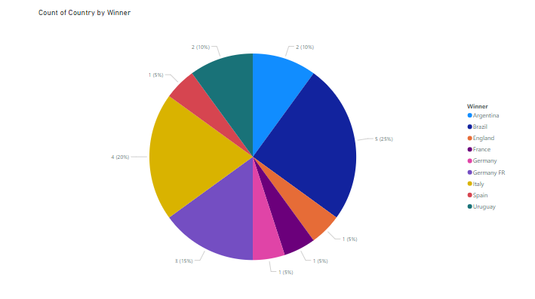

**TASK 02:**

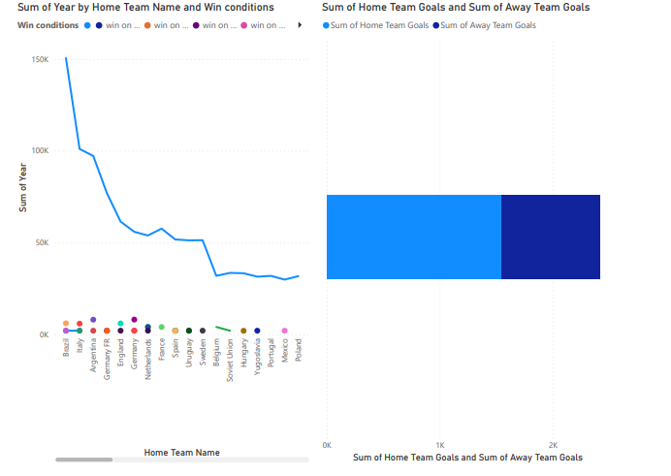

**TASK 03:**

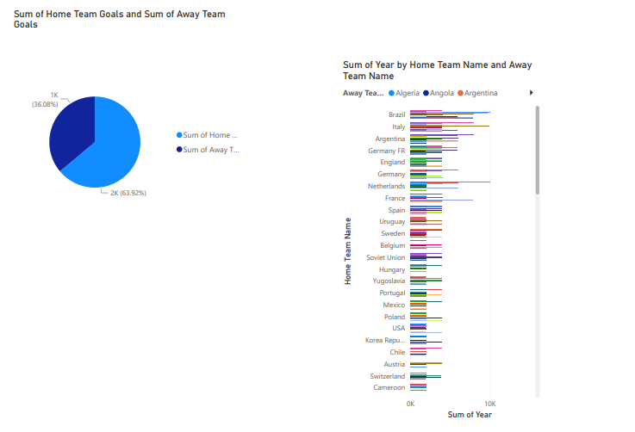

**TASK 04:**

