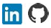
Waseem Khan Dawar
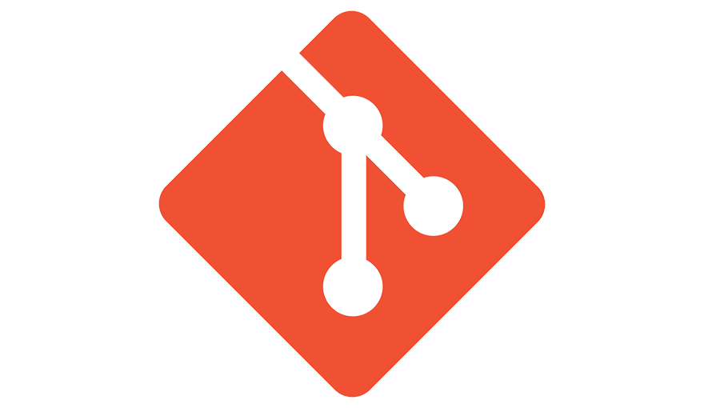
GIT

Agenda

1.Version Control System……………………….
2.Types of VCS...…………………………………….
3.Distributed Version Control System…….
4.What is Git? ……………………………………….
5.Why we use Git?....................................
6.Types of repos in Git…………………………..
7.Git Workflow………………………………………
8.Git Installation……………………………………

Version Control System
Version Control System (VCS) is a software that helps software developers to work together and maintain a complete history of their work. Listed below are the functions of a VCS
- Allows developers to work simultaneously.
- Does not allow overwriting each other’s changes.
- Maintains a history of every version.
Types of VCS
- Centralized version control system (CVCS).
- Distributed/Decentralized version control system (DVCS).
we will concentrate only on distributed version control system and especially on Git. Git falls under distributed version control system.
Distributed Version Control System
Centralized version control system (CVCS) uses a central server to store all files and enables team collaboration. But the major drawback of CVCS is its single point of failure, i.e., failure of the central server. Unfortunately, if the central server goes down for an hour, then during that hour, no one can collaborate at all. And even in a worst case, if the disk of the central server gets corrupted and proper backup has not been taken, then you will lose the entire history of the project. Here, distributed version control system (DVCS) comes into picture.
DVCS clients not only check out the latest snapshot of the directory but they also fully mirror the repository. If the server goes down, then the repository from any client can be copied back to the server to restore it. Every checkout is a full backup of the repository. Git does not rely on the central server and that is why you can perform many operations when you are offline. You can commit changes, create branches, view logs, and perform other operations when you are offline. You require network connection only to publish your changes and take the latest changes.
What is Git?
Git is free and open-source software for distributed version control System: tracking changes in any set of files, usually used for coordinating work among programmers collaboratively developing source code during software development.
Creator of Git - Git was originally authored by Linus Torvalds in 2005 for development of the Linux kernel, with other kernel developers contributing to its initial development. Since 2005, Junio Hamano has been the core maintainer.
Why we use Git?
We use git for version control and collaboration on software development projects. It tracks changes, allows multiple developers to work together, and serves as a backup. Git provides flexibility with branching, transparency with a clear change history, and scalability for large projects.it ensures code integrity and security and is widely used, making it easy to find resources and experienced developers.
Types of repos in Git
- Remote repository
- Local repositor
Git Workflow
Working Directory
Git add operation
Staging Area
Git commit operation

Git Repository
Git Installation
1.Debian/Ubuntu
The below command used to install git in Debian/Ubuntu:
- Sudo apt update
- Sudo apt install git

2.Windows
The below steps used to install git on Windows:
- Download latest git setup from - https://git-scm.com/download/win
- Git Setup wizard screen. Follow the Next and Finish prompts to complete the installation.

Created By,
Waseem Khan Dawar

