Version Control with Git & GitHub

git init
Command: git init
Purpose: Initializes a new Git repository
Example: git init
git clone
Command: git clone
Purpose: Clones a repository from a remote source
Example: git clone https://github.com/user/repo.git
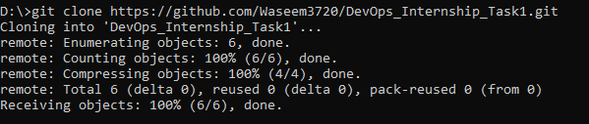
git add
Command: git add
Purpose: Stages changes for commit
Example: git add .

git commit
Command: git commit
Purpose: Saves staged changes with a message
Example: git commit -m "Initial commit"
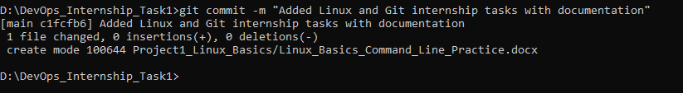
git push
Command: git push
Purpose: Uploads local commits to remote repository
Example: git push origin main
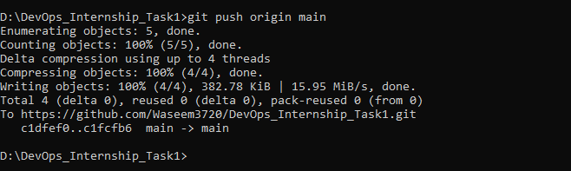
git pull
Command: git pull
Purpose: Fetches and merges changes from remote repository
Example: git pull origin main
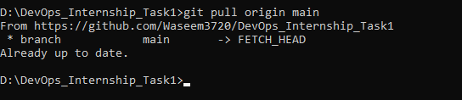
git branch
Command: git branch
Purpose: Lists or creates branches
Example: git branch
