Linux Basics & Command-Line Practice

pwd
Command: pwd
Purpose: Displays the current working directory
Example: pwd
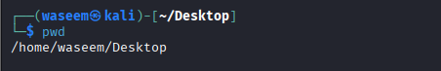
ls
Command: ls
Purpose: Lists files and directories
Example: ls -l

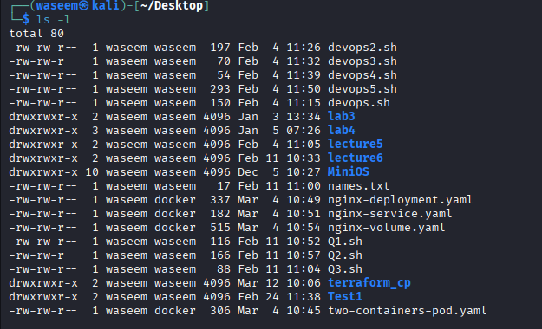
cd
Command: cd
Purpose: Changes the current directory
Example: cd /home/user
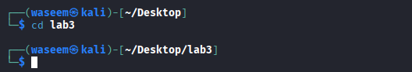
mkdir
Command: mkdir
Purpose: Creates a new directory
Example: mkdir new_folder
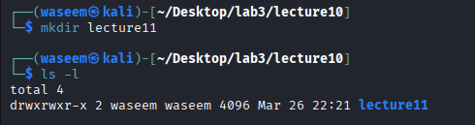
touch
Command: touch
Purpose: Creates an empty file
Example: touch file.txt
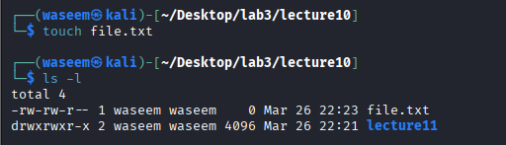
rm
Command: rm
Purpose: Deletes files or directories
Example: rm file.txt
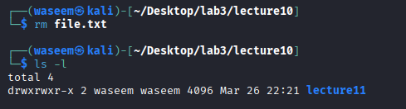
nano
Command: nano
Purpose: Opens a file in nano text editor
Example: nano file.txt
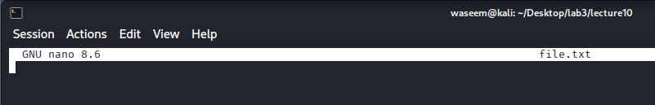
chmod
Command: chmod
Purpose: Changes file permissions
Example: chmod 755 file.sh
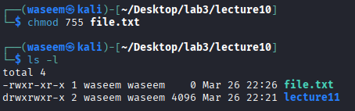
top
Command: top
Purpose: Displays running processes
Example: top
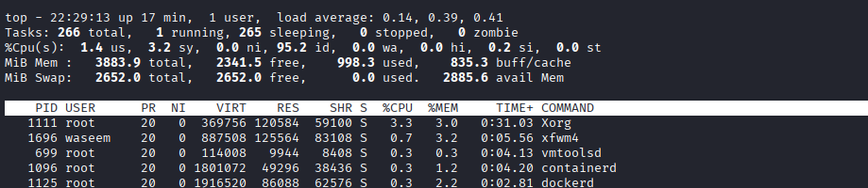
df
Command: df
Purpose: Shows disk space usage
Example: df -h
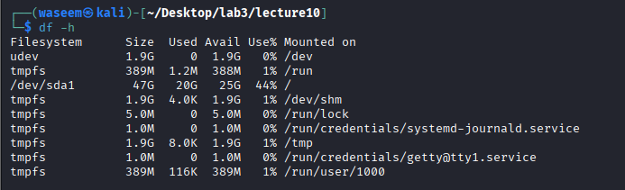
free
Command: free
Purpose: Displays memory usage
Example: free -h
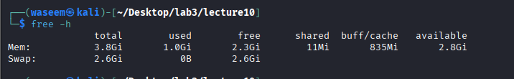
apt update
Command: apt update
Purpose: Updates package list
Example: sudo apt update
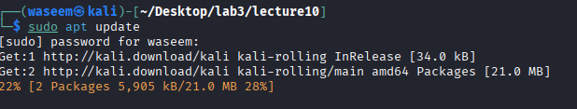

apt install
Command: apt install
Purpose: Installs a package
Example: sudo apt install nginx
