*A project report on*

**PATIENT DATA ANALYTICS BY TERM FREQUENCY MODULATION DIAGNOSIS**

*Submitted in partial fulfillment for the award of the degree of*

## B.Tech (Computer Science and Engineering- Data Analytics)

*by*

**SHAIK MOHAMMAD WASEEM AKRAM (20BCD7141)**

**SCOPE**

May, 2024

**PATIENT DATA ANALYTICS BY TERM FREQUENCY MODULATION DIAGNOSIS**

*Submitted in partial fulfillment for the award of the degree of*

## B.Tech(Computer Science and Engineering- Data Analytics)

*by*

**SHAIK MOHAMMAD WASEEM AKRAM (20BCD7141)**

**SCOPE**

May, 2024

**DECLARATION**

I here by declare that the thesis entitled “PATIENT DATA ANALYTICS BY TERM FREQUENCY MODULATION DIAGNOSIS” submitted by me, for the award of the degree of B-tech(CSE-DA) VIT is a record of bonafide work carried out by me under the supervision of Dr. Arindam Dey.

I further declare that the work reported in this thesis has not been submitted and will not be submitted, either in part or in full, for the award of any other degree or diploma in this institute or any other institute or university.



Place: Amaravati

Date: 12/05/2024 **Signature of the Candidate**

**CERTIFICATE**

This is to certify that the Internship titled “**PATIENT DATA ANALYTICS BY TERM FREQUENCY MODULATION DIAGNOSIS**” that is being submitted by **Shaik Mohammad Waseem (20BCD7141)** is in partial fulfillment of the requirements for the award of Bachelor of Technology, is a record of bonafide work done under my guidance. The contents of this Project work, in full or in parts, have neither been taken from any other source nor have been submitted to any other Institute or University for award of any degree or diploma and the same is certified.



Dr. Arindam Dey (Internal Guide)

**The thesis is satisfactory / unsatisfactory**

** **

**External Examiner External Examiner**

**Approved by**

**PROGRAM CHAIR DEAN**

B. Tech. CSE-DA School of computer science and Engineering

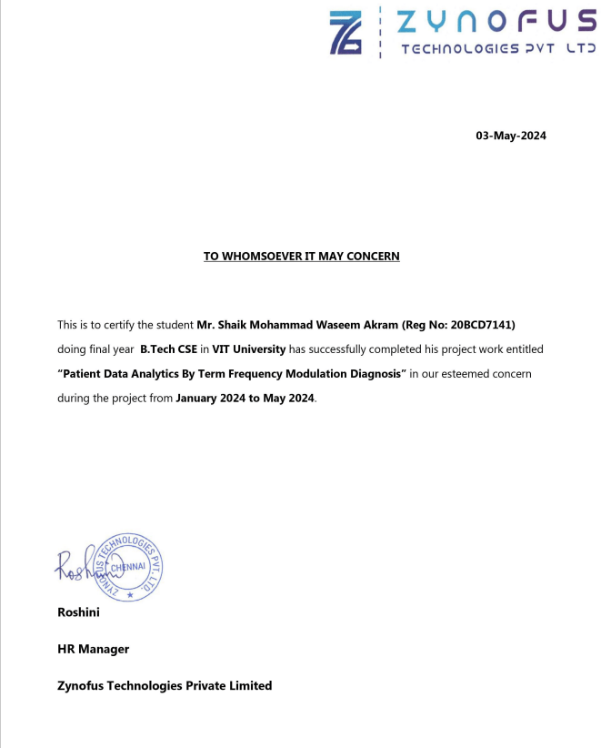

**ABSTRACT:**

In this project we proposed patient data analysis is an essential to develop the machine learning process in healthcare, providing valuable insights that can drive improvements in diagnosis, treatment, and overall patient care. The patient data available in modern healthcare systems include electronic health records, medical imaging data, and real time physiological measurement from wearable device. It acknowledges the complexity and diversity of these data sources advanced machine learning techniques to extract meaningful pattern and knowledge. Machine learning can also support treatment decision-making by providing personalized recommendations based on patient-specific data, ultimately leading to better treatment outcomes. Here we have used an algorithm Term Frequency-Inverse Document Frequency (TF-IDF) and Blowfish. It is calculated as the number of times a specific term appears in a document divided by the total number of terms in the document. The idea is that terms that occur more frequently within a document may carry more importance or relevance. It highlights the potential for improved diagnostics, personalized medicine, proactive disease prevention, and optimized resource allocation. By harnessing the power of machine learning and patient data analysis, healthcare providers can tailor treatment plans, predict disease progression, and ultimately deliver more effective and targeted interventions. It helps to identify important terms in a document and distinguish them from common words that may not carry much meaning. By considering both local term frequency and global corpus statistics, TF-IDF provides a way to capture the specificity and importance of terms in a document collection. Raw patient data often requires preprocessing to handle missing values, outliers, and inconsistent formats. Blowfish has been extensively analyzed since its inception, and no significant weaknesses have been found in its design. Blowfish supports key lengths from 32 bits to 448 bits, making it highly flexible and adaptable to different security requirements. The longer the key, the more secure the encryption. Common preprocessing steps include data cleaning, normalization, and standardization. Data quality checks are performed to identify and correct any anomalies in the data.

**ACKNOWLEDGEMENT**

It is my pleasure to express with deep sense of gratitude to Dr. Arindam Dey,

Assistant professor, Scope, VIT-AP, for his constant guidance, continual encouragement, understanding; more than all, he taught me patience in my endeavor. My association with him is not confined to academics only, but it is a great opportunity on my part of work with an intellectual and expert in the field of Java Full-Stack.

I would like to express my gratitude to Dr. G. Viswanatham, Dr.Sekar Viswanathan, Mr. Sankar Viswanathan, Mr. G. V. Selvam, Dr. S.V. Kota Reddy, and Dr. CH. Pradeep Reddy, Scope , for providing with an environment to work in and for his inspiration during the tenure of the course.

In jubilant mood I express ingeniously my whole-hearted thanks to Dr. Saroj Kumar Panigrahy, Associate Professor , all teaching staff and members working as limbs of our university for their not-self-centered enthusiasm coupled with timely encouragements showered on me with zeal, which prompted the acquirement of the requisite knowledge to finalize my course study successfully. I would like to thank my parents for their support.

It is indeed a pleasure to thank my friends who persuaded and encouraged me to take up and complete this task. At last but not least, I express my gratitude and appreciation to all those who have helped me directly or indirectly toward the successful completion of this project.

Place: Amaravati **Shaik Mohammad Waseem**

Date: 12/05/2024 Name of the student

**CONTENTS**

1. **INTRODUCTION Pg.No**
   1. INTRODUCTION TO PROJECT 5
   2. PURPOSE OF THE PROJECT 5
2. **SYSTEM ANALYSIS**
   1. INTRODUCTION 7
   2. HARDWARE & SOFTWARE REQUIRMENT 8
   3. INPUT AND OUTPUT 9
   4. INPUT DESIGN 9
   5. LIMITATIONS 9
   6. EXISTING STSTEM 10
   7. PROPOSED SYSTEM 10
3. **SOFTWARE REQUIREMENT SPECIFICATIONS**
   1. FUNCTIONAL REQUIREMENTS 12
   2. NON-FUNCTIONAL REQUIREMENTS 12
   3. PERFORMANCE REQUIREMENTS 13
4. **SYSTEM DESIGN**
   1. INTRODUCTION 14
   2. SYSTEM ARCHITECTURE 26
   3. E-R DIAGRAM 26
   4. DATA FLOW DIAGRAM 28
   5. USE CASE DIAGRAM 29
   6. CLASS DIAGRAM 30
5. **OUTPUT SCREENSHOTS** 31
6. **SYSTEM SECURITY**

6.1. INTRODUCTION 48

6.2. SECURITY IN SOFTWARE 48

1. **CONCLUSION & FUTURE ENHANCEMENT**  51
2. **REFERENCES** 52

**CHAPTER-1**

**1.1 INTRODUCTION TO PROJECT**

In modern healthcare, the exponential growth of patient data presents both opportunities and challenges. Among these challenges, the effective analysis of vast amounts of medical records to derive actionable insights is paramount. Traditional methods often struggle to extract nuanced patterns buried within this data deluge. Term frequency modulation involves analyzing the frequency of specific terms within a corpus of text, such as electronic health records (EHRs), to discern patterns indicative of various medical conditions. This technique goes beyond mere keyword searches by considering the context and relationships between terms, enabling a more nuanced understanding of patient data. To demonstrate the efficacy of term frequency modulation in diagnosing medical conditions using patient records. By analyzing the prevalence and co-occurrence of terms within EHRs, we seek to identify patterns associated with specific diseases or clinical presentations. Subsequently, we will calculate the term frequency within the corpus and apply modulation techniques to emphasize terms that are particularly indicative of certain conditions while minimizing noise from irrelevant terms. The application of term frequency modulation in patient data analysis holds immense potential for enhancing diagnostic accuracy and streamlining healthcare delivery. By automating the process of pattern recognition within EHRs, clinicians can receive timely insights that aid in early detection, treatment planning, and personalized care.

## PURPOSE OF THE SYSTEM

* Predictive analytics allows for early detection of serious illnesses, reduced risks during robot-assisted surgeries, and quick identification of high-risk patients.
* With efficiencies unlocked by machine learning, organizations can help more patients without compromising care quality.
* Patient data analysis can uncover hidden patterns and correlations that might not be immediately apparent to healthcare providers.
* This information can be used to proactively intervene and prevent adverse events, such as hospital readmissions or complications, improving patient care and reducing healthcare costs.
* This enables the development of personalized medicine approaches, tailoring treatments to each patient's specific needs and optimizing therapeutic interventions.

**CHAPTER-2**

**SYSTEM ANALYSIS**

**2.1 INTRODUCTION**

In modern healthcare, the exponential growth of patient data presents both opportunities and challenges. Among these challenges, the effective analysis of vast amounts of medical records to derive actionable insights is paramount. Traditional methods often struggle to extract nuanced patterns buried within this data deluge. Term frequency modulation involves analyzing the frequency of specific terms within a corpus of text, such as electronic health records (EHRs), to discern patterns indicative of various medical conditions. This technique goes beyond mere keyword searches by considering the context and relationships between terms, enabling a more nuanced understanding of patient data. To demonstrate the efficacy of term frequency modulation in diagnosing medical conditions using patient records. By analyzing the prevalence and co-occurrence of terms within EHRs, we seek to identify patterns associated with specific diseases or clinical presentations. Subsequently, we will calculate the term frequency within the corpus and apply modulation techniques to emphasize terms that are particularly indicative of certain conditions while minimizing noise from irrelevant terms. The application of term frequency modulation in patient data analysis holds immense potential for enhancing diagnostic accuracy and streamlining healthcare delivery. By automating the process of pattern recognition within EHRs, clinicians can receive timely insights that aid in early detection, treatment planning, and personalized care.

**2.2 HARDWARE AND SOFTWARE REQUIREMENTS**

|  |  |  |  |
| --- | --- | --- | --- |
| Developing Kit | | | |
|  | Processor | RAM | Disk Space |
| Eclipse | Computer with a 2.6GHz processor or higher | 2GB | Minimum 20 GB |
| Database | | | |
| MySQL 5.0 | Intel Pentium processor at 2.6GHz or faster | Minimum 512 MB Physical Memory; 1 GB Recommended | Minimum 20 GB |
| HeidiSQL 8.3 | Intel Pentium processor at 2.6GHz or faster | Minimum 512 MB Physical Memory; 1 GB Recommended | Minimum 20 GB |

**Software Requirements:**

* **Front end :** core java, css, js, servlet
* **Web application :** J2ee Frameworks, Hibernate
* **Back end :** MySQL 5.1

**2.3 INPUT AND OUTPUT**

The major inputs and outputs and major functions of the system are follows:

**Input:**

* The entities such as authority and users must register the account for login. All the user details have been stored the data in our database for the purpose of identifying the entities.
* The E-prospect will upload the requirements for the gel electrolyte like type of battery, quantity, size, etc.

**Output:**

* Only the authorized data users can able to access the data.
* Gel electrolyte ionic conductivity, thermal stability, mechanical stability will be calculated at the given time.

**2.4 INPUT DESIGN**

* Input design is a part of overall system design. The main objective during the input design as given below.
* Input States: User can maintain a database in MySQL server or sql server for his/her business requirement.
* Input Media:

At this stage choice has to be made about the input media. To conclude about the input media consideration has to be given to:

* In this section user can give the input for storage location and get the output from admin side.

**2.5 LIMITATIONS**

* Patient data contains sensitive and personal information, including medical records and demographics.
* Biases within the data, such as underrepresentation of certain demographics or populations, can lead to biased models and unequal healthcare outcomes.
* Lack of interoperability and standardization hampers the seamless analysis and integration of data, reducing the accuracy and effectiveness of machine learning models.
* Limited sample sizes can affect the generalizability of machine learning models and their ability to make accurate predictions for broader populations.
* Resistance to change or lack of trust in automated systems can hinder the adoption of machine learning in healthcare settings.

**2.6 PROBLEMS IN EXISTING SYSTEM:**

To predict how a patient will respond to radiotherapy and the patient’s risk of developing any adverse side effects to the radiotherapy. The project leverages structured and unstructured data from EHRs, including medication records, laboratory results, and clinical notes. It can be used in the early detection and treatment of various health problems. It transfers learning and fine-tuning strategies to optimize model performance with limited labeled data. In addition, you will conduct statistical analysis to determine the impact of dependent factors on the target variable and develop the best possible multiple regression models to calculate the cost of treatment. The outcomes of this project contribute to enhancing drug safety surveillance systems and supporting healthcare providers in early detection and prevention of adverse events. They demonstrate the potential of these techniques in disease diagnosis, treatment recommendation, and adverse event detection, contributing to improved patient care and healthcare decision-making.

**2.7 PROPOSED SYSTEM**

The proposed system discussion on the potential impact of advanced patient data analysis on personalized medicine, treatment planning, and healthcare delivery. To use current advances in machine learning to automate the entire healthcare system, this has never been done before in existing studies. Our proposed methods to implement effective algorithms that monitor patient symptoms to matching correct disease find the results of data. Treatment also predicting in the machine learning algorithms to get the full details to view bacterial, viral, are fungal type also find the results. To maintain the patient, records to developing and planning the predicting more results. The system would facilitate the training of machine learning models using the patient data. Patient data analysis in machine learning projects is an iterative process. Continuously monitor the model's performance from healthcare professionals, and update the model as needed to improve its accuracy and effectiveness.

**Advantages of Proposed System:**

* Predictive analytics allows for early detection of serious illnesses, reduced risks during robot-assisted surgeries, and quick identification of high-risk patients.
* With efficiencies unlocked by machine learning, organizations can help more patients without compromising care quality.
* Patient data analysis can uncover hidden patterns and correlations that might not be immediately apparent to healthcare providers.
* This information can be used to proactively intervene and prevent adverse events, such as hospital readmissions or complications, improving patient care and reducing healthcare costs.
* This enables the development of personalized medicine approaches, tailoring treatments to each patient's specific needs and optimizing therapeutic interventions.

**CHAPTER-3**

**SOFTWARE REQUIREMENT SPECIFICATION**

**3.1 FUNCTIONAL REQUIREMENTS:**

* Following is a list of functionalities of the browsing enabled system.
* An Activity with a UI that allows you to browser settings. Provide a second Activity that allows users to access the share with permission from the administrator. Handle activity lifecycle appropriately. A precondition for any points in this part of the grade is code that compiles and runs.
* Your application should allow a user to browse the shares, buy and sell the shares with specific metadata. The assignment requires you to create a UI for browsing and a UI for integrating the two.
* The Net beans provide a number of useful layout components, views, and tools that you may want to use to create your location browser. As with the final project, you should design your application to only use the buttons on the Key board and mouse as input. Your application should use the Key board, Mouse and keywords.

**3.2 NON-FUNCTIONAL REQUIREMENTS:**

* The system should be supported Net beans. The member should use the System browser. Each member should have a separate system.
* The system should ask the username and password to open the application. It doesn’t permit to unregistered user to access the System.
* The system should have Role based System functions access. Approval Process has to be defined.
* The system should have Modular customization components so that they can be reused across the implementation.
* These are the mainly following:
* Secure access of confidential data. 24 X 7 availability
* Better component design to get better performance at peak time
* Flexible service based architecture will be highly desirable for future extension

**3.3 PERFORMANCE REQUIREMENTS**

Performance is measured in terms of the output provided by the application. Requirement specification plays an important part in the analysis of a system. Only when the requirement specifications are properly given, it is possible to design a system, which will fit into required environment. It rests largely in the part of the users of the existing system to give the required specifications because they are the people who finally use the system. This is because the requirements have to be known during the initial stages so that the system can be designed according to those requirements. It is very difficult to change the system once it has been designed and on the other hand designing a system, which does not cater to the requirements of the user, is of no use.

The requirement specification for any system can be broadly stated as given below:

* The system should be able to interface with the existing system
* The system should be accurate
* The system should be better than the existing system

The existing system is completely dependent on the user to perform all the duties.

**CHAPTER-4**

**SYSTEM DESIGN**

**4.1 INTRODUCTION**

In modern healthcare, the exponential growth of patient data presents both opportunities and challenges. Among these challenges, the effective analysis of vast amounts of medical records to derive actionable insights is paramount. Traditional methods often struggle to extract nuanced patterns buried within this data deluge. Term frequency modulation involves analyzing the frequency of specific terms within a corpus of text, such as electronic health records (EHRs), to discern patterns indicative of various medical conditions. This technique goes beyond mere keyword searches by considering the context and relationships between terms, enabling a more nuanced understanding of patient data. To demonstrate the efficacy of term frequency modulation in diagnosing medical conditions using patient records. By analyzing the prevalence and co-occurrence of terms within EHRs, we seek to identify patterns associated with specific diseases or clinical presentations. Subsequently, we will calculate the term frequency within the corpus and apply modulation techniques to emphasize terms that are particularly indicative of certain conditions while minimizing noise from irrelevant terms. The application of term frequency modulation in patient data analysis holds immense potential for enhancing diagnostic accuracy and streamlining healthcare delivery. By automating the process of pattern recognition within EHRs, clinicians can receive timely insights that aid in early detection, treatment planning, and personalized care.

**MODULES:**

1. EMR
2. Etiology
3. Diagnosis
4. Decision support
5. Admin

**MODULE 1: EMR**

EMR systems the management of medical records, eliminating the need for physical storage space and reducing the risk of lost or misplaced records. Medical data can be organized, updated, and retrieved electronically, improving efficiency and reducing administrative burdens.In this module register the details name, email, id, mobile number and address for login to the page. If it has register then the user will login to the module, then it has been redirected to the home page. It has menus such as a EHR upload, EHR records, EHR send data, final result and treatment approval. EHR upload menu use to load the patient dataset uploaded and single patient record update process. EHR record shows all the patient details send it to the admin to check the patient record accept or reject status shows in the EHR send data of menus. Final result menu use to show the disease and treatment status. Treatment approval menu has two sub menu Direct approve and Treatment approve. Direct approve menu to view the patient treatment status if accept only take the treatment for that patient. Treatment approve menu to view the head doctor suggestion the treatment for that patient.

**MODULE 2: ETIOLOGY**

Etiology can help in predicting the natural course and progression of a disease. Etiological knowledge helps in developing preventive measures and strategies to reduce the incidence or severity of certain diseases. In this module register the details name, email, id, mobile number and address for login to the page. If it has register then the user will login to the module, then it has been redirected to the home page. It has menus such as a new record, Disease upload, EMR data, Find and Not Find. New record menu used to store the single disease record update use. Disease upload menu to load the large number of disease data upload in the menu. EMR data show only admin accepted patient records to check the patient symptoms and disease symptoms to find disease. Find menu to show the find disease record will move to the diagnosis module. Not find menu to show a not finding disease move to the decision support module.

**MODULE 3: DIAGNOSIS**

Treatment plan may involve medications, therapies, lifestyle modifications, surgical interventions, or a combination of these approaches. Confirmed diagnosis healthcare provider develops an appropriate treatment plan tailored to the specific condition.In this module register the details name, email, id, mobile number and address for login to the page. If it has register then the user will login to the module, then it has been redirected to the home page. It has menus such as a treatment upload, find disease, Find and Not Find. Treatment upload menu to load the large number of treatment data upload. Find disease menu check the patient disease to matching the treatment for that patient. Find menu to show the finding treatment data directly send to admin. Not find treatment data send to the decision support module.

**MODULE 4: DECISION SUPPORT**

These systems are designed to provide healthcare professionals with knowledge and patient specific information to assist in making accurate diagnoses and treatment decision. The systems focus specifically on healthcare providers in diagnosis patients by analyzing symptoms test results. In this module register the details name, email, id, mobile number, address and doctor position for login to the page. If it has register then the user will login to the module, then it has been redirected to the home page. It has menus such as a unprocessed disease and treatment, view request disease and treatment, update disease and treatment. Unprocessed disease and treatment data doctor suggestion treatment and find disease requested. Head doctor view request doctor suggestion to view the patient treatment and disease accept or reject the head doctor decision. Update result menu to head doctor accept record given our own treatment update to send the admin team.

**MODULE 5: ADMIN**

Admin to responsible for ensuring accurate and complete data collection through standardized forms and protocols. Patient data is sensitive and confidential, and admin responsibility to ensure the security of patient information. In this module admin will login into their page redirect to the admin home page. It has menus such asa register status, EHR records, Treatment status, Treatment approval and disease status and treatment status. Register status all modules registration shows the request in this menus. EMR patient record send to the EHR records admin to accept only move to the next process. Diagnosis team find the treatment direct to update Treatments status after accepted admin goes to EMR has given treatment on that patient. Decision supports find the disease and treatment update to the both disease status and treatment status menu.

**Database Screen Shot:**

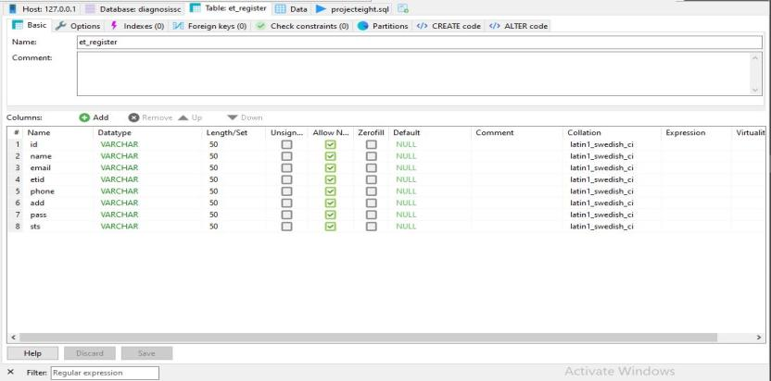

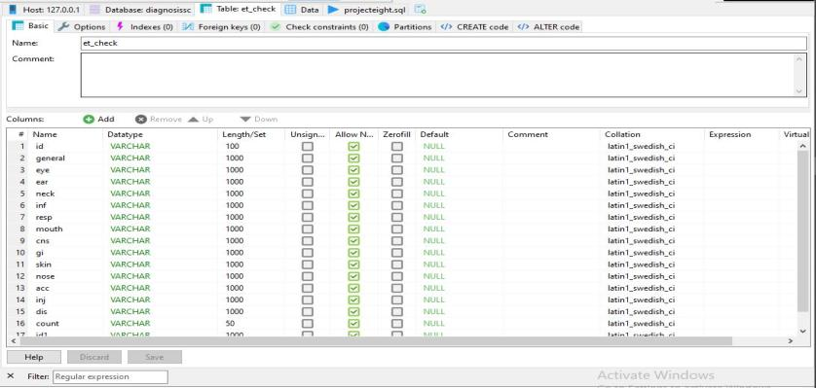

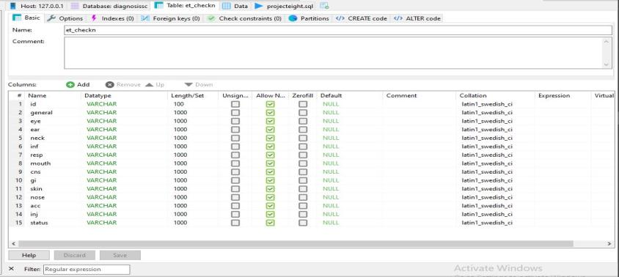

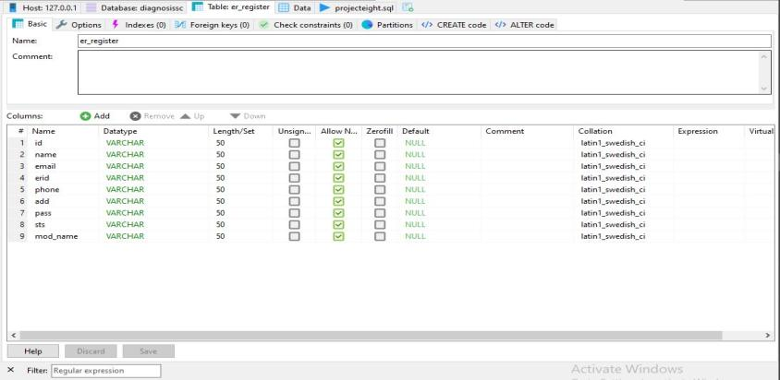

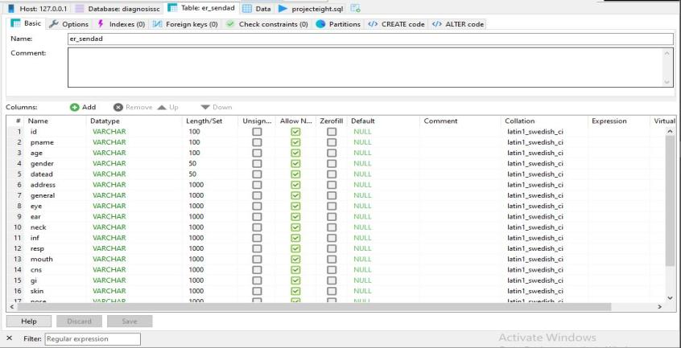

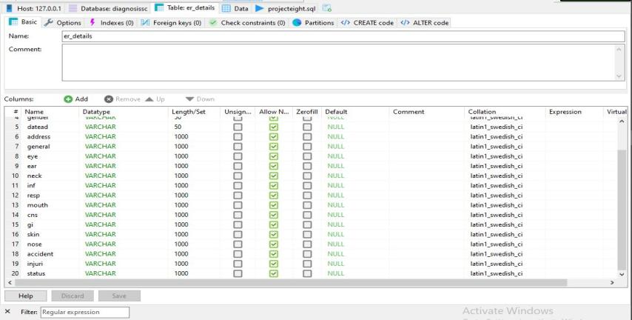

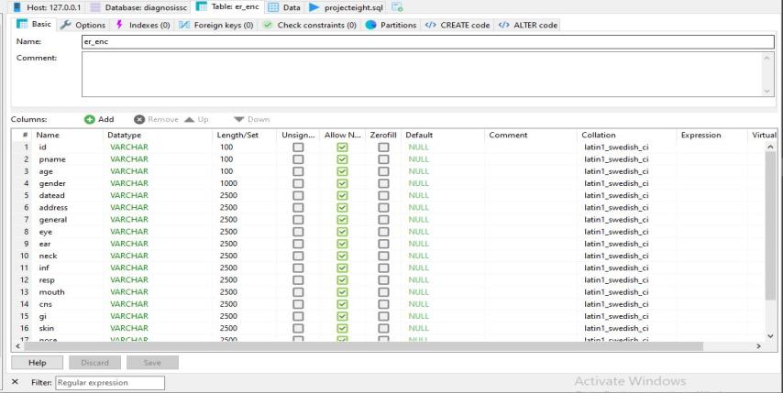

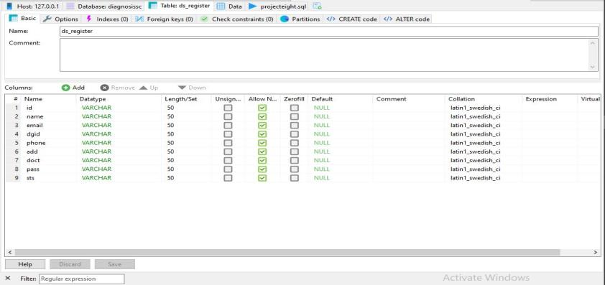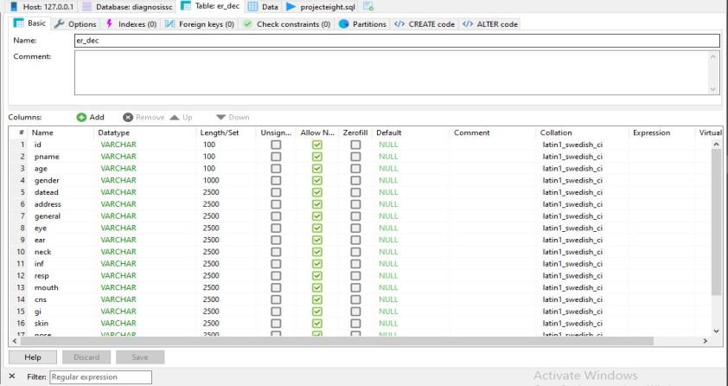

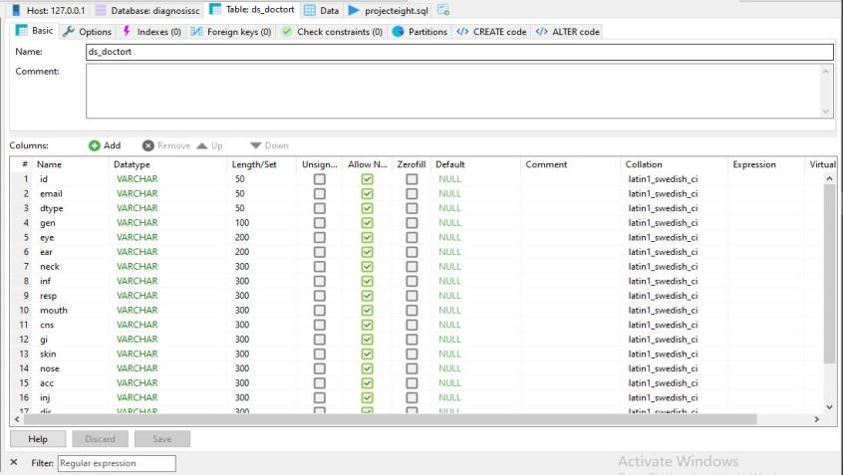

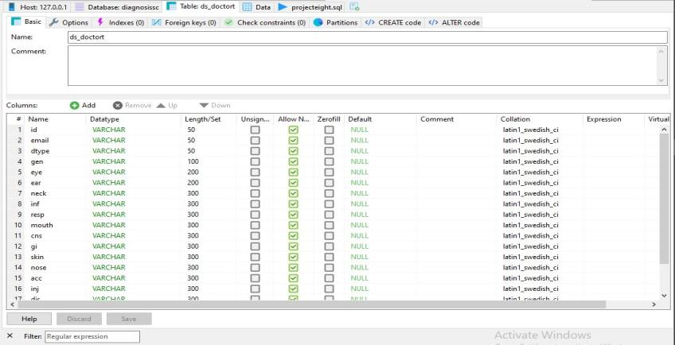

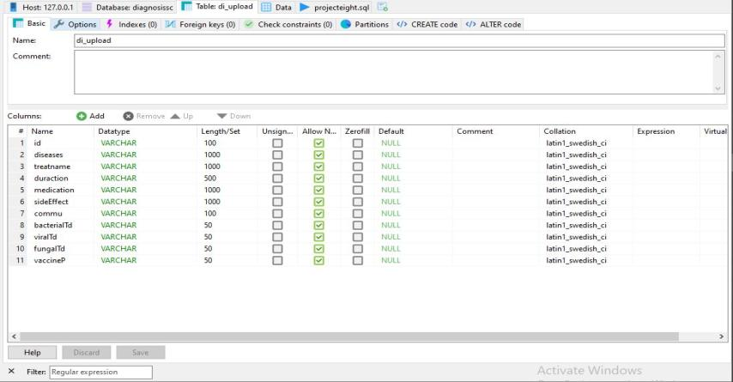

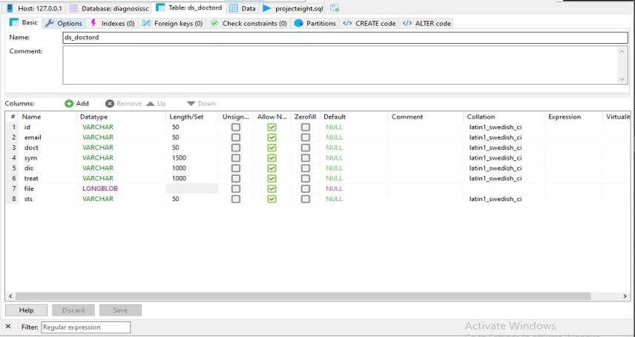

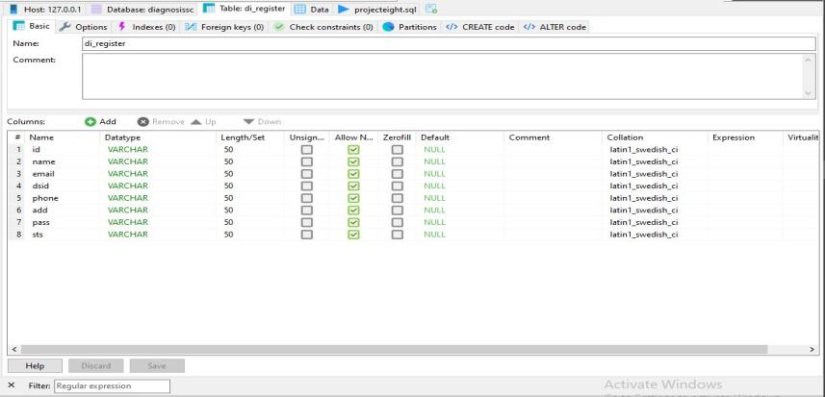

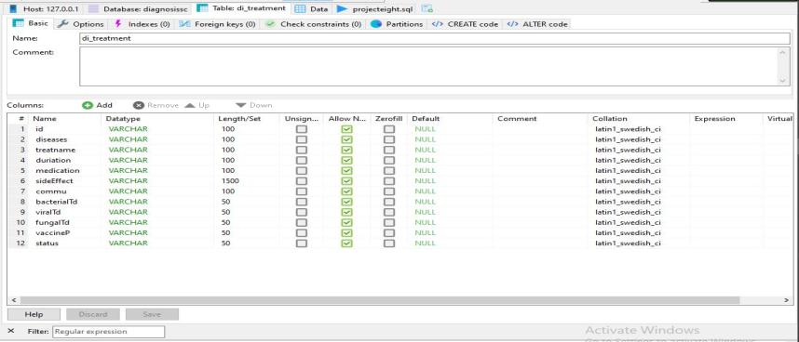

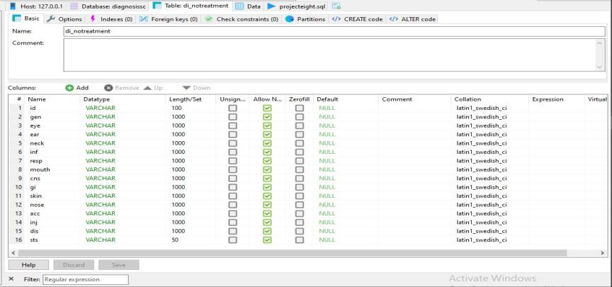

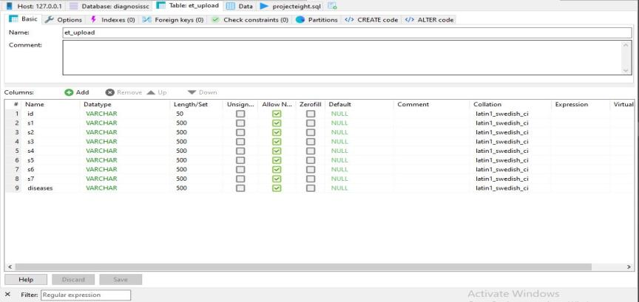

**4.2 System Architecture:**

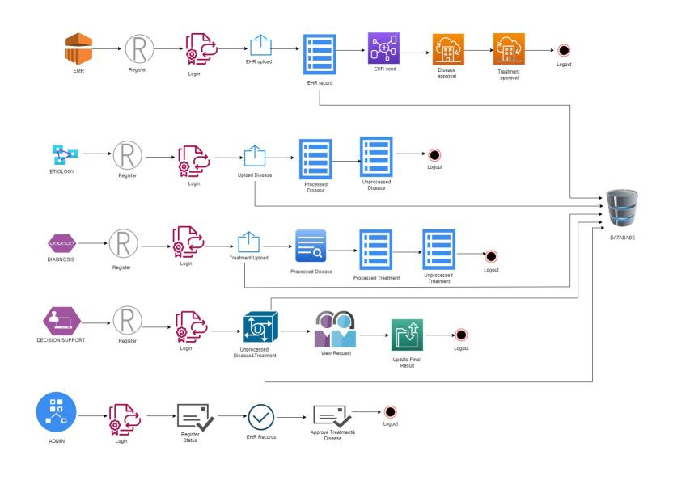

**4.3 E – R DIAGRAMS**

* + The relation upon the system is structured through a conceptual ER-Diagram, which not only specifics the existing entities, but also the standard relations through which the system exists and the cardinalities that are necessary for the system state to continue.
  + The Entity Relationship Diagram (ERD) depicts the relationship between the data objects. The ERD is the notation that is used to conduct, the date modeling activity the attributes of each data object noted, is the ERD can be described resign a data object description.
  + The set of primary components that are identified by the ERD are
  + Data object
  + Relationships
  + Attributes
  + Various types of indicators.

The primary purpose of the ERD is to represent data objects and their relationships.

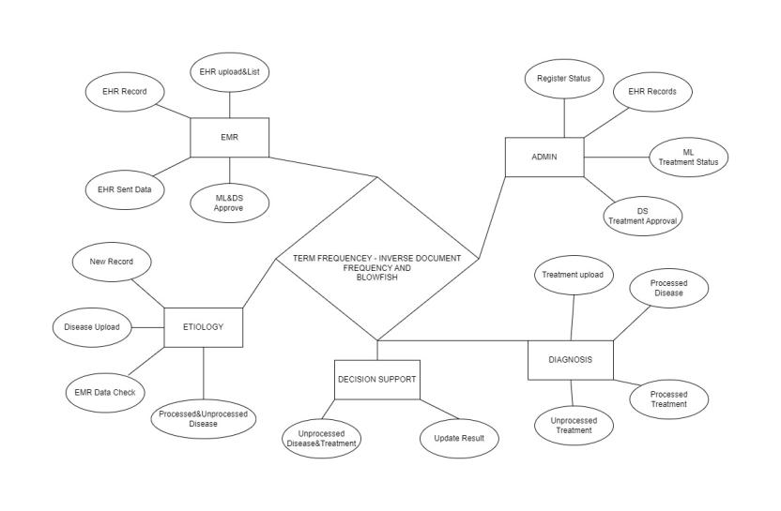

**4.4 DATA FLOW DIAGRAM**

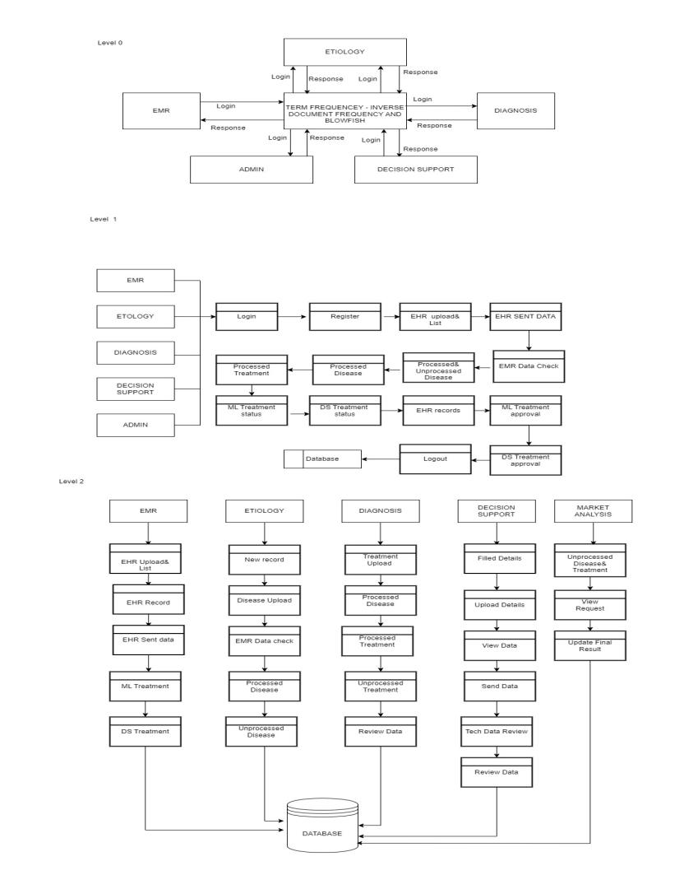

**4.5 USE CASE DIAGRAM**

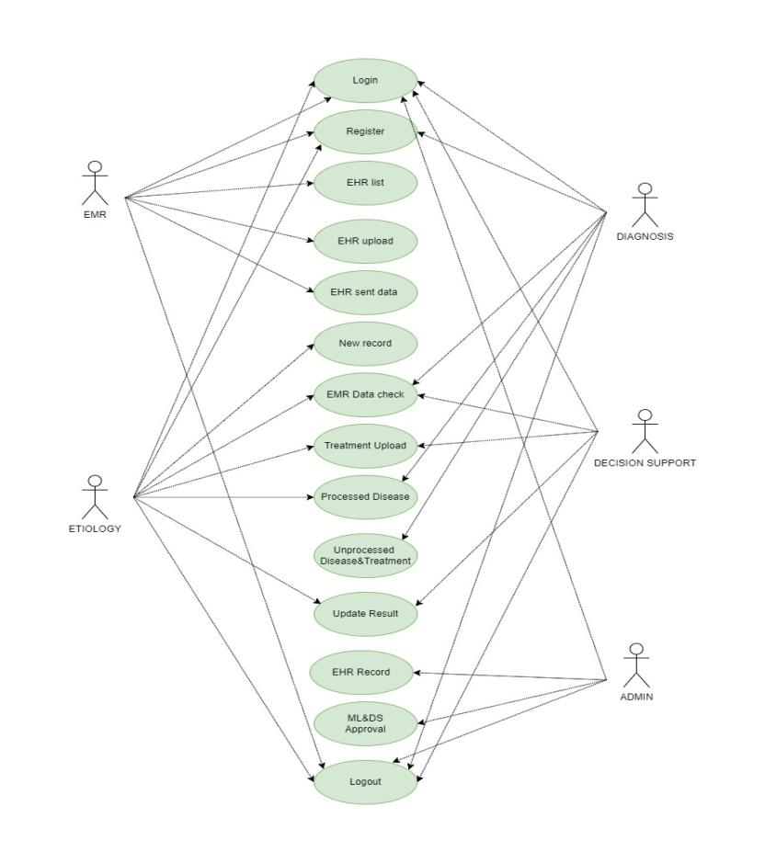

**4.6 CLASS DIAGRAM**

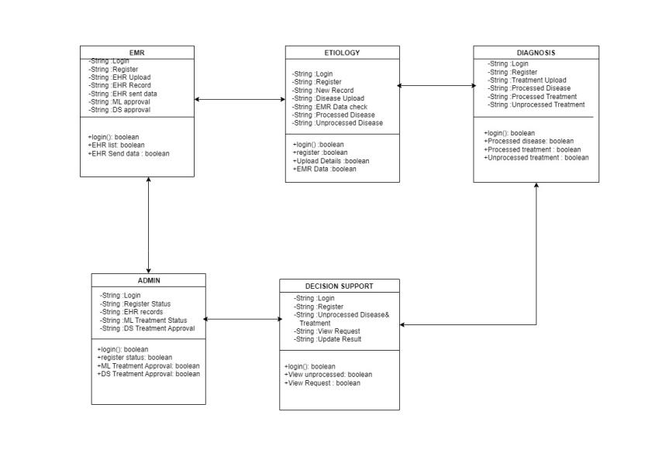

**CHAPTER-5**

**OUTPUT SCREENS**

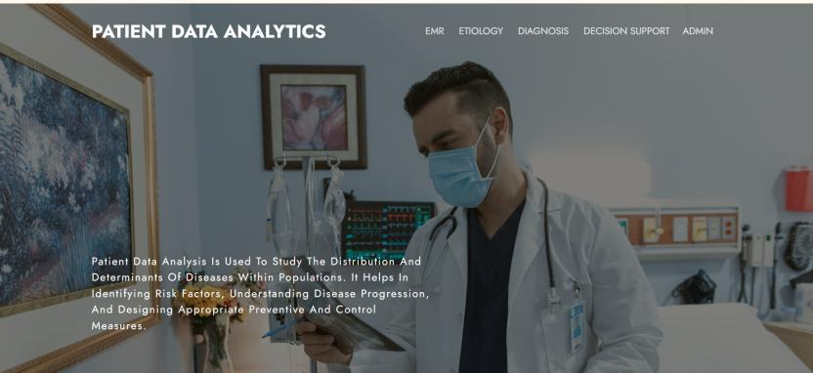

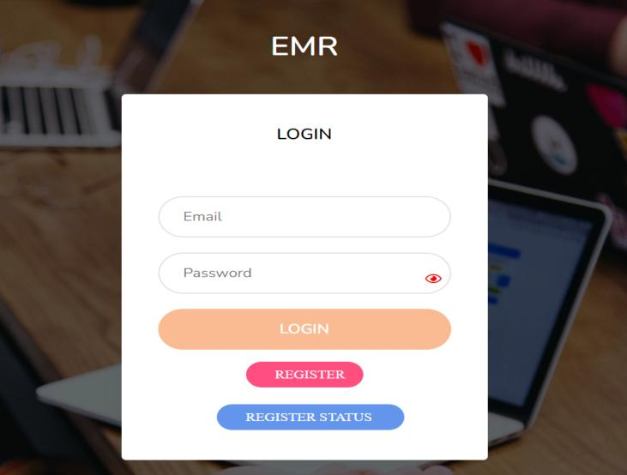

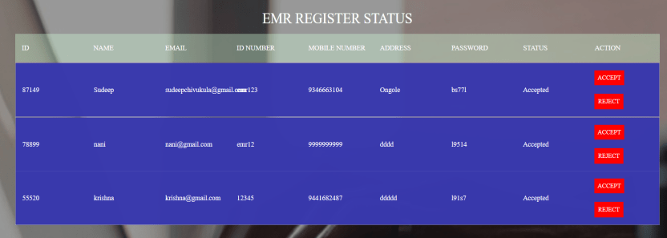

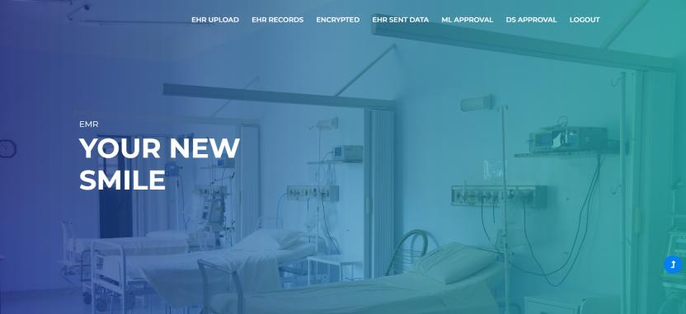

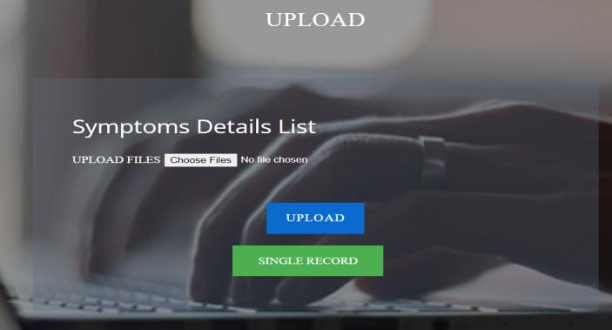

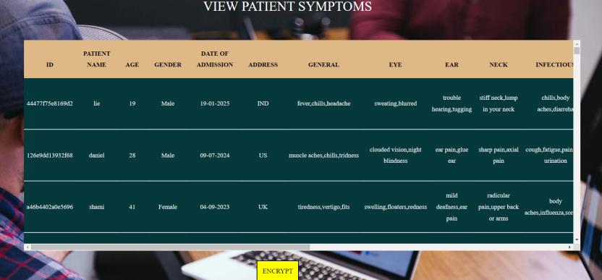

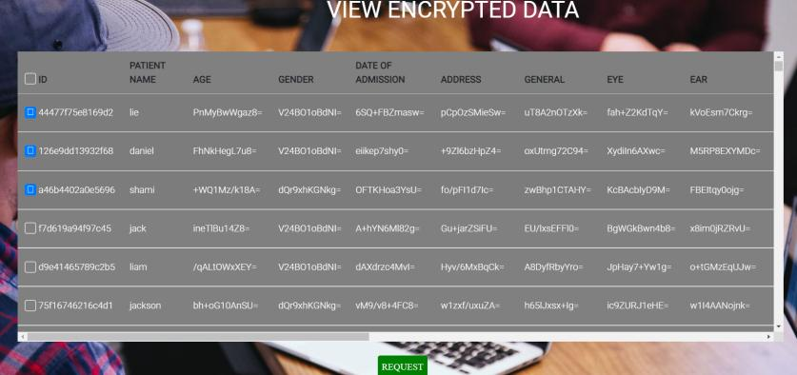

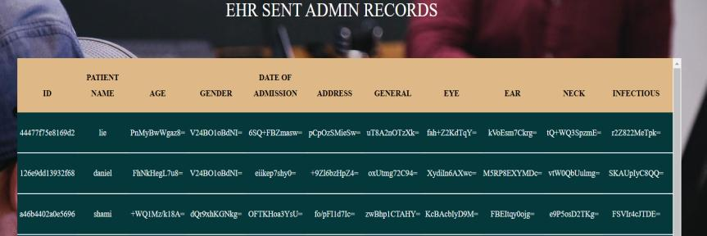

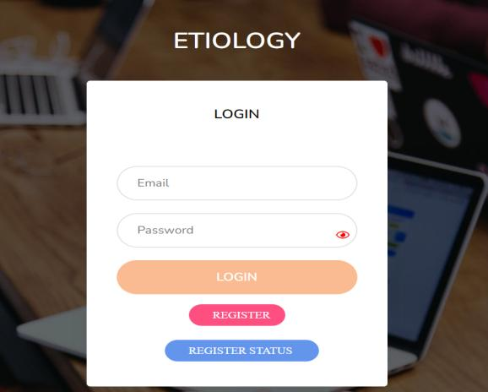

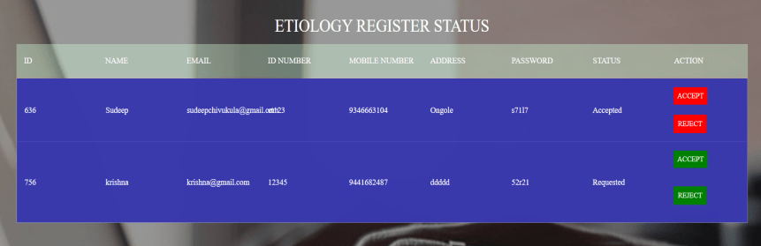

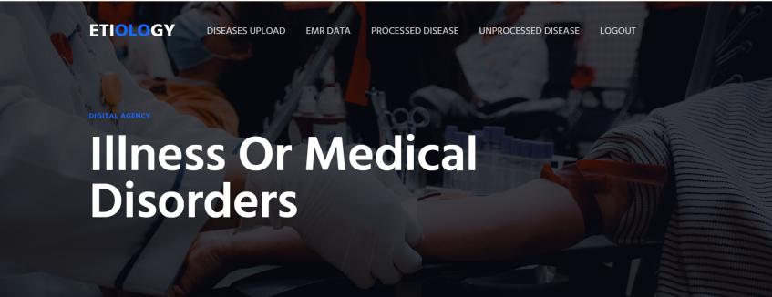

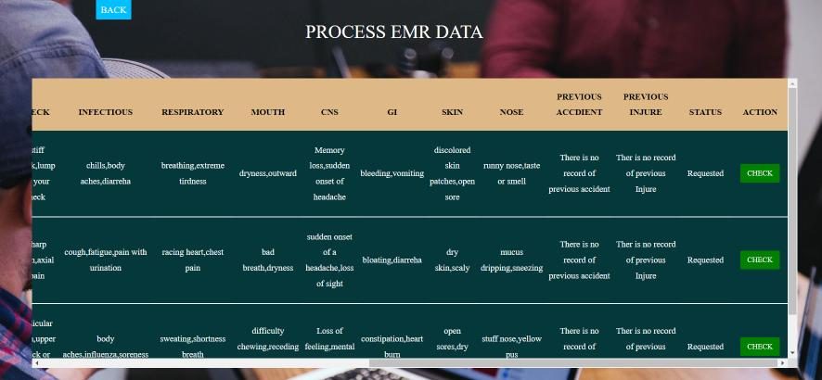

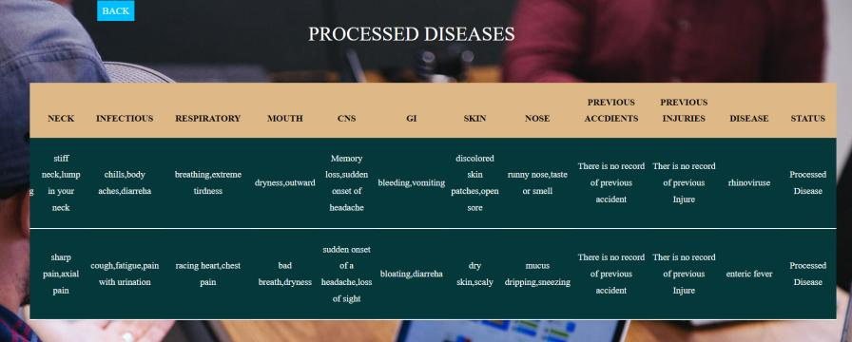

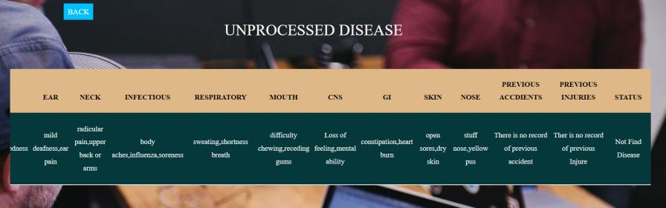

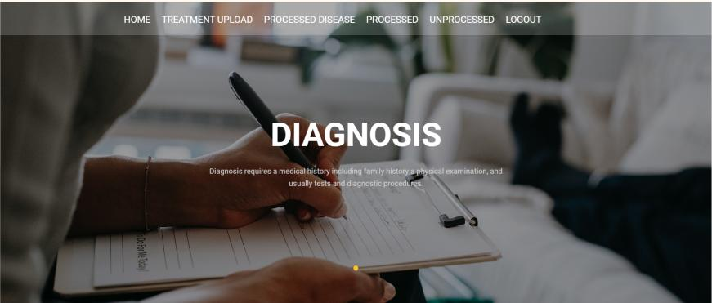

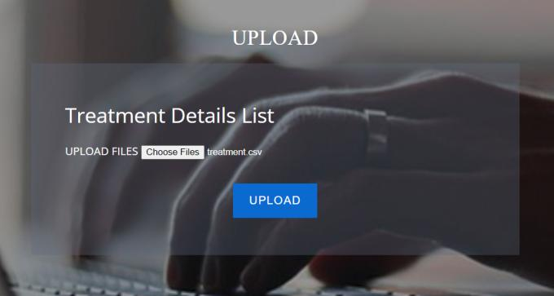

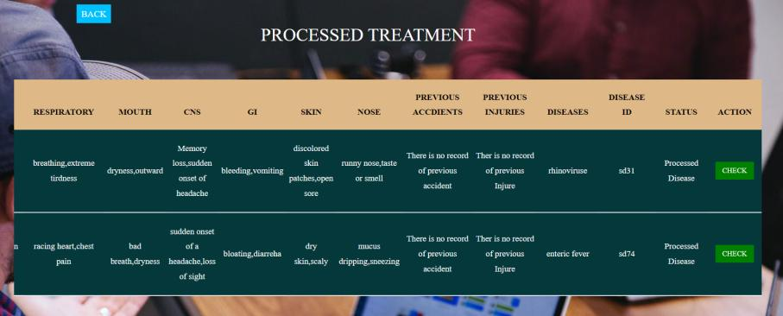

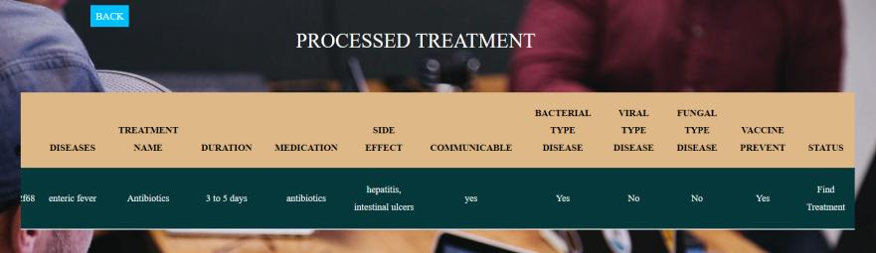

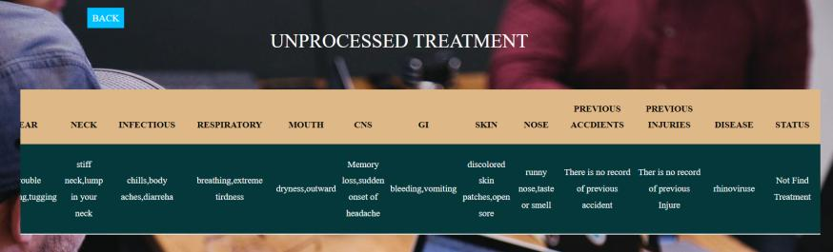



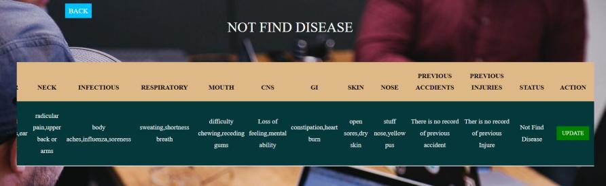

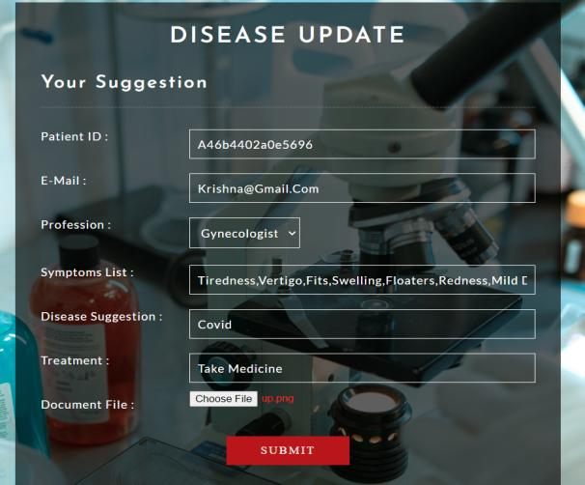

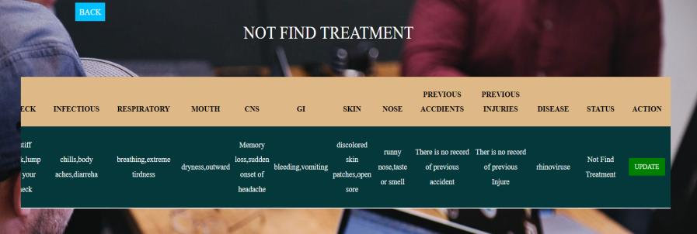

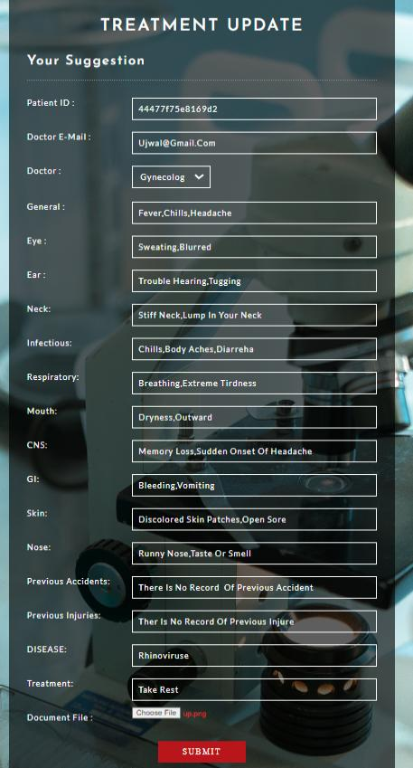

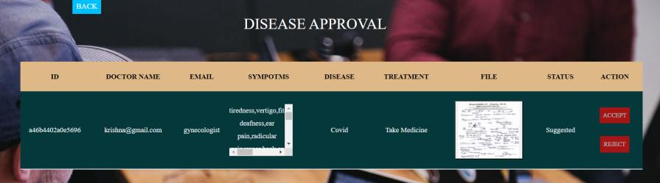

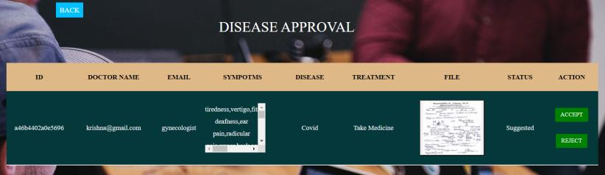

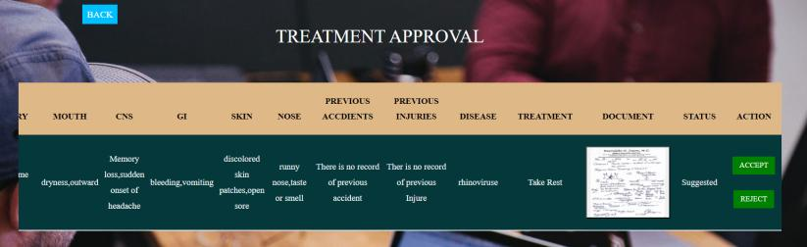

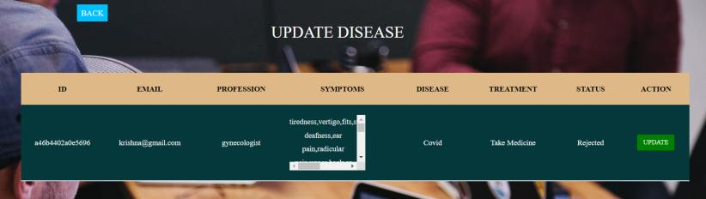

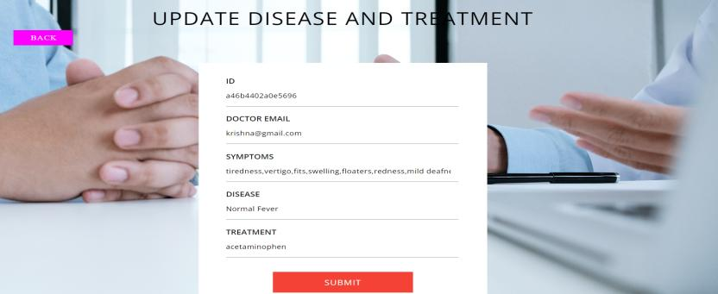

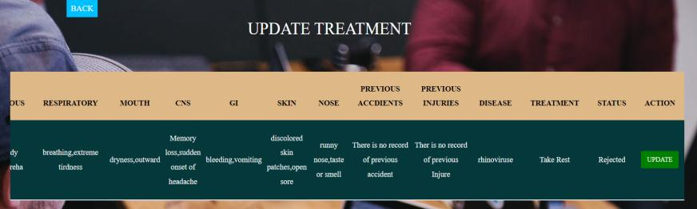

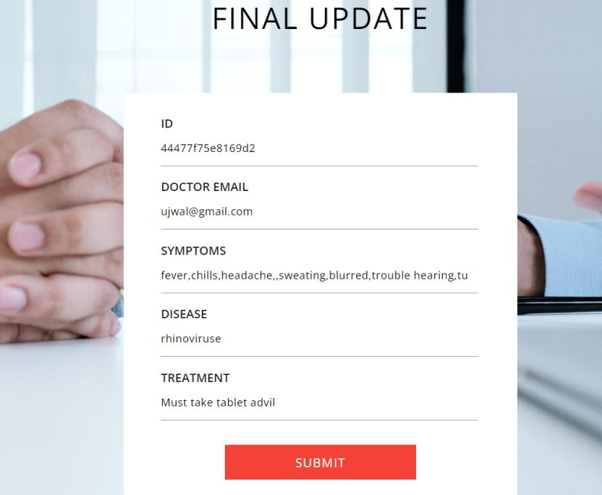

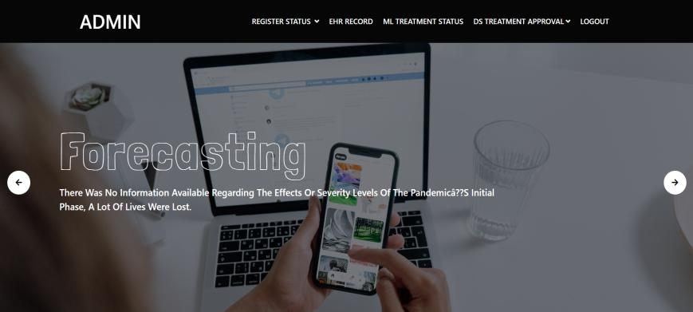

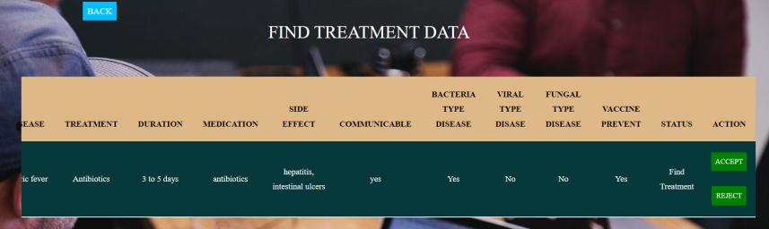

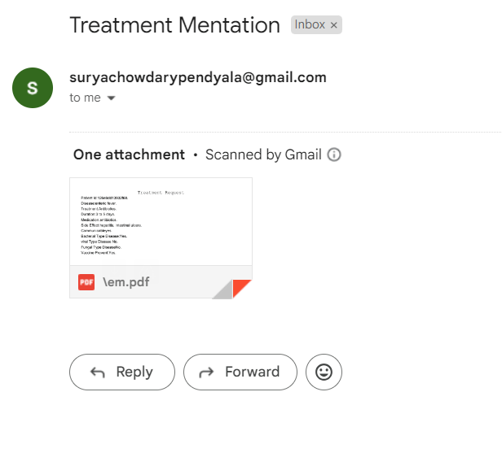

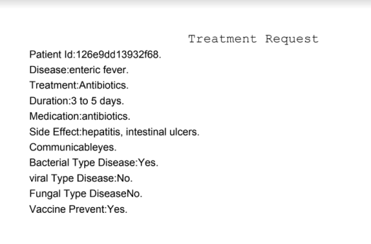

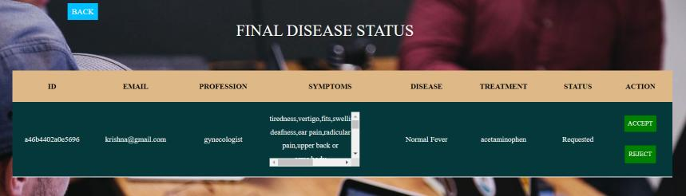

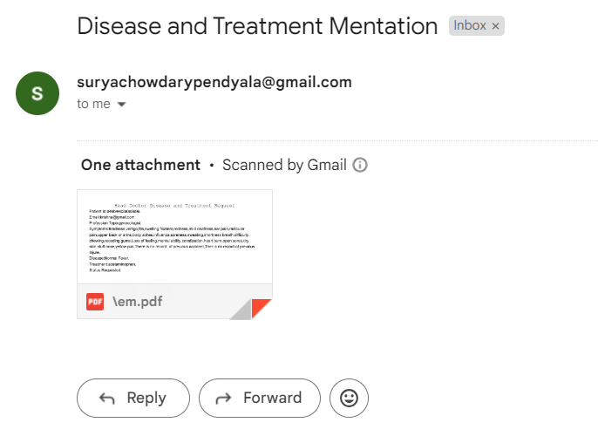

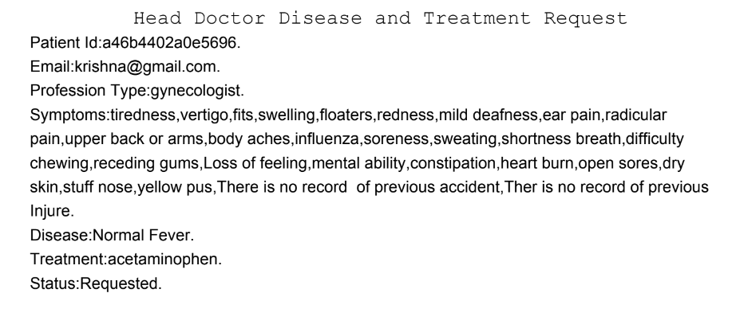

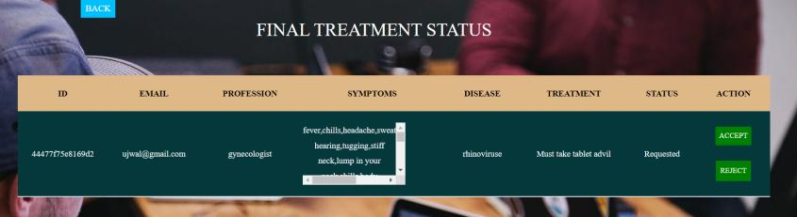

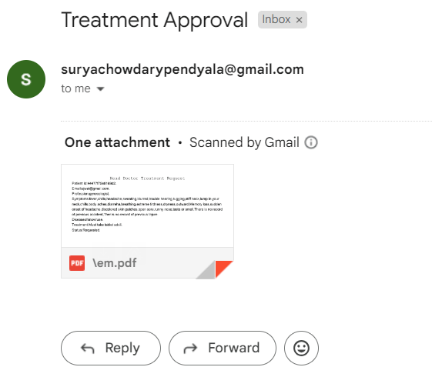

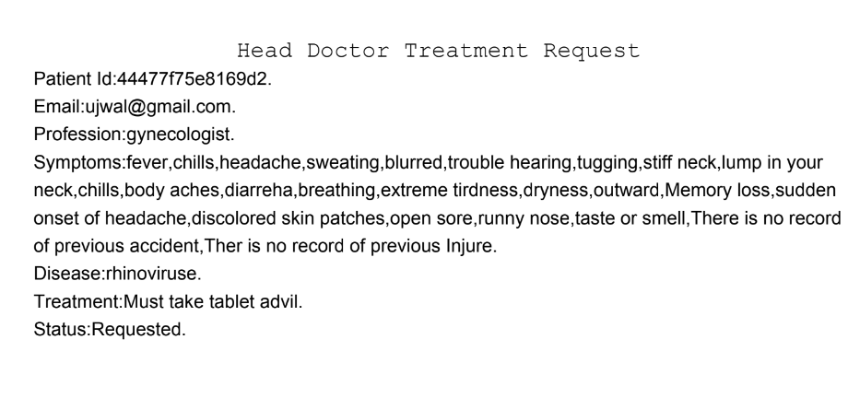

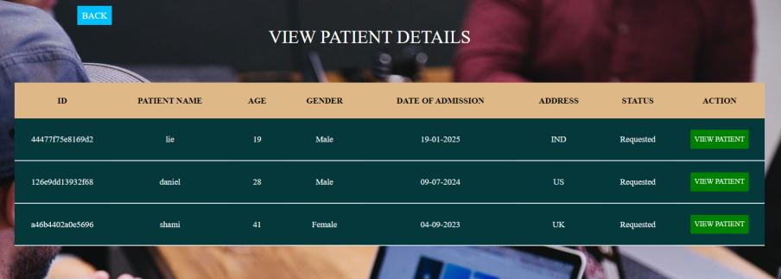

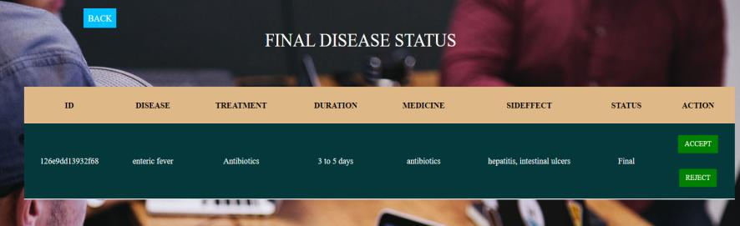

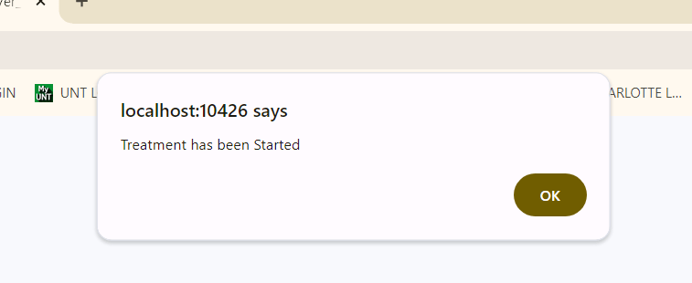

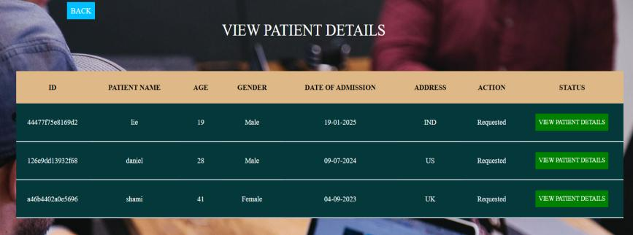

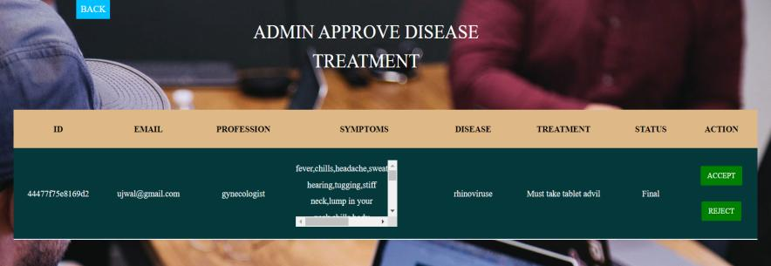

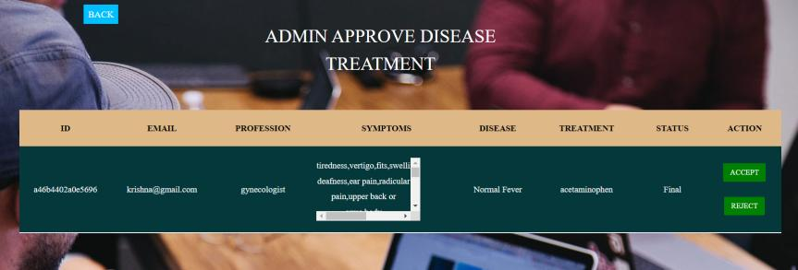

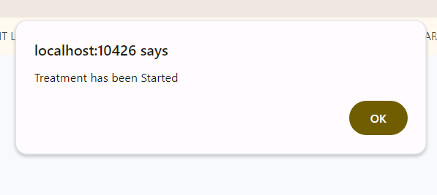

**CHAPTER-6**

**SYSTEM SECURITY**

# 6.1 INTRODUCTION

Security system can be divided into four related issues:

* Security
* Integrity
* Privacy
* Confidentiality

**SYSTEM SECURITY** refers to the technical innovations and procedures applied to the hardware and operation systems to protect against deliberate or accidental damage from a defined threat.

**DATA SECURITY** is the protection of data from loss, disclosure, modification and destruction.

**SYSTEM INTEGRITY** refers to the power functioning of hardware and programs, appropriate physical security and safety against external threats such as eavesdropping and wiretapping.

**PRIVACY** defines the rights of the user or organizations to determine what information they are willing to share with or accept from others and how the organization can be protected against unwelcome, unfair or excessive dissemination of information about it.

**CONFIDENTIALITY** is a special status given to sensitive information in a database to minimize the possible invasion of privacy. It is an attribute of information that characterizes its need for protection.

## 6.2 SECURITY IN SOFTWARE

System security refers to various validations on data in the form of checks and controls to avoid the system from failing. It is always important to ensure that only valid data is entered and only valid operations are performed on the system. The system employs two types of checks and controls:

**CLIENT SIDE VALIDATION**

Various client side validations are used to ensure on the client side that only valid data is entered. Client side validation saves server time and load to handle invalid data. Some checks are imposed:

* JavaScript in used to ensure those required fields are filled with suitable data only. Maximum lengths of the fields of the forms are appropriately defined.
* Forms cannot be submitted without filling up the mandatory data so that manual mistakes of submitting empty fields that are mandatory can be sorted out at the client side to save the server time and load.
* Tab-indexes are set according to the need and taking into account the ease of use while working with the system.

**SERVER SIDE VALIDATION**

Some checks cannot be applied on the client side. Server side checks are necessary to save the system from failing and intimating the user that some invalid operation has been performed or the performed operation is restricted. Some of the server side checks imposed is:

* A server side constraint has been imposed to check for the validity of primary key and foreign key. A primary key value cannot be duplicated. Any attempt to duplicate the primary value results in a message intimating the user about those values through the forms using foreign key can be updated only of the existing foreign key values.
* The user is intimated through appropriate messages about the successful operations or exceptions occurring at server side.
* Various Access Control Mechanisms have been built so that one user may not agitate upon another. Access permissions to various types of users are controlled according to the organizational structure. Only permitted users can log on to the system and can have access according to their category. User- name, passwords and permissions are controlled the server side.
* Using server side validation, constraints on several restricted operations are imposed.

**CHAPTER-7**

**CONCLUSION:**

The conclusion is include medical history, symptoms, laboratory results, and any other pertinent details. Once we have the data, we can apply term frequency modulation techniques to identify patterns and relationships within the data. Term frequency modulation involves analyzing the frequency of terms or keywords within a dataset to understand their importance or relevance. This technique can help identify key terms associated with specific diagnoses or conditions, allowing for more accurate analysis and prediction. After applying term frequency modulation to the patient data, we can generate insights and conclusions based on the patterns and relationships identified. This may include identifying common symptoms or risk factors associated with certain diagnoses, predicting outcomes based on specific variables, or identifying areas for further research or intervention. Patient data analytics using term frequency modulation can provide valuable insights into the diagnosis, treatment, and management of various medical conditions.

**CHAPTER-8**

**REFERENCES**

[1] S. Oprea et al., “A review on deep learning techniques for video prediction,” IEEE Trans. Pattern Anal. Mach. Intell., vol. 44, no. 6, pp. 2806–2826, Jun. 2022.

[2] I. J. Goodfellow et al., “Generative adversarial networks,” in Proc. Int. Conf. Neural Inf. Process. Syst., 2014, pp. 2672–2680.

[3] F. Locatello et al., “Object-centric learning with slot attention,” in Proc. Int. Conf. Neural Inf. Process. Syst., 2020, pp. 11525–11538.

[4] S. Dasari et al., “RoboNet: Large-scale multi-robot learning,” 2019, arXiv: 1910.11215.

[5] M. Ester et al., “A density-based algorithm for discovering clusters in large spatial databases with noise,” in Proc. Int. Conf. Knowl. Discov. Data Mining, 1996, pp. 226–231.

[6] V. L. Guen and N. Thome, “Disentangling physical dynamics from unknown factors for unsupervised video prediction,” in Proc. IEEE Conf. Comput. Vis. Pattern Recognit., 2020, pp. 11 474–11 484.

[7] Z. Xu et al., “Unsupervised discovery of parts, structure, and dynamics,” in Proc. Int. Conf. Learn. Representations, 2019.

[8] A. Goyal et al., “Recurrent independent mechanisms,” in Proc. Int. Conf. Learn. Representations, 2021.

[9] A. Vaswani et al., “Attention is all you need,” 2017, arXiv: 1706.03762

[10] M. Ranzato, A. Szlam, J. Bruna, M. Mathieu, R. Collobert, and S. Chopra,

“Video (language) modeling: A baseline for generative models of natural

videos,” 2014, arXiv:1412.6604.