Get the latest code from GitHub
https://github.com/WaseemALTamer/FMRadioUniversity

This file is going to explain all the architecture of the project and how everything is going to be connected, and how everything is going to be managed using software and code to reach our aims for the project.

This project aims is for us to make use of most of the modules that they give us that include the FM radio modules, buttons, ultrasound modules and the rest that they give us, we are required to put them all together into one system that they can examen and grade us.

Why am I writing this file? The reason is that if we approach this project testing modules separately and trying to implement them all together with no base architecture that all the sub systems (electrical modules) follow they will collide with each other, and as you start fixing one piece of bug it leads to you breaking another thing, that’s why when designing the system we need to keep all the electronic modules isolated that means detecting the button press has nothing to do with using the ultrasound sensor to detect how far something is after we are done with coding and testing our base structure we can then put a layer on top that gets triggered but the button press and complete a certain function, for example when you press a button you say hello on the screen, the button script main purpose is to detect the press then it notify the next layer to execute the function that puts hello on the screen this is just a over simplified example we will go through how exactly for a sub system after I explain the over view of the project and what parts of the project is sub system and what is upper layer and what is even above that.

This file covers those sections
- Events system layer (driven by electrical module)
- Intermediate layer (software stage)
- Output stage layer (driven by audio to control electrical modules)
- Adding new features/modules

Event System layer

Now one things to be aware of is that real life is not the same as theory that we get taught, real life carries most of the theory but it comes with inconsistencies due to imperfect components and tools that we use, In better words expect when you press the button to get two clicks instead of one, this comes down to the metal inside the button bouncing after it hits the metal causing the electricity to go from high to low then to high, what we try to eliminate those inconsistencies before we pass the event to the upper layer, the upper layer this eliminate noise, this way noise is not passed to the upper layer as it lead to many issues especially if more than one electrical module is passing noise it will get really hard to debug and leads to many wasted hours and most of the time people decide they had enough and drop their design and re design it from scratch, or they stay with it and there progress slows down as they move forward in the project, and this is what we are trying to avoid.

now I hear you ask what the base layer is consists off? Well the base layer consists of more than one section and they are completely isolated, the first section is the input section, where it consists of all the modules that they are going to push an input, and the second section consists of all the modules that don’t give you a user input but something that you request your self such as humidity sensor or time tracking, those are not modules that are just information and there noise is not going to break the system so we can be lenient on them through both those sections are going to follow the exact same structure when we structure them.

So, to buy this visually I will provide a list of what each section contains:

Section one Input section
- Buttons
- Encoder
- Infrared sensor
- Ultrasound sensor

Section two Information modules
- Clock (it was a timer just like kris said sorry about that)
- Humidity sensor
- FM modules

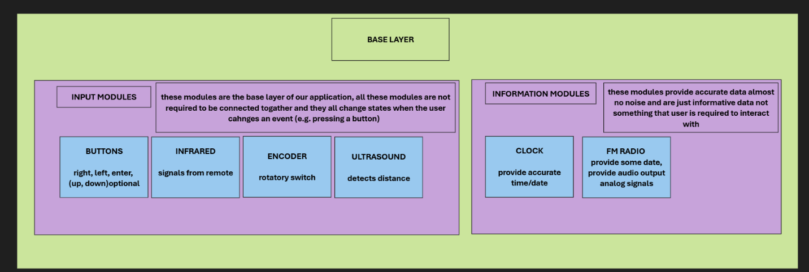
image to visualise of what the base layer consists of

alright now that we covered what our base layer is now we can going to zoom into one of these base layers and understand what we need from them and the structure that they will follow, lets take the rotatory encoder for example when we look at it we want to know two thing from it which direction it is when its rotated and when is it rotated, it sound simple enough, but here the base layer for that module should only tell us those two things when the event of rotating the module happens and that’s it we don’t care when he wants to tell us as long as he inform us.

Alright lets go deeper now when you look at an Arduino and how it works, it basically a system that runs in a loop block that loop and everything stops, so there is two requirements right here to code the base layer the first is that you should never block the main loop, the second is that the module itself needs to eliminate its own noise verify the data that he is feed and then and only then he will execute the tasks that we give it from an upper layer, we don’t code any instructions into it, so the instruction we give it they come from an upper layer.

alright real life example how we want our system to operate, imagen you are waiting for a youtube video to be uploaded so you can watch but you are not bothered to keep checking every single minute it is a waste of time so what you do is set up the notification system you tell youtube to notify you when that event happens, this follows our structure perfectly the upper layer is you, and the base layer is youtube, so in our architecture this what the upper layer is to the base layer, and the base layer doesn’t know what to do until you tell it notify me please when that happens, and the base layer is the layer that detects when something happens, this avoid the problem where each layer tries to detects its own events.

well lets look at how the upper layer will be using the base layer from a code point of view:
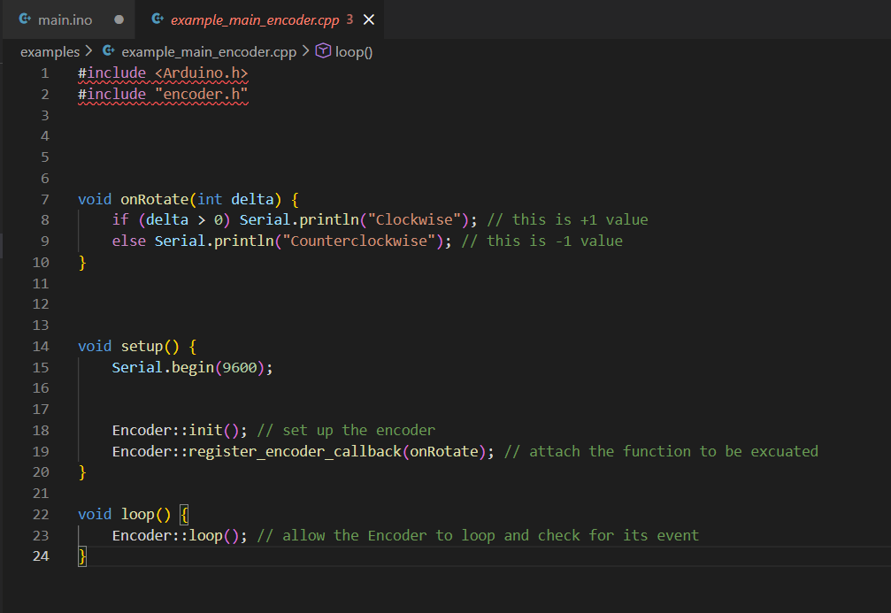
image showing how upper layer use the base layer

alright as you can see from the image above we make a function called OnRotate then we simply just initialize encoder and register the function this function will be executed every time there is an event, and the data that the base layer will pass is reliable data all the noise filtering all the internal bounce filter, all the dirty parts of the system is taken care of before they even reach the upper layer, and as you can see the function needs to contain a parameter called delta which will contain the direction of the rotation, this means you get all the data that you need from when the user rotates the encoder.
The loop function holds the loop of the encoder, the encoder still needs to check for its own events but here is two things because the main loop is not blocked this means you can run all the base layers loop all together to do all the work for you and notify you when there is an event you don’t really care about the loop function the system we are trying to make is event driven.

And it goes like this for all the base modules from buttons to clock to infrared to ultrasound you get the point that am trying to make check the image below for a better example.

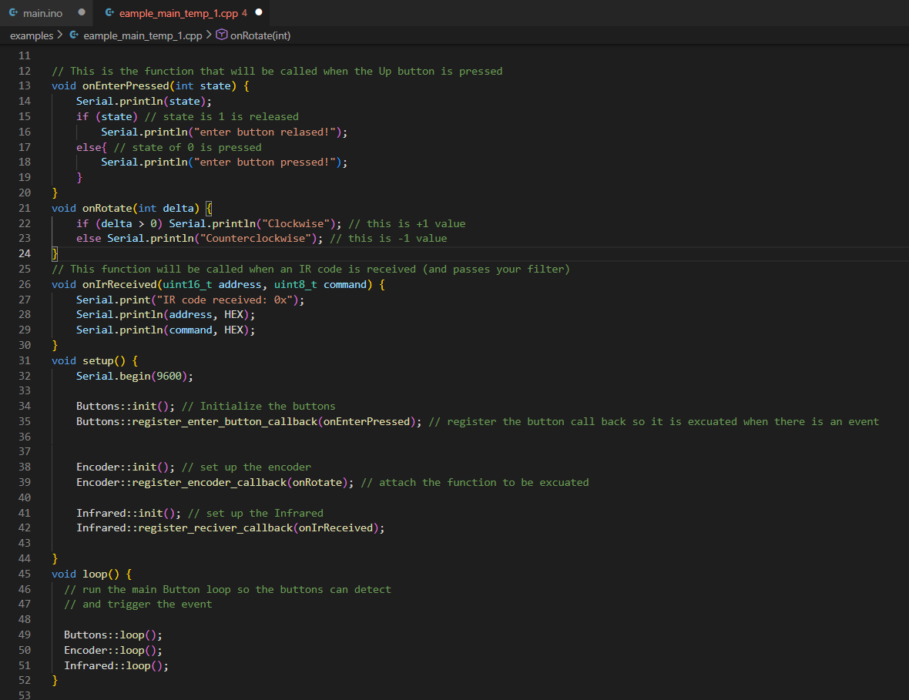
image showing how different events work the same

Alright now we can detect all the inputs that we need now what the system does nothing it just detect the events and that’s it, so what is our aim? Well now we can detect everything no we don’t care about the loop function any more, think about it nothing we want to do is going to be done on a loop rather everything we want to do is going to be driven out of the event system, we don’t need to update the UI unless there is an event, we don’t need to update the time on screen unless there is an clock event, we don’t want to change a number unless the encoder rotates upward and so on and so forth.

Intermediate layer

Alright now we got the intermediate layer, so what is the intermediate layer responsible for? Well it is responsible for many things, it is the core system it self, while it doesn’t track time it doesn’t track anything it should generally have a structure to store all the data that we get from the event system.

First lets cover all the events that we have from the system that we build so far:

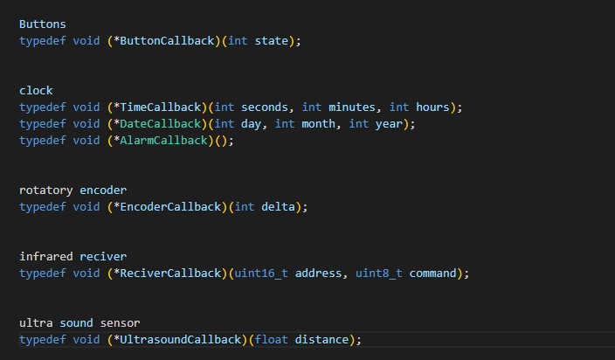
image showing all the events that I covered so far fully functional

as you can see from the image above we can pretty much get the distance the time change each second, the date change get the encoder rotation, and the distance from the ultra sound sensor, which we can all use for our intermediate layer.

but first lets talk about what we want our system to do, am going to put them it in a list:
- Show us current time
- Allow us to set current time
- show current frequency channel
- allow us to set our frequency channel
- show current volume channel
- allow us to change the volume
- show us the time for the alarm
- allow us to change the time for the alarm

those are the current things that we want to be done so far that we discussed in lab notice two things, everything that we what to show we also want to be able to edit it for example:
- Show us current time
- Allow us to set current time

Should be at the same page you can simply just click enter button to go into the numbers then navigate to the number you want to change and simply just increase it or decrease it using the encoder by rotating it either up or down then to finalize your edit you simply just click enter again and it sets the current time for, and we need to be able to do that not just for the time but for the current frequency channel for the volume and so on, basically same system at the end of the day.

This is where “pages” comes in what are pages I hear you ask, they are simple UI page where each page can hold what needs to be displayed and values that we can change on the go then we can navigate to a different page which holds the volume or go back to the previous page which holds the alarm data, you get the point.

This leads to a structural approach of making pages, first factories all the key functionality of what the page needs to do, for example a page template can be just a header title tells you what the page is for, then you get another text under the title which holds the values that you can navigate to and change provided the value is a number, then that page needs to be linked to the next page and previous page so you can just go to them, each page should have those base functions.
Now how can we make that using software, well we cane simple make a structure that contain a pointer to the next page and previous page, then it contain two strings which holds the title and then the second which holds the values that you can change on the go, that’s all we need, we can link the pages through hard coding it there is no avoiding that.

but each page should have a different functionality at the end for example after you change the time, it should set the time, or after you change the frequency channel it should set a new frequency channel, those functions are not unique they have to be specific for each page, so I hear you ask what is the solution for that should we hard code it? The answer is yes but the base of executing the function should not be hard coded think about it like this the structure will hold a pointer to a function that you provide it that function will be executed when they change the number and try to reset the number.

Alright another question that you might hold, what about when an alarm get triggered we need to change the page to a different one completely something that you cant really navigate to using buttons, well you are right, but it is still solvable we can simply have a page ready but the list doesn’t link back to it, but the page it self links back to the list with the previous page and forward page linking to the page that you were on.

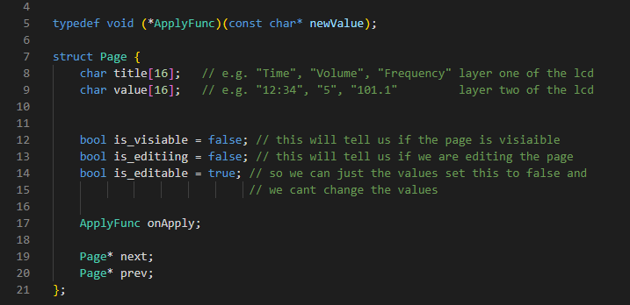 This image shows the structure of the page

The image above shows the structure that am talking about note that the title is just an array of chars this which will be used to pass to later on to the lcd which is basically just a 2 layer above each of 16 letters which fits exactly how we are handling it internally, this will require us to go through the array and get the relevant characters out convert them to integers or float and then set the value which is fine in the grand scheme of how much we abstracted away using this architecture.

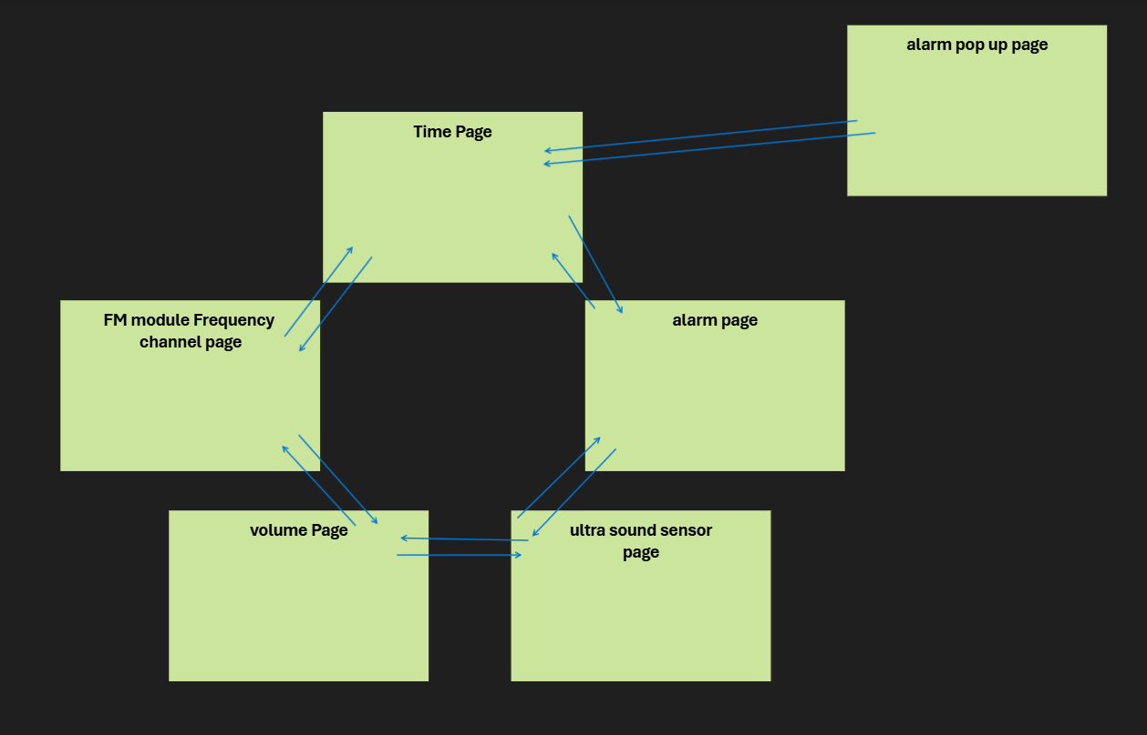
This image shows how the images are connected together visually

Output stage layer

This stage is actually the system that displays the output to the lcd, it might seem just display the page, write a function that displays the current page and call it a day, yes but that is half of the way through, because first you don’t want to update a page if it is not visible to the and for the events needs to be executed before we update the page, this is because what if we update the current page on the screen and then transition to the new page this will cause the next page to not be visible and appear as if it is stuck.

So, let’s trace back the whole system so everything is clear now:

(start)
electronic modules ->
self-contained code that extracts the output ->
event function triggered ->
function linked to the page system whether its change visual or move to next page ->
display on screen
(end)

Basically we are between the last two stages and two things must be done correctly first event comes before screen update, second the display is only update to the correct page and the page it self is free to change but is not free to be updated on display and as long as we keep these two conditions you basically completed the system

Adding new features/modules

Alright but what if we want to add a feature that we don’t have do we need to rebuild the whole system? You probably already know the answer but am going to more in detail because this is the result of the that we are making, we can add it without it effecting any other system, let’s say we want to add the humidity monitoring system, well then we first have to write the code to read the module then filter out the noise if there is any, the humidity module is not capturing user input rather just environment data so the system will not feel janky because user is not using it to interact, so even if noise where to make it way up the layers it wont matter much, but just to be safe we filter out the noise.

Then we move into making a new page, making the page not editable since we can’t edit humidity level, but we might need to calibrate the module using the software to show certain humidity so we might need to make it editable, then that page will be connected to pages that form a circular navigation system between them, this will not interact with any modules code this will not edit any other page code and the page that we make already has the structure and the base functionality that we need from it.

In better words our system will be scalable for different features if we expand to a different lcd we just edit the lcd module that communicates between the pages and lcd nothing more nothing less, debugging systems will be easier because everything is isolated and over all the system will be more predictable, reliable and consistent.

