####################################
This page should not be included in the report, this is a message to the person compiling for the final report submission.

This file is architecture only no implementation only examples that mimic the implementation

####################################

System architecture

Operation flow

Our system contains 3 separate layers that the system goes through from a input/change to the output stage, those stages are in order, and we call them as follows:
- base layer / Input Layer
- intermediate Layer
- Output Layer

Overview of the layers
The first layer , base layer is responsible for taking the data that is being inputted by a module and it simply process what type of input it is, for example if it is a button state change (pressed/released) or if it is an encoder state change (clockwise/ anticlockwise) and so on and so forth, we consider all modules an input layer even the RTC clock module, after the input layer process the type of input it will simply pass forward the event that occurred, please note that the base layer doesn’t handle the logic of what that input triggers rather the upper layer determine its functionality by attaching a function to be executed upon event.

The second layer which is the intermediate Layer, is responsible for managing the state of the machine, such as different page menu, what happens if a button release event is to be passed to it on a specific page and so on and so forth, this is responsible for handling what each event does and so on and so forth.

The last stage output stage is the stage that handles the feedback that the user sees on screen it purpose is not to provide useful information but rather to only mirror what the intermediate stage is at for example which page, content of page and so on and so forth, what it does not do is run any logic beyond displaying on the lcd or screen.

Layers rules

Our system does not run on an interrupt for the when using the Arduino nano, this is because there are only 2 interrupt pins and they are simply not even to make 3 buttons out of the two interrupts, so our system have rules that all the layers follow, each layer will have time to run its own logic in a none blocking way, the base layer will get the first turn then after it is done the second layer the intermediate layer will get the next turn and finally the output layer.

If one of the layers is going to use a “thread.delay” then the whole system is going to wait for that delay and as a result other modules like the ultrasound module which is time sensitive will start to provide wrong data.

The intermediate stage also can run its own logic every loop this is not applied to the whole intermediate stage but rather just to the starting follow of the intermediate stage and the rest of the stage only relies on events that are coming from the base stage.

The output stage is responsible for mirroring what is inside the intermediate stage, while the intermediate stage tells the output stage that an lcd update is needed the output stage will not do it straight away but rather it will schedule an update, and the output layer will do it when it can update this voids lcd flickering and also limits how many updates can be done in a second so the lcd doesn’t change too fast.

There are also other general rules such as:
- Never delay the main thread
- Never run a computationally expensive task every loop
- Input modules should not interact and should be separated
- Use the event system to detect a change rather than code it when you need it
- Do not update the lcd and schedule it when you need an update
- Base layer doesn’t interact with the intermediate layer
- Intermediate layer doesn’t interact with the output layer
- Only upper layers can interact with the layer behind it
- Never use malloc/free it fragments memory and collides with the stack
Breaking any of these rules is going to cause the code to be unstable, and separation of concern becomes vaguer and if you keep breaking them will lead to fixing one problem causes another problem to come to light.

base layer

Almost all the modules that we use are base layers and they go as follows:
- Buttons
- Encoder
- RTC clock
- Humidity sensor
- FM radio
- ultrasound sensor
- infrared sensor
All these modules run in the exact same way, detect a change in a none blocking behavior then simply trigger an event, by triggering an event we mean access an array that contain functions that the intermediate layer placed in there and execute them one by one.

But before triggering the event we need to make sure of two things, first the event is not noise, second the input is intentional, passing any noise or unintentional input to the intermediate layer will cause the intermediate layer to feel buggy and unreliable from the user point of view.

Even if the module wasn’t an input it by name it should still be integrated in the same way, for example the RTC clock is not an input module it doesn’t trigger a change it only tells you the time when you ask it as it also runs on the I2C bus, so the idea right here is to trigger the event with code, every loop when the base layer of the RTC clock is getting executed simply ask the clock and check if the time change from before if so triggered the event, now one thing to keep In mind communicating over the I2C bus is expensive since the bus takes time to give you the data and you need to wait by default so never check the time every loop rather check it only when you think there is an update and for the clock module that is only occurred every second but to keep the time more up to date we do it every 0.8 seconds.

Some base layers are not input at all and only output devices those such as FM radio you only tell it what to do and that’s pretty much it, there is no events, while this is true we don’t need an events but it still should be coded in the same way where it still gets its own loop time even if it doesn’t nothing this doesn’t just make the code follow strict rules but rather it makes the code expandable and maintainable later on down the line.

intermediate Layer

The intermediate layer consists of a whole system within itself, build on top of the base layer, as the base layer is responsible for the interaction for each page and the navigation between the pages.

All the pages follow the same structure as follows:
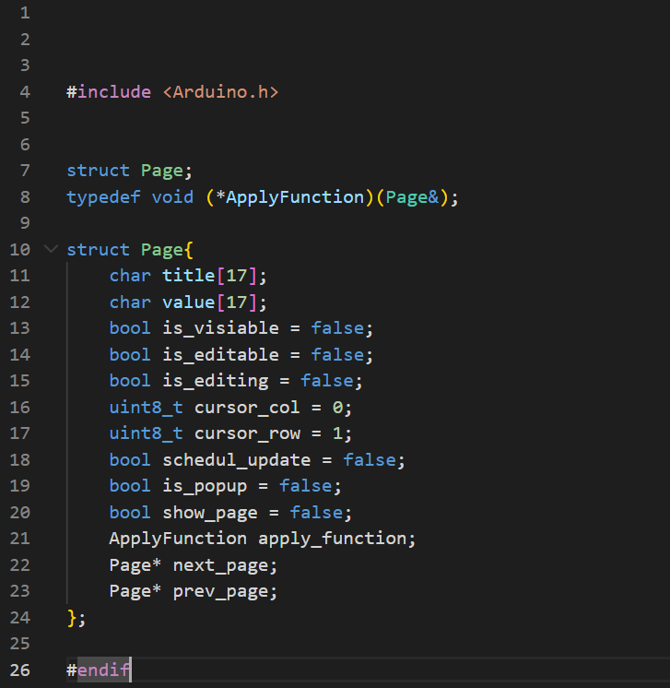
The title char list in the page represent the lcd first layer and the value represent the second lcd layer, so when the output reads the page it will simply copy what is the title and the value in its layers, the “is_editable” value tells the system if the page is editable so you can change numbers and apply them for example you can change the alarm time and so on and so forth.
All the other variables allow the system inside the intermediate layer to track the state of the page itself and help the system work.
The pages’ structure aims to encourage them to be linked to the next and previous pages such that the pages form a looped linked list, so navigation is as simple as accessing the next pages from the page you are on and displaying the next page.

The intermediate layer interduces the interaction system which is responsible for the following:
- setting up the pages
- page linking for navigation
- button/encoder input
- page edit mode and editing digits on screen
Making a page requires you to make a separate file which initiates the page and attaches the required function for the apply variable function holder. The page will also handle which events it needs to subscribe to so for example when the time changes the page time updates upon the event.

Output stage

The output stage is responsible for updating the lcd, it does it through a schedule system where the page in the intermediate section will set the ready to update var on and when the output system sees that variable is set to true and enough time has passed since the updated, then it will simply just update what is on the lcd if not enough time has been passed then it will wait until some time passed so it avoid flicking on the lcd, during that time if another update was schedule it will override the initial update and only the latest one will be displayed on screen.

The output stage does not interact with the base stage as there is no need for it to do so, it does interact with the lcd module though, we support both the lcd which works with the I2C module and one that works without the I2C bus the only difference is in the entry point of the lcd you need to specify which lcd module you are running.

Program entry point / architecture

The entry point shows how the software handles setting up all the modules one by one, it also handles what gets update first and what gets updated last the following photo will show how we setup the modules and the systems.

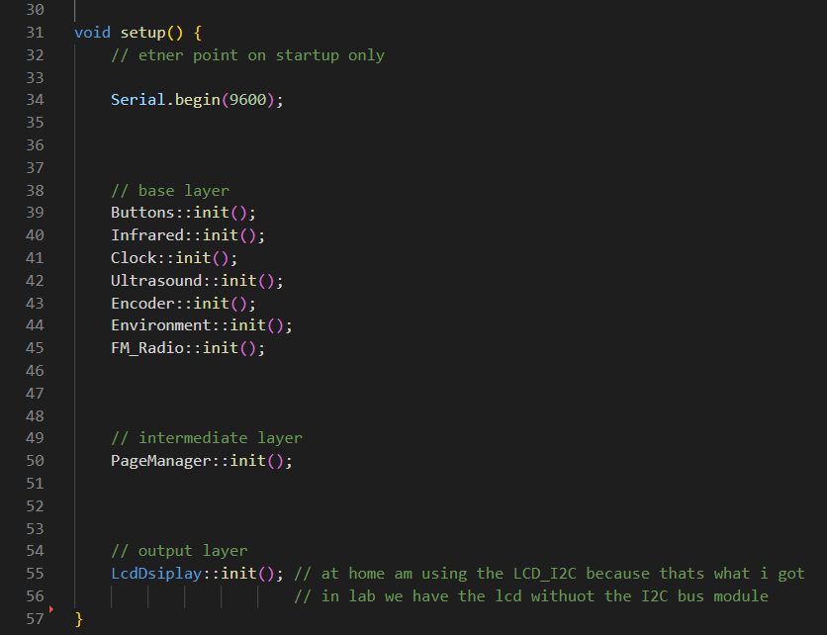

As you can see from the photo above we setup the base layer then the intermediate layer then the output layer.

We loop and update each base module intermediate layer and output layer in the same exact way as you can see in the photo below:
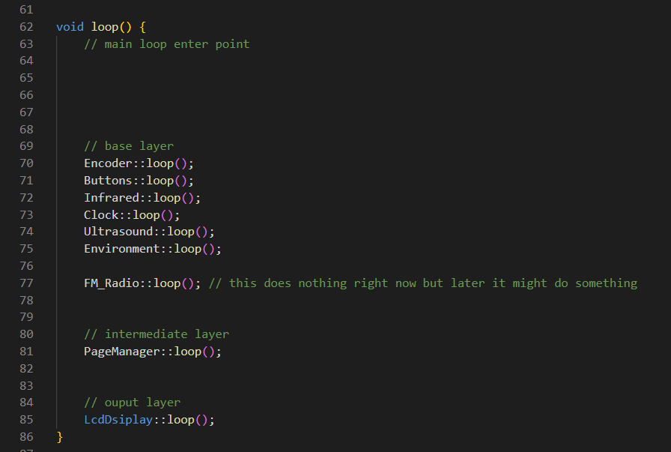
As you can see from the photo above, each layer is updated thoroughly each base component is responsible for checking if there is an event and passing it forward to the subscribed functions, then the page manager runs its own loop logic which is the intermediate layer which feeds of the events as well aside from the loop and finial comes the output layer which responsible for providing user feedback through the lcd.

This entry point is very powerful because disabling and enabling components or whole layers is as simple as commenting lines with “//” this helps us understand which components are colliding and help us debug each component separately.

This architecture also helps us when we try to expand such as making a game with the page system, or adding a completely new module, either way the road is the same that we took from before, make a new base component, make a new page link it up with the page manager and then you got a new feature in the project, as long as you follow the rules we sat for us from before everything should work without colliding with other component.

There is a big advantage for this architecture and it is memory efficiency, we only have a limited 2kb with Arduino nano, and since all the pages have the same logic, we are able to fit all the base layer components wither there separate page menu all in one, if we tried to write different logic from each menu page then we will simply run out way faster as memory in embedded systems is very limited.
The event driven system ensures that we check the buttons only once throughout the whole code which also saves us program memory for other things, this also means lower stack usage from repeated function logic which allows the project to behave predictably.
On top of that our output layer is stateless which is very important for ram, it doesn’t store logic it only mirrors the intermediate state, through a scheduled update as a result very low ram usage and no heavy buffer or temporary processing structure which as a result keeps the lcd functioning without flicking.

Event system example

We use the event system in the following way as shown in the image below:
