Name: WASEEM AKRAM Branch: BE-CSE-AIML
UID- 24BAI70006 Semester: 5
Subject: ADBMS Section- 24KRG-1 ‘A’

LAB-MST

Aim:

- Problem Statement
An online store maintains customers and their orders. Display customers whose total purchase amount is greater than the total purchase amount of every other customer from the same city.
Display Customer Name, City, and Total Purchase Amount. If two customers from the same city tie for the highest total, display both.

Constraint: Only a solution using JOINS and SUBQUERIES is allowed. CTEs and Window Functions are not allowed.

CODE:-
CREATE TABLE Customer (
customer_id INT PRIMARY KEY,
customer_name VARCHAR(50),
city VARCHAR(50)
);

CREATE TABLE Orders (
order_id INT PRIMARY KEY,
customer_id INT REFERENCES Customer(customer_id),
amount INT
);
INSERT INTO Customer (customer_id, customer_name, city)
VALUES
(1, 'Aman', 'Delhi'),
(2, 'Neha', 'Delhi'),
(3, 'Raj', 'Mumbai'),
(4, 'Priya', 'Mumbai'),
(5, 'Karan', 'Pune');

INSERT INTO Orders (order_id, customer_id, amount)
VALUES
(101, 1, 4000),
(102, 1, 3000),
(103, 2, 5000),
(104, 3, 6000),
(105, 3, 2000),
(106, 4, 8000),
(107, 5, 4500);

SELECT
c.customer_name AS "Customer Name",
c.city AS "City",
SUM(o.amount) AS "Total Purchase Amount"
FROM Customer c
JOIN Orders o
ON c.customer_id = o.customer_id
GROUP BY c.customer_id, c.customer_name, c.city
HAVING SUM(o.amount) >= ALL (SELECT SUM(o2.amount)
FROM Customer c2
JOIN Orders o2
ON c2.customer_id = o2.customer_id
WHERE c2.city = c.city
GROUP BY c2.customer_id
);

OUTPUT:-

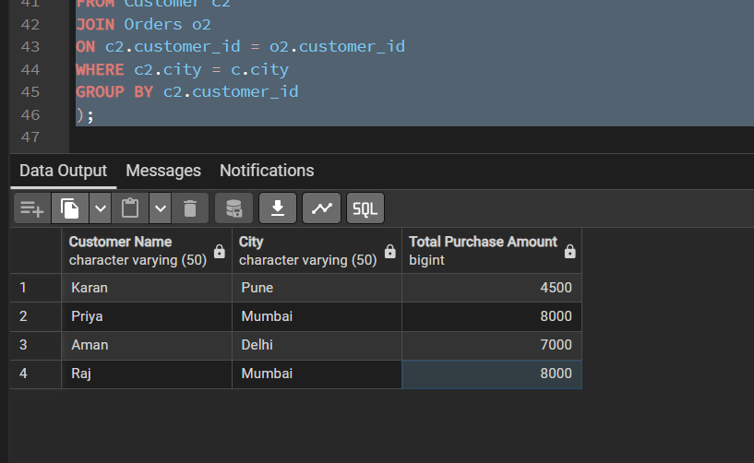

- Problem Statement

An inventory system stores products in product_inventory. Create a trigger that automatically records a log whenever a product is inserted or deleted. Store Product ID, Product Name, action (PRODUCT ADDED/PRODUCT REMOVED), and current timestamp in product_audit.

CODE:-

CREATE TABLE product_inventory (
product_id INT PRIMARY KEY,
product_name VARCHAR(50),
price INT
);
CREATE TABLE product_audit (
audit_id SERIAL PRIMARY KEY,
product_id INT,
product_name VARCHAR(50),
action_type VARCHAR(20),
action_time TIMESTAMP DEFAULT CURRENT_TIMESTAMP
);

CREATE OR REPLACE FUNCTION audit_log()
RETURNS TRIGGER AS $$
BEGIN
IF TG_OP = 'INSERT' THEN
INSERT INTO product_audit
(product_id, product_name, action_type)
VALUES
(NEW.product_id, NEW.product_name, 'PRODUCT ADDED');

ELSIF TG_OP = 'DELETE' THEN
INSERT INTO product_audit
(product_id, product_name, action_type)
VALUES
(OLD.product_id, OLD.product_name, 'PRODUCT REMOVED');
END IF;

RETURN NULL;
END;
$$ LANGUAGE plpgsql;

CREATE TRIGGER prodt_insert_delete_trigg
AFTER INSERT OR DELETE
ON product_inventory
FOR EACH ROW
EXECUTE FUNCTION audit_log();

INSERT INTO product_inventory
VALUES (101, 'Laptop', 50000);

INSERT INTO product_inventory
VALUES (102, 'Mobile', 20000);

DELETE FROM product_inventory
WHERE product_id = 101;

SELECT * FROM product_audit
ORDER BY audit_id;

OUTPUT:-
