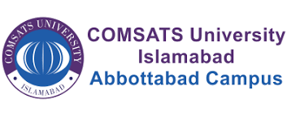

**SDA Lab Final**

**Name: Waseem Riaz**

**Registration # FA22-BSE-055**

**Date: 6th Jan 2025**

**Course: Software Design and Architecture**

**Smart Travelling System**

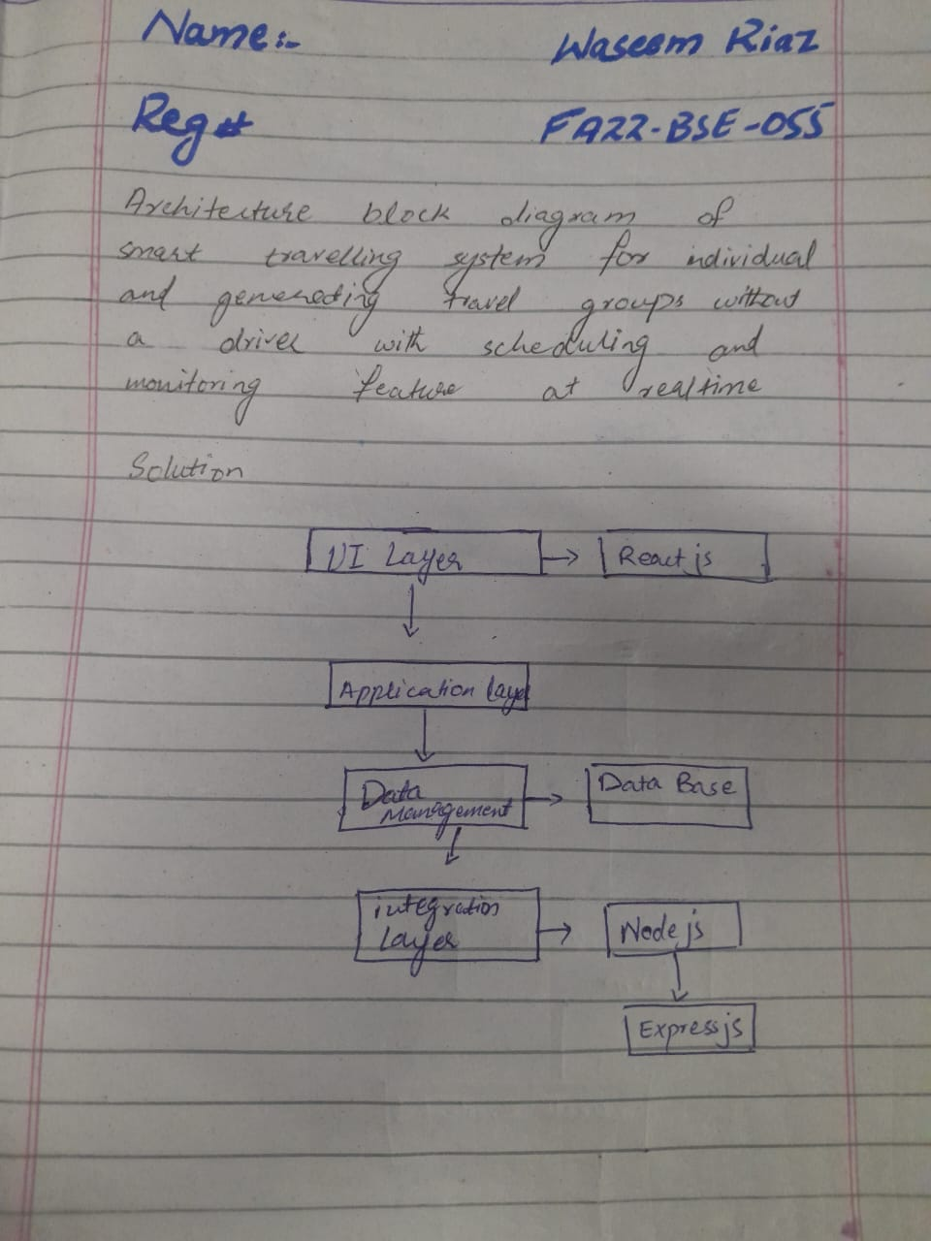

**THANK YOU**