**The Problem’s statement:**

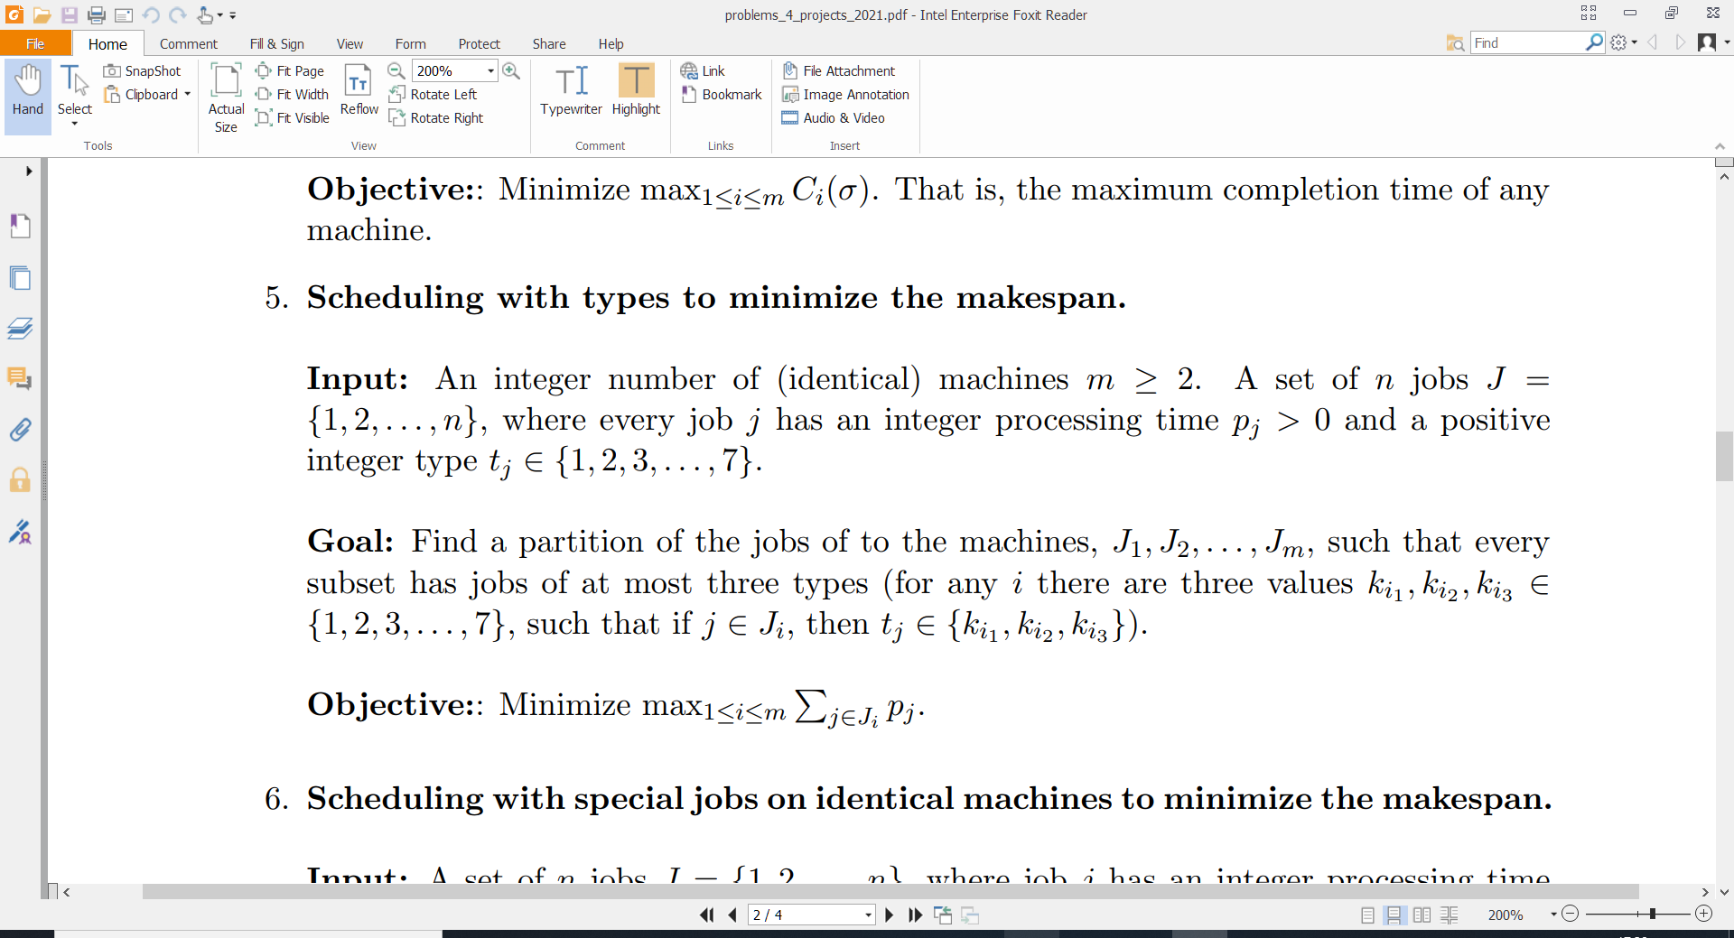

*5 types instead of 7.

**Input i:**

***m=2* *machines*.**

|  |  |  |  |  |  |  |  |  |  |
| --- | --- | --- | --- | --- | --- | --- | --- | --- | --- |
| $$j$$ | 1 | 2 | 3 | 4 | 5 | 6 | 7 | 8 | 9 |
| $$p_{j}$$ | 5 | 9 | 9 | 6 | 10 | 3 | 3 | 10 | 7 |
| $$t_{j}$$ | 1 | 3 | 1 | 1 | 2 | 1 | 2 | 4 | 4 |

*Note: sum on all processing times is 62, so 62/2=31 is a lower bound

**Bad Solution**:

m1 = **{1, 2, 6}**, time=5+9+3=**17**

m2 = **{3, 4, 5, 7, 8, 9}**, time =9+6+10+3+10+17 = **45**

$$Objective function=\max\left\{17, 45\right\}=45$$

**So-so solution:** (view all jobs belonging to the same type as one super-job, and arbitrarily place types 1,2 together, and 3,4,5 on the other machine)

m1 = **{2, 8, 9}**, time = 9+10+7 = **26**

m2 = **{1, 3, 4, 5, 6, 7}**, time = 5+9+6+10+3+3 = **36**

$$Objective function=\max\left\{26, 36\right\}=36$$

**Optimal solution:**

m1 = **{1, 9, 8, 2}**, time = 5+7+10+9 = **31**

m2 = **{3, 6, 4, 5, 7}**, time = 9+3+6+10+3 = **31**

$$Objective function=\max\left\{31, 31\right\}=31$$

**Invalid solution:**

m1 = **{1, 4, 8, 7, 2}\***, time = 5+6+10+3+9 = **33**

**\****(but this machine has* ***4*** *different types, therefore the solution is not valid!)*

m2 = **{3, 6, 9, 5}**, time = 9+3+7+10 = **29**

**Input ii:**

***m=3 machines***

|  |  |  |  |  |  |  |  |  |  |  |  |  |  |  |  |  |  |  |  |
| --- | --- | --- | --- | --- | --- | --- | --- | --- | --- | --- | --- | --- | --- | --- | --- | --- | --- | --- | --- |
| $$j$$ | 1 | 2 | 3 | 4 | 5 | 6 | 7 | 8 | 9 | 10 | 11 | 12 | 13 | 14 | 15 | 16 | 17 | 18 | 19 |
| $$p_{j}$$ | 4 | 5 | 10 | 13 | 3 | 7 | 8 | 9 | 13 | 8 | 16 | 8 | 7 | 2 | 4 | 5 | 8 | 11 | 9 |
| $$t_{j}$$ | 1 | 5 | 3 | 3 | 4 | 2 | 1 | 4 | 3 | 5 | 3 | 2 | 5 | 1 | 3 | 4 | 2 | 1 | 1 |

*Note: sum on all processing times is 150, so 150/3=50 is a lower bound

**Bad Solution**:

m1 = **{1,7,14,18,19,6,12,17,3,4,9,11,15}**, time = 4+8+2+11+9+7+8+8+10+13+13+16+4 = **113**

m2 = **{5,8,16}**, time = 3+9+5 = **17**

m3 = **{2,10,13}**, time = 5+8+7 = **20**

$$Objective function=\max\left\{113, 17, 20\right\}=45$$

**So-so solution:**

m1 = **{3,4,9,11,15}**, time = 10+13+13+16+4 = **56**

m2 = **{6,12,17,2,10,13}**, time = 7+8+8+5+8+7 = **43**

m3 = **{5,8,16,1,7,14,18,19}**, time = 3+9+5+4+8+2+11+9 = **51**

$$Objective function=\max\left\{56, 43, 51\right\}=56$$

**Optimal/near optimal solution:**

m1 = **{3,9,11,15,6}**, time = 10+13+16+4+7 = **50**

m2 = **{12,17,2,10,13,4}**, time = 8+8+5+8+7+13 = **49**

m3 = **{5,8,16,1,7,14,18,19}**, time = 3+9+5+4+8+2+11+9 = **51**

$$Objective function=\max\left\{50, 49, 51\right\}=51$$

**Invalid solution:**

m1 = **{3,9,11,15,6}**, time = 10+13+16+4+7 = **50**

m2 = **{12,17,2,13,4,19}\***, time = 8+8+5+7+13+9 = **50**

**\****(but this machine has* ***4*** *different types, therefore the solution is not valid!)*

m3 = **{5,8,16,1,7,14,18,10}**, time = 3+9+5+4+8+2+11+8 = **50**