**College Management System**

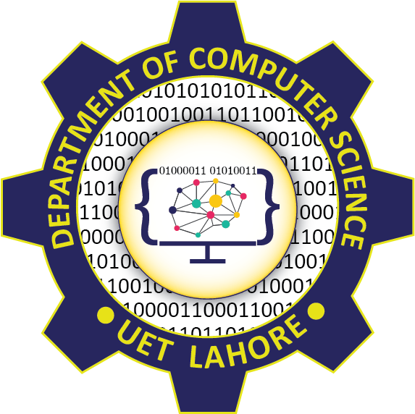

Session: 2021 – 2025

**Submitted by:**

Muhammad Waseem 2021-CS-61

**Supervised by:**

Dr. Awais Hassan

Department of Computer Science

**University of Engineering and Technology**

**Lahore Pakistan**