**Car Racing: With Frameworks**



Session: 2021 – 2025

**Submitted by:**

2021-CS-61 Muhammad Waseem

**Supervised by:**

Dr. Awais Hassan

Department of Computer Science

**University of Engineering and Technology**

**Lahore Pakistan**

**Features of Frameworks:**

This Game Framework provides three features:

1. Movement Framework. (Vertical, horizontal, Keyboard)
2. Collision Framework.
3. Firing Framework.

**Class Diagram:**

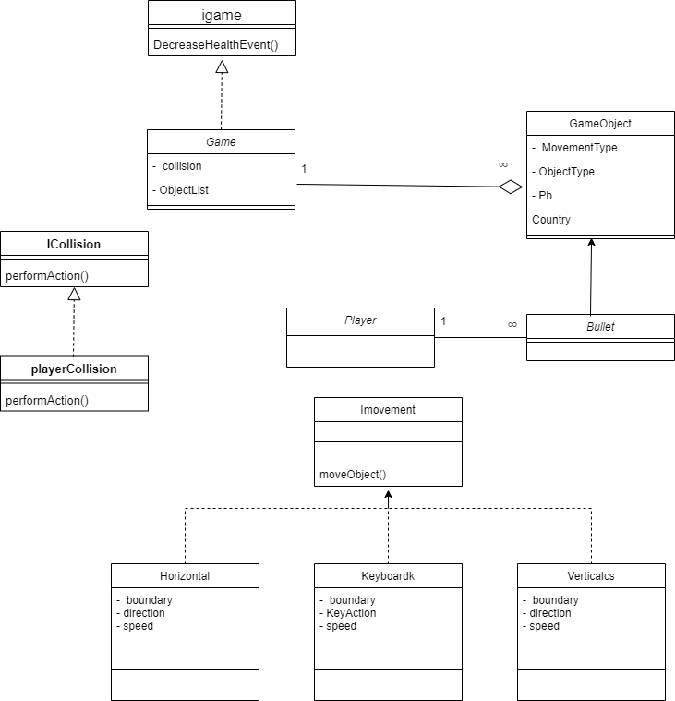

**How to Use Framework:**

**Movement:**

This framework has all the basic movements of vertical, horizontal and with keyboard.

For using movement follow these steps:

* Create an object of **Game** Class.
* There is a function of **addgameobject** in Game class.
* You have to call it and Pass the arguments in the following way:

g.addGameObject(image, top, left, new movementtype(boundary, speed, "up or down"), "ObjectType")

Movement Types are:

* Vectical
* Horizontal
* Keyboard
* Event of addgameobject is made you have to call a function created by yourself of AddintoControls().
* At last you have to call an update fuction present in the Game class in Timetick event.

**Collision:**

* You have to make as many **Collision** Object as you want.
* Pass the following arguments in Constructor:

Collosion c = new Collosion("ObjecttType", "ObjectType", new PlayerCollosion())

* There are Events made for increasehealth , decreases health, increase score you have to call your self made functions according to the event.