**Retail Store System**

**Description:**

The "Retail Store Management System" is a software application designed to manage the operations of a retail store. The system is accessible to two types of users: the Manager and the customers. Both users are required to sign up first and then log in to access the system.

The Manager has the ability to add products to the store, view the existing products, update the stock, and delete products if necessary. In addition, the Manager can also view information about the customers, such as their purchase history and contact details.

On the other hand, the customers can view the available products and make purchases. They can browse through the store's inventory and add the items they wish to purchase to their cart. Once they have selected all the items they want, they can proceed to checkout and pay for their purchases.

The Retail Store Management System aims to streamline the management of a retail store by providing an easy-to-use platform for both the Manager and the customers. With this system, the Manager can efficiently manage the inventory and monitor the sales while the customers can easily browse and purchase the items they need.

**Screenshots of User Interfaces:**

**Login Page:**

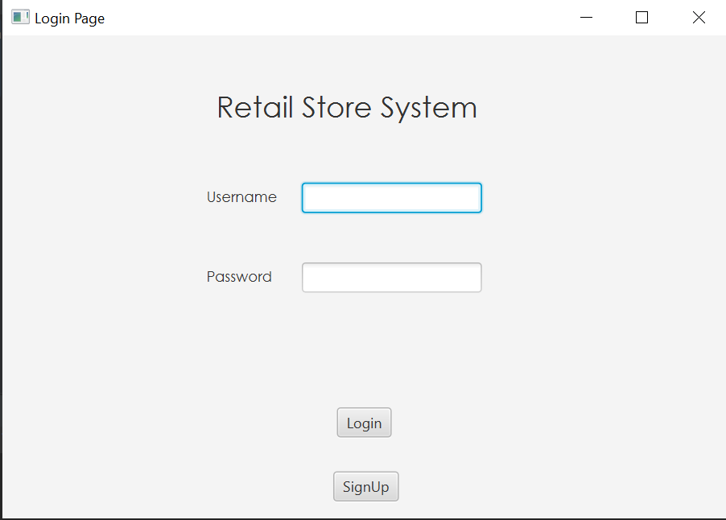

**Explanation:**

An Already Signed In user will enter his username and password to Login to the System.

**Sign Up Page:**

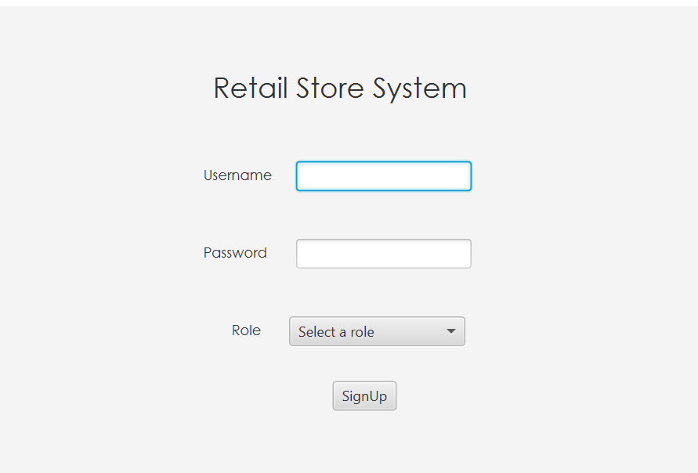

**Explanation:**

A new user to the system will First Sign Up to the system by entering his username and password and choosing his role. Then he will be able to login to the system.

**Manager Dashboard:**

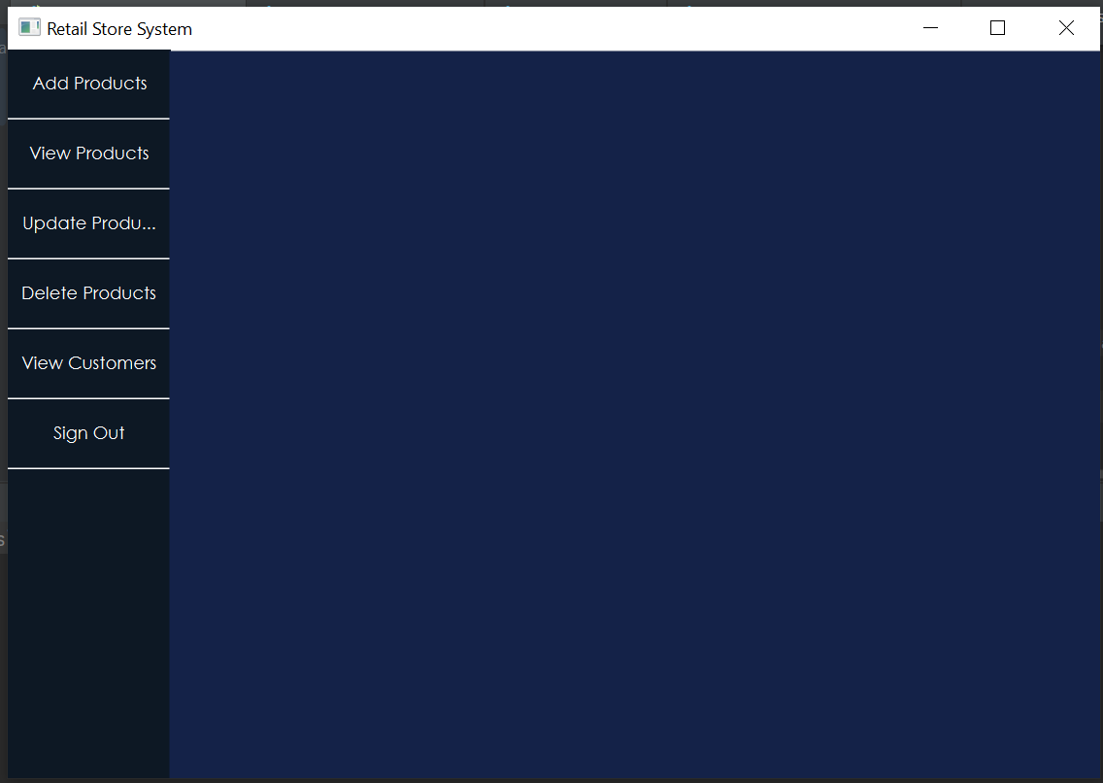

**Add Products(Manager):**

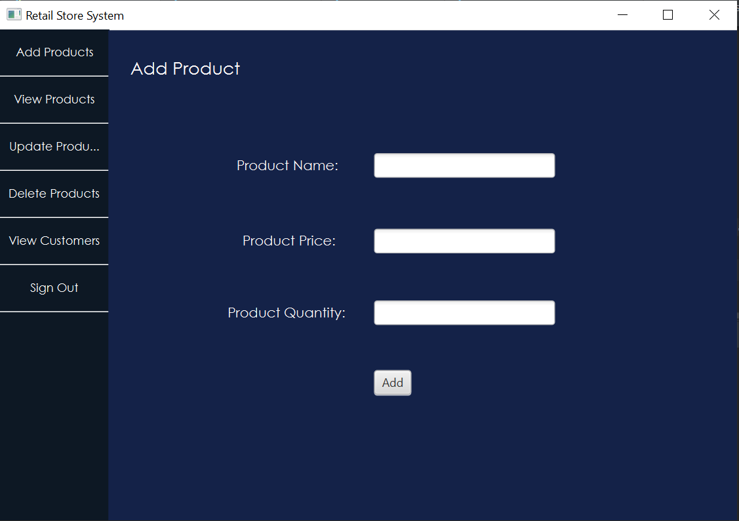

**View Products(Manager):**

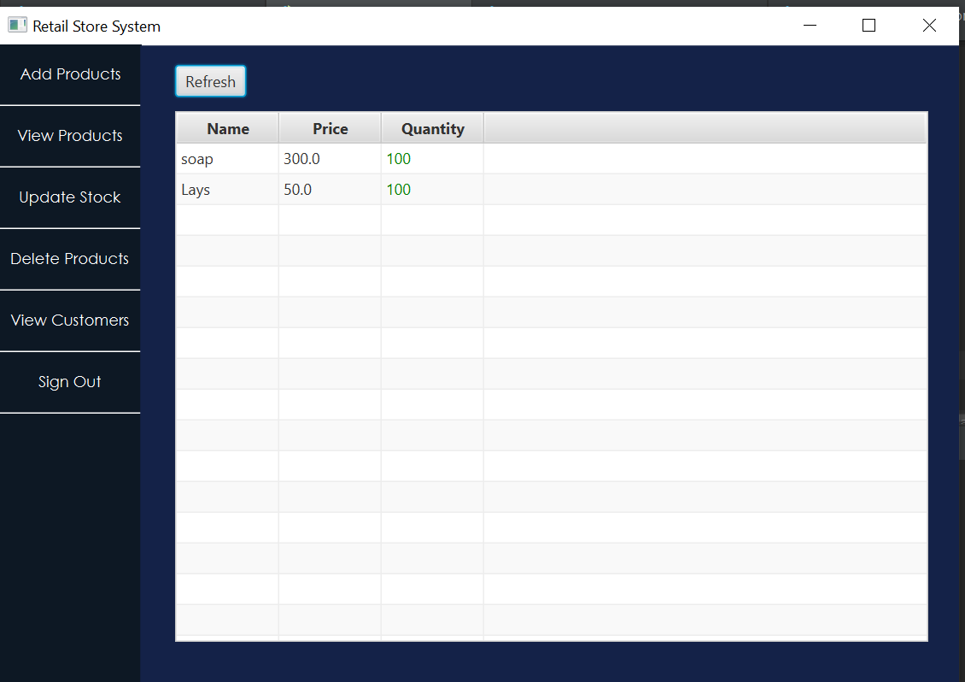

**Update Stock(Manager):**

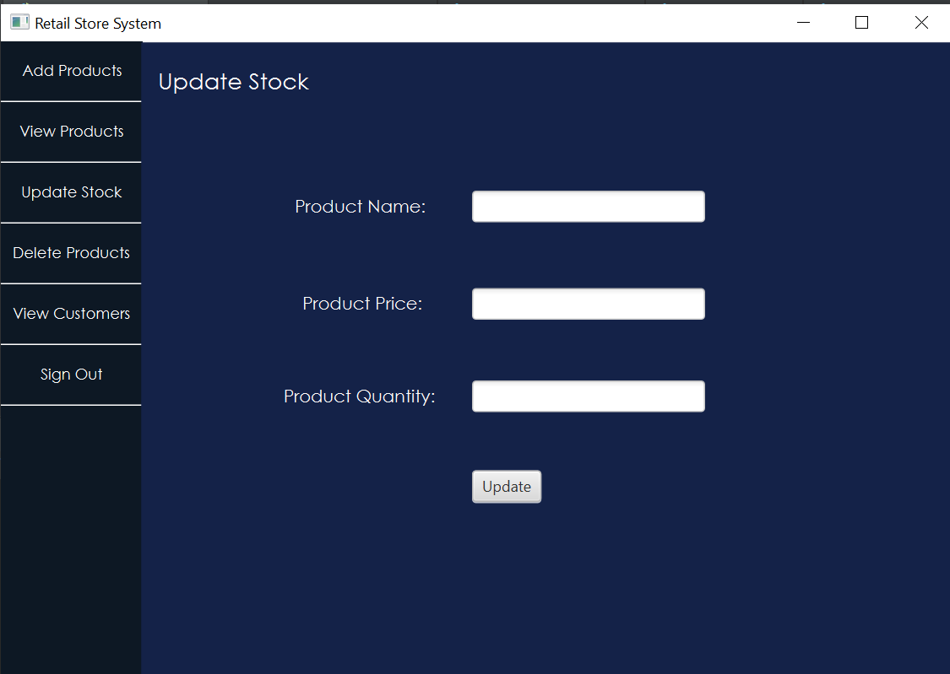

**Delete Product(Manager):**

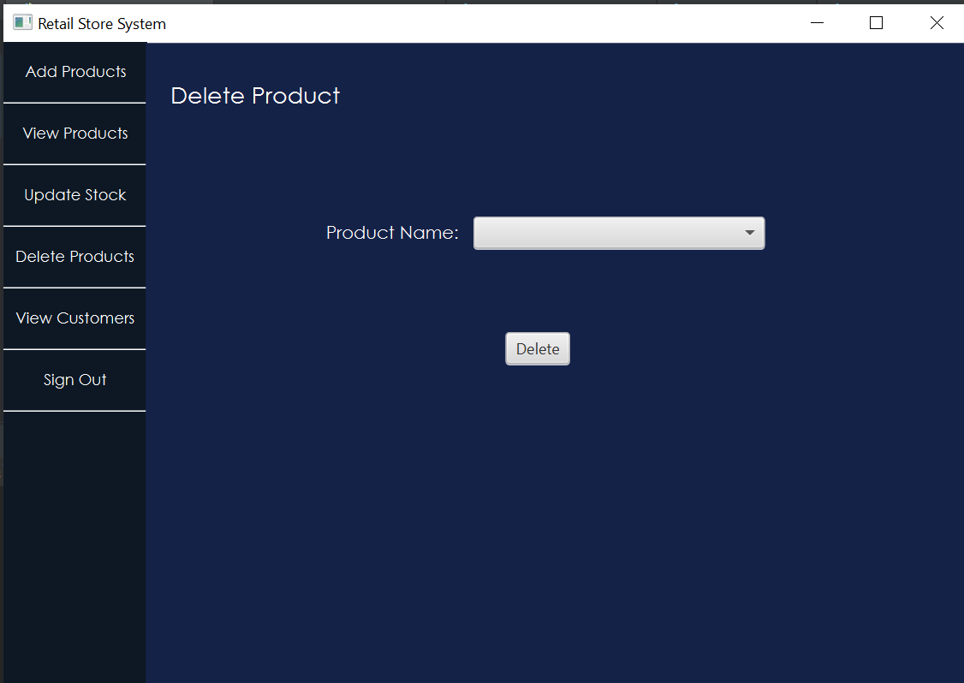

**Buy Product(Customer):**

