CHAPTER 1
INTRODUCTION

Computer Graphics is concerned with all aspects of producing pictures or images using a computer- A particular graphics software system called OpenGL, which has become a widely accepted standard for developing graphics applications .The applications of computer graphics in some of the major areas are as follows

l. Display of information.
2. Design.
3. Simulation and Animation.
4. User interfaces.

OpenGL is a software interface to graphics hardware. This interface consists of about 150 distinct commands that are used to specify the objects and operations needed to produce interactive applications.
This project named "PENDULUM" uses OpenGL software interface and develops an oscillating pendulum. Simple techniques like rotation, transformation, motion, lighting, etc have been used.

1.1 PROBLEM STATEMENT

Computer graphics is no longer a rarity. It is an integral part of all computer user
Interfaces and is indispensable for visualizing 2D, 3D and higher dimensional objects.

In the proposed system, the OpenGL is an graphic software system designed as a
streamlined, hardware-independent interface to be implemented on many different hardware platforms. To achieve these qualities, no commands for performing windowing tasks or obtaining user input are included in OpenGL; instead, you must work through whatever windowing system controls the particular hardware you're using.

OpenGL doesn't provide high-level commands for describing models of three dimensional objects. Such commands might allow you to specify relatively complicated shapes such as automobiles, parts of the body, airplanes, or molecules. With OpenGL, you must build up your desired model from a small set of geometric primitives - points, lines, and polygons.

Key board
Application Program
Graphics library (API)

Drivers

Mouse

Display

Fig1.1 Application programmers model of graphics system

The interface between an application program and a graphics system can be specified through a set of functions the resides in a graphics library .These specification are called the application programmer's interface (API).The application programmer see only the API and is thus shielded from the details of both the hardware and the software implementation of the graphics library. The software drivers are responsible for interpreting the output of the API and converting this data to a form that is understood by the particular hardware.
1.2 OBJECTIVES OF THE PROJECT

The objective of this project is to demonstrate the user how this program interacts with the system and renders the graphic design of rotating objects with a trail following them.

The other objectives of this project are:
- It makes use of interactive programming.
- It provides features of transformations such as translation, rotation, and scaling.
- It makes use of light source and uses concepts of orthogonal and perspective views.

1.3 SCOPE OF THE PROJECT

The application program developed can be used in various fields as follows:

- In the field of science to demonstrate the working of a pendulum.
- A number of real time chaotic pendulums can be designed based on this concept.
- Educational purpose as a teaching aid.

1.4 SUMMARY

This chapter deals with the first phase of development of the project by knowing the drawbacks of the existing computer graphics and proposing a new system .To determine the objectives and scope of the project.

CHAPTER 2
SYSTEM REQUIREMENTS

A software requirement definition is an abstract description of the services which the system should provide, and the constraints under which the system must operate. It should only specify the external behavior of the system. The requirements are specified as below:

2.1HARDWARE REQUIREMENTS
- Operating system: Windows 7 or later
- Processor: Intel Pentium 4 or later
- Memory: 2GB Minimum ,4GB Recommended
- Screen Resolution:1280*1024 or larger
- Application Window Size:1024*680 or larger
- Internet Connection: Not Required

2.2 SOFTWARE REQUIREMENTS:

- Client: Operating System
- Web Server: Apache Tomcat
- Database Server: MYSQL Server
- Language: HTML,JAVA ,CSS

CHAPTER 3
PROBLEM DESCRIPTION
LEAVE MANAGEMENT SYSTEM

ABC COLLEGE OF ENGINEERING has Teaching and Non-Teaching staff categories. Professors, Associate professors and Assistant professors come under Teaching and Lab-Instuctors under Non-Teaching. Teaching faculty has 15 CL’s and Non-teaching has 12 CL’s in a year. The college uses a LEAVE MANAGEMENT SYSTEM to track the different types of leave details for each faculty. The system uses the following tables for maintaining this details.

- FACULTY
- FACULTYLEAVEDETAILS
- APPLIEDLEAVEDETAILS

The table details are as follows
Table 3.1 FACULTY

COLUMN NAME | DTATYPE & SIZE | CONSTRAINTS | DESCRIPTION
FID | VARCHAR(6) | PRIMARY KEY | The facultyID column accepts alphanumerics of length 6 charcter
FNAME | VARCHAR(30) |  | Full name of the faculty
DEPT | CHAR(2) | NOT NULL | Department is of charecter of length 2
DESG | CHAR(7) |  | Use PROF for Professor and ASSTP for Associate Professor AP for Assistant Profesor. LABINST for LabInstrectors
DOJ | DATE | NOT NULL | Date of Joining of faculty
SALARY | FLOAT(6,2) |  | Salary of faculties
CATEG | CHAR(2) | NOT NULL | Use ‘T’ for Teaching and ‘NT’ for Non-Teaching

Table 3.2- FACULTYLEAVEDETAILS

COLUMN NAME | DTATYPE & SIZE | CONSTRAINTS | DESCRIPTION
FID | VARCHAR(6) | PRIMARY KEY AND REFERENCES FID FROM FACULTY | The facultyID column accepts alphanumerics of length 6 charcter and should be there in FACULTY table
CL | FLOAT(2,1) |  | CASUAL LEAVE
OOD | FLOAT(2,1) |  | OFFICIAL ON DUTY
SL | FLOAT(2,1) |  | SICK LEAVE
VL | FLOAT(2,1) |  | VACATION LEAVE
EL | FLOAT(2,1) |  | EARNED LEAVE
LOP | FLOAT(2,1) |  | LOSS OF PAY

Table 3.3 –APPLIED LEAVE DETAILS

COLUMN NAME | DTATYPE & SIZE | CONSTRAINTS | DESCRIPTION
AID | INT | PRIMARY KEY | Application ID
FID | VARCHAR(6) | REFERENCES FID FROM FACULTY | FID from FACULTY table
TYPEOFLEAVE | VARCHAR(4) |  | CL,OOD,VL,EL,SL,LOP
DATEFROM | DATE |  | Leave start date
DATETO | DATE |  | Leave end date
NOOFDAYS | FLOAT(2,1) |  | Number of days
STATUSS | CHAR(10) |  | ‘PENDING’ or ‘APPROVED’
CLASSALTERED | CHAR(2) |  | For Teaching ‘Y’ or ‘N’ and Non-Teaching ‘NA’

CHAPTER 4
SYSTEM DESIGN

4.1 ER Diagram
Definition

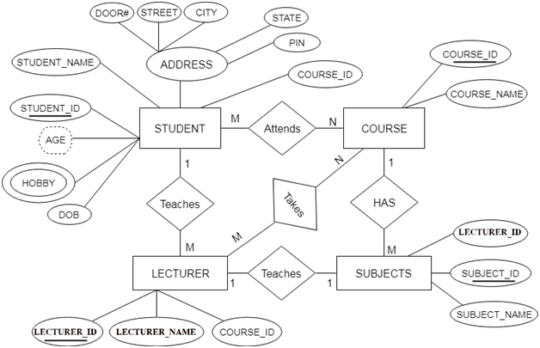

Figure 4.1- ER Diagram for Leave Management System

4.2 Schema Diagram:
Definition

Figure 4.2-Schema diagram for Leave Management system

4.3 Normal Form
4.3.1 First Normal Form(1NF)
Definition

4.3.2 Second Normal Form(2NF)
Definition

4.3.3 Third Normal Form(3NF)
Definition

All the tables in Leave Mangement system satisfy all the three normal forms.

CHAPTER 5
IMPLEMENTATION
5.1 Introduction to software used
Description

5.1.1 Net Beans
Description

5.1.2 MySQL
Description

5.2 Source Code
index.html

5.3 SQL Stored Procedure

5.4 SQL Trigger

CHAPTER 6
SCREEN SHOTS

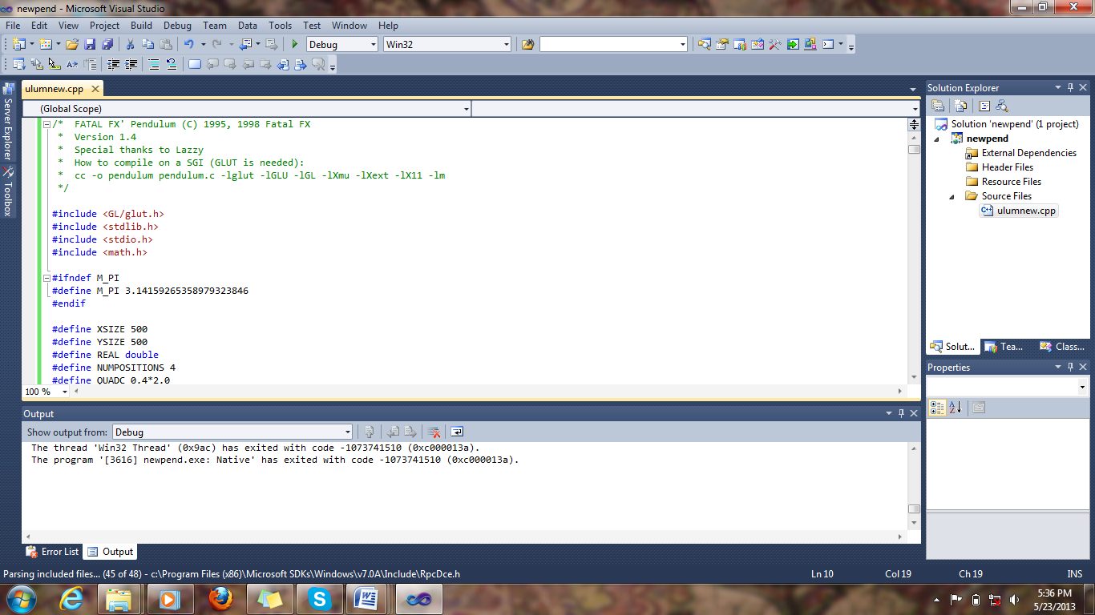
Figure 7.1 LOGIN PAGE
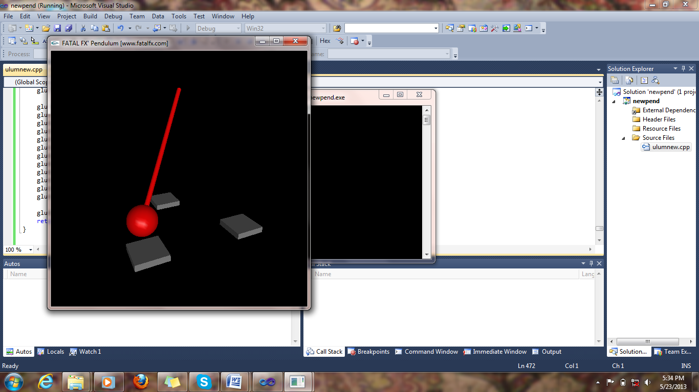
Figure 7.2 USER DETAILS

CHAPTER 7
CONCLUSION & FUTURE SCOPE

In this project, the design and implementation of 3-dimensional graphics Interfacing program has been attempted. We have seen the functions performed by this application and code for the same. In OpenGL, C/C++ provide enormous flexibility in the design and the use of C/C++ graphics programs.
The presence of many in-built OpenGL functions and libraries to take care of many of the functionalities reduces the burden of coding and makes the implementation simpler.
The project started with the designing phase in which we figured the requirements needed the system design, Data flow diagram etc. Then comes the details of the implementation phase where in we have included various functionalities. And now after the testing phase, the project comes to an end.

.

REFERENCES

[1] References for CSS and HTML –https://www.w3schools.com

Note: Add more than 5 references from professional website

