A Web-Based Tracer and Employment Analytics System for the Alumni Relations and Linkages Office
Draft Chapters 1, 2, and 3
Prepared from the current CMU ARLO project documentation and system design artifacts

Institution: Central Mindanao University
System Short Name: CMU ARLO
Coverage: Chapter 1, Chapter 2, and Chapter 3
Included Diagrams: ERD, IPO, and Data Flow Diagram Level 0

CHAPTER 1

THE PROBLEM AND ITS BACKGROUND

Introduction
Alumni information is one of the most valuable institutional resources for higher education institutions because it provides evidence of graduate employability, supports curriculum improvement, and strengthens long-term engagement between the university and its former students. In many offices, however, alumni tracing is still performed through disconnected spreadsheets, social media follow-ups, paper forms, and manual consolidation of records. These approaches make reporting slow, inconsistent, and difficult to sustain over time.
The A Web-Based Tracer and Employment Analytics System for the Alumni Relations and Linkages Office is proposed to address these concerns by providing a centralized, web-based platform where alumni can register, maintain their profiles, submit tracer information, explore job opportunities, and send feedback, while administrators can manage records, publish announcements, review submissions, and generate analytics. Through this structure, the system supports the operational needs of the Alumni Relations and Linkages Office while also improving data accuracy, accessibility, and timeliness.

Background of the Study
Graduate tracer systems are designed to monitor the educational and employment outcomes of alumni after they leave the university. They help institutions determine how well academic programs prepare graduates for employment, what industries absorb graduates, and what improvements may be needed in curriculum, services, and extension programs. For the Alumni Relations and Linkages Office, the absence of a centralized digital system can create repeated data entry, scattered records, limited reporting capability, and delays in responding to alumni concerns.
The current CMU ARLO project already demonstrates the feasibility of such a platform. Based on the project documentation and codebase, the system includes authentication, alumni profile management, tracer data handling, job board workflows, feedback channels, announcements, notifications, analytics, and audit logging. These modules reflect the core functions needed by the office to manage alumni records and produce timely employment insights.

Statement of the Problem
This study is guided by the general problem of how to design and implement a web-based tracer and employment analytics system that will improve the efficiency, accuracy, and usefulness of alumni records management for the Alumni Relations and Linkages Office.
Specifically, it seeks to answer the following questions:
- How can alumni registration, profile maintenance, and tracer data submission be centralized in a single web-based platform?
- How can the system support job posting, job application, feedback submission, and alumni engagement activities?
- How can administrators efficiently manage announcements, submissions, records, and reports using role-based access controls?
- How can the system generate useful employment and tracer analytics that can support planning and decision-making?
- How can the proposed database and process design maintain data consistency, privacy, and traceability?

Objectives of the Study
The general objective of the study is to develop a web-based tracer and employment analytics system for the Alumni Relations and Linkages Office.
Specifically, the study aims to:
- Provide a secure account registration and authentication mechanism for alumni and administrators.
- Allow alumni to maintain personal and employment records through a structured tracer workflow.
- Provide modules for jobs, announcements, feedback, and notifications to strengthen alumni engagement.
- Enable administrators to manage alumni records, submissions, announcements, and reports from a central dashboard.
- Produce analytical outputs that summarize tracer and employment information for institutional use.
- Design a database structure and process flow that support consistent and auditable information management.

Significance of the Study
The study is significant to several stakeholders. For the Alumni Relations and Linkages Office, it offers a more organized and efficient way of collecting, maintaining, and analyzing alumni information. For university administrators, it can support data-driven planning, policy formulation, and reporting. For alumni, it provides a convenient channel for registration, profile updating, job exploration, and communication with the university. For future researchers and developers, the study can serve as a reference for improving alumni information systems, tracer systems, and employment analytics platforms.

Scope and Delimitation
The scope of the study covers the design and documentation of the CMU ARLO platform for the Alumni Relations and Linkages Office. The system includes two major user roles, namely administrator and alumni. Its main functional coverage includes registration, authentication, profile and settings management, tracer record submission, job browsing and application, job opportunity submission, announcements, notifications, feedback handling, analytics, and audit logging.
The study is limited to a web-based implementation and the data structures observed in the current repository. It does not include external enterprise integrations such as payroll systems, third-party human resource platforms, or fully automated labor market data feeds. The content of the chapter draft is also based on the present project documents and system modules rather than externally cited literature.

Definition of Terms
- Alumni Tracer System: A system used to collect and analyze information about graduates, particularly their employment status, professional outcomes, and educational experiences after graduation.
- Employment Analytics: The process of summarizing and interpreting employment-related data to support planning, evaluation, and decision-making.
- Administrator: A user role responsible for managing records, announcements, job postings, reports, and system oversight functions.
- Alumni: A graduate or former student who accesses the system to register, manage profile information, submit tracer data, and participate in alumni services.
- Notification: A system-generated message used to inform users about updates such as announcements, approvals, or reminders.
- Audit Log: A record of important system activities used for monitoring, accountability, and traceability.

CHAPTER 2

REVIEW OF RELATED CONCEPTS AND SYSTEM FRAMEWORK

Overview of Related Concepts
A web-based alumni tracer platform combines several important information system concepts. These include centralized data management, user authentication, role-based access control, record processing, reporting, and feedback management. In the context of higher education, a tracer system becomes more valuable when it does not only store alumni records but also transforms them into usable information for planning and evaluation.
The CMU ARLO project reflects this direction by combining alumni engagement functions with analytical and administrative tools. Instead of treating alumni tracing as an isolated survey activity, the system positions it as part of a broader digital environment that includes announcements, job opportunities, notifications, and office monitoring functions.

Alumni Tracer Systems
Alumni tracer systems are designed to monitor graduates over time. Their essential role is to gather data on graduate employment, continuing education, relevance of curriculum, and professional experiences. Such systems are important because they help identify whether a university program remains aligned with labor market demands. In practice, a good tracer system must make it easy for alumni to respond and equally easy for administrators to organize and interpret the results.

Employment Analytics
Employment analytics refers to the collection, organization, and interpretation of employment-related data for reporting and decision-making. Within an alumni office, this may include employment status, occupation, industry, salary range, job relevance to degree programs, and the time it takes graduates to obtain their first job. By transforming raw tracer submissions into summarized reports, the institution gains evidence that can be used in accreditation, program review, and strategic planning.

Web-Based Information Systems
Web-based information systems provide accessibility, centralized storage, and easier maintenance compared with fragmented manual processes. Because users can access them through standard browsers, they reduce the need for device-specific installations and allow both alumni and administrators to interact with shared records in real time. In the present project, the web-based approach supports multiple modules from a single interface, including authentication, tracer submission, job management, and analytics.

Role-Based Access and Data Privacy
Role-based access control is essential in systems where different user groups have different responsibilities. Alumni need access to their own data, announcements, and employment-related functions, while administrators need access to management, reporting, and audit functions. Data privacy is also a crucial consideration because the system stores personally identifiable information and employment-related records. The current project includes consent-aware registration and settings controls, which support privacy-conscious system use.

Conceptual Framework
The conceptual framework of the proposed study can be presented using the Input-Process-Output (IPO) model. The IPO model explains how user-provided data and administrative inputs are transformed by the system into structured records, services, and analytical outputs. This framework is appropriate because the project revolves around data collection, processing, storage, and reporting.

Input-Process-Output (IPO) Framework
Input | Process | Output
Alumni profile data, registration details, tracer responses, employment information, job applications, feedback entries, and administrative inputs such as announcements and job posting data. | The system validates accounts, stores alumni records, processes tracer submissions, manages job applications, publishes announcements, routes notifications, and generates analytical summaries and audit records. | Updated alumni records, portal views, application status results, published announcements, personalized notifications, management dashboards, analytical reports, and audit trails.
Login credentials, password reset requests, record maintenance requests, report filters, and settings changes from both alumni and administrators. | Authentication, authorization, role-based access control, data retrieval, CRUD operations, aggregation of records, and presentation of summarized information for decision-making. | Secure account access, verified registration results, profile updates, filtered reports, exportable analytics, and decision-support information for the Alumni Relations and Linkages Office.
The input portion of the framework consists of all information submitted to the system by alumni and administrators. These inputs include registration details, tracer responses, employment information, feedback, job submissions, and administrative maintenance activities. The process portion represents the major internal system functions such as account verification, authentication, CRUD operations, data validation, analytics generation, and notification routing. The output portion includes the visible results of processing, such as updated records, dashboards, job application statuses, announcements, and reports. In this way, the IPO framework demonstrates how the proposed system converts raw alumni and administrative inputs into meaningful and usable outputs for decision-making.

Chapter Summary
Chapter 2 discussed the concepts that support the development of the proposed web-based tracer and employment analytics system. It highlighted the role of tracer systems, employment analytics, web-based platforms, role-based access control, and data privacy. It also presented the Input-Process-Output framework as the conceptual guide for understanding how the system transforms data into services and reports.

CHAPTER 3

METHODOLOGY AND SYSTEM DESIGN

Research and Development Approach
For this project, an iterative and incremental development approach is appropriate. The proposed system is composed of multiple but related modules, such as registration, tracer management, jobs, announcements, feedback, analytics, and audit logging. An iterative approach allows each module to be designed, reviewed, refined, and integrated gradually while maintaining overall system consistency.

System Architecture Overview
Based on the current project repository, the system uses Laravel as the main application framework, Blade templates for the user interface, PostgreSQL for live application data, SQLite in memory for automated testing, Vite for asset handling, and supporting libraries such as Chart.js and Boxicons. This architecture supports both transactional operations and presentation-oriented modules needed for an alumni portal and administrative dashboard.

Major Functional Modules
- Authentication and account management
- Alumni profile and settings management
- Tracer and employment data collection
- Jobs, applications, and job submission workflows
- Announcements and notifications
- Feedback monitoring and response
- Analytics, reports, and audit logging

Data Flow Diagram Level 0
The Data Flow Diagram (DFD) Level 0, or context diagram, presents the proposed system as a single major process and shows how it interacts with its two main external entities: the alumni and the administrator.
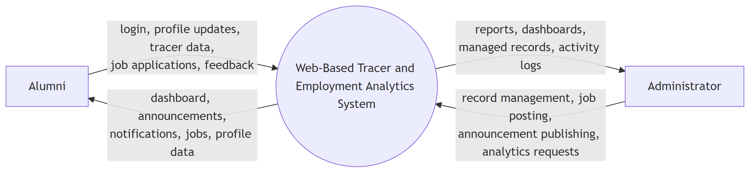
Figure 1. Data Flow Diagram Level 0 of the Proposed Web-Based Tracer and Employment Analytics System
In the diagram, alumni provide inputs such as login credentials, profile updates, tracer submissions, job applications, and feedback. In return, they receive outputs such as portal content, announcements, notifications, jobs, and their personal record information. On the other hand, the administrator provides management inputs such as record maintenance, job posting, announcement publishing, and analytics requests. The system then returns dashboards, managed records, reports, and activity logs. The Level 0 DFD therefore shows the overall communication boundary of the system without yet breaking down its internal processes.

Entity Relationship Diagram
The Entity Relationship Diagram (ERD) illustrates the structure of the database and the relationships among the main entities used by the system.
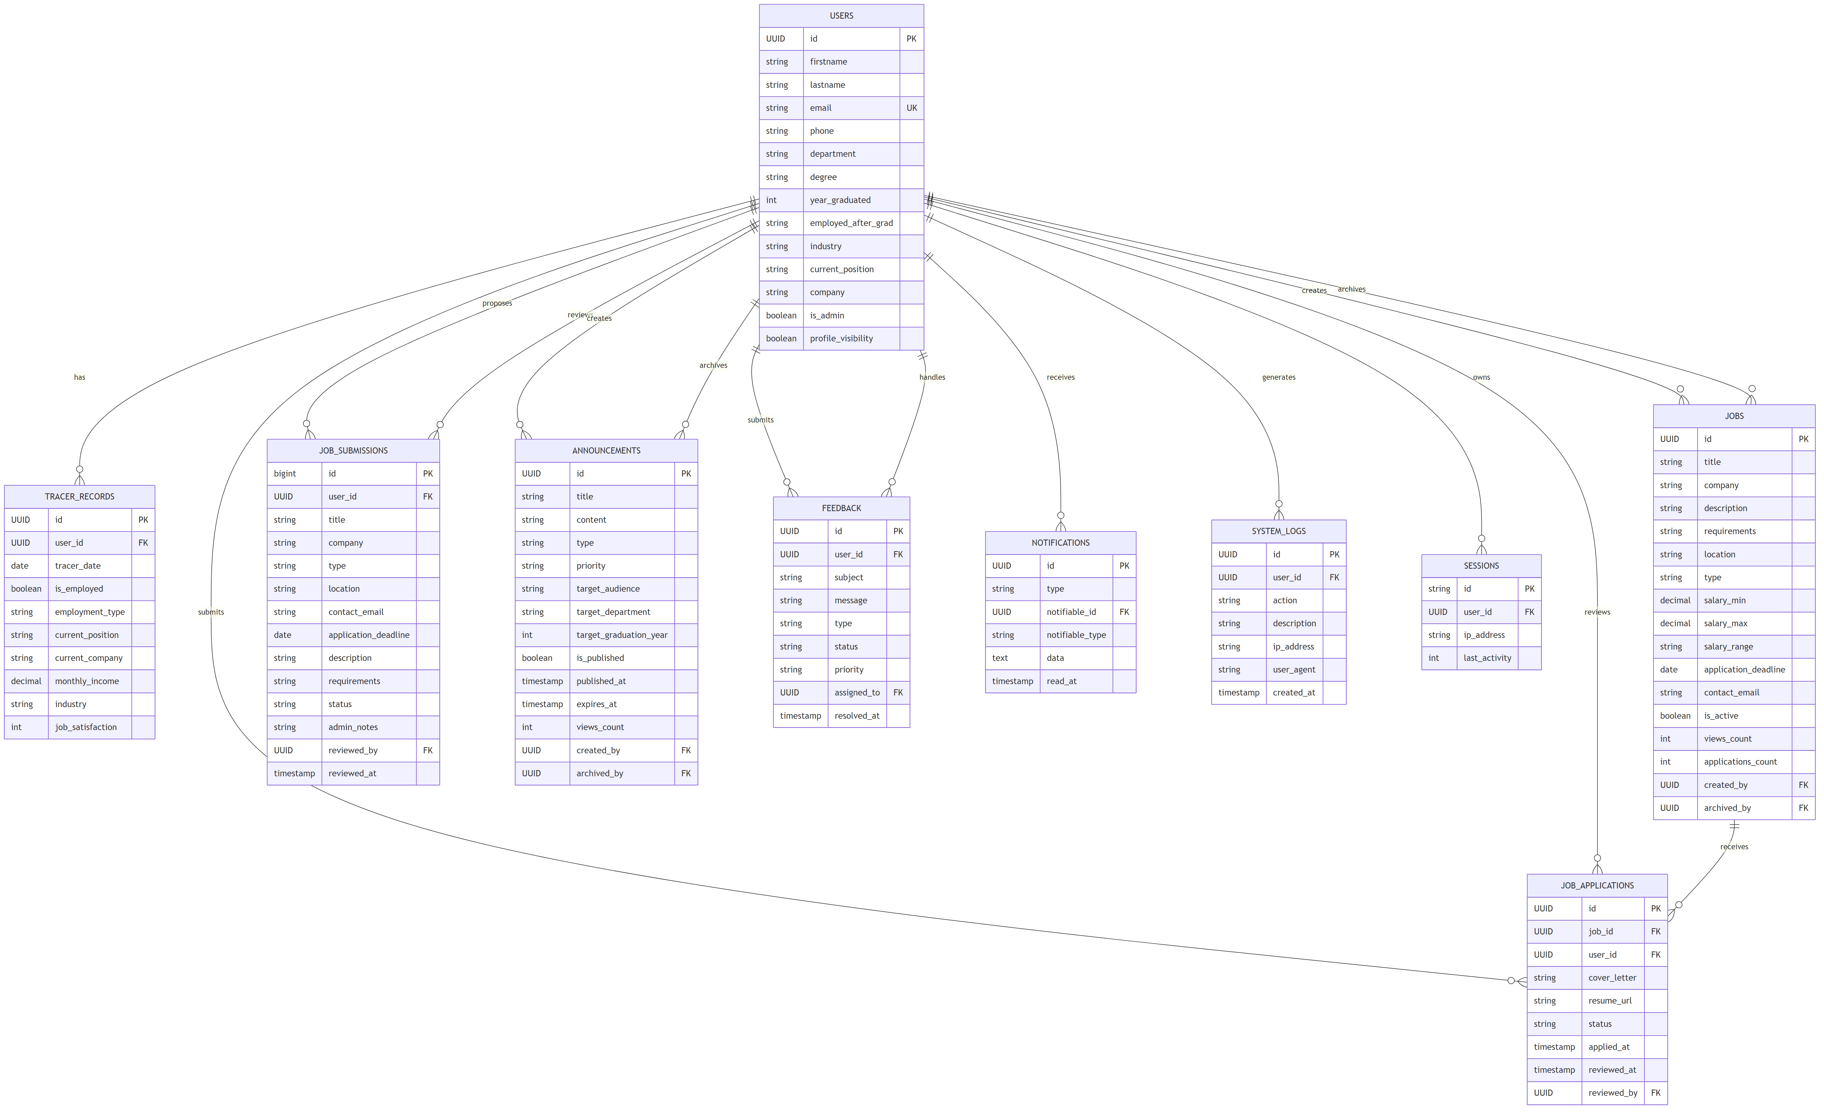
Figure 2. Entity Relationship Diagram of the Proposed Web-Based Tracer and Employment Analytics System
The ERD shows that the Users entity is central to the database because it connects to tracer records, job applications, job submissions, announcements, feedback, notifications, system logs, and sessions. Tracer records store the employment and graduate outcome details linked to a specific alumnus. Jobs and job applications support recruitment and alumni engagement features, while announcements and notifications support information dissemination. Feedback, sessions, and system logs provide monitoring and administrative support functions. This structure helps ensure that the system can store both operational records and analytical data in a consistent manner.

Database Design Explanation
The database design follows a relational structure in which each major module of the system is represented by a table or entity. The user table stores core alumni and administrator information. Tracer records are linked to users to allow one alumnus to have one or more tracer entries over time. Job applications link alumni to job records, while announcements and feedback create separate but related channels for communication and office services. This design supports data integrity, minimizes duplication, and makes it easier to generate filtered summaries for analytics and reporting.

Processing and Validation Strategy
The proposed system uses validation and controlled workflows to improve record quality. Registration includes verification logic, account credentials are processed securely, and role-based functions limit the operations available to each user type. Tracer submissions, feedback entries, and job-related transactions are processed through forms and status-based operations. These strategies help ensure that the information saved in the system remains reliable and usable for future reporting.

Testing and Quality Considerations
The repository includes feature tests for authentication, admin CRUD flows, audit logs, feedback, alumni job applications, announcement visibility, and account deletion cascade behavior. This indicates that the project values verification of critical workflows. In a thesis context, these tests support the claim that the system design is not only documented but also checked for correctness across important user actions.

Chapter Summary
Chapter 3 presented the methodology and system design for the proposed platform. It described the development approach, outlined the major modules, explained the Level 0 DFD and ERD, and discussed the database, processing, and testing considerations of the system. Together, these elements provide a technical foundation for the implementation of the web-based tracer and employment analytics system.

