Project: Flow

By: Wasif Mahmood Tahir 19100192

Summary:

Flow is a popular mobile game. There are multiple colored ‘flows’, two of each color. The objective of the game is to connect each flow with its similar colored flow by drawing a continuous path of that same color while filling the whole grid leaving no space empty.

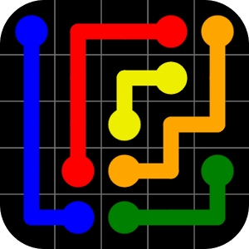

Usage:

The objective of the game is to connect all similar colored Flow pairs with each other i.e one blue with the other blue using a blue path. There shouldn’t be any empty space left for completion of a level. Caps lock should be turned off for the game to function properly as it uses ascii codes. To start the game you have to click anywhere within the game axis one time first.

Options:

The player choses what color the path he/she is to make. Any path of any color can be started and ended anywhere in the game. Upon pressing the initial of the color name on the keyboard and the path will start at the place where the mouse cursor is and spacebar for ending the path.

Features:

In the game the player has control over where and what color the path should start and where it should end. Press (on the keyboard):

(Case sensitive)

‘r’ for red path

‘y’ for yellow path

‘b’ for blue path

‘g’ for green path

‘c’ for cyan path

‘m’ for magenta

‘l’ for light blue

‘Spacebar’ for ending the path

Theory:

For winning the game, the player must connect all the respective Flows while leaving not a single space empty in the grid. All three levels are of 8x8 size with differently placed flows. All levels have at least one possible solution.

Programming

There is a main UI that gives the player an option for choosing between the three levels and there is an option of viewing the instruction manual too.There are 4 separate functions for all 4 options;3 for the levels and one for the instructions. The instruction function contains only a msgbox function with the instructions written in a string.

The functions for the three levels make the axis, the background grid and the colored flows. Then they take an empty ginput to initialize the game code. Upon pressing any of the above-mentioned color initials, the drawmode property of the axis is activated with the color of the path depending upon the key pressed. Pressing the spacebar makes the color disappear or in other words, ending the path. Pressing the keys can be done an infinite number of times and it will always correctly display the color demanded. There are separate function files for each color, which are called by the function responsible for the KeyPressFnc.

Unusual features

Unlike in the real mobile game, this game does not break the previous path if another path in built on it, instead it overlaps it thus making you unable to win.

Structure

The main UI function contains functions which within contain functions each which themselves contain the color functions, working like 4 nested loops.

