ERTIFICATE



C

*of completíon*

P R O U D L Y P R E S E N T E D T O

*{{NAME}}*

has successfully completed the {{POSITION}}Internship of {{DURATION}},

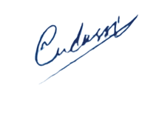conducted by

**DevRolin**

Mudassir Hussain

**CEO Dev Rolin**