

**REF NO: {{REF}}**

**DATE: {{DATE}}**

**To Whom It May Concern**

This is to certify that **{{NAME}}** has successfully completed a **{{DURATION}}** internship in the **Graphic Designing** Department of **DevRolin**, from **{{STARTDATE}}** to **{{ENDDATE}}**.

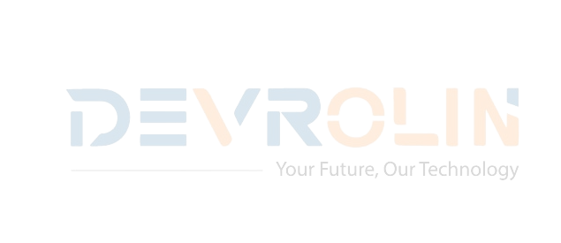 During this period, {{NAME}} actively contributed to our creative design projects, demonstrating strong visual sense, technical proficiency, and a genuine passion for graphic design. Key contributions include:

* **Branding & Identity Design:** Assisted in creating and refining brand assets, including logos, typography, and color palettes, ensuring consistency across client deliverables.
* **Social Media Creatives:** Designed engaging posts, banners, and promotional graphics that increased audience interaction and brand visibility.
* **Print & Marketing Materials:** Contributed to the design of brochures, posters, and presentation decks, aligning visuals with brand guidelines and campaign goals.
* **Collaboration & Communication:** Worked closely with the design and marketing teams, participated in brainstorming sessions, and presented weekly progress updates with clarity and professionalism.

Throughout the internship, {{NAME}} exhibited diligence, adaptability, and an eagerness to learn.

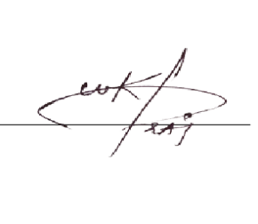We appreciate {{NAME}} dedication during their tenure with DevRolin and wish them every success in their future academic and professional endeavors.

Sincerely,

**Muhammad Bilal**

**Director, Devrolin**