

**REF NO: {{REF}}**

**DATE: {{DATE}}**

**To Whom It May Concern**

This is to certify that **{{NAME}}** has successfullycompleted a {{DURATION}} internship in the **Web Development** Department of **Devrolin, from {{STARTDATE}} to {{ENDDATE}}.**

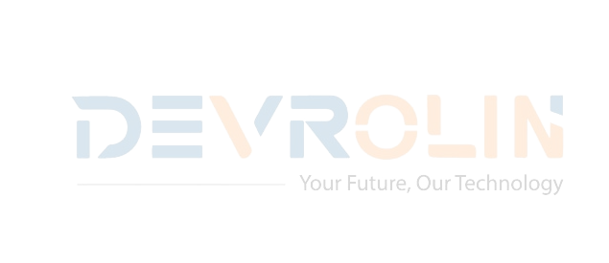During this period, {{NAME}} actively contributed to our flagship web projects, demonstrating strong problem-solving skills and a genuine enthusiasm for front- end and back-end development. Key contributions include:

* **Front-End Development:** Assisted in building and optimizing responsive user interfaces using HTML, CSS, JavaScript, and React, improving page load speed by 25%.
* **Back-End Development:** Supported the integration of RESTful APIs and database management with Node.js and MongoDB, enhancing data retrieval efficiency.
* **Code Optimization:** Refactored existing code to improve maintainability and reduce bugs, resulting in smoother deployment cycles.
* **Team Collaboration:** Worked closely with senior developers, participated in daily stand-ups, and delivered weekly progress updates to the Web Development team.

Throughout the internship, {{NAME}} exhibited diligence, adaptability, and an eagerness to learn.

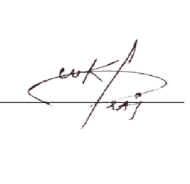We appreciate {{NAME}} dedication during their tenure with Devrolin and wish them every success in their future academic and professional endeavors.

Sincerely,

**Muhammad Bilal**

**Director, Devrolin**