

**REF NO: {{REF}}**

**DATE: {{DATE}}**

**To Whom It May Concern**

This is to certify that **{{NAME}}** has successfully completed a **{{DURATION}}** internship in the Artificial Intelligence Department of DevRolin, from **{{STARTDATE}}** to **{{ENDDATE}}**.

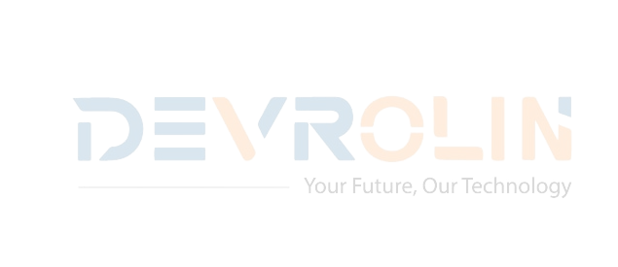During this period, {{NAME}} actively participated in our flagship Al projects, demonstrating strong analytical skills and a genuine enthusiasm for machine learning and data science. Key contributions include:

* **Model Development:** Assisted in developing and fine-tuning a convolutional neural network for image classification, achieving a 92% validation accuracy.
* **Data Preprocessing**: Designed and implemented data-cleaning pipelines that reduced feature-engineering time by 30%
* **Research & Documentation:** Conducted literature reviews on Transformer architectures and prepared concise technical reports that informed our experimental design
* **Team Collaboration:** Collaborated effectively with senior engineers, attended daily stand-ups, and presented weekly progress updates to the Al team.

Throughout the internship, {{NAME}} exhibited diligence, adaptability, and an eagerness to learn.

We appreciate {{NAME}} dedication during their tenure with DevRolin and wish them every success in their future academic and professional endeavors.

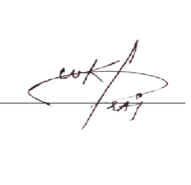Sincerely,

**Muhammad Bilal**

**Director, Devrolin**