**REF NO : {{REF}}**

**DATE : {{DATE}} Offer Letter**

**Dear {{NAME}},**

We are pleased to extend to you an offer for the position of Business Development Intern at Devrolin for a period of {{DURATION}} months, commencing on {{STARTDATE}}.

You will be supervised by {{SUPNAME}} and will support our business growth initiatives through tasks such as {{TASKS}}. This internship aims to provide practical industry exposure and enhance your communication, analytical, and strategic thinking skills in a real-world business environment.

Details of the Internship:

* Position: {{POSITION}}



support@devrolin.com

+971 52 234 7966

Al Abraj Streets Dubai , UAE

* Department: {{DEPARTMENT}}
* Duration: {{FROMANDTODATE}}
* Type: {{TYPE}}
* Location: Oric Pak Korea Building, Arid Agriculture University, Rawalpindi
* Supervisor: {{SUPNAME}}

You are expected to maintain a professional attitude, observe company policies, and uphold strict confidentiality regarding internal projects and materials.

Please confirm your acceptance of this offer by signing and returning a copy of this letter by {{RESPONSEDATE}}. Should you have any questions, feel free to reach out to Mr. zohaibejaz@devrolin.com

We are excited about the opportunity to work with you and look forward to your positive impact at Devrolin.

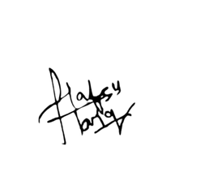

Sincerely,

**HR Manager**