**Muhammad Wasil**

**23703**

**CS 4-2**

**Theory Of Automata**

1. **RegEx:** (gh*g+hm*h+mg*m) gmg
2. **DFA :**

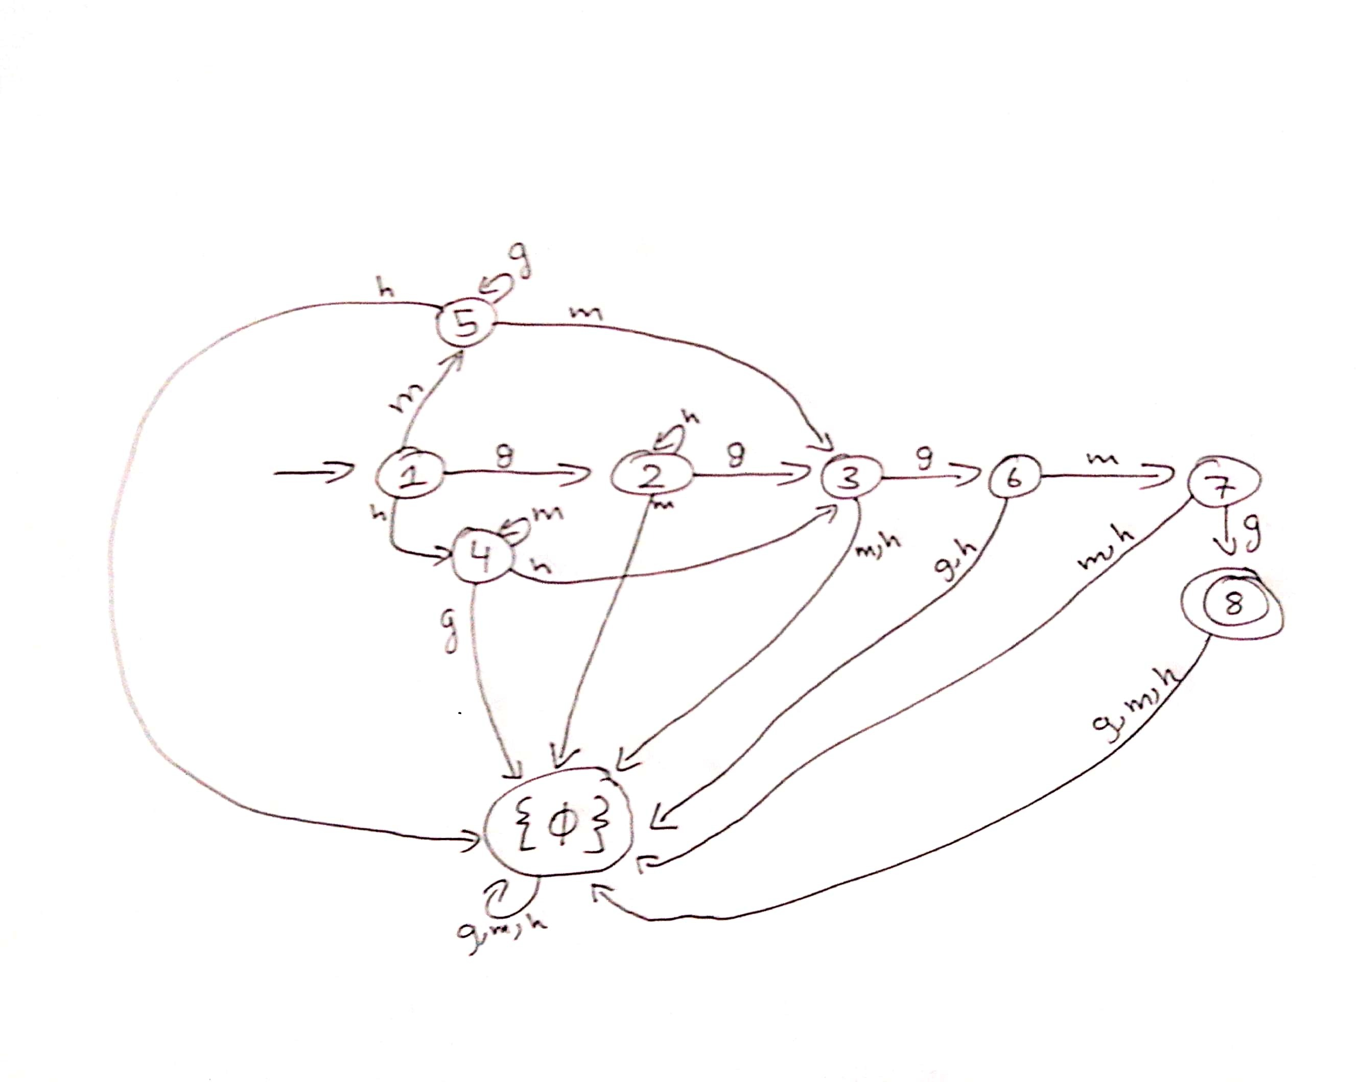

1. **Code Result:**

**Tested Input:**

ghggmg

gggmg

ghhggmg

hmhgmg

hhgmg

hmmhgmg

mgmgmg

mmgmg

mggmgmg

**Result:**

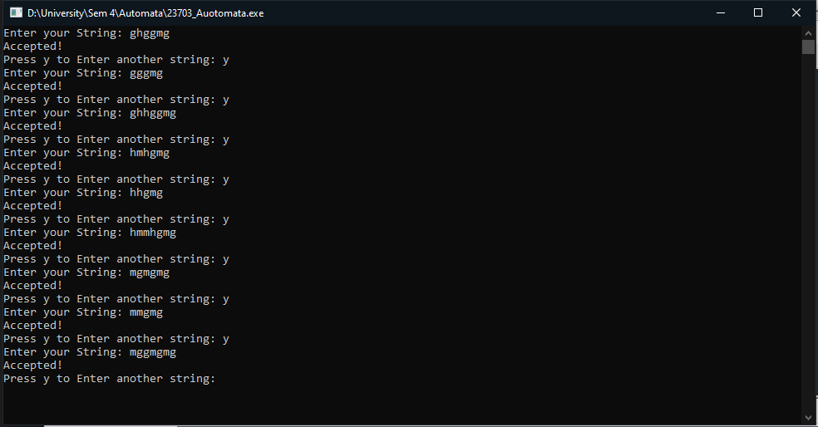

1. **Code (Cpp file is also attached)**

#include <iostream>

#include <string>

using namespace std;

int dfa = 0;

//function for starting state of DFA

void state1 (char c)

{

if(c=='m')

{

dfa =5;

}

else if(c=='g')

{

dfa=2;

}

else if(c=='h')

{

dfa =4;

}

else

{

dfa = -1;

}

}

// function for state 2

void state2 (char c)

{

if (c=='h')

{

dfa = 2;

}

else if(c =='g')

{

dfa = 3;

}

else if (c =='m')

{

dfa = 9;

}

else

{

dfa = -1;

}

}

// function for state 3

void state3 (char c)

{

if ( c == 'g')

{

dfa =6;

}

else if ( c=='m'||c=='h')

{

dfa = 9;

}

else

{

dfa = -1;

}

}

// function for state 4

void state4 (char c)

{

if( c == 'm')

{

dfa = 4;

}

else if (c == 'h')

{

dfa = 3;

}

else if ( c== 'g')

{

dfa = 9;

}

else

{

dfa = -1;

}

}

// function for state 5

void state5 (char c)

{

if (c == 'g')

{

dfa = 5;

}

else if (c == 'h')

{

dfa =9;

}

else if ( c=='m')

{

dfa =3;

}

else

{

dfa = -1;

}

}

// function for state 6

void state6 ( char c)

{

if (c =='m')

{

dfa =7;

}

else if (c=='g'||c=='h')

{

dfa =9;

}

else

{

dfa = -1;

}

}

//function for state 7

void state7 (char c)

{

if(c=='g')

{

dfa =8;

}

else if (c=='m'||c=='h')

{

dfa = 9;

}

else

{

dfa = -1;

}

}

//function for state 8

void state8 (char c)

{

if (c=='g'||c=='h'||c=='m')

{

dfa = 9;

}

else

{

dfa = -1;

}

}

//function for dead state9

void state9 (char c)

{

if (c=='g'||c=='h'||c=='m')

{

dfa = 9;

}

else

{

dfa = -1;

}

}

int isAccepted(string str)

{

// store length of string

int i, len = str.length();

for (i = 0; i < len; i++) {

if (dfa == 0)

state1(str[i]);

else if (dfa == 2)

state2(str[i]);

else if (dfa == 3)

state3(str[i]);

else if (dfa == 4)

state4(str[i]);

else if (dfa == 5)

state5(str[i]);

else if (dfa == 6)

state6(str[i]);

else if (dfa ==7)

state7(str[i]);

else if (dfa == 8)

state8(str[i]);

else if(dfa == 9)

state9(str[i]);

else

return 0;

}

if (dfa == 8)

return 1;

else

return 0;

}

int main()

{

string choice = "y";

while(choice == "y"||choice == "Y")

{

string s;

cout<<"Enter your String: ";

getline(cin,s);

if (isAccepted(s))

printf("Accepted!");

else

printf("Rejected!");

dfa = 0;

cout<<endl<<"Press y to Enter another string: ";

getline(cin,choice);

}

return 0;

}