Kamil Wasilonek, group 2
Repository: https://github.com/Wasilonek/Multiscale-modeling

Multiscale Modeling
Laboratory report

- Technologies used

To implement application used Java SE in version 8. This programing language is very flexible and allow to run program independently from the environment. In order to improve microstructure presentation Java provides multithreading which can be used to real time visualization of growth process. In addition, Object oriented programing principle, which based on classes and object to share state informations , can be easily implemented using Java. The used IDE was IntelliJ IDEA. This IDE is a very powerful and complex tool, which contains a lot of methods to generate, format, and check code to make work faster and easier.

To fulfill requirement of visualization, application uses JavaFx library and Scene builder. This tools provides many of build-in controls, buttons, text fields and other elements which helps to build functional and clear user interface.

During implementation every significant change of code was track by version system control. This solution helped to develop code in more iterative and organise way.

2. Application interface

The figure below shows main window of the application with the default values for required text fields.

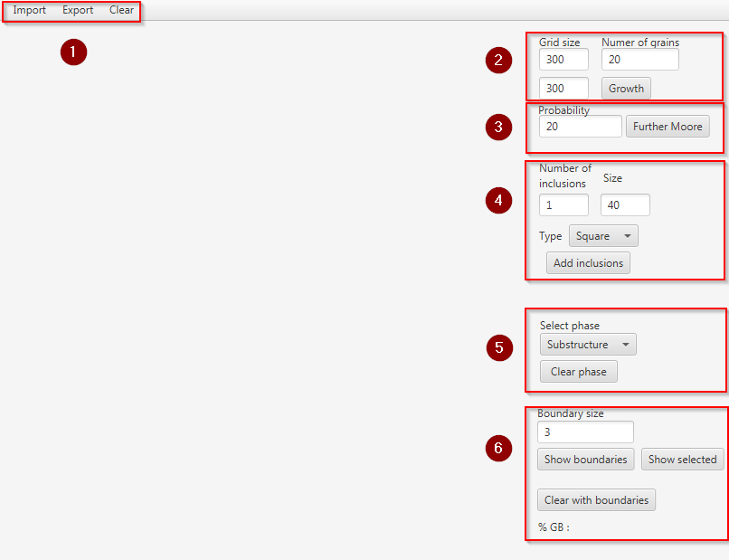
Fig. 1 Main view of the application

2.1.Microstructure growth

First functionality available in the application is generation of simple microstructure [num. 2]. At the start, user has to set size of space. The second information which has to be provided is number of grains to place in space. This data are necessary for the proper functioning of the application. The “Growth” button is responsible for initialization of grid, place particular number of grains and microstructure growth. Described functionality uses Moor's neighbourhood system and periodic boundary condition.

The second option which can be use to growth is "further Moore neighborhood" [num. 3]. This solution require all basic information like size of space and number of grains, but in addition user is obligated to provide probability. To start the growth user has to click “Further Moore” button.
.

After all the growth steps are successful, in the left part of main view [fig. 1] the generated microstructure will be presented automatically.


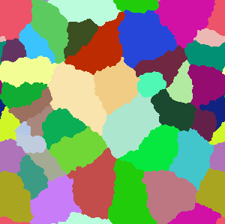
Fig. 2 Moore microstructure Fig. 3 Further Moore microstructure( 10% probability )

2.2. Inclusions

Next group of controls provides user possibility to generate inclusions in defined space [num. 4]. In this part to proper operations, number of inclusions and size of single inclusion need to be typed in text field. Moreover user can select shape of particular inclusions.

This functionality provides two use cases. Firstly, inclusions can be generated before microstructure growth. In such situation place for inclusions will be selected randomly. Otherwise if inclusions will be added after growth, they always will be placed on the grain boundaries.

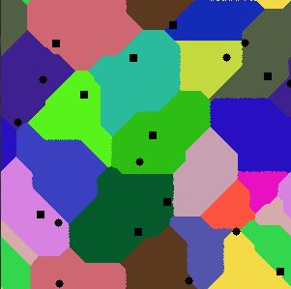
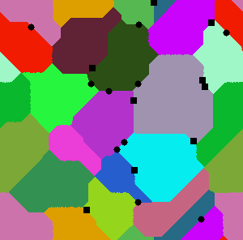
Fig. 4 Microstructure with inclusion Fig. 5 Microstructure with inclusions on boundaries
generated before growth

2.3. Grain selection

Every of the next functionalities are based on selection particular grain using mouse. Algorithm read coordinates on the point which user clicked on microstructure, then change grain to selected state.

2.4. Substructure / Dual phase

Section number 5 enables user to select particular grain and change it to substructure or dual phase. User can switch between those two states using choice box. By second click on the selected grain it will change state to unselect. When the all desired grains are selected, “Clear phase” button will clear hole space and leave only selected grains. Substructure will remain in default color, but dual phase will change grain color to red. After all described operations next growth is possible.



Fig. 6 Generated microstructure Fig. 7 Selected grains
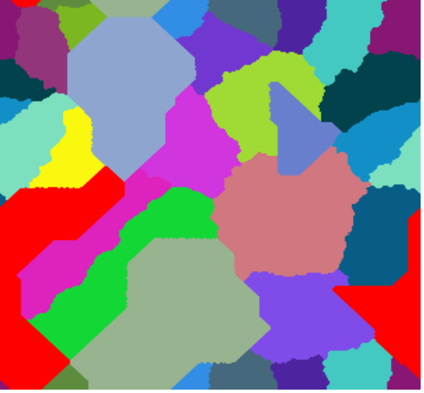
Fig. 8 Microstructure after regrowth

2.5. Boundaries

Controls marked as number 6 are responsible for showing boundaries of specific or all grains. User have possibility to select one or more grains and by using “Show selected” clear space ale leave only boundaries of selected grains. Second case assume growth of microstructure and showing boundary of every grain. User can set thickness of boundary. After clearing space algorithm will calculate the ratio occupied by borders to the whole space.


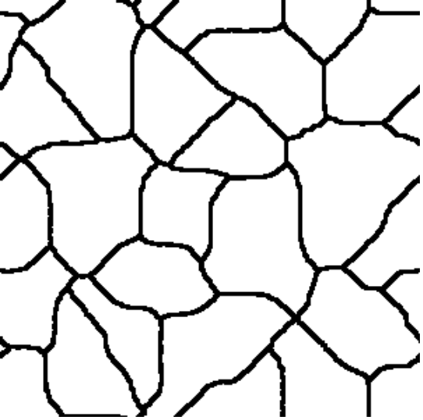
Fig. 9 Generated microstructure Fig. 10 Boundaries of every grain

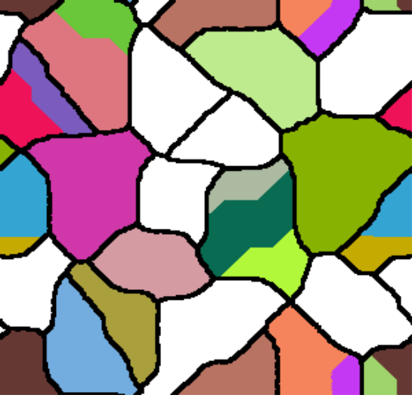
Fig. 11 regenerated mirostructure

2.6. Save / Load

Application provides possibility to save representation of microstructure on every stage. Available formats are bitmap or text file. Moreover user can load all information and continue microstructure manipulation.
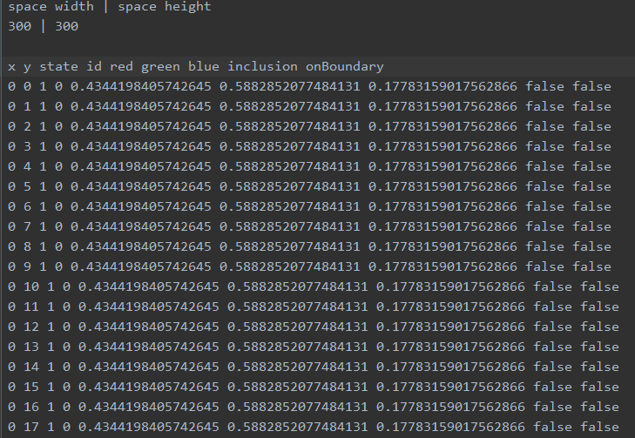
Fig. 12 Part of text file with information about microstructure

3. Real microstrucuters

After preparation of the entire application, an attempt was made to generate microstructures as closely as possible to real structures described in scientific articles

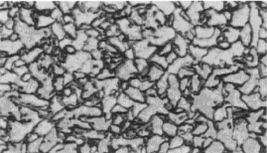
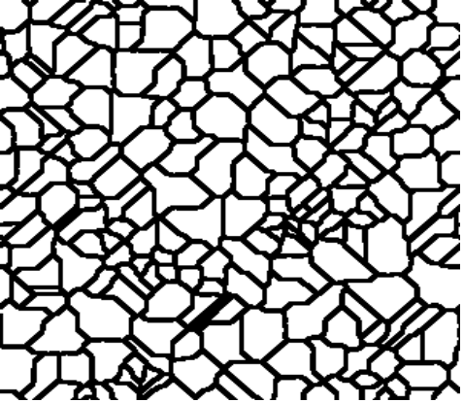
Fig. 12 Microstructure of 0.1C-1.3Mn-0.005Nb steel after deformation Fig. 13 Microstructure from application

Figure 12 shows the microstructure after high temperature deformation and undercooling to 700 oC. Figure 13 shows very similar microstructure generated using application.

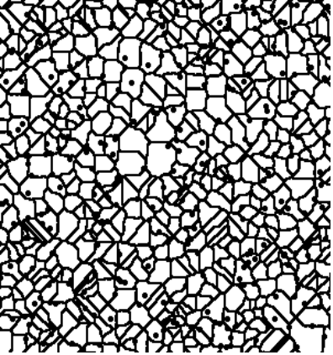
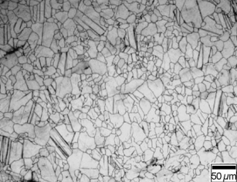
Fig.14 microstructure of the hot rolled AZ31 with rolling reduction: (a) 35% Fig.15 Microstructure from application

Figure 14 shows microstucture of material AZ31 ,which is used in the production of phone and laptop cases and some parts of cars.

Bibliography

[ 1 ] https://www.sciencedirect.com/science/article/pii/S0924013601008007

[ 2 ] https://www.sciencedirect.com/science/article/pii/S0924013603007970

