**Clap Switch**

**(Group Project)**

**Members:**

1. Umed Kumar
2. Diptesh Raj
3. Md Wasim

* **Introduction:** In this modern era of automation and smart technology, the demand for hands-free control systems has grown significantly. This project introduces an innovative solution, a "Clap Switch" using readily available components like an Arduino microcontroller, a sound sensor module, and a relay module. The system is designed to detect clapping sounds and trigger an electrical appliance or light, making it an excellent addition to home automation and accessibility applications.

The heart of the system is the Arduino microcontroller, which processes the audio input from the sound sensor module. The sound sensor module is programmed to recognize specific sound patterns associated with claps, ensuring reliable and precise detection. Once two claps are detected, the Arduino triggers the relay module and appliances connected with relay will turn ON/OFF by two claps. This straightforward and efficient design eliminates the need for physical switches, providing users with a convenient and hands-free method to control their devices.

* **Components:**
* Arduino Uno
* 5V charger
* LM393 sound sensor module
* Relay module
* Bulb Holder
* Socket
* Plug
* Box and some wires
* **Construction:** All the above components are assembled meticulously in a small box to make it compact and portable.
* **Features:**
  + Very small in size
  + Portable
  + Long life
  + Light weight
  + Low power requirement
  + Easy to attach
  + Hands free control
  + Save energy
* **Very beneficial for:**
* Seniors who may have difficulty in reaching and operating traditional switches
* Provide safety to small children
* Pregnant woman who has difficulty in moving
* 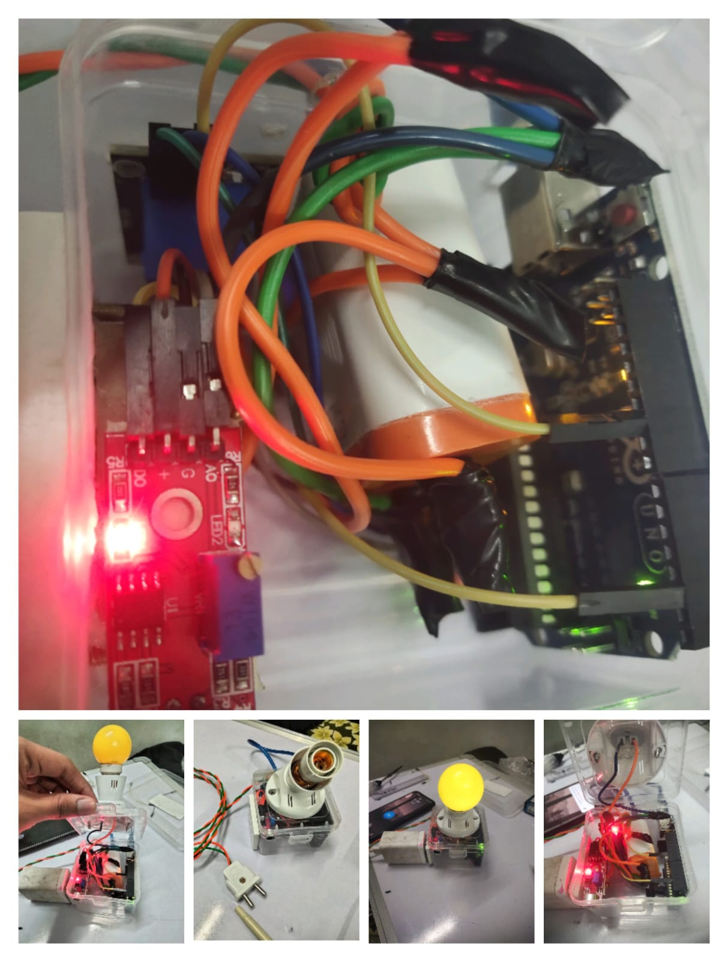Any paralysed person

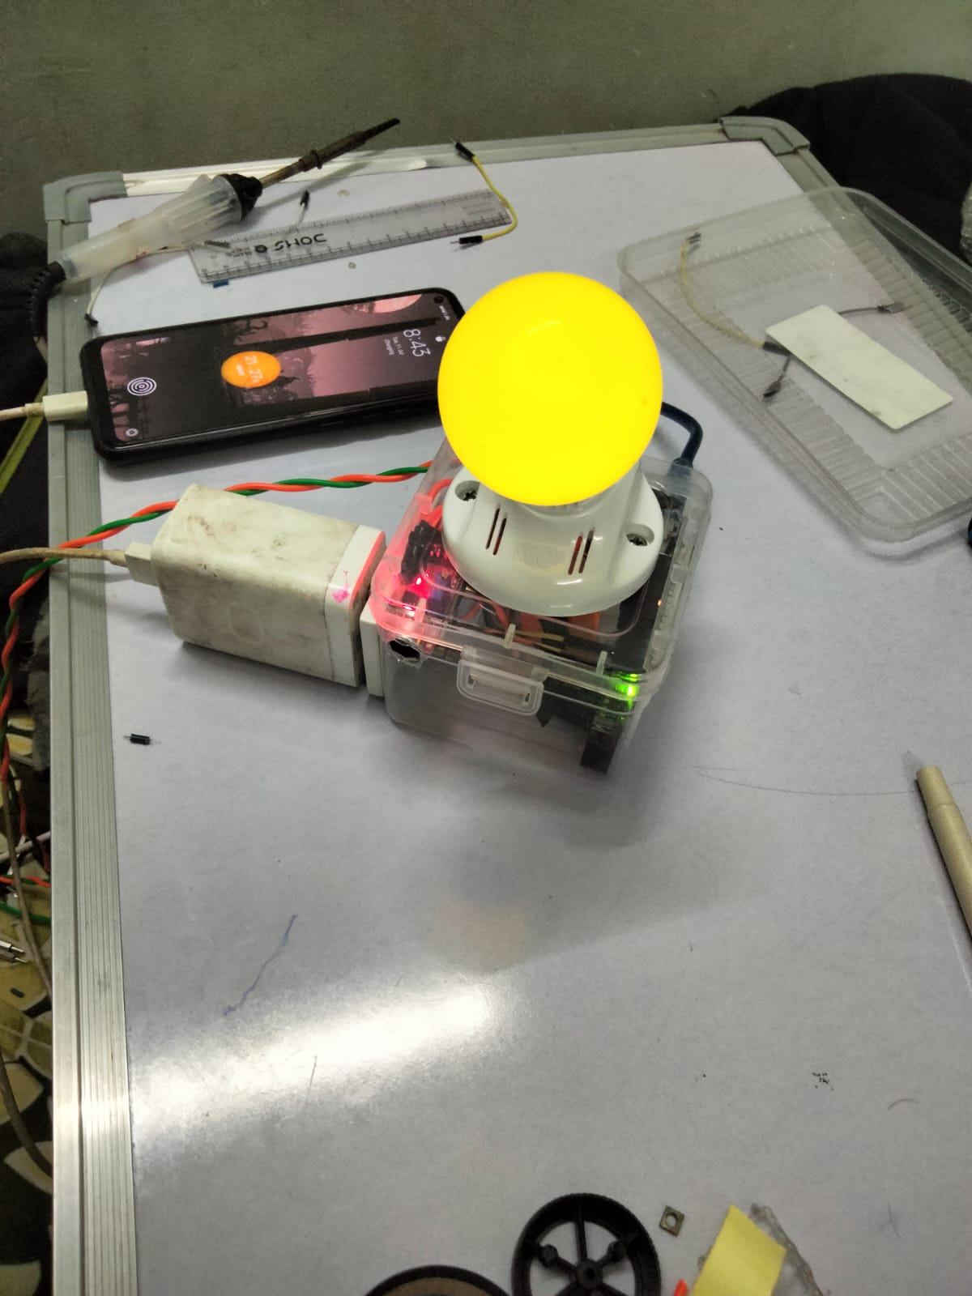

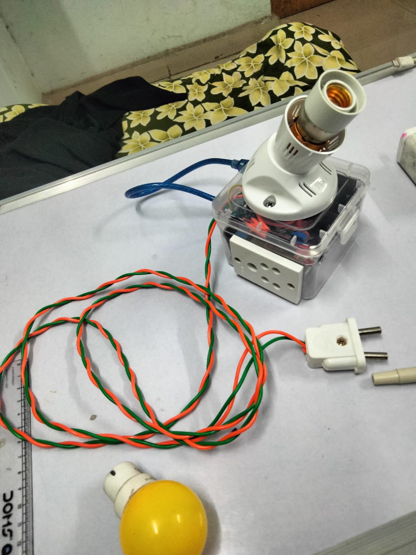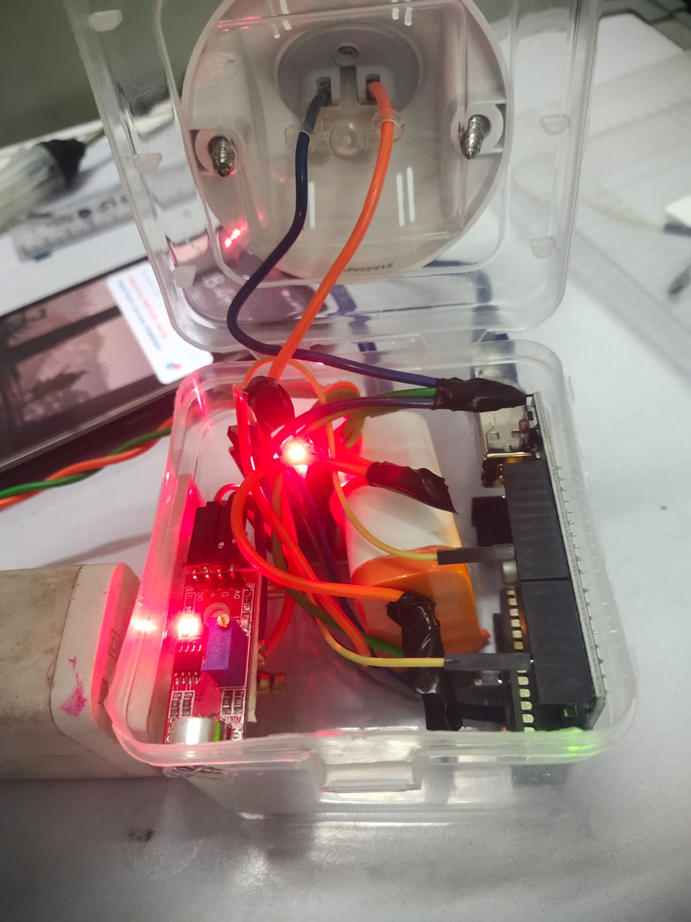

**Approx Cost: ₹ 1071**