**RC Car**

**Using NodeMCU**

* **Introduction:**

This project presents the design and development of a remote-controlled car (RC car) equipped with IoT capabilities, powered by a NodeMCU microcontroller, featuring four DC gear motors, a buzzer, an L298N motor driver, and a Li-ion battery. The integration of these components results in a versatile and engaging robotic vehicle with potential applications in education, entertainment, and beyond.

The NodeMCU serves as the brain of the RC car, enabling wireless communication and remote control through Wi-Fi. Users can control the car's movements and trigger the buzzer remotely using a dedicated smartphone application. The inclusion of a buzzer and LEDs makes it more attractive.

* **Components:**
  + NodeMCU
  + Wheels
  + DC gear motor
  + Buzzer
  + L298N motor driver
  + Battery
  + Chases and some wires
  + Led
* **Features:**
* User Friendly interface
* Long lasting
* Light weight
* Long lasting rechargeable batteries
* Control Remotely with smart phone
* **Uses:**

This IoT-enabled RC car serves as a practical and educational platform for learning about robotics, IoT, and embedded systems. Its modular design allows for easy customization and expansion, encouraging enthusiasts and developers to explore additional sensors and features. With its remote-control capabilities, versatile motor system, and IoT integration, this project showcases the potential of combining modern technology for creating engaging and educational robotic devices.

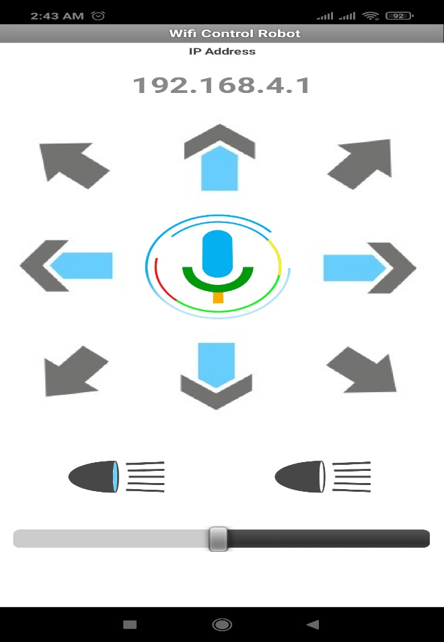

**Approx Cost: ₹ 850**