## HBASE & LINUX

* is open source NoSQL database
* real-time read/write access to those large dataset
* Scales linearly, usually used to store sparse data.
* Column-oriented database

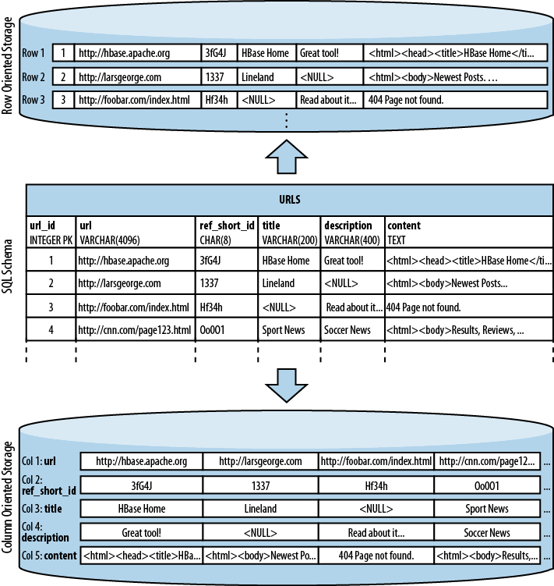

ROW vs COLUMN -oriented

**How many types of data models are there ?**

-

-

-

-

**HBASE ARCHITECTURE OVERVIEW**

* **Hbase Tables :-> Regions(..n) :-> Region Server(Data locality):->Handled by Hmaster (DDL) : -> Zookeeper**

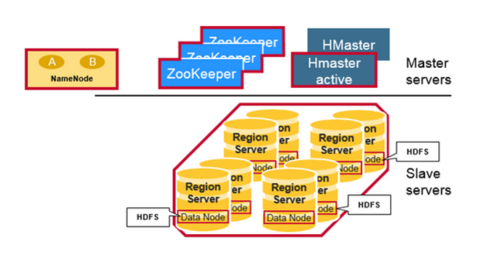

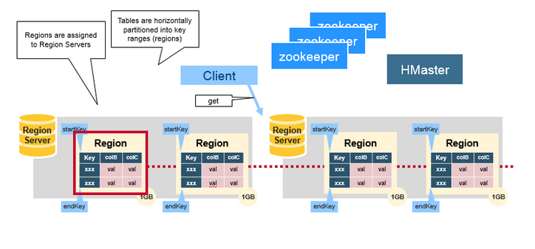

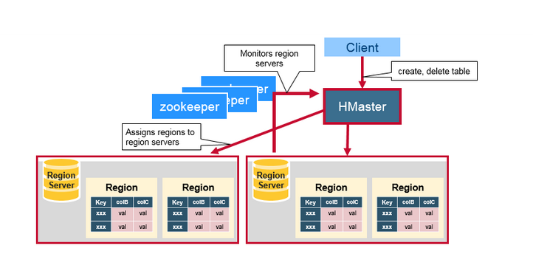

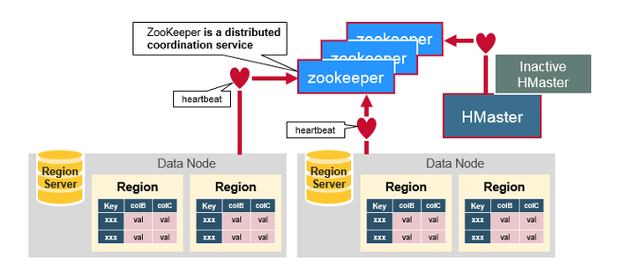

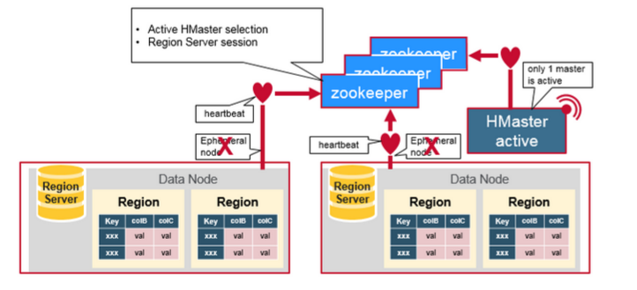

Keywords: Session, Ephemeral nodes, heartbeats,sharding.

Why zookeeper: -> 1)Server state 2)Coordinate shared state info

**HDFS VS HBASE:**

**-**

**-**

**-**

**STORAGE SCHEMA:**

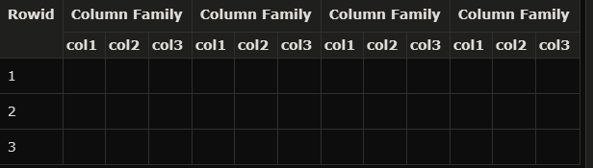

HBASE FIRST READ AND WRITE

**Zookeeper(loc’ns):->Meta table(query & cache’s):->Regions->Rowdata**

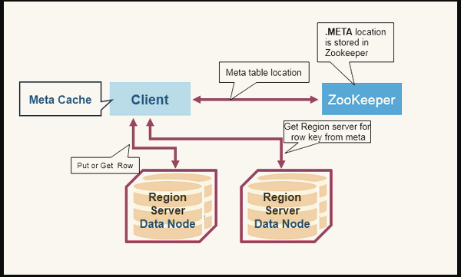

**REGION SERVER COMPONENTS**

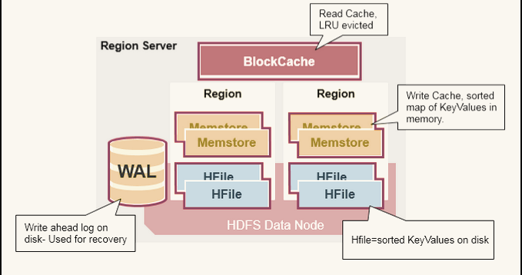

**WAL ,Block Cache, MemStore**

MINOR COMPACTION And MAJOR COMPACTION