PROGRAMMING IN PYTHON
STUDENT RESULT MANAGEMENT AND ANALYZER SYSTEM
Mid-Term Project Report
Summer 25-26 Semester
Group Member Information
No. | Student Name | Student ID
1 | MD. Musfique Mortuza Sadid | 22-49128-3
2 | Wasimul Bari Rahul | 23-50913-1
3 | Anik Chandra Dey | 23-50589-1
4 | AL SAMIL | 24-60323-3
Course: Programming in Python

1. Project Title and Group / Member Information
Project Title | Student Result Management and Analyzer System
Course | Programming in Python
Assessment Type | Group Project
2. Problem Statement and Objectives
Introduction: This project is developed using Python object-oriented programming and a Tkinter graphical interface. JSON file handling is used to save and load student records, while NumPy is used to calculate basic class statistics. The program also uses lists, dictionaries, tuple unpacking, functions, loops, conditional statements, exception handling, CRUD operations, and message boxes to manage student results in a simple and organized way.
Managing student results on paper takes time and can create mistakes. It is also difficult to search, update, or calculate class results manually. This project keeps the student records in one simple desktop application.
Objectives:
- Add student ID, name, and marks.
- Search, update, delete, display, filter, and sort saved records.
- Calculate grade and basic class statistics.
- Save data in a JSON file so the records remain after closing the program.
- Handle empty fields, invalid marks, duplicate IDs, and missing records.
3. Feature List and Target Users
No. | Feature | What It Does
1 | Add Student | Adds a new student record.
2 | Search Student | Finds a student by ID.
3 | Update Student | Changes the saved name or marks.
4 | Delete Student | Removes a selected record.
5 | Show Student | Displays all stored records.
6 | Clear | Clears the input fields.
7 | Show Statistics | Shows total, average, highest, and lowest marks.
8 | Filter | Shows records that match the selected status or grade.
9 | Sort | Orders records by the selected field in ascending or descending order.
Target users: teachers, class representatives, and small academic offices.

Project Requirement Checklist
Requirement | Evidence in This Project | Status | Screenshot / File
User interaction | Tkinter window, entry fields, buttons, and messages | Done | GUI screenshots
Five or more operations | Add, search, update, delete, show, clear, statistics, filter, and sort | Done | Main window
Persistent data | Records are saved and loaded from students.json | Done | Data file
Validation | Checks empty input, numeric marks, range, and duplicate ID | Done | Message boxes
Analysis | Grade, total students, average, highest, and lowest marks | Done | Statistics screenshot
Functions and classes | Separate methods for each task; Student and StudentManager classes | Done | Source code
Data structures | List, tuple, and dictionary are used | Done | Source code
Error recovery | try-except and clear error messages prevent crashes | Done | Source code / GUI
Library use | Tkinter creates the GUI and NumPy performs calculations | Done | GUI / statistics
4. Explanation of Used Python Concepts
Concept | Use in This Project
Variables and data types | Store student ID, name, marks, grade, messages, and calculated values.
Operators | Calculate averages and compare marks with grade conditions.
if / elif / else | Check input, assign grades, and decide whether a record exists.
Loops | Read, display, search, and process student records.
Functions | Separate add, search, update, delete, show, filter, sort, save, load, and statistics tasks.
List | Stores all student records in memory.
Tuple | Keeps fixed grade rules.
Dictionary | Stores each record in key-value form for JSON.
File handling | Reads and writes students.json.
Exception handling and OOP | Handles errors and organizes the program using classes.

5. Data Structure Explanation
Structure | Example | Reason for Use
List | students | Stores all records and supports looping.
Tuple | grade bands | Keeps fixed values that should not change.
Dictionary | {id, name, marks, grade} | Makes JSON saving and loading easy.
6. OOP Design
The program uses two main classes. The Student class represents one student record. The StudentManager class manages CRUD operations, JSON file handling, statistics, record display, filtering, and sorting.
Class / Method | Main Data or Work | Purpose
Student | student_id, name, marks, grade | Represents one student record.
StudentManager | students, filename, selected filter and sort options | Manages records, files, display, filtering, sorting, and statistics.
add_student() | Validates and adds data | Creates a new record.
search_student() | Checks student ID | Finds a saved record.
update_student() | Changes name or marks | Updates a record.
delete_student() | Removes selected data | Deletes a record.
show_students() | Formats all saved records | Displays student records in the result box.
filter_students() | Selected status or grade | Displays only matching student records.
sort_students() | Selected field and Desc option | Orders records by ID, name, marks, or grade.
show_statistics() | NumPy calculations | Shows total, average, highest, and lowest marks.
save_students() / load_students() | JSON file operations | Keeps records available after the program closes.
7. File Handling and Exception Handling
Situation | How the Program Handles It
Save and load | Records are stored in students.json and loaded when the program starts.
Empty ID or name | Shows an error message and does not save the record.
Non-numeric marks | try-except handles ValueError.
Marks below 0 or above 100 | A range check rejects the value.
Duplicate ID | The ID is checked before adding.
Student or file not found | A clear message is shown instead of closing the program.
8. Library / Module Use
Module | Use | Project Evidence
Tkinter | Creates the interface | Labels, entries, buttons, result box, and message boxes.
NumPy | Performs numeric analysis | Average, highest, and lowest marks.
json | Stores and restores data | students.json file.

9. Screenshots and Sample Input / Output
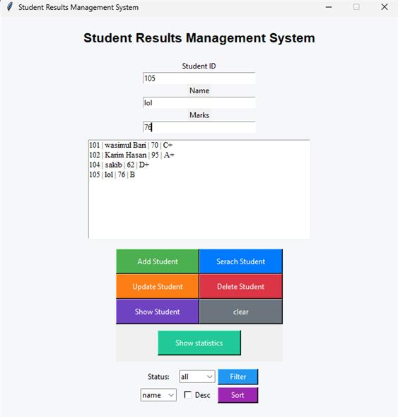  Figure 1: Updated main application window with filter and sort controls | 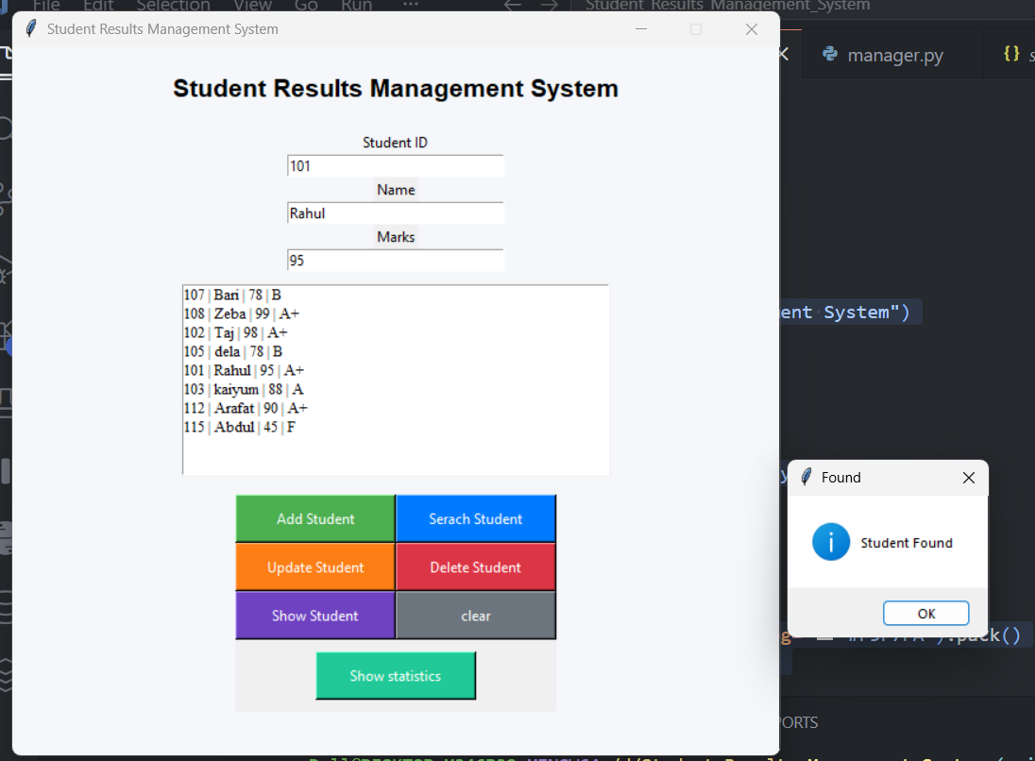  Figure 2: Search Student operation
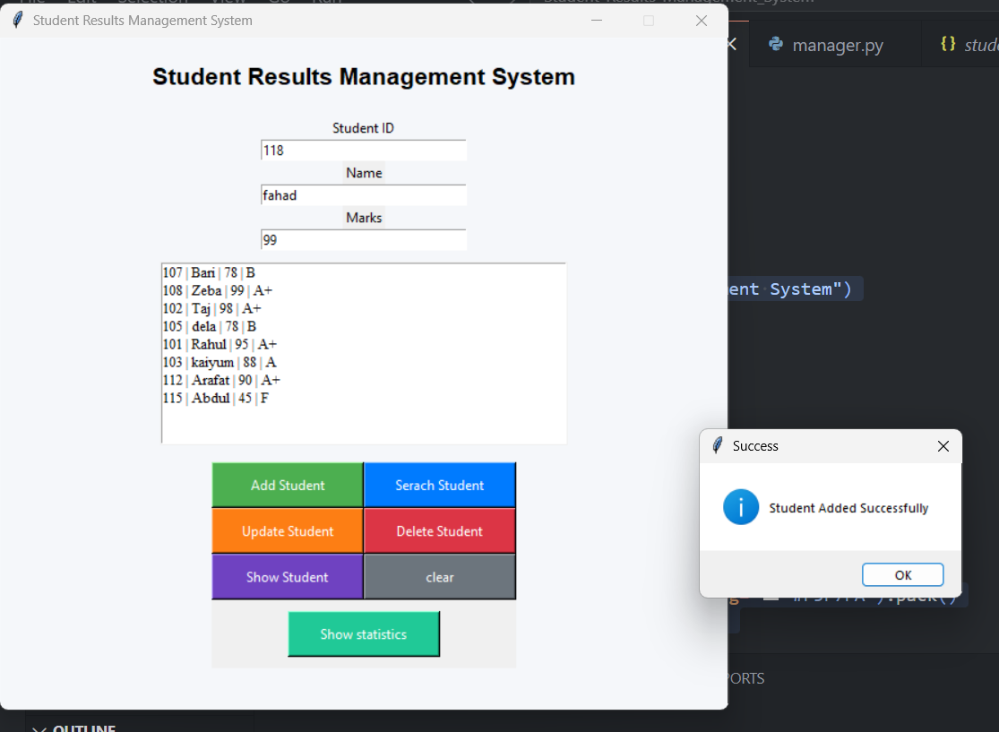  Figure 3: Add Student operation | 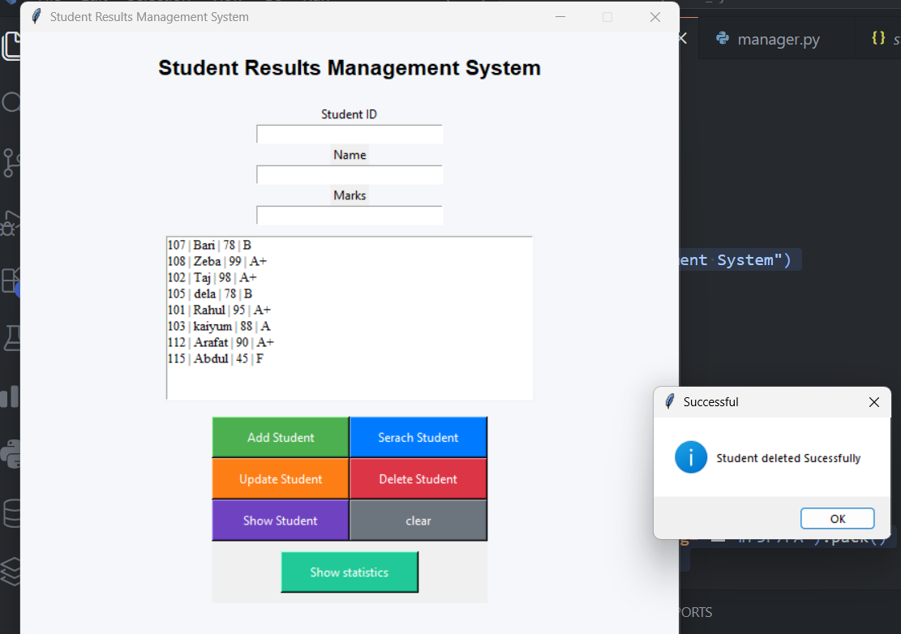  Figure 4: Delete Student confirmation
Sample input: Student ID = 118, Name = Fahad, Marks = 99
Output: Student Added Successfully

9. Screenshots and Sample Input / Output (Continued)
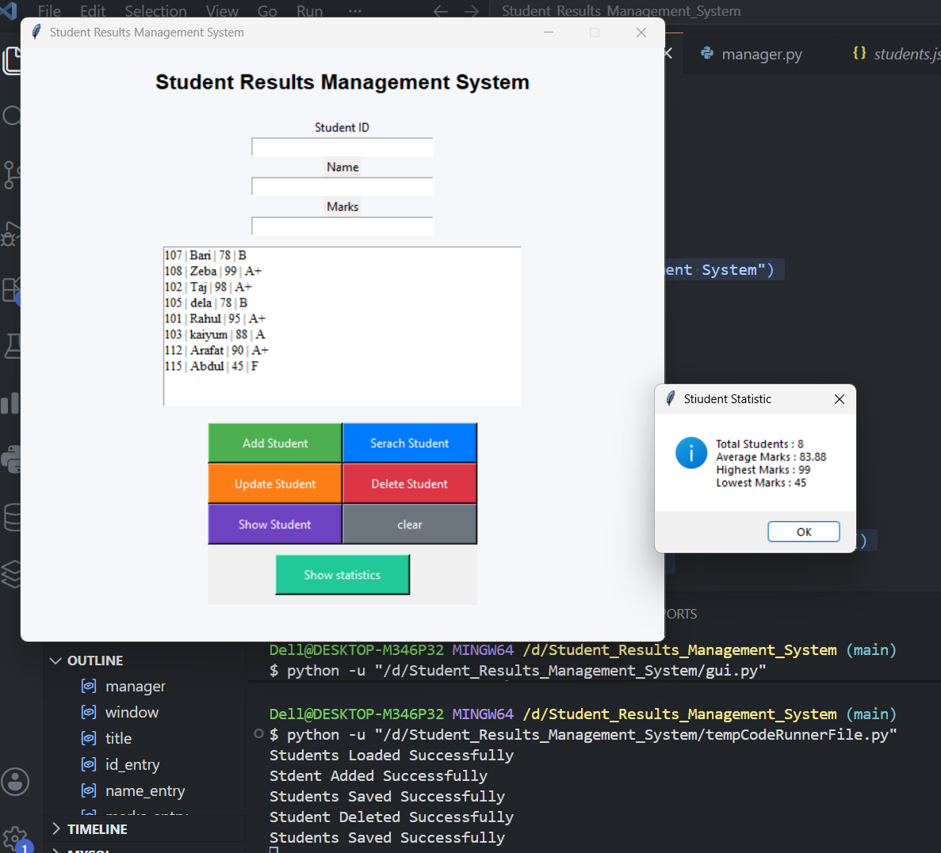
Figure 5: Class statistics output
No. | Student ID | Student Name | Marks | Grade
1 | 101 | Rahul | 95 | A+
2 | 102 | Taj | 98 | A+
3 | 103 | Kaiyum | 88 | A
4 | 105 | Dela | 78 | B
5 | 107 | Bari | 78 | B
6 | 108 | Zeba | 99 | A+
7 | 112 | Arafat | 90 | A+
8 | 115 | Abdul | 45 | F
Total Students | Average Marks | Highest Marks | Lowest Marks
8 | 83.88 | 99 | 45
10. Limitations and Possible Future Improvements
Current Limitation | Possible Improvement
The program is for one local user. | Add login and user roles.
It uses a JSON file. | Use SQLite for larger data.
There is no export option. | Add PDF or Excel export.
It shows basic statistics only. | Add charts and subject-wise results.
Conclusion
This project is a small but complete Python application. It accepts user input, manages student records, saves data, handles common errors, filters and sorts records, and shows a class summary. It covers the main topics required for the mid-term project.
References: Python Documentation, Tkinter Documentation, and NumPy Documentation.

