**Scenario 1:** **Candidate imports their PDF Resume for Autocompletion, the user is prompted for unfilled essential sections (Personal, Skills or Education)**

**Given:** Candidate uploads a pdf resume to auto fill their candidate profile, and one of the essential sections (Personal, Skills or Education) remains unfilled due to parsing errors

**When:** Candidate enters the Profile page

Then: User is prompted at the top of profile page with a red highlight "Your profile is missing some information. Please fill all the highlighted fields in your profile (or click here)." *<Sectional Banner Type 1>*

**And:**Selecting the prompt guides the user to missing sections.

**And:**All the missing sections contain a highlight as well. *<Inline banner for sections>*

**And:**This prompt continues until the essential sections: Personal, Skills and Education have valid entries (no field is missing).

**Scenario 2: User chooses to manually fill their profile**

**Given:** Candidate chooses to fill their profile manually

**When:** Candidate enters the Profile page

**Then:** User is prompted at the top of profile page with a red highlight "Your profile is missing some information. Please fill all the highlighted fields in your profile (or click here)." *<Sectional Banner Type 1>*

**And:**Selecting the prompt guides the user to missing fields/missing essential sections.

**And:**All the missing sections contain a highlight as well. *<Inline banner for sections>*

**And:**This prompt continues until the essential sections: Personal, Skills and Education have valid entries (no field is missing).

**Scenario 3: Candidate profile is missing some fields from entries in any of the sections of the Candidate Profile**

**Given:** Candidate chooses to fill their profile manually or uploads a resume

**When:** Candidate enters the Profile page

**Then:** User is prompted at the top of profile page with a red highlight "Your profile is missing some information. Please fill all the highlighted fields in your profile (or click here)." *<Sectional Banner Type 1>*

**And:**Selecting the prompt guides the user to missing fields/missing essential sections.

**And:**All the missing fields in the respective sections are highlighted as well.

*This is applicable to all sections in which a new entry has been generated but lacks some fields.*

**Scenario 4: Candidate has completed the essential sections (Personal, Skills or Education), or no field is missing in any entry in the profile page.**

**Given:** Candidate has completed the essential sections (Personal, Skills or Education), and all the fields within.

**When:** Candidate is in their profile page

**Then:** User is prompted at the top of profile page with a green highlight "Great! Your profile is complete. You can apply for jobs now." *<Sectional Banner Type 2>*

**Scenario 5: Candidate wants to delete an entry from Education, Experience, Projects or Certification sections**

**Given:** Candidate has added an entry in Education, Experience, Projects or Certification sections

**When:** Candidate clicks on the edit button

**Then:** There is a delete button in the modal, besides save.

**And:** Selecting the delete button gives a dialogue box "Are you sure you want to delete this field?"

**Then:** Selecting 'Confirm' will confirm deletion and "Cancel" will return user to modal.

Example of Sectional Banner:

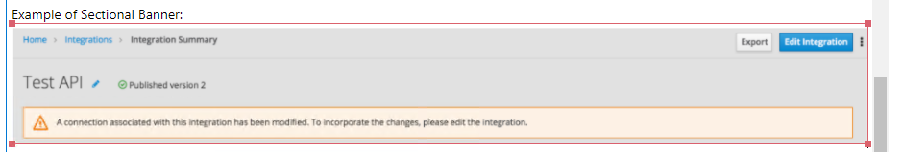

Example of Inline banner and Field Highlights:

