Experiment 1: Lab Setup Report
VMware + Tsurugi Linux Forensic Environment Configuration
Name: Sujal Wasnik | UID: 23015036
Course: Digital Forensics Lab | Experiment No.: 01

1. Objective & Setup Scope
The primary objective of this experiment was to configure and prepare a Tsurugi Linux virtual machine inside VMware for upcoming digital forensic practicals. The setup involved validating system functionality after boot, establishing a pristine restoration snapshot, and structuring a dedicated directory hierarchy for organized case file management.
2. Desktop Boot & Verification
Following the initial launch in VMware, the Tsurugi Linux operating system successfully booted into the desktop interface. I verified system health by checking the top status bar, active system monitors, and pre-installed forensic tools. The terminal prompt confirmed the hostname as tsurugi, verifying that the virtual machine was active and operational prior to executing lab procedures.
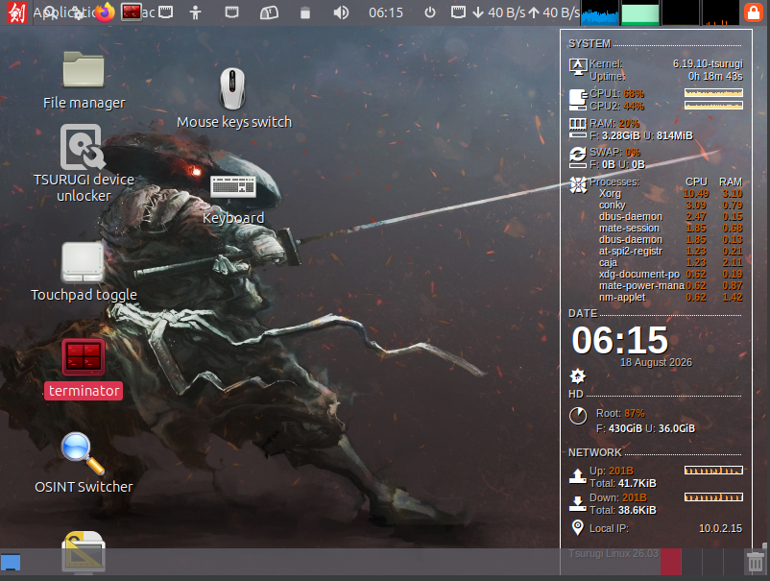
Figure 1: Tsurugi Linux desktop environment loaded successfully post-boot.
3. Baseline Snapshot Creation
To ensure forensic integrity and prevent irreversible system alterations during practical exercises, a clean snapshot was taken using VMware Snapshot Manager. Titled BASELINE-CLEAN, this restore point marks the current active state of the VM. If any artifacts, test files, or system changes accumulate during future practicals, the environment can easily be rolled back to this baseline condition.
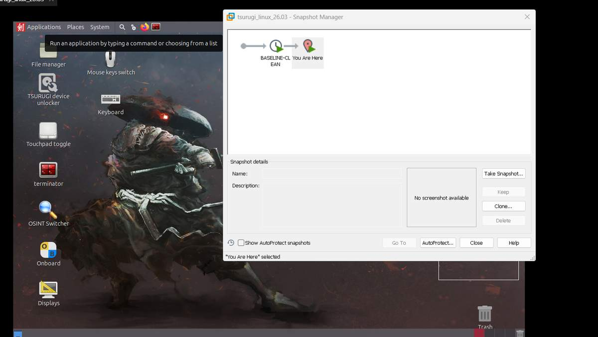
Figure 2: VMware Snapshot Manager reflecting the saved BASELINE-CLEAN state.
4. Case Folder Hierarchy Setup
A structured workspace was initialized to manage digital evidence and practical submissions efficiently. Using the terminal, I created a root directory named Forensics_Case containing subfolders Exp1 through Exp9. Terminal output confirmed that all nine folders were successfully created. Segregating files into distinct experiment folders prevents evidence cross-contamination and simplifies overall case management.
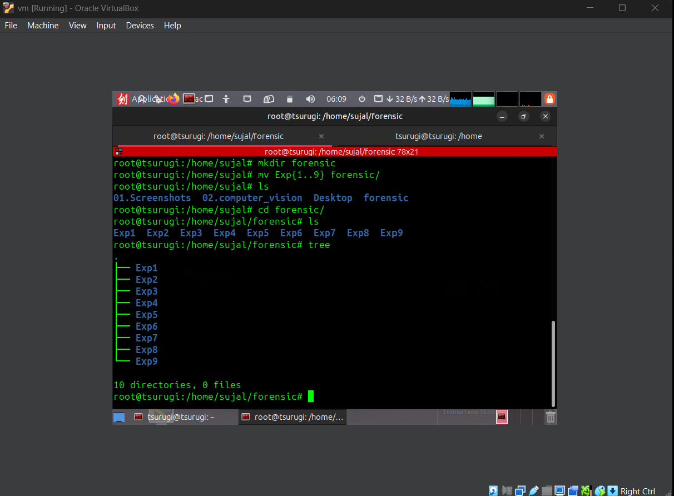
Figure 3: Terminal window confirming creation of Forensics_Case subdirectories.
5. Conclusion
The setup process for the Tsurugi Linux forensic laboratory was completed smoothly. Boot stability was verified, system restoration points were preserved via VMware snapshots, and a dedicated multi-directory case environment was established. The virtual machine is now fully prepared for subsequent forensic investigations and tool execution.

