Email Forensics Report

Experiment 5
Name: Sujal Wasnik
UID: 23015036

Item 1 — Triage Approach

📷 Screenshot
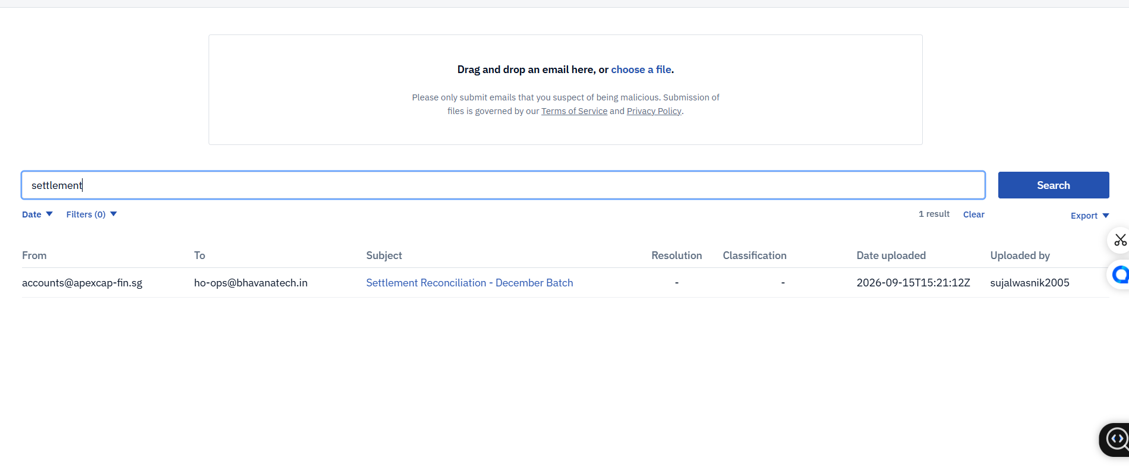
Triage Approach

Description
I triaged the mailbox by applying a search filter for the keyword “settlement”. This approach was selected to quickly narrow down the results and locate emails related to the suspicious fund transfers mentioned in the case.

Item 2 — Relevant Message(s) Identified

📷 Screenshot
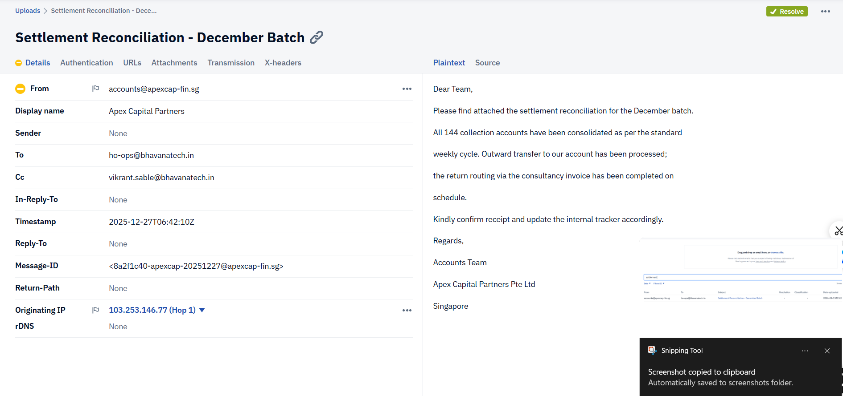
Relevant Message Identified

Description
This email was selected as relevant because the sender accounts@apexcap-fin.sg directly discusses outward transfers, collection accounts, and settlement routing. The financial nature of the message content made it a primary target for further investigation.

Item 3 — Header Chain Reconstruction

📷 Screenshot
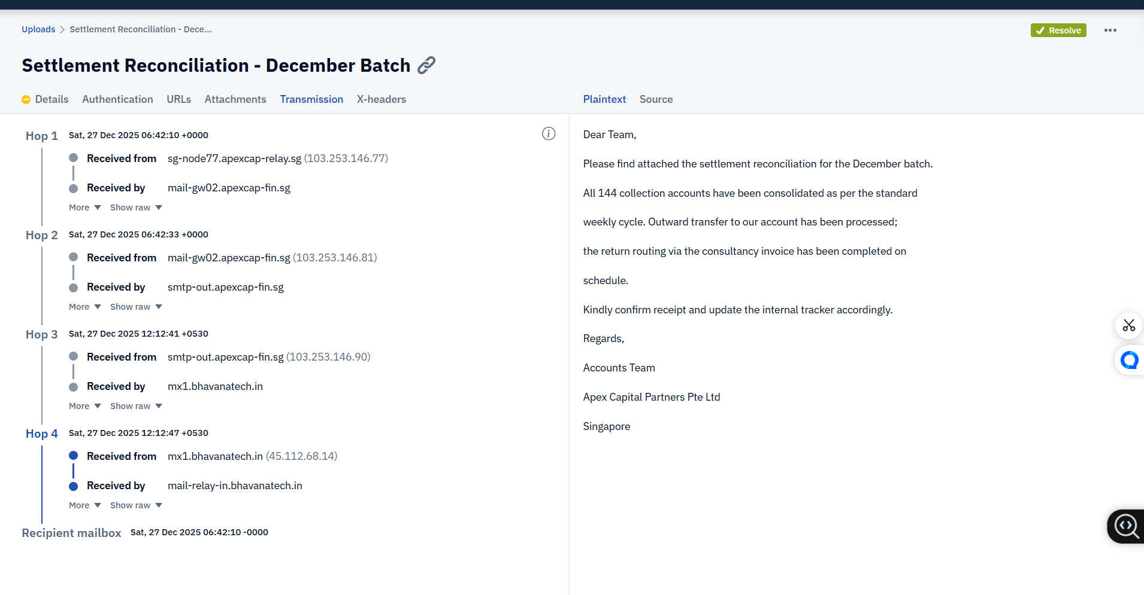
Header Chain Reconstruction

Description
By analyzing the transmission headers, the email’s path was reconstructed chronologically across four distinct hops. The message originated from 103.253.146.77 at Hop 1 and passed through two more relays before arriving at our receiving infrastructure at Hop 4.

Item 4 — Trust Boundary

📷 Screenshot
Trust Boundary

Description
The trust boundary is established at Hop 4, which represents our organization’s internal receiving mail infrastructure. Any routing details recorded prior to this boundary are considered external evidence and must be independently verified for accuracy.

Item 5 — IP Lookup Result

📷 Screenshot
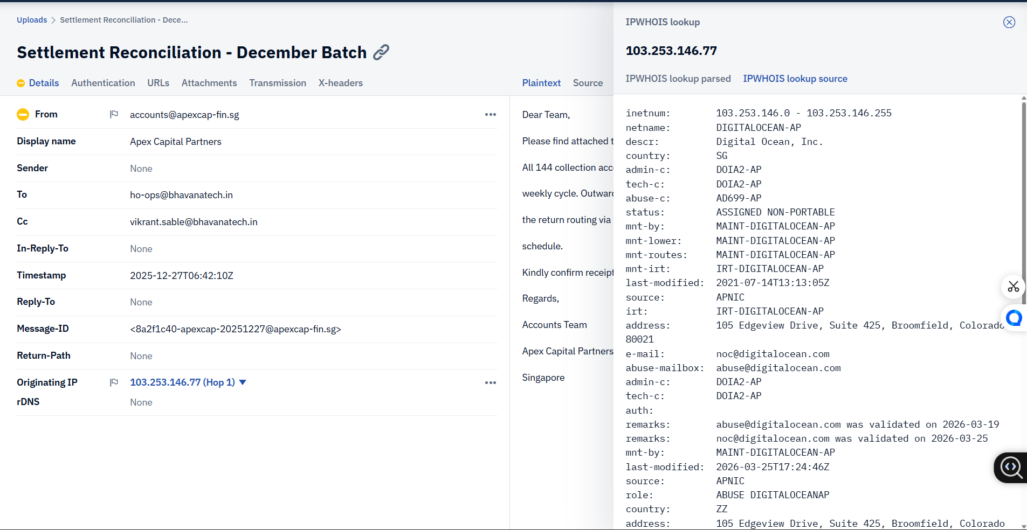
IP Lookup Result

Description
The IPWHOIS lookup on the earliest hop (103.253.146.77) associates the address with Digital Ocean, Inc. The lookup result also geolocates the IP to Singapore (SG), which provides context about the sender’s origin.

Item 6 — Authentication Results

📷 Screenshot
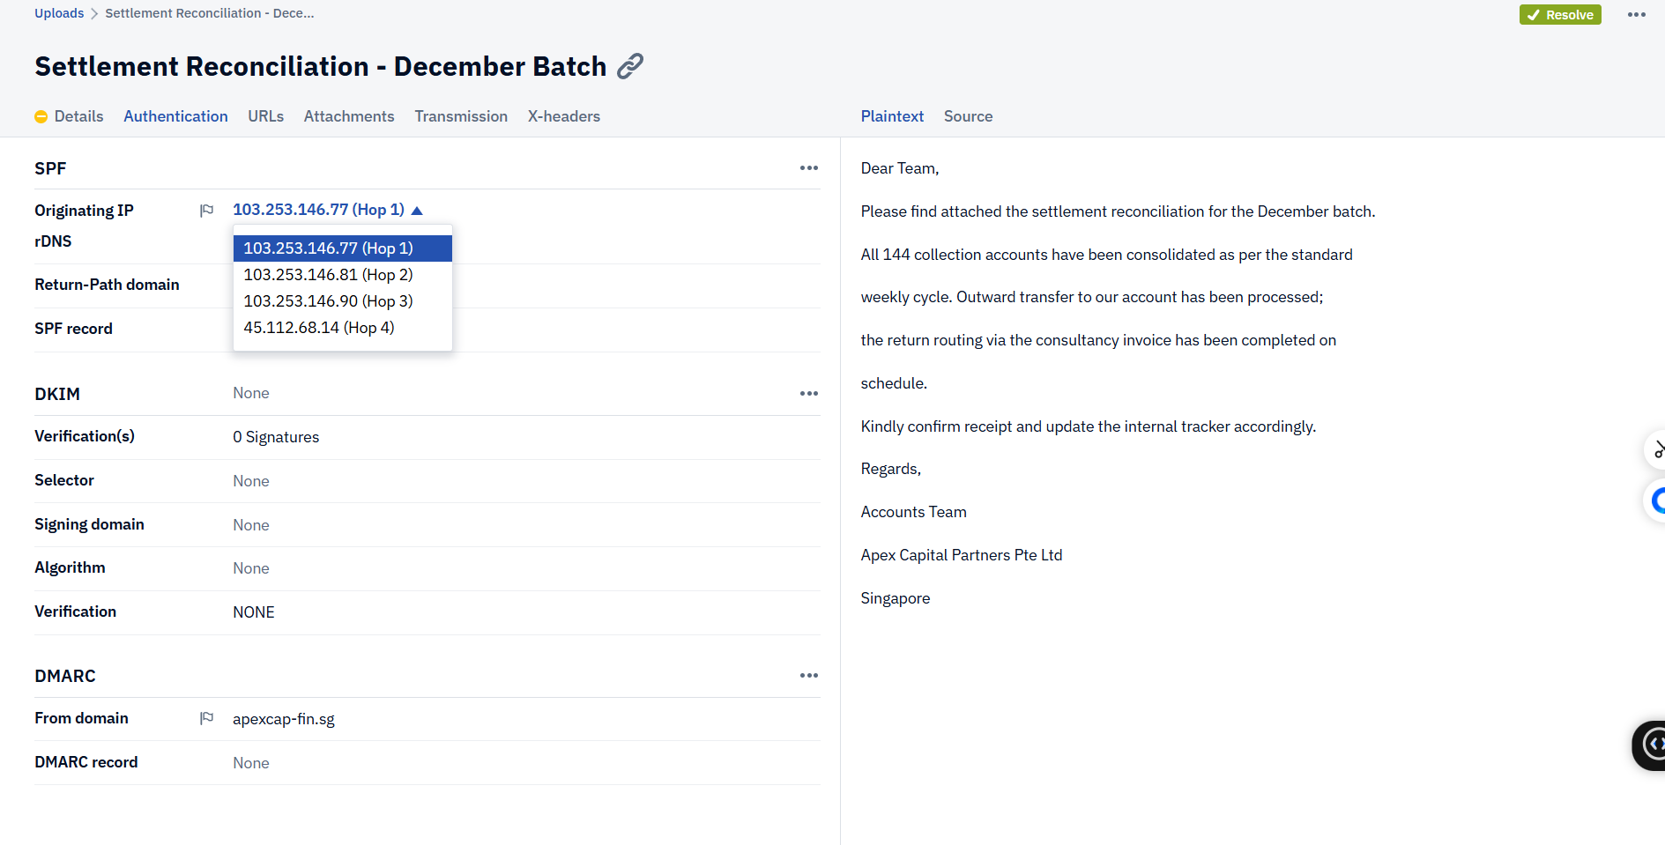
Authentication Results

Description
The authentication results indicate that while SPF was recorded for the Hop 1 IP, both DKIM and DMARC returned a result of “None”. This shows that the email lacks DKIM signatures and DMARC policies, meaning its cryptographic authenticity cannot be fully verified.

Item 7 — Attachment Analysis

📷 Screenshot
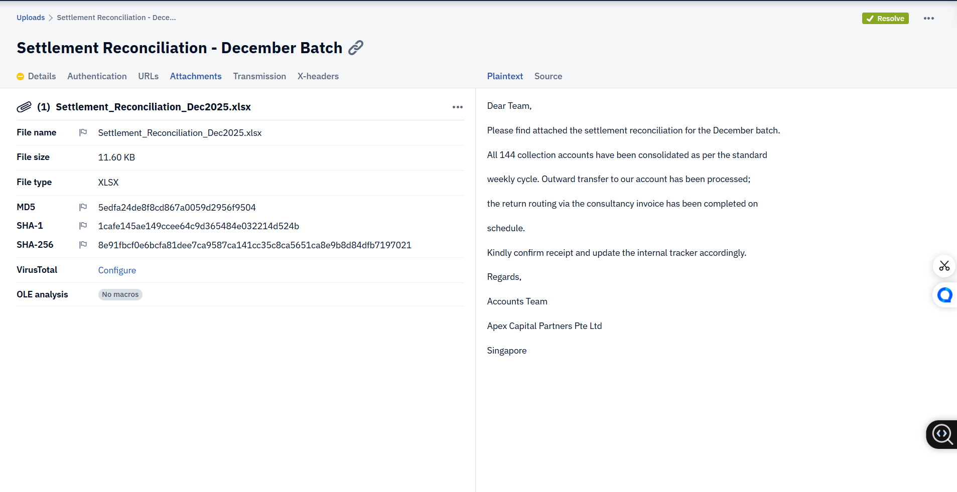
Attachment Analysis

Description
The email contains an attached spreadsheet named Settlement_Reconciliation_Dec2025.xlsx. This file is highly relevant to the investigation as it likely contains the consolidated collection accounts and financial transaction details mentioned in the email body.

Item 8 — CC Field Finding

📷 Screenshot
CC Field Finding

Description
The CC field establishes that vikrant.sable@bhavanatech.in was included as a copied recipient on the communication. However, this only shows they received a copy and does not establish that they read the email, approved it, or actively participated in the transaction.

CFT Findings
CFT{S1NG@P0R3_L1nk_C0Nf1rm3d}
CFT{103.253.146.77}
CFT{4_HOPS_HOP_4_IS_ORIGIN}

