Experiment 6: Memory Forensics Report
Name: Sujal Wasnik Roll No: 23015036 Hostname: sujal Evidence: Vikrant-Sable-Laptop-RAM.raw (256 MB, Linux 6.8.12), analysed with Volatility 3 (v2.28.2)

Item 1: Hash Verification
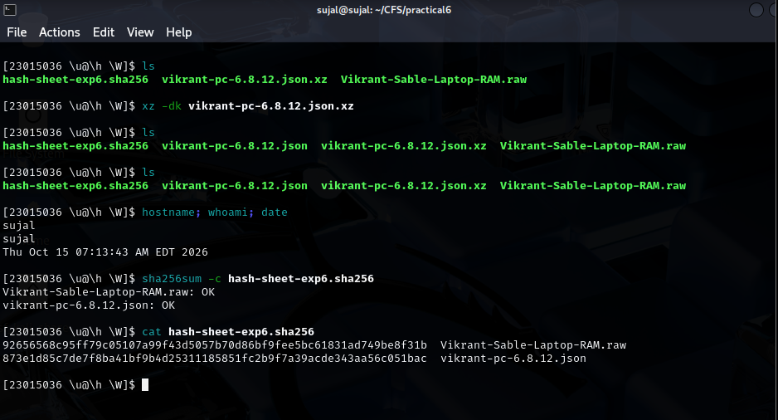
Description:
I ran sha256sum -c against hash-sheet-exp6.sha256 and both the RAM image and the symbol file (after extracting the .json from the .xz) showed OK. This has to be done before any analysis, because if the evidence had changed even slightly, every result after it would be unreliable and I could not prove the exhibit was untouched.

Item 2: Symbol File Setup
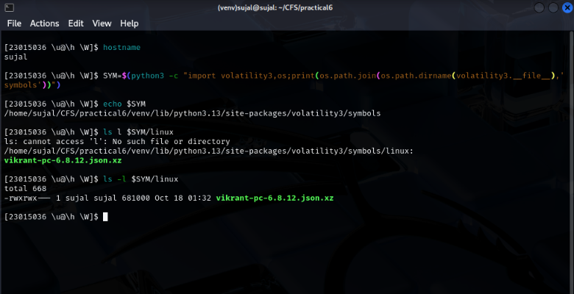
Description:
The symbol file vikrant-pc-6.8.12.json.xz is in the linux folder of Volatility's symbols directory (first screenshot, the ls -l listing; my first ls had a typo and the second one worked). banners.Banners then found the Linux 6.8.12 kernel banner, and the linux.* plugins ran with no symbol error, which is how I knew it was recognised. Without it Volatility cannot read the kernel's data structures, so pslist, pstree and psaux would fail.

Item 3: Process List
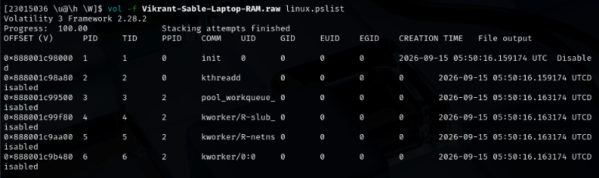
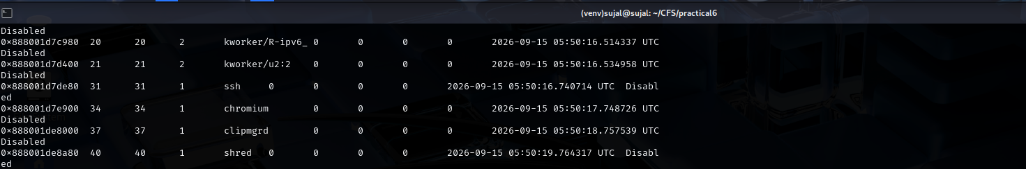
Description:
linux.pslist shows everything alive when the RAM was captured, with PID, PPID and start time. The first screenshot shows the start of the list (init and the kernel threads) and the second shows the end, with four user processes: ssh (31), chromium (34), clipmgrd (37) and shred (40), started about one second apart at 05:50:16 to 05:50:19 on 2026-09-15. It is the starting point because every later check uses these PIDs.

Item 4: Session vs. Background Processes
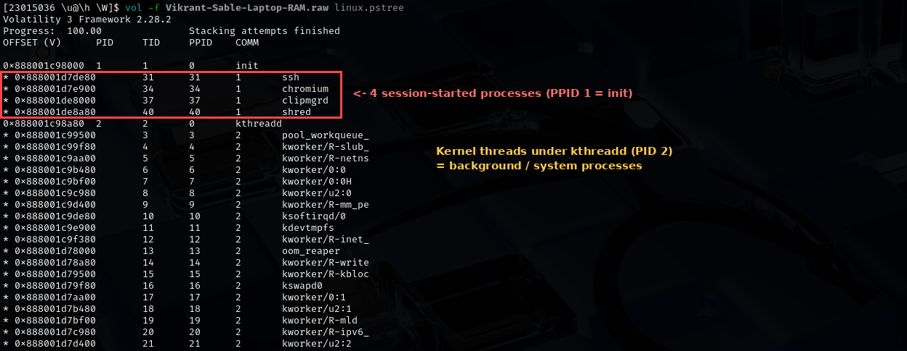
Description:
In pstree the kernel workers all hang under kthreadd (PID 2), which is background housekeeping. Four processes (ssh, chromium, clipmgrd, shred) sit directly under init (PID 1) and are ordinary programs, so I counted them as the session processes. Their start times being one second apart supports that they were launched by hand right before the capture.

Item 5: Command-Line Evidence
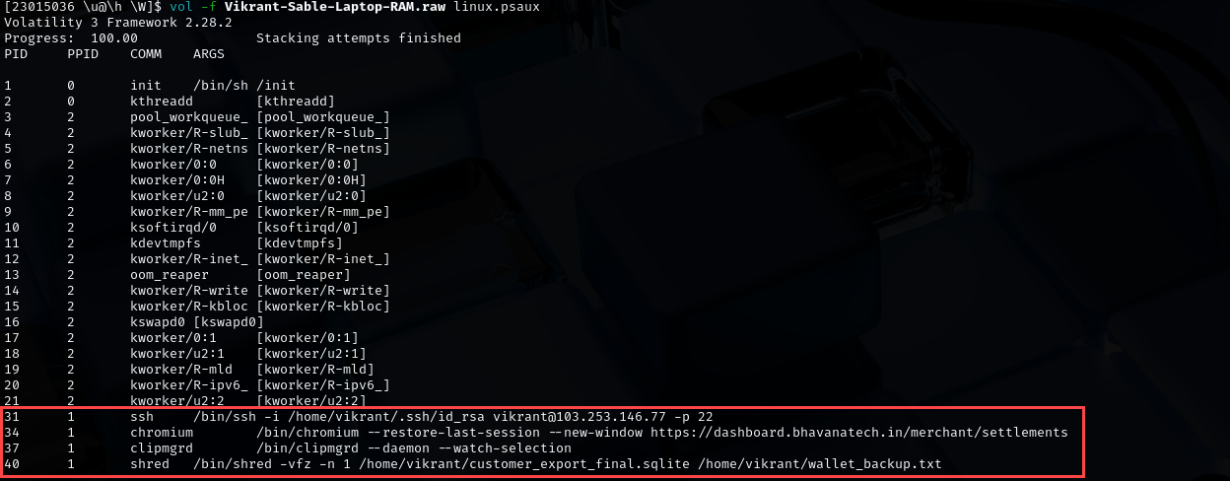
Description:
ssh uses the key id_rsa to connect to vikrant@103.253.146.77 on port 22. chromium was reopened on https://dashboard.bhavanatech.in/merchant/settlements. clipmgrd runs as a clipboard daemon. shred -vfz -n 1 was erasing customer_export_final.sqlite and wallet_backup.txt. I flagged all four, with ssh, shred and clipmgrd as the most significant.
Note on CTF Question 4 (browser panel)
The chromium command line shows the open page was https://dashboard.bhavanatech.in/merchant/settlements, so the panel is Settlements in the merchant dashboard. I confirmed this with linux.psaux --pid 34 and a strings search of the image, which showed the same URL and nothing longer. I submitted it as CFT{merchant_settlements}, but the platform marked it incorrect, so I am recording the evidence here.

Item 6: IP Cross-Reference with Experiment 5
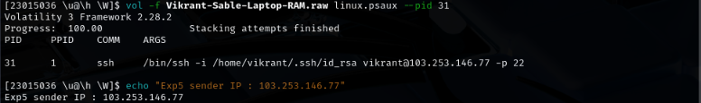
Description:
The SSH target in the psaux line for PID 31 is 103.253.146.77, and the sender IP from Experiment 5 is the same address, so it matches. This links the laptop to the same infrastructure that sent the email. On its own it does not show who was typing, that the owner sent the email, or what was exchanged, because the address could be a shared server or relay.

Item 7: Environment Variable Finding
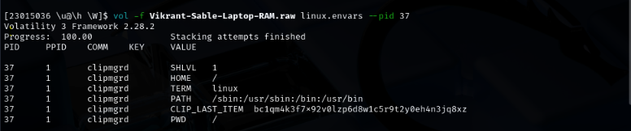
Description:
Running linux.envars on clipmgrd (PID 37) recovered CLIP_LAST_ITEM = bc1qm4k3f7x92v0lzp6d8w1c5r9t2y0eh4n3jq8xz, a value formatted like a Bitcoin wallet address that was copied but never pasted or saved to a file. It carries weight because it came straight from live memory, which is lost at power-off, and it shows what was on the clipboard at the moment of seizure.

Item 8: Proof Table Entry
Artefact | What it establishes | What it does NOT establish
SHA-256 check (sha256sum -c) | The RAM image and symbol file match the reference hash sheet, so the exhibit is unaltered since the sheet was made. | That the memory was captured correctly, or that nothing changed before the hashes were taken.
pstree / pslist | Four hand-started processes (ssh, chromium, clipmgrd, shred) were alive at capture, started about one second apart. | Who launched them or why. All show PPID 1.
ssh command line | A key-based connection to 103.253.146.77 on port 22 was being made as vikrant. | Who was at the keyboard, what was transferred, or whether the login succeeded.
SSH IP vs Experiment 5 sender IP | The laptop was connecting to 103.253.146.77, the same address the Experiment 5 email came from. | Who was typing, that the owner sent the email, or what was exchanged. A shared server or relay could explain a match.
shred command line | Erasure of customer_export_final.sqlite and wallet_backup.txt was in progress at capture. | That the erasure finished, what the files contained, or the intent behind it.
chromium command line | A browser was opened on dashboard.bhavanatech.in/merchant/settlements. | That anyone logged in, or what was viewed or changed there.
clipmgrd envars (CLIP_LAST_ITEM) | A wallet-style address was held on the clipboard at capture. | Who owns the wallet, or that any payment was made.
No separate screenshot is attached for this item; the completed proof table is typed directly above.
Description:
The table lists each artefact, what it establishes and what it does not. For example, the shred line shows a deletion was in progress but not that it finished or what the files held, and the clipboard value shows data was held in memory but not who owns the wallet. Each artefact supports only a narrow claim, so they have to be read together with other evidence.

