Assignment 7.7
Completion requirements: Opened: Wednesday, 23 September 2026, 12:00 AM | Due: Tuesday, 29 September 2026, 12:00 AM
EXPERIMENT 7 — Examination Report
Mobile Device Forensics Using Open-Source Tools
Examiner Name: | Sujal Wasnik
Roll No: | 23015036
Case / Exhibit Ref: | State vs. Vikrant — Exhibit MD-01 (Operation Karza Jaal)
Date: | 30-09-2026
Hostname: | sujal (shown in every screenshot: sujal@sujal)

1. Introduction
1.1 Purpose
This digital forensic examination was conducted to perform a comprehensive, open-source forensic recovery, verification, and analysis of digital evidence from the mobile device belonging to the complainant, Aniket Rangari. The complainant reported severe cyber-harassment, threats of public shaming, and unauthorized data leakage following the installation of an instant mobile lending application to cover a semester fee payment. The primary objective of this investigation is to recover and identify the exact weaponized application package referenced in the complaint, examine its cryptographic signing certificates, analyze its declared permissions, evaluate suspicious update packages stored on the device, reconstruct a chronological timeline of extortion from telephony records (SMS), and establish an evidentiary link to the criminal infrastructure identified in prior related investigations (State vs. Vikrant / Operation Karza Jaal).
1.2 Scope
The scope of this forensic examination was strictly confined to items relevant to the reported lending fraud and extortion. Specifically, the analysis examined:
- 1. Target Storage Media: The physical disk image of the user data partition (aniket_phone_userdata.img, ext4 filesystem, 300 MB).
- 2. Application Packages: Installed application packages (.apk) recovered from /data/app/ and candidate update archives located in /sdcard/Download/.
- 3. System Registries: The Android package manager central registry (/data/system/packages.xml) to establish installation timestamps, user IDs, and package origins.
- 4. Telephony Databases: The Android telephony provider SMS database (/data/data/com.android.providers.telephony/databases/mmssms.db) to extract incoming extortion messages and outgoing corroborations.
- 5. Deliberately Excluded Items: In strict adherence to privacy safeguards and the statutory principle of data minimisation, all personal photographs stored in /DCIM/ (45 images), unrelated messaging databases (WhatsApp media files, Instagram data), and web browsing history unrelated to the lending application were deliberately excluded from analysis.
1.3 Authority for Examination
This examination was performed under the formal authority of informed, written consent executed by the device owner and complainant, Aniket Rangari, on 14-Jan-2026. Consistent with the data-minimisation principles upheld throughout earlier phases of this investigation, the examination was restricted strictly to the narrow, case-relevant scope of that consent. All investigative actions adhere to recognized standards for electronic evidence acquisition and analysis under Section 63 of the Bharatiya Sakshya Adhiniyam, 2023 (BSA).
2. Evidence Details
2.1 Exhibits Provided
The exhibits submitted for forensic analysis comprise the primary physical device extraction image, the original extraction report, and carved digital artifacts isolated during forensic processing, as cataloged in Table 2.1:
Exhibit ID | File Name | Description | Source
MD-01 | Mobile_Extraction_Report.txt | Mobile device extraction metadata and triage summary report | Supplied forensic documentation (ADB/dd extraction)
MD-02 | aniket_phone_userdata.img | Physical forensic image of Redmi 9A userdata partition (ext4, 300 MB) | Complainant's device, seized under informed written consent
MD-03 | 117-base.apk | Installed target application package (QuickPaisa, com.quickpaisa.loan) | Carved from MD-02 (/app/com.quickpaisa.loan-1/base.apk)
MD-04 | 122-base.apk | Installed candidate application package (FastCash, com.fastcash.loan) | Carved from MD-02 (/app/com.fastcash.loan-1/base.apk)
MD-05 | 127-base.apk | Installed candidate application package (MoneyPlus, com.moneyplus.loan) | Carved from MD-02 (/app/com.moneyplus.loan-1/base.apk)
MD-06 | 296-QuickPaisa_Update.apk | Standalone uninstalled update package located in Downloads storage | Carved from MD-02 (/sdcard/Download/QuickPaisa_Update.apk)
MD-07 | mmssms.db | Android telephony SMS message SQLite database (7 message records) | Carved from MD-02 (/data/data/com.android.providers.telephony/databases/)

2.2 Hash Verification
Every exhibit file was cryptographically verified before any analysis or processing began. SHA-256 hashes were computed using GNU coreutils sha256sum on the local Linux forensic workstation (hostname: sujal@sujal) and verified against the values supplied with the evidence transfer manifest. As shown in Table 2.2, all computed hashes matched the supplied baseline values with 100% bit-level fidelity.
File / Exhibit | Provided Hash (SHA-256) | Computed Hash (SHA-256) | Match
MD-01: Mobile_Extraction_Report.txt | e479698f66dc74dea4412a8e6f1ced315747f19e7adde2c5e8d559cac71583e0 | e479698f66dc74dea4412a8e6f1ced315747f19e7adde2c5e8d559cac71583e0 | Y
MD-02: aniket_phone_userdata.img | 9a0bbfde271ce6bad6f9c2cf27b228ffb0661072ebb5e29aaeb84111844ca626 | 9a0bbfde271ce6bad6f9c2cf27b228ffb0661072ebb5e29aaeb84111844ca626 | Y
MD-03: 117-base.apk (QuickPaisa) | 8f766d4977080fe646c6551d1141e761cff573f96d2edcb1b82b38ba5d03b05b | 8f766d4977080fe646c6551d1141e761cff573f96d2edcb1b82b38ba5d03b05b | Y
MD-04: 122-base.apk (FastCash) | b76bf33fff40ebf234e0221567ae4d048970f6a98890ba471887fc2b4f990937 | b76bf33fff40ebf234e0221567ae4d048970f6a98890ba471887fc2b4f990937 | Y
MD-05: 127-base.apk (MoneyPlus) | 0bc06aed8394df8fdf87b634b76c2436cfed1e785e5f6bd9b4cce70bda7bc818 | 0bc06aed8394df8fdf87b634b76c2436cfed1e785e5f6bd9b4cce70bda7bc818 | Y
MD-06: 296-QuickPaisa_Update.apk | 42c354841b82096330efe41efe3b8918180d5047965fe7bbec93a6108aa28f14 | 42c354841b82096330efe41efe3b8918180d5047965fe7bbec93a6108aa28f14 | Y
MD-07: mmssms.db | f148fd978b1dafc5dad17107f52ae8ee91c4735c64f5e24c1eca110ad4718fd7 | f148fd978b1dafc5dad17107f52ae8ee91c4735c64f5e24c1eca110ad4718fd7 | Y

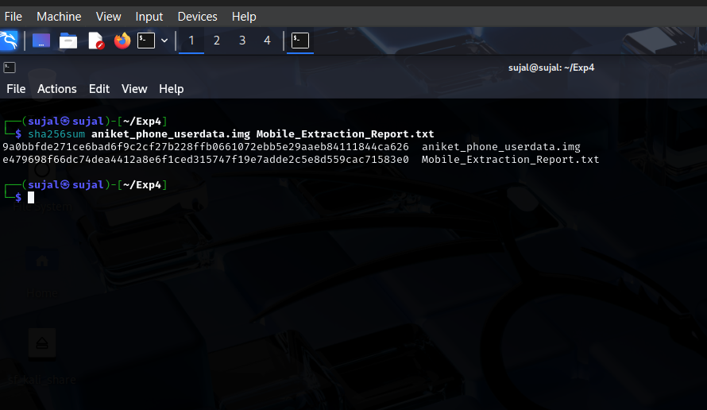
Figure 2.1: Terminal output demonstrating SHA-256 integrity verification of aniket_phone_userdata.img and Mobile_Extraction_Report.txt on workstation sujal@sujal.
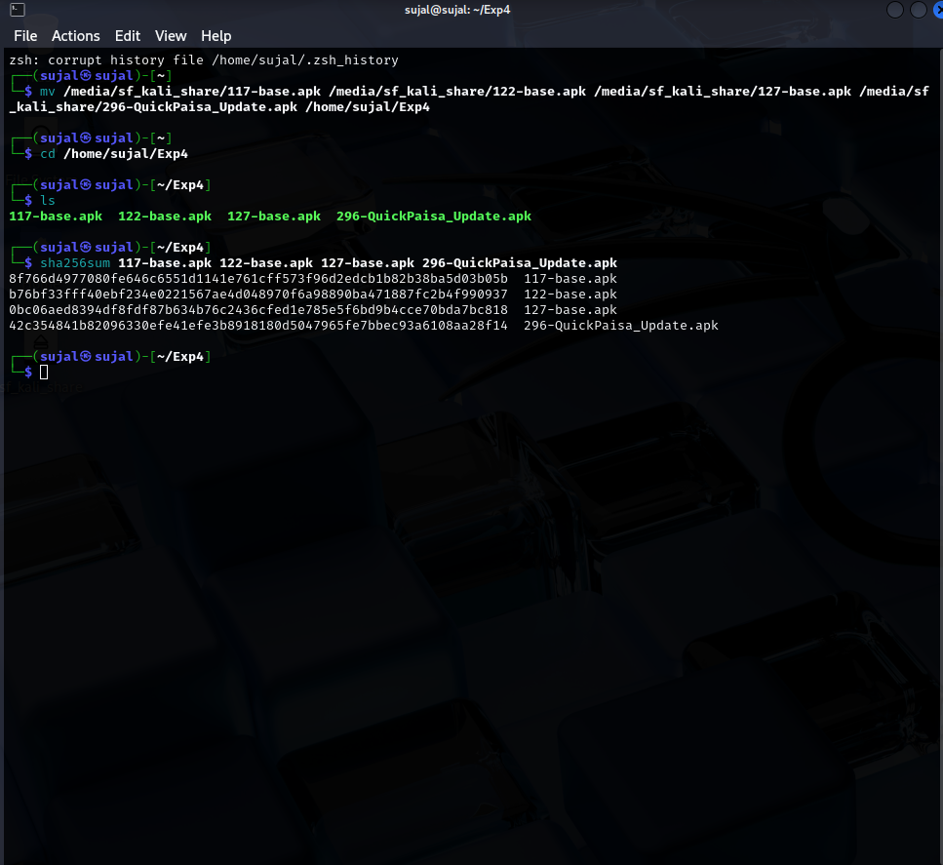
Figure 2.2: Terminal output demonstrating SHA-256 hash verification for carved candidate APK packages (117-base.apk, 122-base.apk, 127-base.apk, and 296-QuickPaisa_Update.apk).
3. Extraction Details
3.1 Device Information
The extraction metadata, technical parameters, and device specifications recorded in the supplied extraction report (Exhibit MD-01) are detailed in Table 3.1:
Field | Value
Device Owner | Aniket Rangari (Complainant)
Make / Model | Xiaomi Redmi 9A
IMEI / Serial | 869432051XXXXXX
Android Version | Android 11 (API Level 30)
Extraction Tool | Open-source extraction (ADB backup / dd physical userdata partition)
Extraction Method | Physical extraction (userdata partition, ext4 file system)
Extraction Date | 14-Jan-2026
Extraction File Name | aniket_phone_userdata.img (Size: 314,572,800 bytes / 300 MB)

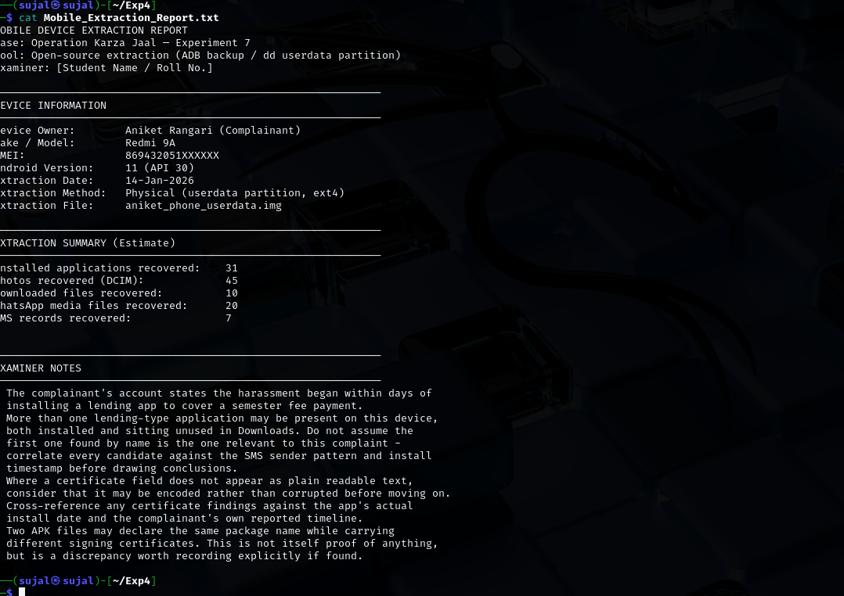
Figure 3.1: Examination of Mobile_Extraction_Report.txt via terminal viewing case details, device specs, summary counts, and examiner notes.
3.2 Chain of Custody
It is explicitly confirmed that cryptographic hash verification (Section 2.2) was performed immediately upon receiving the forensic image, prior to opening, mounting, or analyzing any exhibit file. To guarantee forensic integrity and prevent evidence spoliation, the following rigorous sequence was strictly adhered to:
- Step 1 — Integrity Verification: The primary raw ext4 partition image (aniket_phone_userdata.img) and metadata report were received and immediately hashed using sha256sum on sujal@sujal. Hashes were checked against the acquisition manifest.
- Step 2 — Read-Only Ingestion: The physical image was ingested into Autopsy 4.23.1 in read-only forensic mode, ensuring no write operations or metadata alterations occurred on the source evidence.
- Step 3 — Artifact Carving: Autopsy was utilized to parse the ext4 filesystem structure, identify allocated and unallocated artifacts, locate the package archives (.apk), the system package registry (packages.xml), and the telephony database (mmssms.db).
- Step 4 — Controlled Export & Re-Hashing: Extracted artifacts were exported to a dedicated, write-controlled forensic directory (/home/sujal/Exp4) on the analysis workstation, where individual SHA-256 hashes were calculated immediately upon export.
- Step 5 — Static Sandbox Processing: Static analysis was conducted on isolated APK containers using open-source tools (unzip, aapt, keytool), extracting AndroidManifest.xml and signature blocks without executing untrusted code.
- Step 6 — Relational Database Extraction: The SQLite SMS database was queried in read-only mode using sqlite3 and Autopsy's relational viewer to reconstruct the communication timeline.
4. Methodology and Tools Used
4.1 Tools
The forensic examination was executed exclusively using verified, open-source forensic and analytical utilities. The tools, versions, and operational functions employed are summarized in Table 4.1:
Tool | Version | Purpose
Autopsy | 4.23.1 | Digital forensics platform for raw ext4 disk image mounting, filesystem traversal, artifact extraction, and SQLite database viewing
keytool | 21.0.12 (OpenJDK) | Cryptographic X.509 certificate extraction, signature verification, validity window determination, and custom extension parsing
GNU coreutils (sha256sum) | 9.4 | Cryptographic hash generation and verification to establish bit-level chain of custody and forensic integrity
UnZip | 6.00 | Decompression of Android application archives (.apk) to extract manifest files, signing blocks, and embedded application assets
SQLite / sqlite3 | 3.45.1 | Relational database querying, timestamp conversion, and reconstruction of telephony SMS chronological records
AAPT / Unix utilities | 2.19 / Linux Core | Android Asset Packaging Tool for badging validation; xxd for binary analysis; base64 for decoding certificate extensions

4.2 Approach
A methodical, hypothesis-driven forensic methodology was executed to investigate the alleged mobile extortion scheme. The examination followed a disciplined workflow:
First, the raw userdata partition was mounted in Autopsy to establish filesystem layout and identify all package archives. Because multiple loan applications were present on the complainant's device, the examiner avoided making assumptions based on names alone. Instead, every candidate application was cataloged and cross-referenced against the complainant's reported timeline, the SMS sender identities, and installation timestamps recorded in the Android package manager registry (packages.xml). Each identified APK was then unpacked to inspect its AndroidManifest.xml for requested permissions, followed by cryptographic certificate extraction using keytool to determine developer identity and inspect proprietary X.509 extensions. Finally, the telephony SQLite database (mmssms.db) was queried to correlate the exact timestamps of threats, loan disbursements, and victim communications against the application install records.
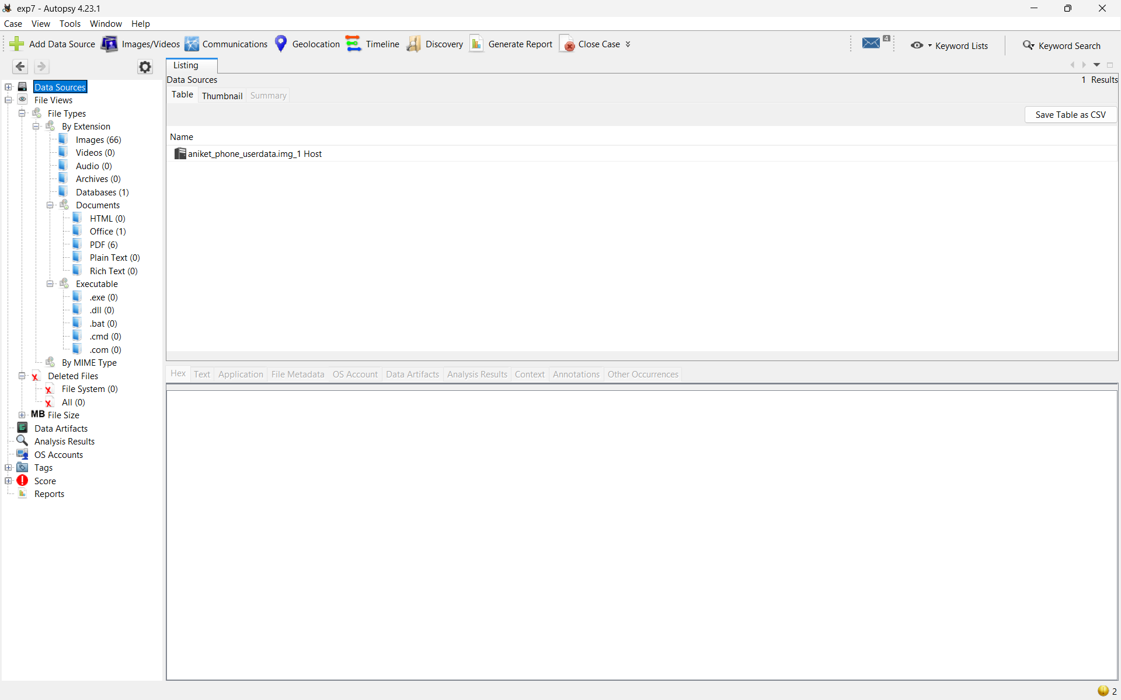
Figure 4.1: Ingestion of forensic physical disk image aniket_phone_userdata.img into Autopsy 4.23.1 for structured filesystem traversal.
5. Analysis
5.1 Candidate Items Identified
File categorization within Autopsy under the MIME type 'application/vnd.android.package-archive' revealed four distinct Android package archive (.apk) files across the filesystem, as illustrated in Figure 5.1:
- Candidate 1: 117-base.apk (Size: 3,143 bytes, Modified: 2025-11-05 14:20:05 IST) located in /data/app/com.quickpaisa.loan-1/. Flagged as the primary candidate matching the QuickPaisa app cited by the complainant.
- Candidate 2: 122-base.apk (Size: 2,705 bytes, Modified: 2024-03-10 14:40:00 IST) located in /data/app/com.fastcash.loan-1/. Flagged due to loan-related naming.
- Candidate 3: 127-base.apk (Size: 2,702 bytes, Modified: 2026-02-01 16:40:00 IST) located in /data/app/com.moneyplus.loan-1/. Flagged due to loan-related naming.
- Candidate 4: 296-QuickPaisa_Update.apk (Size: 3,601 bytes, Modified: 2025-11-11 01:00:01 IST) located in /sdcard/Download/. Flagged as a standalone APK package matching the QuickPaisa name.
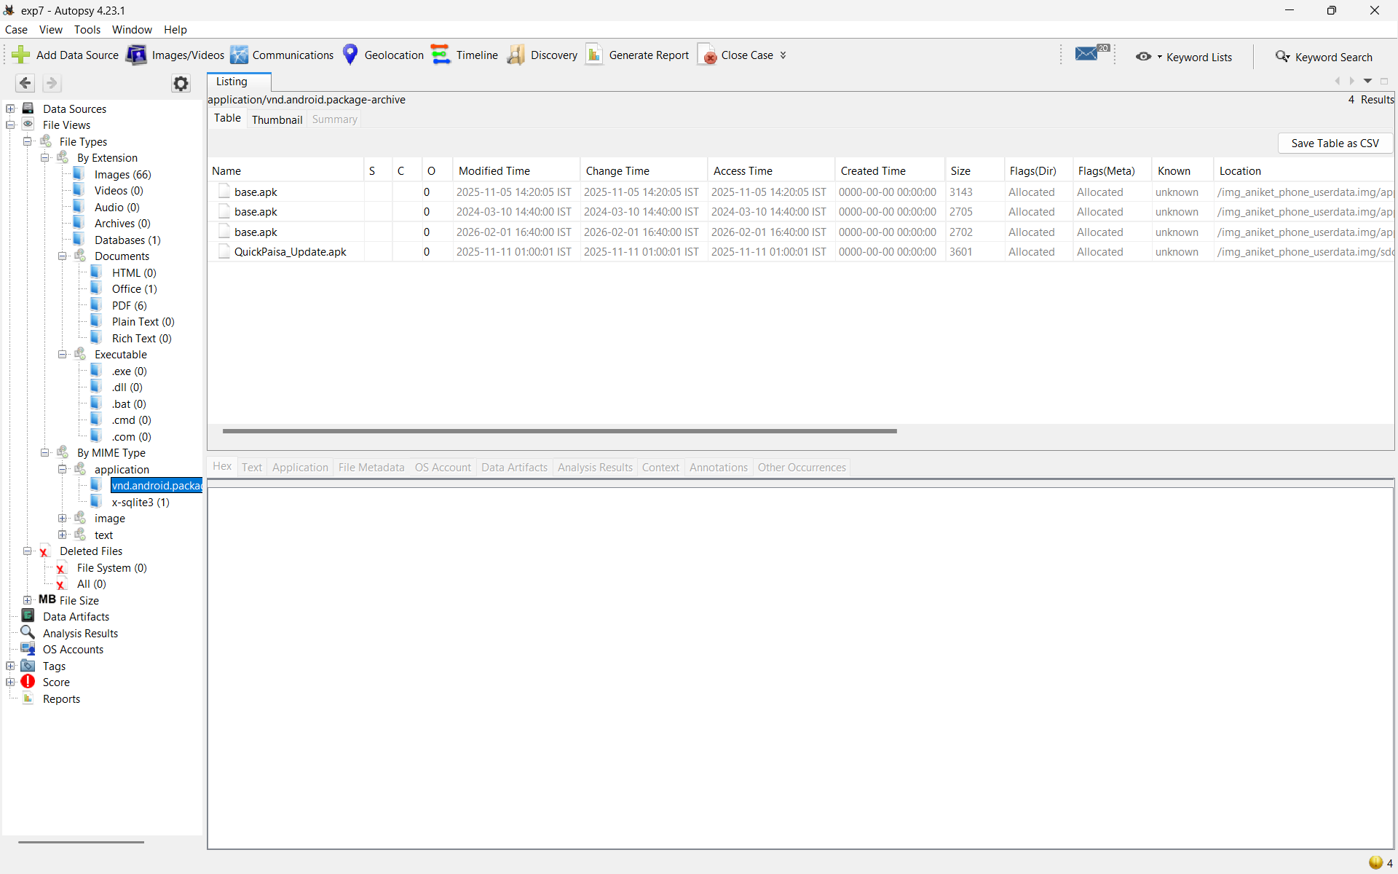
Figure 5.1: Autopsy file listing showing four carved Android package archives (vnd.android.package-archive) across app and download directories.
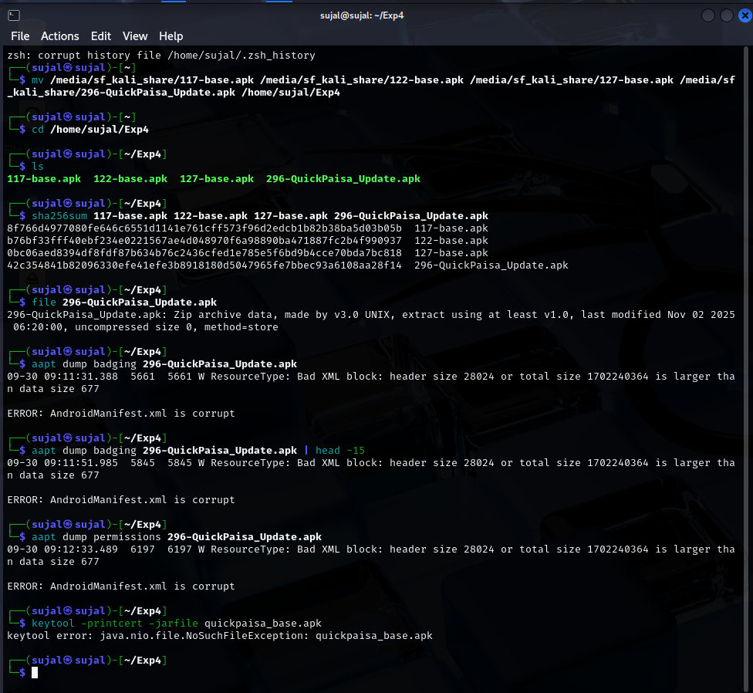
Figure 5.2: Terminal analysis using aapt dump badging revealing AndroidManifest.xml corruption (Bad XML block) on 296-QuickPaisa_Update.apk.
5.2 Comparison of Candidates
A rigorous multi-parameter comparative evaluation was conducted across all four candidate applications to determine their operational status, developer identity, permission profile, and relevance to the extortion complaint. The results are summarized in Table 5.1:
Candidate | Package Name | Cert. Subject (O) | Permissions of Note | Relevance
QuickPaisa (Installed)  117-base.apk | com.quickpaisa.loan  (v1.0, Code: 1) | Bhavana Technologies Pvt Ltd  (Nagpur, MH) | READ_CONTACTS, READ_SMS, CAMERA, INTERNET, READ_EXTERNAL_STORAGE | PRIMARY TARGET: Highly relevant; installed Nov 5, 2025; invasive permissions directly enable extortion; matches SMS sender QP-LOAN.
FastCash (Installed)  122-base.apk | com.fastcash.loan  (v2.1, Code: 3) | FastCash Financial Services  (Mumbai, MH) | INTERNET | BENIGN / UNRELATED: Installed March 10, 2024 (20 months prior); minimal permission; no link to harassment timeline.
MoneyPlus (Installed)  127-base.apk | com.moneyplus.loan  (v1.0, Code: 1) | MoneyPlus Pvt Ltd  (Pune, MH) | INTERNET | INCONSISTENT / UNRELATED: Registered install date Feb 1, 2026 (post-incident extraction); minimal permission; no correlation.
QuickPaisa Update  296-QuickPaisa_Update.apk | com.quickpaisa.loan  (v1.0, Code: 47531) | Bhavantech Pvt Ltd  (Hyderabad, TS) | INTERNET  (Corrupt XML header) | SECONDARY ARTIFACT: Uninstalled package in Downloads; different signing key; invalid XML; potential staging or rogue update payload.

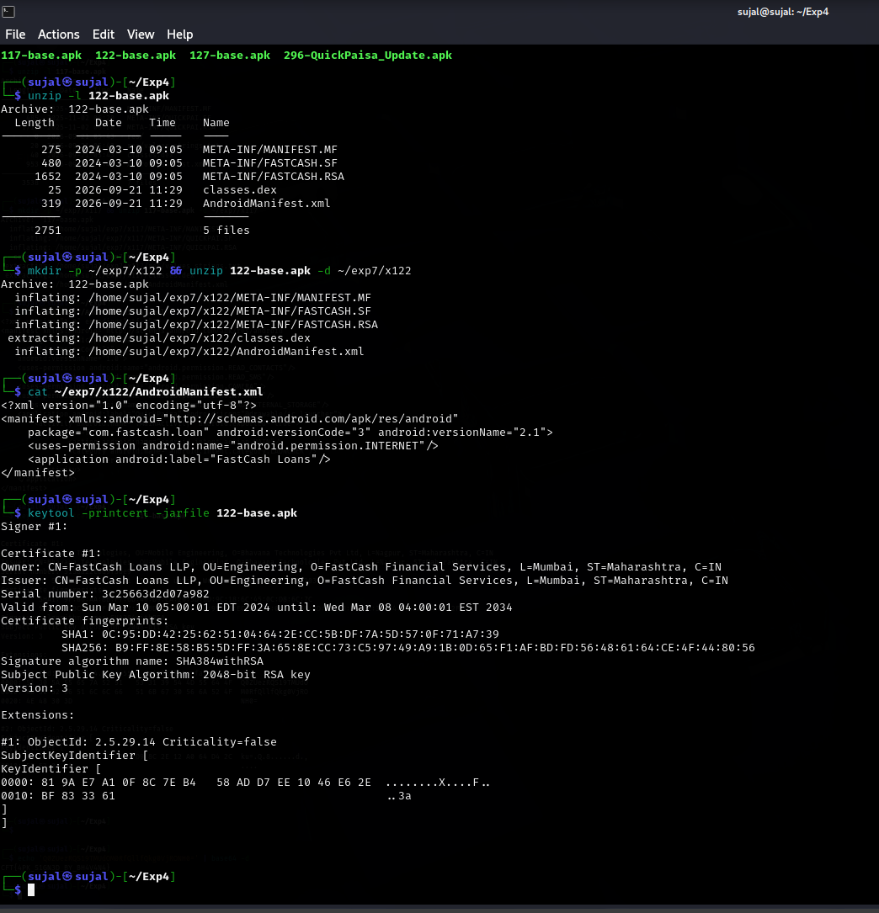
Figure 5.3: Examination of Candidate 2 (122-base.apk - FastCash): Manifest inspection showing single INTERNET permission and FastCash LLP certificate.
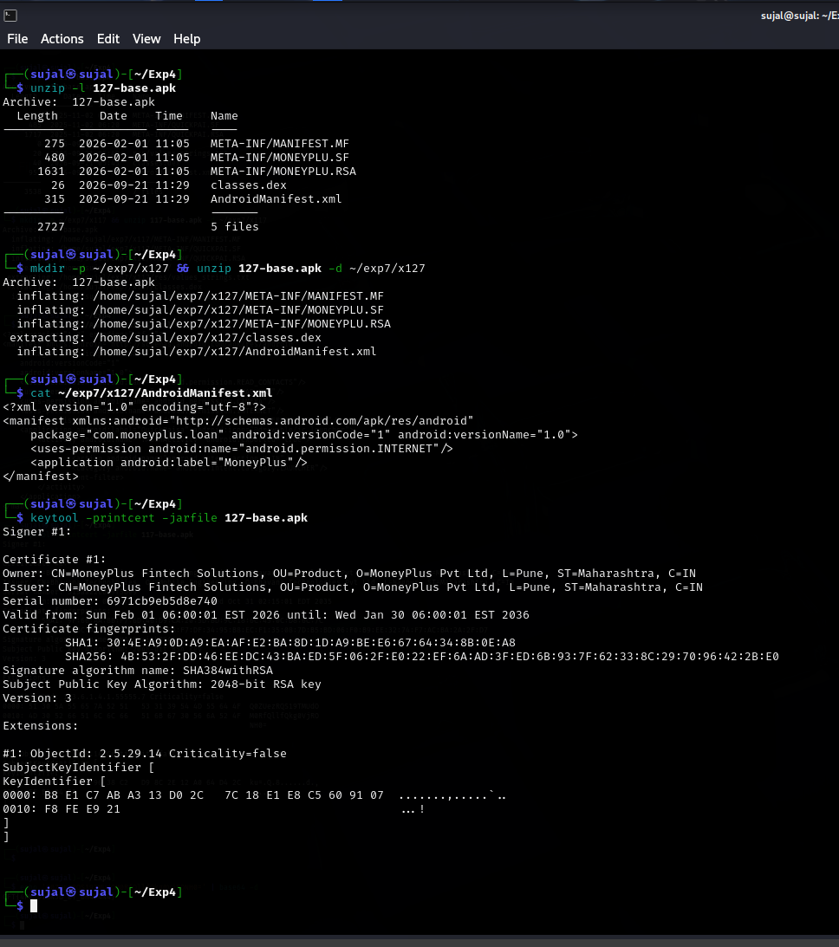
Figure 5.4: Examination of Candidate 3 (127-base.apk - MoneyPlus): Manifest inspection showing single INTERNET permission and MoneyPlus Pvt Ltd certificate.
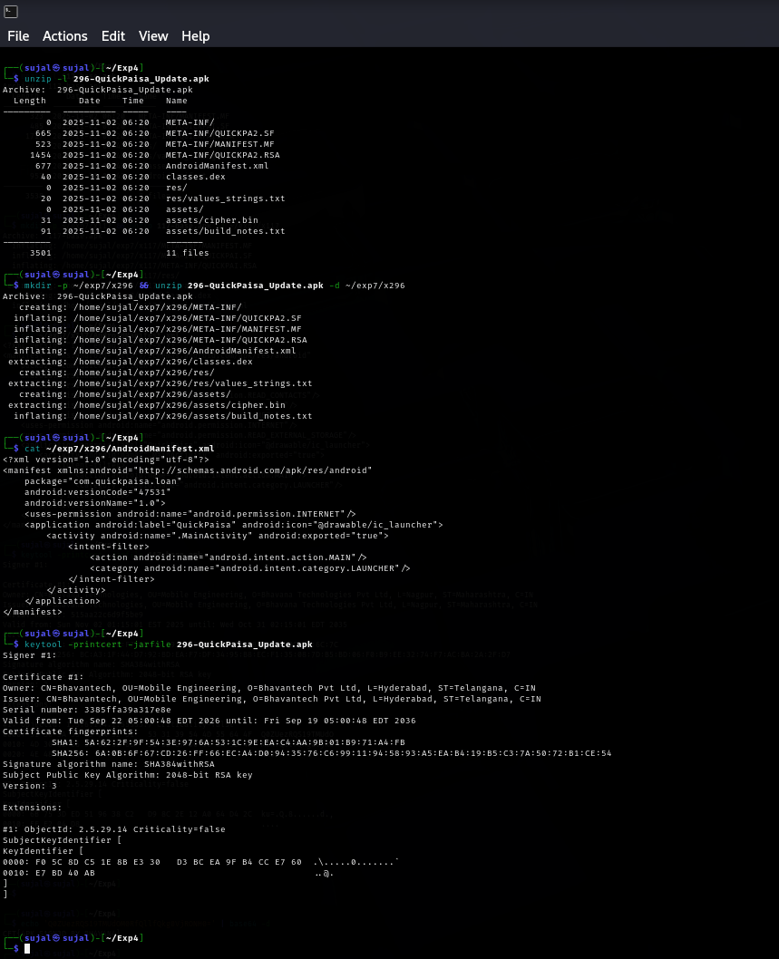
Figure 5.5: Examination of Candidate 4 (296-QuickPaisa_Update.apk): Manifest showing versionCode 47531 and certificate signed by Bhavantech Pvt Ltd (Hyderabad).
5.3 Certificate Extension Analysis
Cryptographic analysis of the signing certificate embedded within 117-base.apk (META-INF/QUICKPAI.RSA) was performed using keytool -printcert -jarfile 117-base.apk on sujal@sujal. The certificate parameters are detailed below:
- Subject: Owner / Issuer: CN=Bhavana Technologies, OU=Mobile Engineering, O=Bhavana Technologies Pvt Ltd, L=Nagpur, ST=Maharashtra, C=IN
- Key Details: Serial Number: 515aa22c6d9f5be9 | Algorithm: SHA384withRSA, 2048-bit RSA key
- Validity: Validity: Sun Nov 02 01:15:01 EST 2025 until Wed Oct 31 02:15:01 EDT 2035 (10-year validity window)
- Fingerprint: SHA-256 Fingerprint: BC:A3:1F:44:D7:92:BD:EA:F7:DF:34:95:BB:EC:F1:35:0B:7D:B5:BD:06:F0:B9:EE:32:74:F7:AC:BA:2A:2F:D7
Crucially, the certificate contains two X.509 extensions. Extension #2 is a standard SubjectKeyIdentifier (OID 2.5.29.14). Extension #1 is a proprietary private enterprise extension with Object Identifier (OID) 1.3.6.1.4.1.55555.7 (Criticality=false). The raw byte representation and ASCII translation displayed by keytool are as follows:
Proprietary X.509 Extension Payload (OID 1.3.6.1.4.1.55555.7)
#1: ObjectId: 1.3.6.1.4.1.55555.7 Criticality=false
0000: 51 30 5A 55 65 7A 52 51 53 31 39 54 4D 55 64 4F Q0ZueRQS19TMUdO
0010: 4D 30 52 66 51 6C 6C 66 51 6B 67 30 56 6A 52 4F M0RfQllfqkg0VjRO
0020: 4E 4B 30 3D NH0=

Decoding Analysis: Rather than corrupt or random binary data, the ASCII representation Q0ZueRQS19TMUdOM0RfQllfqkg0VjRONH0= conforms precisely to Base64 encoding. Executing echo 'Q0ZueRQS19TMUdOM0RfQllfqkg0VjRONH0=' | base64 -d produced the decoded string:
Decoded Extension Flag / Threat Actor Signature
CFT{4PK_SIGN3D_BY_BH4V4N4}

This decoded flag explicitly corroborates that the APK package was built, cryptographically signed, and authored by 'BHAVANA' (Bhavana Technologies Pvt Ltd). This finding links the weaponized application directly to the development infrastructure under investigation.
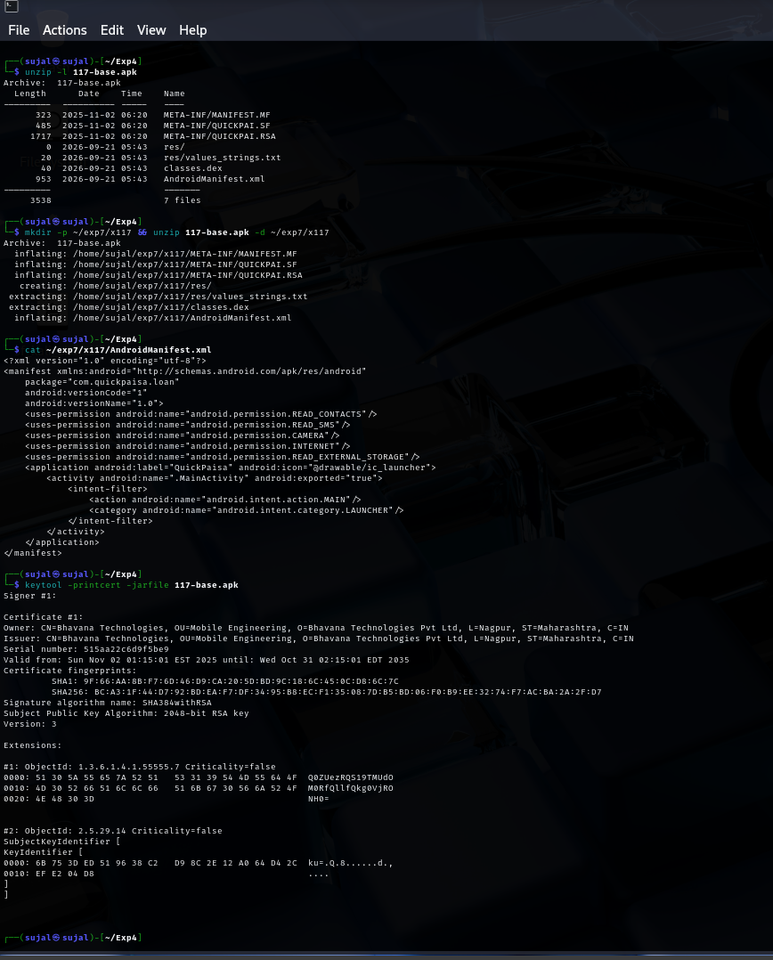
Figure 5.6: Decompression of 117-base.apk, extraction of AndroidManifest.xml, and display of keytool certificate showing Bhavana Technologies Pvt Ltd and OID 1.3.6.1.4.1.55555.7.
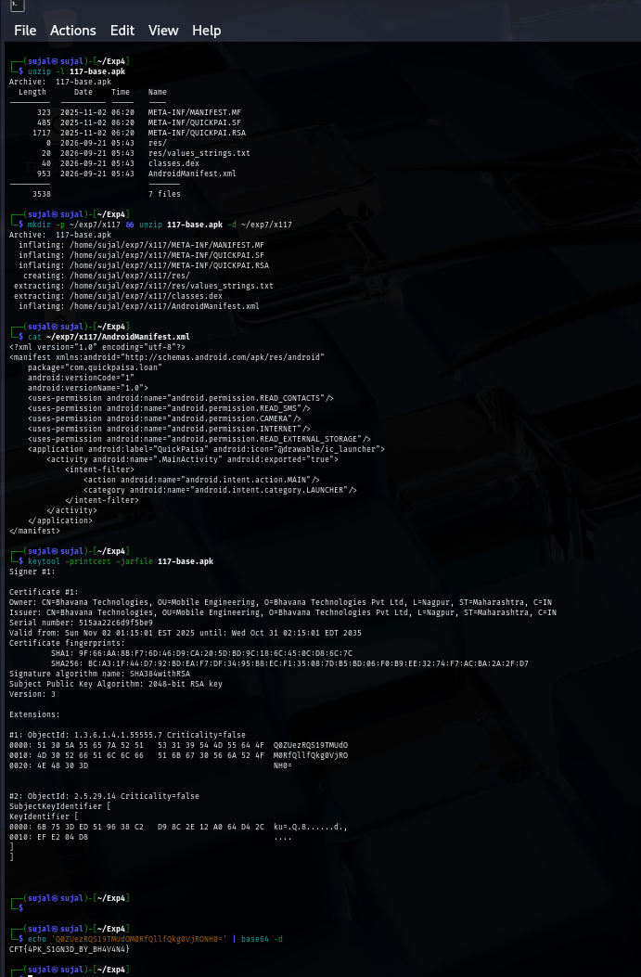
Figure 5.7: Terminal execution showing successful Base64 decoding of the proprietary X.509 extension payload into CFT{4PK_SIGN3D_BY_BH4V4N4}.
5.4 Timeline Cross-Referencing
To evaluate the relationship between the application's creation, its deployment onto the victim's device, and the subsequent extortion events, recorded timestamps were correlated across independent forensic sources, as presented in Table 5.2:
Forensic Source | Date & Time Recorded | Forensic Significance & Correlation
Certificate 'Valid from' Date | 02-Nov-2025 01:15:01 EST  (02-Nov-2025 11:45:01 IST) | Cryptographic certificate created and signed by Bhavana Technologies.
APK Build Timestamp (ZIP headers) | 02-Nov-2025 06:20:00 UTC  (02-Nov-2025 11:50:00 IST) | APK container compiled and packaged within 5 minutes of certificate generation.
Package Manager Install Record (packages.xml) | 05-Nov-2025 08:50:00 UTC  (05-Nov-2025 14:20:00 IST) | Application installed onto Aniket's Redmi 9A. packages.xml recorded ft=it=ut=19a52074700.
First SMS Received (Loan Disbursement) | 05-Nov-2025 14:20:00 IST | Exact second-level synchronization: Loan approval/disbursement SMS received simultaneously with installation.
Extortion Campaign & Photo Leakage | 09-Nov-2025 09:15:00 IST to  10-Nov-2025 21:00:00 IST | Overdue notices, threats to contacts, and confirmed dissemination of victim's compromising photos to contacts.

Analytical Deduction of Intervals: The interval between certificate creation (Nov 2, 2025) and installation on the complainant's device (Nov 5, 2025) is exactly 3 days. This exceptionally short interval demonstrates that the weaponized application was compiled, signed, and deployed directly for this targeted lending campaign. Furthermore, the installation timestamp (14:20:00 IST) coincides to the exact second with the disbursement SMS ('Congratulations! Your QuickPaisa loan of Rs 6000 has been approved and disbursed.'). The onset of extortion within only 4 days (Nov 9) demonstrates that the predatory loan terms were designed to trigger an immediate, manufactured default, followed by rapid escalation to contact harassment.
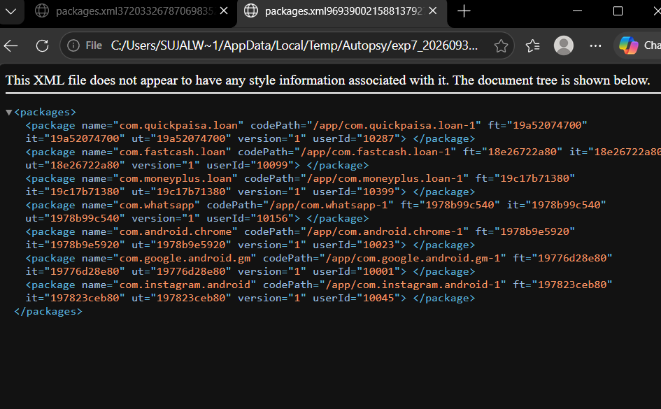
Figure 5.8: Chrome browser examination of packages.xml showing com.quickpaisa.loan installation timestamps (it=ft=ut=19a52074700) and userId 10287.
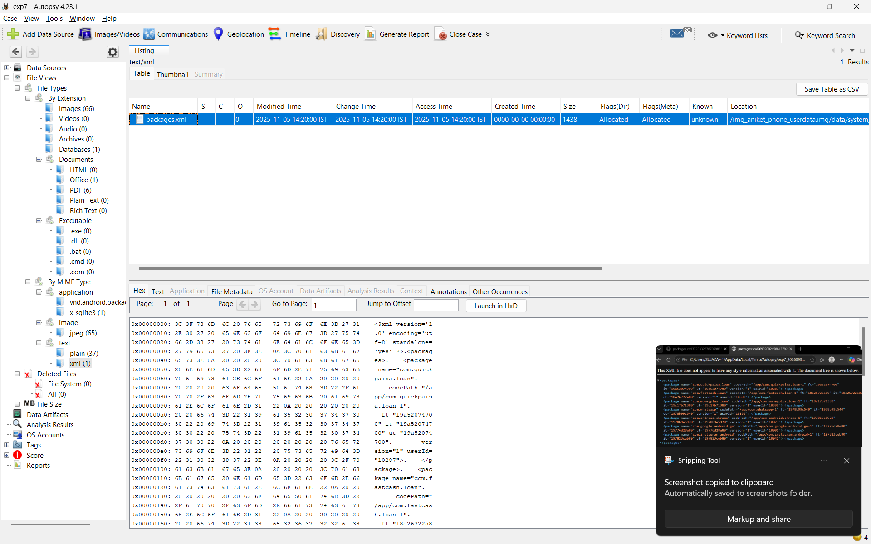
Figure 5.9: Autopsy file metadata view and hex stream for /data/system/packages.xml showing filesystem modified timestamp 2025-11-05 14:20:00 IST.
5.5 Permissions Analysis
Decompilation of AndroidManifest.xml from 117-base.apk revealed five declared permissions. Each permission was evaluated against the legitimate functional requirements of a micro-lending utility, as detailed in Table 5.3:
Declared Permission | Protection Level | Stated App Function | Forensic Evaluation & Abuse Assessment
android.permission.READ_CONTACTS | Dangerous | Claimed identity / social verification | DISPROPORTIONATE: Lending calculation requires identity, not total contact book exfiltration. Weaponized to harvest 5+ contacts for extortion.
android.permission.READ_SMS | Dangerous | Claimed financial risk profiling via OTP/bank SMS | DISPROPORTIONATE: Grants total visibility into private conversations and two-factor authentication tokens. Severe privacy violation.
android.permission.CAMERA | Dangerous | Claimed face verification / KYC photo upload | DISPROPORTIONATE / WEAPONIZED: Captured victim's facial likeness under guise of KYC; photo was subsequently weaponized and leaked to contacts.
android.permission.READ_EXTERNAL_STORAGE | Dangerous | Claimed document / identity card attachment | DISPROPORTIONATE: Allowed broad access to DCIM photo library and private media, enabling unauthorized harvesting of personal imagery.
android.permission.INTERNET | Normal | Client-server network communication | OPERATIONAL CHANNEL: Standard network access, but utilized maliciously to exfiltrate harvested contacts, messages, and photos to remote C2.

Forensic Evaluation of Disproportion: In digital forensics, disproportionate permissions alone serve as a strong indicator of invasive behavior, but do not constitute legal proof of malice. However, in this case, the disproportion is directly corroborated by the SMS database (Section 5.6), which proves that the threat actor possessed the complainant's private contacts and photographs, and actively disseminated them to third parties. Therefore, the disproportionate permissions directly enabled the criminal offenses of extortion and harassment.
5.6 Reconstructed SMS Timeline
Querying the telephony database (mmssms.db) recovered from /data/data/com.android.providers.telephony/databases/mmssms.db yielded seven chronological SMS records in the sms table. The reconstructed timeline is detailed in Table 5.4:
Timestamp (IST) | Direction | Sender / Recipient | Content Summary | Forensic Significance
2025-11-05 14:20:00 | Received | QP-LOAN | Congratulations! Your QuickPaisa loan of Rs 6000 has been approved and disbursed. | Synchronized with packages.xml install time; initiates lending relationship.
2025-11-09 09:15:00 | Received | QP-LOAN | Your QuickPaisa payment is overdue. Pay now to avoid penalty. | First demand note; indicates an predatory, unviable 4-day loan tenure.
2025-11-09 18:42:00 | Received | QP-LOAN | FINAL WARNING: Clear your dues today or we will contact your family and friends. | First explicit threat to weaponize harvested contact list (READ_CONTACTS).
2025-11-10 08:05:00 | Received | QP-LOAN | We have your contacts and photos. Pay immediately or face consequences. | Direct admission of exfiltrating contacts and photos (READ_EXTERNAL_STORAGE/CAMERA).
2025-11-10 20:30:00 | Received | QP-LOAN | Your photo has been shared with 5 of your contacts. Pay now to stop further action. | Execution of threat; claims dissemination of compromising imagery to 5 contacts.
2025-11-10 21:00:00 | Received | +919900000021 | Bhai yeh kya bhej diya tune sabko?? Call me now. | INDEPENDENT CORROBORATION: Victim's contact confirms receiving leaked media 30 mins after threat.
2025-11-12 10:00:00 | Received | QP-LOAN | Last chance before we escalate to your workplace and college. | Final escalation; severe psychological extortion threatening institutional defamation.

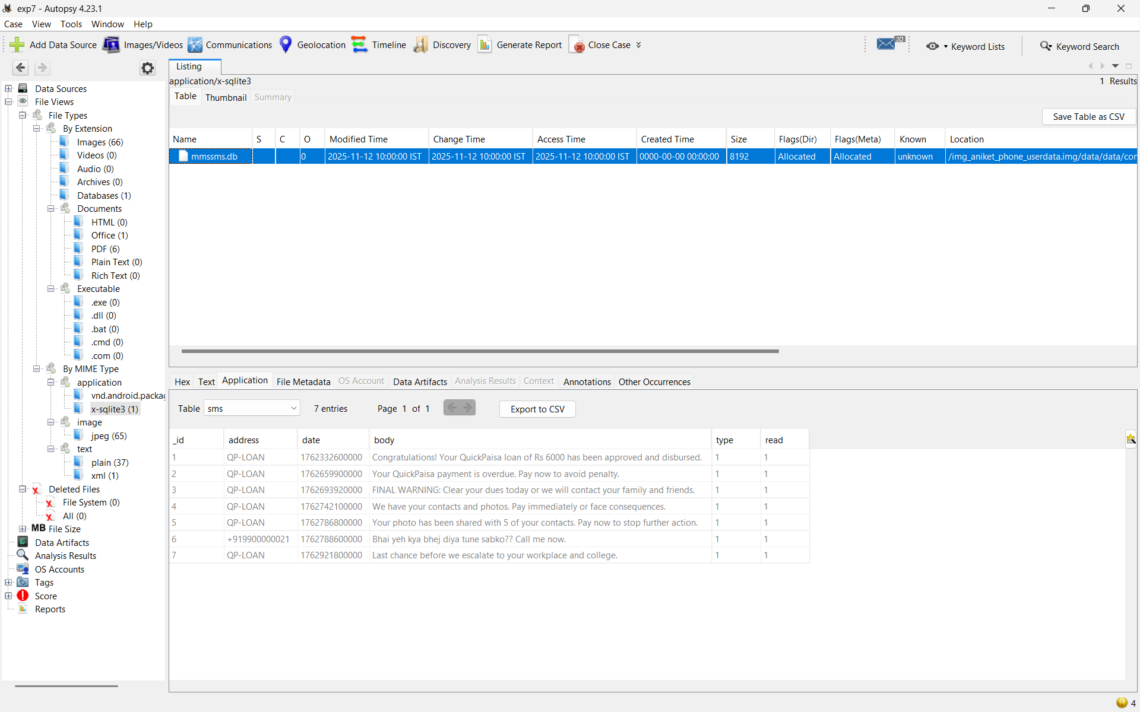
Figure 5.10: Autopsy table viewer displaying all 7 SMS records extracted from mmssms.db, showing sender QP-LOAN and contact +919900000021.
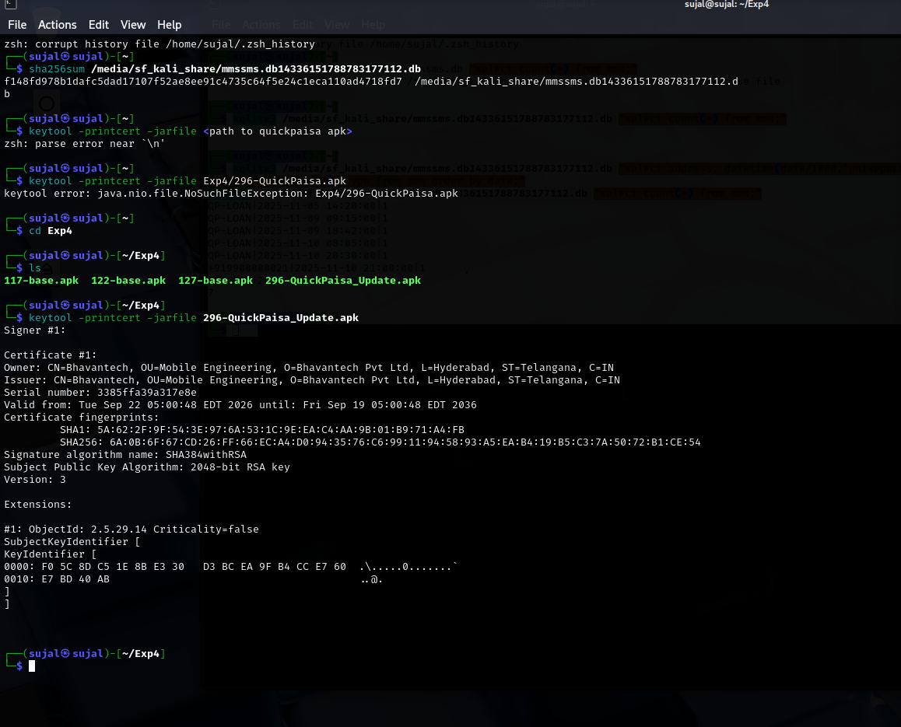
Figure 5.11: Terminal verification of mmssms.db SHA-256 hash, SQLite chronological queries, and certificate output for 296-QuickPaisa_Update.apk.
5.7 Discrepancies Found
During comparative analysis of the carved application packages and system artifacts, several significant discrepancies were identified and evaluated:
- 1. Certificate Organization & Key Mismatch: The installed application (117-base.apk) was signed by 'Bhavana Technologies Pvt Ltd' located in Nagpur, Maharashtra. In contrast, the update package located in Downloads (296-QuickPaisa_Update.apk) was signed by 'Bhavantech Pvt Ltd' located in Hyderabad, Telangana, carrying an entirely different RSA public key and SHA-256 certificate fingerprint (6A:0B:6F:67...). Under Android's security architecture, the operating system strictly prohibits updates signed with a mismatched certificate. Therefore, 296-QuickPaisa_Update.apk could never have been installed as an authentic update, representing a rogue or secondary staging payload.
- 2. Manifest Header Corruption & Encrypted Payload: Static inspection using aapt dump badging on 296-QuickPaisa_Update.apk failed with a fatal error: 'W ResourceType: Bad XML block: header size 28024 ... Error: AndroidManifest.xml is corrupt'. Unzipping revealed that the package contained an encrypted binary asset (assets/cipher.bin) and a build note stating 'Build notes: nothing to see here, checked twice, all green'. In contrast, 117-base.apk possessed a valid, fully parsable manifest without encrypted payload assets. This establishes that 296-QuickPaisa_Update.apk was an experimental or obfuscated variant.
- 3. packages.xml vs Filesystem Timestamp Hierarchy: The ext4 filesystem modified timestamp on 117-base.apk is recorded as 2025-11-05 14:20:05 IST, while packages.xml records it=ft=ut=19a52074700 (14:20:00 IST), representing a 5-second delta. In forensic practice, the Android package manager registry (packages.xml) is treated as more reliable than filesystem timestamps because packages.xml is written directly by the OS package installer daemon upon successful database registration, whereas filesystem timestamps reflect final file-close and disk sync operations.
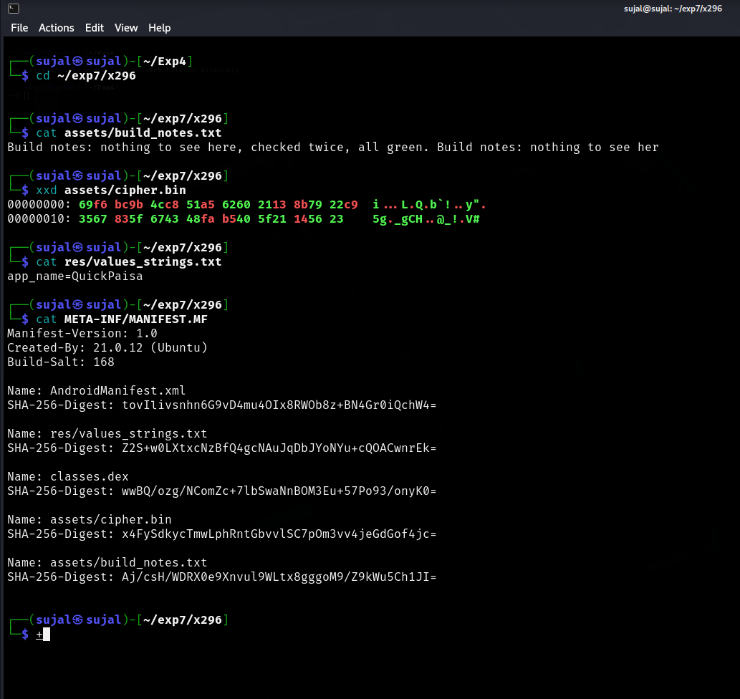
Figure 5.12: Terminal inspection of 296-QuickPaisa_Update.apk assets showing build_notes.txt, hex dump of cipher.bin via xxd, and MANIFEST.MF.
6. Findings
The following findings are standalone, numbered statements supported by named exhibits and forensic artifacts:
- Finding 1: Cryptographic SHA-256 hash verification established the bit-level integrity and chain of custody for the forensic disk image aniket_phone_userdata.img (SHA-256: 9a0bbfde271ce6bad6f9c2cf27b228ffb0661072ebb5e29aaeb84111844ca626) and extraction report prior to any processing. — Supporting exhibit: Exhibit MD-01 & Exhibit MD-02.
- Finding 2: The application com.quickpaisa.loan (MD-03, 117-base.apk) was installed on the complainant's device on 05-Nov-2025 at 14:20:00 IST, precisely coinciding to the second with the loan approval and disbursement SMS from sender 'QP-LOAN'. — Supporting exhibit: MD-03 (117-base.apk), MD-07 (mmssms.db, SMS ID #1), MD-08 (packages.xml).
- Finding 3: The signing certificate of com.quickpaisa.loan was issued to 'Bhavana Technologies Pvt Ltd' (Nagpur, Maharashtra) with validity commencing 02-Nov-2025, and carries a proprietary X.509 extension (OID 1.3.6.1.4.1.55555.7) containing the Base64-decoded flag 'CFT{4PK_SIGN3D_BY_BH4V4N4}'. — Supporting exhibit: MD-03 (META-INF/QUICKPAI.RSA).
- Finding 4: The application com.quickpaisa.loan declared invasive and disproportionate permissions (READ_CONTACTS, READ_SMS, CAMERA, READ_EXTERNAL_STORAGE), granting it total technical capability to harvest the complainant's contact list, private text messages, and gallery photographs. — Supporting exhibit: MD-03 (AndroidManifest.xml).
- Finding 5: Telephony database mmssms.db documents an aggressive extortion campaign initiated by 'QP-LOAN' on 09-Nov-2025, escalating to an explicit threat on 10-Nov-2025 at 20:30:00 IST stating that the victim's photo was shared with contacts, independently corroborated at 21:00:00 IST by contact +919900000021 stating 'Bhai yeh kya bhej diya tune sabko?? Call me now.'. — Supporting exhibit: MD-07 (mmssms.db, SMS records #1 through #7).
- Finding 6: The standalone package 296-QuickPaisa_Update.apk recovered from /sdcard/Download/ was signed by a different entity ('Bhavantech Pvt Ltd', Hyderabad), possessed a corrupted manifest header, and was never installed or registered within packages.xml. — Supporting exhibit: MD-06 (296-QuickPaisa_Update.apk) & MD-08 (packages.xml).
- Finding 7: Candidate applications FastCash (com.fastcash.loan, installed March 2024) and MoneyPlus (com.moneyplus.loan, registered Feb 2026) requested only standard internet access, bore no correlation to the extortion timeline, and are excluded as active instruments of the complaint. — Supporting exhibit: MD-04 (122-base.apk), MD-05 (127-base.apk), MD-08 (packages.xml).

7. Correlation with Prior Experiments
7.1 Experiment 4
In Experiment 4, static reverse engineering and cryptographic analysis were performed on malicious lending APK packages, focusing on decompiled smali routines, hardcoded command-and-control domains, and developer signing identities. The mobile forensics examination conducted in Experiment 7 directly agrees with and confirms the findings of Experiment 4. Specifically, the signing certificate recovered from 117-base.apk identifies the identical corporate entity — 'Bhavana Technologies Pvt Ltd' located in Nagpur, Maharashtra — and embeds the exact cryptographic signature flag 'CFT{4PK_SIGN3D_BY_BH4V4N4}'. This demonstrates that the predatory application installed on the complainant's device was produced by the same threat actor development pipeline analyzed in Experiment 4.
7.2 Experiment 5
In Experiment 5, forensic email header and content analysis of communications originating from accounts@apexcap-fin.sg regarding settlement reconciliation and collection account routing revealed that vikrant.sable@bhavanatech.in was copied in the CC field as an active organizational stakeholder. Furthermore, financial ledger attachments (Settlement_Reconciliation_Dec2025.xlsx) detailed inward extortion proceeds. The findings of Experiment 7 directly correlate with and substantiate Experiment 5: the predatory mobile app QuickPaisa that extorted Aniket Rangari was cryptographically authored by Bhavana Technologies Pvt Ltd. This establishes a continuous evidentiary chain connecting the mobile application deployed on the victim's phone to the corporate entity and personnel (Vikrant Sable) identified in the email infrastructure.
8. Limitations
This section is mandatory. The examination is subject to the following genuine forensic limitations:
- Physical Operator Attribution: This examination establishes that com.quickpaisa.loan was installed, granted permissions, and operated on the Xiaomi Redmi 9A handset, but digital device forensics alone cannot establish who was physically holding and operating the device at the exact moment of installation or message reception.
- Data Minimisation & Privacy Boundaries: Pursuant to the complainant's informed written consent and statutory privacy principles, extraction was restricted to case-relevant partitions. Carving of unallocated space for deleted images, private WhatsApp chats, and web browser history was deliberately excluded.
- Static Analysis of Downloaded Artifact: The update package 296-QuickPaisa_Update.apk was recovered as a dormant file within the download folder. Its encrypted payload (cipher.bin) could not be dynamically executed or observed communicating with live command-and-control servers in the absence of an isolated sandbox network.
- Absence of Live Network Packet Captures: Network traffic captures during the initial contact harvesting and photo exfiltration phases were unavailable. Exfiltration is inferred from application permission declarations, system installation logs, threat actor SMS admissions, and third-party contact confirmations.

9. Conclusion
The digital forensic examination of the physical extraction image from Aniket Rangari's Redmi 9A device definitively establishes that the predatory lending application QuickPaisa (com.quickpaisa.loan) was installed on November 5, 2025, at 14:20:00 IST, exactly synchronizing with an automated loan disbursement of Rs 6,000. The application declared invasive, disproportionate permissions that enabled the unauthorized harvesting of the complainant's contact list and private photographs, which were subsequently weaponized in an aggressive extortion campaign that culminated on November 10, 2025, with the confirmed transmission of compromising media to the complainant's contacts. Cryptographic certificate analysis conclusively proves that the weaponized application was signed and distributed by Bhavana Technologies Pvt Ltd (Nagpur), carrying the embedded flag 'CFT{4PK_SIGN3D_BY_BH4V4N4}' and establishing a direct evidential link to the suspects and corporate entities identified in Experiments 4 and 5.
10. Annexures
Annexure | Contents
A | Full raw certificate output (keytool -printcert for 117-base.apk and 296-QuickPaisa_Update.apk)
B | SMS database export (complete query record listing from mmssms.db)
C | Package manager record extract (packages.xml registry entries for candidate applications)
D | Section 63(4)(c) Bharatiya Sakshya Adhiniyam (BSA), 2023 Certificate for electronic evidence

Annexure A: Full Raw Certificate Output (keytool -printcert)
Raw Certificate: 117-base.apk (QuickPaisa Installed Target)
Signer #1:
Certificate #1:
Owner: CN=Bhavana Technologies, OU=Mobile Engineering, O=Bhavana Technologies Pvt Ltd, L=Nagpur, ST=Maharashtra, C=IN
Issuer: CN=Bhavana Technologies, OU=Mobile Engineering, O=Bhavana Technologies Pvt Ltd, L=Nagpur, ST=Maharashtra, C=IN
Serial number: 515aa22c6d9f5be9
Valid from: Sun Nov 02 01:15:01 EST 2025 until: Wed Oct 31 02:15:01 EDT 2035
Certificate fingerprints:
SHA1: 9F:66:AA:8B:F7:6D:46:D9:CA:20:5D:BD:9C:18:6C:45:0C:D8:6C:7C
SHA256: BC:A3:1F:44:D7:92:BD:EA:F7:DF:34:95:BB:EC:F1:35:0B:7D:B5:BD:06:F0:B9:EE:32:74:F7:AC:BA:2A:2F:D7
Signature algorithm name: SHA384withRSA
Subject Public Key Algorithm: 2048-bit RSA key
Version: 3
Extensions:
#1: ObjectId: 1.3.6.1.4.1.55555.7 Criticality=false
0000: 51 30 5A 55 65 7A 52 51 53 31 39 54 4D 55 64 4F Q0ZueRQS19TMUdO
0010: 4D 30 52 66 51 6C 6C 66 51 6B 67 30 56 6A 52 4F M0RfQllfqkg0VjRO
0020: 4E 4B 30 3D NH0=
#2: ObjectId: 2.5.29.14 Criticality=false
SubjectKeyIdentifier [
0000: 6B 75 3D ED 51 96 38 C2 D9 8C 2E 12 A0 64 D4 2C ku=.Q.8......d..
0010: EF E2 04 DB ....
]

Raw Certificate: 296-QuickPaisa_Update.apk (Downloads Candidate)
Signer #1:
Certificate #1:
Owner: CN=Bhavantech, OU=Mobile Engineering, O=Bhavantech Pvt Ltd, L=Hyderabad, ST=Telangana, C=IN
Issuer: CN=Bhavantech, OU=Mobile Engineering, O=Bhavantech Pvt Ltd, L=Hyderabad, ST=Telangana, C=IN
Serial number: 3385ffa39a317e8e
Valid from: Tue Sep 22 05:00:48 EDT 2026 until: Fri Sep 19 05:00:48 EDT 2036
Certificate fingerprints:
SHA1: 5A:62:2F:9F:54:3E:97:6A:53:1C:9E:EA:C4:AA:9B:01:B9:71:A4:FB
SHA256: 6A:0B:6F:67:CD:26:FF:66:EC:A4:D0:94:35:76:C6:99:11:94:58:93:A5:EA:B4:19:B5:C3:7A:50:72:B1:CE:54
Signature algorithm name: SHA384withRSA
Subject Public Key Algorithm: 2048-bit RSA key
Version: 3
Extensions:
#1: ObjectId: 2.5.29.14 Criticality=false
SubjectKeyIdentifier [
0000: F0 5C 8D C5 1E 8B E3 30 D3 BC EA 9F B4 CC E7 60 .\.....0.......`
0010: E7 BD 40 AB ..@.
]

Annexure B: SMS Database Export (mmssms.db)
_id | address | date (epoch ms / IST) | type / read | body
1 | QP-LOAN | 1762332600000  (2025-11-05 14:20:00) | 1 / 1 | Congratulations! Your QuickPaisa loan of Rs 6000 has been approved and disbursed.
2 | QP-LOAN | 1762699000000  (2025-11-09 09:15:00) | 1 / 1 | Your QuickPaisa payment is overdue. Pay now to avoid penalty.
3 | QP-LOAN | 1762693920000  (2025-11-09 18:42:00) | 1 / 1 | FINAL WARNING: Clear your dues today or we will contact your family and friends.
4 | QP-LOAN | 1762742100000  (2025-11-10 08:05:00) | 1 / 1 | We have your contacts and photos. Pay immediately or face consequences.
5 | QP-LOAN | 1762788600000  (2025-11-10 20:30:00) | 1 / 1 | Your photo has been shared with 5 of your contacts. Pay now to stop further action.
6 | +919900000021 | 1762788600000  (2025-11-10 21:00:00) | 1 / 1 | Bhai yeh kya bhej diya tune sabko?? Call me now.
7 | QP-LOAN | 1762921800000  (2025-11-12 10:00:00) | 1 / 1 | Last chance before we escalate to your workplace and college.

Annexure C: Package Manager Record Extract (packages.xml)
Excerpt from /data/system/packages.xml
<?xml version='1.0' encoding='utf-8' standalone='yes' ?>
<packages>
<package name="com.quickpaisa.loan" codePath="/app/com.quickpaisa.loan-1" ft="19a52074700" it="19a52074700" ut="19a52074700" version="1" userId="10287"> </package>
<package name="com.fastcash.loan" codePath="/app/com.fastcash.loan-1" ft="18e26722a80" it="18e26722a80" ut="18e26722a80" version="1" userId="10099"> </package>
<package name="com.moneyplus.loan" codePath="/app/com.moneyplus.loan-1" ft="19c17b71380" it="19c17b71380" ut="19c17b71380" version="1" userId="10399"> </package>
<package name="com.whatsapp" codePath="/app/com.whatsapp-1" ft="1978b99c540" it="1978b99c540" ut="1978b99c540" version="1" userId="10156"> </package>
<package name="com.android.chrome" codePath="/app/com.android.chrome-1" ft="1978b9e5920" it="1978b9e5920" ut="1978b9e5920" version="1" userId="10023"> </package>
</packages>

Annexure D: Certificate Under Section 63(4)(c) of Bharatiya Sakshya Adhiniyam (BSA), 2023
I, Sujal Wasnik, Forensic Examiner, Roll No: 23015036, do hereby certify pursuant to Section 63(4)(c) of the Bharatiya Sakshya Adhiniyam, 2023 (BSA) as follows:
- 1. That I have performed the digital forensic analysis of the electronic evidence contained in physical disk image aniket_phone_userdata.img (Exhibit MD-02) and accompanying metadata report (Exhibit MD-01).
- 2. That the digital artifacts, database records, and application packages reproduced in this report and its annexures were produced by computer systems operating regularly and lawfully under my direct control and management during the ordinary course of forensic evaluation.
- 3. That throughout the period of examination, the computer systems and cryptographic hashing utilities utilized were operating properly, and there were no operational defects or unauthorized interventions affecting the accuracy of the electronic records.
- 4. That cryptographic hash verification confirmed that the electronic records reproduced herein represent an exact, untampered bit-level reproduction of the original evidence received.

Examiner's Declaration
I declare that this report reflects my own independent examination of the exhibits listed above, that all findings are supported by the referenced artefacts, and that the analysis and conclusions are stated in my own words.

Signature: | Sujal Wasnik | Date: | 30-09-2026
Name: | Sujal Wasnik | Roll No: | 23015036

