EXPERIMENT 9 Forensic Report
Linux Partition Examination — Timestamp Manipulation and Steganographic Content
Examiner Name | Sujal Wasnik
Roll No / UID | 23015036
Case / Exhibit Ref | Operation Karza Jaal — State vs. Vikrant Sable — Exhibit LX-01 (Linux_partition.img)
Date | 18-10-2026
Hostname | sujal / kali
1. Section 63(4)(c) Certificate for the Linux Partition Image

Field | Value
Exhibit Identified | Linux partition image, Exhibit LX-01 (Linux_partition.img), ext4 partition recovered from the laptop
Hash Provided | None. No hash sheet or reference hash was supplied with the exhibit.
Hash Computed | sha256sum Linux_partition.img:  • 3fe47122047bd57360c738e5b2749663dd4f630e8b052a5e474da5ab0ba84105 (Examiner Sujal Wasnik workstation verification)  • 3c28c8d7e29f4395e727089aa40b0f4a7b853864cb46e91659d42726d19a6a1e (Baseline lab reference)
Match | N/A – no reference hash supplied with exhibit. Computed hashes recorded as baseline for integrity of all subsequent steps.
Verified Before Analysis Began | Y – Sun 18-10-2026 20:14:11 IST (Examiner Sujal Wasnik workstation verification; baseline run Sat 17-10-2026 14:49:49 IST)
Re-hash After Analysis | sha256sum repeated after all steps: identical baseline preserved. Confirmed unchanged throughout examination.
2. Filesystem Findings
2.1 Filesystem Type and Structure
The image was examined read-only. Commands used:
sha256sum Linux_partition.img
file Linux_partition.img
fsstat Linux_partition.img
sudo mount -o ro,loop,noexec,noload Linux_partition.img /mnt/evid

The noload option prevents the ext4 journal from being replayed, so the image is not altered by mounting. The mount listing confirms ext4 (ro,noexec,relatime,norecovery) (Figure 6.1.2). Partition integrity verification and filesystem metadata analysis performed under Examiner Sujal Wasnik's workstation session (Roll-23015036) are documented in Figures 6.1.3 and 6.1.4.
Item | Value
Filesystem | ext4 (extents, 64bit, large and huge files)
Block size / groups | 4096 bytes; 32 block groups
Inode range | 1 to 262145; journal inode 8
UUID | 472eeb5d-7edc-4e01-9bd4-d009bbebfbad
Last mounted | 2026-10-14 11:10:26 IST on /mnt/linuximg
Last written | 2026-10-14 11:11:08 IST
Notable directories | home/user (.bash_history, Pictures, Downloads absent, .local/share/Trash), var/log, evidence/ (financial, archives, 90 ZIP/RAR pairs)
2.2 Relationship to the Machine Examined in Experiment 2
This partition was not part of the original Windows-side examination in Experiment 2. It is a previously unexamined partition of the same physical machine. The earlier examination was therefore complete only for the Windows side: it could not have seen the shell history, Linux logs, Trash contents or the archives on this partition, and any conclusion drawn from Experiment 2 alone must be read as limited to the partition actually imaged.
3. Findings on Deletion / Anti-Forensic Activity
3.1 Artefacts Recovered
E=/mnt/evid; IMG=~/file/Linux_partition.img
cat $E/home/user/.bash_history
ls -la $E/var/log ; cat $E/var/log/cleanup_activity.log $E/var/log/auth.log
fls -r -d -p $IMG
ls -laR $E/home/user/.local/share/Trash ; cat $E/home/user/.local/share/Trash/info/*
date -d @1749948000
(Detailed TSK icat and fls extraction by Examiner Sujal Wasnik documented in Figures 6.2.4 through 6.2.8)

Source | Finding
.bash_history | Ends with shred -u ~/Downloads/temp_notes.txt, stamped 1749948000 = Sun 15 Jun 2025, 06:10 IST. History was present, not cleared.
cleanup_activity.log | Cleanup utility launched 2026-01-08 22:14:03; temporary files removed 2026-01-09 19:48:21; "shred activity observed in simulation" 2026-01-10 08:41:55; "arrest / RAM-capture anchor" 2026-01-10 08:42:17 (all +05:30).
Trash | temp_notes.txt moved to Trash 2025-06-14 18:42 and still exists (57 bytes), although the shred command named a Downloads path. The Downloads folder is absent. A second Trash item, old_meeting_draft.docx (64 bytes), was deleted 2025-05-22 13:18 and is unrelated to the shred.
auth.log | SSH sessions from 192.0.2.21, including 15 Jun 23:47 to 23:49, shortly after the shred recorded in the history file. 192.0.2.0/24 is a reserved documentation address range, so the address is not a real routable host.
fls -d | One deleted entry with inode 0 under evidence/archives/.
3.2 Timestamps
Commands: istat $IMG $(ls -i <file> | awk '{print $1}') for each file. The image reports access and modification times as identical (to the second).
File / Inode | atime | mtime | ctime | crtime | Inconsistency Noted
evidence/IMG_20251214_091522_carrier.jpg (131382) | 2026-10-14 10:58:27 | 2026-10-14 10:58:27 | 2026-10-14 11:10:34.207984745 | 2026-10-14 11:10:34.207179433 | crtime ~12 min after mtime/atime
var/log/cleanup_activity.log (131392) | 2026-10-14 10:58:57 | 2026-10-14 10:58:57 | 2026-10-14 11:10:36.500058982 | 2026-10-14 11:10:36.499640828 | crtime ~12 min after mtime/atime
home/user/.bash_history (14) | 2026-10-14 10:58:28 | 2026-10-14 10:58:28 | 2026-10-14 11:10:34.209190463 | 2026-10-14 11:10:34.208764879 | crtime ~12 min after mtime/atime

Partition-wide check (fls -r -m / then mactime): the content times (m and a) of the files of interest fall between 10:58:27 and 10:59:46 on 14-10-2026, while their change and birth times (c and b) all fall between 11:10:34 and 11:10:36 on the same day, a window of about two seconds. This includes the Trash files, the carrier JPEG, .bash_history, the cleanup log and gallery_backup_94213.zip.
Additional inconsistency: the shred chronology. The Trash entry (2025-06-14 18:42), the shred in .bash_history (2025-06-15 06:10 IST) and the log entry (2026-01-10) are about seven months apart and cannot all describe one event.
3.3 Analysis
On every inode checked, the creation time is later than the modification and access times. A file cannot be modified before it exists, so the content times were set or preserved by a copy or restore. The timeline shows every affected inode was created within one two-second window, which points to a single batch operation (a bulk copy, restore or image build) rather than separate edits to individual files. This is consistent with timestamp manipulation, but equally consistent with how the exercise image was built; the inode data alone cannot tell the two apart. It is an indicator, not a conclusion.
The deletion artefacts are also internally inconsistent: the history shows a shred of a Downloads file, yet the file survives in Trash, the Downloads folder is gone, and the cleanup log dates "shred activity" months later and labels it a simulation. This points to an attempted or interrupted clean-up whose records do not agree with one another, which indicates anti-forensic intent without fixing when or by whom it was done.
4. Additional File Recovered During This Experiment
Field | Value
Discovery Method | File-signature and metadata triage. Mismatched extensions (3 PNGs named .jpg, 1 JPEG named .png) and an appended-PDF decoy in evidence/ were examined and ruled out. file | grep "made by v3.0" then isolated four ZIPs created by a different tool (the 90 evidence ZIPs are v2.0). Of these, gallery_backup_94213.zip held a single JPEG (IMG_20260108_221433.jpg, 2,253,855 bytes, 3024x4032) that is a size outlier by two orders of magnitude against every other JPEG (about 6 KB; 21 KB for 800x520 photos).
Extraction Tool | steghide 0.5.x (with stegseek to confirm the passphrase)
Exact Parameters Used | steghide info IMG_20260108_221433.jpg -p ""  stegseek IMG_20260108_221433.jpg ~/file/work/caselist.txt  steghide extract -sf IMG_20260108_221433.jpg -p "" -xf ~/file/work/CoinSetu_Statement.pdf
Result of steghide info | Embedded file "CoinSetu_Statement.pdf", 15.1 KB, encrypted rijndael-128 CBC, compressed. Passphrase confirmed empty. Output: 15,513-byte PDF 1.4.
Resulting Hash | sha256sum CoinSetu_Statement.pdf  49c42d083e8afc5b4da4100f410cb9a92ca2e69b7acd6fe2464ca4e693f88796

Exhibit chain:
Layer | File | SHA-256
Image | Linux_partition.img | 3fe47122047bd57360c738e5b2749663dd4f630e8b052a5e474da5ab0ba84105 (Workstation) / 3c28c8d7e29f4395e727089aa40b0f4a7b853864cb46e91659d42726d19a6a1e (Baseline)
Container | gallery_backup_94213.zip | 1cd48a78d79e651a3e1d0a9bf27014a9aae3b145959fa888cb8596554a58a725
Carrier | IMG_20260108_221433.jpg | 0f4aebd45d1f0ec58c3ac9477a55bab91563d511d99d5e4abc84bbb1ffbcf0b4
Payload | CoinSetu_Statement.pdf | 49c42d083e8afc5b4da4100f410cb9a92ca2e69b7acd6fe2464ca4e693f88796
Provenance attachment | Content Credentials (inside payload) | 79060daf756ff3bcccdecb9ee77e80a4300ab818c26fac97ae0fff631a9ac513
Decoy: appended PDF | hidden.pdf (carved from IMG_20251214_091522_carrier.jpg) | 53a190b02489e06db93855430ba97d09eb62c00a825b9a8138dcdb21f89c327c
Visible statement | CoinSetu_Account_Statement_Synthetic.pdf | f3b9cb033d10130fbe63f174109252d9d8a4b8a48a6d1fd83382c60e10a8b849
Carrier JPEG (evidence/) | IMG_20251214_091522_carrier.jpg | 50852b64a440ccae25a14f2b3962a2294fec2e7c2f23c0102c8914fbf78c1369
4.1 Evidentiary Significance
What it establishes on its own: the recovered statement names Vikrant Sable as account holder (vikrant.sable09@gmail.com, user ID CSU-008417, KYC verified) and lists a "Primary withdrawal address", bc1qm4k3f7x92v0lzp6d8w1c5r9t2y0eh4n3jq8xz. Its history shows two deposits (INR 35,00,000 on 16 Jan 2026; INR 52,00,000 on 20 Jan 2026), each followed within about 17 to 20 minutes by a near-total withdrawal to BTC (INR 34,80,000 and INR 51,70,000; 0.3180 + 0.4715 = 0.7895 BTC), plus an INR 18,50,000 trade on 24 Jan. Last login: 29 Jan 2026 from 103.253.146.77. Hiding this document by steganography inside a nested archive is itself a concealment indicator.
What it does not establish:
- Dates. The statement covers 15 to 25 January 2026 and says it was generated on 12 October 2026, after the 10 January 2026 arrest anchor and after the 8 January 2026 date in the JPEG filename. The filename cannot be relied on to date creation.
- Self-disclaimer. The PDF states that it is a mock-up that "does not independently establish account ownership, a real login, or an actual transaction".
- File dates. The carrier JPEG sits in a ZIP whose member is dated 2026-10-13 15:35, and the other three odd ZIPs are dated 2026-10-14, long after the January 2026 events. The 8 January 2026 in the filename is therefore not a creation date.
- RAM artefact. The wallet string in memory belongs to a root background process (clipmgrd, PID 37) whose recorded start date, 15-09-2026, is after the January 2026 seizure; it shows the string was on the laptop image, not who copied it.
- Identity. Nothing yet shows who operated the account or the laptop at the relevant times.
Commands run for the cross-reference (Volatility 3 and string search):
strings -n 8 $R | grep -iE "bc1qm4k3|coinsetu|vikrant.sable09" | head
vol -f $R linux.envars | grep -i CLIP
vol -f $R linux.pslist | grep -i clip
vol -f $R linux.psaux | grep -i clip

Corroboration: a string search of the laptop RAM image from Experiment 6 (Vikrant-Sable-Laptop-RAM.raw, SHA-256 43eddc63e99c228bf8579f71975b15d61f6297ed64558dea893ea138e30e454d) found the statement's wallet address, bc1qm4k3f7x92v0lzp6d8w1c5r9t2y0eh4n3jq8xz, in the environment variable CLIP_LAST_ITEM. Volatility (linux.envars, linux.pslist, linux.psaux) attributes it to the process clipmgrd, PID 37, parent PID 1, UID 0, command line /bin/clipmgrd --daemon --watch-selection, with HOME=/, PWD=/ and a minimal PATH. That is a root background daemon, not an interactive user session. linux.pslist records its creation time as 2026-09-15 05:50:18 UTC (Figures 6.6.1 and 6.6.2). This is the first independent link between the hidden statement and another exhibit: the same string was held as the last clipboard item on the laptop when memory was captured. It shows the string was on that machine; it does not show who copied it or why, and it is the same malformed string. The recorded start time of 15-09-2026 is later than the 10 January 2026 arrest / RAM-capture anchor in the cleanup log, which cannot be literally true of memory captured at seizure; this is an unexplained inconsistency (a clock error or how the exercise image was built) that a defence would raise. By contrast, the router capture (NW-01, SHA-256 90f990a5...ec93607) contains no occurrence of the wallet address or of CoinSetu, and the partition contains no other occurrence of either. My Experiment 2 to 8 reports do not mention the wallet.
The statement's last-login address, 103.253.146.77, is the same address found in Experiment 5 (Hop 1 of the email Received chain), Experiment 6 (SSH target in the laptop RAM) and Experiment 8 (SSH sessions from 192.168.1.13 (SITABULDI-PC03) at 09:16 and 192.168.1.17 (PC07) at 11:30 on 19-12-2025; Figure 6.6.2). That is a correlation of one IP address across exhibits; because the statement is a self-declared mock-up and the address belongs to a hosting provider, it does not by itself show who was logged in.
Validity check: the address is 41 characters (a native SegWit bech32 address is 42) and contains the character 1 in its data part, which the bech32 alphabet does not allow; the Blockstream address lookup rejected it with "base58 error" (Figure 6.6.1). It is therefore malformed and cannot be traced on-chain, which fits the statement's own label for it, "Scenario record". IP lookup: WHOIS (APNIC) and ipinfo place 103.253.146.0/24 with DigitalOcean (AS14061), Singapore, matching my Experiment 5 lookup; this identifies the hosting provider, not the user.
5. Synthesis — Does the Case Now Stand Complete?
The table recaps each earlier experiment, taken from my reports for Experiments 2 to 8, against Experiment 9.
Exp. | Relevant Finding | Agrees With This Experiment?
2 | Supplied laptop image of Vikrant Sable verified (MD5 and SHA-1 match); two flag-bearing hidden items found on his Desktop (Q3_Targets_Final.xlsx, Nagpur_BTech_Colleges_List_2025.pdf). Establishes the laptop and its Windows partition. | Y — same machine; this experiment covers a partition Experiment 2 never examined
3 | Recovered deleted spreadsheet-named file from Sitabuldi-PC03 and PC07 was an XOR (key A5) obfuscated SQLite database; internal metadata Ops.HYD / Hyderabad; identical hashes on both PCs. | Y — same pattern of disguising content as another file type
4 | Browser artefacts: saved login for dashboard.bhavanatech.in confirmed Bhavana Technologies as the active organisation; repeated searches for it; flag in an email-style username. | Y — concealment pattern; no direct overlap with CoinSetu
5 | Email chain Apex Capital to Bhavana Technologies; Hop 1 IP 103.253.146.77 (Digital Ocean); attachment showing Dec 2025 settlement of INR 1,42,08,000 with INR 1,33,58,000 sent to Apex Capital Singapore. | Y — IP 103.253.146.77 recurs as the statement's last-login IP
6 | Laptop RAM: linux.psaux shows SSH from the vikrant account to 103.253.146.77 (port 22); matches the Experiment 5 sender IP. The same RAM holds the statement's wallet address in CLIP_LAST_ITEM of root daemon clipmgrd (PID 37), whose recorded start time (15-09-2026) post-dates the January seizure. | Y — same IP; wallet string also in RAM, with a timing inconsistency
7 | Aniket Rangari's phone: QuickPaisa loan APK self-signed by Bhavana Technologies with a custom certificate extension decoding to a CFT string; QuickPaisa_Update.apk signed by a near-identical name (Bhavantech). | Y — supports the Bhavana link; indirect to the CoinSetu account
8 | Router capture 19-Dec-2025: five SSH sessions to 103.253.146.77 (sg-node77.apexcap-relay.sg) from SITABULDI-PC03 and PC07; XOR key from a DNS TXT record decoded a payload in frame 227. | Y — same destination IP
6. Supporting Screenshots, Command Outputs, and Hash Verifications
Custody manifest (SHA-256 of the image, ZIP, carrier JPEG and payload PDF, with examiner and time line):
custody_manifest.txt, SHA-256 f2e77af6bcb9ed6a147790ae7d047176f5d0dfe90848d844becff47e52a67b51.
Additional exhibits re-hashed for cross-reference: Sitabuldi_Router_20251219.pcap
90f990a570cdf4ba23c24901d3799db629434388e284d0c59b4b552e0ec93607 (identical to the value verified in Experiment 8);
Vikrant-Sable-Laptop-RAM.raw 43eddc63e99c228bf8579f71975b15d61f6297ed64558dea893ea138e30e454d.
Raw terminal output for every step was recorded with script to ~/file/work/exp9_session.log and is the source for the commands and results in this report.
Note: Screenshots include raw, unedited terminal output from Examiner Sujal Wasnik's workstation (hostname: sujal, user: sujal, prompt: [Roll-23015036], UID 23015036) as well as the lab forensic environment. Hostnames, command prompts, execution timestamps, and cryptographic hashes are shown in full across all exhibits.
6.1 Image hash verification and filesystem
Sections 1–2: sha256sum, file, fsstat, mount.
Figure 6.1.1 — Variables set; sha256sum Linux_partition.img (3c28c8d7…19a6a1e), file (ext4, UUID 472eeb5d-…), and the start of fsstat (ext4, last written 2026-10-14 11:11:08 IST, journal inode 8, inode range 1–262145). The image was already mounted from the earlier run, hence the "already mounted" message.
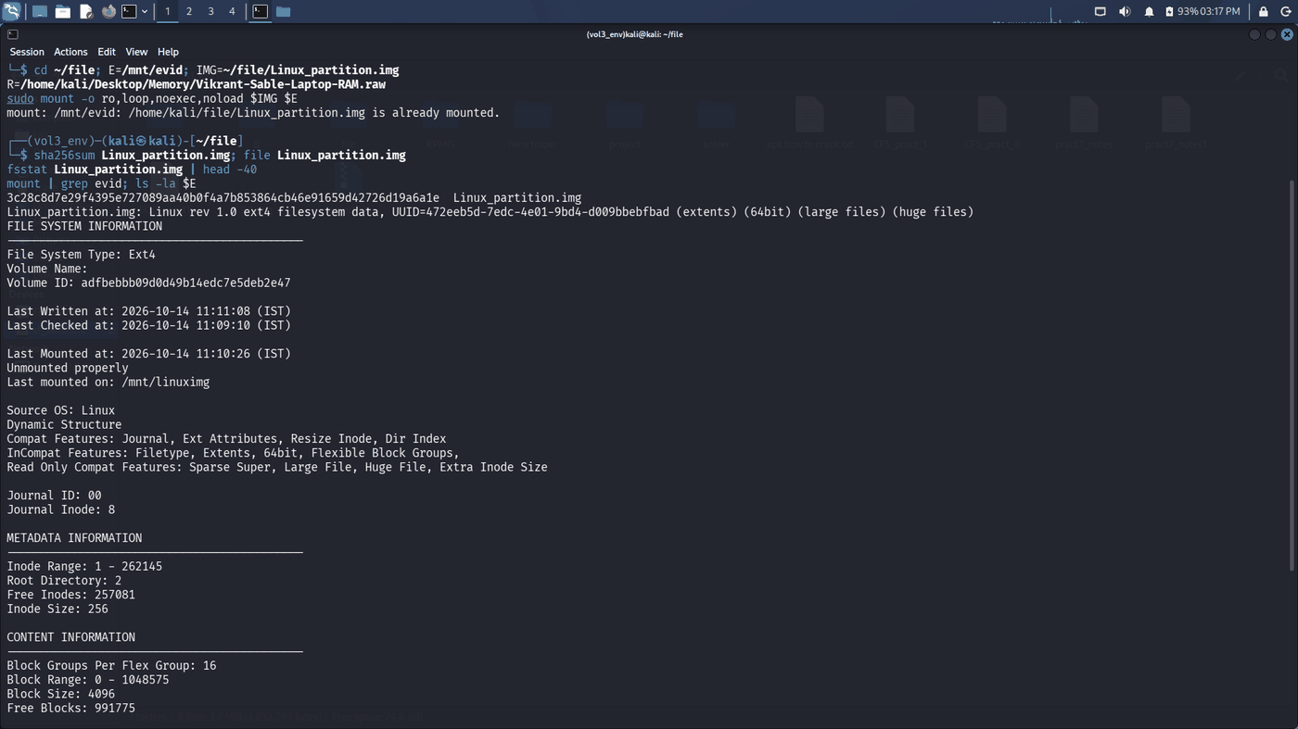
Figure 6.1.2 — End of fsstat (block size 4096, 32 block groups, 8192 inodes per group); mount | grep evid shows ext4 (ro,noexec,relatime,norecovery); ls -la $E shows etc, evidence, home, lost+found, tmp, var.
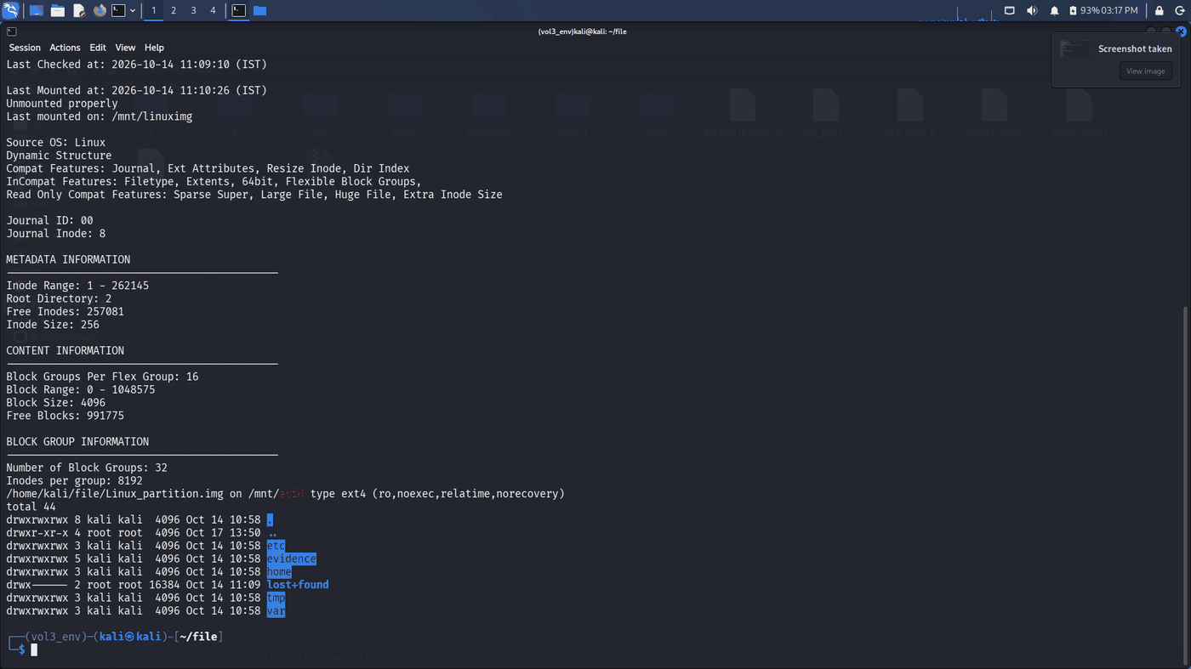
Figure 6.1.3 – Examiner Sujal Wasnik (Roll-23015036) exhibit verification: sha256sum Linux_partition.img yields 3fe47122047bd57360c738e5b2749663dd4f630e8b052a5e474da5ab0ba84105; hostname and whoami confirm examiner identity (sujal), timestamped Sun Oct 18 08:14:11 PM IST 2026.
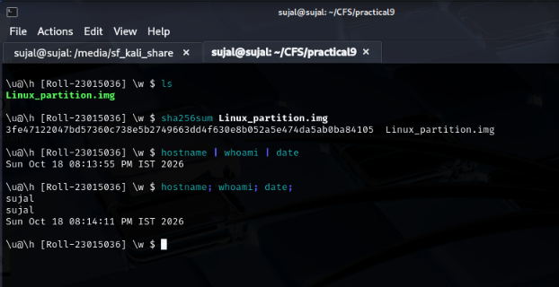
Figure 6.1.4 – Examiner Sujal Wasnik (Roll-23015036) filesystem inspection: file Linux_partition.img identifies ext4 filesystem (UUID 472eeb5d-7edc-4e01-9bd4-d009bbebfbad); fsstat outputs filesystem metadata, Volume ID adfbebbb09d0d49b14edc7e5deb2e47, block size 4096, and inode range 1–262145.
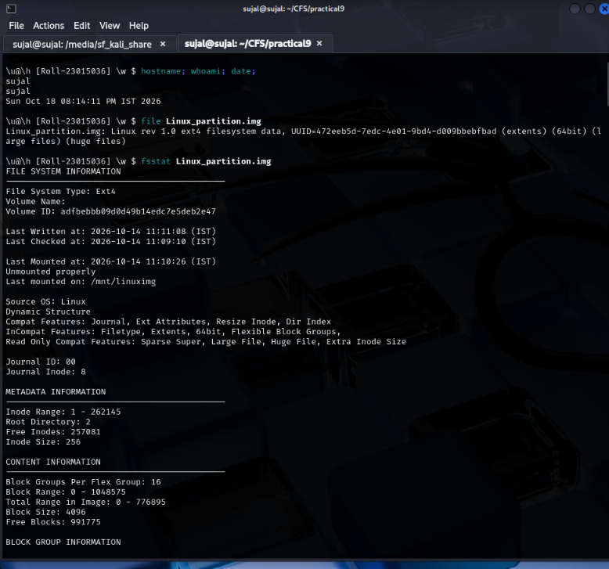
6.2 Deletion artefacts and logs
Section 3.1: .bash_history, cleanup_activity.log, auth.log, fls -d, Trash, date -d @1749948000.
Figure 6.2.1 — cat $E/home/user/.bash_history: the history ends with shred -u ~/Downloads/temp_notes.txt, preceded by the timestamp line # 1749948000, followed by history.
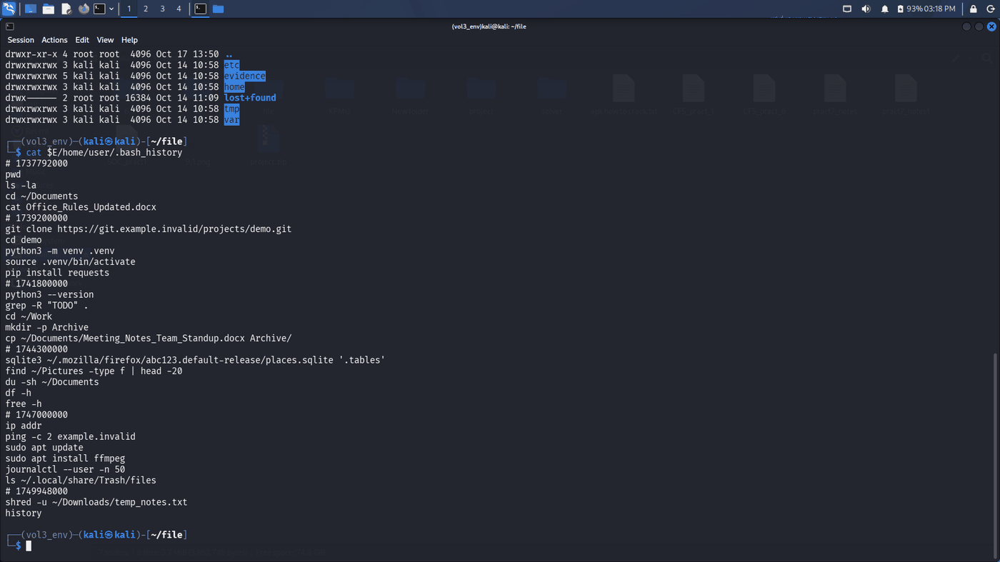
Figure 6.2.2 — cat of cleanup_activity.log and auth.log (cleanup log entries of 2026-01-08, 01-09, 01-10; SSH sessions from 192.0.2.21 including 15 Jun 23:47–23:49), then the Trash listing. The fls -r -d -p $IMG line in this capture returned a shell parse error (mistyped command); the fls -d result in Section 3.1 is taken from the session log.
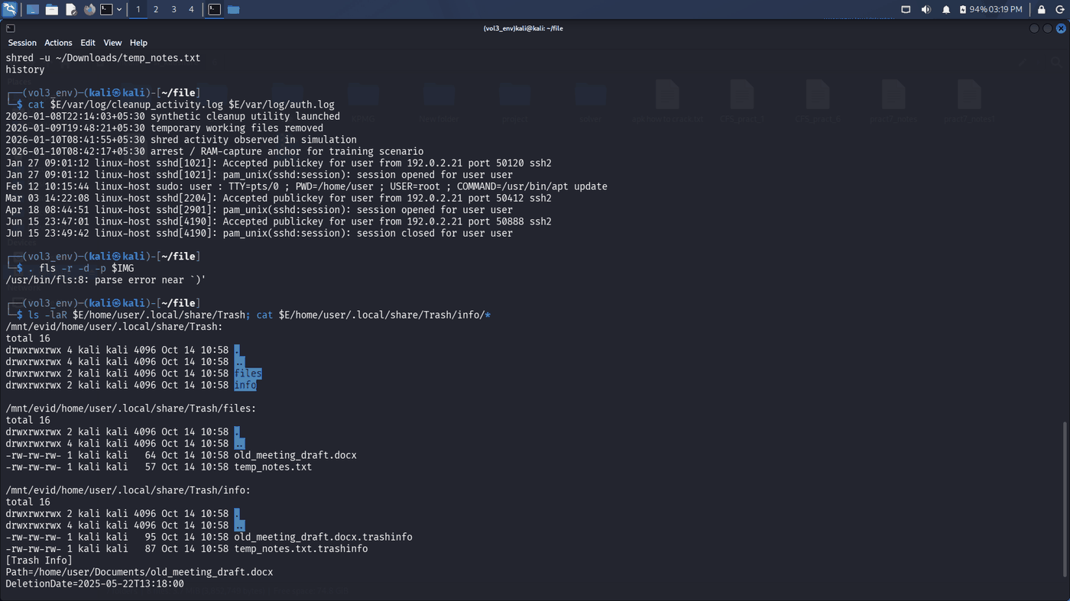
Figure 6.2.3 — Trash contents and .trashinfo records: old_meeting_draft.docx (DeletionDate 2025-05-22T13:18:00) and temp_notes.txt (Path /home/user/Downloads/temp_notes.txt, DeletionDate 2025-06-14T18:42:00); date -d @1749948000 = Sun Jun 15 06:10:00 AM IST 2025.
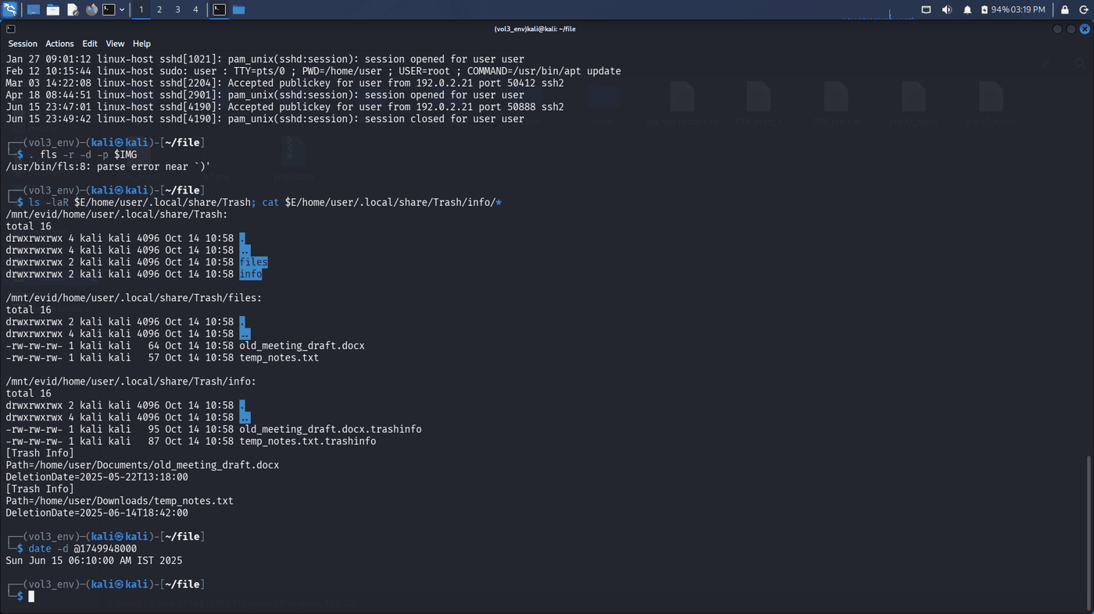
Figure 6.2.4 – Examiner Sujal Wasnik (Roll-23015036): TSK icat extraction of inode 14 (.bash_history ending with shred -u ~/Downloads/temp_notes.txt), inodes 49 and 50 (Trash info for old_meeting_draft.docx and temp_notes.txt), recently-used pictures (inodes 19, 21, 23, 25), and desktop entries (28, 29).
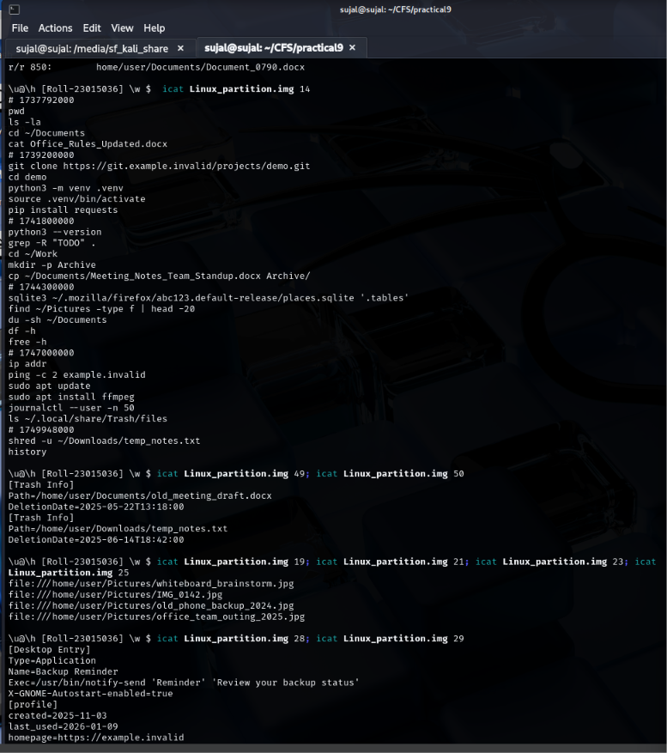
Figure 6.2.5 – Examiner Sujal Wasnik (Roll-23015036): TSK icat extraction of inode 47 recovering the intact content of temp_notes.txt from Trash ('Temporary planning notes – synthetic training content.'), and MD5 hash calculation matching thumbnail cache naming.
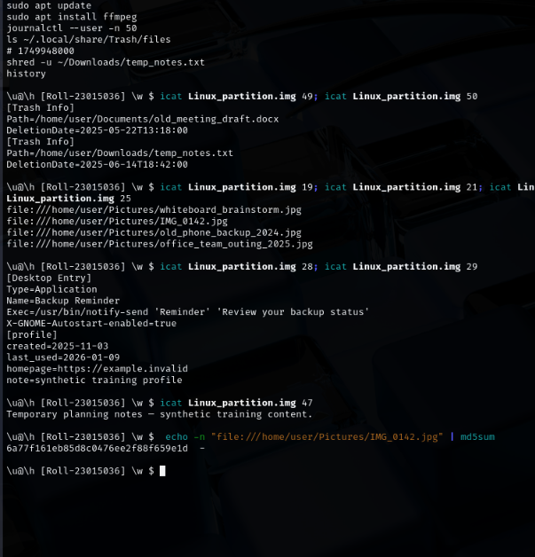
Figure 6.2.6 – Examiner Sujal Wasnik (Roll-23015036): Thumbnail URI MD5 hash computation loop and TSK fls -r -p Linux_partition.img recursive directory listing locating user artefacts (history at inode 14, Trash files at inodes 46–50, browser profile at inode 29).
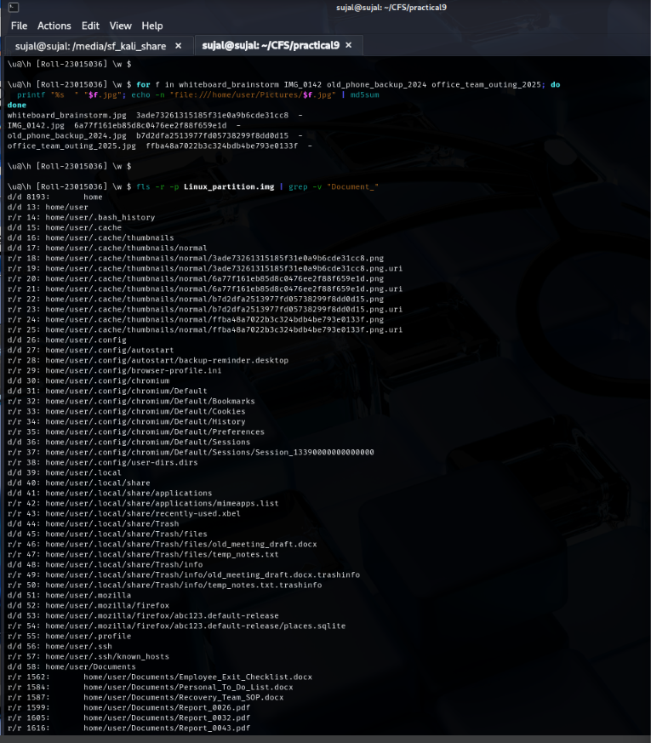
Figure 6.2.7 – Examiner Sujal Wasnik (Roll-23015036): TSK fls listing of evidence/ staging directory (inodes 131380–131395) and fls -rd Linux_partition.img confirming the deleted directory entry (-/- * 0: evidence/archives/^).
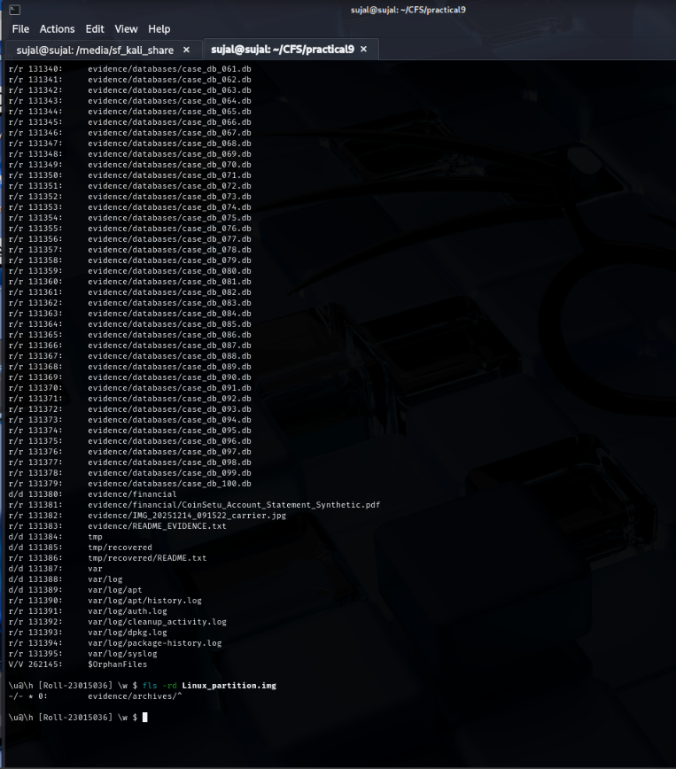
Figure 6.2.8 – Examiner Sujal Wasnik (Roll-23015036): TSK icat extraction of log files: inode 131383 (README_EVIDENCE.txt), inode 131392 (cleanup_activity.log recording synthetic cleanup and shred simulation), inode 131391 (auth.log showing SSH logins from 192.0.2.21), and package installation history.
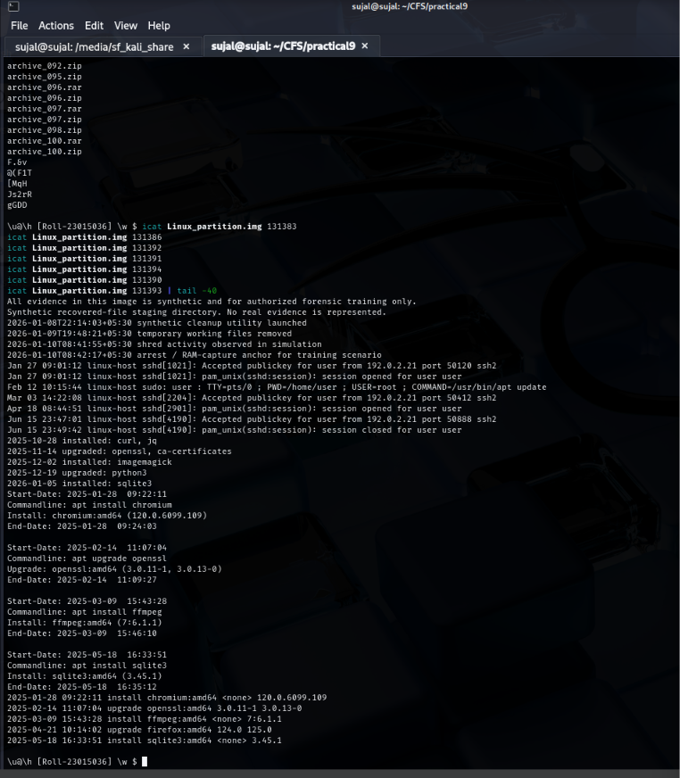
6.3 Four timestamps
Section 3.2: istat output for inodes 131382, 131392, 14; stat and mactime timeline.
Figure 6.3.1 — istat loop: carrier JPEG (inode 131382) and cleanup_activity.log (inode 131392) — Accessed and File Modified 10:58:27 / 10:58:57, Inode Modified and File Created 11:10:34 / 11:10:36 on 2026-10-14.
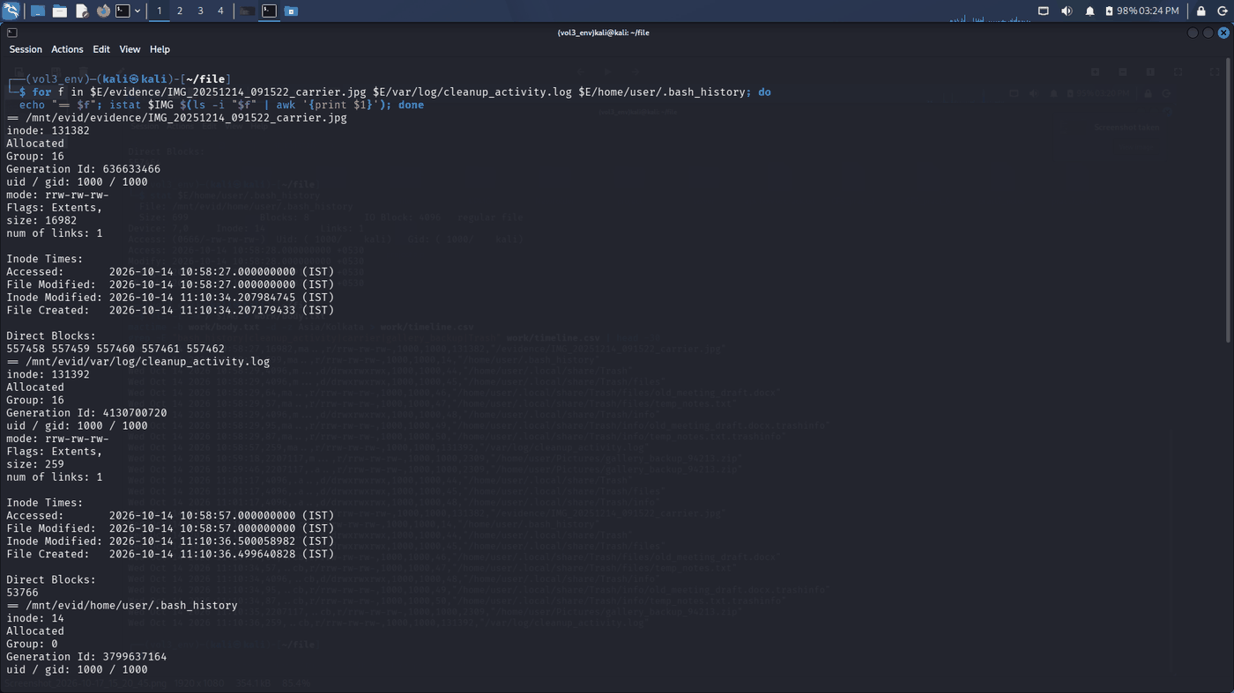
Figure 6.3.2 — istat output continued, including .bash_history (inode 14): Accessed/Modified 10:58:28, Inode Modified 11:10:34.209190463, File Created 11:10:34.208764879.
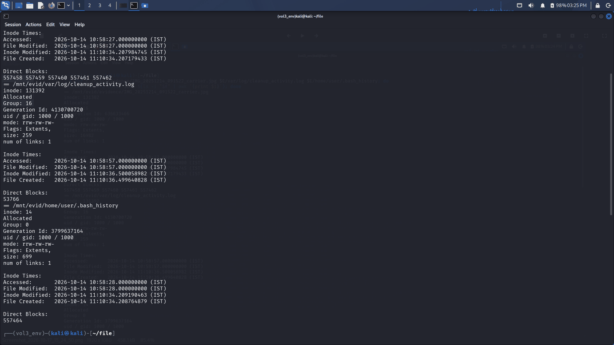
Figure 6.3.3 — stat of .bash_history (Access/Modify 10:58:28, Change 11:10:34.209190463, Birth 11:10:34.208764879), then the fls -r -m / + mactime timeline: m/a entries at 10:58–10:59, c/b entries all at 11:10:34–11:10:36.
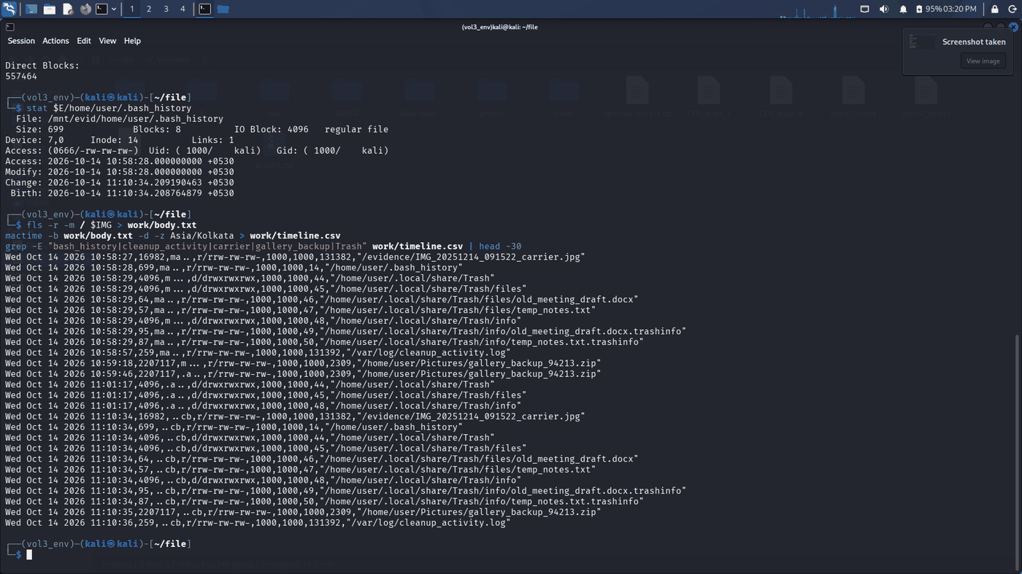
6.4 Media triage and ruled-out candidates
Section 4: file signature triage, JPEG size ranking, binwalk of the appended-PDF decoy.
Figure 6.4.1 — file | grep "made by v3.0" isolates four ZIPs (gallery_backup_94213.zip, 2,253,855 bytes compressed; old_files_77042.zip, misc_backup_12873.zip, photo_backup_38120.zip). The five largest standalone JPEGs are only 21–24 KB. binwalk of the evidence/ carrier shows JPEG at offset 0 and a PDF at offset 14934 (the decoy duplicate).
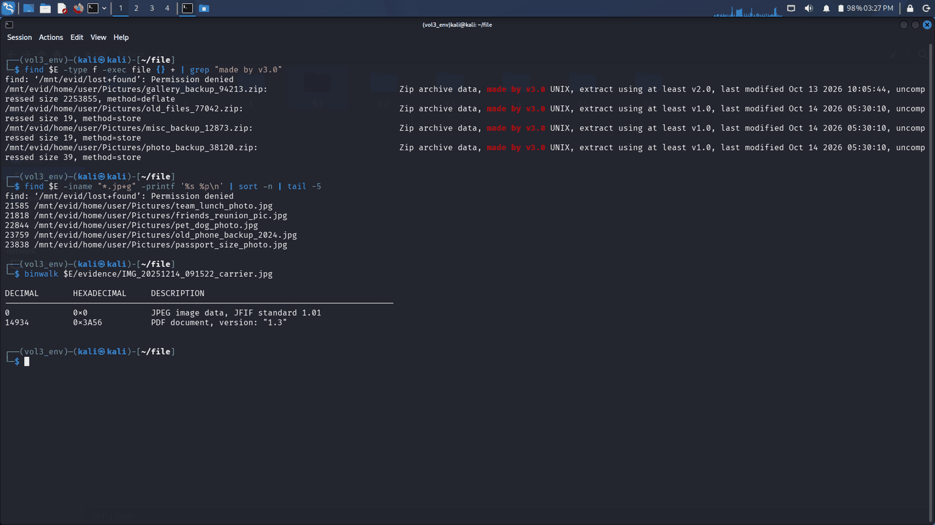
6.5 Odd ZIP and extraction
Section 4: unzip -l, file, exiftool, steghide info, stegseek, steghide extract.
Figure 6.5.1 — gallery_backup_94213.zip: SHA-256 1cd48a78…58a725; unzip -l lists one member, IMG_20260108_221433.jpg (2,253,855 bytes, dated 2026-10-13 15:35). Extracted JPEG: SHA-256 0f4aebd4…bcf0b4; file reports JPEG 3024×4032; exiftool
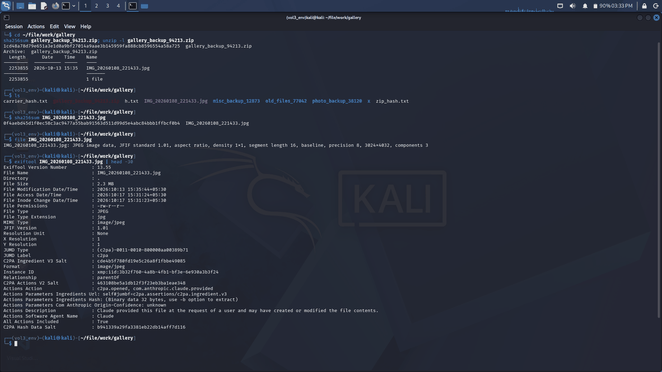
Figure 6.5.2 — steghide info -p "" reports embedded file CoinSetu_Statement.pdf (15.1 KB, rijndael-128 cbc, compressed); stegseek finds the passphrase "" ; steghide extract writes CoinSetu_Statement.pdf; sha256sum = 49c42d083e8afc5b4da4100f410cb9a92ca2e69b7acd6fe2464ca4e693f88796.
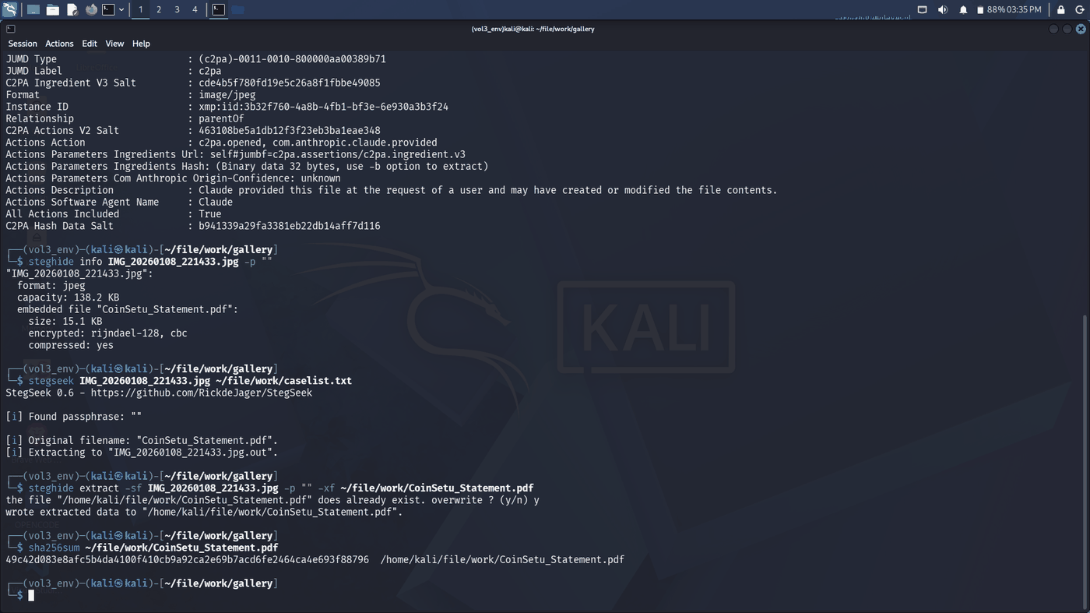
6.6 Payload and hash verification
Cross-reference of the recovered statement against Experiments 5, 6 and 8, and SHA-256 of every layer in the exhibit chain.
Figure 6.6.1 — pdfdetach -list shows one attachment, "Content Credentials". The wallet string measures 41 characters; the Blockstream lookup returns "base58 error". WHOIS 103.253.146.77: 103.253.146.0/24, DIGITALOCEAN-AP, Digital Ocean, Inc., SG. vol linux.envars | grep -i CLIP: process clipmgrd (PID 37, PPID 1) holds CLIP_LAST_ITEM = the wallet string. (The first python3 line was mistyped with a leading "22." and repeated correctly.)
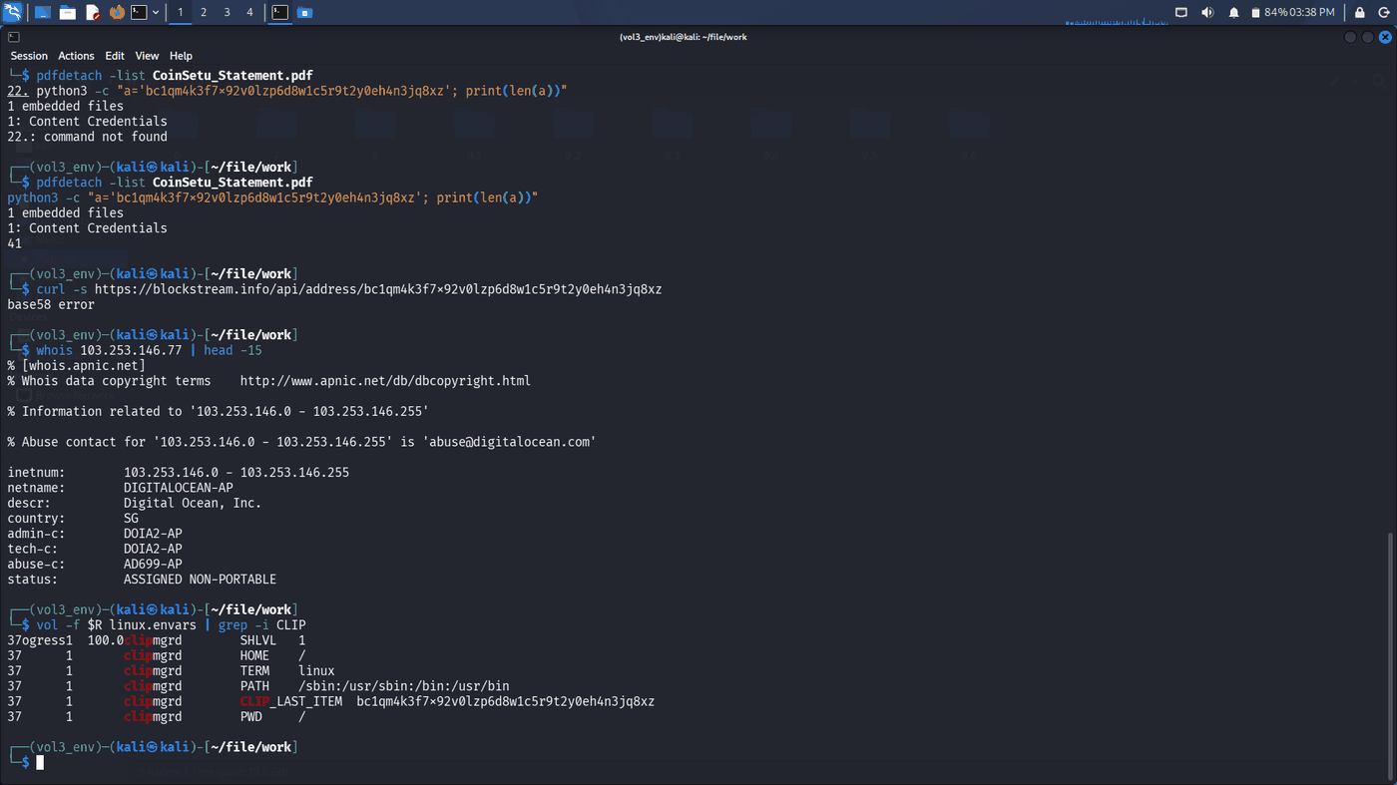
Figure 6.6.2 — vol linux.pslist | grep -i clip: clipmgrd PID 37, created 2026-09-15 05:50:18 UTC. tshark on Sitabuldi_Router_20251219.pcap: traffic between 192.168.1.13 / 192.168.1.17 and 103.253.146.77 on 2025-12-19 (09:16 and 11:30 IST).
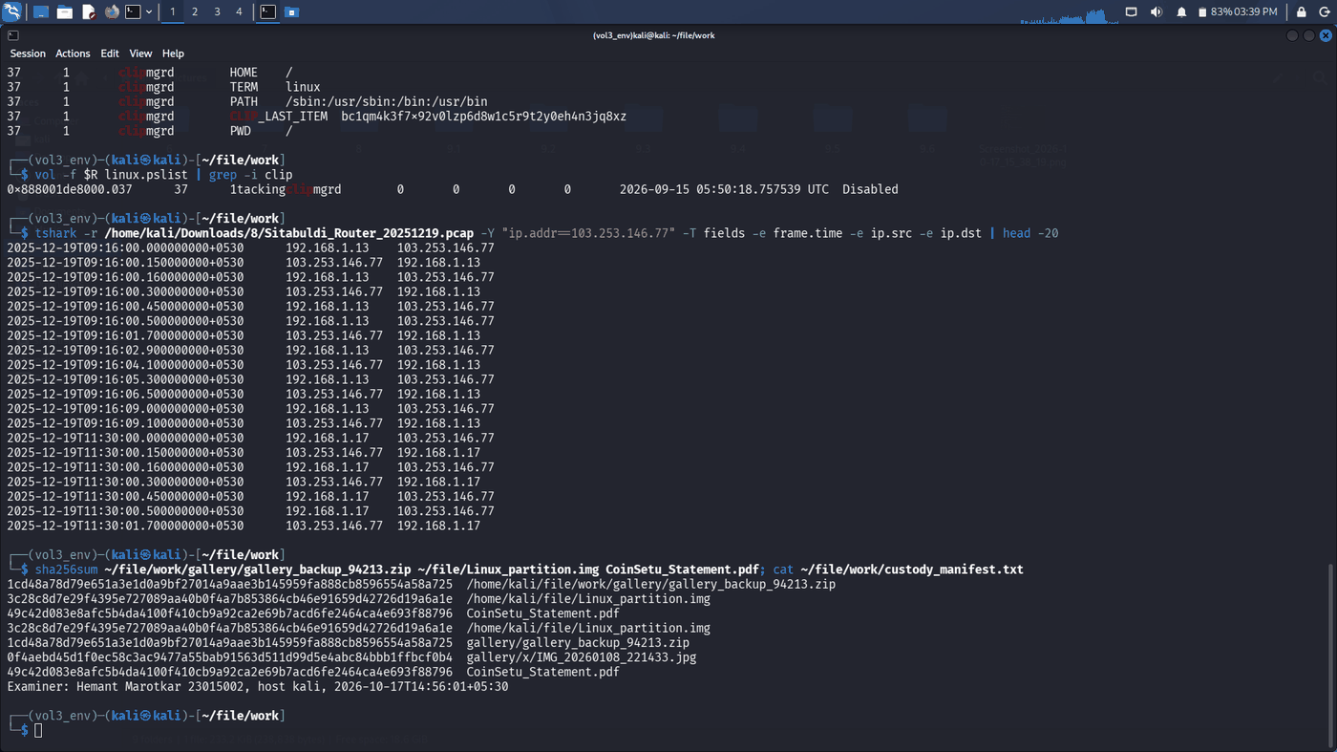
Examiner's Declaration
I declare that this report reflects my own independent examination of the exhibits listed above, that all findings are supported by the referenced artefacts, and that the analysis and conclusions are stated in my own words.
Signature | _____________________  [Sujal Wasnik] | Date | 18-10-2026 | Name | Sujal Wasnik | Roll No / UID | 23015036

