~~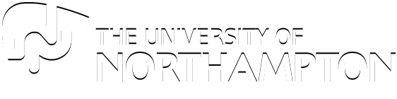~~

CONTENTS

Submitted By – Esha Rajbhandari

UN ID: 16418519

WEB DESIGNING

Module: CSY1018

1. Introduction………………………………………………………………………………
2. Design Initiation…………………………………………………………………………
   1. Phase 1: Initial design wireframe……………………………………………..
   2. Phase 2: Design modification wireframe…………………………………….
   3. Phase 3: Final wireframe………………………………………………………
3. Draft………………………………………………………………………………………
4. Screen Mock Up…………………………………………………………………………
   1. Screen mock up: mobile responsive…………………………………………..
5. Testing……………………………………………………………………………………
6. Citation and Referencing……………………………………………………………….

INTRODUCTION

This assignment explicitly covers the use of HTML code and the implementation of css and css3 concepts to create a usable personal website. The website gives a general information about me, my skills and my education details.

Creating this project challenged me in various possible ways. The assignment was an interesting task to begin with. The first part of the html coding and the basics of css was stimulating. They clearly illustrated the design of the wireframe of my website. The selection of color combination for the website was a little problematic since I wanted the website to look simple and at the same time a little exciting. To add the element of appeal, the search was tedious because of the limitation of usable language (HTML, CSS). Without the help of other languages such as JavaScript and JQuery, the design I had decided for my website was difficult to implement. This posed an obstacle as my design was plain and simple with no striking features. The sliding images in the home page is fairly common in most of the websites. This became the basis of my idea but most of the sliding effects were entirely dependent on the use of other languages. However, the application of concept of css3 helped me out in this situation. Its animation effects made my website more playful and attractive. Lots of animations in a website is not as appealing. Thus, it was difficult for me to reach a final decision of where the animations best suit good. Although, the use of css and css3 made the look of the website lively, the actual application of the code was complex and confusing. In the course of this website development, I faced a lot of errors and the debugging was slow and time-consuming. This project took a lot of effort and time. I dedicated a total of 24 hours in the making of this assignment. Besides the creation of this websites for the computer browsers, the design of the mobile responsive sites were more confusing since it was my first time making such user-friendly and technology-friendly website design.

This assignment helped me realize my weakness and strength in the web designing course. I learned different and alternative techniques to deal with different situation which may arise.

For the preliminary stage of the designing, I visited different websites from which I referenced my initial design. This helped in creating a framework of how my website would look. I further performed various editing and restructured my website to achieve a satisfactory result.

**Phase 1: Initial Design Wireframe**

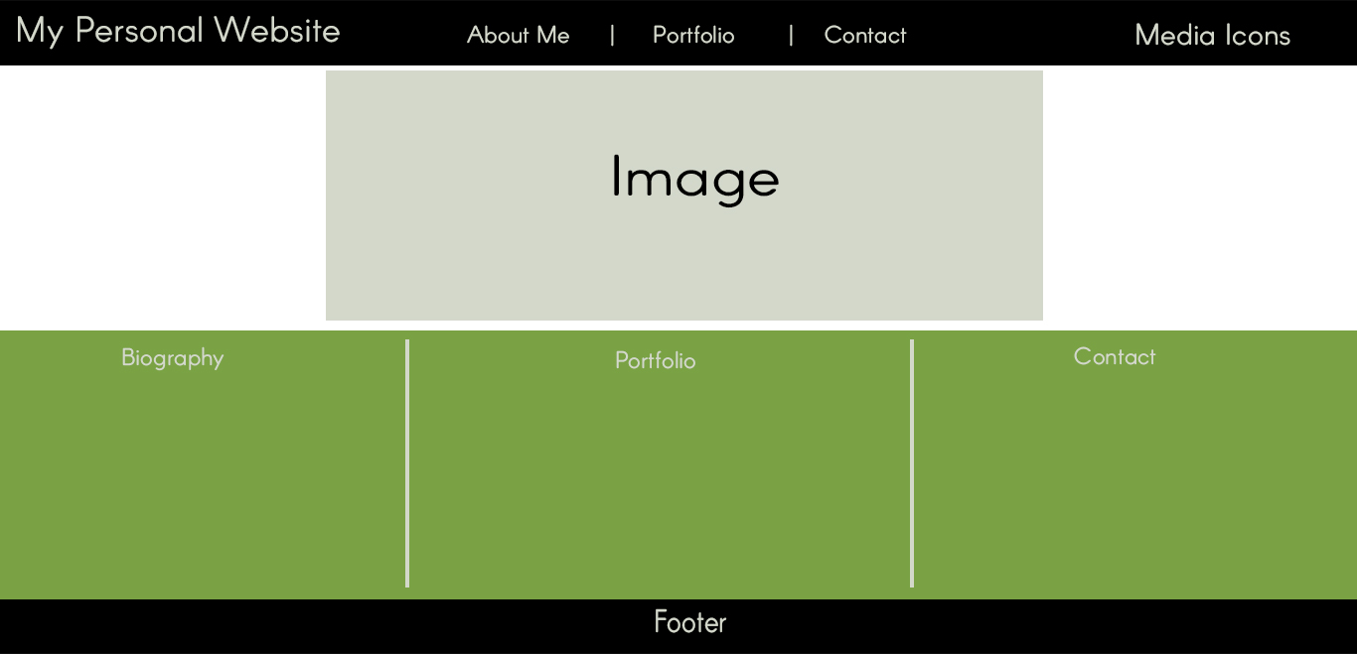

Figure 1: Home page

The mapping of the home page in the initial stage included my logo on the top left corner and social media icons on the right side of the header. To allow quick access to various other links, I planned on creating a menu in the middle section of the header. The section part of my website was divided into two divisions. The top division had an image set to it and the bottom division provided a brief information about the entities of the menu. In this design, I wanted to have a simple footer.

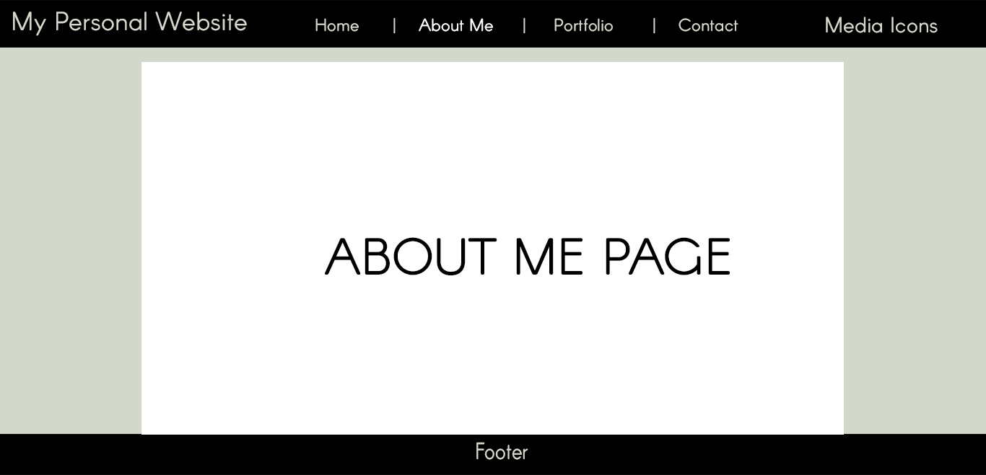

Figure 2: about me

I wanted my website to be simple and attractive. Initially I planned on keeping the header and the footer same for the all the pages. Home tab was further added in the menu section so that all the pages can easily be viewed from every section. In this page, all the information related to my biography would be written in the middle section.

**Phase 2: Design modification wireframe**

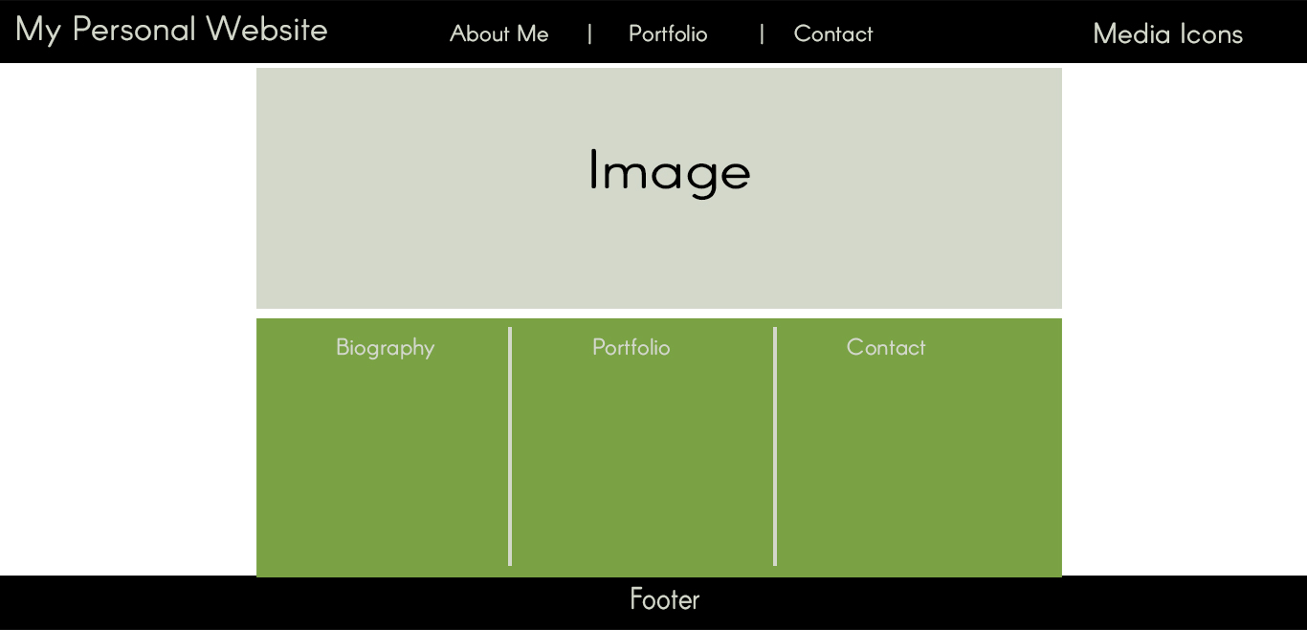

Figure 3: Home page

The phase1 design of website satisfied the requirement of simplicity. However, it failed to look attractive. So, for phase2, I redrafted the initial stage design and equally aligned both top and bottom section. This further defined the simplicity of the design.

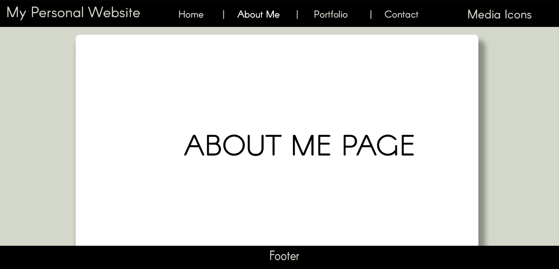

Figure 4: about me

All the structure of the about me page and other pages were similar to the phase1 design except for the writing section. Border radius was defined in the box where the text was to be included.

**Phase 3: Final Wireframe**

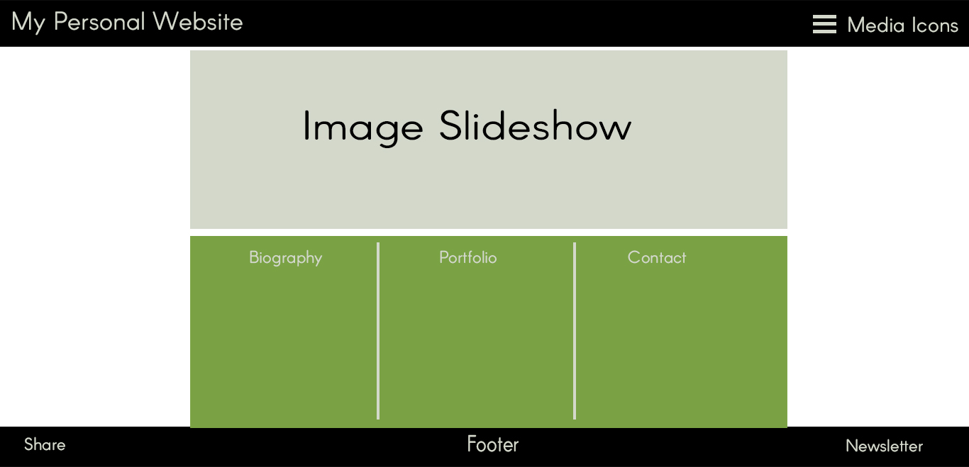

Figure 5: home page

The phase2 design was further modified to add some animations and edit some features. In my final design, the menu bar section from the header was removed and was instead displayed in the dropdown. The dropdown style was added to the hamburger icon in the right. Beside this change, the top section now contains multiple images demonstrated with slide show effect. Features of newsletter was also added in the footer section.

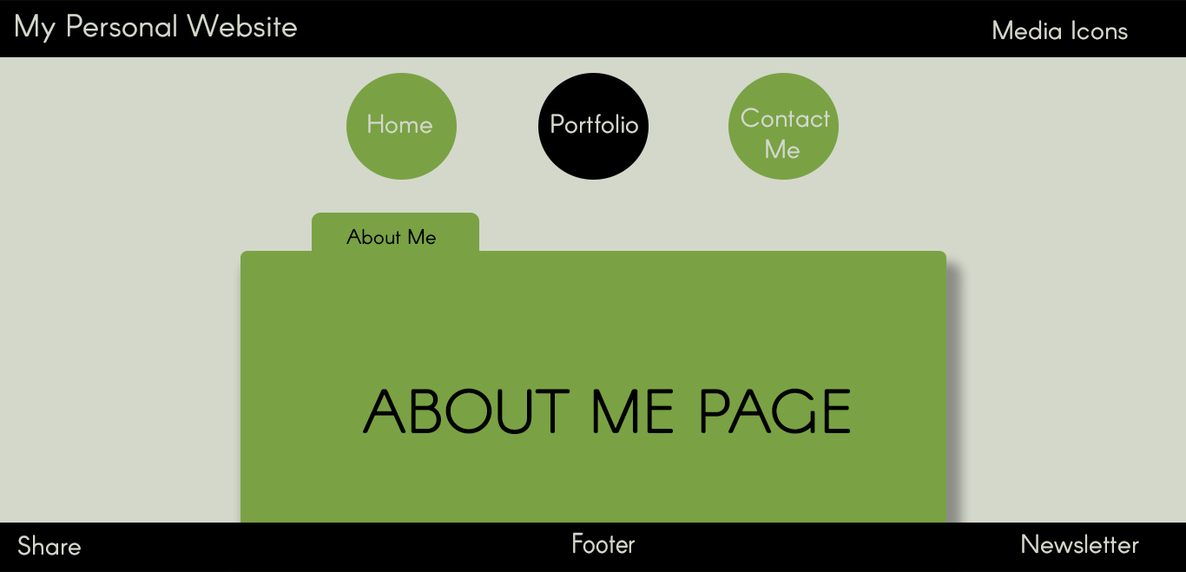

Changes were done in all the other pages. In the final design of the website, the menu list instead of being enlisted in the dropdown menu, was separately placed in the top section inside a circular figure. The bottom section included the text to be displayed.

DRAFT

The sketches of my final design looked like this:

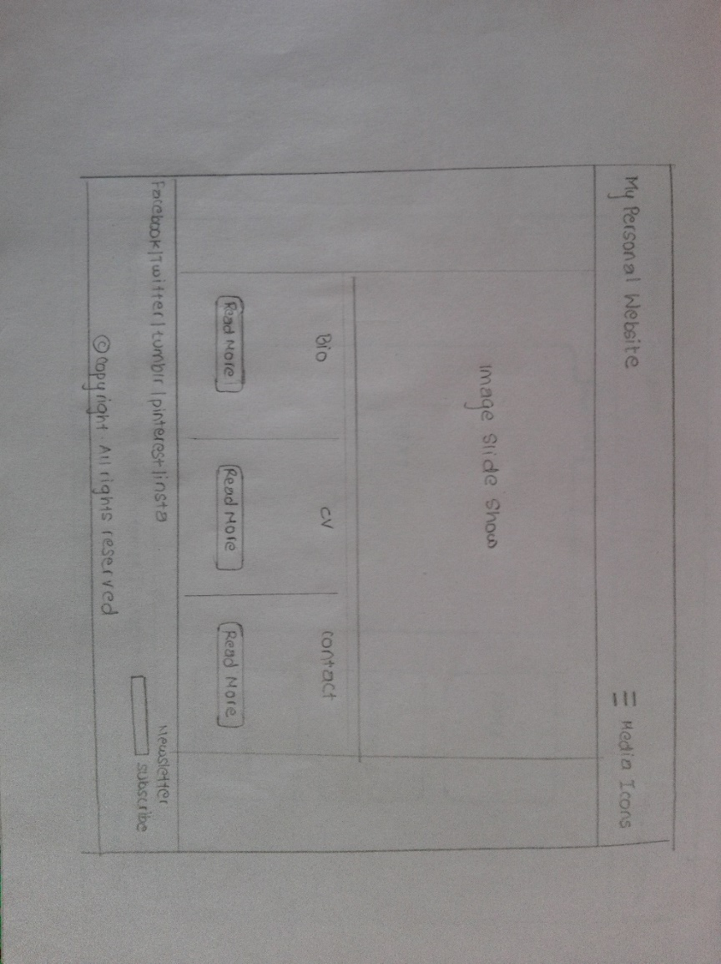

Figure 6: Home page wireframe

The home page will contain a logo in the left of the header and social media in the right. All the menu list will be displayed in the dropdown. The main section will be classified into two divisions. The top division will contain slideshow of the image. The bottom division will be further classified into three divisions and displayed in row. Each such division will brief about the contents of the menu. The footer will also be divided into two sections and displayed in column. The top portion of the footer will contain share feature in the left portion and subscribe in the right portion. The bottom section of the footer will contain the copyright information.

All the other pages will include the same header and footer design as the home page. Only the menu will be included in the top division of the main section. This will ensure easy navigation across all other pages. The bottom division of the main section will be designed by adding border radius and shadow effects. The contents will be displayed as per the topic of the page.

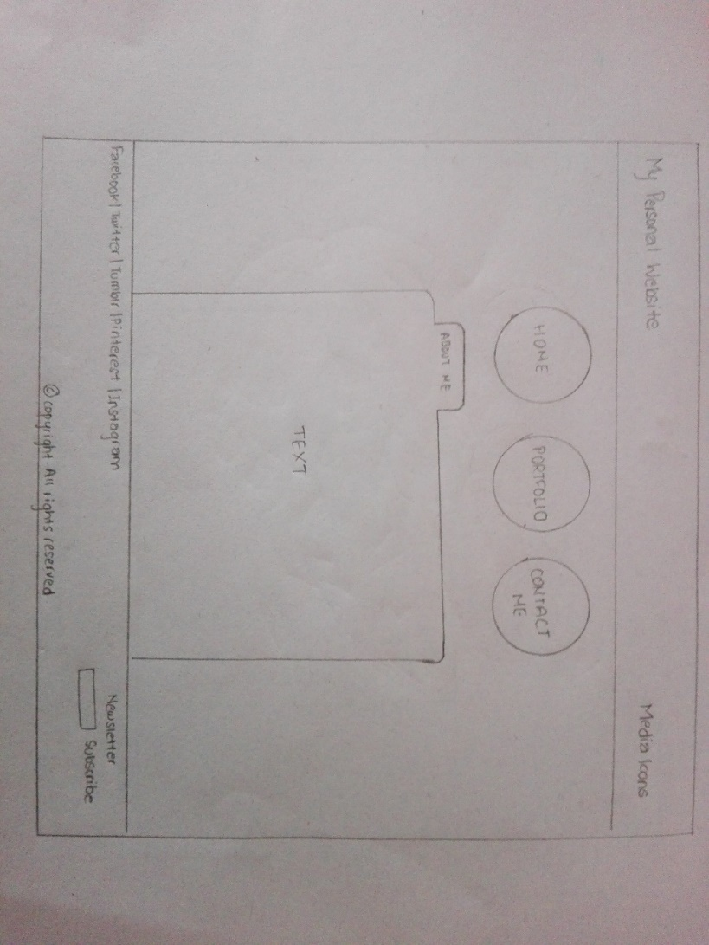

Figure 7 : about page wireframe

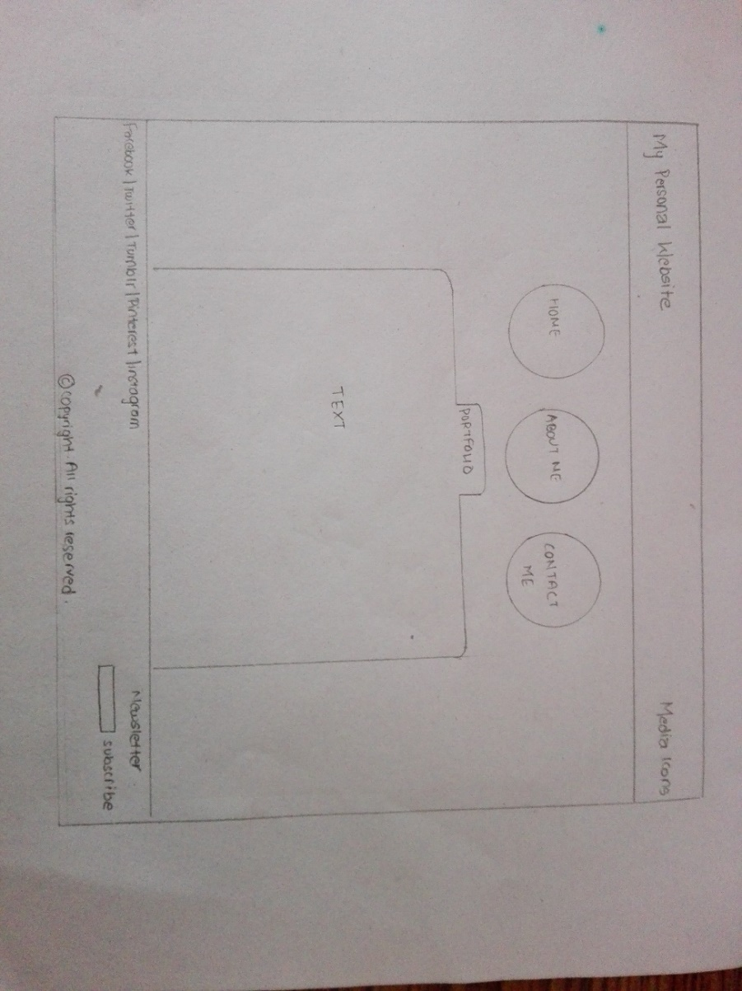

Figure 8: portfolio wireframe

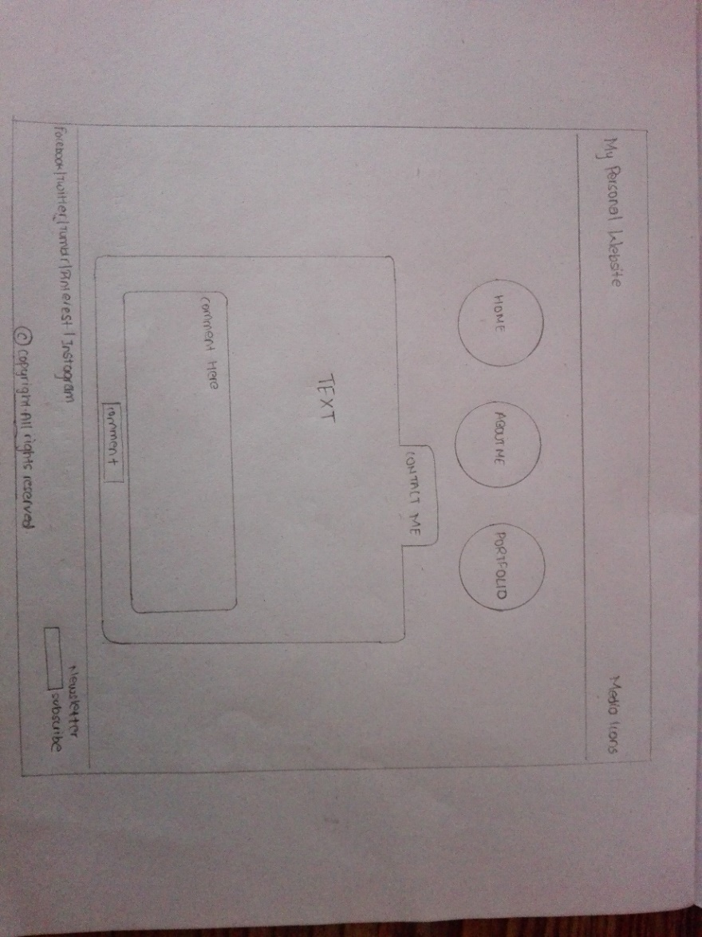

Figure 9: contact wireframe

SCREEN MOCK UP

Based on my final draft of the design, the actual website looks like this:

All the images used in the website are copyright free. These were personally made using Adobe Photoshop CC and Adobe Illustrator CC. The images were inspired from various images found in Google.

Home page 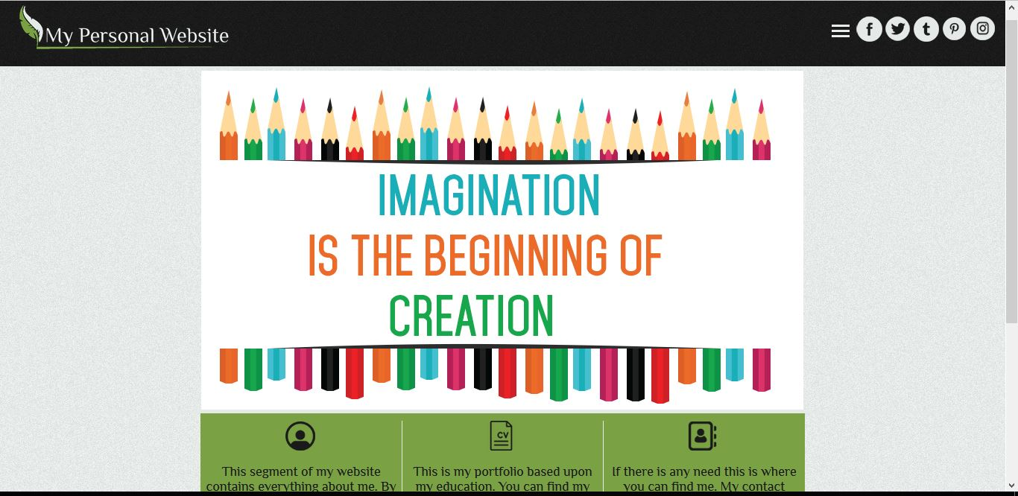

About me page 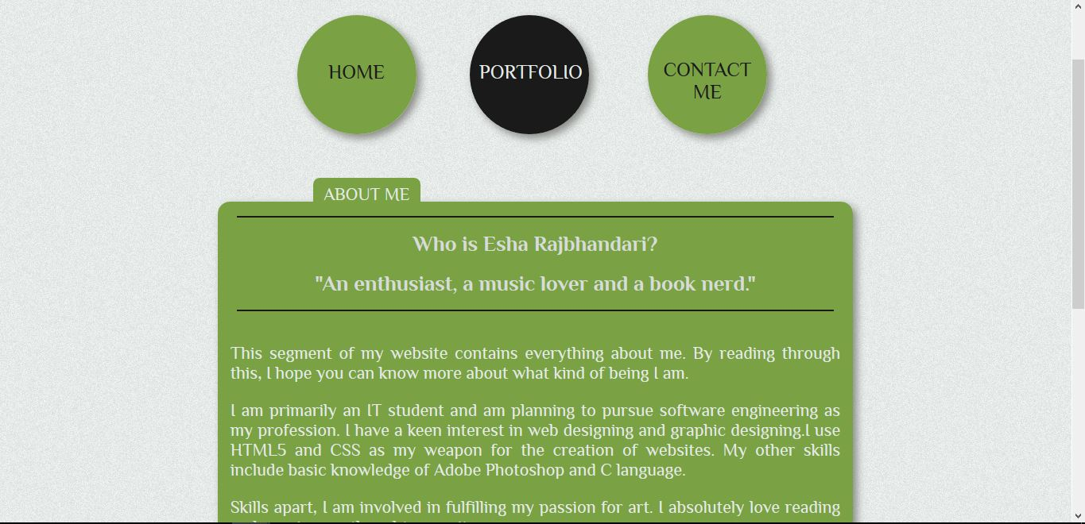

Contact page 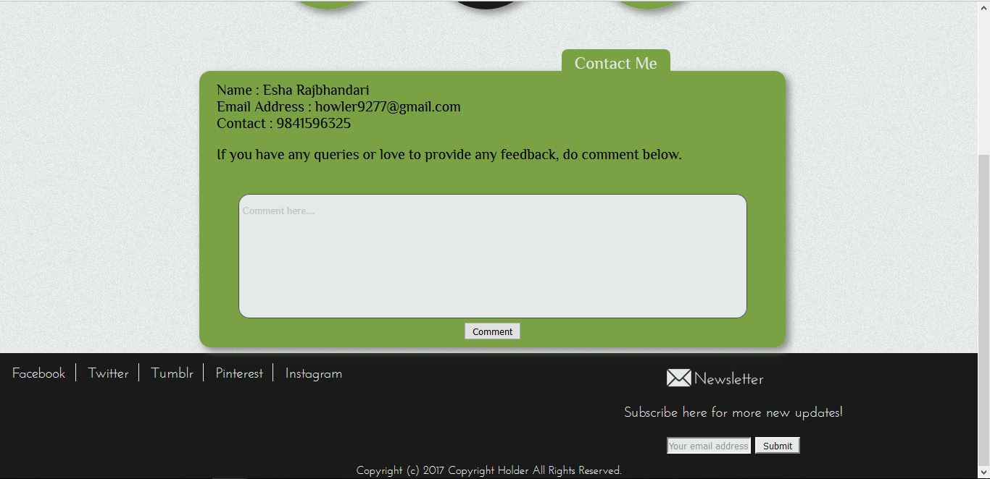

Portfolio page 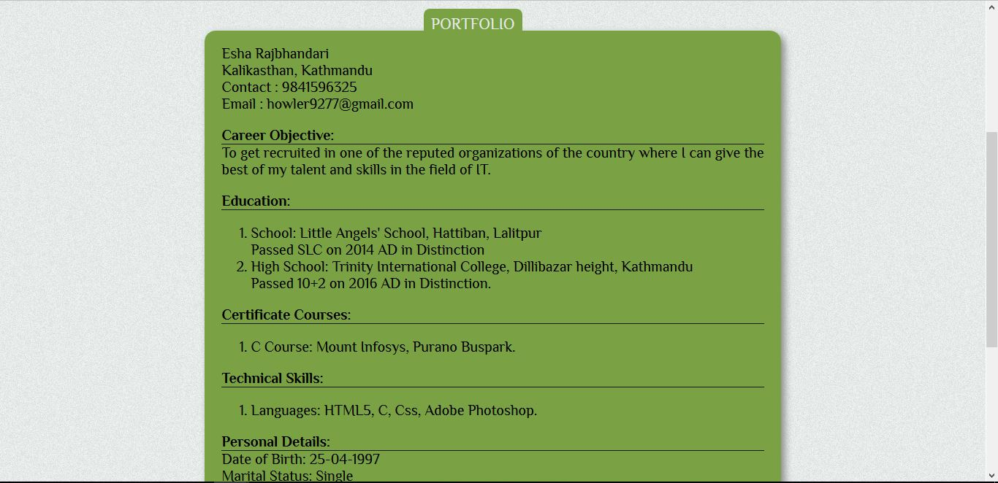

SCREEN MOCK UP: MOBILE RESPONSIVE

The website is also made mobile responsive. When the width is less than or equals to 600px, the elements are displayed in slightly different format than when it is displayed in the web. All the division which were displayed in row in web is displayed in column in mobiles responsive. The social icons in the right of the header is not displayed in this format. The footer contains all the information.

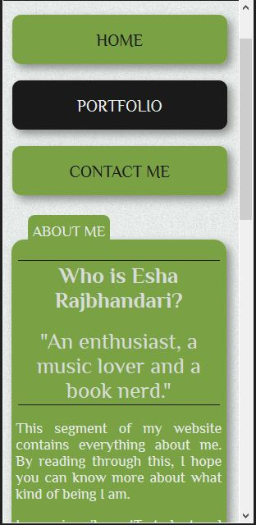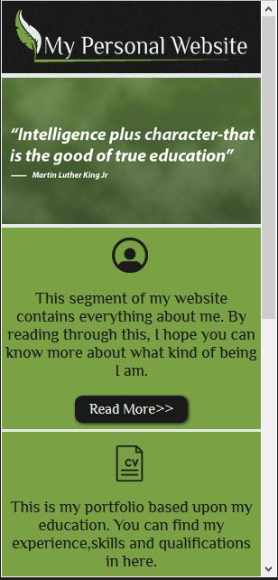

Mobile responsive: About Me page

Mobile responsive: Home page

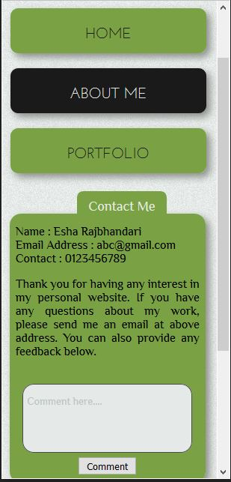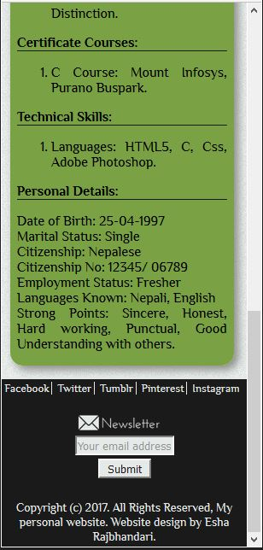

Mobile responsive: Contact page

Mobile responsive: Portfolio page

TESTING

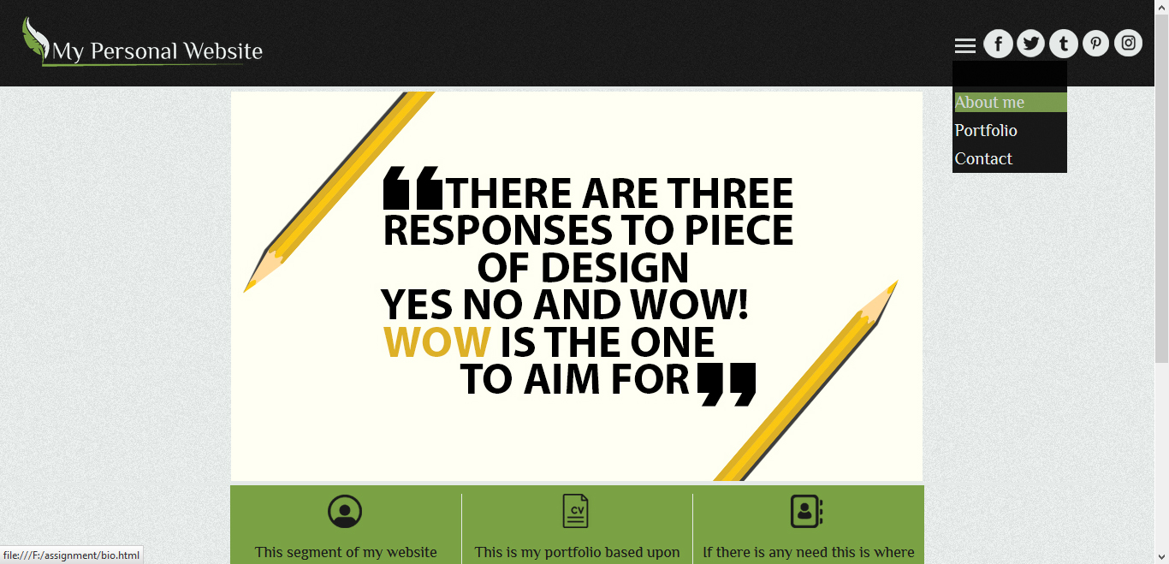

In the home page, when the hamburger menu bar is hovered, a dropdown menu is displayed. The menu comprises of "About me", "Portfolio" and "Contact". Clicking on them will navigate the user to their specific page.

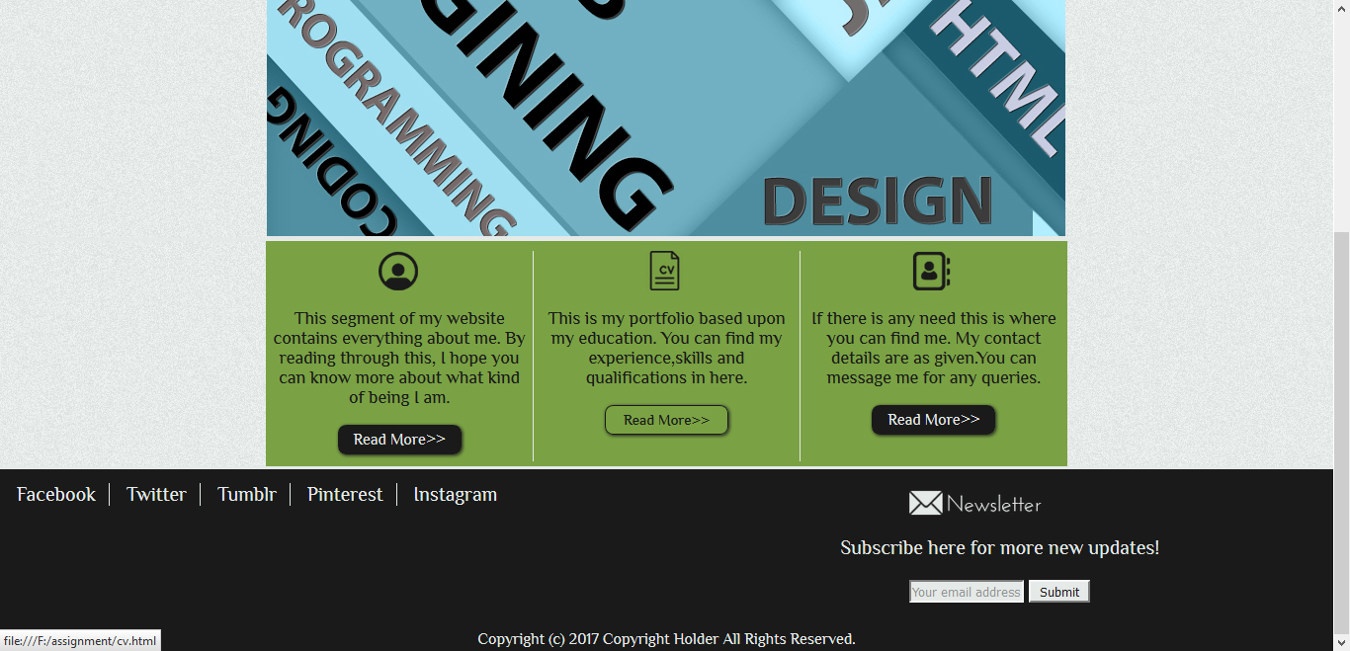

In the home page, when the read more button in the bottom division is hovered, the color of the button will change. Clicking on it will lead the user to that specific page.

CONCLUSION

The website is created based on the use of HTML5, CSS and some basic concept of CSS3 animations. The wireframes were redrafted and edited multiple times before the actual designing took place. During its creation, many problems were faced due to the restriction of other languages. This created problem in the actual application of the framework. To overcome this problem, this website is created with the use of simple codes. Many other websites were referred to for the designing process.

CITATION AND REFERENCE

1. Experts-exchange.com, (2014).*Build A Pure CSS3 Slideshow (No Javascript Here)*. [online] Available at: https://www.experts-exchange.com/articles/14861/Build-a-Pure-CSS3-Slideshow-no-javascript-here.html[Accessed 03-04-2017].