Abstract

This project presents Vision Talk, an intelligent video analysis platform aimed at transforming surveillance footage into structured, searchable, and semantically rich information by leveraging advanced multimodal artificial intelligence techniques. With the continuous growth of video data produced by modern surveillance systems, manual analysis has become increasingly inefficient, time-consuming, and prone to human error. Vision Talk addresses these challenges by enabling automated understanding and exploration of large-scale video content.
The proposed solution is based on a modular architecture designed to ensure flexibility, scalability, and seamless integration within existing surveillance environments. Its primary objective is to bridge the gap between low-level visual perception and high-level semantic understanding. By allowing users to interact with video data through natural language queries, the platform simplifies video analysis and makes complex surveillance data more accessible and intuitive.
The platform is composed of four core modules. A video processing module extracts frames from video streams and generates semantic descriptions using Vision–Language Models (VLMs). These descriptions are stored in a vector memory module that performs semantic indexing to support efficient similarity search and information retrieval. A reasoning module based on the Retrieval-Augmented Generation (RAG) paradigm combines retrieved contextual knowledge with language generation models to deliver accurate, coherent, and context-aware responses to user queries. Finally, a web-based interface provides an intuitive interaction layer, enabling users to query surveillance footage and visualize relevant frames associated with precise temporal references.
By integrating visual understanding with natural language reasoning, Vision Talk significantly reduces the cognitive workload of human operators, enhances situational awareness, and accelerates access to critical events within large video archives. This approach improves the practicality, reliability, and usability of intelligent video surveillance systems and represents a meaningful contribution toward more efficient real-world deployment of AI-driven surveillance solutions.
Keywords: Intelligent video surveillance, Computer vision, Vision–Language Models, Retrieval-Augmented Generation, Semantic search, Multimodal AI.

Résumé

Ce projet présente Vision Talk, une plateforme intelligente d’analyse vidéo visant à transformer les séquences de vidéosurveillance en informations structurées, exploitables et sémantiquement riches, en s’appuyant sur des techniques avancées d’intelligence artificielle multimodale. Face à la croissance continue des volumes de données vidéo produits par les systèmes de surveillance modernes, l’analyse manuelle devient de plus en plus inefficace, chronophage et sujette aux erreurs humaines. Vision Talk répond à ces limitations en proposant une compréhension automatisée et une exploration efficace de grands ensembles de données vidéo.
La solution proposée repose sur une architecture modulaire conçue pour garantir flexibilité, évolutivité et intégration aisée au sein d’environnements de surveillance existants. Son objectif principal est de réduire l’écart entre la perception visuelle de bas niveau et la compréhension sémantique de haut niveau. En permettant aux utilisateurs d’interagir avec les données vidéo à travers des requêtes formulées en langage naturel, la plateforme simplifie l’analyse des contenus de surveillance et rend ces systèmes plus accessibles et intuitifs.
La plateforme se compose de quatre modules principaux. Un module de traitement vidéo extrait automatiquement des images à partir des flux vidéo et génère des descriptions sémantiques à l’aide de modèles Vision–Langage (VLMs). Ces descriptions sont stockées dans un module de mémoire vectorielle chargé de l’indexation sémantique et de la recherche par similarité afin d’assurer une récupération efficace de l’information. Un module de raisonnement, basé sur le paradigme de la Retrieval-Augmented Generation (RAG), combine les informations contextuelles récupérées avec des modèles de génération de langage pour produire des réponses précises, cohérentes et contextualisées. Enfin, une interface web intuitive constitue la couche d’interaction, permettant aux utilisateurs d’interroger les séquences de surveillance et de visualiser les images pertinentes associées à des références temporelles précises.
En intégrant la compréhension visuelle et le raisonnement en langage naturel, Vision Talk réduit significativement la charge cognitive des opérateurs humains, améliore la perception situationnelle et accélère l’accès aux événements critiques au sein de vastes archives vidéo. Cette approche renforce l’efficacité opérationnelle, la fiabilité et la convivialité des systèmes de vidéosurveillance intelligents, et constitue une contribution pertinente à leur déploiement efficace dans des contextes réels.
Mots-clés : Vidéosurveillance intelligente, Vision par ordinateur, Modèles Vision–Langage, Retrieval-Augmented Generation, Recherche sémantique, Intelligence artificielle multimodale.

General Introduction

With the rapid advancement of computer vision technologies and the widespread deployment of video surveillance systems, the volume of visual data generated on a daily basis has reached unprecedented levels. As of 2025, more than 1.2 billion connected cameras are estimated to be in operation worldwide, and the global video surveillance market continues to experience sustained growth [1]. These systems are extensively deployed in public spaces, enterprises, industrial facilities, and critical infrastructures for purposes such as security monitoring, access control, and incident prevention. Consequently, continuous video streams constitute a rich and valuable source of information that has the potential to provide detailed insights into real-world environments and activities.
Despite the abundance of visual data, its effective exploitation remains a significant challenge. Most existing video surveillance systems are primarily designed for recording and storage, with limited capabilities for intelligent or semantic content analysis. As a result, identifying events of interest and extracting relevant information largely depends on manual inspection by human operators. This process is inherently time-consuming, inefficient, and prone to errors, particularly in large-scale deployments involving numerous cameras and continuous streams of data.
In operational settings, human operators are frequently required to monitor multiple video feeds simultaneously, which often leads to cognitive overload and reduced attention levels. Several studies have demonstrated that prolonged visual monitoring adversely affects human vigilance, increasing the likelihood of missed or delayed event detection in surveillance scenarios [2]. Furthermore, the absence of semantic indexing mechanisms limits efficient access to archived footage, forcing users to rely on low-level metadata such as timestamps or camera identifiers when searching for specific events.
Recent progress in artificial intelligence has opened new avenues for addressing these limitations. In particular, developments in Vision–Language Models (VLMs) and Retrieval-Augmented Generation (RAG) have enabled stronger integration between visual perception and natural language understanding [3]. These approaches make it possible to automatically generate semantic descriptions from visual data and to support more intuitive interaction with complex multimedia content through natural language queries, thereby redefining traditional paradigms of video analysis and retrieval.
  - Company Introduction

Figure 1:Wonviz Corporation

  - Context and Motivation
Video surveillance systems are mainly used as continuous monitoring tools that record scenes and allow them to be reviewed when needed. In many professional environments, these systems play an important role in ensuring security, supporting daily operations, and enabling post-event investigations. They are widely deployed in industrial sites, logistics platforms, public infrastructures, and large enterprises.
Despite their widespread use, video surveillance systems are mostly used in a reactive manner rather than a proactive one. In most cases, video data is analyzed only after an incident has occurred. This requires operators to manually review long and continuous video recordings in order to find relevant moments. In large-scale environments, such as industrial sites or distribution centers with many cameras, this process can take several hours and carries a high risk of missing important events.
In addition, operators working in control rooms are often exposed to a high cognitive workload due to the need to monitor multiple video streams at the same time. Long periods of visual attention lead to fatigue, reduced focus, and lower detection accuracy. As artificial intelligence systems become more capable of understanding complex visual scenes, there is a growing tendency to rely on automated solutions to handle repetitive and mentally demanding monitoring tasks [4].
Furthermore, current surveillance systems mainly provide a technical and low-level view of video data. Access to recordings is generally based on camera identifiers, dates, or timestamps, rather than on the semantic content of the scenes. Although features such as motion detection or facial recognition are commonly used, they remain limited to specific tasks and do not allow users to search or interact with video content using natural language.
These limitations clearly show the need for more intelligent surveillance systems that can help users better understand, analyze, and interact with video data in a more efficient, flexible, and semantically meaningful way.
  - Problem Statement
Despite the widespread use of video surveillance systems, their effective exploitation remains limited. Most existing systems focus mainly on recording and storing video streams, without automatically understanding or interpreting the content of the scenes. As a result, video data remains unstructured and difficult to analyze efficiently.
In practice, only a small portion of recorded surveillance footage is actually reviewed by human operators. Manual analysis of video recordings is slow and inefficient, especially in environments with a large number of cameras and long recording durations. This process is also affected by human limitations such as fatigue, reduced attention, and repetitive tasks, which often lead to missed or delayed detection of important events.
Furthermore, traditional surveillance systems do not support natural language interaction. Users cannot express their information needs in a direct and intuitive way. Searching for specific events usually requires manually browsing long video sequences using timestamps or camera identifiers, which significantly reduces efficiency and responsiveness.
These limitations lead to the following central research question:
How can an intelligent system be designed to automatically understand video content, structure the extracted information, and allow users to query surveillance data using natural language in an efficient and relevant manner?
  - Project Objectives
The main objective of this project is to design and develop an intelligent system that improves the use of video surveillance data through automatic content understanding and semantic access. Instead of treating video streams as passive recordings, Vision-Talk aims to transform them into structured and searchable information that users can interact with in a natural and efficient way.
To achieve this objective, the system is designed around several complementary goals. First, it provides an automatic video analysis mechanism capable of extracting meaningful information from visual scenes at configurable time intervals. This allows continuous and adaptive processing of video streams without requiring constant human intervention.
Next, the system generates semantic textual descriptions of video content using Vision-Language Models (VLMs). These models convert raw visual information into natural language representations that describe the main elements, actions, and context present in each scene.
The extracted information is then stored and organized within a dedicated semantic memory. This memory layer enables efficient and scalable information retrieval. Unlike traditional surveillance systems that rely mainly on metadata such as timestamps or camera identifiers, Vision-Talk uses content-based semantic indexing, allowing information to be retrieved based on the actual events occurring in the video.
On top of this structured memory, the system supports natural language querying, enabling users to interact with video content in a simple and flexible manner. Users can ask questions freely, without needing technical knowledge or predefined filters.
Finally, the system is designed to provide contextual and evidence-based responses. The answers are enriched with relevant video frames and precise temporal references, ensuring that the results are both understandable and visually grounded, which supports faster and more reliable decision-making.
  - Methodology

Introduction to Scrum
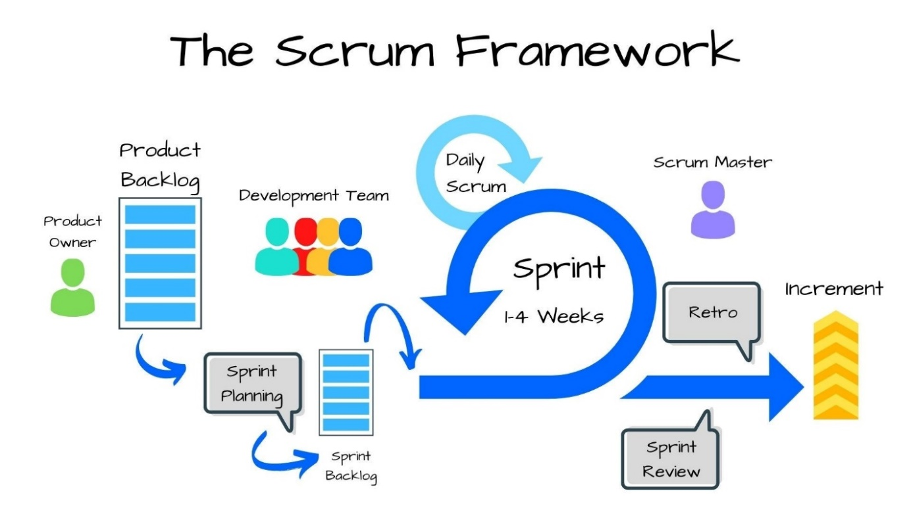
Figure 2: SCRUM Framework
Scrum is an Agile framework used to manage and organize complex software development projects. It is part of the Agile methodology and is widely adopted because it promotes flexibility, continuous improvement, and effective collaboration among team members.
Scrum is based on short and iterative development cycles called sprints. Each sprint allows the team to develop and deliver a functional part of the system. This iterative approach enables regular feedback, continuous improvement, and better adaptation to changes during the development process. As a result, Scrum helps maintain a strong focus on delivering value throughout the project.
The Scrum framework is built around the following key elements:
- Product Backlog: The product backlog is an ordered list of features, tasks, and requirements needed for the project. It is continuously updated and refined based on project progress and stakeholder feedback.
- Sprints: Sprints are short development cycles, usually lasting between two and four weeks. Each sprint aims to deliver a functional and usable increment of the system.
- Sprint Planning: Sprint planning is a meeting where the team selects items from the product backlog and defines the objectives of the sprint based on priorities and available time.
- Daily Scrum: The daily scrum is a short daily meeting where team members share progress, describe current tasks, and discuss any obstacles that may affect their work.
- Sprint Review: The sprint review is held at the end of each sprint. During this session, the completed work is presented to stakeholders in order to gather feedback and evaluate project progress.
- Sprint Retrospective: The sprint retrospective is a meeting where the team reflects on the completed sprint, identifies what went well, highlights areas for improvement, and defines actions to improve future sprints.

Key Benefits of Scrum :
- Flexibility and Adaptivity: Scrum allows projects to adapt easily to changing requirements and new constraints during development, without negatively affecting overall progress.
- Incremental Value Delivery: By delivering functional parts of the system at the end of each sprint, Scrum ensures continuous progress and early validation of results throughout the project.
- Improved Team Collaboration: Regular meetings and clearly defined roles encourage strong communication, coordination, and shared responsibility among team members.
- Continuous Process Improvement: Feedback collected during sprint reviews and retrospectives helps the team continuously improve both the product and the development process.

Scrum Roles
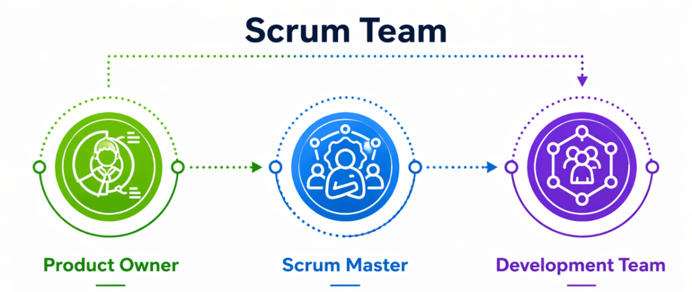
Figure 3: SCRUM Roles
The Vision-Talk project team was organized according to the three main roles defined by the Scrum framework. This organization ensured a clear distribution of responsibilities and effective collaboration throughout the development process.
The Product Owner was responsible for defining the system requirements and prioritizing features based on their value and technical constraints. This role ensured that each delivered increment remained aligned with the overall vision of the project. The Product Owner also acted as the main link between stakeholders and the development team.
The Scrum Master was responsible for ensuring that Scrum principles were correctly applied during the project. This role involved facilitating team activities, monitoring sprint progress, and removing any obstacles that could slow down development or affect productivity.
The Development Team was responsible for the implementation of the system. This included the design, development, and integration of all functional components, while ensuring that the system met the required performance, quality, and usability standards.
Within this framework, the roles were assigned as follows:
- Sayed Hamdi acted as Scrum Master and Company Supervisor. He supervised the Scrum process, ensured proper coordination within the team, and provided continuous technical and professional guidance from the company perspective.
- Ayoub Stiti served as Product Owner. He defined the vision of the Vision-Talk system, prioritized features, and maintained communication between stakeholders and the development process to ensure alignment with project objectives.
- Wassim Hfaiedh contributed as Software Developer. I was responsible for the complete implementation of the system, including backend development, frontend design, and the integration of key AI components such as Vision-Language Models (VLMs), Large Language Models (LLMs), and the Retrieval-Augmented Generation (RAG) pipeline.

Product Backlog
The Product Backlog defines the main functionalities required for the development of the system. Each backlog item is formulated as a user story in order to capture the user’s needs clearly. The items are prioritized according to their importance for the system and their implementation complexity.
Table 1 summarizes the main Product Backlog items identified for this project.
Table 1: Product Backlog
User Story | Priority | Complexity
As a user, I want to upload a video so that it can be analyzed by the system. | High | Medium
As a user, I want the system to automatically extract frames at regular intervals. | High | Medium
As a user, I want the system to generate descriptive captions for each frame using AI models. | High | High
As a user, I want the generated captions to be stored with timestamps for accurate retrieval. | High | Medium
As a user, I want to search video content using natural language queries. | High | High
As a user, I want to receive answers linked to relevant video segments and timestamps. | High | High
As a user, I want a simple and intuitive web interface to interact with the system. | Medium | Medium

Sprint Planning
For the Vision-Talk project, sprint planning was used to organize the development work into clear and structured phases. In each sprint, a set of important features was selected from the product backlog and implemented step by step.
Each sprint focused on a specific part of the system, such as video processing, semantic memory, or the RAG module. This approach helped ensure steady progress and better organization throughout the development process. Figure 4 presents the sprint planning used for the project.
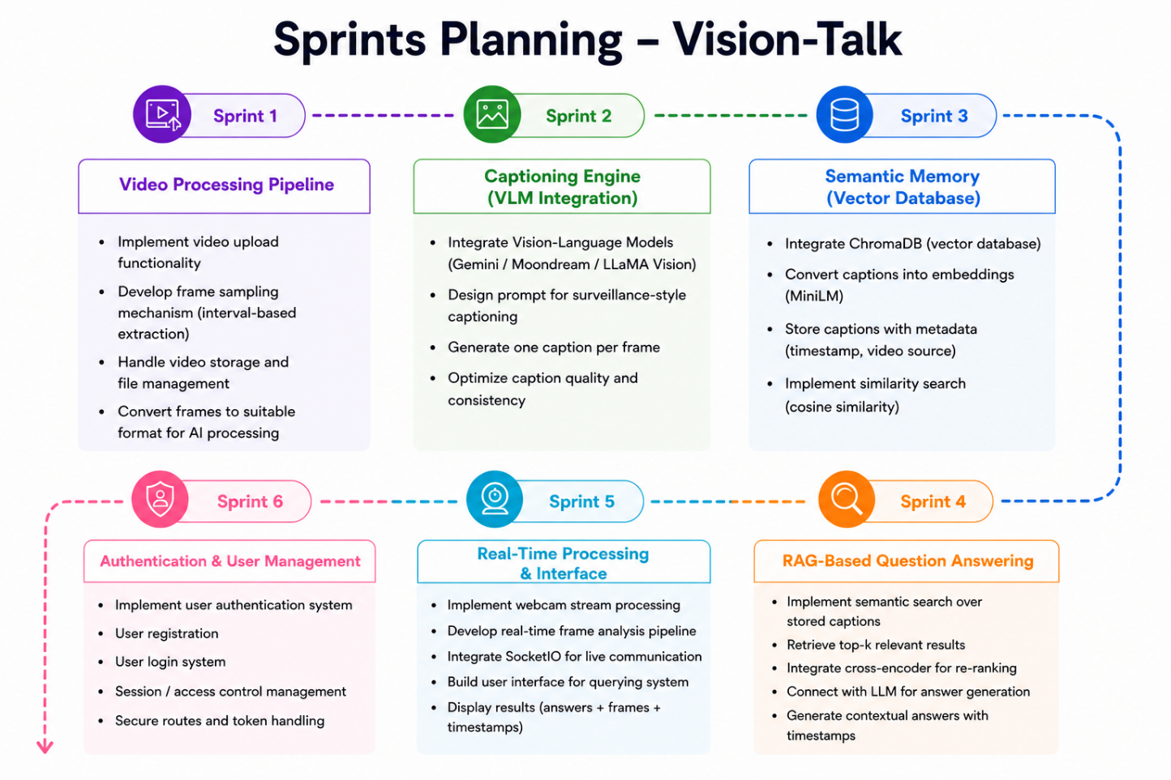
Figure 4: Sprints Planning
  - Report Structure :
This report is organized into four main chapters, each addressing a specific aspect of the proposed system.
Chapter 1 presents the state of the art. It introduces fundamental concepts related to computer vision and deep learning, and discusses Vision-Language Models, Large Language Models, and Retrieval-Augmented Generation. This chapter also reviews existing approaches and solutions in the field of intelligent video analysis.
Chapter 2 focuses on system analysis and design. It describes the functional and technical requirements, the overall architecture, and the main system components.
Chapter 3 is dedicated to the implementation phase. It explains how the different modules were developed and integrated to build the complete system.
Chapter 4 presents the testing and evaluation results. It describes the evaluation methodology and analyzes the system’s performance and effectiveness.

Chapter 1: State of the Art

Introduction :
This chapter presents the theoretical and technical background required to understand the proposed system. It begins with an overview of the fundamentals of computer vision and deep learning, which form the basis of automatic visual analysis.
It then introduces Vision-Language Models (VLMs) and Large Language Models (LLMs), highlighting their role in connecting visual data with natural language. The chapter also explains the principles of Retrieval-Augmented Generation (RAG) and vector databases, which enable semantic search and reasoning over large amounts of visual information.
Finally, existing solutions in the field of intelligent video analysis are reviewed. Their limitations are discussed in order to motivate the need for a more effective and semantically driven approach.

1.1 Fundamentals of Computer Vision
Computer vision is a field of artificial intelligence that aims to enable machines to interpret and understand visual information such as images and videos. It focuses on extracting meaningful information from visual data in order to describe scenes, recognize objects, and analyze activities. These capabilities form the foundation of many modern applications, including video surveillance, robotics, medical imaging, and autonomous systems [9].
At a fundamental level, computer vision systems rely on digital image representations composed of pixels, where each pixel encodes color or intensity information. By applying image processing techniques such as filtering, edge detection, and feature extraction, low-level visual structures can be identified and analyzed. These basic operations allow systems to detect shapes, textures, and patterns that are essential for higher-level interpretation [9].
Computer vision addresses several key tasks. Image classification aims to assign semantic labels to images based on their content, while object detection focuses on identifying and localizing objects within images or video frames. In video analysis, tracking techniques are used to follow objects across consecutive frames, enabling the study of motion and temporal behavior in dynamic scenes [11].
Traditional computer vision approaches are mainly based on handcrafted features and rule-based algorithms. While effective in controlled environments, these methods often struggle with complex real-world conditions such as variations in lighting, scale, and viewpoint. The introduction of learning-based approaches, particularly those based on deep learning, has significantly improved the robustness and accuracy of visual recognition systems by allowing models to automatically learn features directly from large datasets [10].

1.2 Deep Learning for Vision
Deep learning has become a fundamental approach in modern computer vision, as it allows systems to automatically learn visual representations directly from data. Unlike traditional methods based on handcrafted features, deep learning models extract relevant patterns from images through training on large datasets. This data-driven paradigm has significantly improved performance in complex vision tasks such as classification, detection, and scene understanding, especially in real-world environments with high variability [10].
Among the different deep learning architectures used in computer vision, Convolutional Neural Networks (CNNs) and Vision Transformers (ViT) are the most widely adopted. Each architecture follows a different modeling strategy and offers distinct advantages for visual representation and perception.
Overall, deep learning has become the dominant approach in modern computer vision systems. Its ability to automatically learn rich visual representations makes it a fundamental technology for advanced vision applications, including intelligent video surveillance and semantic video analysis.

1.2.1 Convolutional Neural Networks (CNN)
Convolutional Neural Networks (CNNs) are the most established deep learning models for computer vision applications. They are specifically designed to process image data by exploiting spatial locality and hierarchical feature extraction. CNNs use convolution operations to apply learnable filters over local regions of an image, enabling the detection of low-level features such as edges, corners, and textures.
A typical CNN architecture is composed of convolutional layers, activation functions, pooling layers, and fully connected layers. Early layers extract simple visual patterns, while deeper layers learn increasingly complex and abstract representations, such as object parts and semantic concepts. Pooling layers reduce spatial resolution while preserving essential information, improving robustness and computational efficiency [11].
CNNs have demonstrated strong performance in a wide range of vision tasks, including image classification, object detection, face recognition, and video analysis. However, their reliance on local convolution operations limits their ability to model long-range dependencies across an image. This limitation has motivated research into alternative architectures capable of capturing global contextual relationships.
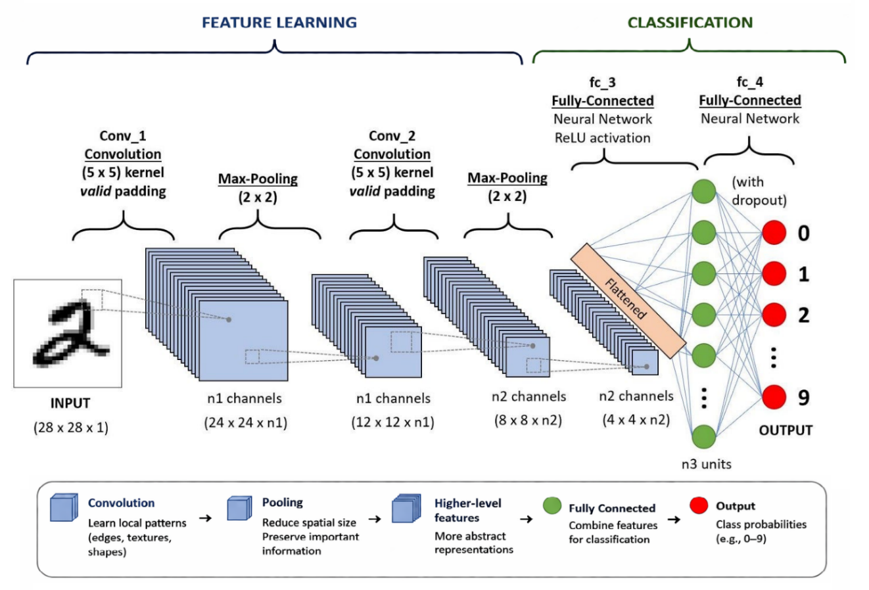

1.2.2 Vision Transformers (ViT)
Vision Transformers (ViT) represent a modern deep learning architecture designed for computer vision tasks by adapting the transformer model to visual data. Unlike Convolutional Neural Networks (CNNs), which rely on convolution operations to process local image regions, Vision Transformers use attention mechanisms to analyze relationships between different parts of an image at a global level. This approach was introduced to address the limitations of convolution-based models in capturing long-range dependencies within visual scenes [12].
In the ViT architecture, an input image is first divided into a set of fixed-size, non-overlapping patches. Each patch is flattened and mapped into a vector through a linear projection, forming a sequence of visual tokens. These tokens are processed similarly to word tokens in natural language processing models. To preserve spatial information, positional embeddings are added to the patch representations before they are passed through the transformer encoder [12].
The transformer encoder consists of multiple layers built around self-attention and feed-forward networks. The self-attention mechanism allows the model to evaluate interactions between all image patches simultaneously, enabling it to capture global contextual relationships directly. This global modeling capability distinguishes Vision Transformers from CNNs, which typically require several stacked convolution layers to progressively build an understanding of the entire image [12].
Vision Transformers have demonstrated strong performance in large-scale image recognition tasks, particularly when trained on very large datasets or initialized using pre-trained weights. Their ability to model global dependencies makes them well suited for complex visual reasoning tasks. However, ViTs generally demand higher computational resources and larger training datasets compared to CNN-based approaches. To mitigate these constraints, hybrid architectures that combine convolutional layers with transformer components are often explored in practice [12].
Overall, Vision Transformers introduce a significant shift in computer vision by moving from local feature extraction toward attention-based global representation learning. This paradigm complements convolutional approaches and plays an important role in the evolution of modern and scalable vision systems.
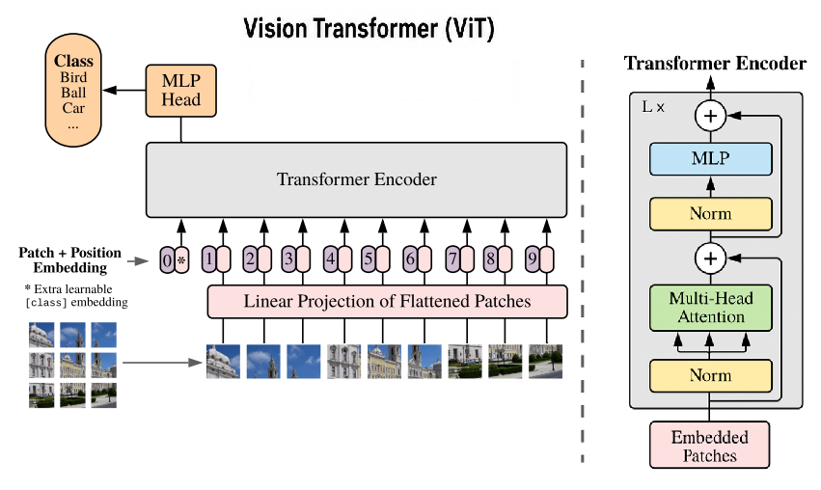

1.2.3 Pre-trained Models and Transfer Learning
Training deep learning models for computer vision from scratch often requires large amounts of labeled data and significant computational resources. In many practical scenarios, especially in applied projects, such requirements are difficult to meet. To address this limitation, pre-trained models and transfer learning techniques are widely adopted in modern vision systems.
A pre-trained model is a neural network that has already been trained on a large and diverse dataset and has learned general visual features such as edges, shapes, textures, and object structures. These features are not task-specific and can be reused for other vision tasks. By starting from a pre-trained model, it is possible to benefit from previously learned representations rather than learning everything from the beginning.
Transfer learning refers to the process of adapting a pre-trained model to a new task or domain. This is typically achieved by fine-tuning some layers of the model or by using the pre-trained network as a fixed feature extractor. Transfer learning allows models to achieve good performance even when the target dataset is relatively small, while also reducing training time and computational cost.
In computer vision, transfer learning is commonly used with both Convolutional Neural Networks and Vision Transformers. Pre-trained models provide a strong initialization that improves model stability and generalization, especially in complex real-world environments. As a result, transfer learning has become a standard practice in the development of efficient, scalable, and high-performance vision applications.
Overall, the use of pre-trained models and transfer learning plays an important role in bridging the gap between theoretical deep learning architectures and practical deployment. These techniques enable the effective application of advanced vision models in real-world systems where data and resources may be limited.

1.3 Vision-Language Models (VLMs)
Vision-Language Models (VLMs) are multimodal artificial intelligence models designed to jointly process visual information and natural language. Their primary goal is to establish a semantic connection between visual data—such as images or video frames—and textual representations. By integrating vision and language, VLMs enable machines to interpret visual content in a more flexible and expressive manner.
The motivation behind VLMs arises from the limitations of traditional computer vision systems, which are typically designed for fixed and narrowly defined tasks. VLMs address this limitation by allowing interaction through natural language, making visual understanding more intuitive and adaptable to a wide range of use cases.

1.3.2 Model Architecture
Most Vision-Language Models are built around a multimodal architecture composed of three main components: a visual encoder, a projection or fusion module, and a language model. The visual encoder extracts semantic features from images or video frames, capturing information about objects, actions, and spatial relationships.
The projection module adapts these visual features into a representation that can be processed by the language model. The language model then integrates visual and textual information to generate coherent and context-aware responses. This architecture enables effective interaction between vision and language, allowing the system to reason across modalities rather than processing them independently.
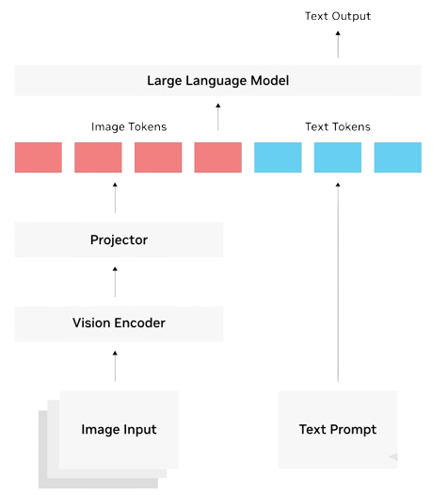

1.3.3 Core Tasks of Vision-Language Models
Vision-Language Models support a variety of tasks that require both visual understanding and language reasoning. One common task is visual description, where the model generates natural language captions that summarize the content of images or video segments.
Another key task is visual question answering, which allows users to ask questions in natural language and receive answers based on visual input. VLMs also enable semantic retrieval, making it possible to search visual data using text-based queries instead of low-level metadata.
These tasks demonstrate the ability of VLMs to move beyond simple recognition and provide high-level semantic interpretation of visual data.

Bibliographie
[1] [1] TechPro Security, “AI-Powered Video Monitoring: How Smart Analytics Are Changing Security”,
techprosecurity.com, Mars 2026.
[En ligne]. Disponible :
https://techprosecurity.com/security-articles/video-monitoring/ai-powered-video-monitoring-smart-analytics/

[2] Ambient AI, “AI Video Analytics for Physical Security: What Works in 2026”,
ambient.ai.
[En ligne]. Disponible :
https://www.ambient.ai/blog/ai-video-analytics-in-physical-security

[3] Mordor Intelligence, “AI Video Analytics Market Size & Share Outlook to 2031”,
mordorintelligence.com, Janvier 2026.
[En ligne]. Disponible :
https://www.mordorintelligence.com/industry-reports/global-ai-video-analytics-market

[4] Hanwha Vision Europe, “Video Surveillance Trends 2026: Trustworthy AI and Sustainability”,
hanwhavision.eu, Décembre 2025.
[En ligne]. Disponible :
https://hanwhavision.eu/video-surveillance-trends-2026-trustworthy-ai-and-sustainability/

[5] SOSmaster Pro, “97 statistiques clés sur la vidéosurveillance en entreprise pour 2026”,
sosmaster.pro, Janvier 2026.
[En ligne]. Disponible :
https://sosmaster.pro/statistiques-videosurveillance-2026/

[6] Ambient AI, “The Enterprise Guide to AI-Powered Physical Security in 2026”,
ambient.ai, Mars 2026.
[En ligne]. Disponible :
https://www.ambient.ai/blog/ai-powered-physical-security

[7] Ambient AI, “The ROI of AI in Physical Security”,
ambient.ai, 2026.
[En ligne]. Disponible :
https://www.ambient.ai/blog/the-roi-of-ai-in-physical-security

[8] OpenCV, Open Source Computer Vision Library, 2026.
[Online]. Available: https://opencv.org/

[9] R. Szeliski, Computer Vision: Algorithms and Applications, 2nd ed., Springer, 2022.
[Online]. Available: https://szeliski.org/Book/

[10] I. Goodfellow, Y. Bengio, and A. Courville, Deep Learning, MIT Press, 2016.
[Online]. Available: https://www.deeplearningbook.org/

[11] Stanford University, CS231n: Convolutional Neural Networks for Visual Recognition, 2026.
[Online]. Available: https://cs231n.stanford.edu/

[12] A. Dosovitskiy et al., “An Image is Worth 16×16 Words: Transformers for Image Recognition at Scale,”
in International Conference on Learning Representations (ICLR), 2021.
[Online]. Available: https://arxiv.org/abs/2010.11929

