University 20 August 1955 Skikda
Faculty of Sciences - Department of Computer Science
2nd Year Computer Science - Database Mini Project

Medical Clinic Management System

Theoretical Report

1. General Introduction
Managing a medical clinic manually is a complex task because the doctor and the secretary need to handle many repetitive operations such as patient files, appointments, consultations, prescriptions and medical certificates. Paper-based management can cause loss of patient records, difficulty in searching for information, repeated rewriting of files and conflicts in appointment planning.
The objective of this project is to design and implement a software application that automates the management of a medical clinic. The system is based on a well-designed and normalized database, and it provides simple graphical interfaces for the main users: the administrator, the doctor and the secretary.

2. Main Objectives
- Store personal and medical patient information securely.
- Plan and manage appointments through the secretary interface.
- Record medical consultations with symptoms, diagnosis, treatment and medical report.
- Manage prescriptions and medicines.
- Manage medical certificates, sick leaves and medical tests.
- Display and print the full medical history of each patient.
- Provide add, update, delete and search operations for all important data.

3. Entity Relationship Model / MCD
The following diagram presents the main entities of the future application and the relationships between them.
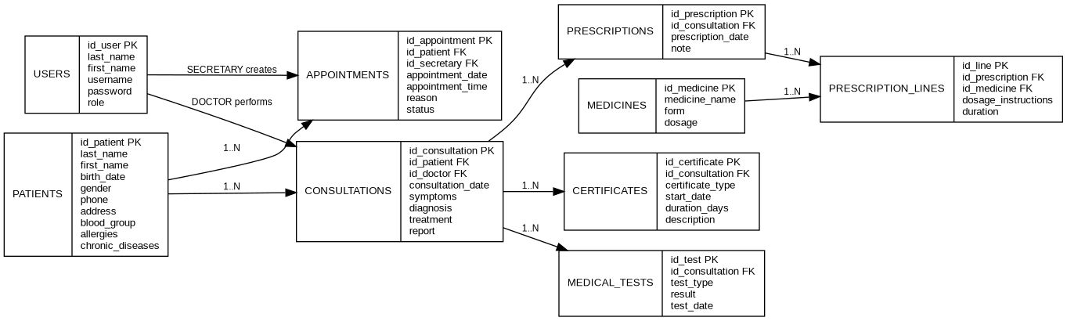

4. Relational Model
- USERS(id_user, last_name, first_name, username, password, role)
- PATIENTS(id_patient, last_name, first_name, birth_date, gender, phone, address, blood_group, allergies, chronic_diseases)
- APPOINTMENTS(id_appointment, id_patient, id_secretary, appointment_date, appointment_time, reason, status)
- CONSULTATIONS(id_consultation, id_patient, id_doctor, consultation_date, symptoms, diagnosis, treatment, report)
- PRESCRIPTIONS(id_prescription, id_consultation, prescription_date, note)
- MEDICINES(id_medicine, medicine_name, form, dosage)
- PRESCRIPTION_LINES(id_line, id_prescription, id_medicine, dosage_instructions, duration)
- CERTIFICATES(id_certificate, id_consultation, certificate_type, start_date, duration_days, description)
- MEDICAL_TESTS(id_test, id_consultation, test_type, result, test_date)

5. Application Users and Roles
User | Role
Administrator | Manages user accounts and has access to all modules.
Secretary | Registers patients, plans appointments and performs searches and updates.
Doctor | Records consultations, prescriptions, certificates, medical tests and checks patient history.

6. Practical Part
The practical part is implemented as a Java Swing application connected to a MySQL database using JDBC. The application contains the following modules:
- Login and role-based access
- Patients
- Appointments
- Consultations
- Prescriptions
- Certificates and sick leaves
- Medical tests
- Patient medical history
- Users management
- Printing output documents

7. Work Distribution Between 3 Members
Member | Main responsibility | Tasks
Member 1 | Database and report | ERD/MCD, relational model, SQL database, report writing.
Member 2 | Secretary side | Login, patients module, appointments module.
Member 3 | Doctor side | Consultations, prescriptions, certificates, medical tests, history and printing.

8. General Conclusion
In this mini project, we designed and developed a medical clinic management system. The application helps the doctor and the secretary organize daily tasks, reduce manual errors, accelerate information search and improve the reliability of patient records. The project allowed us to apply database concepts such as entity relationship modeling, relational modeling, primary keys, foreign keys, normalization and data manipulation through a Java application.

